CROP YIELD PREDICTION USING MACHINE LEARNING ALGORITHM

Ms. ANCY Y. DAS
Assistant Professor
Department of CSE,
BGS Institute of technology
ACU, BG Nagar
ancyydas91@gmail.com
Mrs. VANI N
Assistant Professor
Department of CSE,
BGS Institute of technology
ACU, BG Nagar
vanin@bgsit.ac.in

ABSTRACT

In our country, Agriculture has the largest contribution in the case of GDP. But currently the farmer’s are not getting the proper worth price of the crops. This will happen because of the improper irrigation system techniques are used for crops or inappropriate crops selection pattern techniques used or also sometimes the crop yield is less than that of expected land/area. By analyzing the soil and atmosphere at particular region best crop in order to have more crop yield and the net crop yield can be predicting. This prediction will help the farmers to choose appropriate crops for their farm according to the temperature, soil PH and Rainfall. This prediction can be carried out using machine learning algorithm. The World population is constantly increasing and it is necessary to have sufficient crop production. Monitoring crop growth scale and yield estimation of prediction are very important factor for the economic development of a country. The prediction of crop yield has direct impact on national and international economies scale and play important role in the food management and food security of a country. Deep learning gains importance on crop monitoring, crop type classification and crop yield estimation applications with the recent advances in image classification using Deep Neural Networks. Traditional crop yield prediction systems are based on remote sensing, it consists of classical Machine Learning methods. India is an agriculture country; its economy predominantly depends on agriculture yield growth and agro-industry products. Data Mining technology is an emerging research technology in crop yield analysis.

Keywords—Agriculture, Prediction, Machine learning algorithm

INTRODUCTION

Predicting the crop yield is a crucial addressing emerging challenges in the food security, particularly in an era of global climate change. Accurate yield predictions are help and support farmers to make informed economic and management decisions and also support famine prevention efforts. Machine learning is a decision support tool for crop yield prediction, including supporting decisions on what type of crops to grow and what to do during the growing season of the crops. Different machine learning algorithms and techniques have been applied to analyze the crop yield prediction research. Machine learning model predictions allow businesses to make highly accurate guesses as to the likely outcomes of a question based on the historical data, which will be about all types of things – customer churn likelihood, possible fraudulent activity, and more. Machine learning technique allows the user to make feed a computer algorithm an immense amount of information and it have the computer analyze and make data-driven recommendations and decisions based on only the input data.
Based on the climatic input parameters the present study provided the demonstration of the potential use of data mining techniques in predicting the crop yield based. The developed web page is user friendly and the accuracy of predictions are above 75 are is used.
percent in all the crops and districts selected in the study indicating higher accuracy of prediction. By providing climate data of that place, there is a user-friendly web page was developed for crop yield prediction and it can be used by user their choice of crop.

To collect all data needed by giving the GPS locations of an area and accessing from Rain forecasting system technique by the government, we should predict all types of crops by just giving the GPS location. And also, we should develop the model to avoid over and under crisis of food. In coming next years, we can try to applying the data independent system for crop prediction. That is, whatever the format of our system should work with the same accuracy. Integrating the details of soil to the system is a main advantage, as for the selection of knowledge of different types of crops on soil is main parameter of this system. Irrigation process required properly and it’s a very important needed feature for crop cultivation. In reference to rainfall, we can depict water availability and also check the water availability is needed or not. This research program can be eligible to higher level by availing it to whole over India.

LITERATURE SURVEY

D. Jayanarayana Reddy, M. Rudraa Kumar, “The Crop Yield Prediction Using Machine Learning technique”, 2021.

Agriculture is the pillar of the Indian economy and more than 50% of India's population are dependent on agriculture for their survival. Weather, climate, and other such environmental condition variations have a major risk for the healthy existence of agriculture. Machine learning technique (ML) plays a significant and major role as it has decision support tool for the Crop Yield Prediction (CYP) including and supporting decisions on what types of crops to grow and what to do next during the growing season of the crops. This research deals with a systematic study that extracts and synthesize the features used for CYP and furthermore, there are a different kind of methods that were developed to research the crop yield prediction using artificial intelligence technique.

Nathaniel D. Mueller, Vangimalla R. Reddy ,“The Random Forest method for Global and Regional Crop Yield Predictions.”, 2020.

At the regional and global scales, the very accurate predictions of crop yield are critical for developing effective agricultural and food policies. To evaluate a machine- learning technique, Random Forests (RF) method, for its ability to predict the crop yield responses to climate and biophysical variables at global and regional scales in crops such as wheat, maize, and potato in comparison with multiple linear regressions (MLR) serving as a benchmark.

Hrishikesh Mashire, Prasad Tilekar, “A machine learning approach for forecasting crop yield based on Climatic Parameters”, 2019.

In today’s world the most important thing for living in the Indian economy is Agriculture. Above 70% of the world's population is likely to be dependent on agriculture. Many crops are cultivated in India, with wheat being one of the most important food grains cultivated and exported by this country. It can be seen the crop such as wheat is a big part of the agricultural system as well as the economy of India. Therefore, it is very important to maintain the steady production of the above-stated crop. To handle the system segmentation use the crop predictive model for the prediction of crops. Planning for agriculture plays a major role in agro- based countries' economic development and food security.

OBJECTIVES

This project aims at predicting the crop yield at a particular weather condition and thereby recommending suitable crops for that field. It involves the following steps.
- Collect the data such as weather, crop yield, soil type and the rainfall and then merge these all datasets in a structured format and finally clean the data. Data Cleaning is used to remove inaccurate, incomplete and unreasonable data that is increases the quality of the data and also increases the overall productivity.
- Perform Exploratory Data Analysis (EDA) that helps in analyzing the complete dataset and summarizing the main characteristics. It is used to discover patterns, spot anomalies and to get graphical representations of various attributes. Most importantly, it tells us the importance of each attribute, the dependence of each attribute on the class attribute and other crucial information.
- Divide the analysed crop data into training and testing sets and train the model using the training data to predict the crop yield for given inputs.
- Compare various Algorithms by passing the analysed dataset through them and calculating the error rate and accuracy for each. Choose the algorithm with the highest accuracy and lowest error rate.
- Implement a system in the form of a mobile application and integrate the algorithm at the back end.
- Test implemented system to check the accuracy and failures.
- The reason for this decline in the agriculture sector is due to the fact that farmers are not empowered and due to lack of application of in the farming sector.
- Farmers have lack of knowledge about different kinds of crops and climate changes.
- To overcome the obstacle by applying different machine learning techniques to predict the crop yield as well as the name by considering various factors such as temperature, rainfall, season and area.

IMPLEMENTATION

The implementation of this crop prediction technique was divided into two types; That is; crop yield prediction and rainfall prediction (for fertilizers module).

Crop Yield Prediction
The crop yield prediction module returns the prediction of crops production is based on the user's input. If the user wants to know the production of a particular crop, the system takes the crop as the input as well. Else, it will returns a list of different crops and along with the production as output.
- Fertilizers Module
This module is used to suggest the farmer on usage of fertilizer based on the rainfall in next few days. To predict the rainfall for the next 15 days we are using an API service provided by Open Weather. We suggest that the farmer are not to use the fertilizer, if it is likely to rain.

Develop and refine the model

In this experiment, to make adjustments for this model to use your whole outside knowledge and intuitions. Firstly, to train the data, and then it validates, and also you will need to split data into training, validation, and test datasets.

Many data scientists are start working with the most basic algorithms when developing a model and moving up from there:

- Linear regression for basic regression.
- Logistic regression for basic classification.

The following libraries of python are used they are:

Pandas

Numpy

Seaborn

Matplotlib

Components
The Jupyter Notebook combines three components:
- The notebook web application
- Kernels
- Notebook documents

RESULTS

The project uses the data as shown in below fig 7.1, this are the data set used for crop yield predication which contains all the data which is necessary for crop yield predication.
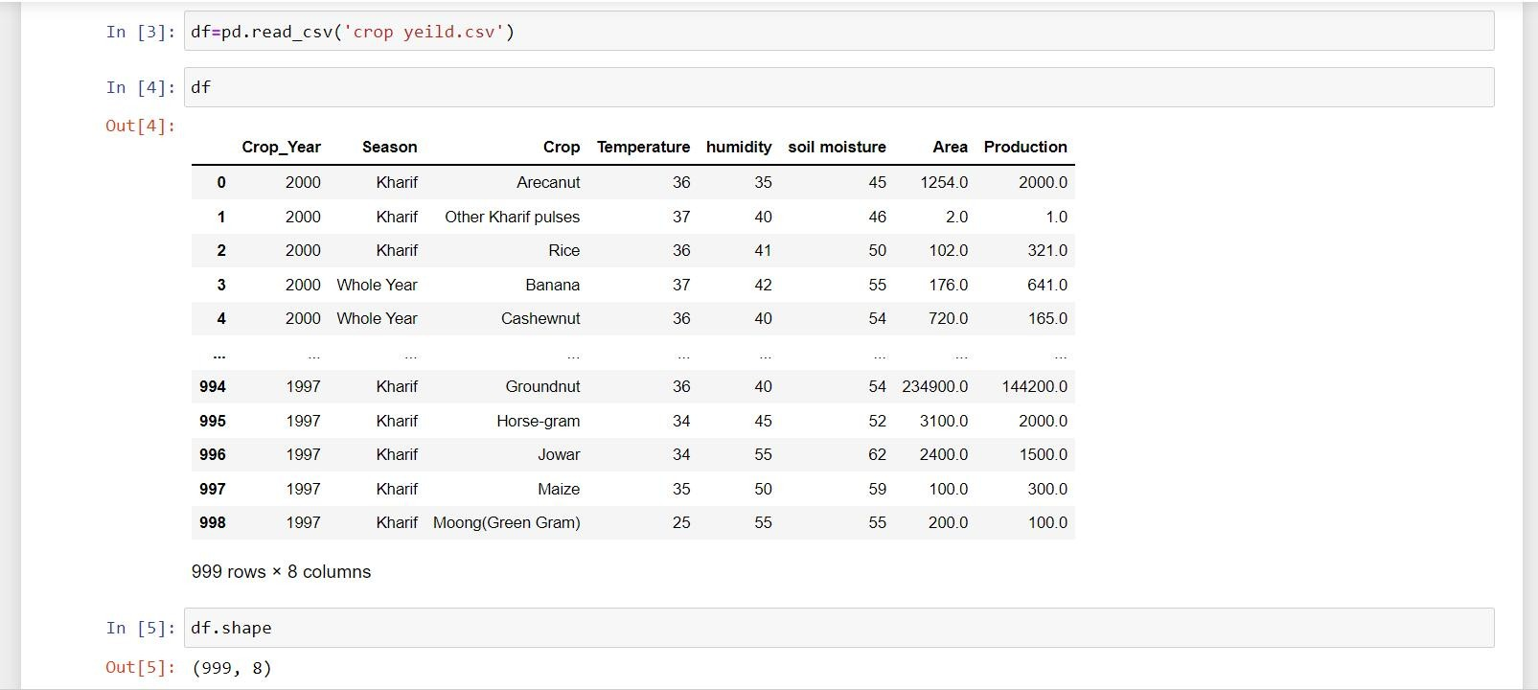
Fig 1: Data set

Description:This fig 7.2 Shows the complete information about the X test which is present in the given data set.
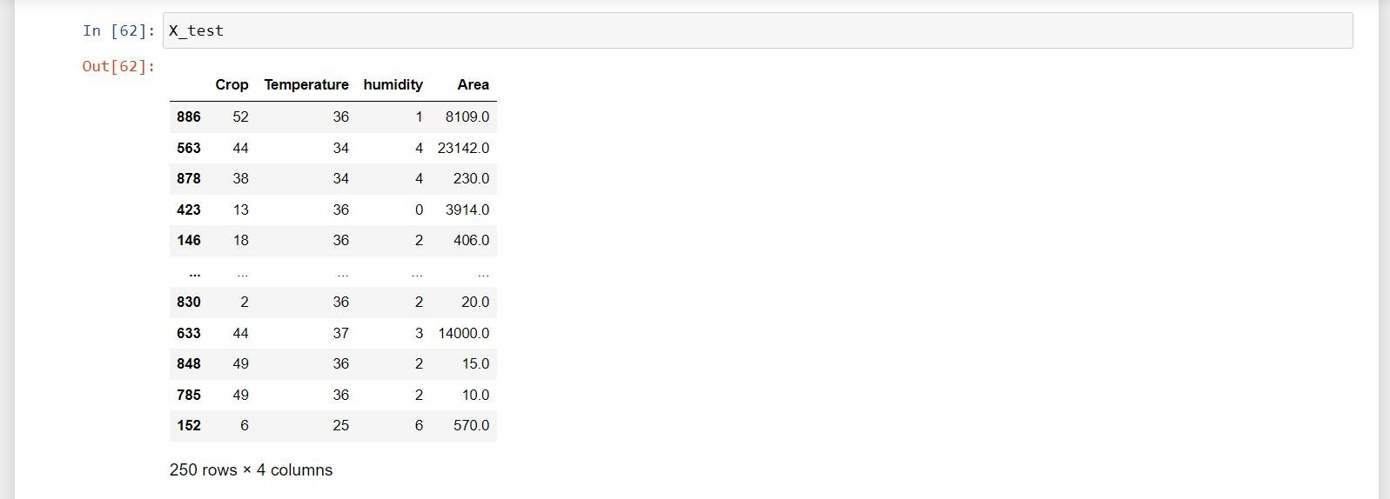

Fig 2: Shows X_TestDescription

This fig 7.3 shows the bar graph which plots the graph p v/s l rate and bar graph contains object of three attributes.
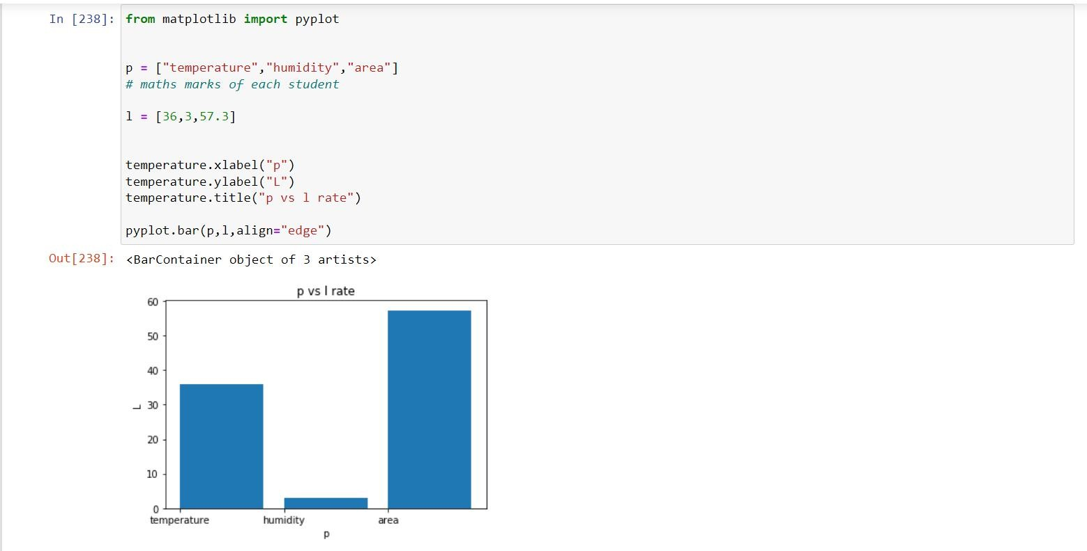

Fig 3: Shows Bar graph

Description:This fig 7.4 Shows the score of linear regression for the given data set and linear regression is a continues process and it minimize the errors in the regression process.
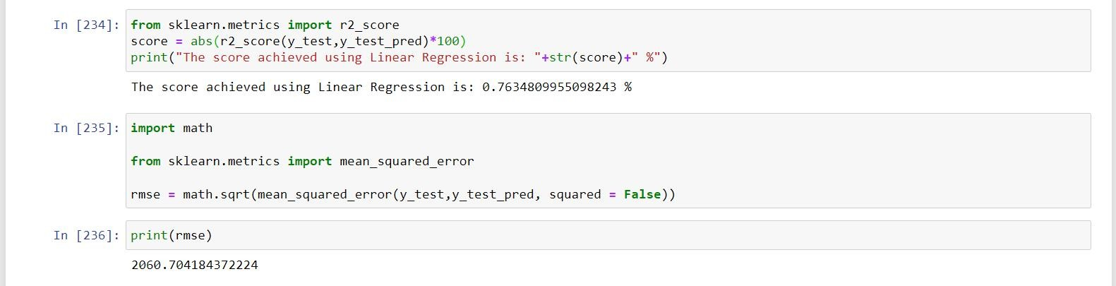
Fig 4: Score of Linear Regression
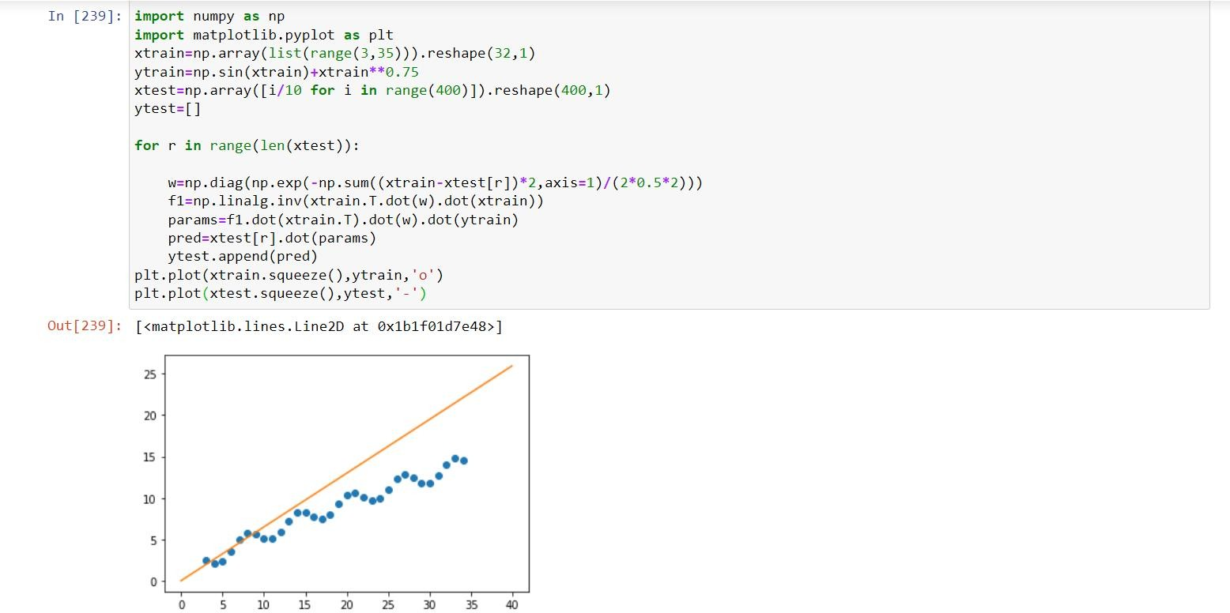
Description: This fig 7.5 Shows the histogram graph for the given data set and this graph represents the data that buckets a range of outcomes into columns along the X-axis.

Fig 5: Histogram

CONCLUSION

The main focuses on this are prediction of crop and calculation of its yield with the help of machine learning techniques are used. Several machine learning methods are used to calculate the accuracy. Random Forest classifier technique was used to predict the crop for chosen district. A system was implemented to crop prediction from the past data collection. The proposed system was helping the farmers in decision making and also crop to cultivate in the field. This proposed work is useful to search out the knowledge gain about the crops as well as it can be deployed to make an efficient and useful harvesting. The accurate prediction of different types of crops across different areas will help the farmers. This will be improving our Indian economy by maximizing the crop production yield rate.

REFERENCES
- Aruvansh Nigam, Saksham Garg, Archit Agrawal “The Crop Yield Prediction using Machine Leaning Algorithm “,2019.
- Priya, P., Muthaiah, U., Balamurugan, M.”Predicting Yield of Crops Using Machine Learning Algorithm”,2015.
- Leo Brieman, “Random Forests”, 2001.
- Mishra, S., Mishra, D., Santra, G. H.,“Applications of machine learning techniques in agricultural crop production”,2016.
- Dr.Y Jeevan Kumar,”Supervised Machine Learning Approach for Crop Production”,2020.
- Ramesh Medar,Vijay S, Shweta, “Crop Yield Prediction using Machine Learning Techniques”, 2019.

