Sustainability – The future Brand in the Market
Author 1
Prof.Suma
Assistant Professor
Department of Management
East West College of Management
Bangalore
Email: suma.mgt@ewcm.edu.in
Author 2
Prof. Divya
Assistant Professor
Department of Management
East West College of Management
Bangalore
Email: divya.mgt@ewcm.edu.in
Introduction to Sustainability
Sustainability means meeting the requirements of individual interests and reaching unborn prospects without negotiating the capability of unborn generations. Sustainability includes natural, profitable, and social coffers demanded to lead life sufficiently. Sustainability isn't just a talk of the terrain but also a need and a concern for social equity and profitable development in society. Business sustainability, also known as commercial sustainability, is the operation and collaboration of environmental, social, and fiscal demands and enterprises to ensure responsible, ethical and ongoing success. The three pillars of sustainability are social, environmental, and profitable demands. And in the global environment, they call it the triadic nethermost line. The conception of the nethermost line evaluates all sweats in terms of the short-term effect on gains. A sustainable business, or a green business, is an enterprise that has a minimum negative impact or potentially a positive effect on the global or original terrain, community, society, or frugality — a business that strives to meet the triadic nethermost line. The thing about sustainable development is to concentrate more extended timeline for return on investment after the original investment is made. Illustration For illustration, you could look for a paper supplier that uses only recycled accouterments in their products to take care of all of your company's printing and mailing requirements. By doing business with another sustainable company, you save paper and contribute to a culture of being environmentally conscious at your business.
History:
The Bruntdland Commission In 1983, the United Nations tapped former Norwegian high minister Gro Harlem Brundtland to run the new World Commission on Environment and Development1. After decades of trouble to raise living norms through industrialization, numerous countries were still dealing with extreme poverty. It sounded that profitable development at the cost of ecological health and social equity didn't lead to long-continuing substance. It was clear that the world demanded to find a way to harmonize ecology with substance. The “Brundtland Commission” released its final report, Our Common Future. It famously defines sustainable development as development that meets the requirements of the present without compromising the capability of unborn generations to meet their requirements.
Sustainability:
Sustainability is the conception of icing that a person or business can constantly give for themselves using limited coffers. Although the idea of sustainability in business is frequently brought up in a fiscal environment to bandy whether a business can support its operations grounded on its income, it’s most generally associated with an environmental and social impact. Environmental sustainability can perform by trying to reduce environmental pollution and contributing to perfecting the health and care for the earth and the being ecosystem. Profitable Sustainability It's important for everyone across the globe to be suitable to lead their lives with independence and have access to the coffers to bear the food of life. Social Sustainability Universal mortal rights and introductory musts are attainable by all people, who have access to enough coffers to keep their families and communities healthy and secure and all people are defended from demarcation.
Definition:
The Academic Advisory Committee for the Office of Sustainability at the University of Alberta put together a working definition of sustainability - Sustainability is the process of living within the limits of available physical, natural and social resources in ways that allow the living systems in which humans are embedded to thrive in perpetuity.
Sustainability is rapidly making its way into teaching and learning, research, outreach, and the operations of the organization
Why sustainability?
Sustainability is the conception of icing that a person or business can constantly give for themselves using limited coffers. Although the idea of sustainability in business is frequently brought up in a fiscal environment to bandy whether a business can support its operations grounded on its income, it’s most generally associated with an environmental and social impact. Environmental sustainability can perform by trying to reduce environmental pollution and contributing to perfecting the health and care for the earth and the being ecosystem. profitable Sustainability It's important for each and everyone across the globe to be suitable to lead their lives with independence and have access to the coffers to bear the food of life. Social Sustainability Universal mortal rights and introductory musts are attainable by all people, who have access to enough coffers to keep their families and communities healthy and secure and all people are defended from demarcation.
Benefits of sustainability in a business:

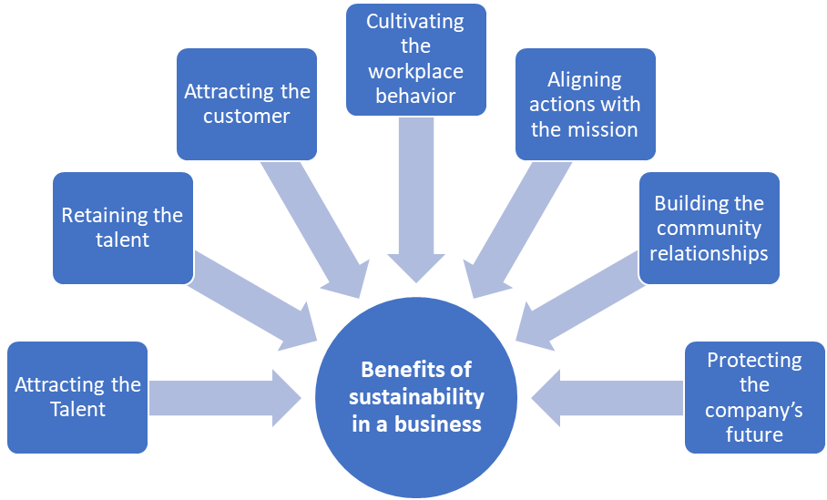

Needs for the sustainable environment
- Assess the current impact of an organization
- Set the fixed standards and measure the goals
- Regularly updating the company policies
- Concentrate on multiple products
- Research on the company suppliers
- Implementing green technology to avoid natural waste.
- Work on CSR activities

Key factors facilitating the implementation of sustainable development

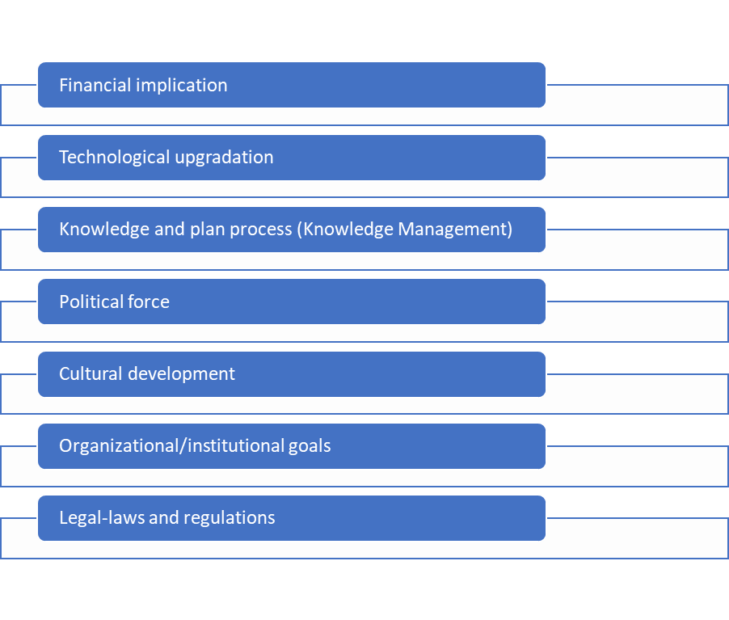

Factors that influence sustainable human resource
- Personal Factors (Competent, qualification, Knowledge, Skills, Experience, Self-confidence, etc...)
- Employees Motivation
- Communication Factor
- Trendy HR Practices
- Employee involvement/Participation/Empowerment factors
- Gender factor
- Clarity in work roles & responsibilities
- Retention strategies
- Compensation strategy
- Employee engagement practices
- Organizational culture
- Organizational effectiveness

Model of sustainable Human Resources Management both employer and employee contribution
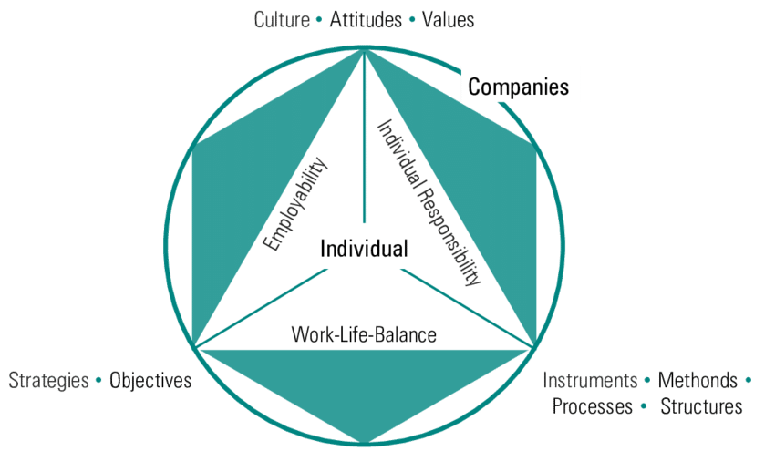
Figure 1. Model of Sustainable Human Resource Management
Source: based on Zaugg et al., 2001, p. 3.

The model explains that the sustainability of mortal coffers explains that individualities have to concentrate on employability, responsibility, and work-life balance. Every factor has a significant part in the sustainability of the individualities. The companies have to plan on the different parameters which are having significant benefactions towards sustainability. Each parameter explains about culture, station, values, strategies, objects, instruments, styles, processes, and structures of the companies. The donation of workers toward sustainability and companies’ parameters towards sustainability has to match for the success of sustainability of mortal coffers.
- Employability is one how the hand is more able of developing the chops to fulfill the required job and how he stands relative to others in this profitable condition and growth of the association.
- Work-life balance is defined as that individualities bear a reasonable balance between the demands of factual conditions of work and other aspects of life. To manage work-life balance, it's veritably important necessary to get maximum support from home and in the plant. The shy support from life and work leads to an effect on the factual performance and home connections.
- Work autonomy leads to substantial freedom, independence, and discretion in cataloging the work and the procedures to be used to carry out it. Work autonomy influences a hand’s perception of their authority to negotiate different demands.

Importance of Sustainable Human resources development
Moment, enterprises are getting decreasingly apprehensive of the significance of social, ethical, and ecological objects. In addition to fiscal profit, associations are setting themselves new pretensions, fastening on an individual, collaborative, and environmental-friendly performance and development. One of the disciplines that are promoting “ green ” associations is Sustainable Human Resource Management( SHRM). Sustainable development pretensions( SDGs) are achieved through the relinquishment of new ecological ways by the association’s mortal capital and by the integration of innovative sustainable strategies. Since industrialization started, the globe has changed drastically with technological improvements and needs the improvement of chops for the hand to make the whole association sustainable. inclusively working on the sustainability of mortal coffers leads relinquishment of new ways, styles, processes, styles, systems, and structures. The creation of new employment, new chops, and new operation and administration styles leads to the effectiveness of an association. It greatly works on the relinquishment of SHRM and GHRM makes the whole process towards environmental sustainability, enhancing the chops and relinquishment of new chops leads to hand sustainability, with the enhancement of hand productivity and organizational effectiveness leads to sustainable companies.
Findings:

- This chapter has a wide understanding of the sustainability of mortal coffers in general.
- This chapter specifies the significance of sustainability of mortal coffers in the association to reach their effectiveness and maintain their musts towards the association for their survival.
- This chapter includes the significance and requirements of mortal coffers in the association and their sustainability and their impact on the organizational benefits.
- The chapter also covers certain factors which are contributing to and grease the sustainability of mortal coffers, and those are the pillar of mortal coffers sustainability which makes to understand their individuality, organization donation towards achieving their sustainability, connection to the organizational culture for the retention strategy, and reaching the organizational effectiveness with the applicable policy for the mortal coffers.
- Certain Crucial factors are linked to enforcing and easing sustainable mortal coffers development.
- Suggested the model which is developed by Zaugg et., 2001, for the sustainability of mortal coffers which describes the three major factors. Individual with organizational employability, an association with individual responsibility, and an individual with work-life balance.
- The whole chapter gives the theoretical generalities of sustainability of mortal coffers and its significance for organizational effectiveness by espousing certain factors and styles.
Conclusion:
Competitiveness, legality, and ecological responsibility are the motives that uphold organizational change( Bansal and Roth, 2000). This metamorphosis is described as a paradigm shift toward a " green " operation and a transformation generating binary objects in social and fiscal situations( Harris and Tregidga, 2012). Concentrating on ecological, environmental, and social development is the most important in sustainable development. Meeting the requirements of present generation companies, the company has to take care of sustainability and look after the better effectiveness of the companies.

Bibliography:

- https://fardapaper.ir/mohavaha/uploads/2018/11/Fardapaper-On-the-importance-of-sustainable-human-resource-management-for-the-adoption-of-sustainable-development-goals.pdf
- https://www.mcgill.ca/sustainability/files/sustainability/what-is-sustainability.pdf
- https://www.techtarget.com/whatis/definition/business-sustainability
- https://www.indeed.com/hire/c/info/sustainability-definition
- https://www.ejournals.eu/ijcm/2017/Numer-16(3)/art/11306/
- Kjersti Granås Bardal *, Mathias Brynildsen Reinar, Aase Kristine Lundberg and Maiken Bjørkan Bardal, Kjersti Granås, Mathias Brynildsen Reinar, Aase Kristine Lundberg, and Maiken Bjørkan, ‘Factors Facilitating the Implementation of the Sustainable Development Goals in Regional and Local Planning—Experiences from Norway’, Sustainability (Switzerland), 13.8 (2021) <https://doi.org/10.3390/su13084282>

