Affect of Social Networking on Social Interaction, Self Concept and Loneliness on Today’s Youth

Saba Aziz
MOT (Pediatrics),
Jamia Hamdard, New Delhi
Assistant Professor,
Department of Occupational Therapy,
Jamia Hamdard, New Delhi.
Email id : dr.azizsaba79@gmail.com
Komal Rana
Bachelor of Occupational Therapy
Intern,
Department of Occupational Therapy,
Jamia Hamdard, New Delhi.

ABSTRACT
Social networking is used to link people from various countries, ages, and cultures. However, numerous studies have been undertaken on how excessive use of social networking has created a barrier to connection, with people becoming lonely without realizing it, addicted, and beginning to compare themselves to others. However, we will examine social interaction anxiety, loneliness, and self-concept among today's youth in this study. Which of these is the one that is being impacted the most? This raise the question here that is social media connecting or disconnecting people?

Keywords— Loneliness, Self Concept, Social Interaction, Social Networking, Youth, etc

INTRODUCTION

We are immersed in a digital society, in which our social relationships communication, education, leisure and work are transformed. Our vital trajectories, our autonomy, and our well-being, are influenced by digitalization. The new generations, intensive users of technology, are considered digital natives, and therefore digital competences play a key role in their well-being.

From our point of view, social networking sites play a key role in the lives of young people and relevantly affect the different dimensions of well-being. In this digital environment, below we present the results of our research on digital skills and the well-being of young people ^{[1]}. Online social networking sites, can offer great opportunities, in terms of interaction with others, for individual with social anxiety. Two different hypotheses have been proposed in order to explain why socially anxious individuals use computers, which can easily be applicable to online social networking sites. The first hypothesis proposed is the social compensation hypothesis, according to which individuals use online social networking sites in order to compensate for deficits in social skills or discomfort in face-to-face situations. The second theory, opposed to the first, is called the social enhancement hypothesis. According to this hypothesis, socially skilled individuals use online social networking sites to find additional opportunities to interact with others ^{[2]}. Digital technologies have become a universal feature of young people’s lives. Exposure to screen increasingly complex environment for youth. Social media offers a prime context for navigating these tasks in new, increasingly complex ways: peers are constantly available.

In form of “likes” and “views”, social comparison may be another risk associated with youth’ social media use. Individuals frequently engage in selective self-presentation on social media, resulting in a stream of posts and images that are often carefully crafted to portray users in a positive light, abilities, or appearance. This may lead some youth to engage in negative social comparisons regarding their own accomplishments, abilities, or appearance ^{[3]}.
Social networks facilitate interpersonal and group communications, and enable conversations between more persons who might never meet under ordinary circumstances. Individual’s ability to respond (interactivity) transforms the min to an audience that participates in the experiences of another person.
The virtual social sphere allows people to maintain socialties―from the real world and develop them, and at the same time helps people who lack gratifying socialties to construct a social world by creating new friendship ties online (Green & Schleien ,1991). Feeling of loneliness is subjective, and it is the interpretation that an individual gives to his own reality. That is to say, a person can feel lonely even if she is surrounded by people, or can feel socially gratified even if she is involved in a small number of social ties. A feeling of loneliness directs us to seek gratifying social interactions and avoid unsatisfying social interactions (Masietal., 2011).^{[4]}
The direct relation of the self-concept and self-esteem was postulated over one hundred years ago by William James’ (1980/1952) who stated that self-esteem is a product of an individual’s own sense of their achievements and aspirations. The higher the self-evaluation is when compared to the person’s aspirations, the higher the self-esteem. Therefore, people who perceive themselves as successful in areas of their aspirations should have higher self-esteem than people with lower self-assessments. James did not specify which area of self-evaluation should exert most impact on self-esteem - the one related to perception of one’s own competence, morality or acceptance by others. He rather pointed out that self-image is a significant factor in self-esteem development especially when the area of self-perception is considered as important by individual.^{[5]}

The increased use of social media and universality of social media presences has altered the expectations of self-presentation. Users are encouraged to take advantage of social media platforms by creating and communicating an identity on their profiles (boyd & Ellison, 2007). The ability for users to control and produce their own press to an audience of family and friends, makes it easy to mold public person as; and, use such person as to influence the impressions and perceptions others make and create about them. The material users choose to share can often reflect their self-concepts: ideas and beliefs they have about themselves ^{[6]}. Research regarding problematic online social networking sites in adolescents in scarce, and very few studies have investigated the relationship between social networking addict and youth mental health problems ^{[7]}. Many research studies have highlighted that the psychological construction of a positive self-concept by the students, during their academic stage, leads to success in educational environments and social and emotional situations (Eccles, 2009 et al 2013).^{[8]}
There are many reasons for young adults to join social networking websites as they try to communicate within their social system. The principal reason reported was to maintain relationships with existing acquaintances that were already part of their social network (Sheldon, 2008). Although there are exceptions, most social network site users primarily interacton these sites to support pre-existing social relations, as opposed to meeting new people (Boyd & Ellison, 2007) ^{[9]}. The number of social websites has also grown exponentially offering different focuses designs and features for their users.^{[10]} The importance of processing positive social information in social anxiety has only recently begun to be investigated adequately ^{[11]}. Individual high in openness personality are more prone to be creative, inventive, imaginative and original while individual who has low level of openness to experience are more tend to conventional, traditional, realistic and amount of interest to new things/experiences (Ryanand Xenos, 2011).^{[12]} Social behavior is a result of both impulsive and controlled processes. Personality may be understood as the result of typical functioning of both types of processes. On the one hand, typical operation of reflective processes-how people typically perceive and categorized situations. On the other hand, the typical functioning of impulsive processes-what kind of action are automatically performed ^{[13]}.
Social media provide Health Care Professionals with tools to share information and to promote health behaviors, to engage with the public, and to educate and interact with patients, students, and colleagues. HCPs can use social media to potentially improve health outcomes, develop a professional network, increase personal awareness of news and discoveries, motivate patients, and provide health information to the Community ^{[14]}. Many turned to the Internet to escape from the pressures and discomfort of their lives. Online, they found a world where they could be accepted and where their technical skills could be used to gain prestige ^{[15]}.

II. MATERIALS AND METHODS
- Study Design
A Survey
- Subjects
100 subjects were taken from Community by Convenient sampling method.
- Inclusion criteria
Age group 18-30 years
- Exclusion criteria
Youth diagnosed with any psychiatric Condition or having any medical condition of long tern nature.
- Withdrawal criteria
Youth not willing to participate and who did not complete the protocol due to any reason.
- Outcome Measures / Scales
- Social interaction anxiety scale. (SIAS) is a self-report scale that finds distress when meeting and talking with other people that is commonly used in clinical settings and by social anxiety research scholars. The measure also assesses social anxiety disorder, which is fear or anxiety about one or more social situations where the individual is subject to possible scrutiny.
- UCLA Loneliness scale. The UCLA Loneliness Scale is a commonly-used measure of loneliness. It was originally released in 1978 as a 20-item scale. It has since been revised several times, and shorter versions have been introduced for situations where 20 questions is too much, such as telephone surveys.
- Robson self- concept Questionnaire. This questionnaire deals with attitudes and beliefs which some people have about them.
III. DATA ANALYSIS/RESULT
The study's findings show the prevalence of social interaction anxiety, loneliness, and self-concept with the use of various social networking sites, such as video games, Facebook, Instagram, and Whatsapp, in relation to the number of hours spent by the participant, such as (M1=more than one hour, M2=more than two hours, M3=more than three hours).

Table 1 shows Frequency distribution on the basis of Gender

Gender
 |  | Frequency | Percent | Valid  Percent | Cumulative  Percent
Valid | Male | 53 | 53.0 | 53.0 | 53.0
 | Female | 47 | 47.0 | 47.0 | 100.0
 | Total | 100 | 100.0 | 100.0

Figure 1 shows Graphical representation of gender with respect to their usage of mode of internet and hours they have spent on it
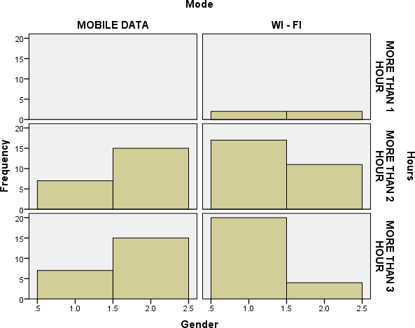

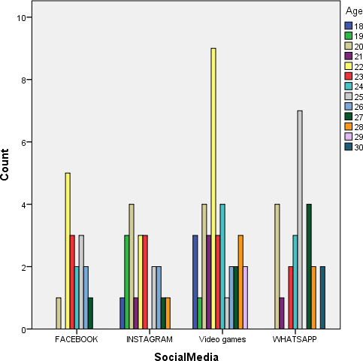
Figure 2 shows Graphical representation of different social media users according to age
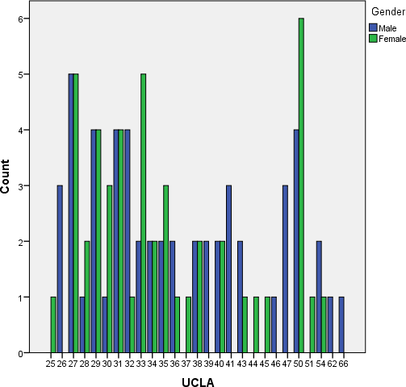

Figure 3 shows Graphical representation of participants of Loneliness scale

Figure 4 shows Graphical representation of participants of social interaction anxiety scale

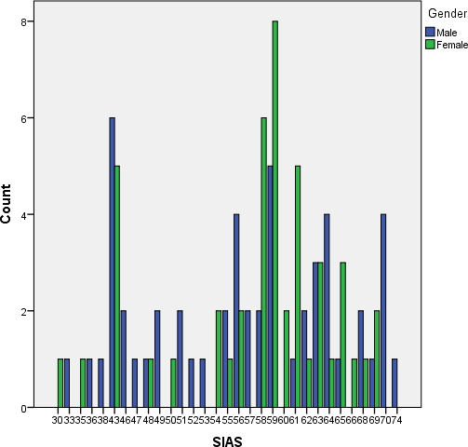

Figure 5 shows Graphical representation of participants of self-concept scale
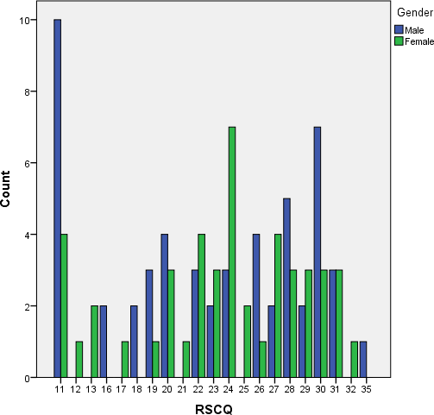

IV. DISCUSSION
The current study added to our understanding of social interaction anxiety, loneliness, and self-concept difficulties related to social networking site overexposure. Males spend more than three hours online, while ladies spend more than two hours. Both males and girls were found to spend greater time on social networking when they were 22 years old. Video games are the most popular social networking site, with 37 users (36 men and 1 woman) on it. What's app is the second most popular social media platform, with 25 users (12 men and 13 women). The third most used social networking site was instagram with 21individuals from which (1 is male and 20 are female). Face book is the last most popular social networking site, with 17 users, (4of whom are male and13 of whom are female).This demonstrates that video games are the most popular among males and instagram among females, with What'sApp being the second most popular choice among both the genders.

We found that whereas few men had the maximum score in social interaction anxiety, females show a consistent range of high scores in social interaction anxiety. This indicates that men who play video games have more concerns with social interaction anxiety. Few Males score higher range in loneliness than females, although females were more affected by loneliness than males. This indicates that females were more lonely than males, but females who use Face book have greater loneliness scores. In the self-concept scale, males scored the lowest in factor 'A' (attractiveness as approved by others), whereas females scored the lowest in factor 'A' as well as Factor 'C, 'i.e. ("autonomus self regard"), where females who used Instagram scored low in Factor A. In social networking sites, low scores in Factor 'C' were seen in the mix of all the given option. The findings of our study was fond to be comparative with the studies of (e.g. Giulia Fioravanti , Silvia Casalein 2015.)

Loneliness was found to spread faster than perceived social relationships, with friends spreading faster than family members and women spreading faster than males. The findings contribute to a better understanding of the broad social forces that drive loneliness, and they suggest that efforts to reduce loneliness in society could benefit from aggressively targeting people on the periphery to help them repair their social networks and create a protective barrier against loneliness that can prevent the entire network from unraveling (e.g. By Cacioppo, John T., Fowler, James H., Christakis, Nicholas A. 2009). This study also shows the influenced in all aspects of judgment, memory ,and overt behavior by the currently accessible pool of thoughts, attitudes, and beliefs (Nisbett & Ross 1980, Higgins & King 1981, Shermanetal 1981, Snyder1982). All of this points to the notion that these factors can have an impact on one's personality, behavior, and perception of self and society. The difference in mean values was caused by the fact that there were more male participants than female individuals.

V. CONCLUSION
Our research is one of the few that has coupled issues of social interaction anxiety, loneliness, and self-concept with exposure to social networking sites. According to the findings, more social networking exposure in terms of hours spent increases interaction anxiety and loneliness while decreases the value of self-concept. Overall, our research found that an increase in these specific factors can cause personality, behavior, and self-perception changes.

Conflicts of interest: The authors report no conflicts of interest in this work.
Findings sources: Self
Ethical clearance: Necessary permission was obtained. Verbal consent and written consent were obtained from all the participants who elected to participate in the survey.

REFRENCES
- Castillo de Mesa J, Gómez-Jacinto L, López Peláez A, Erro -Garcés A. Social networking sites and youth transition: The use of Facebook and personal well-being of social work young graduates.Frontiers in psychology.2020Feb18;11:230.
- Dobrean A, Păsărelu CR. Impact of Social Media on Social Anxiety: A Systematic. New developments in anxiety disorders. 2016 Dec 7;129.
- NesiJ. The impact of social media on youth mental health: challenges and opportunities. NorthCarolinamedicaljournal.2020Mar1;81(2):116-21.
- Yavich R, Davidovitch N, Frenkel Z. Social Media and Loneliness--Forever Connected?. Higher Education Studies. 2019;9(2):10-21.
- Lachowicz-Tabaczek K, Śniecińska J. Self-concept and self-esteem: How the content of the self-concept reveals sources and functions of self-esteem. Polish Psychological Bulletin. 2011(1).
- Blanchar JC. Social Media Responses To Self-Concept Threats. The Undergraduate Journal Of Psychology At Berkeley. 2020;13:44.
- Dobrean A, Păsărelu CR. Impact of Social Media on Social Anxiety: A Systematic. New developments in anxiety disorders. 2016 Dec 7;129.
- Herrera L, Al-Lal M, Mohamed L. Academic achievement, self-concept, personality and emotional intelligence in primary education. Analysis by gender and cultural group. Frontiers in psychology. 2020 Jan 22;10:3075.
- Sponcil M, Gitimu P. Use of social media by college students: Relationship to communication and self-concept. Journal of Technology Research. 2013 Jul 1;4(1):37-49.
- Keenan A, Shiri A. Sociability and social interaction on social networking websites. Library review. 2009 Jun 26.
- Vassilopoulos SP, Banerjee R. Social interaction anxiety and the discounting of positive interpersonal events. Behavioural and Cognitive Psychotherapy. 2010 Oct;38(5):597-609.
- Alan AK, Kabadayı ET. The effect of personal factors on social media usage of young consumers. Procedia-Social and Behavioral Sciences. 2016 Nov 24;235:595-602.
- Back MD, Schmukle SC, Egloff B. Predicting actual behavior from the explicit and implicit self-concept of personality. Journal of personality and social psychology. 2009 Sep;97(3):533.
- Morahan-Martin J, Schumacher P. Loneliness and social uses of the Internet. Computers in human behavior. 2003 Nov 1;19(6):659-71.
- Akram W, Kumar R. A study on positive and negative effects of social media on society. International Journal of Computer Sciences and Engineering. 2017 Oct 30;5(10):351-4.

