A Rising Tendency in Humans’ Farming and Linking Farmers to Data Science& IOT Technology

¹Dr A Arun Kumar, Associate professor
Department of CSE
Marri Laxman Reddy Institute of Technology and Management
Dundigal, Hyderabad -500043.

²Dr. Madhavi Pingili, Professor & HoD
Department of Information Technology
CMR ENGINEERING COLLEGE (CMREC)
HYDERABAD
TELANGANA - 501401

ABSTRACT
A potential invention that can be connected in a wide range of areas, from natural observation to fiasco the executives, is a particularly appointed system. Additionally, specially designed technologies can be used to automate procedures in a wide range of contemporary applications. Occasions, for example, quakes can frequently serve to represent the shortcoming of midway overseen systems and the significance of innovative work in impromptu systems Technology in data science to make smarter decisions, reduce costs, and boost production of crops through GPS – based application development for web and mobile platforms to keep track of farm feeds and check soil moisture levels, wearable device integration to connect with the farmer's community and share information among them to updates day-to-day activities. Automation of farm equipment through online marketing, data warehousing, management, cloud-based services for weather, maps, visual aids to comprehend data for a faster decision-making system. Space technology aids in the urgent need for quick, objective information regarding India's crop status. It gives digital data that may be used for a variety of analyses that call for details about different types of crops, estimated crop areas, crop conditions, agricultural damages, crop growth, etc.
Keywords - E-agriculture, Data Science technology, Sciences, GPS.

INTRODUCTION

The management of massive data sets from various sources to produce precise results that support informed decision-making is known as data science. Market for National Agriculture Indian Society of Agribusiness Professionals, Department of Agriculture, Cooperation and Farmers Welfare, Agriculture Insurance, Farmer's Portal, E-Couple, Big Basket, indiancommodities.com, agricoop.nic.in, An tremendous amount of data is produced in the healthcare sector by numerous studies, patient diagnoses, hospital record systems, elderly care, and many other connected services and goods.
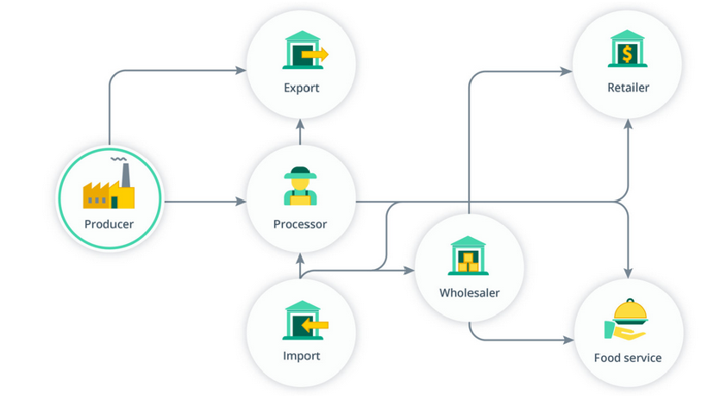
FIGURE 1 Role of Farming
Nowadays, the majority of nations use "IoT" technology in agriculture to improve food production and safety through clever logistics and warehousing. gathering information and studying soil health, agricultural diseases, and weather forecasts. Integrated pest management and control includes monitoring, checking, identifying, keeping track of records, and automatically spraying pesticides using remote agricultural A potential invention that can be connected in a wide range of areas, from natural observation to fiasco the executives, is a particularly appointed system. Additionally, specially designed technologies can be used to automate procedures in a wide range of contemporary applications. Events like earthquakes can frequently be used to highlight the shortcomings of haphazardly monitored systems and the importance of creative work in impromptu system monitoring, climate monitoring, and forecasting, as well as water management because crops will not survive in the absence of an adequate water supply. With the help of a few sensors, data, and other tools, "IoT" improves water management for smart farming, allowing a farmer to get real-time information on the agriculture process. The paper aims at making modern agriculture using advanced machinery like remote sensing, Geographical Information System (GIS), soil and seed development through.
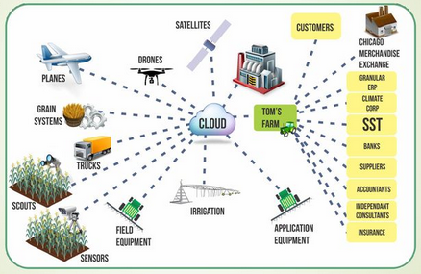
FIGURE 1.1 Sources and application of Data

PROEDURE OF E-AGRICULTURE IN NOIDA

E-agriculture is to establish communication through the virtual will be given to agricultural extension officer who acts as an interface, and plays a crucial role in executing agro advisory services to empower the farmer, and enable to provide the updated information about the government subsidies and initiatives. so the farmers are well aware of the eco-system and enable the process of getting information of weather, soil, humidity, climate change data by storing wireless sensor in the agricultural fields, get the direct market value and ask the queries through video calling directly by the scientist. The Government of India also creates an awareness campaign for the farmers on how best they can use modern technologies to conduct agribusiness.
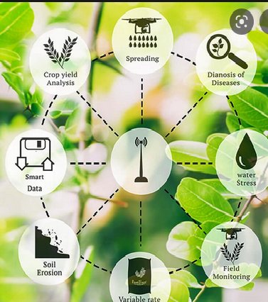

FIGURE 1.2 E-Agriculture Architecture
SMART AGRICULTURE MANAGEMENT SYSTEM
Advanced machinery for routine operations is used instead of using in traditional farming as manual labor work. get the direct market value and ask the queries through video calling directly by the scientist. The Government of India also creates an awareness campaign for the farmers on how best they can use modern technologies to conduct agribusiness Crop & water management, pest management, soil monitoring, and crop area estimation, food production storage, and safe processing get the direct market value and ask the queries through video calling directly by the scientist. The paper aims at making modern agriculture using advanced machinery like remote sensing, Geographical Information System (GIS), soil and seed development through.
Water will harm the crops, so the Indian government also runs a campaign to educate farmers on how to use contemporary technology to their advantage. With the help of a few sensors, data, and other tools, "IoT" improves water management for smart farming, allowing a farmer to get real-time information on the agriculture process. The purpose of the article is to enhance agriculture through the use of cutting-edge technology, such as remote sensing, and to make information on farm research, planning, extension, production, monitoring, marketing, and trade available.
E-agricultural market capable of handling all market operations auctions and price discovery

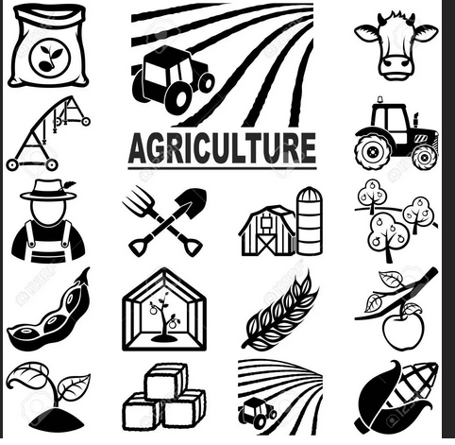

FIGUR1. 3 Smart Agriculture Methodology Framework
E-AGRICULTURE MARKET STRATEGY
E-agriculture is a set of contemporary instruments and technology for information and communication that boosts agricultural productivity and makes information available for farm research, planning, extension, production, monitoring, marketing, and trade. The e-agricultural market is capable of managing all market activities, including price discovery and auctions, trade fulfilment, fund processing, and increasing the price at which produce is sold. By using internet trading for agricultural commodities, delays in transaction completion will be eliminated, and transparency will be achieved. Although there are a lot of businesses producing data products and may even be in the final testing stages, we have not yet encountered this type of technology in South Africa. There are many data products and services in the US that are accessible to the general public, but they are still in their infancy. The true innovation won't happen for a while, but when it does, it will be revolutionary.
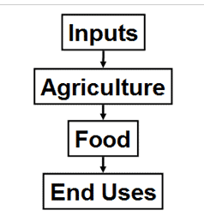
FIGURE1. 4 Online Commodities Marketing of Farming
The paper aims at making modern agriculture using advanced machinery like remote sensing, Geographical Information System (GIS), soil and seed development through.Transforming rural India with the E-Agriculture concepts farmers get better returns for their farm produce. With improved access to government policies and initiatives for farmers, on soil advice, crop management, weather, and marketing of agricultural products, India's rural agricultural market would change. Digital Temperature Sensor: The temperature sensor uses a single digital pin to read the temperature. Soil Moisture Sensor: The soil moisture sensor FC-28 interface provides us with the output of moisture level. Produce from pressure sensor agriculture with e-aid. Cooperation and Farmers Welfare provides an estimate of food grain production in the Department of Agriculture's report.

The purpose of the study is to develop contemporary agriculture employing cutting-edge equipment like remote sensing and geographic information systems. A lot of money has been invested in digital agriculture as the globe moves in that direction. To increase farms' productivity, a lot of research and development is being done. The development of soil and seeds through the use of modern technology will increase the yields of both small- and large-scale farms. According to the agricultural economics and statistics graph below, the three most common crops grown are wheat, rice, and maize, which all experience exponential growth as a result of agricultural practises. But if we look at the worldwide open market for crop exports, according to the survey report of a global agricultural commodities market for chosen countries by 2050, a lot of money has been invested in digital agriculture. To increase farms' productivity, a lot of research and development is being done. The results of crop exports are decreased as a result of incorporating new technology, as indicated in the study, which strives to modernise agriculture through the use of cutting-edge equipment like remote sensing, Geographical Information System, soil and seed development.

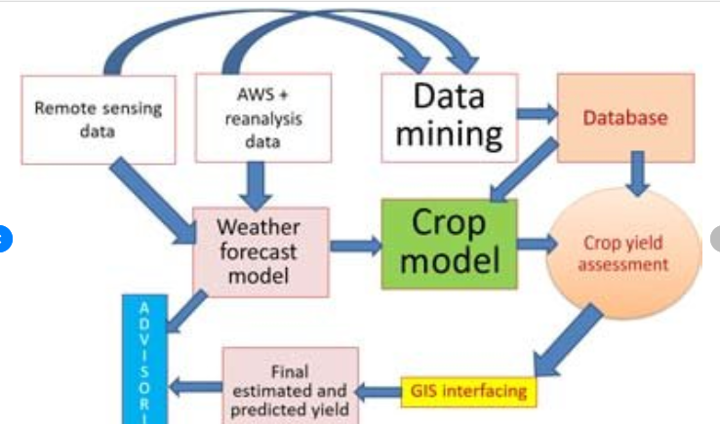
FIGURE 1.5 open markets' effects on net trade positions, and production in India
SOLUTION ARCHITECTURE AND IOT COMPONENTS
The following elements are needed to create a complete "IoT" system architecture for agriculture: Digital Temperature Sensor: The temperature sensor uses a single digital pin to read the temperature. Soil Moisture Sensor: The soil moisture sensor FC-28 interface provides us with the output of moisture level. Measures pressure A potential invention that can be connected in a wide range of areas, from natural observation to fiasco the executives, is a particularly appointed system. Additionally, specially designed technologies can be used to automate procedures in a wide range of contemporary applications.
Quakes, for instance, can frequently be used to highlight the shortcomings of systems that are overseen in the middle of their development and the importance of creative labour in impromptu systems. Digital Temperature Sensor: The temperature sensor uses a single digital pin to read the temperature. Soil Moisture Sensor: The soil moisture sensor FC-28 interface provides us with the output of moisture level. either a pressure sensor or an air quality sensor: both. Uses a digital humidity sensor. Light Intensity Sensor & Amplifier: Digital Light Sensor detects a wide range at high resolution.
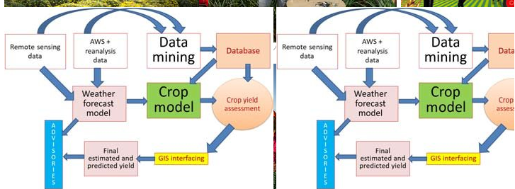
FIGURE1. 6 Based Agriculture Field Monitoring
NOVEL PROPOSED IOT WORKING MODEL
A potential invention that can be connected in a wide range of areas, from natural observation to fiasco the executives, is a particularly appointed system. Additionally, specially designed technologies can be used to automate procedures in a wide range of contemporary applications. Quakes, for instance, can frequently be used to highlight the shortcomings of systems that are overseen in the middle of their development and the importance of creative labour in impromptu systems. Both the soil moisture sensor and humidity sensor are interconnected to carry out a task; in the event of an emergency, the data will be sent to a database via the internet cloud and then sent to the farmers via a device known as a GSM Module. In “IoT" based crop field monitoring system the motor will be automatically ON through a Soil moisture sensor, it will show you on your handheld devices (Mobile or Tablets) shown through a webpage or mobile application
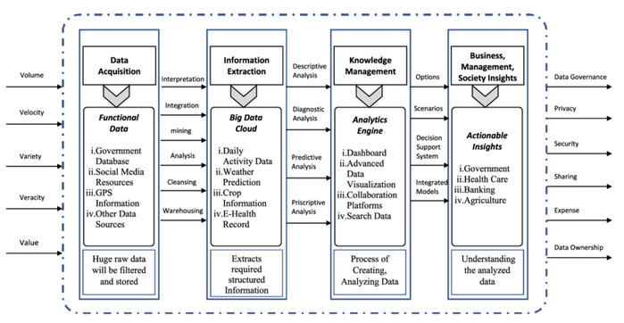
FIGURE 7 Working Model
The foundation of the Indian economy is agriculture. Statistics indicate a decline in the number of rural residents and the amount of arable land per person. For a nation with a population of over one billion people, more than 66% of whom live in rural regions, this is a worrying development. This essay seeks to review recent agricultural research and studies. The motor should have its power supply step-down by a transformer if the moisture readings are a little low. In this scenario, the motor will gather all the data from all sensors, send it to the server, and then do data analytics.
RESULTS
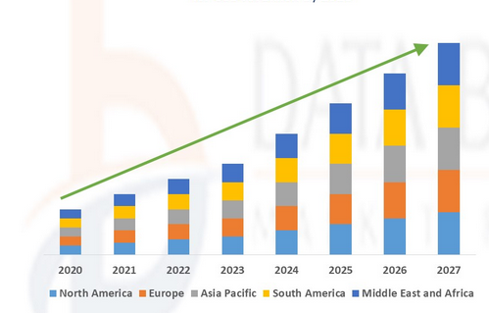

CONCLUSION
E-Farming, which is rapidly expanding in the agricultural industry, gives our farmers new ways to share and access information. The agriculture industry has a lot of room for innovation because to modern e-agriculture technology, including machine learning, the internet of things, cloud computing, big data, and data analytics. A potential invention that can be connected in a wide range of areas, from natural observation to fiasco the executives, is a particularly appointed system. Additionally, specially designed technologies can be used to automate procedures in a wide range of contemporary applications. Quakes, for instance, can commonly be used as a metaphor for the limitations of halfway monitored systems and the importance of creative work in unplanned systems to fulfil the goals and problems that our farmers confront in light of current trends. The Government of India also creates an awareness campaign for the farmers on how best they can use modern technologies to conduct agribusiness.
References
- Chaitanya S, K., Ilayarajaa, K., Karthikeyan, & Reddy, K. M. (2017). ANDROID BASED IOT FOR AGRICULTURE AUTOMATION. International Journal of Pure and Applied Mathematics , XVII (21), 169-176.
- Chandra, G. N., Khayongek, S., Armedia, N., Soni, R., & Brahma, B. (2016). E-AGRICULTURE STRATEGY GUIDE. Bangkok: Food and Agriculture Organization of the United Nations and International Telecommunication Union .
- Chauhan, R., Jagtap, S., Ahire, S., Bhoyate, A., & Nalavade, K. (2017). E-trading of Agricultural Products from Farm to Customer Application. International Research Journal of Engineering and Technology , IV (3), 2756-2759.
- da Silva, J. G. (2018). The State of Agricultural Commodity Markets 2018. Agricultural trade, climate change and food. Rome: Food and Agriculture Organization of the United Nations.
- Ghogare, S. A., & Monga, P. M. (2015). E-Agriculture” Introduction and Figuration of its Application. International Journal of Advanced Research in Computer Science and Software Engineering , V (1), 44-49.
- Gondchawar, N., & Kawitkar, R. S. (2016). IoT based Smart Agriculture. International Journal of Advanced Research in Computer and Communication Engineering , V (6), 838-842.
- M R, S., Pabshettiwar, A., Ghumatkar, K., Budhehalkar, P., & Jaju, P. (2012). E-FARMING. International Journal of Computer Science and Information Technologies , III (2), 3479-3482.
- Madhusudhan, L. (2015). Agriculture Role on Indian Economy. Business and Economics .
- Malavade, V. N., & Akulwar, P. K. (2016). Role of IoT in Agriculture. IOSR Journal of Computer Engineering , 56-57.
- Patil, G. L., Gawande, P. S., & Bag, R. V. (2017). Smart Agriculture System based on IoT and its Social Impact Social Impact. International Journal of Computer Applications , XVI (1), 1-5.
- Raju, K., Naik, G., Ramseshan, R., Pandey, T., & Joshi, P. (2016). Transforming Agricultural Marketing in India: Linking Farmers to a National Gateway and E-Markets. Telangana, India: ICRISAT Development Center.
- Sangtrash, H. M., & Hiremath, A. S. (2017). Review on IoT for Indian Farmers. International Journal of Scientific Research in Computer Science, Engineering and Information Technology , II (3), 236-239.
- Sharma, D., Shukla, A., Bhondekar, A. P., Ghanshyam, C., & Ojha, A. (n.d.). A Technical Assessment of IOT for Indian Agriculture Sector. International Journal of Computer Applications , 1-5.
- Strzębicki, D. (2011). Selling of agricultural products via the Internet. 176-195.
- Sundar, I. (2016). AGRIBUSINESS SCOPE, OPPORTUNITIES AND CHALLENGES IN INDIA. EPRA International Journal of Economic and Business Review , IV (7), 171-178.
- Thankachan, S., & Kirubakaran, S. (2014). E-Agriculture Information Management System. International Journal of Computer Science and Mobile Computing , III (5), 599-607.
- Myung Jong Lee, Jianling Zheng, Xuhui Hu, Hsin-hui Juan, Chunhui Zhu, Yong Liu, June Seung Yoon, and Tarek N. Saadawi, “A New Taxonomy of Routing Algorithms for Wireless Mobile Ad Hoc Networks: The Component Approach”, IEEE Communications Magazine, vol. 44, no.11, pp. 116-123, November 2006
- K. Akkaya and M. Younis, “A Survey of Routing Protocols in Wireless Sensor Networks”, Elsevier Ad Hoc Network Journal, Vol 3/3,pp.325-349, 2005
- Veena Venugopa, Radim Barto, Michael J. Carter, and Sai S. Mupparapu, “Improvement of Robustness for Ad Hoc Networks Through Energy-Aware Routing”, University of New Hampshire, Durham, NH 03824, USA,2002.

- Charles E. Perkins, “Ad hoc On-Demand Distance Vector (AODV) Routing”, INTERNET DRAFT, Mobile Ad Hoc Networking Working Group, 17 February 2003.
- Rabaey, J. Ammer, J. L. da Silva Jr, D. Patel, “PicoRadio: Ad hoc Wireless Networking of Ubiquitous Low-Energy Sensor/Monitor Nodes”, Proceeding WVLSI '00 Proceedings of the IEEE Computer Society Annual Workshop on VLSI (WVLSI'00), 2001.

