Author: Dr. Subia Ekram¹, Dr. Mohammad Kashif Noorani²
Title: Dental Implant Treatment Planning on “Implant design” – Review of Literature
Abstract
Dental implants are subjected to various force of magnitudes and direction during function. Implant design, implant stability, materials used in dental implants are the main factors required for the long-haul accomplishment of a dental implant. This article shall help the learner in making a judicious informed decision regarding the implant design.
Keywords: Dental implant, Implant design
Introduction
Dentistry has experienced remarkable advancements in dental restorative materials, techniques, and strategies that are predictably effective for the long-term management of tooth loss. The ultimate goal of dental implant therapy is to satisfy the patient’s desire to replace one or more missing teeth in an esthetic and functional manner with long-term success.¹ Scientifically proven approaches have evolved that now provide the dental patient with esthetically and functionally excellent options for tooth replacement. The partially edentulous patient can now undergo replacement of a one tooth or several missing teeth with implant retained crowns that provide the same function and esthetics that they had with their natural teeth. Successful dental implant treatment requires careful treatment planning, meticulous surgical technique, and precise prosthetic restoration. The typical implant team consists of a restorative dentist, a properly trained and experienced surgeon, and a dental laboratory technician, who work together.
Osseointegration is the key biologic and biophysical process that has made dental implant therapy predictably effective for replacing missing teeth. Histologically defined, osseointegration is the direct structural and functional connection between organized, living bone and the surface of a load-bearing implant without intervening soft tissue between the implant and bone. The features of the design of dental implants are one of the most critical factors that have an effect on primary stability and on the implant’s ability to sustain loading after osseointegration.²
INFLUENCE OF IMPLANT MATERIAL ON OSSEOINTEGRATION
There are no excellent scientific studies from which it can be deduced which implant design or surfaces are superior. Most of the time, implant success will depend on treatment planning, surgical skills, prosthetic design, and patient behavior rather than on the implant surface. In a retrospective analysis of 2349 implants in 677 patients to identify risk factors associated with failures of Bicon implants using multivariate regression analysis, it was determined that implant surface was not a factor, but that failures were due to tobacco use, implant length, staging, well size, and immediate implants.³ Osseointegration per se is not linked to any particular surface characteristics, because a great number of different surfaces achieve clinical osseointegration. However, the stronger or weaker bone responses may be related
to the surface characteristics.⁴ Five features can be used to describe the dental implant body: shape, surface macro and micro structure, length and diameter.
Implant Design
Dental implants can be categorized into threaded and non-threaded, cylindrical, or “press-fit” designs. Implant design can increase surface area of support. A threaded design implant has 30% to 200% greater surface area compared with a cylinder implant of the same size. Although more difficult to place, the threaded implant in poorer density bone is strongly encouraged. Biomechanical aspects of thread designs also affect the total increase in the surface area (i.e., thread pitch, shape and depth).⁶
Roughened surface conditions or hydroxyapatite coating on the implant has been shown to increase the rate of osseous adaptation to implants and provide greater initial rigid fixation. In addition, an increase of surface-to-bone contact and amount of lamellar bone and the relatively greater strength of the coronal bone around the roughened-surface implants occur when compared with machined or smooth titanium implants.⁷⁻⁸ Therefore, coatings or roughened surfaces on implant bodies are suggested in the compromised D3 or D4 bone density.
Discussion
The main focus of any implant design is to improve surgical success rate and reduce plaque-related complication after treatment. Surgical success rate can depend upon when proper osseointegration takes place. The rationale behind macro and micro features in implant design is that the bone is stronger when loaded in compression, contrary to when subjected to tensile force and loaded in shear. Thus, when an implant is placed, it should be attempted to increasing the compressive force excerted.⁹⁻¹⁰ It is offended supported Wolff’s law which states that “nature economizes on bone and tends to eliminate dispose of bone that is not optimally used”.¹¹
Implant shape can be on different types such as tapered or threaded cylindrical or smooth cylindrical. Cylindrical implants can be placed in anterior and posterior teeth regions but tapered only in anterior region. Smooth sided cylindrical implants provide ease in implant placement however, they supply greater shear conditions.
Implant thread are incorporated into implants to improve initial stability ^{12,} ¹³ enlarge implant surface area, and distribute stress favorably. ^{14,15} Kohn et al ¹⁶ demonstrated the presence of a bone bridge from the depth of ‘1’ thread to another, when the implants were laterally loaded and concluded that strain is more concentrated within the area where bone contacts the crest of the thread and the strain decreased from the crest to the root of the thread.
Thread shape is set by the thread thickness and thread face angle. Knefel¹⁷ investigated five different thread profiles and found the most favorable stress distribution to be demonstrated by an ‘asymmetric thread’, the profile of which varied along the length of an implant. Misch et al ⁹ suggested that “v”shape (30° angle) generate higher shear force than reverse buttress thread (15° angle). Both sort of threads are shown to get forces which can result in defect formation. ^{18.}
Pitch is that the distance from the center of the thread to the center of the next thread, measured parallel to the axis of the screw. The pitch is thought to have a significant effect due to the available surface area (SA) for bone to implant contact (BIC). With lower pitch, the number of thread increase, which in turn gives higher SA and BIC results in a more favorable stress distribution. According to Kong ¹⁶ et al. 0.8mm is the optimal thread pitch for primary stability and optimum stress production on cylindrical implants with V shape threads. Thread geometry includes thread pitch, depth and configuration or shape which can play a role in the stress distribution of an implant to the surrounding bone. This
distribution can be observed at primary placement, healing and during the loading phase of the implant.
Threads are used to maximize initial contact, improve initial stability, enlarge implant area,¹⁹ and favor dissipation of interfacial stress.²⁰ Thread depth, thread thickness, thread face angle, thread pitch, and thread helix angle are some of the varying geometric patterns that determine the functional thread surface and affect the biomechanical load distribution of the implant.²¹ The influence of the threads can be easily understood as the greater the number of threads that are present as well as the greater the depth of the threads, the more functional surface area that is available.
The Implant Diameter is measured from the crest of the widest thread to the identical point on the alternative side of the implant.²² According to the diameter, implants would also be classified a mini when diameter is ≤2.7 mm narrow when the diameter is >2.7 mm but ≤3.75 mm regular when it ranges from 3.75−5 mm and wide when the diameter is >5 mm. An increase in the diameter of an implant is associated with an increase in its surface area. For instance, increasing the diameter in a 3 mm implant by 1 mm increases the surface area by 35% over the same length.²³ Also, a 3.75*10 mm implant has 61% less surface area than 6 mm diameter implant of the same length. The diameter of the roots is usually estimated at 2 mm apical to the cementoenamel junction (Figure 4). In order to obtain a restoration with an optimal emergence profile the implant platform is usually placed at about 2 mm apical to the cementoenamel of the adjacent teeth. If an implant is placed deeply below the crest of bone the crown height is increased which may lead to mechanical failure of implant components and compromise aesthetic outcomes. When the implant is placed more superficially restoration may be deemed impossible and aesthetic treatment outcome is also compromised.²⁴ It is important to distinguish between the implant diameter and platform diameter as they may not be equal. The implant platform represents the part of the implant that is connected to the prosthetic (abutment) counterpart.
According to Albrektsson (1981) et al factors affecting implant osseointegration are surgical technique host bed, implant design, implant surface material biocompatibility and loading conditions.²⁵Internal connections implant design shows about 0.2–0.3 mm of bone loss. While external connection displays up to 1 mm of average bone loss.
Multiple factors however, influence the choice of the radiographic techniques used for any particular case. Such factors as cost, availability, radiation exposure, and the type of case must be weighed against the accuracy of identifying important anatomic structures within a given bone volume and the ability to perform the surgical placement without injury to these structures.²⁶
Table 1: The areas of study radiographically included
1. The location of important structures
A. Mandibular canal
B. Anterior loop and extension of the mandibular canal
C. Mental foramen
D. Maxillary sinus (floor, septum’s, walls, pathologic features)
E. Nasal cavity
F. Incisive foramen
2. Bone height
3. Root proximity and angulation of existing teeth
4. Evaluation of cortical bone
5. Bone density and trabeculation
6. Pathologic features (eg, abscess, cyst, tumor)
7. Existence of anatomic variants (eg, incomplete healing of extraction site, impacted teeth)
8. Cross-sectional topography and angulation (best determined using CT and CBCT)
9. Sinus health (best evaluated using CT and CBCT)
10. Skeletal occlusal classification (best evaluated using lateral cephalometric images)

Table 2: The critical measurements specific to implant placement include the following
- At least 1 mm inferior to the floor of the maxillary and nasal sinuses
- Incisive canal (maxillary midline implant placement) to be avoided
- Five millimeters anterior to the mental foramen
- Two millimeters superior to the mandibular canal
- Three millimeters from adjacent implants
- One and one half millimeters from the roots of the adjacent teeth

A comparison of implant stability readings by Bailleri and colleagues²⁷ failed to demonstrate a right way relationship between implant length and primary stability. Their results indicated that a short implant could be as stable as a long implant. Primary implant stability plays a vital role in successful osseointegration. In addition to length and width, thread shape and thread details also play a dominant role on local stress patterns at the bone-implant interface. Thread geometry in terms of pitch, depth, and width will affect the stress distribution forces all around the implant contacted bone. The ultimate goal of the thread design should be to avoid or minimize stress peaks under loading. In this regard, thread depths seemed to play a very significant role on implant stability in both trabecular and cortical bone, whereas variations of pitch (the distance from the center of the thread to the center of the next thread) and the thread face angle (the angle between a face of a thread and a plane perpendicular to the long axis of the implant) do not influence implant stability in trabecular bone.²⁸ Chung and colleagues²⁹ found that implants with a pitch distance of 0.6 mm had more crestal cortical bone loss than implants with 0.5-mm pitch. These Implant Design and Osseointegration ³⁰ suggestive of pitch decreased, the surface area increased, leading to a more favorable stress distribution. Implant with a higher number of threads is advisable in poor bone quality, areas with high occlusal forces, and in short implants. However, from a surgical point of view, the lesser the threads, the easier and faster it will be to insert the implant. Misch and colleagues⁹ stated that “the deeper the threads, the broader the surface area of the implant” which is a design that is very advantageous in softer bone and higher occlusal force areas because of a higher functional surface area in contact with the bone itself. In summary, implant threads should yield allow for increased stability and more implant surface contact area.
Conclusion
The answer to the question of what constitutes success in implant dentistry remains complex. There’s no unanimous definition of clinical success for implants or teeth. Teeth and implants don’t permit a strict diagnosis of total health or failure. A tooth with periodontal pocket depths of 5 mm may have therapy but is still within a range of "success." Failure is usually easier to explain but if a dental unit does not qualify as failure, it does not necessarily qualify as a successful. The first criteria for assessing implant quality are pain and mobility. The presence of either factor greatly compromises the implant, and removal is typically indicated.
According to Misch ^{[9} ] criteria for success in implant dentistry includes:
- Pain
- Rigid fixation
- Probing depth
- Bone loss
- Bleeding index
- Peri-implant disease
- Percussion
- Radiographic evaluation
Reference
[1] Hupp, J. and Laskin, D., 2017. Introduction to implant dentistry A student guide. 2nd ed. Suppl. USA: Elizabeth Perill, Michele Willmunder.
[2] Ogle O. Implant Surface Material, Design, and Osseointegration. Dental Clinics of North America. 2015;59(2):505-520.
[3] Chuang SK, Wei LJ, Douglass CW, et al. Risk factors for dental implant failure: a strategy for the analysis of clustered failure-time observations. J Dent Res 2002;81:572–7.
[4] Wennerberg A, Albrektsson T. On implant surfaces: a review of the current knowledge and opinions. Int J Oral Maxillofac Implants 2010;25(1):63–74.
[5] Misch CE, Maxillary Posterior Edentulism: Treatment Options for Fixed Prostheses
Chapter 22. pp
[6] Strong JT, Misch CE, Bidez MW, et al: Functional surface area:
thread for parameter optimization for implant body design,
Compend Contin Educ Dent 19:4–9, 1998.
[7] Trisi P, Marcato C, Todisco M: Bone-to-implant apposition with machined and MTX microtextured implant surfaces in human sinus graft, Int J Periodontics Restorative Dent 23:427–437, 2003.
[8] Xie J, Baumann MJ, McCabe LE: Osteoblasts respond to hydroxyapatite surfaces with immediate changes in gene expression, J Biomed Mater Res 71(1):108–117, 2004.
[9] Misch, C.E. et al. (2008). Scientific rationale for dental implant design. In: Misch, C.E., ed. Contemporary Implant Dentistry. 3rd edition, 200–229. St Louis: Mosby.
[10] Abuhussein, H. et al. (2010). The effect of thread pattern upon implant osseointegration. Clin. Oral Impl. Res, 21,129–136.

[11] Frost, H.M. (1990). Skeletal structural adaptations to mechanical usage (SATMU): redefining Wolff law: the bone modeling problem. Aanat Rec, 226,403-413.
[12] Frandsen, P.A. et al. (1984). Holding power of different screws in the femoral head. A study in human cadaver hips. Acta Orthop Scand, 55,349 –351.
[13] Ivanoff, C.J. et al. (1997). Influence of implant diameter on integration of screw implants. An experimental study in rabbits. Int J Oral Maxillofac Surg, 26,141 –148.
[14] Brunski, J.B. (1988). Biomaterials and biomechanics in dental implant design. Int J Oral Maxillofac Implants, 3, 85 –97.

[15] Siegele, D., & Soltesz, U. (1989). Numerical investigations of the influence of implant shape on stress distribution in the jaw bone. Int J Oral Maxillofac Implants, 4,333 –340.
[16] Kong, L. (2006). Optimized thread pitch design and stress analysis of the cylinder screwed dental implant. Hua Xi Kou Qiang Yi Xue Za Zhi, 24,509–512–515.
[17] Knefel, T. (1989). Dreidimensionale spannungsoptische Untersuchungen verscheidener Schraubenprofile bei zahnarztlichen Implantaten. Dissertation, Ludwig-Maximilians-Universitat, Munchen.
[18] Hansson, S., & Werke, M. (2003). The implant thread as a retention element in cortical bone: The effect of thread size and thread profile: A finite element study. J Biomechanic, 36,1247–1258.
[19] Ivanoff CJ, Grondahl K, Sennerby L, et al. Influence of variations in implant diameters: a 3- to 5-year retrospective clinical report. Int J Oral Maxillofac Implants. 1999;14:173–180.
[20] Brunski JB. Biomechanical considerations in dental implant design. Int J Oral Implantol. 1988;5:31–34
[21] Misch CE. Contemporary Implant Dentistry, 2nd ed. St. Louis: Mosby; 1999
[22] Lee JH, Frias V, Lee KW, Wright RF. Effect of implant size and shape on implant success rate: a literature review. J Prosthet Dent 2005; 94: 377−381
[23] Misch CE, Qu M, Bidez MW. Mechanical properties of trabecular bone in the human mandible: implications for dental implant treatment planning and surgical placement. J Oral Maxillofac Surg 1999;57: 700−706.
[24] Jacobs SH, O’Connell BC. Dental Implant Restoration: Principles and Procedures 1st edn. New Malden, UK: Quintessence Publishing, 2001
[25] Albrektsson, T., Branemark, P. I., Hansson, H. A. & Lindstrom, J. (1981a).
Osseointegrated titanium implants. Requirements for ensuring a long-lasting,
direct bone-to-implant anchorage in man. Acta Orthop Scand 52, 155-170
[26] Hupp JR, Ellis E III, Tucker MR: Contemporary Oral And Maxillofacial Surgery (ed 6). St. Louis, MO, Elsevier, 2014
[27] Bailleri P, Cozzolino A, Ghelli L, et al. Stability measurements of osseointegrated implants using Osstell in partially edentulous jaws after 1 year of loading. Clin Implant Dent Relat Res 2002;4(3):128–32.
[28] Ausiello P, Franciosa P, Martorelli M, et al. Effects of thread features in osseointegrated titanium implants using a statistics-based finite element method. Dent Mater 2012;28:919–27.
[29] Chung SH, Heo SJ, Koak JY, et al. Effects of implant geometry and surface treatment on osseointegration after functional loading: a dog study. J Oral Rehabil 2008;35:229–36.
[30] Strnad Z, Strnad J, Povysil C, et al. Effect of plasma-sprayed hydroxyapatite coating on the osteoconductivity of commercially pure titanium implants. Int J Oral Maxillofac Implants 2000;15(4):483–90.

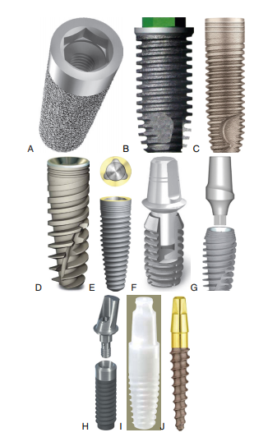
Figure: 1 Different Implant Design
A - Non-threaded implant of Endopore system with hexagonal internal connection. B - Threaded implant with square threads and hexagonal external connection.
C – Parallel body design with self-tapping thread design from Alpha Bio.
D - Tapered body with variable thread design.
E - Tapered implant from Nobel Biocare with triangular internal connection.
F - Tapered internal connection implant.
G - Taper internal connection.
H - Soft tissue level single-stage implant from Straumann.
I - White sky zirconium implant.
J - One-piece implant

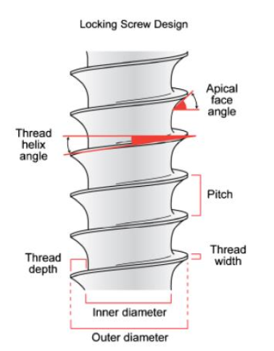
Figure: 2
Implant Thread Design
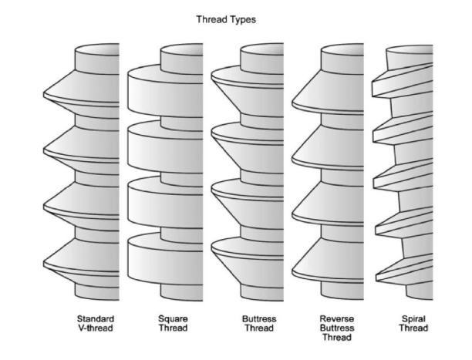
Figure3: Thread Type

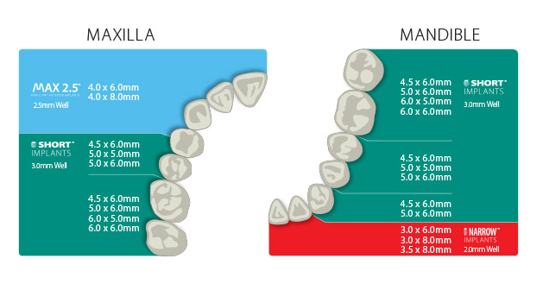
Figure 4: Implant size chart

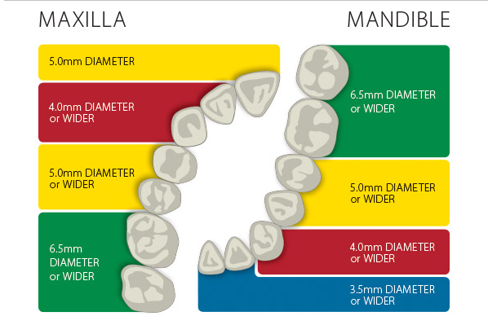
Figure 5: Abutment Diameter Selection Guide for Non-Shouldered Abutments

*The chart above contains recommendations only. Actual clinical conditions and the clinician’s assessment of the patient should be the main criteria for choosing the size of an abutment for a particular situation.

