Human Augmentation through IoT Smart Wearable Devices
– A Conceptual Framework & Future Research Directions

Samuel Mores Geddam^{1*}, Dr. Anil B Gowda², Dr. Arabinda Bhandari³
¹Assistant Professor, Presidency University, Itgalpur, Bangalore 560 064, Karnataka, India.
²Associate Professor, Presidency University, Itgalpur, Bangalore 560 064, Karnataka, India.
³Associate Professor, Presidency University, Itgalpur, Bangalore 560 064, Karnataka, India.

Corresponding Author: gsmorse1988@gmail.com
Abstract:
Introduction – Augmentation of Humans through digital technologies and wearable devices have opened a wide variety of opportunities to enhance the capabilities and performance of Humans. Assisted Wearable devices help to have enhanced understanding of the real world as they are supported with digital sensory stimulus, digital visual elements, which opens Augmented Reality (AR). Humans indeed have become deeply entwined with assisted augmented wearable devices, whether at work or play as it expands a person’s psychological and physical potential.
Purpose – The paper aims to carry out the SLR (Systematic Literature Review), Bibliometric Analysis, Text Mining / Content Analysis on Human Augmentation (HA).
Design/Methodology/Approach – The SLR technique has been used for identifying the research papers. PRISMA has been applied to remove irrelevant, insignificant papers. Systematic Review of Literature, Bibliometric Analysis, Content Analysis, Cluster Analysis & Text Mining have been attempted with the existing literature on Human Augmentation to identify the factors significant for the Human Augmentation concept and also the managerial processes.
Findings – The four factors, viz., User & Purpose, Device & Sensors, Efficacy and Individual Body explains 67.095% of Human Augmentation concept. These factors are very crucial in management especially human resources. The factors are very crucial in managerial processes such as, Group communication, Data Analytics, Decision Making Support, Ubiquitous Media Access, Data Processing and Metaverse.
Practical Implications – This paper reviews the existing literature available on Human Augmentation using wearable technologies, identifies factors that would provide directions for future research, help the product developers to come up with robust models for wearable augmented devices.
Originality/Value – This study is a first of its kind of study which presents the research areas within Human Augmentation, Content Analysis, Bibliometric Analysis. The study provides actionable future research directions.
Keywords – Human Augmentation, Assisted Wearable Devices, Artificial Intelligence, Augmented Reality, SLR, Bibliometric Analysis.
Paper Type – Research Paper

Introduction:
Humans are entwined with wearable augmented devices whether work or home. The concept of human augmentation as it shines could impact more productivity and well-being (Jarrahi, 2018). Human augmentation takes place with humans working in harmony with machine intelligence and technology to expand their capabilities to experience life more in more meaningful ways. The term ‘Augmented Humanity’ was first coined by the CEO of Google, Schmidt in 2010 and, called these converging phenomena as “the age of augmented humanity” (Gannes, Liz;, 2010). Augmentation happens through wearable smart devices which generate deep information cascades which are converted to meaningful data to augment humans to enhance their abilities (Stella, Cristoforetti, & Domenico, 2019). As AI technologies grow, there is more human-machine symbiosis which raised the division between humans and machines. This scenario has been shaping such that the mundane jobs shall be taken care of by machines and humans can focus on more creative jobs. Hence, AI is about to augment humans not replace them. This defines that AI is a tool for extending human capabilities (augmentation) rather not replacing them (automation) (Jarrahi, 2018). Wearable human augmented devices are no longer simply functional gadgets, but they are have become more or less like an extension to the human body (Nelson, Verhagen, & Vollenbroek-Hutten, 2019) and they offer direct interplay with the human mind (McCullagh, Lightbody, Zygierewicz, & Kernohan, 2014).
Human Augmentation can be of three main categories based on its applications (Rangaiah, 2020)
- Replicating Human Ability – The human augmentation technology replicates natural and routine human abilities such as sensory abilities (Benssassi, Gomez, Boyd, Hayes, & Ye, 2018).
- Supplementing Human Ability – Human augmentation supplements human abilities such as sight, walking, etc. (Erat, Isop, Kalkofen, & Schmalstieg, 2018).
- Exceeding Human Ability – Human augmentation helps to carryout any phenomenon humans are physically limited naturally such as the ability to fly or breathe underwater, etc. such as (Gerez, Gao, Dwivedi, & Liarokapis, 2020)
Human Augmentation can be categorized based on what the augmentation is for
- Augmentation for Physical Abilities such as in (Stella, Cristoforetti, & Domenico, 2019) (Lee, Kwak, McLain, Kan, & Young, 2020) (O'Connell, et al., 2015)
- Augmentation for Mental Abilities such as in (Mohlman, et al., 2020)
- Augmentation for Sensor Abilities such as in (Gerez, Gao, Dwivedi, & Liarokapis, 2020)
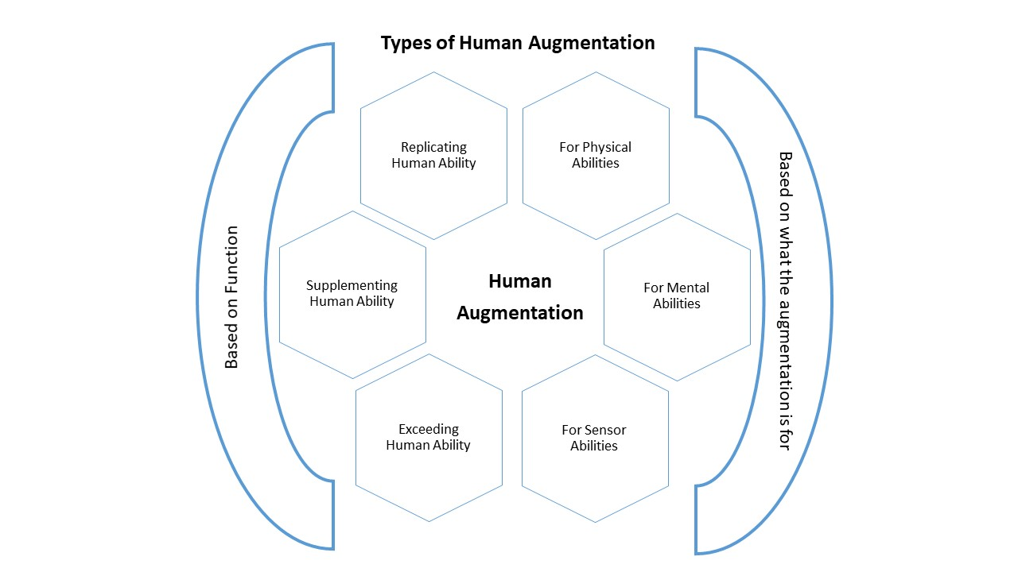
Picture: Types of Human Augmentation

The Rationale for the Research:
Research in Human Augmentation is an interesting emerging area prominently in Computer Sciences, Medical Sciences, and Social Sciences. It is still in the budding stage. Human Augmentation is a novel technology that is tapping a wide variety of opportunities in all sectors. Medical Sciences see it as a source of enabling physical and mental abilities for specially-abled people. Computer Science sees it as dynamite for automization of data processing activities. The benefits of Human Augmentation to the Social Sciences is not clear, but probably it is a technology that changes how the industry operates. It is a great tool for delivering customized products and services for consumers.
None of the prior studies have taken into account all of the Human Augmentation articles; rather, they have focused on a single SSC area and have not shown how the field's research has evolved over time. The current study describes every aspect of human augmentation. This study differs from other studies in the field of human augmentation since it combines systematic literature review, bibliometric analysis, and content analysis.
Research Questions:
The following research questions were considered for the study.
RQ1. What is the year-wise research publication trend, author wise and journal wise?
RQ2. What are the different themes of clusters in the existing literature and who are the most influential authors in each cluster?
RQ3. What are the significant variables for the study on the topic ‘Human Augmentation’?
RQ4. What are the future research directions in the topic ‘Human Augmentation’?
Research Methodology:
Systematic Review of Literature method has been adopted to gather publications related to the research topic.
Step 1: Publications were identified by searching with the keywords “Augmented Human”, “Human Augmentation” and “Augmented Humanity” in the Scopus Database. Scopus Database is considered for the study considering the reliability of the data in the Scopus.
Step 2: Systematic Literature Review (SLR) method was adopted to identify and report the relevant articles. PRISMA was conducted to screen the irrelevant, redundant, duplicate, non-article journal publications, etc.
Step 3: Bibliometric Analysis was attempted to find out influential authors, journals, countries, and research domains that are existing.
Step 4: Content Analysis has been conducted using VosViewer to identify clusters in the existing literature through bibliometric coupling.
Step 5: Scheme through the existing literature in each cluster and analyze the findings and conclusions of the top authors in each.
Step 6: Text Mining has been done using VosViewer to identify significant variables, to analyze interrelations among the selected variables through a correlation matrix in Excel. 14 significant variables have been identified for the Human Augmentation concept through Text Mining using VosViewer.
Step 7: Factor Analysis has been done using a correlation matrix developed in SPSS to narrow down the variables to 4 factors.
Step 8: Provide future research directions based on the analysis and the findings.
Tools Used: VosViewer, Microsoft Excel & IBM SPSS.
Methods Used: Systematic Literature Review (SLR), Bibliometric Analysis, Content Analysis, Text Mining, and Factor Analysis.
Search Terms and Search Results:
The research area of Human Augmentation consists of two words ‘Human’ and Augmentation’, so to ensure the coverage of relevant articles three search strings were used with a combination of keywords, for (1) Augmented Human = ((“Augmented Human”) OR (“Augmented Humanity”) AND (2) Human Augmentation = (“Human Augmentation”) in Scopus Database. Data was gathered from the Scopus database. Scopus offers a Boolean syntax that allows authors to combine search-string keywords with AND, NOT, and OR operators to produce the right results. The topic of Human Augmentation can be considered as a combination of two words, Human and Augmentation. Similar Keywords for Human Augmentation has been used with OR operator and AND operator to gather articles related to Human Augmentation. Scopus Database has been used as the Scopus offers robust tools for evaluating the research data (Archambault, Campbell, Gingras, & Larivière, 2009). Google Scholar database is different; however, the quality of data may be poor (Battisti & Salini, 2012). Even Scopus offers around 20% greater coverage than Web of Science, but Google Scholar's findings are erratic. (Falagas, Pitsouni, Malietzis, & Pappas, 2007).
For Human Augmentation | Search String Used
Augmented Human  AND  Human Augmentation | “Augmented Human” OR “Augmented Humanity”  AND  “Human Augmentation”

Inclusion and Exclusion Strategy
Inclusion Strategy | Exclusion Strategy
Related to Human Augmentation | Books, Book Chapters, Conference Papers
Only English Language | Articles in the press
Peer-Reviewed
Articles Published (Final)

Preferred Reporting Items for Systematic Review and Meta-Analysis Flowchart – PRISMA
PRISMA has been conducted to screen and to remove improper formatting publications, irrelevant, duplicate, conference papers, Books, Book Publications, and the publications in Press. PRISMA has been conducted as follows
IDENTIFICATION
SCREENING
ELIGIBILITY
INCLUDING
Records Identified through Scopus “Augmented Human” – 211 Augmented Humanity” – 6 “Human Augmentation” – 246
Total n = 463
Publications Such as Books, Book Chapters, Conference Publications, etc., other than articles from Journals identified and deleted (n = 235)
Total Publications Considered for the Study (n = 126)
Duplicate Publications Identified and Deleted (n = 74)
Publications other than in English Language Identified and Deleted (n = 7)
Publications in Press Identified and Deleted (n = 8)
Improper Format Publications Identified and Deleted (n = 13)

Descriptive Analysis:
Year-Wise Publication Trend
Year-Wise Publication trends explain the research publications in Human Augmentation appeared majorly from 2017. The publications trend as per the following bar chart shows that the research in the “Human Augmentation” topic is emerging and progressive from then. It is also clear that there is great research being conducted in Human Augmentation from the year 2017 onwards. Noticeably the publications per year are not significantly large indicates that the area of Human Augmentation is underexplored.
Source: Author

Journals publishing on Human Augmentation
Journal | Publications
IEEE Access | 5
IEEE Pervasive Computing | 5
Computer | 4
IEEE Robotics and Automation Letters | 3
PLoS ONE | 3
Advanced Robotics | 2
American Journal of Clinical Pathology | 2
Biochemical and Biophysical Research Communications | 2
Blood | 2
Clinical Immunology and Immunopathology | 2
Endocrinology | 2
Frontiers in Neuroscience | 2
IEEE Transactions on Neural Systems and Rehabilitation Engineering | 2
International Journal of Cancer | 2
Molecular Immunology | 2
Others (One article for each journal) | 86
Total | 126

Countries Involved in ‘Human Augmentation’ research
Cluster 1 | Cluster 2 | Cluster 3 | Cluster 4 | Cluster 5 | Cluster 6 | Cluster 7 | Cluster 8 | Cluster 9
Canada  China  France  Singapore  Switzerland | Finland  Japan  United States | Australia  United Kingdom | Spain | Germany | Italy | South Korea | Taiwan | Netherlands

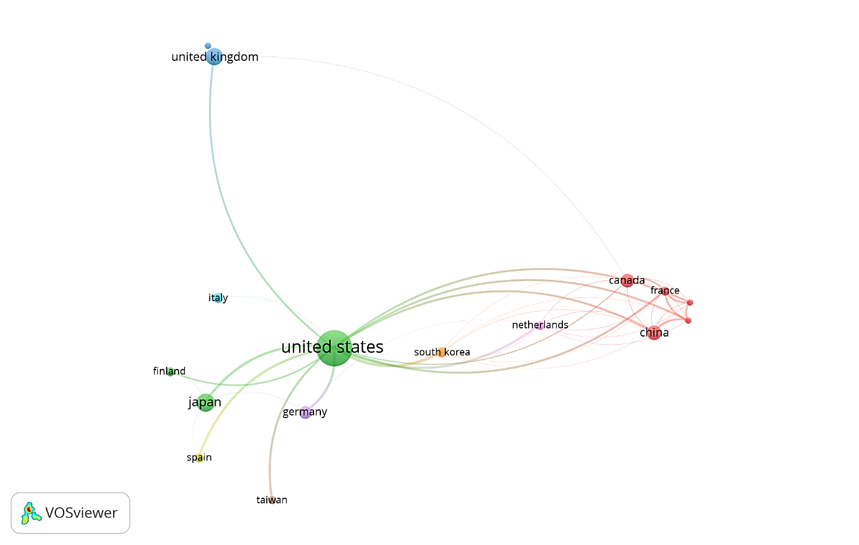
Chart: Countries Involved in ‘Human Augmentation’ research
Clusters of Authors based on Co-Citations
Cluster 1 | Cluster 2 | Cluster 3 | Cluster 4
Braun, d.j.  Collins, s.h.  Ding, y.  Ferris, d.p.  Galle, s.  Herr, h.  Herr, h.m.  Kuo, a.d.  Malcolm, p.  Rouse, e.j.  Sawicki, g.s.  Walsh, c.j.  Young, a.j.  Zelik, k.e. | Anderson, m.c.  Asada, h.h.  Kim, s.  Lee, j.  Lee, s.  Li, x.  Liu, h.  Navab, n.  Sato, K.  Wang, h.  Wang, j.  Zhang, j.  Zhang, x.  Zhang, y. | Chen, j.  Lee, c.  Wang, x.  Wang, z.l.  Yang, y.  Zhang, h. | Cheng, h.  Guo, h.  Kazerooni, h.

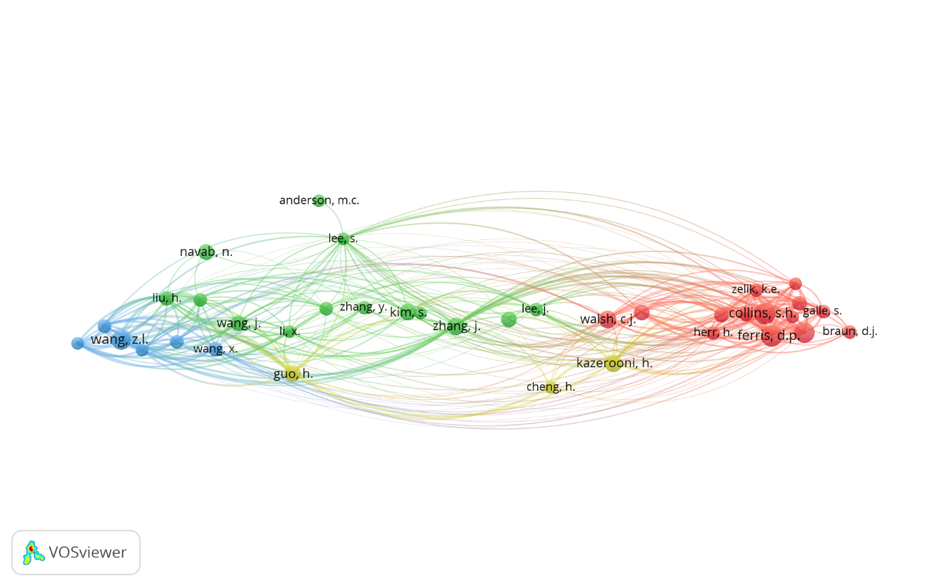
Chart: Clusters of Authors based on Co-Citations

Cluster Analysis
Cluster 1 | Cluster 2 | Cluster 3
Artificial Intelligence | Human-Computer Interaction | Augmentation Solutions for different humans
Artificial Intelligence | Human Augmentation | Adult
Augmented Human | Human-Computer Interaction | Female
Augmented Reality | Human-Robot Interaction | Human
Brain-Computer Interface | Man-Machine Systems | Humans
Human Experiment | Pervasive Computing | Male
Normal Human | Robotics | Nonhuman
Virtual Reality | Wearable Technology

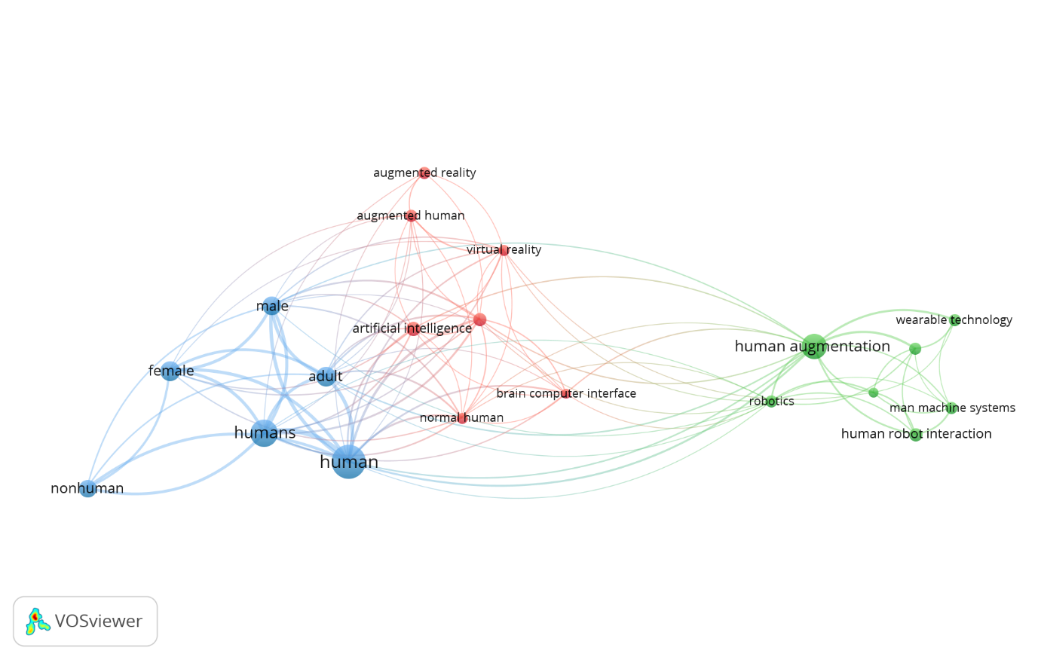
Chart: Three Clusters for Human Augmentation

Top 10 Authors of Cluster 1 – Artificial Intelligence (AI)
S.No. | Author | Title | Framework /Methodology | Findings
 | (Jarrahi, 2018) | “Artificial intelligence and the future of work: Human-AI symbiosis in organizational decision making” | Model to Explain AI in Decision Making | The development of AI necessitates a revolutionary human-machine symbiosis, which changes how humans and robots share work. Machines will handle routine tasks, freeing humans to concentrate on more creative work.  Instead of displacing human abilities, AI is a tool for enhancing rather than supplanting them (automation). AI can support human decision-making rather than taking the role of people.
 | (Yandell, Quinlivan, Popov, Walsh, & Zelik, 2017) | “Motion Analysis in a biomechanical analysis to evaluate exosuit to human power transmission which enabled to parse augmented power during walking.” | Experiment by estimating interface power dynamics during movement tasks | To optimize and derive human augmentation benefits, wearable assistive devices, it is very significant throughout the design and evaluation phases to enhance the human-device interface dynamics.
 | (Erat, Isop, Kalkofen, & Schmalstieg, 2018) | “Drone-Augmented human vision: Exocentric control for drones exploring hidden areas” | Investigating the potential of drone augmented human vision | By stimulating X-ray vision, drone-enhanced human vision can offer a realistic perspective inside a closed area.  The user's ability to explore inaccessible space promotes spatial awareness and enhances organic drone engagement.
 | (Goss-Varley, et al., 2017) | “Microelectrode implantation in motor cortex causes fine motor deficit: Implications on potential considerations to Brain Computer Interfacing and Human Augmentation” | Quantification of the motor deficit caused by microelectrode implantation in the motor cortex in healthy rats. | Future enhancement applications and numerous disorders show significant promise for microelectrodes. Over time, the performance of the implants has limitations.  Motor function was impaired as a result of chronic foreign body reaction and intracortical injury brought on by microelectrode insertion.
 | (McCullagh, Lightbody, Zygierewicz, & Kernohan, 2014) | “Ethical challenges associated with the development and deployment of brain computer interface technology” | Ethical Challenges in Brain-Computer Interface (BCI) | BCI has a lot of potential for human augmentation.  Complex BCI development and lengthy recording sessions are needed to enable personalisation, which presents ethical concerns includingData Security  - Privacy  - Confidentiality  - Raised Expectations  - Stress and Fatigue  - Knowledge Transfer
 | (Stella, Cristoforetti, & Domenico, 2019) | “Influence of augmented humans in online interactions during voting events” | Building an accurate map of real-world political parties and electoral ranks for Italian elections in 2018 using Twitter Data | While consistently infiltrating every one of the indicated groups, augmented humans produce deep information cascades to the degree of news media and other broadcasters.  The main source of augmentation is smart devices.
 | (Leigh, Sareen, Kao, Liu, & Maes, 2017) | “Body-borne computers as extensions of self” | Three areas of augmentation of the human body and its sensorimotor capabilities | Wearable devices offer a direct interaction with the mind and is no longer just a functional piece of equipment.  The most important criteria for augmented technology success are  - Reliability  - Robustness  - Running Times  - Health Effects
 | (Fass, 2006) | “Rationale for a model of human systems integration: The need of a theoretical framework” | HSI (Human Systems Integration) model for increasing human capabilities and improving human performance using behavioural technologies. | Wearable interactive systems provide technical gesture assistance.  There are several constraints for building HIS safe and efficient  - A virtual environment is a knowledge-based environment based on artefacts. A neurophysiological strategy is required for knowledge and human-in-the-loop design.  - Sensorimotor integration and motor control  - Coherence and HIS - The absence of coherence causes illusions, vection or vagal reflex, as well as perceptual and motor disorders.
 | (Cavazza, 2018) | “A motivational model of BCI-controlled heuristic search” | A motivational approach application in the AI influences the solution produced in heuristic search using Brain-Computer Interfaces (BCI) signal reflecting the user’s disposition to achieve anticipated result. | It was proposed to use human enhancement in a new way to keep people in control of autonomous AI systems whose performance might one day be better than that of human experts.
 | (Mohlman, et al., 2020) | “Improving Augmented Human Intelligence to Distinguish Burkitt Lymphoma from Diffuse Large B-Cell Lymphoma Cases” | 10818 Images from Burkitt Lymphoma (BL) and Diffuse Large B-cell Lymphoma (DLBCL) differentiation | Conventional Neutral Network (CNN) are promising augmented human intelligence tools for differentiation.

Top 10 Authors of Cluster 2 - Human-Computer Interaction
S.No. | Author | Title | Framework /Methodology | Findings
 | (Kunze, Minamizawa, Lukosch, Inami, & Rekimoto, 2017) | “Superhuman Sports: Applying Human Augmentation to Physical Exercise” | An Application area to explore human augmentation and enhance human abilities in sports. | Enhancing a sports practitioner’s innate abilities using wearable technologies and implantables.  Information technology is used in augmented training to increase training and the skills of professional and amateur athletes.
 | (Zientara, et al., 2017) | “Third Eye: A Shopping Assistant for the Visually Impaired” | Using algorithms, hardware accelerators, and wearable cameras, a vision-based autonomous shopping assistant is created for people who are blind or visually handicapped. | The third eye employs feature extraction and matching over the entire shelf to bring the user closer to the area of the shelf where the desired item is located.
 | (Campeau-Lecours, Otis, & Gosselin, 2016) | “Modeling of physical human-robot interaction: Admittance controllers applied to intelligent assist devices with large payload” | Admittance controller models have been suggested as a way to effectively augment human potential and foster human-robot cooperation. | The use of a motorised mechanical device to expand human capacity must be extremely safe and user-friendly for the operator.
 | (Schmidt, 2017) | “Augmenting Human Intellect and Amplifying Perception and Cognition” | Describe the author's views on improving human intelligence and perception and cognition. | Technologies for cognition and perception are becoming more integrated with human bodies, giving people a natural and implicit sense of control over them.
 | (Maier, Ebrahimzadeh, & Chowdhury, 2018) | “The Tactile Internet: Automation or Augmentation of the Human?” | The dichotomy between automation (replacing capabilities) and augmentation (expanding capabilities) of humans via the tactile internet. | Human-robot symbiosis coordination fosters human expertise creates new jobs humans can hardly imagine.
 | (Benssassi, Gomez, Boyd, Hayes, & Ye, 2018) | “Wearable Assistive Technologies for Autism: Opportunities and Challenges” | Augmentation through wearable assistive technologies for Autism. | Wearable assistive technologies help persons with autism learn skills not only in clinical and educational settings, but also in the real world with immediate feedback in a variety of social contexts.
 | (Leigh, Agrawal, & Maes, Robotic Symbionts Interweaving Human and Machine Actions, 2018) | “Robotic Symbionts: Interweaving Human and Machine Actions” | When creating collaborative human-robot integrations, the following two issues must be taken into consideration: support available and level of control | When creating human robotic augmentation, type of assistance and degree of system control are two factors that cannot be overlooked. Future systems will have more fluid coordination as a result of human-robot interaction.
 | (Wahl, Zhang, Freund, & Amft, 2017) | “Personalizing 3D-Printed Smart Eyeglasses to Augment Daily Life” | Smart eyeglasses as a personalized wearable augmented accessory | Personalized wearable accessories can address a wide challenge in wearable computing.  To assist users in understanding behaviour change, wearables can assess multiday trends in sensor data.  Smart eyeglasses may replace their classic counterparts.
 | (Hafi, et al., 2020) | “System for augmented human–robot interaction through mixed reality and robot training by non-experts in customer service environments” | Interaction between humans and robots doing typical service duties in a retail or home setting | Users can intuitively visualise the robot perception and interact with it through the use of a mixed-reality interface, which is provided.  Service robots in the retail environment require  - Robots to have the ability for high-level cognition  - Interaction is necessary for people to understand how robots perceive the world in the same way that humans can.
 | (Braun, Chalvet, Chong, Apte, & Hogan, 2019) | “Variable Stiffness Spring Actuators for Low-Energy-Cost Human Augmentation” | Actuator for Low energy cost Human Augmentation | Actuators operated on human joints can provide human augmentation and act as a supplement to joint stiffness. It provides low energy cost stiffness modulation.

Top Authors of Cluster 3 – Augmentation Solutions for different humans
S.No. | Author | Title | Framework /Methodology | Findings
 | (Yandell, Tacca, & Zelik, Design of a Low Profile, Unpowered Ankle Exoskeleton That Fits Under Clothes: Overcoming Practical Barriers to Widespread Societal Adoption, 2019) | “Design of a Low Profile, Unpowered Ankle Exoskeleton That Fits Under Clothes: Overcoming Practical Barriers to Widespread Societal Adoption” | Human Augmentation through an Ankle Assistance Device | Human Augmentation through a novel ankle wearable exoskeleton to enhance healthy walking and assist individuals for neurological injuries.  It fits under the clothing or inside/under shoes, seamlessly integrates into daily life.
 | (Tong, et al., 2019) | “Low-cost sensor-integrated 3D-printed personalized prosthetic hands for children with amniotic band syndrome: A case study in sensing pressure distribution on an anatomical human-machine interface (AHMI) using 3D-printed conformal electrode arrays” | 3D printed Personalized prosthetics for children – A case study | creation of prosthetic hands with sensor-integrated Anatomical Human Machine Interface (AHMI) for children with the amniotic band syndrome defect.
 | (Fass, 2006) | “Rationale for a model of human systems integration: The need of a theoretical framework” | HSI (Human Systems Integration) paradigm for using behavioural technology to enhance human capabilities and performance. | Technical gesture help is provided through wearable interactive systems.  Coherence and HIS - The absence of coherence causes illusions, vection or vagal reflex, as well as perceptual and motor disorders.
 | (Cinel, Mack, & Ward, 2018) | “Towards augmented human memory: Retrieval-induced forgetting and retrieval practice in an interactive, end-of-day review” | Human Memory Augmentation Experiments | An interactive and concluding review can improve recall capacity in people.
 | (Romero-Brufau, et al., 2020) | “What's in a name? A comparison of attitudes towards artificial intelligence (AI) versus augmented human intelligence (AHI)” | Survey to compare Clinical Staff attitudes towards AI (Artificial Intelligence) and AHI (Augmented Human Intelligence) | The use of the terms AI and AHI are similar by clinical staff.

Research Gaps:
There is extensive research conducted in the area of Augmentation for physical abilities, for instance, (Stella, Cristoforetti, & Domenico, 2019) (Lee, Kwak, McLain, Kan, & Young, 2020) (O'Connell, et al., 2015). Negligible research on augmenting mental abilities like (Zientara, et al., 2017) was conducted and also on sensor abilities such as in (Gerez, Gao, Dwivedi, & Liarokapis, 2020). There is no research conducted to analyze behavioural aspects changes after being augmented through wearable devices.
Given that augmented humans have an edge over non-augmented humans, augmented humanity has the potential to lead to prejudice and discrimination in the workplace. For instance, enhanced people could complete their tasks more quickly than people who don't use equipment to improve their performance. People who do not use enhanced humanity technology may be prejudiced against those who require "boosters" to make up for shortfalls. The development of AI necessitates a revolutionary human-machine symbiosis, which changes how humans and robots divide labour. Machines should do routine chores, and people should concentrate on more creative activities. Instead than replacing human abilities, AI is a tool for enhancing rather than supplanting them (automation). AI may support human decision-making, not take the place of it (Jarrahi, 2018). In this context, there is no significant research conducted to ascertain the changes demanded at the workplace and HR policies and Management practices. The hiring or promotion process might be impacted by augmented humanity. Because they are more capable than their non-augmented counterparts, human resource experts may start to favour augmented humans. On the other hand, hiring managers and leaders might also favour the "genuine" skilled candidate over augmented ones. Therefore, corporations may need to implement new workforce or hiring practises with augmented humanity in mind.
Content Analysis:
VosViewer has been used to do text mining to read the titles and abstracts of the 126 publications identified through PRISMA. Of the identified variables, 14 variables were selected based on the judgement of the author considering their relevance to the study.
Terms Identified: Accepted and Rejected
Accepted Terms: accuracy, body, device, effect, field, impact, individual, performance, person, presence, sensor, subject, user, work.
Rejected Terms: mouse, cell, contrast, addition, day, role, muscle, impact, effect, exoskeleton, patient, subject, ieee, paper, level, experiment
The following table represents the frequency of occurrence in the existing literature (Titles & Abstracts) and their relevant score.
Table: 14 variables identified through text mining
Id | Term / variable | Occurrences | Relevance Score
1 | accuracy | 14 | 0.4836
2 | body | 15 | 0.1519
3 | device | 22 | 0.2375
4 | effect | 30 | 2.0904
5 | field | 11 | 0.4134
6 | impact | 10 | 2.6483
7 | individual | 13 | 0.1571
8 | performance | 20 | 0.4073
9 | person | 12 | 0.1648
10 | presence | 9 | 6.3271
11 | sensor | 11 | 0.3036
12 | subject | 14 | 0.2087
13 | user | 22 | 0.233
14 | work | 21 | 0.1732

The interrelations among these variables in the entire publications considered for the study have been analyzed through correlation analysis. The following Correlation Matrix explains the interrelations among the variables considered for the study.

Correlation Matrix
 | Column 1 | Column 2 | Column 3 | Column 4 | Column 5 | Column 6 | Column 7 | Column 8 | Column 9 | Column 10 | Column 11 | Column 12 | Column 13 | Column 14
Column 1 | 1 | -0.08343 | 0.000671 | -0.12955 | 0.138033 | -0.13006 | 0.019877 | 0.306638 | -0.05572 | -0.12272 | 0.229758 | 0.173355 | -0.06845 | -0.13039
Column 2 | -0.08343 | 1 | 0.187781 | -0.14351 | 0.213707 | 0.050543 | 0.257496 | 0.00608 | 0.021656 | -0.03028 | 0.035474 | 0.077195 | 0.053465 | 0.064338
Column 3 | 0.000671 | 0.187781 | 1 | -0.28195 | 0.126592 | -0.09088 | 0.087262 | 0.16338 | 0.179932 | -0.16126 | 0.203291 | 0.000671 | 0.132997 | 0.147853
Column 4 | -0.12955 | -0.14351 | -0.28195 | 1 | -0.15248 | 0.078479 | -0.0506 | -0.20664 | -0.03298 | 0.179994 | -0.15248 | -0.00484 | -0.22982 | -0.1653
Column 5 | 0.138033 | 0.213707 | 0.126592 | -0.15248 | 1 | -0.00722 | -0.13142 | 0.148135 | -0.12557 | -0.10699 | 0.083992 | -0.13714 | -0.10351 | 0.059086
Column 6 | -0.13006 | 0.050543 | -0.09088 | 0.078479 | -0.00722 | 1 | -0.02588 | -0.16097 | -0.01687 | 0.130777 | -0.11339 | -0.13006 | -0.17089 | -0.08455
Column 7 | 0.019877 | 0.257496 | 0.087262 | -0.0506 | -0.13142 | -0.02588 | 1 | 0.182976 | 0.226483 | -0.1176 | 0.057897 | 0.190492 | 0.158595 | 0.170493
Column 8 | 0.306638 | 0.00608 | 0.16338 | -0.20664 | 0.148135 | -0.16097 | 0.182976 | 1 | -0.10175 | -0.15189 | -0.0108 | 0.091783 | -0.07617 | -0.06565
Column 9 | -0.05572 | 0.021656 | 0.179932 | -0.03298 | -0.12557 | -0.01687 | 0.226483 | -0.10175 | 1 | -0.11236 | 0.168373 | 0.120878 | 0.253769 | 0.191791
Column 10 | -0.12272 | -0.03028 | -0.16126 | 0.179994 | -0.10699 | 0.130777 | -0.1176 | -0.15189 | -0.11236 | 1 | -0.10699 | -0.12272 | -0.16126 | -0.15659
Column 11 | 0.229758 | 0.035474 | 0.203291 | -0.15248 | 0.083992 | -0.11339 | 0.057897 | -0.0108 | 0.168373 | -0.10699 | 1 | 0.046308 | -0.02681 | 0.059086
Column 12 | 0.173355 | 0.077195 | 0.000671 | -0.00484 | -0.13714 | -0.13006 | 0.190492 | 0.091783 | 0.120878 | -0.12272 | 0.046308 | 1 | 0.208041 | 0.221192
Column 13 | -0.06845 | 0.053465 | 0.132997 | -0.22982 | -0.10351 | -0.17089 | 0.158595 | -0.07617 | 0.253769 | -0.16126 | -0.02681 | 0.208041 | 1 | 0.26545
Column 14 | -0.13039 | 0.064338 | 0.147853 | -0.1653 | 0.059086 | -0.08455 | 0.170493 | -0.06565 | 0.191791 | -0.15659 | 0.059086 | 0.221192 | 0.26545 | 1

Factor Analysis has been conducted to identify the significant factors for the study. Factor Analysis revealed 4 important factors for the study which explains 67.095% of the human augmentation topic cumulatively. Sphericity has been done to the correlation matrix data using KMO and Bartlett’s test.
Total Variance of the Factors
Total Variance Explained
Component | Initial Eigenvalues |  |  | Extraction Sums of Squared Loadings |  |  | Rotation Sums of Squared Loadings
 | Total | % of Variance | Cumulative % | Total | % of Variance | Cumulative % | Total | % of Variance | Cumulative %
1 | 3.786 | 27.042 | 27.042 | 3.786 | 27.042 | 27.042 | 3.136 | 22.399 | 22.399
2 | 2.593 | 18.522 | 45.564 | 2.593 | 18.522 | 45.564 | 2.486 | 17.757 | 40.156
3 | 1.738 | 12.415 | 57.979 | 1.738 | 12.415 | 57.979 | 2.410 | 17.214 | 57.370
4 | 1.276 | 9.117 | 67.095 | 1.276 | 9.117 | 67.095 | 1.362 | 9.726 | 67.095
5 | 0.966 | 6.898 | 73.993
6 | 0.750 | 5.356 | 79.349
7 | 0.662 | 4.725 | 84.074
8 | 0.571 | 4.079 | 88.153
9 | 0.490 | 3.499 | 91.653
10 | 0.461 | 3.291 | 94.944
11 | 0.323 | 2.305 | 97.249
12 | 0.215 | 1.536 | 98.784
13 | 0.170 | 1.216 | 100.000
14 | 3.197E-16 | 2.283E-15 | 100.000
Extraction Method: Principal Component Analysis.

Impact of Variables for each factor
The impact of the 14 variables in each factor has been identified through a rotated component matrix created using the Varimax method with the Iterations Convergence value 25. Coefficients less than 0.3 have been suppressed and the coefficients of the variable values greater than or equal to 0.3 are only considered as they have a moderate or high impact on the identified factors.
Rotated Component Matrixª
 | Component |  |  |  | Variables
 | 1 | 2 | 3 | 4
VAR00001 |  |  | 0.796 | -0.328 | accuracy
VAR00002 |  | 0.600 |  | 0.567 | body
VAR00003 |  | 0.738 |  |  | device
VAR00004 |  | -0.740 | -0.329 |  | effect
VAR00005 | -0.493 | 0.676 |  |  | field
VAR00006 | -0.363 |  | -0.604 |  | impact
VAR00007 | 0.516 |  |  | 0.515 | individual
VAR00008 |  |  | 0.787 |  | performance
VAR00009 | 0.765 |  |  |  | person
VAR00010 | -0.433 | -0.458 | -0.480 |  | presence
VAR00011 |  | 0.336 |  | -0.691 | sensor
VAR00012 | 0.535 |  | 0.518 |  | subject
VAR00013 | 0.794 |  |  |  | user
VAR00014 | 0.700 |  |  |  | work
Extraction Method: Principal Component Analysis.
Rotation Method: Varimax with Kaiser Normalization.
a. Rotation converged in 6 iterations.

Above 0.7 | Strong Impact
0.5 to 0.69 | Moderate Impact
0.3 to 0.49 | Less Impact

Four Factors that explain 67.09% of the Human Augmentation Concept
S.No. | Factor | Sub-Factor | Variance Explained (%)
1 | User | Work | 22.399
2 | Device | Sensors | 17.757
3 | Performance | Accuracy | 17.214
4 | Body | Individual | 9.726

The below Scree plot explains that the 4 factors considered for the study are significant as the eigenvalue for those factors is greater than 1.
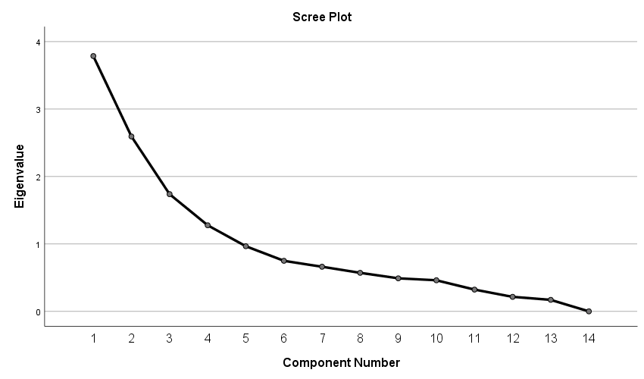
Factor 1: User & Purpose:
Any wearable Human Augmenting device has a purpose, maybe to enhance physical, mental or sensor abilities. Usually, such devices are located very close to the human body. The Augmented human shall have an advantage over those who are not augmented with wearable augmenting devices as they get meaningful insights from the devices processed through AI. Type of support and Degree of Systems control are the two aspects very critical in designing human robotic augmentation. Human-robot interaction will result in more fluid coordination in future systems (Leigh, Agrawal, & Maes, Robotic Symbionts Interweaving Human and Machine Actions, 2018). The following table explains different categories of users and how the AH helps those users to get their work done.
User Type | Work done through Augmentation
Home User | - Surveillance  - Personal Accessories  - Interactive Gaming  - Outdoor navigation  - Virtual Coach  - Weight / Energy Check  - Chronic Disease Management  - Rescue Tracking  - Identity Recognition  - Emergency Services  - Emotional Response  - Self-Management  - Implants
Workers / Employee | - Working Support  - Posture Correction  - Shared Experience  - Identity recognition  - Meaningful insights derived from Analytics
Business Decision Makers / Managers | - Group Communication  - Data Analytics  - Decision Making Support  - Ubiquitous Media Access  - Data Processing  - Metaverse
Student / Youngsters | - Weight / Energy Check  - Sport Performance  - Interactive gaming  - Responsive Learning  - Personal Accessories  - Physical Expression  - Decorative Display / Fashion

The works mentioned for home users are also common for other users. For other users, the works that are specific for them are mentioned as they are a special category of users.
Factor 2: Device & Sensors:
Wearable Augmented devices have proven the potential to improve individual capabilities. The benefits of Human augmentation depend on how efficiently data is transmitted from human to device and device to human. It also depends on how effectively the device read the data from the human body and environment. This is possible through the effective use of sensors. Sensors help the device to read the data about the changes in the human behaviour and environment (Yandell, Quinlivan, Popov, Walsh, & Zelik, 2017) (Campeau-Lecours, Otis, & Gosselin, 2016).

Factor 3: Efficacy:
The performance of the AH device is an important factor as it defines the purpose of the device. The performance of the device should be accurate and reliable. If coherence is absent in the performance of the device, the device is not reliable. Illusions and disturbances appear in the performance of the device that lacks coherence (Fass, 2006). The key parameters in the success of augmented technology are
- Reliability
- Robustness
- Running Times
- Health Effects (Leigh, Sareen, Kao, Liu, & Maes, 2017).
All the parameters mentioned above are somewhat related to the performance and accuracy of the augmented device. The device performance that is used to augment human capacity should be safe and intuitive for the user (Campeau-Lecours, Otis, & Gosselin, 2016).
Factor 4: Individual Body:
Wearable human augmented devices are more or less like an extension to the human body (Nelson, Verhagen, & Vollenbroek-Hutten, 2019) and they offer direct interplay with the human mind (McCullagh, Lightbody, Zygierewicz, & Kernohan, 2014). They usually are worn on the body may or may not undergarments. In order to help users understand how their behaviours evolve, wearables can evaluate multiday trends in sensor data. (Wahl, Zhang, Freund, & Amft, 2017). Technologies for cognition and perception are becoming more integrated with human bodies, giving people a natural and implicit sense of control over them (Schmidt, 2017).

Human Augmentation Conceptual Framework:
HUMAN AUGMENTATION
Based on Augmentation Function
Based on what augmentation it is for
TYPES OF AUGMENTATION
Replicating Human Ability
Supplementing Human Ability
Exceeding Human Ability
For Physical Abilities
For Mental Abilities
For Sensor Abilities
FACTORS AFFECTING HUMAN AUGMENTATION

User
Work
Device
Sensors
Performance
Accuracy
Body
Individual
Factor 1 – User and Purpose
Factor 2 – Device and Sensors
Factor 3 - Efficacy
Factor 4 – Individual Body
22.39% 17.75% 17.21% 9.72%
VARIANCE EXPLAINED BY THE FACTORS
Managerial Implications:
As there is not much research conducted to test the impact of human augmentation on Management or Industry especially Human Resources Management. The factors that were adding to 67.095% of Human Augmentation were very crucial in management especially human resources. As emphasized in the research gaps that there is no significant research conducted to ascertain the changes demanded at the workplace and HR policies and Management practices. It is very difficult to ascertain the managerial implications of the Human Augmentation as there is no empirical data in this context. But certain assumptions can be made as to the managerial implications with respect to the human augmentations which has to be validated with a proper empirical study.
The augmented human with enhanced abilities shall have an advantage over those who are not augmented as the wearable augmented device give meaningful insights that are processed through Artificial Intelligence.
For an ordinary user, the advantages from the insights through the augmented devices shall be limited to personal management but when it comes to organization or human resources management, the insights are really helpful in better management. Human Augmentation shall contribute the management in the following areas as cited above
- Group Communication – Communication has a great impact at the work place with respect to work and efficiency. There shall be grey areas or blind spots which leads to misunderstandings and miscommunication. The communication shall be efficient when the workers at the are equipped with the augmented devices. Many scholars have emphasized the role of augmentation in communication. Some authors have coined the term ‘Augmentative Communication’ or ‘Alternative Communication’ for such communication (What is AAC?, n.d.) (Light & McNaughton, 2014). Augmentative communication is a great blessing for those who have speech defects or complex communication needs. Many potential candidates were not taken into jobs as they are not efficient communicators. In the era the people were screened based on the communication abilities, the human augmentation shall change the dynamics of recruitment and selection criteria in terms of communication abilities.
- Data Analytics – Collecting data is a very essential requirement for the data analytics. Data analytics plays an important role in execution of managerial functions. Data collection and readability of data through manual labels is very expensive and time consuming. Data collection through the augmented devices is very dynamic increases efficiency, accuracy, versatility and readability. It also helps in many other ways, for instance, data mining, data manipulation, slicing, etc. can be done with augmented data (Mi, Xiao, Cai, & Jia, 2021).
- Decision Making Support - The real time data collected through augmented devices helps the business to be agile as the quick decision making is possible. Meaning decisions are possible as the augmented data can be tweaked and manipulated as per the requirements. This versatility shall not be there if the data is collected through the manual systems.
- Ubiquitous Media Access – Connecting the world with ubiquitous and access everywhere is the key for any business. It helps to develop solutions quick to the problems and take decisions quickly (Keengwe, 2017).. The Ubiquitous Media access has provided the business to be more agile to grab the opportunities and resolve the problems quickly. The human augmentation provides the data quickly and the data access is possible anywhere at any time.
- Data Processing: The augmented devices with the support of AI provides data processing which saves a lot of time and money. It also provides for the data ready for execution of managerial functions. The AI and Machine Language technologies revolutionized the landscape and the Data analytics through them is providing competitive opportunities even for the small businesses by helping them to make smarter decisions (Myers, 2019).
- Metaverse: This is an emerging technology which provides the participants a 3D world, allowing them creating virtual structures. This technology helps the business in many ways. It would help to have virtual business meets which saves lot of time and money over travel and other requirements for conducting business meets. It may provide virtual office space for organizing business activities. If the metaverse has to be implemented in the business setting, the augmented devices play a prominent role in the interactions among the business participants (Balis, 2022).
Conclusion:
The human augmentation with the augmented devices is a very promising technology is in budding stage especially the business organizational are trying to figure out the applications that would help them to execute the business processes and application using the technology. Many studies have proven that that some top companies started using the wearable devices to read the sensory information from the business participants especially employees to manage them. The new technologies such as Metaverse is very promising that it would change the landscape of business operations into the next level. Any digital technology without the digital augmented devices is no possible. The augmented devices are changing their shape and functionalities. Sky is the limit for the benefits that can be reaped with an appropriate use of the augmented wearable devices in the business setting.

References
Archambault, É., Campbell, D., Gingras, Y., & Larivière, V. (2009). Comparing bibliometric statistics obtained from the Web of Science and Scopus. Journal of the American Society for Information Science and Technology, 60(7), 1320-1326. doi:10.1002/asi.21062
Balis, J. (2022, January 03). How Brands Can Enter the Metaverse. Retrieved January 22, 2022, from hbr.org: https://hbr.org/2022/01/how-brands-can-enter-the-metaverse
Battisti, F. D., & Salini, S. (2012). Robust analysis of bibliometric data. Statistical Methods & Applications, 22, 269-283. doi:10.1007/s10260-012-0217-0
Benssassi, E. M., Gomez, J.-C., Boyd, L. E., Hayes, G. R., & Ye, J. (2018). Wearable Assistive Technologies for Autism: Opportunities and Challenges. IEEE Pervasive Computing, 17(2), 11-21. doi:10.1109/MPRV.2018.022511239
Braun, D. J., Chalvet, V., Chong, T.-H., Apte, S. S., & Hogan, N. (2019). Variable Stiffness Spring Actuators for Low-Energy-Cost Human Augmentation. IEEE Transactions on Robotics, 35(6), 1435-1449. doi:10.1109/TRO.2019.2929686
Campeau-Lecours, A., Otis, M. J.-D., & Gosselin, C. (2016). Modeling of physical human-robot interaction: Admittance controllers applied to intelligent assist devices with large payload. International Journal of Advanced Robotic Systems, 13(5), 1-12. doi:10.1177/1729881416658167
Cavazza, M. (2018). A motivational model of BCI-controlled heuristic search. Brain Sciences, 8(9). doi:10.3390/brainsci8090166
Cinel, C., Mack, C. C., & Ward, G. (2018). Towards augmented human memory: Retrieval-induced forgetting and retrieval practice in an interactive, end-of-day review. Journal of Experimental Psychology: General, 147(5), 632-661. doi:10.1037/xge0000441
Erat, O., Isop, W. A., Kalkofen, D., & Schmalstieg, D. (2018). Drone-Augmented human vision: Exocentric control for drones exploring hidden areas. IEEE Transactions on Visualization and Computer Graphics, 24(4), 1437-1446. doi:10.1109/TVCG.2018.2794058
Falagas, M. E., Pitsouni, E. I., Malietzis, G. A., & Pappas, G. (2007). Comparison of PubMed, Scopus, Web of Science, and Google Scholar: strengths and weaknesses. FASEB J., 338-342. doi:10.1096/fj.07-9492LSF
Fass, D. (2006). Rationale for a model of human systems integration: The need of a theoretical framework. Journal of Integrative Neuroscience, 5(3), 355-372. doi:10.1142/S0219635206001239
Gannes, Liz;. (2010, September 7). Eric Schmidt: Welcome to “Age of Augmented Humanity”. Retrieved September 15, 2021, from gigaom.com: https://gigaom.com/2010/09/07/eric-schmidt-welcome-to-the-age-of-augmented-humanity/
Gerez, L., Gao, G., Dwivedi, A., & Liarokapis, M. (2020). A hybrid, wearable exoskeleton glove equipped with variable stiffness joints, abduction capabilities, and a telescopic thumb. IEEE Access, 8, 173345-173358. doi:10.1109/ACCESS.2020.3025273
Goss-Varley, M., Dona, K. R., Mcmahon, J. A., Shoffstall, A. J., Ereifej, E. S., Lindner, S. C., & Capadona, J. R. (2017). Microelectrode implantation in motor cortex causes fine motor deficit: Implications on potential considerations to Brain Computer Interfacing and Human Augmentation. Scientific Reports, 7(1). doi:10.1038/s41598-017-15623-y
Hafi, L. E., Isobe, S., Tabuchi, Y., Katsumata, Y., Nakamura, H., Fukui, T., . . . Taniguchi, T. (2020). System for augmented human–robot interaction through mixed reality and robot training by non-experts in customer service environments. Advanced Robotics, 34(44289), 157-172. doi:10.1080/01691864.2019.1694068
Jarrahi, M. h. (2018). Artificial intelligence and the future of work: Human-AI symbiosis in organizational decision making. Business Horizons, 61(4), 577-586. doi:10.1016/j.bushor.2018.03.007
Keengwe, J. (2017). Handbook of Research on Mobile Technology, Constructivism, and Meaningful Learning. USA: University of North Dakota. Retrieved Jan 25, 2022, from https://www.igi-global.com/book/handbook-research-mobile-technology-constructivism/181918#table-of-contents
Kunze, K., Minamizawa, K., Lukosch, S., Inami, M., & Rekimoto, J. (2017). Superhuman Sports: Applying Human Augmentation to Physical Exercise. IEEE Pervasive Computing, 16(2), 14-17. doi:10.1109/MPRV.2017.35
Lee, D., Kwak, E. C., McLain, B. J., Kan, I., & Young, A. J. (2020). Effects of Assistance during Early Stance Phase Using a Robotic Knee Orthosis on Energetics, Muscle Activity, and Joint Mechanics during Incline and Decline Walking. IEEE Transactions on Neural Systems and Rehabilitation Engineering, 28(4), 914-923. doi:10.1109/TNSRE.2020.2972323
Leigh, S.-w., Agrawal, H., & Maes, P. (2018). Robotic Symbionts Interweaving Human and Machine Actions. IEEE Pervasive Computing, 17(2), 34-43. doi:10.1109/MPRV.2018.022511241
Leigh, S.-w., Sareen, H., Kao, H.-L. (., Liu, X., & Maes, P. (2017). Body-borne computers as extensions of self. Computers, 1(12). doi:10.3390/computers6010012
Light, J., & McNaughton, D. (2014, Mar 10). Communicative Competence for Individuals who require Augmentative and Alternative Communication: A New Definition for a New Era of Communication? Augmentative and Alternative Communication, 30(1), 1-18. doi:10.3109/07434618.2014.885080
Maier, M., Ebrahimzadeh, A., & Chowdhury, M. (2018). The Tactile Internet: Automation or Augmentation of the Human? IEEE Access, 6, 41607-41618. doi:10.1109/ACCESS.2018.2861768
McCullagh, P., Lightbody, G., Zygierewicz, J., & Kernohan, W. G. (2014). Ethical challenges associated with the development and deployment of brain computer interface technology. Neuroethics, 7(2), 109-122. doi:10.1007/s12152-013-9188-6
Mi, Q., Xiao, Y., Cai, Z., & Jia, X. (2021, Jan). The effectiveness of data augmentation in code readability classification. Information and Software Technology, 129(106378). doi:10.1016/j.infsof.2020.106378
Mohlman, J. S., Leventhal, S. D., Hansen, T., Kohan, J., Pascucci, V., & Salama, M. E. (2020). Improving Augmented Human Intelligence to Distinguish Burkitt Lymphoma from Diffuse Large B-Cell Lymphoma Cases. American Journal of Clinical Pathology, 153(6), 743-759. doi:10.1093/AJCP/AQAA001
Myers, G. (2019, July 29). How Data Analysis Improve Decision Making. Retrieved January 25, 2022, from reflectivedata.com: https://reflectivedata.com/how-data-analysis-improve-decision-making/
Nelson, E. C., Verhagen, T., & Vollenbroek-Hutten, M. (2019). Is Wearable Technology Becoming Part of Us? Developing and Validating a Measurement Scale for Wearable Technology Embodiment. JMIR Mhealth Uhealth, 7(8). doi:10.2196/12771
O'Connell, S. G., Kerkvliet, N. I., Carozza, S., Rohlman, D., Pennington, J., & Anderson, K. A. (2015). In vivo contaminant partitioning to silicone implants: Implications for use in biomonitoring and body burden. Environment International, 85, 182-188. doi:10.1016/j.envint.2015.09.016
Rangaiah, M. (2020, May 09). An Introduction to Human Augmentation. Retrieved September 15, 2021, from analyticssteps.com: https://www.analyticssteps.com/blogs/introduction-human-augmentation
Romero-Brufau, S., Wyatt, K. D., Boyun, P., Mickelson, M., Moore, M., & Cognetta-Rieke, C. C. (2020). What's in a name? A comparison of attitudes towards artificial intelligence (AI) versus augmented human intelligence (AHI). BMC Medical Informatics and Decision Making, 18(1). doi:10.1186/s12911-020-01158-2
Schmidt, A. (2017). Augmenting Human Intellect and Amplifying Perception and Cognition. IEEE Pervasive Computing, 16(1), 6-10. doi:10.1109/MPRV.2017.8
Stella, M., Cristoforetti, M., & Domenico, M. D. (2019). Influence of augmented humans in online interactions during voting events. PLoS ONE, 14(5). doi:10.1371/journal.pone.0214210
Tong, Y., Kucukdeger, E., Halper, J., Cesewski, E., Karakozoff, E., Haring, A., . . . Johnson, B. N. (2019). Low-cost sensor-integrated 3D-printed personalized prosthetic hands for children with amniotic band syndrome: A case study in sensing pressure distribution on an anatomical human-machine interface (AHMI) using 3D-printed conformal electrode arrays. PLoS ONE, 14(3). doi:10.1371/journal.pone.0214120
Wahl, F., Zhang, R., Freund, M., & Amft, O. (2017). Personalizing 3D-Printed Smart Eyeglasses to Augment Daily Life. Computer, 50(2), 26-35. doi:10.1109/MC.2017.44
What is AAC? (n.d.). Retrieved Jan 22, 2022, from assistiveware.com: https://www.assistiveware.com/learn-aac/what-is-aac#:~:text=Communication%20devices%2C%20systems%2C%20strategies%20and,has%20difficulties%20communicating%20using%20speech.&text=Augmentative%20communication%20is%20when%20you%20add%20something%20to%20your%2
Yandell, M. B., Quinlivan, B. T., Popov, D., Walsh, C., & Zelik, K. E. (2017). Physical interface dynamics alter how robotic exosuits augment human movement: implications for optimizing wearable assistive devices. Journal of NeuroEngineering and Rehabilitation, 14(1). doi:10.1186/s12984-017-0247-9
Yandell, M. B., Tacca, J. R., & Zelik, K. E. (2019). Design of a Low Profile, Unpowered Ankle Exoskeleton That Fits Under Clothes: Overcoming Practical Barriers to Widespread Societal Adoption. IEEE Transactions on Neural Systems and Rehabilitation Engineering, 27(4), 712-723. doi:10.1109/TNSRE.2019.2904924
Zientara, P. A., Lee, S., Smith, G. H., Brenner, R., Itti, L., Rosson, M. B., . . . Narayanan, V. (2017). Third Eye: A Shopping Assistant for the Visually Impaired. Computer, 50(2), 16-24. doi:10.1109/MC.2017.36

