Effect of Fiber Content and Length on the Mechanical Properties of Fragrant Screw Pine Fiber Reinforced Vinyl Ester Composite

S.Venkatarajan
Department of Physics
Alagappa Chettiar Government College of Engineering and Technology
Karaikudi, India
Venkatrajan69@gmail.com
C.Subbu
Department of Physics
Alagappa Government Arts College
Karaikudi, India
Subbucphysics@gmail.com

A.Athijayamani
Department of Mechanical Engineering
Alagappa Chettiar Government College of Engineering and Technology
Karaikudi, India
athimania@gmail.com

ABSTRACT
The content, length, composition, and orientation of the natural fibers as well as the interfacial bonding between the fiber and the matrix are some of the main factors of the mechanical properties of a plant-based natural fiber-reinforced polymer composite. This paper studied the influence of fiber content and length on the mechanical properties of vinyl ester composites reinforced with fragrant screw pine fibers. Using the hand lay-up method, fragrant screw pine fiber/vinyl ester composites with fiber lengths of 3 and 13 mm were developed for the range of 8.43 to 45.3 vol.% by volume. Mechanical tests on composite samples were conducted; the mechanical properties of the composite were evaluated. Up to a 35.57vol.% increase in fiber content, tensile, flexural, and impact strength increases; after that, it began to decrease for two cases of fiber length. Fiber content increased from 8.43 to 45.3 vol.% increasing the tensile and flexural modulus values. For all fiber contents, composites with fiber lengths of 13 mm exhibit the highest level of mechanical properties in comparison to composites with fiber lengths of 3 mm. This study found that the optimal fiber content for achieving the best mechanical properties in FSP/vinyl ester composites is 35.57 vol.%.
Keywords— Fragrant screw pine fiber, Vinyl ester, Composites, Mechanical properties.

INTRODUCTION

Natural cellulose fibers' potential in polymer composites has received considerable attention in recent years among material researchers and scientists worldwide due to their good mechanical performance and eco-friendliness [1, 2]. Plant-based natural fibers are an appealing alternative to synthetic fibers used in polymer composites due to their availability, renewability, low density, and low cost, as well as their satisfactory mechanical properties [3]. Banana Fiber (BF)-reinforced polyurethane (PU) composites with conductive polypyrrole (PPy) coatings were created and studied by Merlini et al. [4]. These conducting fibers can be employed as reinforcement for polymer matrices because it was shown that PU/PPy-BF composites had higher mechanical properties than pure PU and PU/PPy. Sujaritjun et al. [5] investigated the tensile properties of polylactic acid (PLA) composites reinforced with untreated and flexible epoxy-treated bamboo, vetiver grass, and coconut fibers. The flexible epoxy surface treatment significantly improved the tensile strength of bamboo fiber and coconut fiber reinforced PLA composites. In comparison to vetiver grass and coconut fibers, bamboo fiber proved to be the most effective reinforcement. Chen et al. [6] evaluated the effect of isocyanatoethy methacrylate treatment on the water absorption and mechanical properties of hemp fiber-reinforced unsaturated polyester composites. The results showed that fiber treatment increased the tensile strength, flexural strength, flexural modulus, and water resistance of the resulting composites while decreasing the impact strength.
Udaykumar et al. [7] investigated the flexural properties of a hand-lay-up short coir fiber-reinforced Polypropylene composite with varying fiber percentages. The results show that flexural properties increase as fiber percentage increases; however, after a certain fiber weight percentage, the properties decrease. It was determined that polymer composites with 20% coir reinforcement and a thickness of 4mm exhibited a higher percentage of elongation. The effects of moisture absorption on the tensile properties of woven sisal/cotton hybrid fiber-reinforced polyester composites were investigated by Naveen et al. [8]. The results show that moisture absorption reduced the tensile properties of the resulting composites.
The tensile, flexural, and impact characteristics of epoxy and randomly oriented short jute fiber reinforced epoxy composite were studied by Bisaria et al. [10]. Jute fibers of varying lengths of 5, 10, 15, and 20 mm were incorporated into an epoxy matrix during the hand lay-up process to create composite materials. According to the results, the composite with 15 mm of fiber length was found to have the highest levels of tensile and flexural capabilities, while the composite with 20 mm of fiber length had the highest levels of impact properties. The effects of pineapple leaf fiber (PLF) loading and their alkali treatment on the properties of PLF/polypropylene (PP) composites were studied by Kasim et al. [11]. The fabrication was made by compression molding technique with random orientation of PLF and also with five different fiber loading of PLF (30, 40, 50, 60 and 70 wt.%). The results revealed that the voids percentage and interfacial bonding between the PLF and PP affected the mechanical properties of the PLF/PP composite. It can be concluded that the PLF/PP composite with the composition ratio of 30wt.% has shown the best mechanical properties compared to other composition ratios. Gerald Arul Selvan and Athijayamani [12] investigated the mechanical properties of fragrant screw pine fiber reinforced unsaturated polyester composites as a function of fiber length, fiber treatment, and water absorption. The tensile, flexural, and impact properties of composites were found to decrease as the percentage of moisture uptake increased. After 3 hours of alkali treatment with 3% NaOH, the percentage of moisture uptake of the composite was reduced. Fourier transform infrared spectroscopy, energy dispersive spectroscopy, and scanning electron microscopy were used to examine the chemical composition, the elemental composition of the fiber, and surface morphology of the composite, respectively. Wan Mohamed et al. [13] developed the 60/40 blend of High-Density Polyethylene (HDPE) and Natural Rubber (NR) with fiber diameters of 125 µm, 250 µm, and 500 µm at fiber contents of 10, 20, and 30%. At 20% fiber content and a 250 m fiber size, the maximum tensile strength, and tensile modulus were achieved. Impact strength steadily reduced at fiber sizes of 125 µm and 250 µm as the proportion of fiber content increased. For all of the sizes being studied, 10% fiber content resulted in the maximum tensile strain at break and the lowest amount of water absorption. Keeping the view of the above literature review, in this paper, the Fragrant Screw Pine (FSP) fibers reinforced vinyl ester composites are prepared for five different fiber contents (10, 20, 30, 40, and 50 vol.%) and two different fiber lengths (3 and 13 mm) using hand lay-up technique. The effect of fiber content and length on the mechanical properties of composites are evaluated.

EXPERIMENTAL DETAILS

Materials and preparation of composites
Fragrant screw pine (FSP) fibers were used as reinforcement agent as received condition without any modifications. Commercially available vinyl ester resin was used as a polymer resin matrix. Methylene ethyl ketone peroxide, cobalt 6 percent naphthenate, and N-N dimethyl aniline were utilized as promoters, catalysts, and accelerators. The Satyan Polymer, which was supplied by GVR Enterprise, in Madurai, Tamil Nadu, India, was the source of all the chemical agents employed in this investigation.
A mould measuring 150 x 150 x 3 mm was used to make FSP fiber-reinforced vinyl ester composites. To make it easier to remove the composite from the mould after curing, wax was first placed within the mould box as a releasing agent. The vinyl ester resin and calculated amount of fibers were then mechanically stirred for 30 minutes. After adding the accelerator, catalyst, and promoter, the mixture was mixed for another 15 minutes to achieve homogeneity before being placed in the mould. The mould was then allowed to cure for 24 hours at room temperature and pressure under a 60 kg weight. The cured composite plates were then removed from the mould box and stored for future investigation.

Testing of composite specimens
A computerized universal testing machine was used to conduct tensile tests on composite specimens. The tests were conducted in accordance with ASTM D 638 at a crosshead speed of 2 mm/min and a gauge length of 50 mm. The tensile modulus is calculated using the slope of the stress-strain curve's initial straight line. The flexural properties were assessed using the three-point bending test method on the same computerized universal testing machine used for tensile tests in accordance with ASTM D 790. The tests were run at room temperature with a crosshead speed of 2 mm/min. The slope of the initial straight line of the stress-strain curve determines flexural modulus. The Tinius Olsen Impact machine was used to perform the Izod impact test on composite specimens in accordance with ISO 180.

RESULTS AND DISCUSSION

Mechanical properties of composite having the fiber length of 3 mm
Figure 1 displays the mechanical properties of the FSP fiber-reinforced vinyl ester composites with various fiber contents. The results demonstrated that the tensile property values of the FSP fiber-reinforced vinyl ester composites are dramatically increasing with the increase in fiber content. The tensile strength and modulus of composites were lower than those of the neat resin sample at 8.43vol.%. The tensile strength and modulus values of the neat resin sample are reached by composites, which are 26.19vol.%. The highest tensile strength value was recorded at 35.57 vol.%. When compared to the neat resin sample, an improvement of 34.56% is attained at 35.57 vol.% composite. Composites with 26.19 vol.% and 45.3vol.% fiber content has nearly the same tensile strength value. The tensile modulus value increased from 8.43 to 45.3 vol.% as fiber content increased. The maximum tensile modulus value is found in composites containing 45.3 vol.% of FSP fibers. When compared to neat resin samples, the tensile modulus improved by nearly 11.17%.

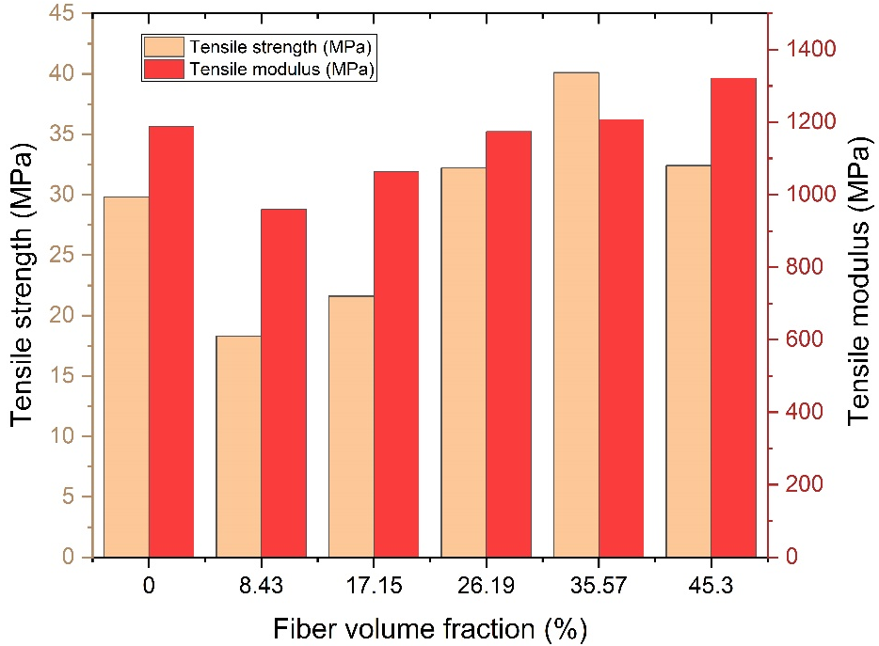
Figure 1: Variation of tensile strength and modulus based on the fiber content in FSP fiber/vinyl ester composites

Figure 2 illustrates how the fiber content in the composite influences its flexural strength. The flexural strength of the composite has increased up to 48.1 MPa as the fiber content increases in the composites up to 35.57vol.%. As the fiber content continued to increase, the flexural strength continued to decrease. The Flexural strength of a composite with 45.3 vol.% fiber content is 36.2 MPa. According to the graph, the recorded flexural strength is higher at the fiber content of 26.19vol.% than at the fiber content of 45.3 vol.%. Additionally, it has been found that flexural strength decreases as fiber content increases above 35.57 vol.%. Figure 2 clearly shows that the flexural modulus of the composite material increases with an increase in fiber content of up to 45.3 vol.%. The flexural modulus of the composite is lower than that of the neat resin sample at lower fiber content (8.43vol.%). Because the fiber density is lower than the resin, the load is not properly transmitted to the fiber at this stage.
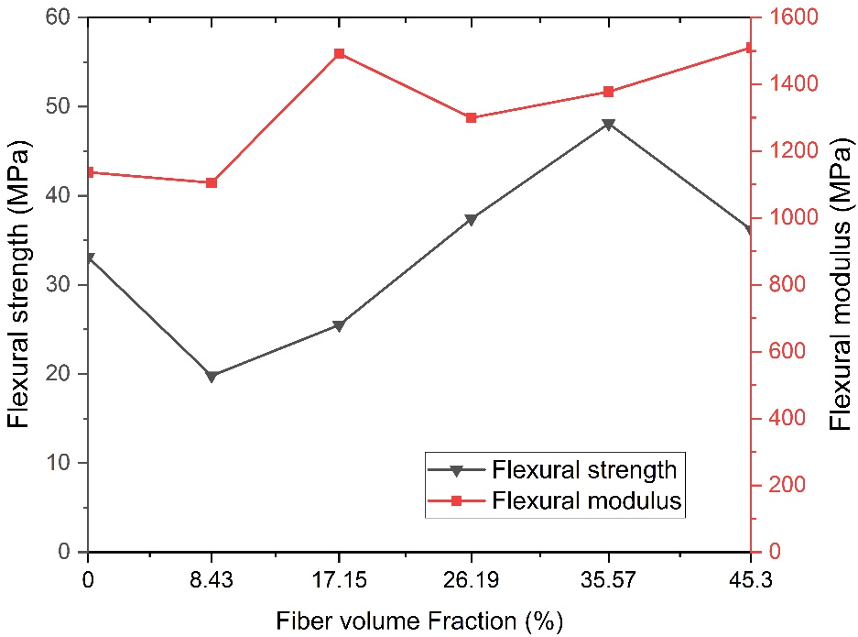

Figure 2: Variation of flexural strength and modulus based on the fiber content in FSP fiber/vinyl ester composites

The influence of fiber content on the composites' impact strength has been seen in Figure 3. As seen in Figure 3, the FSP fiber/vinyl ester composite showed an increasing trend in impact strength from 8.43 to 35.57vol.%. The FSP fiber/vinyl ester composites' maximum impact strength value (1.39 KJ/m2) was observed for 35.57 vol.% of the composite. Compared to the neat resin sample, the impact strength has increased by 59.77 %. The composite with a fiber content of 8.43vol.% had minimum impact strength of 0.62 KJ/m2.

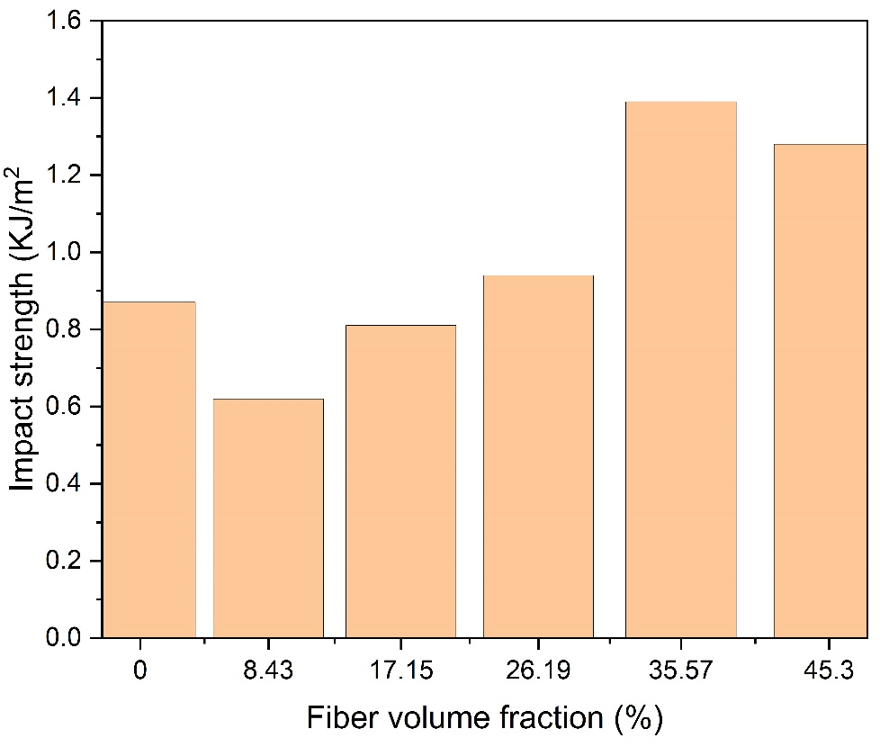
Figure 3: Variation of impact strength based on the fiber content in FSP fiber/vinyl ester composites

Mechanical properties of composite having the fiber length of 13 mm

In general, adding fibers to a polymer matrix improves the mechanical properties of polymer composites significantly because the fibers have higher strength and stiffness values than the matrices. Figure 4 depicts the variation in tensile properties of FSP fiber/vinyl ester composite with a change in FSP fibers content. At 17.15 vol.%, composites achieve the tensile strength of the neat resin sample. Composite tensile strength values increased with fiber content up to 35.57vol.%, i.e., the maximum tensile strength (46.2 MPa), and then decreased. Tensile strength improved by nearly 55.03% when compared to the neat resin sample. The vinyl ester resin matrix was unable to completely wet the FSP fibers after 35.57 vol.% of fiber content, which resulted in the weak interfacial bonding between the fiber and matrix. In comparison to 45.3vol.% composite, 26.19vol.% composite has a greater tensile strength value. The tensile modulus values of composites increased linearly from 8.43 to 45.3 vol.%. At 26.19vol.%, the composite reaches the tensile modulus of the neat resin sample. The highest tensile modulus value was found at 45.3 vol.% composite. In comparison to the neat resin sample, an improvement of 17.56% was achieved.
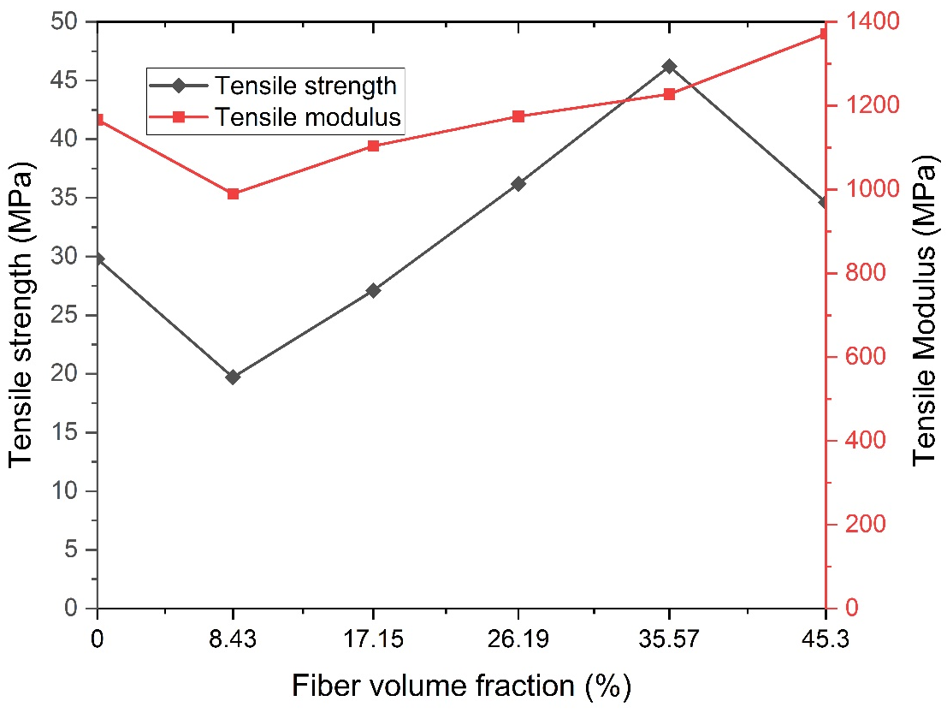
Figure 4: Variation of tensile strength and modulus based on the fiber content in FSP fiber/vinyl ester composites

Figure 5 demonstrates how the flexural strength of vinyl ester composites is greatly impacted by the addition of fiber. The composite with a fiber percentage of 35.57 vol.% had the highest flexural strength. The interaction between the fiber and matrix can be used to explain why flexural strength decreases as FSP fiber content increases. The compatibility between the FSP fiber and the vinyl ester matrix decreases as the amount of FSP fibers in the composite increases. Flexural strength and modulus were found to be around 47.8MPa and 1579.8 MPa, respectively, at fiber contents of about 45.3 vol.%. The flexural modulus of the FSP fiber/vinyl ester composites was found to increase steadily with increasing fiber content, with 35.57 vol.% fiber content increasing by 19.91% and 45.3vol.% increasing by 35.37 %.
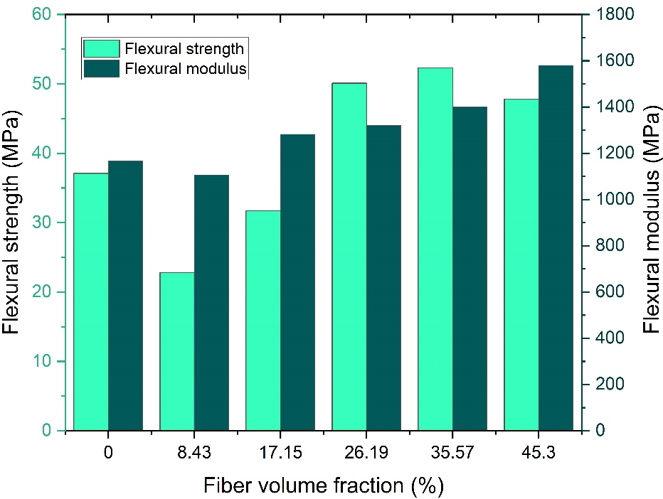
Figure 5: Variation of flexural strength and modulus based on the fiber content in FSP fiber/vinyl ester composites
Figure 6 displays the impact strength of FSP fiber/vinyl ester composites. Composites can withstand 17.15vol.% of the impact of a pure resin sample. It was discovered that impact strength increases up to 35.57vol.% before beginning to decrease. When compared to a pure resin sample, a 64.37% improvement at 35.57vol.% composite was seen. When compared to specimens made of 35.57vol.% composite, 45.3vol.% of the composite specimen showed a 10.49% drop in impact strength. Initial results show a 17.24% reduction at 8.43vol.% composite when compared to the neat resin sample. The impact strength increased with fiber content after 8.43vol.%.
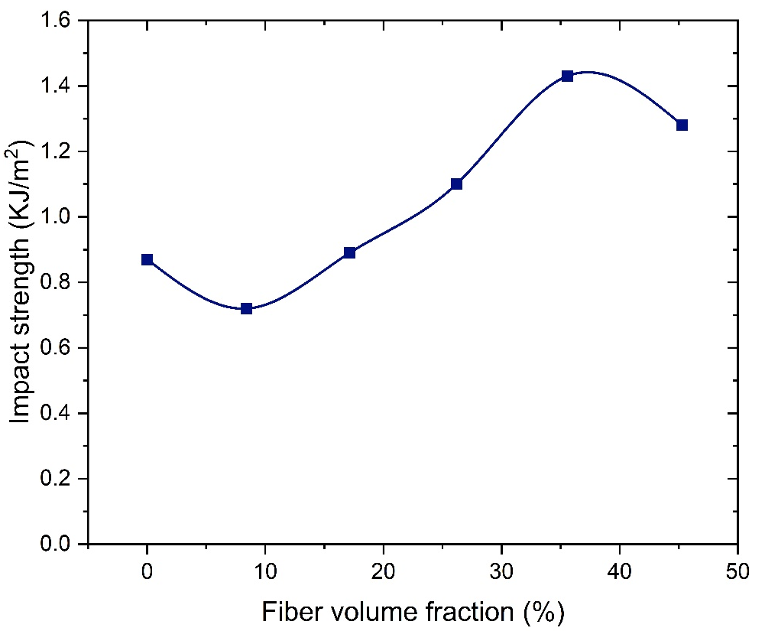
Figure 6: Variation of impact strength based on the fiber content in FSP fiber/vinyl ester composites

Figures 1 to 6 show that in all combinations of fiber contents, FSP fiber reinforcement in a vinyl ester resin matrix has a considerable impact on the mechanical properties of composites. At the strength values of composites with fiber lengths of 13 mm, a substantial difference can be seen. In all cases of fiber contents, composites with fiber lengths of 3 mm also exhibit a moderate change in mechanical properties. It was determined that the compatibility between FSP fibers and the vinyl ester resin matrix is minimal. The main highlighted problem with plant-based natural fibers was their hydrophilic nature on the surface, which affects the interfacial adhesion between the hydrophilic fiber and a hydrophobic matrix. According to the preceding discussion, the optimal fiber content for achieving the best mechanical properties in FSP fiber/vinyl ester composites was 35.57vol.%.

CONCLUSION

This paper presents the results of an experimental investigation into the mechanical behavior of FSP fiber- reinforced vinyl ester composites. Both the fiber content and the length of the fiber have a significant impact on the mechanical properties (tensile strength, flexural strength, and impact strength) of the FSP fiber-reinforced vinyl ester composite material. Up to a 35.57 vol.% increase in fiber content, tensile, flexural, and impact strength increases; after that, it began to decrease for two cases of fiber length. When compared to composites with fiber lengths of 3 mm, those with 13 mm fibers exhibit the highest level of mechanical properties. The values of the tensile and flexural modulus increased as the fiber content increased from 8.43 vol.% to 45.3 vol.%. The composite material's impact strength increased as the fiber content increased.

REFERENCES
- A.K. Sinha, H.K. Narang, and S. Bhattacharya, “Mechanical properties of natural fibre polymer composites”. J. Polym. Eng., vol. 37, pp. 879-895, 2017.
- E.L. Bourhis, F.Touchard, “Mechanical Properties of Natural Fiber Composites”, Encyclopedia of Materials: Composites, vol. 3, pp 135- 148, 2021.
- M. Asim, M. Jawaid, K. Abdan, M.R. Ishak, O.Y. Alothman, “Effect of Hybridization on the Mechanical Properties of Pineapple Leaf Fiber/Kenaf Phenolic Hybrid Composites”, J. Renew. Mater., vol. 6, pp.38-46, 2018.
- C. Merlini, S.D.A.S. Ramôa, and G.M.O. Barra, “Conducting polypyrrole-coated banana fiber composites: Preparation and characterization”, Polym. Compos., vol.34, pp. 537-543, 2013.
- W. Sujaritjun, P. Uawongsuwan, W. Pivsa-Art and H. Hamada, “Mechanical property of surface modified natural fiber reinforced PLA biocomposites”, Energy Procedia, vol.34, pp.664-672, 2013.
- T. Chen, W. Liu and R. Qiu, “Mechanical properties and water absorption of hemp fibers –reinforced unsaturated polyester composites: Effect of fiber surface treatment with a heterofunctional monomer”, BioRes., vol.8, pp. 2780-2791, 2013.
- P.A. Udaykumar, S. Rajanna, and Ramalingaiah, “Studies on effects of short coir fiber reinforcement on flexural properties of polymer matrix”, Int. J. Eng. Res. Technol., vol. 03, pp. 37-41, 2014.
- J. Naveen, T.P. Sathish Kumar, and S. Satheesh Kumar, “Effect of Moisture Absorption on the Behavior of Woven Hybrid Natural Reinforced Polymer Composites”, Int. j. innov. res. sci. technol., vol. 3, pp. 1091-1095, 2014.
- H. Bisaria, M.K. Gupta, P. Shandilya, R.K. Srivastava, “Effect of Fibre Length on Mechanical Properties of Randomly Oriented Short Jute Fibre Reinforced Epoxy Composite”, Mater. Today: Proc., Volume 2, pp. 1193-1199, 2015.
- A.N. Kasim, M.Z. Selamat, N. Aznan, S.N. Sahadan, M.A. Mohd Daud, R. Jumaidin, and S. Salleh, “Effect of pineapple leaf fiber loading on the mechanical properties of pineapple leaf fiber - polypropylene composite”, Jurnal Teknologi., vol. 77, pp. 117–123, 2015.
- M. Gerald Arul Selvan, and A. Athijayamani, (2016). “Mechanical properties of fragrant screw pine fiber reinforced unsaturated polyester composite: Effect of fiber length, fiber treatment and water absorption”, Fibers and Polym., vol. 17, pp. 104-116, 2016.
- W. Wan Mohamed, A. Baharum, I. Ahmad, I. Abdullah, and N. Zakaria, "Effects of fiber size and fiber content on mechanical and physical properties of mengkuang reinforced thermoplastic natural rubber composites", BioRes., vol. 13, pp. 2945-2959, 2018.

