SMART FARMING –FUTURE OF AGRICULTURE
T. Geetha Jebarathnam Kuttibai¹, M.S. Bhagavathi² and V. Prakash³
Professor And Head¹, Associate Professor^{2&3}
School of Agriculture, Bharath Institute of Higher Education and Research,
Chennai, Tamilnadu ,India

World Food production need to be increased by 70% during 2050 as stated by the UN Food and Agriculture Organization owing to the shrinking land resources and the tremendous growth of the world population exponentially. Despite the fact, the scarce availability of fresh water and arable land ,migration of agriculture workforce ,linked with declined yield trends had further pushed too far the problem. Ratification of super highway in agriculture had been a head start to combat the declining agricultural workforce. Agriculture has undergone many revolutions, regardless of the domestication of plants and animals, way back a millennium ago, standardized adoption like rotations of crop, other farming practices a few years ago or the applications of technologies like plant breeding and in organics for yield escalation and pest and weed control a decennial ago the green revolution In the dawn of the new millennium, the thrust in agriculture is undergo a fourth revolution trigger by the opportunity of exponentially escalating use of information and communication technology (ICT).
The cutting edge technologies, for example unmanned aerial vehicles with lightweight cameras preferred for farm management improvements, create a technical revolt that will generate incredible changes in agricultural practice. Such delicate changes in practices not only big challenge but with massive scope mostly the minimized site-specific application of inputs, viz; fertilizers and pesticides, in precision agriculture systems will moderate leaching harms as well as the emission of greenhouse gases, reduced labour requirement, input cost that finally lead to increased net income. Wherein the optimal, site-specific weather forecasts, yield prediction and prospect maps for diseases and disasters based on a dense network of weather and climate data allow cultivation of crops in an most favorable way, to achieve the final target of a farmer.
The Agriculture Industry isn't an exception as of now the Industrial Internet of Things (IoT) has interrupt many industries. Persistently till the end of 2018, the connected agronomics market ranked at USD 1.8 billion universally is predictable to grow to USD 4.3 billion by 2023 at a Compound Annual Growth Rate (CAGR) of 19.3% .The IoT technology has realized the smart wearable's, connected devices, automated machines and driverless cars. However, in agriculture, the IoT has bring the most impact. In fact, few of the recent report tells that the IoT device installation will see a compound annual growth rate of 20% in the agriculture industry. And the number of associated devices (agricultural) will grow from 13 million in 2014 to 225 million by 2024. Site-specific in order also enable new business opportunity for the entire value chain, input suppliers to farmers, processors and the retail sector in developed societies. IoT in agriculture technologies comprise specialized equipment, wireless connectivity, software and IT services.

A Way Forward
Smart farming and networks across all of the agri-food sector can provide a concentrated path out of locked-in technologies towards sustainable agriculture by diversification of technologies, crop and livestock production systems. Collateral to the discourse and apprehension of “smart cities,” the possibilities of ICT will lead to a diversity of farming systems rather than one globally uniform and rapidly accepted farming. Even if farmers have not produced a certain crop previous to, technical innovations causal to diversification are further assisted by management advice if given with high reliability and clarity. However, although the “Internet of Things,” including agricultural machinery, can be used to manage standard farming situations to be on the look out for unanticipated circumstances. Crop pests in treatments of disease or in monitoring and treating livestock and diseases need only be tackled when positive thresholds, determined with new ICT applications are reached. Smart farming is focused on the use of data acquire through various sources in the management of farm activities. Smart farming employs themselves through their ability to record the data hardware (IoT) and software (SaaS) , capture the data and give useful insights to manage all the operations on the farm both pre and post - harvest. The data, available all the time and full of data on all facets of economics and field operations is well prepared that can be monitored from anywhere in the world. IoT have the potential to transform agriculture in many aspect and these are the main ones. Data are collected by smart agriculture sensors in this approach of farm management a key component are sensors, control systems, robotics, automated hardware, variable rate technology, motion detectors, button camera and wearable devices. This data can be used to track the state of the business in general as well as staff performance and equipment efficiency. The ability to foresee the output of production allows to plan for better product distribution.
Agricultural Drones: Ground-based and aerial-based drones are being used in agriculture in order to supplement various agricultural works crop health monitoring, planting, irrigation, crop spraying and soil and field analysis.
Livestock tracking and geo-fencing: Farm pruners, in order to monitor the well-being and health of their cattle can utilize wireless IoT applications to collect data regarding the location. This in sequence helps to prevent the spread of disease and also lower labor costs.

Smart Greenhouses: A smart greenhouse designed with the help of IoT intelligently monitors as well as controls the climate, maintains ideal microclimate conditions, prevents theft and improve security and control, infection and avoid disease outbreak, enhance irrigation and fertilizer application practices.
Predictive analytics for smart farming :A farm centric analysis is vital for any peasant to make thoughtful decisions regarding the cropping schemes, agronomic practices, calendar of operations from seed to seed, post-harvest managements to predict performance of the crop. Artificial network use information collected by sensors from the farm includes parameter such as soil, pressure, rainfall temperature and humidity contributes the farmers to get an accurate soil data either by the dashboard or customized mobile applications.

Applications of IoT in Agriculture:

1. Climate Conditions:
Agro meteorology as a whole, plays a essential role in agriculture. Having inadequate knowledge about climate and weather parameters and its impact on farming heavily deteriorate the quantity and quality of the crop production. But IoT solutions enables real-time weather conditions, sensors are placed outside and inside of the agriculture fields. The compilation of data from the environment favors the right choice of crop that perform the best in the particular climatic condition. Perhaps IoT system is made up of sensors that can detect real-time weather conditions like rainfall, humidity, temperature, direction, dewfall, atmospheric pressure, wind speed, soil temperatures, and more very accurately and raise crops to avoid all losses . Innumerable sensors are available to detect all these parameters and configure accordingly to suit your smart farming requirements. These sensors monitor the condition of the crops and the weather surrounding them. If any disturbing weather conditions are found, then an alert is sent and warnings to overcome the aberration during the disturbing climatic conditions accustomed which eventually increases productivity, help farmers to reap higher agriculture benefits.

2. Precision Farming:
Precision agriculture / Precision farming is one of the most eminent applications and best accomplishment of IoT in agriculture. Further it makes the farming practice more precise and controlled by realize smart farming application such as vehicle tracking, livestock monitoring, field observation and inventory monitoring. The goal of precision farming is to analyze the data and generated via sensors to react accordingly. Precision farming help farmer to generate data with the help of sensors and analyze that information to take intelligent and quick decisions. There are different precision farming techniques like irrigation management, livestock management, vehicle tracking and many more which plays a important role in increasing the efficiency and effectiveness. With the help of precision farming, analysis of soil status and other related parameters to increase the operational efficiency also detects the real-time working condition of the connected device to detected water and nutrient levels.

3. Smart Greenhouse:
According to particular set of instruction IoT has enabled weather station to automatically adjust climate condition to make green houses smart. Adoption of IoT in greenhouses makes the process cost-effective and with increased accuracy, simultaneously has eliminated human interventions. For instance, using solar-powered IoT sensors builds modern and inexpensive greenhouses and these sensor collect and transmit real-time datas which helps in monitoring the greenhouse state very precisely in real-time. Apart from this the water consumption and greenhouse state can be monitored via emails or SMS alerts with the help of sensor. Automatic and smart irrigations carried out with the help of IoT sensor, help provide information on the pressure, temperature and light level.

4. Data Analytics:
As the usual database systems does not have sufficient storage for the data collected from the IoT sensor cloud based data storage space and an end-to-end IoT platform plays an vital role in the smart agriculture system. These systems are estimated to plays a far reaching role for better performance of activities. In the IoT world sensors are the main source of collecting data on large scale and this data analyzed and transformed to significant information using analytical tools. The data analytics help in the analyses of weather conditions, and crop conditions, soil status, soil and crop residues, weed persistence, etc. The data collected leverages the technological innovations to make better decisions with the help of the IoT devices. The real-time status of the crops by capturing the data from sensors is perceived usage of predictive analytics provides an insight to make better decision related to all agricultural practice. IoT in the Agriculture backed with the trend analysis helps the farmers in considerate upcoming weather condition from crop quality to soil status and all practice until harvest of crop

5. Agricultural Drones:
Technological advancements have almost revolutionized the agriculture operations and the introduction of agricultural drones is trending shift. The Ground and Aerial drones are customized for assessment of crop monitoring, planting, crop health, crop spraying and field analysis. With proper strategic approach and planning based on real-time data drone technology has given a high rise and transformation to the agriculture manufacturing. Drones with thermal or multispectral sensor recognize the areas that require changes in irrigation requirement of specific crops and alert irrigation frequencies, once the crops start growing; sensors indicate their health and calculate vegetation index. Eventually smart drones have reduced the environmental impact as on -site specific technologies are obviously carried out keeping all resource at the limited applications. Moreover, the weed infestation monitored and immediate remedies action lead to a profitable farming, hence the resulting effect of drone technology cause a massive reduction and least persistence of in organics in the groundwater.

Conclusion
IoT enabled agriculture has help, apply modern technological solutions to time tested knowledge bridging the gap between quality, production, quantity and productivity. Data ingested by obtain and importing information from multiple sensor for real time use or storage in database make certain swift action and in turn the less damage to crops but making a successful crop productions. The farm to table that ethically sourced, with consistent end to end intelligent operation and improves the business process execution, produce gets processed faster which is favorable outcome of smart agriculture. Labour being the scarce commodity for the past few years, the inception of IoT as a driving force for increasing agricultural production is a cost-effective way to promising feature that encourage agriculture back to farm, a boon to economy as an individual and nationwide. Perhaps in future, smart farming characterize the drop in use of pesticides and fertilizers but rise in the overall efficiency is certainand realizations that the IoT as a driving force for ample opportunity for businesses willing to join in. In fact IoT technologies will also trace out the hazardous residues in soil and the economic and biomass output ensuring better food traceability, which in turn will lead to increased food safety. Besides the right usage of chemicals in minimal quantities, shift in the use of organics adequately will be helpful to the environment, generating sustainable farming, which is ecologically safe and economically possible.
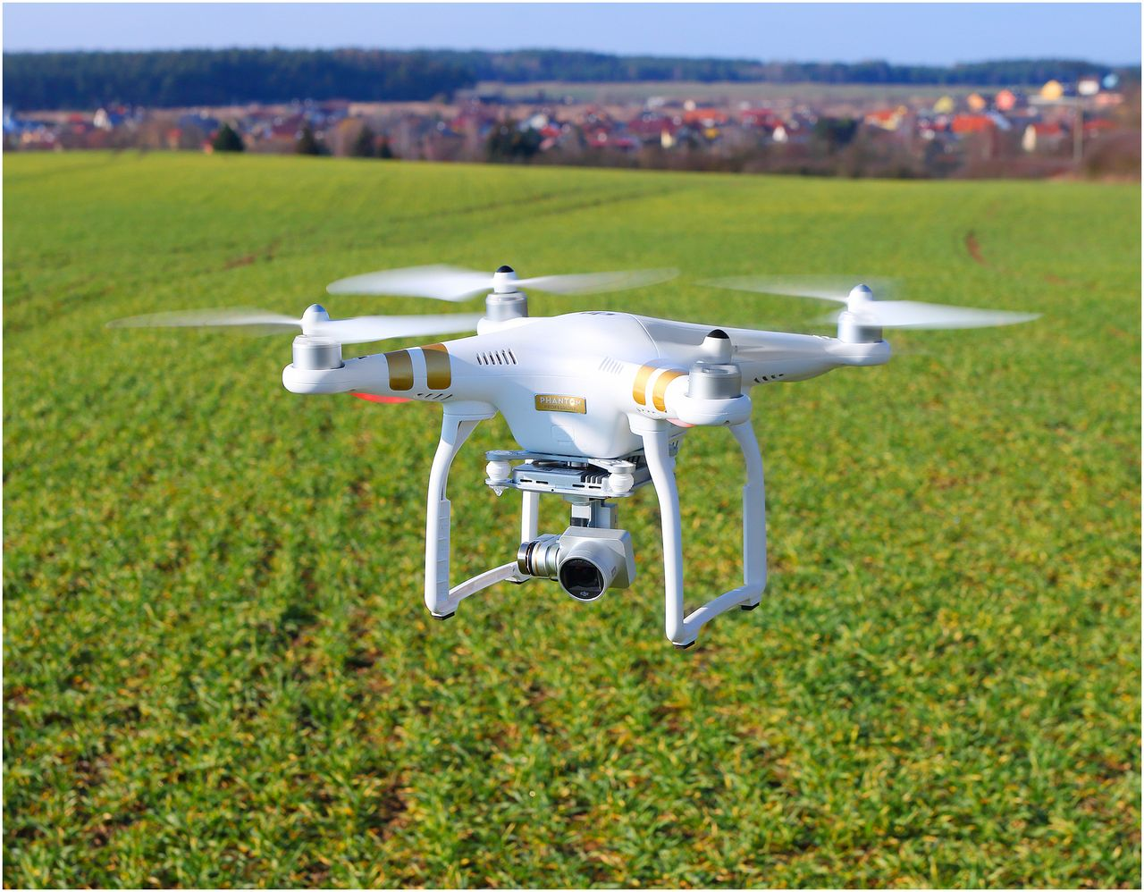

Therefore, smart farming is worthy of its enormous potential to deliver a more productive and sustainable form of agriculture production, based on a more precise and resource-efficient approach .This as a turn-key for emerging new farms will finally realize the eternal dream of bright future as a whole to feed our population, which may explode to 9.6 billion by 2050.

