Reporting of Potholes on Roads to Aid Drivers
Pragati Jain
Assistant Professor, Dept. of Mathematics, Govt. College Manawar
Ishita Jain
Computer Science Engineer & Analytics Consultant
Diksha Mulchandani
Information Technology Engineer & Data Analyst

Abstract: Finding and repairing potholes in a timely and accurate manner is crucial to avoid road accidents. Currently, road distresses are identified manually that requires a lot of time and effort. The proposed system is an algorithm-based system which detects potholes in real time using a smartphone. The user will provide the source and destination location as inputs. Using the android application, the user can view all the potholes present on the route.
Keywords: Pothole detection, Object Detection, Single Shot Multi box Detector, Road Accidents, Safe Driving, Android
Introduction:
India's traffic congestion has been worsening because of economic expansion, urbanization, and a significant increase in the number of cars. Because of terrible road conditions, the number of reported accidents is growing dramatically. The roads are degrading as more people use them and less is done to maintain them. Because to the bad road conditions, drivers have a tough time identifying manholes, bumps, and other hazards, which leads to catastrophic mishaps. Recently, researchers have looked on automatic pothole detecting systems that use a variety of sensors. Existing suggestions are divided into three categories: vibration-based approaches, laser-scanning methods, and vision-based methods.

Camera-based techniques are suitable for precisely identifying potholes across a large region at a low cost. Many techniques based on 2D pictures and video data have been investigated. Koch and Brilakis pioneered the use of 2D pictures to identify potholes. Their technique entailed looking for certain pothole characteristics and identifying pothole areas. They employed a remote-controlled robot vehicle prototype outfitted with a webcam positioned 60 cm above the ground. Buza et al. proposed a new unsupervised vision-based technique that does not need expensive equipment, extra filtering methods, or a training phase. Jog et al. developed a novel method for detecting and quantifying the breadth, number, and depth of potholes using a monocular camera positioned on the back of a vehicle.
Object detection is a technique used in visual data to discover a candidate region for a detection target in order to recognise a specific target and forecast the kind and position of the object (bounding box) proposed by Boukhriss RR, Fendri E, Hammami M. R-CNN by Ma C, Chen L, Yong J, and YOLO by Jamtsho Y, Riyamongkol P, Waranusast R. are some of the algorithms used for this. To enhance object detection, T. Gong et al. presented a multi-label classification approach. Accuracy of Single Shot Multiple Box Detector has higher accuracy than RCNN, Fast RCNN and YOLO hence, we will be using SSD in our project.
When compared to other approaches, laser scanning provides superior detection performance. This method proposed by Li Q, Yao M, Yao X, Xu B collects very detailed road-surface information by employing a technology that uses reflected laser pulses to generate exact digital models.
Here, we present a pothole detecting system that makes use of a smartphone camera. We also present a pothole detection method in which camera and sensors run in background for real time detection of potholes. Our pothole-detection technology may be utilised as an effective and low-cost pothole-maintenance method.

2. Methodology

An android application is developed for traffic information that additionally detects potholes and acts as a warning system. Each vehicle has its own speed limit. So primarily based on a single vehicle, we can't estimate the traffic density of that road. We make use of the Global Positioning System or GPS which is a space-based navigation device, and it captures the region and time in all climate conditions, anywhere on the Earth. By GPS, we can discover out if the automobiles are moving slowly, as a result, there is traffic congestion, and we can decide that the road has excessive density traffic.

2.1 Camera Based Pothole Detection

The rear camera records a continuous movement and sends individual frames to a trained custom object detection model; the Single Shot Multi-Box Detector or SSD which are designed to assist units with low computational capabilities like the Smartphone, however, performs better than YOLO and CNN. Pothole pictures are recorded and labelled for the dataset and the TensorFlow object detection API is employed.

Data Acquisition
On the Android phone, the camera will operate in the background. There are numerous frames of images in the video stream captured by the camera. Single shot multi-box detector algorithm is used in this model.

Detection using SSD algorithm
SSD is an algorithm that is used to identify objects. It generates bounding boxes around identified objects, along with confidence scores for each one. Convolutional filter is used to forecast object categories and feature maps are multiplied by this filter for detection at different scales. Even low-resolution pictures may be detected with great accuracy because of this technique. SSD is faster and more accurate than R-CNN and YOLO. Devices with minimal computing capabilities such as mobile phones can benefit from the use of SSD-Mobile nets.

Detection using TensorFlow API
TensorFlow object identification API includes pre-trained deep learning models and transfer learning capabilities. TensorFlow is used to train this model on the custom dataset that will be gathered. It will also be converted into a lightweight model using TensorFlow Lite, which can be incorporated into Android applications for real-time detection.

Dataset and Labelling
Over 300 photos of potholes will be taken for training. For each picture, LabelImg tool will create an XML file with the annotations. As a final step, all pictures and XML files have been transformed to TensorFlow RECORD format.

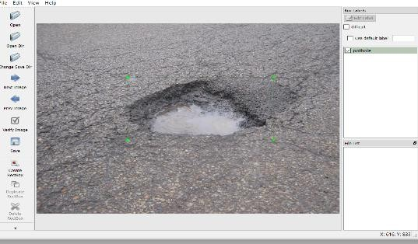
Figure 1. Label Img tool for labelling potholes
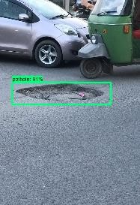
Figure 2. Pothole detection through SSD

2.2 Sensor Based Pothole Detection

The spikes in Accelerometer and Gyroscope readings when an automobile passes over a pothole had been recorded.
The user first selects the mode of transportation and specifies the source and destination. There is an option for the user to specify the distance within which he wishes to know the traffic information. GPS then gives a route, and the application displays the segments containing the traffic density of different kinds of transportation along the path. The average speed of the vehicles in that path is also displayed. This helps the user to select an optimum path with low traffic. The information regarding the traffic is updated frequently.
Traffic density also depends on disorganized mess such as potholes. Whenever a vehicle passes over a pothole, the accelerometer senses the vibration and if the vibration value is equal to the one specified in the code, the latitude and longitude value of the pothole is stored into the database. The database stores all values of the potholes detected. If a pothole is detected three times by the user, then a mail is sent to the Corporate automatically by the system regarding the location of the pothole and the same is updated to the public website. Once the problem is rectified, potholes values are removed from the database. In this project we make an assumption that commuters on the road use this application, which makes it easy to know traffic related information.

Dataset Acquisition

The model's accuracy is mostly determined by the parameters that are supplied into it as input. When the car travels over a pothole, the gyroscope sensor, which monitors rotational velocity, captures the vibrations and uneven motions of the vehicle. As the name implies, an accelerometer detects acceleration in three dimensions (x, y, z). Measurements per second will be recorded by the application running on the smartphone Whenever any car passes over a pothole, the data will be manually tagged.

Real time detection

On smartphone, the machine-learned model will be transferred to TensorFlow Lite and used for real-time pothole identification. As soon as the model determines that the reading is due to a pothole, the location coordinates are uploaded to the database. On the map, these co-ordinates can be seen by other users of the system.

Results: For each experiment, we randomly divided the dataset into training set and testing sets at a ratio of 80:20. We used a dataset that includes 350 pothole images that were in different daylight conditions, different road conditions, and with different shapes and sizes. The pothole dataset was trained with SSD algorithm. After the training is completed, we have converted the weights into TensorFlow version. Once the model is converted into TensorFlow version, we can now test the model on a route in Indore. The user has to first register in the Pothole Detection Application and provide input of source and destination location based on which a route will be marked on the map and a notification will be sent to the user whenever a pothole is detected. The user interface and camera-based pothole detection are shown below –
Figure 3. Sign Up Page

Figure 4. Sign in Page

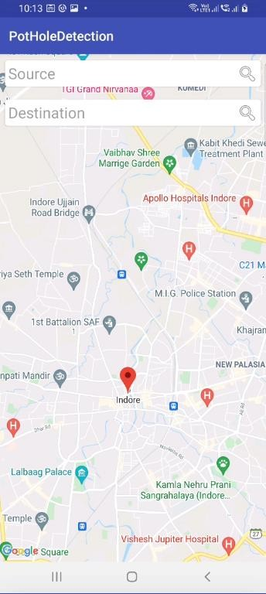

Figure 5. User Interface for Source and Destination location

User enters the source and destination location according to which a route will be marked on the map. After clicking on the Camera based pothole detection button, the application runs camera and detects pothole. Rectangular box with confidence interval will appear whenever a pothole will be detected.

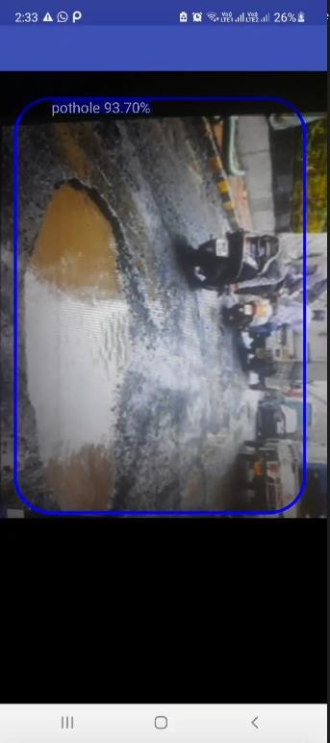

Figure 6. Camera based Pothole detection on a route in Indore with Confidence Interval

References

      - Chang, K. T., Chang, J. R., & Liu, J. K. (2005). Detection of pavement distresses using 3D laser scanning technology. In Computing in civil engineering (2005) (pp. 1-11).
      - De Zoysa, K., Keppitiyagama, C., Seneviratne, G. P., & Shihan, W. W. A. T. (2007, August). A public transport system-based sensor network for road surface condition monitoring. In Proceedings of the 2007 workshop on Networked systems for developing regions (pp. 1-6).
      - Eriksson, J., Girod, L., Hull, B., Newton, R., Madden, S., & Balakrishnan, H. (2008, June). The pothole patrol: using a mobile sensor network for road surface monitoring. In Proceedings of the 6th international conference on Mobile systems, applications, and services (pp. 29-39).
      - Ghose, A., Biswas, P., Bhaumik, C., Sharma, M., Pal, A., & Jha, A. (2012, March). Road condition monitoring and alert application: Using in-vehicle smartphone as internet-connected sensor. In 2012 IEEE international conference on pervasive computing and communications workshops (pp. 489-491). IEEE.
      - Howard, A. G., Zhu, M., & Chen, B. (2017). Dmitry, Kalenichenko, Weijun Wang, Tobias Weyand, Marco, Andreetto, and Hartwig Adam. Mobilenets: Efficient, convolutional neural networks for mobile vision applications., CoRR,,, abs/1704, 4861, 1.
      - Li, Q., Yao, M., Yao, X., & Xu, B. (2009). A real-time 3D scanning system for pavement distortion inspection. Measurement Science and Technology, 21(1), 015702.
      - Liu, W., Anguelov, D., Erhan, D., Szegedy, C., Reed, S., Fu, C. Y., & Berg, A. C. (2016, October). Ssd: Single shot multi-box detector. In European conference on computer vision (pp. 21-37). Springer, Cham.
      - Mednis, A., Strazdins, G., Zviedris, R., Kanonirs, G., & Selavo, L. (2011, June). Real time pothole detection using android smartphones with accelerometers. In 2011 International conference on distributed computing in sensor systems and workshops (DCOSS) (pp. 1-6). IEEE.
      - Raj, S., Jain, A., & Misra, R. (2013, June). Smartphone sensing for large data set collection of potholes. In Proceeding of the 11th annual international conference on Mobile systems, applications, and services (pp. 517-518).
      - Vigneshwar, K., & Kumar, B. H. (2016, December). Detection and counting of pothole using image processing techniques. In 2016 IEEE International Conference on Computational Intelligence and Computing Research (ICCIC) (pp. 1-4). IEEE.Research,2016
      - Yadav, N., Binay, U. (2017, November) Comparative Study of Object Detection Algorithms. IRJET vol.4 (pp-586-590)
      - Yu, B. X., & Yu, X. (2006). Vibration-based system for pavement condition evaluation. In Applications of Advanced Technology in Transportation (pp. 183-189).

