PRODUCTION OF BIO-ENZYME BY USING (Citrus sinensis) AND TESTING ITS ANTIMICROBIAL ACTIVITY OF MICROBES AGAINST HUMAN (Homosapiens) HAND
*EUGIN AMALA.V¹., NAJMA BEGAM.N¹., ASHEERA ASHRIN.M¹., LAVANYA.S¹.,
ASIYA NACHIYA.H¹
1.EUGIN AMALA.V¹ Assistant professer and Head , PG and Research Department of Microbiology. Idhaya college for women Kumbakonam.
1. NAJMA BEGAM.N¹, ASHEERA ASHRIN.M¹ ,
LAVANYA.S, ASIYA NACHIYA.H¹ UG students Department of Microbiology .Idhaya college for women Kumbakonam.
Corresponding Author :* Email-amalaeugin@gmail.com
Abstract:
Citrus sinunsis belong to the family Rutaceae.it originated in south chinaand myanmer.It used to treat constipation,crapms,cold ,and prevent kidney stones.the presnt study the bioenzyme was prepared and its antimicrobial activity tested against microbes isolated from Human hands.it is effective against E.coli, Klebsiella sp and Staphylococcus sp.
INTRODUCTION:
Human skin is the largest organ .it made of protein, Minerals and fat. It is inhabitate of rods and cocci bacterium’s ,the microbes like Klebsiella sp, E.coli, Proteus sp, Enterobacter. The skin also contain some extrinsic microbes. (P.Zeeumen,etal.,2013).The pathogenic and nonpathogenic microbes and microbial ecology of human skin in health and disease (D.Fredricks,et al.,2001) Regular hand washing and practicing use of sanitizer rountine. (WORLD HEALTH ORGANISATION,2009) World Health Organisation recommended all people should,wash their hand before and after preparing food and before eating food. Bio-enzyme is a natural organic enzyme made from fermented Citrus sinensis. It can be used for floor cleaner,Glass cleaner and Dish washing.It also used in laundary.

MATERIALSAND MEHODS.
The collected sample was inoculated on to nutrient agar and incubated at 37℃ for 24 hours to be 48 hours. After the incubation period, selected colonies of samples were transferred from mixed culture of the plate of Nutrient agar ,.then it streaked on EMB agar ,blood agar, Mac conkey agar, and citrate agar ,the microbes on hand samples confirmed by various biochemical tests,Indole test, Methyl red test, VP test,Citrate utilization test, TSI agar test , Gelatin hydrolysis, Catalase test , Urease test, Starch hydrolysis

PREPARATION OF Citrus sinensis BIO-ENZYME PRODUCTION:
Bio-enzyme products are added of jaggery (Gud) or black strap molasses is 100g and Citrus sinensis peels is 300g is added and the distilled water 1000ml is added and also the quarter (1/4)teaspoon dry yeast.The ratio is 1:3:10 ratio of jaggery: Citrus sinensis:peel:water

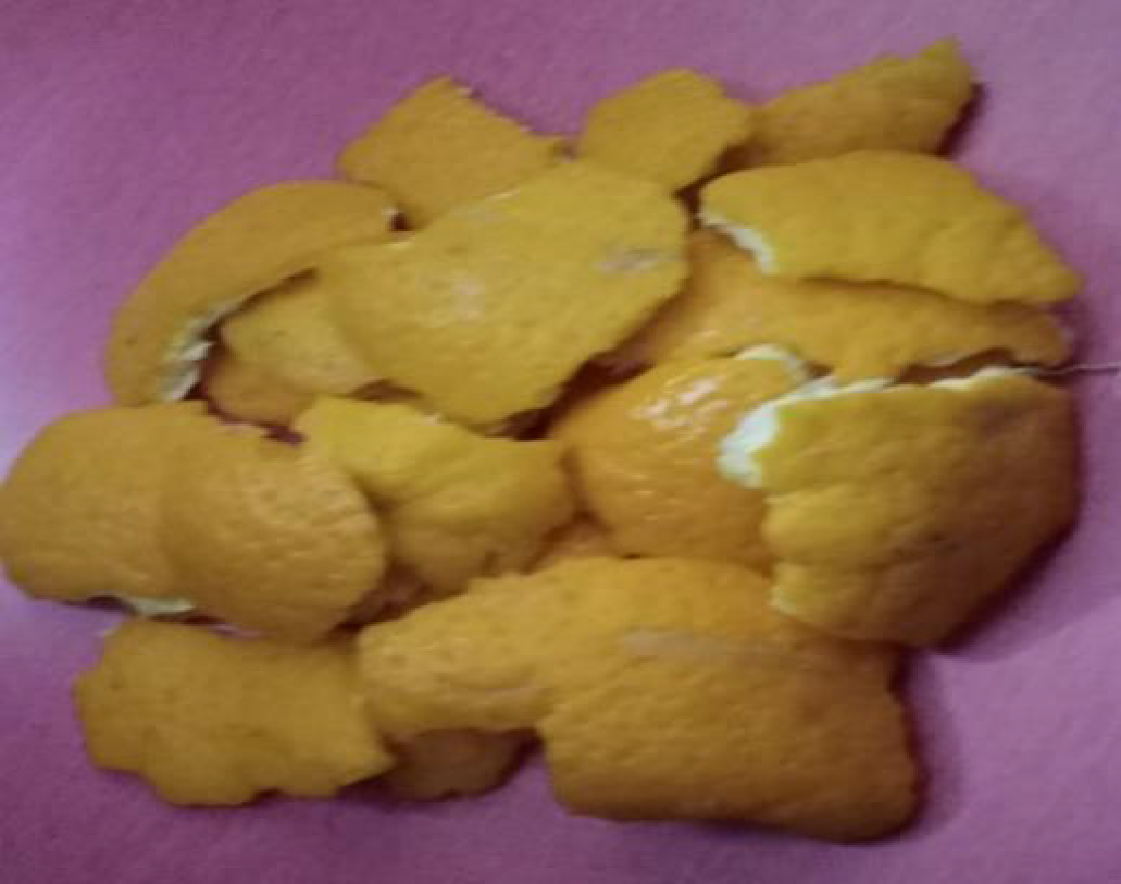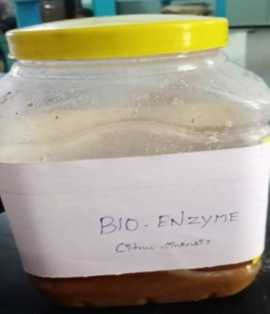
Citrus sinensis peels BIO-ENZYME
Citrus sinensis 26

Result
Table-1:ISOLATION OF MICROBES FROM HANDS
S.no | Microbes | Total Bacterium cfu/ml  Before using sanitizers | Total microbial load cfu/ml Afterusing sanitizer
1 | Klebsiella sp., | 2.4 ×10³ | 2.2 ×10³
2 | Proteus sp., | 2.2 ×10³ | 2.1 ×10³
3 | Staphylococcus sp., | 2.6 ×10³ | 1.2 ×10³

Table-2:Biochemical Characteristics of Staphylo coccus sp.,

S.No | Biochemical Test/Morphology | Results
1 | Gram staining | Coccus Rod
2 | Cultural characteristics on agar slant | Abundant ,opaque
3 | Gelatin liquefication | + ve
4 | Starch hydrolysis | -ve
5 | Lipid hydrolysis | + ve
6 | lactose | Acid production
7 | Dextrose | Acid production
8 | Sucrose | Acid production
9 | H2s production | -ve
10 | No₃ reduction | +ve
11 | Indole production | -ve
12 | MR Reaction | +ve
13 | VP reaction | +
14 | Citrate | -ve
15 | Urease activity | -ve
16 | Catalase activity | +ve
17 | Oxidase activity | -ve

1.(+)-positive 2.(-)-Negative 3.A-Acid
Fig:1Biochemical characters of Staphylo coccus sp.,
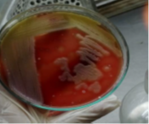
- Staphylo coccus sp., in Blood Agar Medium
Table -3:Biochemical Characteristics of Klebsiella sp.,
S.No | Biochemical Test/Morphology | Results
1 | Gram staining | Rod (-)
2 | Cultural characteristics on agar slant | Slimy,white,somewhat,  translucent,raised growth
3 | Gelatin liquefication | -ve
4 | Starch hydrolysis | -ve
5 | Lipid hydrolysis | -ve
6 | lactose | Acid gas
7 | Dextrose | Acid gas
8 | Sucrose | Acid gas
9 | H2s production | -ve
10 | No₃ reduction | +ve
11 | Indole production | -ve
12 | MR Reaction | +ve
13 | VP reaction | +
14 | Citrate | -ve
15 | Urease activity | -ve
16 | Catalase activity | +ve
17 | Oxidase activity | -ve

1.(+)-positive 2.(-)-Negative 3.AG-Acid gas

Fig:2 Biochemical characters of Klebsiella sp.,
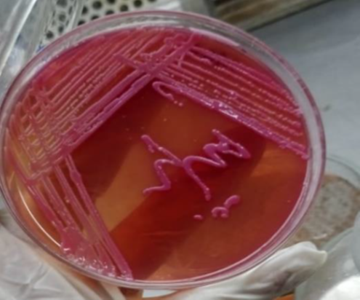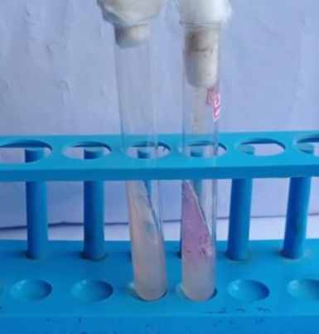
- Klebsiella sp.,in Mac Conkey,s Agar B)Urease +VE

Table-4:Biochemical characteristics of proteus sp.,

S.NO | Biochemical Test/Morphology | Results
1 | Gram staining | Coccus rod
2 | Cultural characteristics on agar slant | Thin ,blue-grey,spreading growing
3 | Gelatin liquefication | +ve
4 | Starch hydrolysis | -ve
5 | Lipid hydrolysis | -ve
6 | lactose | -ve
7 | Dextrose | Alkaline
8 | Sucrose | Alkaline+_
9 | H2s production | +ve
10 | No₃ reduction | +ve
11 | Indole production | +ve
12 | MR Reaction | +ve
13 | VP reaction | -ve
14 | Citrate | -ve
15 | Urease activity | +ve
16 | Catalase activity | +ve
17 | Oxidase activity | -ve

1.(+)-positive 2.(-)-Negative 3.(A)-Alkaline

Fig:3 Biochemical characters of Proteus sp.,
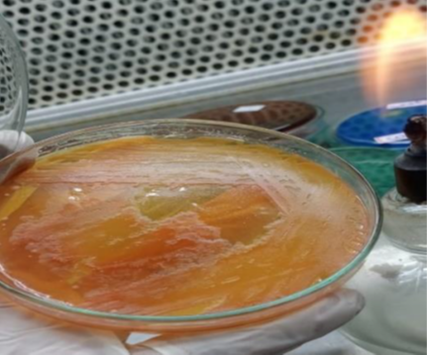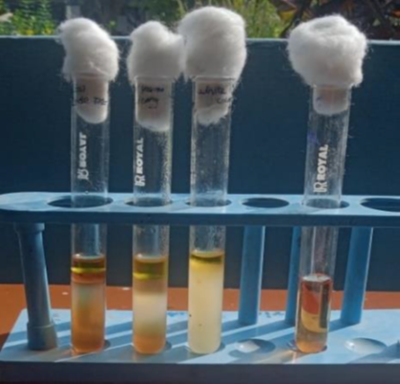
a)Proteus sp., in Macconkey agar b)Indole +VE

Table-5:Testing Antimicrobial sensitivity of Isolates Against Bio-enzyme (Citrus sinensis)
S.NO | Tested oraganism | Zone of inhibition
1 | Klebsiella sp., | 15mm
2 | Proteus sp., | 14mm
3 | Staphylo coccous sp., | 16mm

Fig: 4 Antimicrobial Activity of Isolated microbes Against Bio-Enzyme (Citrus sinensis)
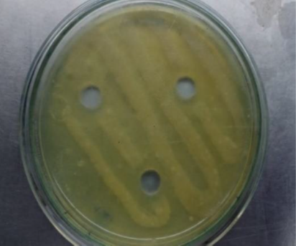
A)Antibacterial Activity of Citrus sinensis Bio-Enzyme Against Proteus sp.
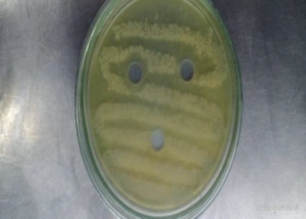

B)Antibacterial Activity of Citrus sinensisBio-Enzyme Against Klebsiella sp
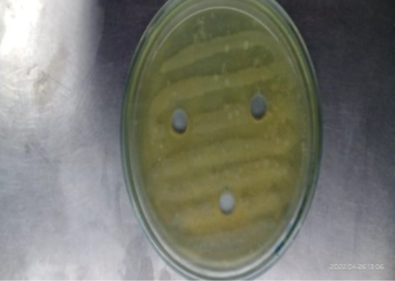
C) Antibacterial Activity of Citrus sinensis Bio-Enzyme Against Staphylo coccous sp.,
Table-1:Shows biochemical characters of Staphylo coccous sp., In Staphylo coccous sp., appears gram positive coccus rods. it appears thin, grayish growth. It appears positive on gelatin liquefaction, lipid hydrolysis, NO3 reduction ,Methyl red reaction, voges prauskers reaction and Catalase activity. It appears negative on starch hydrolysis, H2S production, Indole production, ,citrate, Urease activity ,Oxidase activity . Fig:1)
Table-2:Shows biochemical characters of klebsiella pneumonia sp. Appears gram negative rods.Cultural characteristics it appears Thin, grayish growth. It appears positive on NO₃reduction, Citrate, Urease activity, Catalase activity. It appears negative on gelatin liquefaction, Starch hydrolysis, Lipid hydrolysis, H₂S production, Indole production, Methyl red reaction, ,Oxidase activity. (Fig:2)
Table -3:The biochemical characters of proteus sp., It appears gram negative rods. Cultural characteristics on agar slant it appears Thin, even grayish growth. It appears positive on gelatin liquefaction, H₂S production, NO₃ reduction, Insole production ,MR reaction ,Urea’s activity, Catalase activity. It appears negative on starch hydrolysis, lipid hydrolysis ,lactose ,VP reaction ,citrate. It appears acid production on Dextrose , sucrose. (Fig :3)
Table-4:Shows the antimicrobial avtivity isolates against Bio-enzymes (Citrus sinensis).It is more effective on staphylo coccous sp., ( Fig :4)
SUMMARY AND CONCLUSION
The present work carried out on preparation of Bioenzymes from citrus sinensis and testing its It is more effective on Klebsiella sp.,Staphylo coccous sp, and proteus. The present study concluded the Citrus sinensis Bio-enzymes shows potential antimicrobial activity, so the present study concluded that Citrus sinensis. Bio- enzymes act as a potential hand sanitizer.

REFERENCE
*Zeeuwen.P, M. Kleerebezem, H. Timmerman , J.Schalkwijk Microbiome and skin diseases
Curr.Opin. Allergy Clin.Immunol., 5(2013), pp. 514-520
*Fredricks. D Microbial ecology of human skin in health and disease J.Investig. Dermatol.
Symp.Proc., 6(2001), pp.167 -169
*Mathieu. A,T.Delmont, T.Vogel Life on human surfaces : skin metagenomics PLOS ONE , 8(6)
(2013) , p. e65288

*World Health Organization. WHO guidelines on Hand hygiene in health care . First Global Patient
Safety Challenge. Clean Care is SaferCare. Geneva: WHO; 2009
*Food and Agriculture Organization of the United Nations (FAO). Statistics- FAOSTAT: Food
Supply-Crops Primary Equivalent.

