Noise Reduction and compression of Very Low Frequency (VLF) Transients using Wavelet Based Techniques

D.K. Sondhiya  School of Science  SAGE University Bhopal, India | Dr. Preeti Singh  Department Of Physical science  Rabindra Nath Tagore University , Bhopal
S.K. Kasde
Department of Physics
Government College Bhainsdehi, Betul, India

ABSTRACT
For few decades environmental noises were increased tremendously due to natural and manmade causes like excess use of heavy machines, spacecraft’s, lighting and sometimes due to volcanic eruption and earthquakes. These noises degrade the quality of observed signals and responsible for the loss of information. To retrieve the information from these noisy signals various methods based on Linear Band Pass Filter (BPF) were used, but efficiency of BPF was compromised when dealing with Non-Gaussian like natural Very Low Frequency (VLF) signals containing Gaussian background and narrow pulse due to lighting discharge, Power Line Harmonic Radiation (PLHR) and sometimes due to earthquake and volcanic eruption. Here, we have used wavelet thresholding based denoising method for denoising of VLF signal. It was found that wavelet treshholding method perform well and completely restore the shape of original signal. Also we improve the performance of wavelet thresholding algorithm in terms of Signal to Noise Ratio (SNR) and Crest Factor.
Keywords - VLF signal, Wavelet Transform, wavelet thresholding, Filter bank

- Introduction
Noise in the signal were defined as unwanted frequency content in the signal and generally considered as undesired parts of the signal. Presence of noise masks the signal and corrupt the relevant features of the signal. Retrieval of significant information from noisy signal is an important task in signal processing. Linear Band Pass Filter (BPF) were used to perform this tasks, which is based on phase properties. BPF perform well for stationary signal but it efficiency reduce in case of non-stationary signal [1]. Weiger filter were used as alternative solution of this problem it focus on elimination of mean square error between observed and denoised signals [2]. But it also does hold good for the VLF transients due to its highly non-stationary nature. To denoised the VLF signal wavelet based denoising [4] and compression [5] technique were used for the VLF transient noise reduction and compression.
- Wavelet Analysis
In wavelet analysis similarity is calculated between the signal and wavelet function known as mother wavelet $ψ\left(t\right)$is computed for different time intervals and results were represented in two or three dimensional plot.
Criterion for Mother Wavelet:
- A wavelet must have finite energy
$$E=\int_{-∞}^{∞}{{\left|ψ(t)\right|}^{2}<∞} (1)$$

- If $\hat{f}\left(ω\right)$ is the Fourier transform of the wavelet $ψ\left(t\right),$ the following condition must hold
$${ C}_{ψ}=\int_{0}^{∞}{\frac{{\left|\hat{f}\left(ω\right)\right|}^{2}}{f}df<∞} \left(2\right)$$
This condition implies $\left(ψ\left(0\right)=0\right),$ i.e. the mean of the wavelet $ψ\left(t\right)$ must be equal to zero. It is known condition of admissibility.
- For complex wavelets the Fourier transform $ψ\left(f\right)$ must be real and vanish for negative frequencies.
- Wavelet Transform and its types
There are two types of Wavelet transform
- Continuous Wavelet Transform (CWT)
- Discrete Wavelet Transform (DWT)
- Continuous Wavelet Transform (CWT)
The CWT of a function$f\left(t\right)$is given by:
$$Wf\left(x,s\right)=\frac{1}{\sqrt{\left|s\right|}}\int_{-∞}^{∞}{f\left(t\right)ψ^{*}}\left(\frac{t-x}{s}\right)dt (3)$$
Where $s=$ Scale factor
$Wf(x,s)$ gives the variation of $f(t)$ in neighborhood of$x$ which size is proportional to $s.$ When scales $s$ goes to zero, the decay of wavelet coefficients characterizes the regularity of $f(t)$in the neighborhood of $x$[5].
To normalize the energy of VLF signals at various scales the wavelet coefficients are divided by the factor$\sqrt{\left|s\right|}$ and also $ψ(t)$ localized in frequency and time. Increasing the value of $s$ decrease the time resolution $∆t$ and increases the frequency resolution$∆f$. It is well established that $∆t.∆f$ is constant, which implies that $∆f$ is proportional to$f$, or
$$\frac{∆f}{f}= (4)$$
Where $c$ is constant, which implies that frequency resolution is constant in wavelet analysis.
The value of CWT is calculated by using the discrete value of scaling parameter $s$ and translation parameter $x$ and the coefficients were known as wavelet series. The constant relative frequency resolution known as Q property of wavelet analysis is defined as the center frequency $f_{c}$ divided by the bandwidth $f_{b}$ [6]. A dyadic sample grid seems to be more suitable constant Q analysis because it discretizes the scale parameter on a logarithmic scale and the time parameter is also discretizes with respect to the scale parameter. The suitable choice to construct a wavelet series looks series like:
${ Wf}_{m,n}=\int_{-∞}^{∞}{f\left(t\right)ψ_{m,n}\left(t\right)dt, }$ With $ψ_{m,n}=s_{0}^{-\frac{m}{2}}ψ\left(s_{0}^{-m}t-nτ_{0}\right) (5)$
Here integer’s $m$ and $n$ control the wavelet dilation and translation. For a dyadic grid, $s_{o}=0$ and $τ_{0}=1$. Following condition allows the reconstruction of the original signal by
$$f\left(t\right)=\sum_{m=-∞}^{∞}{\sum_{n=-∞}^{∞}{{Wf}_{m,n}ψ_{m,n}}\left(t\right) }(6)$$
The CWT provides good frequency resolution and good time resolution for high frequencies (small scales) and low frequencies (large scales) respectively.
Most often used wavelet for analysis is Morlet wavelet obtained by using a Gaussian (bell shaped) window:
$ψ\left(t\right)=g\left(t\right)e^{-j2πf_{c}t},$ $g\left(t\right)=\sqrt{πf_{b}}e^{\frac{t^{2}}{f_{b}}} (7)$
Here center frequency $f_{c}$ and the bandwidth parameter $f_{b}$ of the wavelet are the tunning parameters. Together these parameters determine the number of cycles in analyzing function. For the Morlet wavelet scale and frequency are coupled as
$$f=\frac{f_{c}}{s} (8)$$
The true discrete wavelet transform makes use of filter banks for the analysis and synthesis of the signal.
- Discrete wavelet transform
For discrete time series the orthonormal bases are much easier to design and interpret than their continuous equivalent. It is realized by a structure called filter bank. The expanded filter bank has the same time-frequency resolution properties as the wavelet transform.
Filter banks

H(z)
↓2
$$H^{,}(z)$$

↑2

$$f(t)$$
$$y(t)$$

L(z)

↓2
$$L^{,}(z)$$

↑2

Analysis bank
Synthesis bank

Figure 1: A filter bank of two channels

Filter banks is a collection of discrete filters with a common input and/or a common output. Figure 1 shows a filter bank of two channels. It separates the frequency content of a signal in to two frequency bands of equal width using a low pass filter $L\left(z\right)$and a high pass filter$H\left(z\right)$. The outputs of these filters are called sub-bands and the technique is known as sub-band coding. Output of each filters contain half the frequency content, but an equal amount of samples as the input signal. The two outputs together contain the same frequency content as the input signal; however the amount of the data is doubled. Hence, down sampling by a factor two $\left(↓2\right)$ is applied to the outputs of the filters in the analysis bank.
Synthesis filter bank is used to reconstruct the original signal during this process signal are up-sampled by factor $\left(↑2\right)$ and passes through $L^{'}\left(z\right)$ and$H^{'}\left(z\right)$, which is similar to filters of analysis bank [7].
Down and up sampling
Down sampling by a factor two is seems to be logical after the application of analysis bank as the information is not double so no need to double the number of samples. The down sampling operation is a non-invertible operation as, it saves only even numbered output components, which prevent the data loss. By using Shannon sampling theorem loss of information should be reduced, which states that down sampling a signal by factor M generate a signal whose spectrum is calculated by partitioning an original signal into M equal bands. Before filtering signals were up sampled by factor 2, which was performed by adding zeros in between the original signals.

$x=\left[\begin{matrix}. \\ \begin{matrix}x(0) \\ \begin{matrix}x(1) \\ x(2) \\ x(3)\end{matrix} \\ x(4)\end{matrix} \\ .\end{matrix}\right]$ $\left(↓2\right)=\left[\begin{matrix}. \\ \begin{matrix}x(0) \\ x(2) \\ x(4)\end{matrix} \\ .\end{matrix}\right]$ $\left(↑2\right)\left(↓2\right)=\left[\begin{matrix}. \\ \begin{matrix}x(0) \\ 0 \\ x(2)\end{matrix} \\ \begin{matrix}0 \\ x(4) \\ .\end{matrix}\end{matrix}\right] (9)$

The transpose of $\left(↓2\right)$ is$\left(↑2\right)$
Hence,$\left(↑2\right)\left(↓2\right)=I$, since $\left(↑2\right)$
So it is possible to obtain original signal
Perfect reconstruction
For perfect reconstruction of signal, the filter bank needs to be biorthogonal. Also for perfect reconstruction of signal some designing criterion for preventing the aliasing and distortion should be fulfilled for both the analysis and synthesis filters.
Figure 1 shows a two channels filter bank in which filters $L\left(z\right)$ and $H\left(z\right)$ fragmented the signal into two frequency bands. For perfect brick wall filter down sampling would not leads to loss of information, but is not possible to realized in practice as shown in Figure 2. Apart from aliasing this leads to amplitude and phase distortion in each channel of filter band.

$$\left|H\right|$$
$$\left|L\right|$$

$$\frac{1}{2}f_{n}$$
$$f_{n}$$

Figure 2: Phase Response of Two channel Filter Bank

For the two channel filter bank (Figure 1), aliasing can be prevented by synthesis filter bank as:
$${ L}^{'} \left(z\right)=H\left(-z\right) (10)$$
$${ H}^{'} \left(z\right)=-L(-z) (11)$$
${ P}_{0}\left(z\right)=L^{'}\left(z\right)L(z)$ is defined as products filter to eliminate the distortion. Also it is avoided if $H^{'}\left(z\right)$
${ P}_{0}\left(z\right)-P_{0}\left(-z\right)=2z^{-N}$ $(12)$
Where N is the overall delay in filter banks

Multiresolution Filter Banks
L(z)
H(z)
$$↓2$$
$$↓2$$

L(z)

H(z)

$$↓2$$

$$↓2$$

L(z)

H(z)

$$↓2$$

$$↓2$$

$$↑2$$

$$↑2$$
$$H^{'}(z)$$
$$L^{'}(z)$$

$$↑2$$

$$↑2$$

$$H^{'}(z)$$

$$L^{'}(z)$$

$$↑2$$

$$↑2$$

$$H^{'}(z)$$

$$L^{'}(z)$$

Level 1
Level 2
Level 3
Level 3
Level 2
Level 1
$$x(n)$$
$$y_{3}(n)$$
$$y_{2}(n)$$
$$y_{1}(n)$$
$$y_{0}(n)$$
$$\hat{x}(n)$$
$$y_{3}(n)$$
$$y_{2}(n)$$
$$y_{1}(n)$$
$$y_{0}(n)$$

- Synthesis Bank

- Analysis Bank

Figure 3: Three Channel Filter Bank
It is possible to obtained multiresoution of signal with the help of Discrete Wavelet Transform (DWT) at various frequency range. The DWT uses filter banks, in which low-pass and high pass filtering branches of the filter bank gives the approximation and details of the signal. It is possible to find any desired level of resolution using filter bank of higher order, a three level filter bank is illustrated in Figure 3. In Figure $y_{l}\left(x\right)$coefficient represents the lowest half of the frequencies in $x\left(n\right)$. Also frequency resolution is double during the down sampling due to which only half numbers of samples are presents in$y_{l}(x)$.
Wavelet Filters

$$H_{h}(z)$$
$$H_{lh}(z)$$
$$H_{llh}(z)$$
$$H_{lllh}(z)$$
↓2
↓4
↓8
↓8
↑2
↑4
↑8
↑8
$$H_{h}^{'} (z)$$

$$H_{lh}^{'}(z)$$

$$H_{llh}^{'}(z)$$
$$H_{lllh}^{'}(z)$$
$$y(n)$$
$$c_{h}(k)$$
$$c_{lh}(k)$$
$$c_{llh}(k)$$
$$c_{lllh}(k)$$
$$y(n)$$

Figure 4: Equivalent of Figure 3

To compare the CWT and DWT filter bank of Figure 3 can be redrawn in Figure 4. An increase rate of down sampling provides large time grid for the lower frequencies (or higher scale). Filter can be interpret as a wavelet function at various scales, but this wavelet functions are not accurately scaled. At higher level if impulse level of a particular filter is a stable waveform $L\left(z\right)$and $H\left(z\right)$ are considered as wavelet filters. The subsequent filters become its scaled versions and known as regular [8]. These wavelet filter are further classified as orthogonal and biorthogonal filters. For the easiest construction of limit functions the impulse responses are calculated from the reconstruction path. Starting from the lower branch of synthesis bank (Figure 3 (c)), which consists of low-pass filters and up sampling in between. Both filters are FIR filters from the definition of Quadratic Mirror Filter (QMF). If impulse response of this sequence converges to a final function $l(n)$ after several interaction and holds the following difference equation, then [9]
$$∅\left(t\right)=\sum_{n=0}^{N}{l\left(n\right)∅(2t-n)} (13)$$ This function is known as wavelet scaling function. Similarly, it is also possible to obtain a final function for the band pass sequence by this method, except for high pass filter and this function $h_{c}$(t) is known as the wavelet$ψ(t)$:
$$ψ\left(t\right)=\sum_{n=0}^{N}{h\left(n\right)ψ(2t-n)} (14)$$
For the wavelet $c_{lll}$ the sub band $cA$ and $cD$ is known as approximation and details, which contains the lowest frequencies and detail information of the signal respectively.
For a p-level decomposition, the highest approximation coefficients $cA$ as a function of sample frequency $f_{s}$ is calculated as
$${ f}_{l}=\frac{f_{s}}{2^{p+1}} (15)$$
Also the approximation frequency band$cA$ and detail frequency bands $cD$ can be calculated as
${ f}_{cA}=[0, 2^{-p-1}f_{s}$] $(16)$
$${ f}_{cD_{p}}=[2^{-p-1}f_{s, }2^{-p}f_{s}] (17)$$
The resolution of decomposition is strongly depends on chosen wavelet filter and signal properties.
- Wavelet Based Noise Reduction Techniques
The Wavelet decomposition of VLF transients gives a matrix, whose coefficients contains all the necessary information required for reconstruction the signal. The large coefficient have very good correlation with the input VLF transients and the other hand small coefficient have comparably poor correlation them. For signal noise reduction it is important to choose the wavelet coefficient in order to preserve the complete shape of transients and remaining the coefficient associated with signal noise. There are two properties of wavelet transform which separate the noise coefficient from the rest are:
- The significant choice of wavelet basis, matched with the signal characteristic so results will have a low information cost and contains relatively few significant information.
- The coefficient of transformation for input transients that are a zero mean with uncorrelated sample (white noise). Also for Gaussian distributed transients wavelet coefficients will be Gaussian and independent. For suitable basis applied to decomposed a noisy signal will produced a high degree of correlation and low degree of correlation with noise for suitable basis applied to decompose a signal. It produced an idea to establish a cut off level (threshold) for those coefficient to be retained.
The denosing process is summarized as follows:
- Decompose the input signal using suitable basis function by wavelet transform.
- Removing the noise using non-linear thresholding method.
- Reconstruct the signal using inverse wavelet transform.
- The Noise Estimation
The estimation of proper denoising level is most important step in the noise reduction process. Generally it is done by threshold the signal from a specified level.
If the coefficients of transformed are viewed as a series of noisy observations$w_{i}$, then from the multivariate normal decision theory, we are given observations $w={(w_{i})}_{i=1}^{n}$ according to
$w_{i}=θ_{i}+εz_{i}$ $\left(i=1,…, n\right), (18)$
Where $z_{i}$ are distributed independent and identically (i.i.d) as $N\left(0,1\right), ε>0$ is the known noise level and $θ=\left(θ_{i}\right)$ is the quantity of interest (signal to retained).
To solve this problem it is very necessary to assume or compute a value of$ε$. Donoho and Jonhstone [10] estimates the value of $ε$ as the absolute median deviation$E$ of the coefficient at finest scale divided by $0.6745$. To explain the result consider a random variable$X=\left\{x_{i}\right\}$ which is independently and identically distributed (i.i.d)$N\left(0,ε\right)$and define $E$ as:
$E=median\left|x_{i}-median(X)\right|=median\left|x_{i}\right|$ $(19)$
The second term in the equation results forms the definition of$X$. Next, define $q_{1}$and $q_{2}$ as two values of $X$ that it bounds the center 50% of the distribution$X=\left\{x_{i}\right\}$ illustrated in Figure 3. From the table of standard normal distribution$q_{2}=-q_{1}=0.6745ε$. The absolute value of $X$ will have $50\%$ of its values bounded by $0≤X≤q_{2,}$so that$median\left|x_{i}\right|=q_{2,}=E=0.6745ε$, or $ε=E/0.6745.$

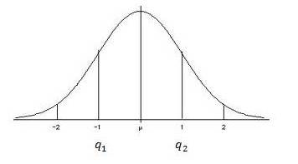

Figure 5: Normal distribution curve indicating center 50%
Once the noise level of the transformed data is estimated a threshold value can be set. The simplest choice is to set the threshold ${(T}_{u})$ at some constant multiple of the noise standard deviation (e.g.,$T=m*o$, where $m$ typically lies in the interval $2<m<5$. Four methods of computing a threshold value are described below.
- The Universal Threshold
Leadbetter et al. [11] estimate the value of universal threshold by statistical theorem given. Let us consider an independent and identical distribution $N\left(0,ε\right)$of variables${ X}_{i}$, then as$N→∞$,
$P\left(\max_{i}\left|X_{i}\right|≤T_{u}\right)=1$ $(20)$
Where $T_{u}$ is given by
${ T}_{u}=σ\sqrt{2\log\left(N\right)}$ $\left(21\right)$
Equation (20) shows that for a Gaussian distributed random variable X in a sample of size N there is no element, which have magnitude greater than universal threshold $T_{u}$.
To understand the rationales for this threshold consider a VLF transient $"s"$ as a vector of zeros, whose transformation coefficients $\left\{D_{j,t}^{(s)}\right\}$ are a part of an independent and identical distribution Gaussian sequence $\left\{e_{j,t}\right\}$ having zero mean and variance$σ_{ε}^{2}$ . If $N→∞$, we have
$P\left[max\left\{\left|D_{j,t}^{(s)}\right|≤T_{U}\right\}\right]≡P\left[max\left\{\left|e_{j,t}\right|≤T_{U}\right\}\right]→1$ $(22)$
Universal thresholding removes the noise therefore some time small signal coefficients are mistakenly set to zero. The value of $σ_{ε}^{2 }$ is estimated by the procedure which is based on Median Absolute Deviation (MAD) standard deviation estimate using just the $N/2$ level $j=1$ coefficients in $D_{1}^{(s)}.$ The standard deviation estimator is defined as:
$${\hat{σ}}_{MAD}≡\frac{median\left\{\left|D_{1,0}^{(s)}\right|,\left|D_{1,1}^{(s)}\right|,…, \left|D_{1,\frac{N}{2}-1}^{(s)}\right|\right\}}{0.6745} (23)$$To make ${\hat{σ}}_{MAD}$ suitable estimator of standard deviation for Gaussian white noise the factor $0.6745$ was rescaled. ${\hat{σ}}_{MAD}$ was estimated from the elements of $D_{1}^{(s)}$because it is noise dominated with the possible exception of the largest values.
- Steins Unbiased Risk Estimator (SURE) Threshold
Donoho and Johnstone [12] proposed a new method of threshold calculations known as SURE threshold based on the work of Stein [13], which calculates the estimated mean square error (risk) for a range of threshold values $(T_{s})$ with the resulting minimum risk.
- Hybrid Threshold
In case of signal with low energy SURE threshold $(T_{s})$ provides inaccurate results due to dominating noise coefficients and produced a false threshold values. Therefore hybrid method threshold ${(T}_{H })$is selected among (${ T}_{u})$ and $(T_{s})$ on the basis of detected signal energy. Here ($T_{s})$ was selected only if signal is significant.
- MiniMax Threshold
The minimax principle is intended to select the estimators that minimizes the worst case (maximum) errors of the set. Donoho and Johnstone, [10] and Bruce and Gao [14] used this principal in wavelet thresholding where they tabulate the values of MiniMax thresholds TM as a function of the sample size.
- Wavelet Thresholding Methods
Two different methods of thresholding are generally used in denoising problem known as hard and soft threshoding.
- Hard Thresholding
The non-linear hard thresholding function $y_{hard}$ is defined as:
$y_{hard}=\left\{\begin{aligned} D_{j,t}^{(s)} \left|D_{j,t}^{(s)}\right|>thr thr≥0 \\ 0 \left|D_{j,t}^{(s)}\right|≤thr\end{aligned} \right. (24)$
here “thr” is the threshold estimated by user [15]. It retained all the coefficient above the threshold value and set all other to zero. Main disadvantage of this method that it removes all fine details below threshold level and produce fictitious oscillations.
B. Soft Thresholding
The non-linear hard thresholding function known as soft thresholding or “wavelet shrinkage” $y_{soft}$ is defined as:
$y_{soft}=\left\{\begin{aligned}sign\left(dD_{j,t}^{(s)}\right).\left(\left|dD_{j,t}^{(s)}\right|-thr\right) \left|D_{j,t}^{(s)}\right|>thr,thr≥0 \\ 0 \left|D_{j,t}^{(s)}\right|≤thr\end{aligned}\right.$ $(25)$
In this process all transform coefficient whose magnitude is smaller than the threshold value $“thr”$ are set to zero and remaining coefficient are reduced in the magnitude according to threshold value [10]. In this thresholding method the results are not associated with the precise value of the threshold $“thr”$ as in the case of Hard thresholding, but the general shape of the signal might be slightly affected because the large coefficients are modified.
- Translational Invariant Denoising
Wavelet denoising with DWT can occasionally produce artefacts due to bad alignment the signal discontinuity's with the decomposing wavelet at a specific shift and scale. The artefacts appear as erroneous oscillations adjacent to the signal discontinuity [15]. Cycle Spinning (CS) denoising algorithm based on wavelet denoising technique was proposed by Coifman and Donoho [15] to get rid of these difficulties. CS algorithm was designed to suppress artefacts around the discontinuities introduced by DWT. Data is shifted for a variety of delays and its DWT is computed as a result the outcome is unshifted. In order to create a quasi-shift-invariant DWT, this process is repeated for a variety of shifts, and the results are averaged. The number of shifts that this transform produces in the input signal directly relates to how redundant it is. In terms of all circular shifts of the input signal, CS and a translation-invariant WT are equal.
The wavelet coefficients of the original and translated signals can differ significantly and are not connected by a straightforward translation or permutation if s(i) is the original signal and s(i-p) is the translated signal.
$s_{B}^{p}\left(α\right)=〈s\left(n-p\right),g_{α}\left(n\right)〉=〈s\left(n\right),g_{α}\left(n+p\right)〉 (26)$
The approximation of the translated signal is not correlated to the approximation of$s$ because the vectors $g_{α}\left(n+p\right)$are not in the basis$B={\left\{g_{α}\right\}}_{α∈A}$. It yields an estimate $\hat{u^{p}}$ for every translated version$s^{p}$ of the original signal:
$$\hat{u^{p}}=Ds^{p }= \sum_{α∈A}{a^{p}\left(α\right)s_{B}^{p}(α)g_{α}} (27)$$CS based Translation Invariant Wavelet Thresholding $(TIWT)$ was achieved by averaging these estimations after translated in inverse sense:
$$TIWT\left(s\right)= \frac{1}{\left|I\right|}\sum_{p∈I}{{\hat{u}}^{p}(i+p)} (28)$$ VI. Data

To test the performance of proposed algorithm VLF whistlers and hiss transients were taken from French Micro satellite DEMETER during 2004-2010 for the mid latitude.
VII. Wavelet Based Noise Reduction Algorithm
A. DWT and Universal Thresholding
The observed VLF signal consists of VLF transients with some type of atmospheric noises analytically written as:
$s=x+ε$ $(29)$ Where $x$ is a VLF transient and $ε$ represents $N$ dimensional vector of independent and identically distributed (i.i.d) Gaussian noise.
For the purpose of denoising via thresholding Dohono and Johonstone, [10] recommended computation of partial DWT of level $J_{0}$ giving coefficient vectors $cD_{1}^{(s)},…., {cD}_{J_{0}}^{(s)}$ and${ cA}_{J_{0}}^{(s)}$. We have:
${cD}_{j,t}^{\left(s\right)}=d_{j,t}+e_{j,t}$ $(30)$
$j=1,…, j_{0}; t=0,…., N_{j}-1.$($j_{0}$ must be specified by the user)
Hence, only the coefficients in the ${cD}_{k}^{(s)}$ vectors are subjected to thresholding; i.e., the elements of ${c A}_{J_{0}}^{(s)}$ are untouched so that portion of $s$ is automatically assigned to the signal$X$.
Next a threshold must be chosen. A key property about an orthonormal transform (such as the partial DWT) of i.i.d Gaussian noise is that the transformed noise has the same statistical properties as the untransformed noise so that $\left\{e_{j,t}\right\}$are also i.i.d Gaussian noise with mean zero and variance$σ_{ε}^{2}$ . For this purpose universal threshold was used.
Finally, for ${cD}_{j,t}^{(s)}, j=1, …, J_{0}$ and $t=0,…, N_{j}-1,$we apply a chosen thresholding rule such as hard thresholding to obtain the threshold coefficients$\left\{c{\hat{D}}_{j,t}^{(s)}\right\}$, which are then used to form${\hat{ cD}}_{j}^{(s)}, j=1, …, J_{o}$. D is estimated as $\hat{X}$ obtained by inverse transforming $c{\hat{D}}_{1}^{(s)}, …, {\hat{cD}}_{J_{0}}^{(s)}$ and${ \hat{cA}}_{J_{0}}^{(s)}$.
VIII. Denoising Algorithm
Algorithm for signal denoising was illustrated in Figure 9.

Observed VLF Signal
Normalization of Observed VLF signal
Wavelet Decomposition of VLF signal
Wavelet Threshold
Inverse Wavelet transform of VLF signal
Denoised VLF signal

Figure 6: Denoising algorithm using Wavelet thresholding
- Normalizing the Noise
The threshold values are calculated as multiple of estimated noise standard deviations. For Scaling of the input $N (0,1)$ noise is prodiced by accomplished by using the normnoise.m function of Wavelab.700 toolbox [16].
- Segmenting the VLF transients
Segmentation the data in to blocks prior to processing provides the opportunity to handle large amount of stored data and allow the extension of technique. Also provides a way to adjust the algorithm parameters for the changes in the data stream over time. In our case Sampling frequency of VLF signal recorded by DEMETER satellite was$40 kHz$, hence $32768$ sample approximately represents $0.81 sec$ of VLF signal.
- Signal Decomposition
Selection of proper wavelet basis plays an important role in in overall performance of algorithm, but unfortunately there is no precise method to choose proper wavelet basis. Primarily it is done by comparison of results using various wavelet basis.
- Thresholding
Soft thresholding with modified universal threshold value T_{u} and level dependent the thresholding were used in this work.
- Reconstruction
Each denoised signal segment is transformed back to signal domain and weighted and overlapped to allow for smooth reconstruction.
IX. Performance Analysis of Proposed Denoising Algorithm Based on Wavelet Thresholding
In proposed noise reduction algorithm Quadratic Mirror Filters (QMF) are used to smooth the signal observed at the normalization stage. In the next stage transients are decomposed in various sub-bands with “Morlet” wavelet function with level of decomposition 5.
The value of threshold is estimated by modified universal threshold function given in equation (21). Finally this estimated value is used with the soft thresholding method to reconstruct the signal. The waveform of transients observed with their denoised version is illustrated in Figure 7 and Figure 8.
Signal to noise ratio (SNR) and crest factor (C.F) were used to test the performance of algorithem. The result is summarized in a Table 1 and Tables 2.
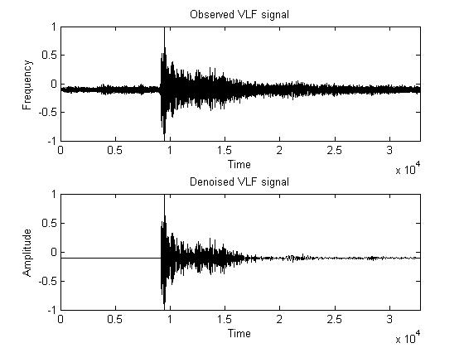
Figure 7: Observed VLF Whistler (Upper panel) and Denoised signal (Lower panel)
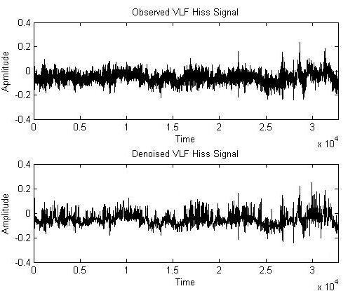

Figure 8: Observed VLF Hiss (Upper panel) and Denoised signal (Lower panel)
- Signal to Noise Ratio (SNR)
SNR is a very popular and effective method in signal processing. SNR is used to quantify how much the signal has been corrupted by noise. It is defined as the ratio of signal power to noise power of corresponding signal. Analytically it is given by:
$SNR=10\log_{10}\left(\frac{P_{signal}}{P_{noise}}\right)=P_{signal}-P_{Noise}\left(indb\right)$ $\left(31\right)$
Denoising is successful when post SNR is higher than the pre SNR values [17]. Results shows that for VLF whistlers post SNR is high as compare to pre SNR.

- Crest Factor (CF)
It is defined by ratio of peak amplitude of the waveform with RMS value of the waveform [18]:
$CF=\frac{{\left|x\right|}_{peak}}{x_{rms}}$ $(32)$
Where ${\left|x\right|}_{peak}=$amplitude of waveform
$x_{rms}=$RMS value of waveform
Table 1: Performance of algorithm for VLF Whistlers

Signal | Nos Of Sample | SNR (in db) | Creast Factor
Observed | 32768 | 11.89 | 8.21756
Denoised | 32768 | 12.73 | 8.23699

Table 2: Performance of algorithm for VLF Hiss

Signal | Nos Of Sample | SNR (in db) | Creast Factor
Observed | 32768 | 22.5667 | 3.3571
Denoised | 32768 | 25.004 | 3.2154

Visual analysis
Spectrogram were used for visual inspection of observed and denoised signal illustrated in Figure 9 and Figure 10.
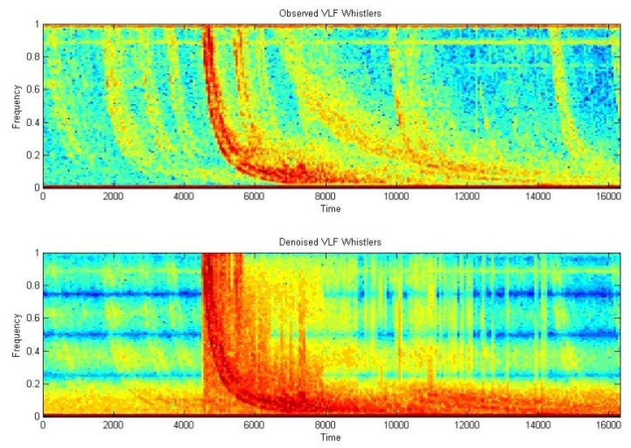
Figure 9: Spectogram of VLF Whistler (Upper panel) and Denoised signal (Lower panel)

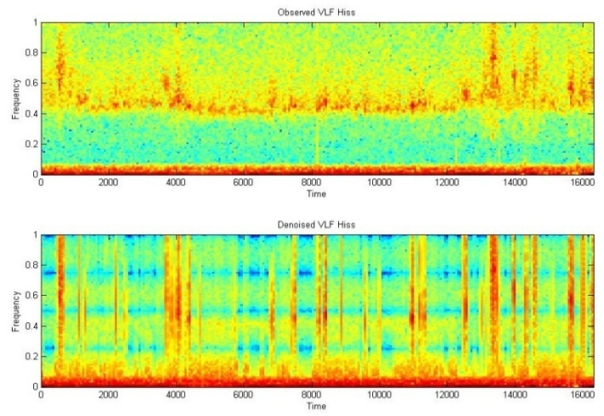
Figure 10: Spectogram of VLF Hiss (Upper panel) and Denoised signal (Lower panel)
X. Noise Reduction with Wavelet Based Compression Technique
Natarajan [19] proposed a method for the removal of additive noise form the signals, which does not require any previous knowledge of observed signal or its noise content which is very indispensable in traditional filtering technique. Natarajan [20] used piecewise linear compression technique for signal noise reduction. Jeffryes [21] used this method for seismic data compression by splitting the data in to subsets. Kiely [22] and Stromberg et al., [23] use sub band coding and Low bit-rate efficient compression for seismic data respectively. Huang [24] used principle component analysis as a foundation for atmospheric data compression of uncelebrated and non-normalized Interferograms. Hedstrom et al., [25] propose a scheme of data compression for speech signal Time-Frequency masking. In the last few decades many signal compression technique based on wavelet transform have been developed [26]-[33].
Level Dependent Thresholding
It is derived from Birge-Massart strategy which is characterized by the three parameters;
J = level of decomposition,
M = length of the coarsest approximation coefficients
$α$ = always real and greater than 1 [34].
The strategy is such that:
- At level $J_{0}+1$ all is kept.
- The absolute value of larger coefficient $n_{J}$ for level $J$ from 1 to $J_{0}$is given by:
$${ n}_{J}=\frac{m}{{\left(J_{0}+1-J\right)}^{α}} (33)$$
The suggested value for $α$ is 1
Let us consider L represent the length of coarsest approximation coefficients for the VLF transients. On the basis of value of L three different choices scarce high, medium and low are proposed for M for which M=L, M = 1.5*L and M = 2*L respectively.
Balance Sparsity-Norm.
If c denote all the detail coefficients, then two curves were associated for each possible threshold value t, two percentages:
- The 2-norm retrieval in percentage
- The relative sparsity in percentage achieved from the compressed VLF transient by setting to 0 the coefficients less than t in absolute value
Remove Near 0.
Let c denote the detail coefficients at level 1 achieved from the decomposition of the VLF transients using mother wavelet db1. The threshold value is set to median (abs(c)) or to 0.05*max(abs(c)), if median(abs(c)) = 0.
XI. Algorithm for Noise Reduction and Compression Using By-Level Wavelet Thresholding
The process used for signal compression is depicted in Figure 11. The compress algorithm involves three main steps:-
- Wavelet Decomposition
- Thresholding the detail coefficient
- Reconstruction
The waveform of VLF whistler and hiss observed from DEMETER satellite during Sep, 2009 at Indonesia with their compressed signal is shown in Figure 12 and Figure 13.

Observed VLF Signal
Normalization of Observed VLF signal
Wavelet Decomposition of VLF signal
Wavelet Threshold (By-Level thresholding)
Inverse Wavelet transform of VLF signal
Output VLF signal

Figure 11: VLF signal Noise reduction and compression

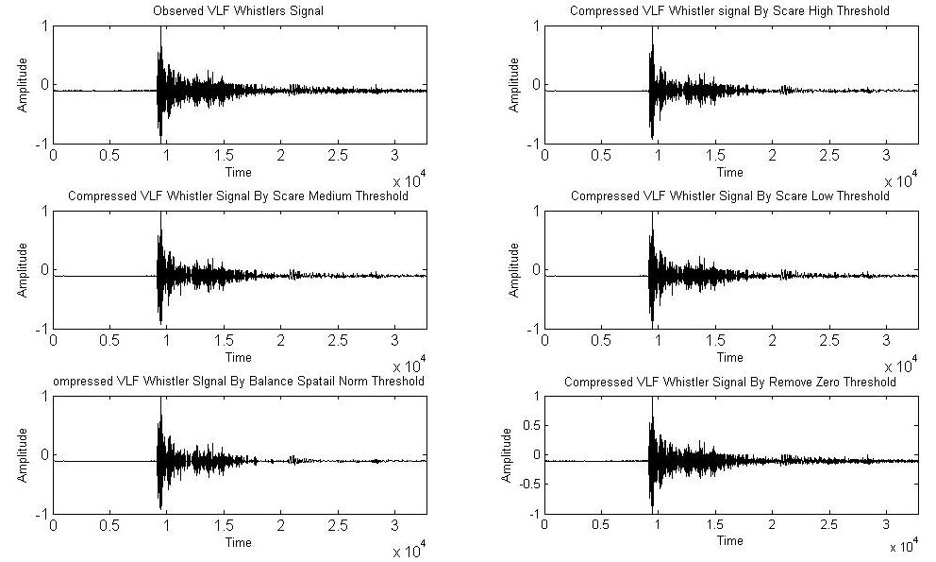
Figure 12: Waveform of observed and Compressed VLF Whistlers signal

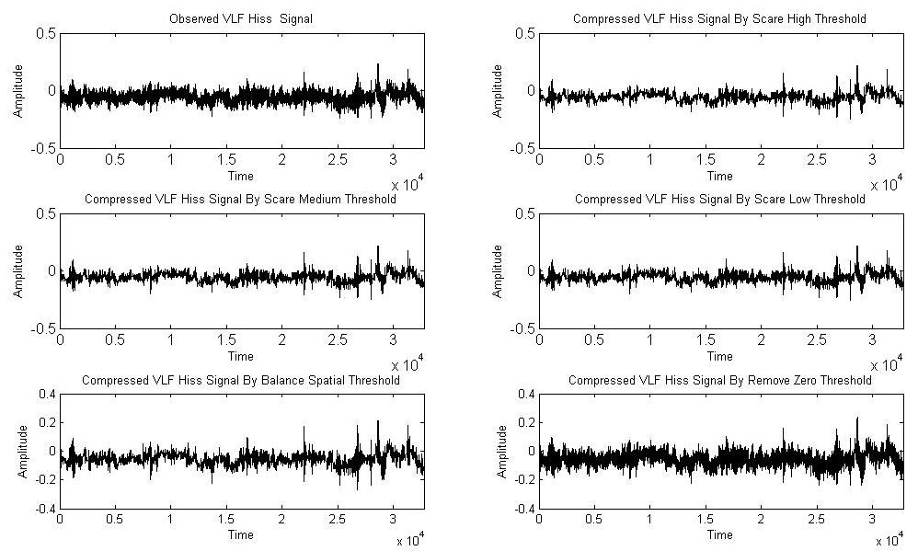

Figure 13: Waveform of observed and Compressed VLF Hiss signal

In compression process various thresholding methods such as Scare high (SH), Scare Medium (SM), Scare Low (SL), Balance Spatial Norm (BSN) and Near Zero (NZ) method were applied and tested for large number of observed signals. Each methods gives different results allowing efficient evaluations and comparisons of the used methods and parameters.
XII. Performance Analysis of Proposed Noise Reduction Algorithm Based on Level Thresholding
To test the performance of proposed algorithm percentage of zeros (% Z) and percentage of energy retained (% ER) are also calculated with SNR and CF for every observed and compressed signal. The results are summarized in Table 3 and Table 4.
Table 3: Performance of Level dependent Thresholding for VLF Whistlers signal

Signal | Thresholding | % E.R. | Nos of Zeros | SNR | CF
Observed | - | - | - | 14.42 | 14.14
Compressed | SH | 72.29 | 94.29% | 15.03 | 14.14
Compressed | SM | 78.08 | 92.99% | 14.55 | 13.16
Compressed | SL | 82.50 | 91.70% | 14.35 | 13.25
Compressed | BSN | 91.15 | 91.80% | 13.79 | 12.56
Compressed | NZ | 99.97 | 99.97% | 14.43 | 12.01

Table 4: Performance of Level dependent Thresholding for VLF Hiss signal

Signal | Thresholding | % E.R. | Nos of Zeros | SNR | CF
Observed | - | - | - | 24.39 | 4.27
Compressed | SH | 72.29% | 94.29% | 24.99 | 4.24
Compressed | SM | 78.08% | 92.99% | 24.90 | 4.22
Compressed | SL | 82.50% | 91.70% | 24.80 | 4.27
Compressed | BSN | 91.15% | 91.80% | 24.04 | 4.12
Compressed | NZ | 99.97% | 99.97% | 24.13 | 4.11

We retained maximum $99.97\%$ and minimum $72.00\%$ of signal energy. An enhanced SNR value indicate the enhancement quality of signal. The value of C.F. is approximately same in most of the cases.
XIII. Conclusion
In this chapter two different algorithm based on wavelet thresholding were proposed for the denoising of VLF signal. For this purpose soft thresholding is used. To maintain the stability of representation translation invariant denoising is used in this work. Proposed denoising algorithm is depends on resolution hence to increased the resolution level chosen threshold function must be changed. The algorithm is particularly more important when signal contains the same variation pattern like VLF Hiss. It also provides more detail picture of Whistlers transients.
It was concluded that wavelet based methods were efficient for denoising of VLF transients. The compression and decompression applications created a set of capable and robust tools that would be useful for many scientific datasets.
REFERENCES

[1] S. Umbaugh, “Computer Vision and Image Processing,” Prentice Hall, PTR, New Jersey, 1998.
[2] K. Toyamu, K. Krumm, B. Brumitt and B. Meyers, “Wallflower: Principles and practice of background maintenance”, Computer vision, The proceeding of seventh IEEE international conference, 1999.
[3] D.L. Donoho, “ Denoising by Soft Thresholding”, Technical Report no. 409, University, December 1992.
[4] J. Karam and R. Saad, “The Effect of Different Compression Schemes on Speech Signals”, International Journal of Biological and Life Sciences 1:4, 2005.
[5] S.G. Mallat and W.L. Hwang, “Singularity Detection and Processing with Wavelets”, IEEE Transactions on Information Theory, vol. 38, 1992, pp. 617–643.
[6] M.G.E. Schneiders, “Wavelets in control engineering”, Master’s thesis, Eindhoven University of Technology, 2001.
[7] G. Strang and T. Hguyen. “Wavelets and Filter Banks”, Wellesley-Cambridge Press, second edition, 1997.
[8] I. Daubechies, “Ten lectures on wavelets”, Society for industrial and Applied Mathematics , PA, 1992.
[9] P.S. Addison, “The Illustrated Wavelet Transform Handbook”, IOP Publishing Ltd, 2002.
[10] D. Donoho and I. Jonhstone, “Ideal Spatial Adaptation by Wavelet Shrinkage”, Biometrika, Journal of the American Statistical Association, Vol. 81, issue 3, 1994, pp.425-455.
[11] M. Leadbetter, G. Lindgren and H. Rootzen, “Extremes and Related properties of random sequences and Process”, Speinger-verlag, New York, 1983.
[12] D. Donoho and I. Johnstonne, “Adapting to Unknown Smoothness via Wavelet Shrinkage”, Vol. 90, 1200-1244, 1995.
[13] C. Stein, “Estimation of the Mean of a Multivariate Normal Distribution”, Annals of Statistics, vol. 9, 1981, pp. 1135-1151.
[14] A. Bruce, H. Gao and Waveshrink, “Shrinkage Functions and thresholds”, Technical Report, Statsci Division of Mathsoft, Inc, 1995.
[15] R. Coifman and D. Donoho, “Translational-Invariant Denoising”, Internal Report, Department of Statistics, Stanford University, 1995.
[16] C.S. Buckheit, D. Donoho and J. Scargle, “Wavelab.700”, http://www.wavelab/playfair.stanford.edu, 1996.
[17] S. Mallat, “A Wavelet Tour of Signal Processing: The Sparse Way”, Academic Press, 2008.
[18] P.D. Hill, B.W.V Lee, J.S. Osborne, E.L. Osman, “Palatal snoring identified by acoustic crest factor analysis", PHYSL MEAS, vol. 20, issue 2, 1999, pp. 167-174.
[19] B.K. Natarajan, “Filtering random noise via data compression”, Proceeding IEEE Data Compression Conf., Snowbird, Utah, 1993, pp. 60-69.
[20] B.K. Natarajan, “A General Technique for Filtering Random Noise”, Computer Systems Laboratory, 1994.
[21] B.P. Jefryes, “Data compression for Seismic Signal data” United States patent, patent number 593370. 3,1999.
[22] A. Kiely and F. Pollara, “Subband Coding Methods for Seismic Data Compression”, DCC, 1995.
[23] J.O. Stromberg, R. Coifman, A. Vassiliou, A.Z. Averbuch and F. Meyer, “Low bit-rate efficient compression for seismic data”, IEEE transactions on image processing, vol. 10, issue 12, 2001, pp. 1801-1814.
[24] Z. Huang, “3D Laser holographic interferometry measurements”, Phd thesis, The University of Michigan, 2006
[25] P. Hedström and J. Arbring, and J.M. Johansson, “Data Compression using Time-Frequency masking for TDOA localization of Radio Transmitters” RF Measurement Technology Conference, Gävle, Sweden, 2011.
[26] J. Chen, S. Itoh and T. Hashimoto, “ECG data compression by using wavelet transform” IEICE Trans. Inform. Syst. Vol. E76-D, issue 12, 1993, pp.1454–1461.
[27] Y. Xu, J.B. Weaver, M. Denni, J. Healy and L.U. Jian, “Wavelet Transform Domain Filters: A Spatially Selective Noise Filtration Technique”, IEEE Transactions on Image processing, vol. 3, 1994.
[28] Y.K. Sun, “Wavelet Transform and its Applications”, China Machine Press, Beijing, 1998, pp. 219-244. (in Chinese).
[29] B.A. Rajoub, An efficient coding algorithm for the compression of ECG signals using the wavelet transform. IEEE Transactions on Biomedical Engineering, vol. 49, issue 4, 2002, pp. 355–362.
[30] I.B. Ciocoiu, “ECG Signal Compression Using 2D Wavelet Foveation”, International Journal of Advanced Science and Technology, Vol. 13, 2009.
[31] S. Sunjay “High Performance Computation by Graphics Processor Unit Technology for Geophysical Seismic Signal Processing”, Search and Discovery Article, 4072, 2011.
[32] J. Jing, M. Lidong, J. Shijin, J. Lin, “A Signal Denoise Algorithm based on Wavelet transform” American Journal of Engineering and Technology Research, vol. 11, issue 9, 2011.
[33] J. Karam, “A Global Threshold Wavelet-Based Scheme for Speech Recognition”, Third International conference on Computer Science, Software Engineering Information Technology, E-Business and Applications, Cairo, Egypt, Dec. 27-29, 2004.
[34] J. Karam and R. Saad, “The Effect of Different Compression Schemes on Speech Signals”, Inter-national Journal of Biomedical Sciences, vol. 1, issue 4, 2006, pp. 230-234.

