SMART SENSORS: WORKING AND IT’S APPLICATIONS

Ashish Gupta¹, Indra Nath Sahu¹, Amit Alok Herenz¹, Rahul Deo Sah¹
Department of Computer Applications and Information Technology, Dr. Shyama Prasad Mukherjee University¹,
Ranchi, Jharkhand, India.
drgupta1910@gmail.com, rc.insahu@gmail.com, amitalokherenz@gmail.com, rahuldeosah@gmail.com,

ABSTRACT

In the field of instrumentation, sensors are playing a very important role. Presently, most of the sensors used are smart. In case of smart sensors, the sensing elements and the related electronics are integrated on the same chip. So, the integration of electronics and sensors for creating an intelligent sensor is known as a smart sensor.
Smart sensors can make sensible decisions. These sensors have many advantageous features like fast signal conditioning, auto-calibration, high reliability, small physical size, higher Signal to Noise (S/N) ratio, self-testing, detection and prevention of failure. So, the main objective of this article would be to discuss about the smart sensor, it’s working, and it’s applications.

Keywords—smart sensor; formatting; style; styling; insert (key words)

I. Introduction: A Smart Sensor's concept?

A smart sensor is a device that uses a transducer to collect data/information from the physical environment, performs specified and programmed functions, and then sends it over a networked connection.
The following are some of the smart sensor's key features: Smart calibration and compensation, multi-sensing capability, self-identification, digital sensor data, sensor communication for remote and remote monitoring settings, and so on..
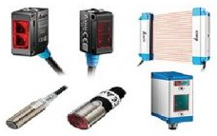
Figure 1: Smart Sensors

II. Working Principle of Smart Sensors

Smart sensors operate on the following principle: they collect data from physical settings and turn it into calculable electrical signals, such as the presence of persons, mass, temperature, pressure, or speed. These sensors incorporate a Digital Motion Processor (DMP), a type of microprocessor that enables the sensor to perform onboard data processing such as noise filtering and signal conditioning.
Smart sensors have four primary functions:
1. Measurement: Measurements are made simply by sensing physical impulses and converting them into electrical signals. This will aid in the monitoring and measurement of variables such as temperature, traffic, and industrial uses.
2. Configuration: The configuration function is important since it enables the smart sensor to detect position, which would otherwise result in installation issues.
3. Verification: The verification function has a variety of applications, including continuous monitoring of sensor activity through the employment of a set of supervisory circuits or equipment run within the sensor.
4. Communication: Finally, the communication capability allows the sensor to communicate with the main microcontroller/microprocessor.
III. Block Diagram of a Smart Sensor

The block diagram of the smart sensor is shown in the figure given below. The block diagram consists of different blocks like sensing unit, signal conditioning, analog to digital convertors, application algorithms, local user interface, memory, and communication unit or transceiver.

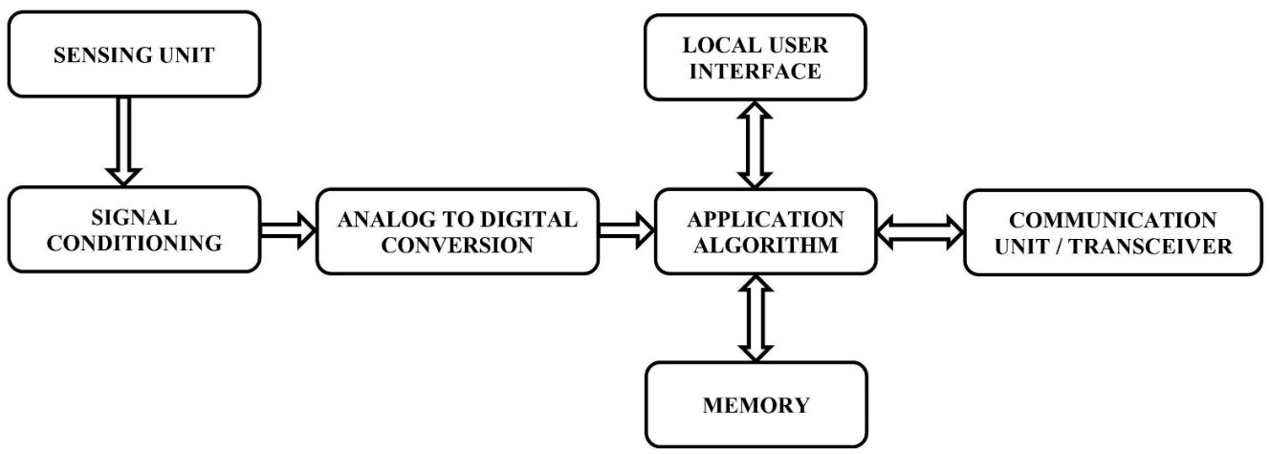
Figure 2: A Smart Sensor's Block Diagram

The main functions of the various blocks of the Sensors are –

1. Sensing Unit: It detects the changes in physical parameters and correspondingly generates an electrical signals equivalent to it.
2. Signal Conditioning Unit: The signal conditioning unit controls the signal to meet the necessities of next-level operations without losing data.
3. Analog to Digital Converter (ADC): The ADC converts an analogue signal to a digital version and sends it to the CPU.
4. Local User Interface: The local user interface or LUI is a panel-mounted device used to allow building operators to monitor and control system equipment.
5. Application Algorithm: The signals from smart sensors reaches here and process the received data based on the application programs previously loaded here and generates the output signals.
6. Memory: It is used to store media for saving received & processed data.
7. Communication Unit: The output signals from the application algorithm or microprocessor are transmitted to the main station through the communication unit. This unit also gets command requirements from the key station to execute specific tasks.

IV. Types of Smart Sensor

There are different types of smart sensor which are commercially available and are explained below.
(a) Level Sensors: One type of equipment used to monitor, measure, and maintain liquid levels is a level sensor. When the level of liquid is detected, this sensor converts the information into an electric signal.
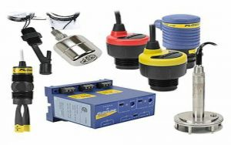
Figure 3: Level Sensors
Level sensors are further classified into two types: point level and continuous level.
(i) A point level sensor is used to specify whether a liquid has achieved an exact point within a container. (ii) A continuous level type sensors are used to provide precise measurements for liquid level.
These sensors are mainly used in different industries like automotive, manufacturing, and also in household applications.

(b) Temperature Sensors: Temperature sensors are used to measure temperatures like liquid temperature, air temperature, or solid matter temperature. These sensors are available in different types which use different principles to measure the temperature like RTDs, NTC thermistors, thermopiles and thermocouples. These sensors are mainly used in medical devices, computers, automobiles, cooking appliances and other types of machinery.
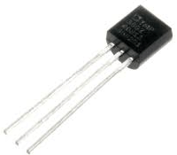
Figure 4: Temperature Sensors

(c) Pressure Sensors: A pressure sensor is a type of transducer that converts mechanical pressure into an electrical output signal. Pressure sensors are classified into several varieties based on their capacity, size, sensing technology, measurement technique, and output requirements. These sensors are critical in monitoring pipelines and alerting supervisors if there are any leaks or other irregularities so that pipelines may be repaired or maintained.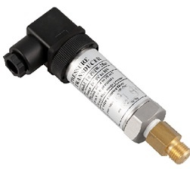
Figure 5: Pressure Sensors

(d) Infrared Sensors: An infrared sensor is an electronic device that emits light to detect objects in the environment, measures the heat of the objects, and detects motion. In general, all objects will generate some type of thermal radiation within the IR spectrum, which is undetectable to the naked eye but detectable by the IR sensor.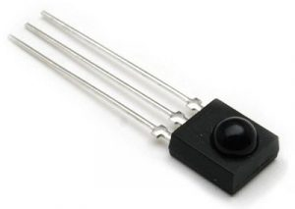
Figure 6: Infrared Sensors
IR sensor includes a transmitter like an IR LED and receiver as an IR photodiode. For infrared transmission, three types of media are used vacuum, atmosphere and optical fibers. These sensors are used in night vision devices, radiation thermometers, IR tracking, IR imaging, etc.

(e) Proximity Sensors: A smart sensor like a proximity sensor is used to notice the existence of objects in its surrounding area without contacting them. These sensors are frequently used in collision avoidance systems and collision warnings. This sensor uses light, sound, IR radiation otherwise electromagnetic fields to notice an object.
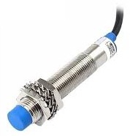
Figure 7: Proximity Sensors
These sensors are applicable in consumer robotics, industrial applications and also utilized in vehicles to detect the physical contact of other vehicles and also for parking-assist functions.

(f) Air Quality Detection Sensors: Air quality detection sensors are electronic devices that detect and monitor air pollution in the surrounding environment. As a result, these sensors can be used both indoors and outdoors. Air quality sensors can detect CO2 concentrations via VOC (volatile organic compounds), which contain the gases methane and ammonia.
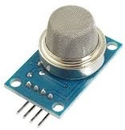
Figure 8: Air Quality Detection Sensors

(g) Motion Sensors: Motion sensors are electronic devices, used to detect movement inside and surroundings of your home and give an alert. For instance, this sensor can activate the lights once it detects you while entering into a room otherwise, they can give an alert once an intruder is trying to enter your home. These types of sensors are mainly used in homes, security systems, paper towel dispensers, phones, virtual reality systems and game consoles.
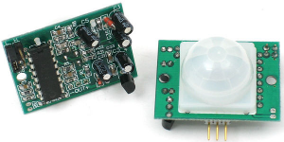
Figure 9: Motion Sensors

(h) Smart Plant Sensors: Plant sensors are advanced gardening sensors used to provide the data to the user from stem surface, leaf to root probes to feed the plants. They explain to us what nourishment and care are required for the plant.
Figure 10: Plant Sensors

This sensor is very simple to use by placing it into the soil of the plant pot beside the potted plant. After that, it monitors the level of moisture, light intensity, the temperature automatically to maintain the plant properly. The current plant sensors give an alert through smartphones to keep checking your plant’s condition remotely and take appropriate action.

(i) Smart Climate Sensors: Smart climate sensors are used to gather the data of barometric pressure, temperature and humidity that assist in evaluating the exact weather conditions and calculate as well. These sensors will assist you in setting your plan accordingly because these sensors are connected through your Smartphone to send alerts throughout the frequent changes within the weather. These sensors are essential for gardening and are connected to smart irrigation systems.
Figure 11: Climate Sensors

V. Difference between Normal Sensor and Smart Sensor
The difference between a normal sensor and a smart sensor includes the following.

Normal Sensor | Smart Sensor
A normal sensor is a device which detects the physical change and chemical environment. | The part of a sensor is known as a smart sensor that is used for the computer.
A normal sensor doesn’t include a DMP or digital motion processor. | A smart sensor includes a DMP or Digital Motion Processor.
The normal sensor includes three components namely sensor element, packaging and connections, and signals processing hardware. | Smart sensors include different components like amplifiers, transducers, analog filters, excitation control, and compensation sensors.
The different types of normal sensors are pressure, position, temperature, vibration, force, humidity and fluid property. | The different types of smart sensors are electric current, level, humidity, pressure, proximity, temperature, heat, flow, etc.
Normal sensor output cannot be used directly because we should convert it into a usable format. | The output of the smart sensor is ready to use.
Normal sensors are preferred while designing a device which requires complete control on sensor input. | Smart sensors are generally preferred over normal sensors because they include natural processing capabilities.
Normal sensors inexpensive because they contain fewer components. | Smart sensors are expensive as compared to normal sensors.

VI. Advantages of Smart Sensors

The advantages of the smart sensor include the following.
- These are small in size.
- These sensors are very easy to use, design and maintain.
- The performance level is higher.
- Speed of communication and reliability is higher due to the direct conversion with the processor.
- These sensors can perform self-calibration and self-assessments.
- These sensors can notice issues like switch failures, open coils and sensor contamination.
- These sensors optimize manufacturing processes easily that need changes.
- They can store many systems’ data.

VII. Smart Sensors' Disadvantages

The smart sensor has the following drawbacks.

• One of the biggest disadvantages of smart sensors is their unreliability; if they are stolen or damaged, they can disrupt a variety of systems.

• It necessitates the use of both sensors and actuators.

• An external processor must manage sensor calibration.

• Because wired smart sensors are sophisticated, the cost is also significant.
VIII. Applications

The applications of the smart sensor include the following: These sensors play a key role in monitoring different industrial processes like data collecting, measurement taking and transmitting the data to centralized cloud computing platforms wherever data is collected & analyzed for different patterns. So, this collected data can be simply monitored at any time by decision-makers.
Smart sensors are used mainly for monitoring and control mechanisms in different environments like water level and food monitoring systems, smart grids, traffic monitoring and control, environmental monitoring, conserving energy in artificial lighting, monitoring of the remote system, and fault diagnostics of equipment, transport and logistics, agriculture, telecommunications, industrial applications, animal tracking, etc.
The most widely used smart sensors are as follows: AWR1243, AWR1443, AWR1642, CC2650STK, etc.

IX. Smart Sensor Technology for the Internet of Things (IoT)
Internet of Things (IoT) applications — whether for city infrastructures, factories, or wearable devices — use large arrays of sensors collecting data for transmission over the Internet to a central, cloud-based computing resource. Analytics software running on the cloud computers reduces the huge volumes of generated data into actionable information for users, and commands to actuators back out in the field.
Sensors are one key factor in IoT success, but these are not conventional types that simply convert physical variables into electrical signals. They have needed to evolve into something more sophisticated to perform a technically and economically viable role within the IoT environment.
The smart sensor is also an important and necessary component of the internet of things (IoT), an increasingly common environment in which virtually everything imaginable may be supplied with a unique identity and the ability to communicate data over the internet or a similar network. Smart sensors can be used as components of a wireless sensor and actuator network (WSAN), which has thousands of nodes, each of which is linked to one or more additional sensors and sensor hubs, as well as individual actuators.
There are numerous applications for smart sensors. They are widely employed in industrial settings and are a driving force behind Industry 4.0.
- SMART sensors are common sensors with wireless connectivity and embedded microprocessors that can monitor, examine, and maintain a specific system. This was the end result of experienced engineers' finite fabrication, smart structures, and designs, which managed to develop a smarter future from the core of intelligence and creativity. This is a new sensor step that was developed to improve the capabilities of a standard sensor.
- The capacity to monitor at the same time ensures safety as well. The primary distinction between traditional and smart sensors is that smart sensors have greater intelligence than traditional sensors.
• Sensing component (Transistor, Capacitors, Photo Diode etc).
• Signal transmission and processing
• The Sensor Interface.

Several technologies are involved in the operation of this sort of sensor; these technologies offer the sensor universality and make it the "smart" means of sensing.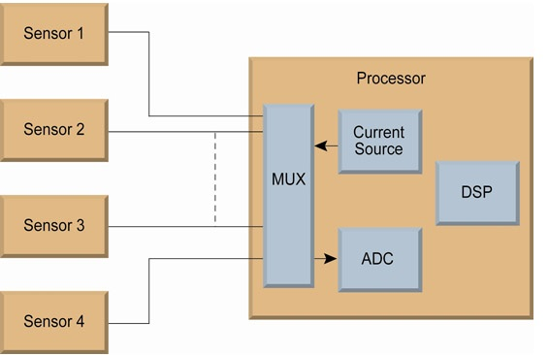
Figure 12: Simple Representation of Wireless Sensor System

Micro Electro Mechanical Systems (MEMS): This technology enables sensors to function smarter by allowing them to manage massive amounts of data in a fraction of a second. The typical data obtained by the sensor is processed by microprocessors, which clean or store the data using advanced calculation.
This type of technology makes sensors more flexible and improves their self-calibration abilities. The key to the smart sensing age is the monitoring system, which is fully supported by traditional instruments and computing technology to bring something sturdy like SMART sensors.

Very Large-Scale Integration Technology (VLSI): VLSI is used to develop the devices that comprise the Micro Electro Mechanical System. This means that the components can perform mechanical as well as electrical activities. MEMS tools can be utilised in any setting. This technology also incorporates the chemical phenomena required for sensing, which turns recorded data to electrical signals that can be used for processing, display, recording, and transmission. The key benefit of this technology to the smart sensing gadget is its basic form and compact size.
The Importance of Wireless Sensors in Smart Sensing Technology: Wireless technology is at the heart and soul of SMART sensors. The wireless technology ensures that the sensor can be installed anywhere without the complexities of dealing with wires or their associated installation. Several projects and studies have recently been undertaken in this industry in order to develop affordable wireless sensors that are both cost-effective and simple to use. This work has advanced tremendously, and today one can examine wireless sensors at reasonable rates while avoiding the complexity of cabling and lining.

X. What Does The IoT Expect of its Sensors?

Sensors have traditionally been functionally simple devices that convert physical variables into electrical signals or changes in electrical properties. While this functionality is an essential starting point, sensors need to add the following properties to perform as IoT components:
- Low cost, so they can be economically deployed in large numbers
- Physically small, to “disappear” unobtrusively into any environment
- Wireless, as a wired connection is typically not possible
- Self-identification and self-validation
- Very low power, so it can survive for years without a battery change, or manage with energy harvesting
- Robust, to minimize or eliminate maintenance
- Self-diagnostic and self-healing
- Self-calibrating, or accepts calibration commands via wireless link
- Data pre-processing, to reduce load on gateways, PLCs, and cloud resources
Information from multiple sensors can be combined and correlated to infer conclusions about latent problems; for example, temperature sensor and vibration sensor data can be used to detect the onset of mechanical failure. In some cases, the two sensor functions are available in one device; in others, the functions are combined in software to create a ‘soft’ sensor.

XI. Applications for Smart Sensor Networks

1. Industrial: In industries, machines and equipment are monitored and controlled for pressure, temperature, humidity level, and vibrations. A Smart Sensor can monitor all of these factors simultaneously and connect to the network without the use of any additional hardware. This aids in the maintenance of machinery while also ensuring the safety of personnel who work with it.

2. Finger Recognition: A fingerprint sensor scans the fingerprint pattern and captures a digital image of it. The acquired image is known as a livescan. A biometric template will be built and stored using the live scan.

3. Pattern Recognition: When a sensor detects an object's outlines, it compares them to models in a reference image.
5. Smart Dust: Smart dust is a fictitious wireless network of microscopic microelectromechanical (MEMS) sensors, robots, or gadgets that can sense (for example) light, temperature, or vibration. The gadgets will eventually be the size of a grain of sand, or even a dust particle, with self-contained sensing, computing, communication, and power.
Biomedical Applications (6): Using chip technology, many smart sensors for biomedical purposes have been produced. Biochips, for example. Micro-physiometer cyto-sensor: biological applications of silicon technology
7. MEMS and Process Control: Micro-Electro-Mechanical Systems (MEMS) are extremely small physical systems. MEMS sensors are a hybrid of electrical and mechanical components. MEMS is made using modified integrated circuit (computer chip) fabrication techniques and materials.
8. Defence Applications: Smart cameras can detect objects, perform population pattern analysis, secure zone infiltration detection, and so on by utilising powerful software analytics and reporting alarms over IP network facilities. Smart Sensors are also used to monitor EMI fatigue loading, temperature cycling, vibration, and shock levels, as well as corrosive conditions.
XII. Conclusion

Chip manufacturers and researchers have been responding to the IoT’s need for smart sensors. This has partly been a matter of adding intelligence and communications capabilities to the basic transducer function, but it also involves improved fabrication. By integrating the MEMS sensor elements and CMOS computing components onto a single substrate, smart sensors can be implemented in small, low-cost packages that can be embedded in space-constrained applications with resilience to their environmental conditions.
Accordingly, IoT designers can source the sensors that they need — small, cheap, resilient, and low-power enough for ubiquitous deployment, while having the intelligence to deliver useful information as well as raw data. They also facilitate more flexible, granular automation, as they can accept incoming commands for recalibration to accommodate production changes.

REFERENCES

[1] Iannacci, Jacopo. Microsystem-based Energy Harvesting (EH-MEMS): Powering the Pervasiveness of the Internet of Things (IoT) - A Review with a Focus on Mechanical Vibrations, Journal of King Saud University - Science, 31(1): 66-74, 2019.
[2] A. Ismail and Safwat. 2020 June 16-19; Montreal, QC, Canada: 2020 18th IEEE International New Circuits and Systems Conference (NEWCAS). August 2020.
[3] MEMS and IoT Applications in ISLE-based STEM Physics Learning Media for Mechanics Topic with LabVIEW Integration L 2019 October 16-17; North Sumatera Province, Indonesia: 2020 Irwandi et al. February 2020, J. Phys.: Conf. Ser..
[4] Phua, W.K. Rabeek, S.M. Han, and colleagues MEMS (Micro-Electro-Mechanical System) Hydrophone Sensors Based on AIN for IoT Water Leakage Detection System. Water 2021; 13(8):1-12
[5] Avraham, M. Golan, G. Vaiana, and others Wide Pressure Range Wafer-Level Packaged CMOS-SOI-MEMS Thermal Sensor for IoT Applications Eng. Proc. 2020, 2(1), pp. 1-7
[6] J. Iannacci. RF-MEMS for High-Performance and Widely Reconfigurable Passive Components - A Review with Focus on Future Telecommunications, Internet of Things (IoT), and 5G Applications, King Saud University Journal of Science: 2017;29(4):436-443.

[7]. I. Akita, T. Okazawa, and Y. Kurui. A Capacitive MEMS Accelerometer Analog Front-End Noise Reduction Technique for Ultra-Low-Power IoT Applications. 2020; 55(6):1599-1609 IEEE Journal of Solid-State Circuits [8] Xu, Q., Yang, Z., Sun, Y., and others. Shock-Resistant MEMS-Based Inertial Microswitch for IoT Applications under Reverse Directional Ultra-High g Acceleration Scientific Reports, 7(1), 1-9, 2017.
[8] J. Clark. Self-Calibration and Performance Control of MEMS with IoT Applications. Sensors: 18(12); 18: 1-19, 2018.
[9] R. Rashidzadeh and A. Attaran Radio Frequency Identification Tag with No Chip for IoT Applications IEEE Internet of Things Journal, 3(6), 1310-1318, 2016.
[10] J. Aditya Khatokar, M. Mounisha, and M.A. Nayana. Battery Management System: A Survey. 2020; 7(1): 29-35. Journal of Industrial Safety Engineering: 2020; 7(1): 29-35.
[12] Aditya Khatokar J, Nayana M A, Soundarya N, et al. Electric Vehicles: A Green Zone Transition. 2020; 7(2): 12-17. Trends in Transport Engineering and Applications: 2020; 7(2): 12-17..
[14] Vinay N., Aditya Khatokar J., Ajay Sudhir Bale. Analysis on Synthesis of Quantum Dots with Their Applications on Photochemistry. International Journal of Photochemistry. 2020; 6(1): 1–11
[15] Ajay Sudhir Bale, Bharath G, Kiran Mohan M S. Thin-Films: Study of Medical, Display and Environmental Applications. International Journal of Energetic Materials: 2020; 6(1): 1–6.
Ajay Sudhir Bale, Suhaas V. Reddy, and Shivashankar A. Huddar, Electromechanical characterisation of a Nitinol-based RF MEMS switch. Today's Materials: Proceedings: 2020: 27(1); 443-445
[17] Shantanu Singh, Ajay Sudhir Bale, J. Aditya Khatokar September 2020. Nanotechnology is enabling cross-domain engineering applications. [online] DOI: 10.1016/j.matpr.2020.09.076
[18] Aditya Khatokar, N. Vinay, Ajay Sudhir Bale, and others December 2020. An investigation on enhanced procedures in the field of micro-electromechanical systems technology. [online] Available at:
https://doi.org/10.1016/j.matpr.2020.10.993.

[19] Ajay Sudhir Bale, J. Aditya Khatokar, M.S. Kiran Mohan, and others. Nanotechnology as a technique for cancer treatment. [online] DOI: 10.1016/j.matpr.2020.12.1175.
Kishan Das Menon H, Aditya Khatokar J, and Ajay Sudhir Bale Using an Automated Locomotive Simulator to Improve Railway Operations Transportation Engineering and Applications Trends 2020; 7(1): 17-23.
[24] Hosamani Ummar Farooq N, Shivashankar Huddar, Ajay Sudhir Bale PLC-controlled diesel transfer system. Journal of Industrial Safety Engineering, 6(1), pp. 8-14, 2019.
[25] Venkatesh M S, Manoj Patil, Ajay Sudhir Bale, and colleagues Design of a Remotely Monitorable Low Power Phototherapy Unit for Neonatal Hyperbilirubinemia Treatment: September 2017; Davangere, India: National Conference at Bapuji Engineering College, November 2019.

[26] J. Aditya Khatokar, M.A. Nayana, and Ajay Sudhir Bale A Look at High Frequency Radios and Their Applications 2020; 7(1):7-12. Journal of Industrial Safety Engineering [30] S. S. Kumar, A. Sudhir Bale, P. M. Matapati and V. N. Conceptual Study of Artificial Intelligence in Smart Cities with Industry 4.0: 2021 March 4-5; Greater Noida, India: International Conference on Advance and Innovative Technologies in Engineering (ICACITE). April 2021.
[31] A. S. Bale, S. Saravana Kumar, P. Rao and A. K. J. A Recent Trend in DC Microgrid: 2021 March 4-5; Greater Noida: India: International Conference on Advance Computing and Innovative Technologies in Engineering (ICACITE). April 2021.

