Metal Filled polymer filaments for FDM Method and Study on Mechanical Properties of 3D printed Products by FDM Method- A review

**Abstract** In addition to traditional manufacturing methods, Additive Manufacturing (AM) has become a widespread production technique used in the industry. The Fused Deposition Modeling (FDM) method is one of the most known and widely used additive manufacturing techniques. Due to the fact that polymer-based materials used as depositing materials by the FDM method in printing of parts have insufficient mechanical properties, the technique generally has limited application areas such as model making and prototyping. With the development of polymer-based materials with improved mechanical properties, this technique can be preferred in wider application areas. In this context, analysis of the mechanical properties of the products has an important role in the production method with FDM. This study investigated the mechanical properties of the products obtained by metal/polymer composite filament production and FDM method in detail. It was reviewed current literature on the production of metal/polymer composite filaments with better mechanical properties than filaments compatible with three dimensional (3D) printers. As a result, it was found that by adding reinforcements of composites in various proportions, products with high mechanical properties can be obtained. Thus, it was predicted that the composite products obtained in this way can be used in wider application areas.

# 1. Introduction

Additive Manufacturing (AM), also known as three dimensional (3D) production and 3D printers, has been used in many applications in daily life, especially in recent years, with great technological progress. 3D printers, also known as one of the rapid prototyping methods, are used in research and academic studies as well as industry [1]. AM is a general definition that covers several methods used in the manufacturing of 3D objects. 3D production refers to a computer-aided mode of production using a data file derived from geometry data of objects with simple or complex geometry. The parts to be produced layer by layer based on different joining principles according to traditional methods used from the derived data file [2, 3].

AM is the process of depositing materials by layers on the layer to create parts from 3D model data instead of traditional production methodologies and stereotyped manufacturing methods. Traditional manufacturing methods are based on the principle of extracting chip materials from the raw materials during the manufacture of the parts. The device used in manufacturing by following a tool path derived from the part geometry to be produced. Due to this peculiarity of additive manufacturing, it is possible to manufacture parts with complex geometries, as there is no chip removal during manufacturing, so material loss is minimal [3, 4]. AM has great potential to reduce both production time and cost of a product.

1.1. Literature Studies.

The literature studies on the metal/polymer composite filament manufacture and the mechanical properties of the products via the FDM method are given in Table 1.

In the literature studies, a commercial PLA filament has an average tensile strength of 60 MPa; it is expected that the tensile strength of any piece to be produced in the same cross-sections from the pure PLA filament is also close to that value. Various additives and additive ratios are subject to experimental studies in order to increase this value. For example, Matsuzaki et al. [5], in their work, while the material produced with the addition of 6.6% carbon to the PLA filament achieved 185.2MPa tensile strength and increased the tensile strength of the material, achieved a tensile strength (57.1 MPa) close to the unadulterated PLA filament with the addition of jute at the same contribution rate (6.1%).

Significant increases in the tensile strength of the parts produced from composite filament, which is formed by adding additives such as carbon, carbon fiber, aramid, and glass fiber to a commercial filament without additives, decreased the strength of the material in the addition of materials with low strength such as cardboard powder. For example, Van Der Klift et al. [6], with the addition of 20.7% carbon to nylon filament, achieved 464.4MPa tensile strength; Gregor-Svetek et al. [7] in HDPE reached the value of 1.89MPa tensile strength with the addition of 75% cardboard powder to the filament. Similarly, Bettini et al. [8] achieved 203MPa tensile strength with 8.6% aramid additive to PLA filament; Akhoundi et al. [9] made PLA of 479MPa tensile strength with the addition of 49% glass fiber to the filament. He et al. [10]. In their experimental study, reached a high tensile strength value of 939.7MPa with the addition of carbon fiber to the PA6 filament by removing the gaps formed in the part with the controlled compression method during production.

In addition to the type of additive, additive ratios are very important in determining the mechanical properties of the material. Adding the same type of additive to the same filament in different proportions can also lead to significant changes in the mechanical properties of the material, and increasing the proportion of the additive does not always mean that it will increase the strength of the material (for example, Hwang et al. [11]). While ABS has a tensile strength of 42MPa by adding 10% copper to the filament, tensile strength decreased to 26.5MPa when they increased the copper additive to 30%. The increase in the tensile strength of the material was observed until the contribution rate increased from 10% to 40% (Rajpurahit et al. [12]). As the rate of graphene used as additive material increases, a decrease in tensile strength of the material was observed.

# 2. Additive Manufacturing (AM)and 3D Printing Technologies

In this section, additive manufacturing methods, application areas of 3D printing technologies, history, advantages, mechanical properties of production, and products with the FDM method are explained.

2.1. A Brief History of 3D Printing Technology. 3D printing technology was first developed by Charles Hull in 1984. Within 5-10 years, different printing technologies have been developed by making investments in 3D printing technology. SLS and FDM technologies were found in 1988. 3D printing technology started to be used in our daily life as the source of open source printers under the name of Reprap which entered the technology world in 2007 [13].

2.2. Advantages of 3D Printing Technology. The advantages of 3D printing technology include the following: minimum amount of waste material, low cost, enabling the production of complex geometry parts, no need for molds, enabling the production of parts with the desired composition, use in office-type working environments, measurement accuracy, chip removal, deburring, and no need for successive operations.

2.3. Application Areas of 3D Printing Technologies. Today, 3D printing technologies are used in sectors such as the automotive, aerospace, defence, and aviation industries, but their use in architectural structures, product and machine designs, prototype part production, education, textiles, toys and medical devices, and organ, prosthesis, and implant applications in the healthcare industry is becoming widespread.

2.4. Additive Manufacturing (AM) Methods. Many methods can be used in additive manufacturing and production, and the differences between methods are generally related to the method of creating layers. Selective Laser Sintering (SLS), Selective Laser Melting (SLM), Electron Beam Melting (EBM), Laser Metal Deposition (LMD), Fused Deposition Modeling (FDM), Stereolithography (SLA), and Digital Light Processing (DLP) technologies are among the most applied technologies for additive manufacturing [13, 14].

2.5. Production with FDM Method. Part production in 3D printers of the FDM type is similar to the traditional polymer extrusion process. The first stage of production is modelling the part in Computer-Aided Design (CAD) environment. The designed model is then converted into STL format to enable data transfer between the CAD environments. After 2D slicing of the model, data related to the model in STL format is transmitted to the 3D printer. 3D geometry of the piece designed in the computer environment is obtained with the superposition of thermoplastic molten material called filament, which is deposited from the nozzle of the 3D printer. Briefly, the FDM method is the process of pouring the molten material in a hot nozzle onto a heated flat table surface in layers (Figure 1). The FDM production method is based on the principle of melting and bonding thermoplastic material where the polymer is used as the printing material. The method is becoming more and more widespread due to the advantages of the thermoplastic material used, such as cheap, long life, high toughness, easy to find, enabling recycling, some types can be dissolved quickly in nature, low shaping temperature, and reshaping when heated. Today, home users can also produce various parts with this method. Due to the simple working principle and low equipment required, the costs of devices producing with the FDM method are lower than the devices used in other AM methods. Due to these features, the FDM method produced devices called 3D printers suitable for desktop use (Figure 2). Due to the low cost and other advantages of both devices and thermoplastic materials, the FDM method has also been used by individual users. Thermoplastics used in production with FDM are materials of polymer class; they can be softened and shaped when they are heated while being present in a solid state at low temperatures. After the thermoplastic-forming process is finished, it cools and solidifies, and in this way, the product with the desired geometry is obtained.

2.6. Filaments Used in 3D Printers. Thermoplastic-based filaments used in 3D printers are produced by plastic extrusion machines called filament extruders. Extrusion systems work with the logic of mixing raw plastic granules and other additives, if any, in a mechanical mixer and then transporting the composite granules formed through a feed hopper to the heater nozzle side with the help of a screw shaft (Figure 3). The raw material, which is melted in the filament extruder and gained fluidity, is removed in the desired diameter (usually 1.75mmor 3mm) and turned into a film strip in various colors and properties, called filament, ready for use in a 3D printer (Figure 4).

Polymers with filament raw materials are preferred as matrix materials in the production of composite materials due to their low shaping costs and ability to work with many traditional production methods, enabling the production of complex-shaped parts due to their low density, and ease of metal removal processes. In addition to these advantages, polymer materials have low mechanical properties and thermal resistance. Therefore, metal/polymer composites with high mechanical and thermal properties are needed in the industry. Polymers used as a polymer matrix in composite materials are thermosets and thermoplastics. Metal/polymer composite filaments are produced by making particle reinforcement to improve many properties such as thermal resistance, strength, and impact resistance to polymer materials (Figure 5). Thus, with the development of polymer-based materials with improved mechanical properties, the production with the FDM method can find a wider application in the industry.

In addition to the polymer filament type used as the matrix phase on the mechanical properties of the parts produced by the FDM method, adding the additives to improve the mechanical properties with the production parameters are also effective. Although the types of filaments frequently used in production are Acrylonitrile Butadiene Styrene (ABS), Polylactic Acid (PLA), and Polyethylene Terephthalate-Glycol (PET-G) [15, 16], metal/polymer composite materials produced by adding metal or thermoplastic materials in various proportions have also been used in recent years. This study also compiled important literature studies to improve the mechanical properties of existing filaments using additional additives. The aim of the research is to bring together the most important studies in this field and to reveal what are the additives that provide improvement in the mechanical properties of the composite filaments produced. In addition, it is intended to be a practical guide in experimental studies and planning for those who will start new research in this field or those who designs a new composite filament.

2.7. Mechanical Properties of Products. In order for the materials to be used successfully, it is necessary to know the mechanical properties, and if necessary, these properties should be improved according to the usage area. When the mechanical properties of the material are mentioned, tensile strength, impact strength, elastic modulus, yield strength, fatigue strength, hardness, etc., features come to mind. If we evaluate the determination of the mechanical properties of the products printed by the FDM method under two main headings, we can conclude that the first of these is the printing parameters and the other is additives and additive ratios.

Many studies have been conducted in the literature to examine the effect of 3D printing parameters on the mechanical properties of 3D printed products [17–25]. Kam et al. [17] in their study produced six different filling test samples by keeping parameters such as the filling ratio, printing speed, layer thickness, filament, and nozzle diameter constant. As a result of the experimental study, it was concluded that the strength of the parts produced with the rectilinear filling pattern is approximately 15% higher than the parts produced with the other filling pattern. It is also stated in the same study that the full honeycomb filling method shows more extension than other filling forms. In this study, studies to investigate the effect of additive, which is another important issue in determining the mechanical properties of the parts produced by the FDM method, on the mechanical properties of the parts produced by the FDM method, were compiled.

# 3. Conclusion

In this review study, works on the changes in the mechanical properties of metal/polymer composite filaments or products printed by FDM method adding various additives to commercial filaments were compiled. According to the results obtained from experimental studies, the following inferences are made:

(i) Plastic and metal additives in different ratios are used in metal/polymer composite filament manufacturing. The optimum contribution rates were tried to be determined in the experimental studies conducted in the literature.

(ii) In determining the mechanical properties of the parts produced using composite filament, besides the characteristic properties of the commercial filament, the type of additive and additive ratios have important changes to the mechanical properties of the products. Considering that a commercial PLA filament has an average tensile strength of 60 MPa, it is expected that the tensile strength of any piece to be produced in the same cross-sections from the pure PLA filament is also close to that value. Various additives and additive ratios are subject to experimental studies in order to increase this value.

(iii) Significant increases in the tensile strength of the parts produced from the composite filament, which are formed by adding additives such as carbon, carbon fiber, aramid, and glass fiber to a commercial filament without additives, decreased the strength of the material in the addition of materials with low strength such as cardboard powder.

(iv) In addition to the type of additive, additive ratios are very important in determining the mechanical properties of the material. Adding the same type of additive to the same filament in different proportions can also lead to significant changes in the mechanical properties of the material, and increasing the proportion of the additive does not always mean that it will increase the strength of the material.

(v) As can be understood from the experimental data, besides the optimal test parameters, the filament used as a matrix material and the type of additives and the additive ratios are extremely effective on the mechanical properties of the produced parts.

(vi) Finally, as production with the FDM method is an increasingly widespread and promising technology, the studies in this area have been increasing rapidly in recent years.

(vii) The FDM method and composite material technology have a wide range of applications and composite filaments that have widespread use and are close to the desired mechanical properties which can be produced with different filaments and different additives and additive ratios in academic studies.

Table 1: Literature studies on composite filament production.

|  |  |  |  |  |  |  |  |  |
| --- | --- | --- | --- | --- | --- | --- | --- | --- |
| Study | Matrix  materials | Additive  materials | Fiber volume  percentage  (%) | Tensile  strength  (MPa) | Tensile  modulus  (GPa) | Flexural  strength  (MPa) | Flexural  modulus  (GPa) | Breaking  elongation  (%) |
| Çantı [2] | ABS | ZrB2 | 1.5 | 40.2 | 2.14 | - | - | 5.88 |
| SiO2 | 1.5 | 44.72 | 2.49 | - | - | 4.84 |
| MWCNTs | 1.5 | 41.2 | 1.68 | - | - | 4.05 |
| Al | 1.5 | 44.56 | 2.55 | - | - | 6.99 |
| Liu et al. [26] | PLA | Cu | - | 58.3 | 1.01 | 118.7 | 3.84 | - |
| Wood | - | 38.7 | 0.8 | 71 | 2.65 | - |
| Ceramic | - | 46.5 | 1.05 | 100.1 | 4.62 | - |
| Al | - | 51.1 | 0.83 | 97.8 | 3.27 | - |
| CF | - | 41.3 | 0.74 | 75.6 | 2.93 | - |
| Tian et al. [27] | PLA | CF | 27 | - | - | - | - | - |
| Cu | 10 | 42 | 0.93 | - | - | - |
| Cu | 30 | 26.5 | 0.91 | - | - | - |
| Hwang et al. [28] | ABS | Cu | 0 | 44.75 | 0.71 | - | - | - |
| Fe | 1 | 43.65 | 0.81 | - | - | - |
| Fe | 3 | 31.60 | 0.60 | - | - | - |
| GF | 5 | 24.65 | 0.57 | - | - | - |
| Nabipour et al.  [29] | PE | Cu | 25 | 17.12 | 0.7 | - | - | 8.46 |
| Cu | 50 | 18.25 | 0.79 | - | - | 7.45 |
| Cu | 75 | 19.41 | 1.2 | - | - | 5.95 |

**Figures**

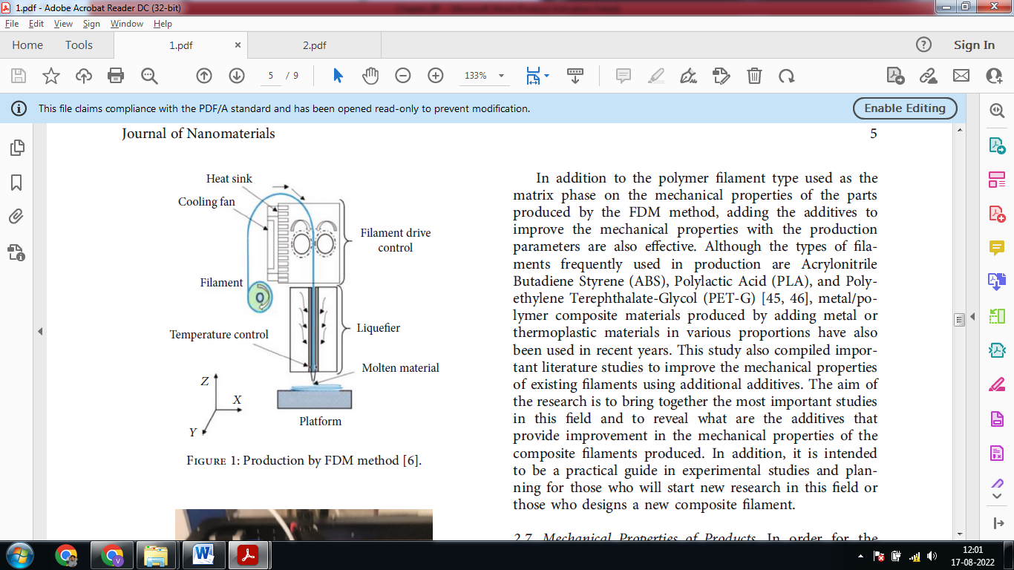

Figure 1: Production by FDM method

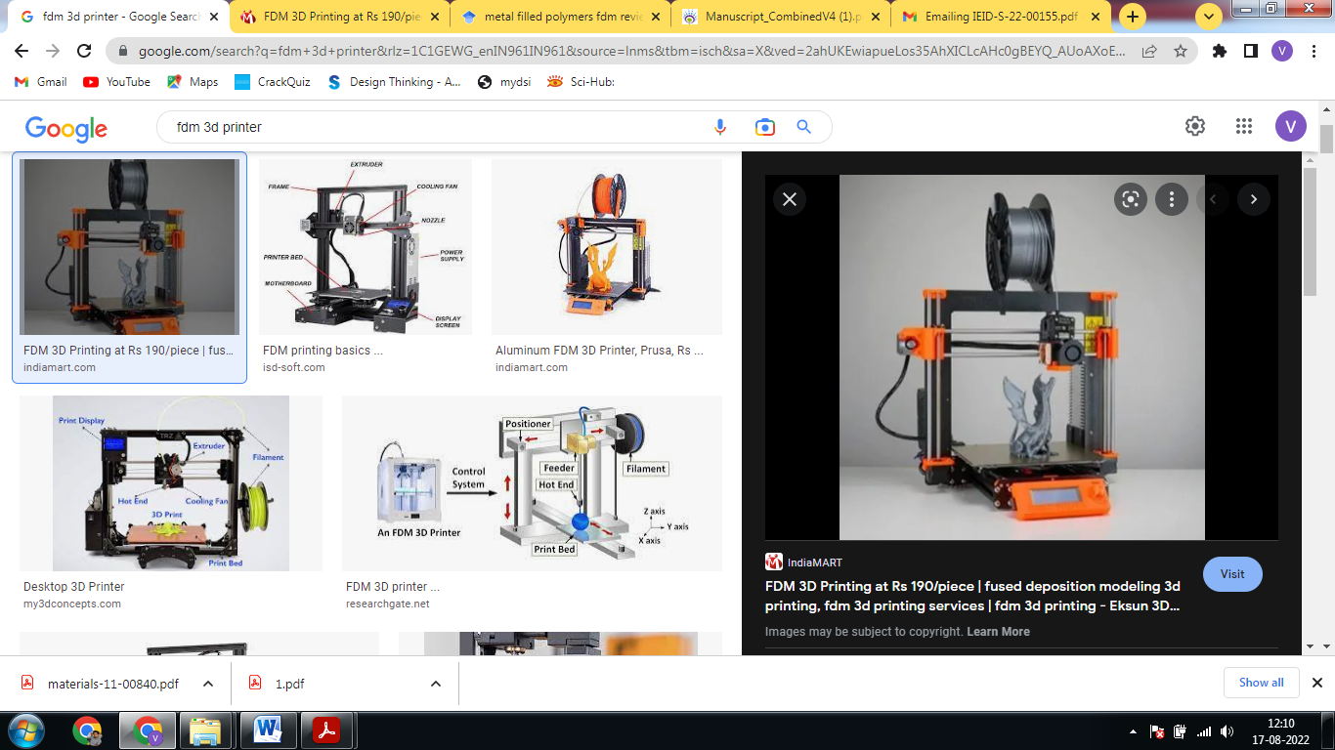  
 Figure 2: 3D printer.

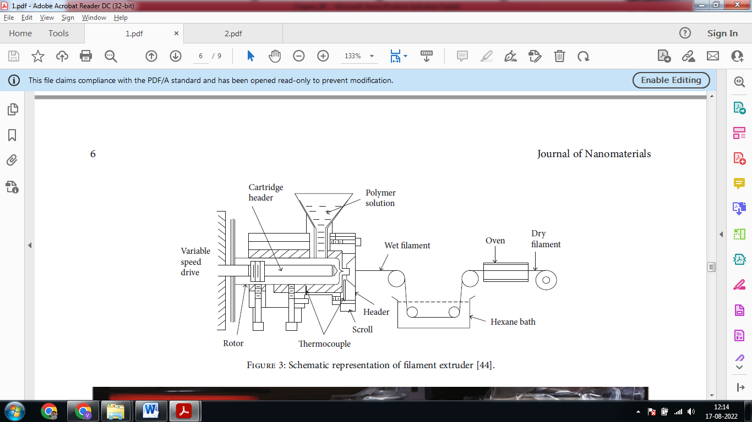

Figure 3: Schematic representation of filament extruder

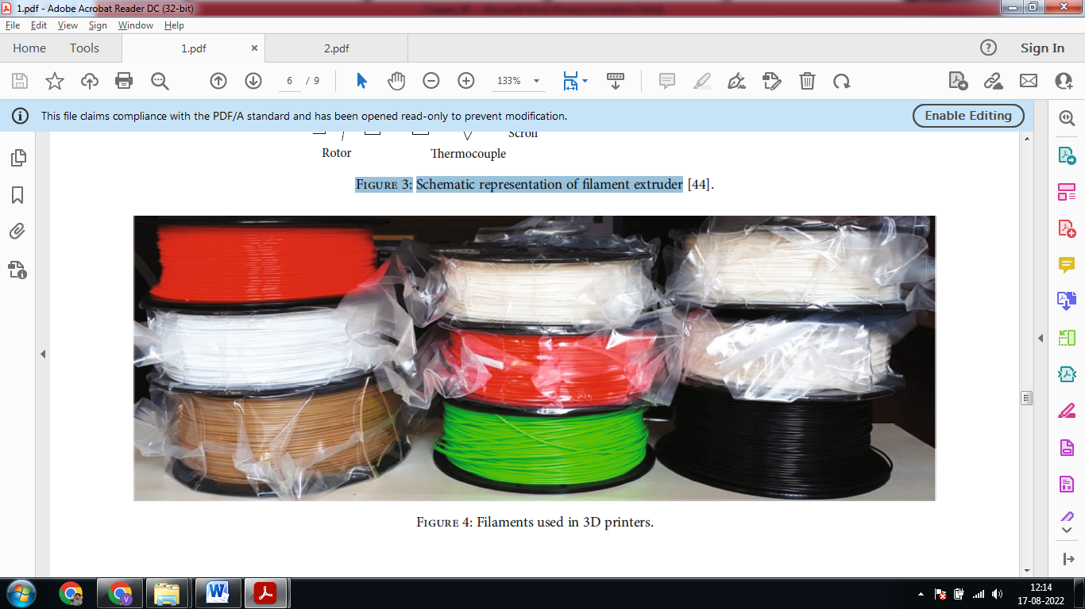

Figure 4: Filaments used in 3D printers.



Figure 5: Composite copper + PLA filament.

Reference

[1] Singh, S.; Ramakrishna, S.; Singh, R. Material issues in additive manufacturing: A review. J. Manuf. Process. 2017, 25, 185–200.

[2] E. Çantı, “Production and characterization of polymer nanocomposite filaments for 3D printers,” Master Thesis. [Production and characterization of polymer nanocomposite filaments for 3d printers] [thesis in Turkish], Dumlupınar University, Kütahya, 2016.

[3] D. Ding, Z. Pan, D. Cuiuri, H. Li, N. Larkin, and S. van Duin, “Automatic multi-direction slicing algorithms for wire based additive manufacturing,” Robotics and Computer-Integrated Manufacturing, vol. 37, pp. 139–150, 2016.

[4] C. Klahn, B. Leutenecker, and M. Meboldt, “Design strategies for the process of additive manufacturing,” Procedia CIRP, vol. 36, pp. 230–235, 2015.

[5] R. Matsuzaki, M. Ueda, M. Namiki et al., “Three-dimensional printing of continuous-fiber composites by in-nozzle impregnation,” Scientific reports, vol. 6, no. 1, 2016.

[6] F. Van Der Klift, Y. Koga, A. Todoroki, M. Ueda, Y. Hirano, and R. Matsuzaki, “3D printing of continuous carbon fibre reinforced

[7] D. Gregor-Svetec, M. Leskovšek, U. Vrabič Brodnjak, U. Stankovič Elesini, D. Muck, and R. Urbas, “Characteristics of HDPE/cardboard dust 3D printable composite filaments,” Journal of Materials Processing Technology, vol. 276, p. 116379, 2020.

[8] P. Bettini, G. Alitta, G. Sala, and L. di Landro, “Fused deposition technique for continuous fiber reinforced thermoplastic,” Journal of Materials Engineering and Performance, vol. 26, no. 2, pp. 843–848, 2017.

[9] B. Akhoundi, A. H. Behravesh, and A. Bagheri Saed, “An innovative design approach in three-dimensional printing of continuous fiber–reinforced thermoplastic composites via fused deposition modeling process: in-melt simultaneous impregnation,” Proceedings of the Institution of Mechanical Engineers, Part B: Journal of Engineering Manufacture, vol. 234, no. 1-2, pp. 243–259, 2020.

[10] Q. He, H. Wang, K. Fu, and L. Ye, “3D printed continuous CF/PA6 composites: effect of microscopic voids on mechanical performance,” Composites Science and Technology, vol. 191, p. 108077, 2020.

[11] S. Hwang, E. I. Reyes, K. S. Moon, R. C. Rumpf, and N. S. Kim, “Thermo-mechanical characterization of Metal/Polymer composite filaments and printing parameter study for fused deposition modeling in the 3D printing process,” Journal of Electronic Materials, vol. 44, no. 3, pp. 771–777, 2015.

[12] S. R. Rajpurohit and H. K. Dave, “Fused deposition modelling using graphene/pla nano-composite filament,” International Journal of Modern Manufacturing Technologies, vol. 6, no. 2, pp. 2067–3604, 2019.

[13] Gibson, I.; Rosen, D.; Stucker, B. Additive Manufacturing Technologies. 3D Printing, Rapid Prototyping, and Direct Digital Manufacturing, 2nd ed.; Springer: New York, NY, USA, 2015.

[14] J.-P. Kruth, M. C. Leu, and T. Nakagawa, “Progress in additive manufacturing and rapid prototyping,” Keynote Papers, vol. 47, no. 2, pp. 525–540, 1998.

[15] A. İpekçi, M. Kam, and H. Saruhan, “Investigation of 3D printing occupancy rates effect on mechanical properties and surface roughness of PET - G material products,” Journal of New Results in Science, vol. 7, no. 2, pp. 1–8, 2018.

[16] M. Kam, A. İpekçi, and H. Saruhan, “Investigation of 3D printing filling structures effect on mechanical properties and surface roughness of PET-G material products,” Gaziosmanpasa Journal of Scientific Research, vol. 6, pp. 114–121, 2017.

[17] M. Kam, H. Saruhan, and A. İpekçi, “The effect of filling structures on strength of printed products by 3D printers,” Duzce University Journal of Science & Technology, vol. 7, no. 3, pp. 951–960, 2019.

[18] M. Kam, H. Saruhan, and A. İpekci, “Investigation the effects of 3D printer system vibrations on mechanical properties of the printed products,” Sigma Journal of Engineering and Natural Sciences, vol. 36, no. 3, pp. 655–666, 2018.

[19] M. Kam, H. Saruhan, and A. İpekçi, Investigation of surface treatment effect on mechanical properties of printed products by fused deposition modelling method, IV. International Academic Research Congress, Antalya, 2018, Volume: ISBN: 978-605-196-226-9.

[20] M. Kam, H. Saruhan, and A. İpekçi, Surface treatments effect on surface roughness of printed products by fused deposition modelling method, IV. International Academic Research Congress, 2018.

[21] M. Kam, H. Saruhan, and A. İpekçi, Determination of optimum printing parameters of printed products by open and closed type of 3d printer systems with different filament materials, IV. International Academic Research Congress, Antalya, 2018.

[22] M. Kam and A. İpekçi, Experimental and simulation comparison of the effect of filling structures on strenght in fdm products, IV. International Academic Research Congress, Antalya, 2018.

[23] M. Kam, A. İpekçi, and Ö. Şengül, “Effect of FDM process parameters on the mechanical properties and production costs of 3D printed PowerABS samples,” International Journal of Analytical, Experimental and Finite Element Analysis, RAME Publishers, vol. 7, no. 3, pp. 77–90, 2020.

[24] M. Kam, H. Saruhan, and A. İpekci, “Investigation the effect of 3D printer system vibrations on surface roughness of the printed products,” Duzce University Journal of Science & Technology, 2019.

[25] M. Kam, H. Saruhan, and A. İpekci, “Experimental analysis of vibration damping capabilities of sleeve bearings printed using FDM method,” Journal of Polytechnic, 2021.

[26] Z. Liu, Q. Lei, and S. Xing, “Mechanical characteristics of wood, ceramic, metal and carbon fiber-based PLA composites fabricated by FDM,” Journal of Materials Research and Technology, vol. 8, no. 5, pp. 3741–3751, 2019.

[27] X. Tian, T. Liu, C. Yang, Q. Wang, and D. Li, “Interface and performance of 3D printed continuous carbon fiber reinforced PLA composites,” Composites Part A: Applied Science and Manufacturing, vol. 88, pp. 198–205, 2016.

[28] S. Hwang, E. I. Reyes, K. S. Moon, R. C. Rumpf, and N. S. Kim, “Thermo-mechanical characterization of Metal/Polymer composite filaments and printing parameter study for fused deposition modeling in the 3D printing process,” Journal of Electronic Materials, vol. 44, no. 3, pp. 771–777, 2015.

[29] M. Nabipour, B. Akhoundi, and A. Bagheri Saed, “Manufacturing of polymer/metal composites by fused deposition modeling process with polyethylene,” Journal of Applied Polymer Science, vol. 137, no. 21, 2020.