Technological Advancements and Innovations in Total Hip Arthroplasty: The Future Ahead
Authors: Dr. Narendra Singh Kushwaha, Dr. Mohammad Baqar Abbas, Dr. Prakash Gaurav Tiwari, Dr. Shailendra Singh
Introduction
Since the 1940s, hip replacement surgery has been reported in the literature [1,2]. The first clinical application of Sir John Charnley's low-friction total hip arthroplasty occurred in the 1960s [3,4]. The early outcomes of total hip arthroplasty with and without bone cement were underwhelming due to the poor design of the implants, the small femoral components, the mediocre cementing technique, the periprosthetic osteolysis, and the considerable wear of the polyethylene liner [5–12]. However, over the past three decades, total hip replacement has steadily advanced (e.g., better acetabular and femoral component design, refined implantation surgical techniques, and increased understanding of cementing procedures), leading to appreciable advancements in implant survival and clinical outcomes. Clinical outcomes over the past 30 years have shown that total hip replacement is one of the most successful and effective surgical methods for treating a variety of pathological hip problems, and it is recognised as a milestone treatment in the history of contemporary medicine [13].

Total joint arthroplasty has experienced an increase in the use of 3D printing technologies in recent years. By using this technology to develop patient-specific guidance, patient-specific instrumentation (PSI) enables the operating surgeon to precisely position the implants in accordance with the preoperative strategy [14]. Additionally, the ability of 3D printed metal to mimic the pore size and elasticity of trabecular bone opens up a wide range of possibilities for cementless implants [15].
Technical goals for THA include restoring native hip biomechanics and achieving correct implant location. In order to reduce human error and increase implant placing precision, computer navigation and robotics have been developed as a result of advancements in surgical technology. With the aid of preoperative CT scans, this cutting-edge technology typically allows surgeons to plan and carry out the best acetabular implant sizing and positioning in order to achieve the desired femoral offset, inclination, anteversion, and leg-length correction while maintaining hip stability [16].

Future of Total Hip Arthroplasty
Technology has some really intriguing applications, particularly in the field of orthopaedic surgery. However, one can question whether these technological developments actually enhance THA and how this stacks up to the most advanced treatment available today.

Virtual Reality and Surgical Training
Since Rembrandt's time in the 17th century, surgeons have traditionally been taught on cadavers through cadaver dissection [17]. This strategy demands particular conditions, is costly, occasionally difficult to set up, and carries the danger of infecting trainers and trainees [18]. It is now possible to simulate surgery using virtual reality by using "virtual" surgical simulation, which just requires a set of controllers connected to a laptop computer and a set of special glasses. The learning and consolidation of surgical methods and movements is made possible by this simulation, which can be accessed from anywhere and provides an unlimited number of practise hours [19]. As a result, execution errors could be reduced while maintaining the ability for continuous operator assessment [20]. Multiple operators can also "operate" concurrently remotely on the same surgical site by coordinating their efforts. Virtual reality offers several prospects for complete joint replacement [21], not merely for the development of technical skills [22]. Surgeons may test out fresh surgical techniques and practise utilising new instruments thanks to this great technology.
Virtual reality can also be a huge help in arthroplasty's tough learning curve and technically demanding skills. The first two steps involve breaking down a skill into smaller, more achievable tasks and confirming the learning curve. The implementation of a proficiency-based technique, in which less experienced surgeons proceed in phases only after passing competency criteria, is therefore an option [23]. Virtual reality has the potential to improve orthopaedic teaching, according to an increasing body of research. A thorough examination of 18 primary studies revealed significant improvements and "real-world" advantages for knee and shoulder arthroscopic procedures, but not enough proof to support the use of VR for arthroplasty [24]. Studies on cost-effectiveness are also required to decide whether simulators' increased cost is reasonable.
3D Printing and Orthopedics
The use of 3D printing is considered an industrial revolution nowadays. The "subtractive" manufacturing of implants, in which the final implant design is produced by manually or mechanically modifying metal subtraction to obtain the appropriate features from a mould made by forging, is a practise to which we have grown accustomed. Applications in orthopaedics are presently limited, mostly because it takes so long to process each successive layer to create an implant of a quality that is acceptable and because mass production is so expensive. Orthopaedics today uses specialised equipment manufactured to order, such as prototypes or case-specific implants, as well as medical technology developed in small quantities [25].
For knee prostheses, for example, functional models can be made directly from computer plans in orthopaedics using PSI (patient-specific instrumentation) [26], single-use instruments for particular indications, especially in maxillofacial surgery, or prototypes intended for the evaluation of new implants. An important use is the incorporation of metal to complex structures such porous surfaces in accordance with a preset design [27], duplicating the cortical bone's 3D structure with flawless substrate cohesiveness [15]. This is frequently employed in the cementless implantation of tibial endplates and knee prosthesis cups [28, 29]. Additionally, this technology enables the exact replication of complicated bone structures, such as implants for severe bone loss used in tumour surgery that are specially created for this purpose [25].
Prosthetic surgery is a very promising technology for the future because, despite its current drawbacks, the costs connected with its technological requirements are so high. The time needed for mass manufacture as well as the legal specifications for the certification of 3D-printed implants are additional considerations.
Robotics in Total Hip Arthroplasty
Although robotic-assisted hip arthroplasty has been tried before, it needs to be revisited since new technology allows for improved planning and user experience and is anticipated to produce significantly better results than earlier versions [31].
There is a risk that all systems and all approaches will be grouped together when analysing any type of robotic or computer-assisted surgery [32]. Resisting this is necessary. Robotic-assisted surgery is currently a very competitive business, and each system must produce its own evidence-based data and be evaluated separately [34]. In a similar spirit, robotics is distinct from navigation and must be assessed with a flexible perspective [33]. Navigation commonly increased implant delivery accuracy during arthroplasty procedures, particularly in the knee [34]. Modern robotics offers much more, and it may someday allow us to provide patient-specific functional plans with the necessary accuracy, competence, and precision [35]. There are numerous ways that robots can work. Some are autonomous, while others are activity restricted and, in essence, the surgeon's slaves. The Mako system is currently the most widely used system for hip arthroplasty. It is an active-constrained system that gives the surgeon a 3D plan based on CT scans so they may then optimise the intended surgery on that basis.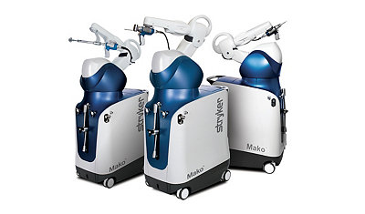
Stryker Mako Robotic Arm. (https://www.stryker.com/us/en/portfolios/orthopaedics/joint-replacement/mako-robotic-arm-assisted-surgery.html)
Once the bone has been registered intraoperatively, good implant delivery and precise bony preparation are both made possible [36]. The goal is to go from this level to high accuracy and high precision, which are needed to construct patient-specific designs [37]. Currently, manual techniques tend to have poor accuracy and low precision. The planning of robotic THA is a development that allows for knowledge of spinopelvic parameters and intraoperative analysis of potential impingement [38], whether it be implant-on-bone or bone-on-bone, and allows us to minimise it. This journey also calls for a clear understanding of the outcomes we hope to achieve for each patient.
A segmented CT scan was the first step in the workflow for robotic THA [39]. In order to facilitate registration, arrays are attached to both the femur and the pelvis in addition to the standard surgical exposure. Then, using a robotic arm and computer to prepare the bone, the components are carefully inserted to enable the replication of length, offset, and centre of rotation [15].
The surgeon's role is vital since the robotic arm implements a surgeon-led plan. An experienced surgeon may easily incorporate this into their workflow, which will be helpful for both common and challenging patients. However, it also offers a fantastic chance to collect a wealth of data collected at each stop along the way, from the CT through planning, plan modifications, and final execution that results in the patient's ultimate outcome [39]. We will soon be able to use artificial intelligence and machine learning to make better surgical plans for doctors who might perform fewer operations [40].
We have also benefited from the understanding of our long-term goals provided by robotic technology and 3D planning and execution. We must be aware of each patient's functional hip position in order to give customized THA [35]. This will eventually lead to the recognition of robotic-arm aided surgery as a cost-effective approach [39, 42] and a crucial instrument in the surgical toolbox [40], as well as a decrease in complications, readmission, and revision rates, and an increase in patient satisfaction [41].
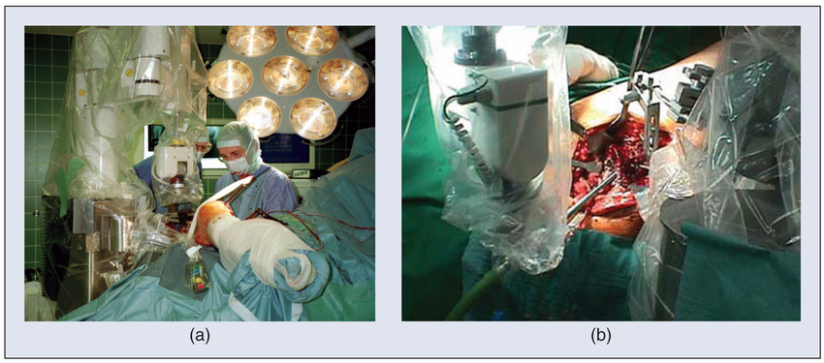

ROBODOC system (https://www.researchgate.net/figure/The-ROBODOC-system-for-orthopedic-surgery-a-The-robot-is-being-used-for-total-hip_fig2_43352313)

Implants in THA
Larger femoral heads
Larger femoral heads have been used in THA more commonly over the past 10 years because they increase the hip's range of motion prior to impingement and consequently reduce dislocation rates [43]. The most common femoral head dimensions, according to various arthroplasty registries , are 32 and 36 millimetres [44–46]. One purported disadvantage of larger heads is corrosion at the taper-trunnion interface, which may produce groyne discomfort and reduce the lifespan of THA [47]. 32 mm and 36 mm heads appear to be superior in dislocation rate and implant survival, depending on the articulating materials. There were no long-term studies that supported the safety of femoral heads larger than 36 mm until recently.

Dual Mobility Cups
Dual mobility cups have been in use in France for a while, though not frequently. Dual mobility has become much more common and used outside of France over the last 10 to 15 years [48, 49]. Dual mobility cups, which extend range of motion, head-to-neck ratio, and jump distance, reduce the risk of instability [50, 51]. Dual-mobility cups decrease the rate of dislocation in both initial and revision THA [52]. Dual-mobility cups have drawbacks such as higher wear and intra-prosthetic dislocation [53]. Dual mobility is an excellent choice for patients who are at risk for instability following an original or revision THA [54]. Additionally, even after going through rigorous testing and certification procedures, some potentially undiscovered side effects of new THA implants can only be discovered after extended follow-up.
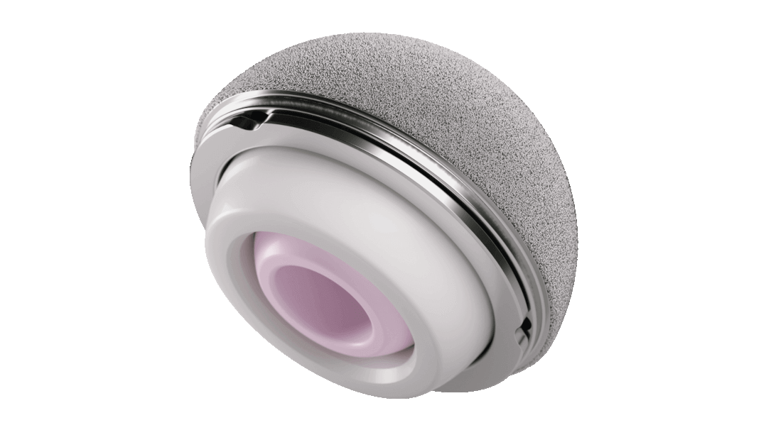
Dual mobility cup. (https://www.jnjmedtech.com/en-US/product/pinnacle-dual-mobility-liner)
Conclusion
Total hip replacement is a safe operation with a big effect size that offers patients significant improvements at a reasonable price. However, there has been a noticeable increase in the total number of THAs carried out globally, along with a substantial rise in the proportion of younger patients receiving THA. The best functional outcomes are essential since this generation is more demanding and frequently looks forward to returning to sports. Along with the developments and discoveries in the field, this shift in the population's interest in THA shows that significant advancements are still possible.
The use of virtual reality in total hip arthroplasty allows for a better education for the upcoming generation of hip arthroplasty surgeons. It might also make it simpler to experiment with brand-new techniques and tools. Applications in total hip arthroplasty are still, however, restricted, mostly because of time and financial limitations. The possibilities are numerous with three-dimensional printing. Using promising 3D printing technology, patient-specific tools, case-specific implants, and prototypes can be made. Robotic technologies and computer-assisted surgery have demonstrated superiority in the radiographic placement of implants despite the paucity of long-term data demonstrating improvements in quality of life.
According to preliminary research, the use of a robotic arm facilitates precise and reproducible implant placement, with simultaneous anteversion and centre of rotation measurements being of utmost importance. It is crucial to know the functional hip position and pelvic alignment in order to reduce impingement and make the transition to customized THA easier in the future.
Additionally, robotic technology opens up a wide range of opportunities for data collecting, from CT scans through the planning and execution of implant positioning. Big data, machine learning, and artificial intelligence will help us personalise our approach and better understand the steps needed to achieve individualised care. Our surgical plan can also be made more accessible to physicians outside of the top, high-volume arthroplasty specialists and run more smoothly with the use of AI and machine learning.

References
- Law WA. Post-operative study of vitallium mould arthroplasty of the hip joint. J Bone Joint Surg Br. 1948;30:76-83.
- Smith-Petersen MN. Evolution of mould arthroplasty of the hip joint. J Bone Joint Surg Br. 1948;30:59-75.
- Charnley J. Anchorage of the femoral head prosthesis to the shaft of the femur. J Bone Joint Surg Br. 1960;42:28-30.
- Charnley J. Arthroplasty of the hip. A new operation. Lancet. 1961;1:1129-32.
- Amstutz HC, Campbell P, Kossovsky N, Clarke IC. Mechanism and clinical significance of wear debris-induced osteolysis. Clin Orthop Relat Res. 1992;(276):7-18.
- Chandler HP, Reineck FT, Wixson RL, McCarthy JC. Total hip replacement in patients younger than thirty years old. A five-year follow-up study. J Bone Joint Surg Am. 1981; 63:1426-34.
- Collis DK. Cemented total hip replacement in patients who are less than fifty years old. J Bone Joint Surg Am. 1984; 66:353-9.
- Cooper RA, McAllister CM, Borden LS, Bauer TW. Polyethylene debris-induced osteolysis and loosening in uncemented total hip arthroplasty. A cause of late failure. J Arthroplasty. 1992;7:285-90.
- Goetz DD, Smith EJ, Harris WH. The prevalence of femoral osteolysis associated with components inserted with or without cement in total hip replacements. A retrospective matched-pair series. J Bone Joint Surg Am. 1994;76:1121-9.
- Gruen TA, McNeice GM, Amstutz HC. “Modes of failure” of cemented stem-type femoral components: a radiographic analysis of loosening. Clin Orthop Relat Res. 1979;141: 17-27.
- Phillips FM, Pottenger LA, Finn HA, Vandermolen J. Cementless total hip arthroplasty in patients with steroidinduced avascular necrosis of the hip. A 62-month followup study. Clin Orthop Relat Res. 1994;(303):147-54.
- Salvati EA, Cornell CN. Long-term follow-up of total hip replacement in patients with avascular necrosis. Instr Course Lect. 1988;37:67-73.
- Reese A, Macaulay W. Hybrid total hip arthroplasty: stateof- the-art in the new millennium? J South Orthop Assoc. 2003;12:75-8.
- Rivière C, Harman C, Logishetty K, Van Der Straeten C (2020) Hip replacement: Its development and future. In: Personalized Hip and Knee Joint Replacement. Rivière C, Vendittoli P-A. Springer International Publishing, pp. 23–32.
- Haddad FS, Plastow R (2020) Is it time to revisit cementless total knee arthroplasty? Bone Jt J 102, 965–966.
- Kayani B, Konan S, Thakrar RR, Huq SS, Haddad FS (2019) Assuring the long-term total joint arthroplasty: A triad of variables. Bone Jt J 101B, 11–18.
- Hayashi S, Naito M, Kawata S, Qu N, Hatayama N, Hirai S, Itoh M (2016) History and future of human cadaver preservation for surgical training: from formalin to saturated salt solution method. Anat Sci Int 91, 1–7.
- Benninger B, Maier T (2015) Using ATP-driven bioluminescence assay to monitor microbial safety in a contemporary human cadaver laboratory. Clin Anat 28, 164–167.
- Bartlett JD, Lawrence JE, Stewart ME, Nakano N, Khanduja V (2018) Does virtual reality simulation have a role in training trauma and orthopaedic surgeons? Bone Jt J 100B, 559–565.
- Logishetty K, Rudran B, Cobb JP (2019) Virtual reality training improves trainee performance in total hip arthroplasty: A randomized controlled trial. Bone Jt J 101-B, 1585–1592.
- Laverdière C, Corban J, Khoury J, Ge SM, Schupbach J, Harvey EJ, Reindl R, Martineau PA (2019) Augmented reality in orthopaedics: A systematic review and a window on future possibilities. Bone Jt J 101-B, 1479–1488.
- Lohre R, Bois AJ, Pollock JW, Lapner P, McIlquham K, Athwal GS, Goel DP (2020) Effectiveness of immersive virtual reality on orthopedic surgical skills and knowledge acquisition among senior surgical residents. JAMA Netw Open 3,e2031217.
- Sirimanna P, Gladman MA (2017) Development of a proficiency- based virtual reality simulation training curriculum for laparoscopic appendicectomy. ANZ J Surg 87, 760–766.
- Bartlett JD, Lawrence JE, Stewart ME, Nakano N, Khanduja V Does virtual reality simulation have a role in training trauma and orthopaedic surgeons? Bone Jt J 100B, 559–565.
- Levesque JN, Shah A, Ekhtiari S, Yan JR, Thornley P, Williams DS (2020) Three-dimensional printing in orthopaedic surgery: A scoping review. EFORT Open Rev 5, 430–441
- Hooper J, Schwarzkopf R, Fernandez E, Buckland A, Werner J, Einhorn T, Walker PS (2019) Feasibility of single-use 3D-printed instruments for total knee arthroplasty. Bone Jt J 101-B, 115–120.
- Tanzer M, Chuang PJ, Ngo CG, Song L, TenHuisen KS (2019) Characterization of bone ingrowth and interface mechanics of a new porous 3D printed biomaterial. Bone Jt J 101-B, 62–67.
- Sporer S, MacLean L, Burger A, Moric M (2019) Evaluation of a 3D-printed total knee arthroplasty using radiostereometric analysis. Bone Jt J 101-B, 40–47.
- Hasan S, Hamersveld KTV, Vande Mheen PJM, Kaptein BL,
- Nelissen RGHH, Toksvig-Larsen S (2020) Migration of a novel
- McDonnell JM, Ahern DP, O’Doinn T, Gibbons D, Rodrigues KN, Birch N, Butler JS (2020) Surgeon proficiency in robotassisted spine surgery a narrative review. Bone Jt J 102, 568–572.
- Vermue H, Lambrechts J, Tampere T, Arnout N, Auvinet E, Victor J. 2020. How should we evaluate robotics in the operating theatre? Bone Jt J 102 B, 407–413.
- Robinson PG, Clement ND, Hamilton D, Patton JT, Blyth MJG, Haddad FS (2019) A systematic review of robotic-assisted unicompartmental knee arthroplasty: Prosthesis design and type should be reported. Bone Jt J 101 B, 838–847.
- Laende EK, Richardson CG, Dunbar MJ (2019) A randomized controlled trial of tibial component migration with kinematic alignment using patient-specific instrumentation versus mechanical alignment using computer-assisted surgery in total knee arthroplasty. Bone Jt J 101 B, 929–940.
- Oussedik S, Abdel MP, Victor J, Pagnano MW, Haddad FS (2020) Alignment in total knee arthroplasty. Bone Jt J 102 B, 276–279.
- Kayani B, Konan S, Huq SS, Ibrahim MS, Ayuob A, Haddad FS (2019) The learning curve of robotic-arm assisted acetabular cup positioning during total hip arthroplasty. HIP Int. https://doi.org/10.1177/1120700019889334.
- Banger MS, Johnston WD, Razii N, Doonan J, Rowe PJ, Jones BG, MacLean AD, Blyth MJG (2020) Robotic arm-assisted bi-unicompartmental knee arthroplasty maintains natural knee joint anatomy compared with total knee arthroplasty: A prospective randomized controlled trial. Bone Jt J 102 B, 1511–1518.
- Kayani B, Konan S, Ayuob A, Ayyad S, Haddad FS (2019) The current role of robotics in total hip arthroplasty. EFORT Open Rev 4, 618–625.
- Abdelfadeel W, Houston N, Star A, Saxena A, Hozack WJ (2020) CT planning studies for robotic total knee arthroplasty what does it cost and does it require a formal radiologist reporting? Bone Jt J 102, 79–84.
- Haddad FS, Horriat S (2019) Robotic and other enhanced technologies: Are we prepared for such innovation? Bone Jt J 101-B, 1469–1471.
- Kayani B, Konan S, Tahmassebi J, Rowan FE, Haddad FS (2019) Infographic: Robotics are guiding arthroplasties to less pain and faster recovery. Bone Jt J 101B, 22–23.
- Clement ND, Deehan DJ, Patton JT (2019) Robot-assisted unicompartmental knee arthroplasty for patients with isolated medial compartment osteoarthritis is cost-effective: A Markov decision analysis. Bone Jt J 101-B, 1063–1070.
- Tsikandylakis G, Overgaard S, Zagra L, Kärrholm J (2020) Global diversity in bearings in primary THA. EFORT Open Rev 5, 763–775.
- Swedish Hip Arthroplasty Register Annual Report 2017. https:// shpr.registercentrum.se/shar-in-english/the-swedish-hip-arthroplasty- register/p/ryouZwaoe. Accessed 2 Jan 2021.
- Norwegian National Advisory Unit, on Arthroplasty and Hip Fractures June 2019 – Nasjonalt Register for Leddproteser. http://nrlweb.ihelse.net/eng/Rapporter/Report2019_english.pdf.
- The National Joint Registry 16th Annual Report 2019 [Internet] – PubMed. https://pubmed.ncbi.nlm.nih.gov/32744812/. Accessed 2 Jan 2021.
- Muratoglu OK, Bragdon CR, O’Connor D, Perinchief RS, Estok DM, Jasty M, Harris WH (2001) Larger diameter femoral heads used in conjunction with a highly cross-linked ultra-high molecular weight polyethylene: A new concept. J Arthroplasty 16, 24–30.
- Kreipke R, Rogmark C, Pedersen AB, Kärrholm J, Hallan G, Havelin LI, Mäkelä K, Overgaard S (2019) Dual mobility cups: Effect on risk of revision of primary total hip arthroplasty due to osteoarthritis: A matched population-based study using the nordic arthroplasty register association database. J Bone Jt Surg – Am 101, 169–176.Heckmann N, Weitzman DS, Jaffri H, Berry DJ, Springer BD,
- Lieberman JR (2020) Trends in the use of dual mobility bearings in hip arthroplasty. Bone Jt J 102-B, 27–32.
- Mohaddes M, Cnudde P, Rolfson O, Wall A, Kärrholm J (2017) Use of dual-mobility cup in revision hip arthroplasty reduces the risk for further dislocation: analysis of seven hundred and ninety one first-time revisions performed due to dislocation, reported to the Swedish Hip Arthroplasty Register. Int Orthop 41, 583–588.
- Neri T, Boyer B, Batailler C, Klasan A, Lustig S, Philippot R, Farizon F (2020) Dual mobility cups for total hip arthroplasty: Tips and tricks. SICOT-J 6, 17.
- Khoshbin A, Haddad FS, Ward S, O hEireamhoin S, Wu J, Nherera L, Atrey A (2020) A cost-effectiveness assessment of dual-mobility bearings in revision hip arthroplasty. Bone Jt J 102-B, 1128–1135.
- Fabry C, Langlois J, Hamadouche M, Bader R (2016) Intraprosthetic dislocation of dual-mobility cups after total hip arthroplasty: potential causes from a clinical and biomechanical perspective. Int Orthop 40, 901–906.
- Jones CW, De Martino I, D’Apolito R, Nocon AA, Sculco PK, Sculco TP (2019) The use of dual-mobility bearings in patients at high risk of dislocation. Bone Jt J 101-B, 41–45.

