Behaviour of Free-surface Profile in Single-layer Fluid Flow Problem

Srikumar Panda

Assistant Professor

Department of Mathematics

Vidyasagar College, Kolkata, INDIA

shree.iitg.mc@gmail.com

ABSTRACT

The behavior of the free-surface profile in single-layer flow of an inviscid and incompressible fluid over an undulated bottom is analyzed. Based on the linear theory, the problem is formulated mathematically in term of a mixed boundary value problem. Perturbation analysis in conjunction with Fourier transform technique is applied to solve the governing boundary value problem, and the free-surface profile which is unknown at the outset is determined. Also, the role of Fourier transform technique is highlighted in an elaborate way. The behavioral changes of the free-surface profile are also studied. Finally, the effect of undulated bottom profile is also explained.

Keywords—Fluid flow; Linear theory; Mixed BVP; Froude number; Bottom profile

# INTRODUCTION

Many researchers considered free-surface flow problems to model various situations occurring in oceanography and atmospheric science. Solutions of such fluid flow problems are helpful to analyze the mechanism of wave generation. Various challenges have been faced by the scientists to study the free-surface flow over arbitrary bottom topography. Hence, the fluid flow problem has been a topic of interest in mathematical as well as physical sciences.

From the available literature, it is found that the problems involving free-surface fluid flow over obstacles are examined by many applied mathematicians and physicists. The attention to the free-surface flow over an irregular bottom has been increasing rapidly over the last three decades and a substantial progress has been made in this direction. For instance, Forbes and Schwartz [1] studied the fluid flow problem over a semicircular obstruction attached to the bottom of a running stream. They have calculated the wave resistance using a numerical approach. Vanden-Broeck [2] explained the problem of Forbes and Schwartz [1] numerically, and discussed the existence of supercritical solutions. They have shown that supercritical solutions depend on the Froude number, a physical quantity. Later on, Forbes [3] presented a numerical solution for the critical flow over a semicircular obstruction. In the presence of surface tension, Yong [4] described the generation of nonlinear capillary-gravity waves in a fluid system over a concave bottom. Dias and Vanden-Broeck [5] considered the fluid flow problem over a triangular obstacle, and solved the problem numerically with the help of series truncation method. Shen *et al*. [6] studied the numerical solution for the fluid flow problem in the presence of a semicircular as well as a semielliptical obstacle. Dias and Vanden-Broeck [7] analyzed the steady flow problem numerically, and demonstrated that there exist supercritical flows with waves downstream only. Panda *et al.* [8] solved the nonlinear flow over an arbitrary bottom topography using a new approach which is different and simpler than the methods available in literature. Higgins *et al.* [9] offered an analytical series method to attain the solutions of three different kinds of fluid flow problems: supercritical flow, transcritical flow and subcritical flow. It is worthy to mention here that the above studies were intensive on the solution of the steady flow. In case of unsteady flow, Grimshaw and Smyth [10] presented a theoretical study of a stratified fluid using weak nonlinear theory. They have shown that the flow can be described by a forced Korteweg-de Vries equation. Stokes *et al*. [11] applied numerical technique to investigate the unsteady flow in the presence of a submerged point sink. For the case of time dependent flow (i.e., the submerged obstacle is moving), Milewski and Vanden-Broeck [12] solved the time dependent problem by applying weak nonlinear theory. From the above-mentioned literature, it is clear that a specific type of bottom topography such as semi-circle [1, 2], semi-ellipse [13], a step [14], triangle [15], is considered in most of the cases due to the simplification. Hence, the flow over arbitrary bottom topography is remained unsolved. This is because of the governing boundary value problems become mixed and coupled, and therefore their explicit solutions are not possible always.

In the present study, two-dimensional potential flow of an inviscid and incompressible fluid is considered. The problem involving single-layer flow in a channel having small obstruction is studied using linear theory. The physical problem is formulated mathematically in terms of mixed boundary value problem. Using perturbation analysis along with Fourier transform technique, the boundary value problem is solved to determine the analytical expression of the free-surface profile which is unknown at the outset. In addition, the role of the Fourier transform technique is highlighted. Also, the behavior of the unknown free-surface profile is analyzed.

# DESCRIPTION AND FORMULATION OF THE PROBLEM

We have considered a two-dimensional potential free-surface fluid flow in which the fluid is inviscid and incompressible. The fluid is flowing from the left to the right over an irregular bottom *y* = B(*x*) having a small undulation. The flow domain is depicted in Figure 1. Let us assume that the *x*-axis is measured along the undisturbed bottom and the *y*-axis is measured vertically upward. It is also assumed that the flow is uniform with a constant velocity *c* at the far upstream. Let *H* be the upstream depth of the fluid and *ρ* be the density of fluid. Let $ϕ$ (*x*,*y*) be the velocity potential thus the velocity of the fluid, $\overline{q},$ can be expressed as $\overline{q}=\left(\frac{∂ϕ}{∂x}, \frac{∂ϕ}{∂y}\right)$. The free-surface, which is unknown at the outset, is given by $y=η\left(x\right).$ The effect of the surface tension is neglected here and the flow is stationary. Hence, the partial derivatives with respect to the time vanish. The consider problem is made dimensionless using *H* as the length scale and *c* as the velocity scale. Therefore, the work proceeds purely with dimensionless variables.

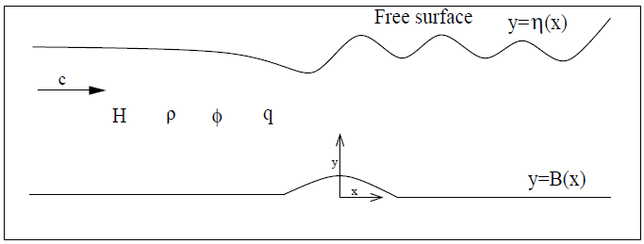

**Figure 1: The flow domain.**

In the fluid region, the equation of continuity yields the Laplace equation

|  |  |
| --- | --- |
|  | (1) |

As no fluid particle leaves the surface, the kinematic condition on the free surface can be written as

|  |  |
| --- | --- |
|  | (2) |

where is the normal derivative at a point (*x*,*y*) on the surface.

Using Bernoulli's equation, the other condition on the free surface is derived as

|  |  |
| --- | --- |
|  | (3) |

where is the Froude number and *g* is acceleration due to the gravity. In the present work, the subcritical flow is only considered, and hence the value of the Froude number is chosen as *F*<1.

The condition of no penetration at the bottom gives rise

|  |  |
| --- | --- |
|  | (4) |

In addition, the conditions at the upstream are

|  |  |
| --- | --- |
|  | (5) |

The objective of the this work is to determine the unknown parameters $ϕ$ (*x*,*y*) and $η(x)$. These unknowns can be obtained once the boundary value problem (1)-(5) is solved. In the following section, the above BVP is solved using perturbation analysis along with the Fourier transform technique.

# SOLUTION OF THE PROBLEM

It is assumed that the undulating bottom is given bywhere is a small dimensionless quantity and represents the maximum height of the undulating bottom. As the height is small, then the solution of the boundary value problem (1)-(5) can be derived with the help of perturbation expansion in powers of retaining only the first-order terms. Now, the velocity potential and the free-surface profile can be expressed asymptotically as

|  |  |
| --- | --- |
|  | (6) |
|  | (7) |

where and are the first-order velocity potential and free-surface profile, respectively. Now, the velocity potential and the free-surface profile can be determined once the parameters and  are evaluated. Hence, the parametersand  will be determined in the following part. Using relations (6) and (7) in (1)-(4); and then comparing the first order terms of on both the sides of all equations, the following mixed boundary value problem is obtained:

|  |  |
| --- | --- |
|  | (8) |
|  | (9) |
|  | (10) |
|  | (11) |

where and are, respectively, the first order derivatives of *f*(*x*) and with respect to *x*.

In order to solve the mixed boundary value problem (8)-(11), the first-order potential and the bottom profile *f*(*x*) are assumed such that the Fourier transforms of and *f*(*x*) exist, which are defined as

|  |  |
| --- | --- |
|  | (12) |

with inverse

|  |  |
| --- | --- |
|  | (13) |

and

|  |  |
| --- | --- |
|  | (14) |

where *M*(*k*) determines the bottom profile. For the free-surface profile, let us define as

|  |  |
| --- | --- |
|  | (15) |

Applying Fourier transform along with its inverse; and using the relations (14) and (15), the solution of the BVP (8)-(11) is obtained as

|  |  |
| --- | --- |
|  | (16) |

where

|  |  |
| --- | --- |
|  | (17) |

with

|  |  |
| --- | --- |
|  | (18) |

It should be noted that the relation

|  |  |
| --- | --- |
|  | (19) |

is called as *dispersion relation.* It can be proved (confirmed in Section IV) that the relation (19) has two real roots: one is positive real root and another one is negative real root having the same magnitude as that of the positive real root. It should be noted that the positive real root of the dispersion relation plays a crucial role in the study of fluid flow problem as it indicates the wave number of the downstream waves. It can be noticed, from relations (15) and (17), that the first-order free-surface profile(hence the free-surface profile) depends on the shape of the bottom profile. Hence, it is very much important to know the shape of the bottom profile. In the present study, the following bottom profile is considered to establish the results:

|  |  |
| --- | --- |
|  | (20) |

where *L* is the half length of the obstacle.

Using relations (14), (17) and (20), *a*(*k*) is obtained as

|  |  |
| --- | --- |
|  | (21) |

Now, using the value of *a*(*k*) into the relation (15), the first-order free-surface profile is determined as

|  |  |
| --- | --- |
|  | (22) |

From the relation (22), it is clear that the integrals contain a simple pole on the real axis at the zero of *E*1(*k*). Hence, Cauchy principal value with an indentation below the singularity is used to determine the above integration (22). Applying the residue theorem, we have obtained the following free-surface profile:

|  |  |
| --- | --- |
|  | (23) |

where *k*0 is the real and positive root of the relation (19).

From the above relation (23), the following observations can be made:

the profileis oscillatory in nature, representing a wave with a constant amplitude.

the free-surface possesses a wave train downstream preceded by a wave-free region at the upstream.

# COMPUTATIONAL RESULTS AND DISCUSSION

In this section, some of the numerical results which are important for the present study are discussed. For instance, a detail discussion on the real roots (*i.e*., the wave number) of the dispersion relation (19) is provided in a tabular form. Also, the effects of several system parameters on the free-surface profile are presented.

The roots of the aforesaid dispersion relation are calculated with the help of Newton's method for several values of Froude number (*F*), and are shown in Table 1. From this table, it is clear that the dispersion relation (19) has two non-zero real roots. Out of these two real roots, one is positive and another one is negative having same magnitude. This affirms the theoretical observation reported in Section III. In addition, it is also clear (*refer* Table 1) that the wave number (real positive root of the dispersion relation) decreases, i.e., the wave length increases as the Froude number *F* increases.

### **Table 1: Roots of the dispersion relation (19) for D=0.7 and γ =1**

| Parameter value | F = 0.2 | F = 0.3 | F = 0.4 | F = 0.5 | F = 0.6 |
| --- | --- | --- | --- | --- | --- |
| Real roots | 24.99999,  -24.99999 | 11.11111,  -11.11111 | 6.24995, -6.24995 | 3.99730, -3.99730 | 2.75541, -2.75541 |

Figure 2 illustrates the behavior of the free-surface profile  for two different values of Froude number such as *F*=0.5 and 0.6 with = 0.1 and *L*=1. From the figure, it is clear that the nature of the free-surface profile is oscillatory. This phenomenon indicates that the free-surface profile represents downstream waves having constant amplitude. The wavy nature arises due to the interaction of the fluid with the undulated bottom. It is also clear (*refer* Figure 2) that the amplitude of the downstream wave increases as the Froude number increases. It is well known that the wave number decreases (i.e., wavelength increases) as the speed of the fluid increases. From the relation we know that the fluid speed increases as the Froude number increase. Hence, the wavelength of the downstream wave increases as the Froude number increases. This phenomenon is also observed in Figure 2.

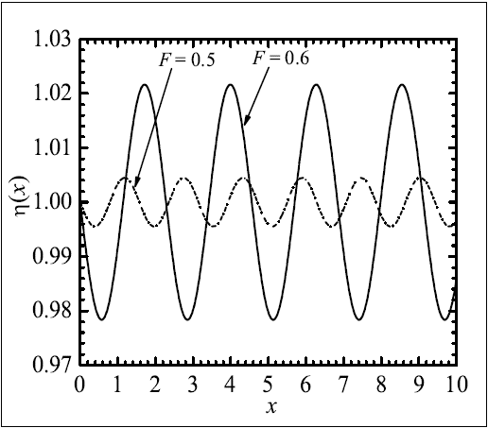

**Figure 2: Free-surface profile  for = 0.1, *L*=1.**

Figure 3 describes the effect of the height of the undulated bottom on the free-surface profile. In this figure, the free-surface profile is shown for three different values of the bottom height = 0.01, 0.05 and 0.1 with *F* = 0.6 and *L*=1. From the physical intuition, it is obvious that the amplitude of the downstream wave increases as the height of the bottom increases. This phenomenon is also observed (*refer* Figure 3) in the present study. In this figure, we have kept the Froude number same (i.e., *F* = 0.6) for each free-surface profile (or downstream wave). And we have noticed that the wavelengths of the downstream waves are same (*refer* Figure 3). This is completely consistent with the phenomenon that the wavelength depends on the Froude number.

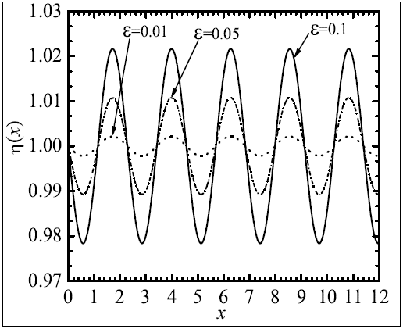

**Figure 3: Free-surface profile** **for *F*=0.6, *L*=1.**

##### REFERENCES

1. L.K. Forbes and L.W. Schwartz, “Free-surface flow over a semicircular obstruction,” J. Fluid Mech., vol. 114, pp. 299-314, 1982.
2. J.-M. Vanden-Broeck, “Free-surface flow over a semi-circular obstruction in a channel,” Phys. Fluids, vol. 30, pp. 2315-2317, 1987.
3. L.K. Forbes, “Critical free-surface flow over a semi-circular obstruction,” J. Engrg. Math., vol. 22, pp. 3-13, 1988.
4. Z. Yong, “Resonant flow of a fluid past a concave topography,” Appl. Math. Mech.-Engl. Ed., vol. 18(5), pp. 479-482, 1997.
5. F. Dias and J.-M. Vanden-Broeck, “Open channel flows with submerged obstructions,” J. Fluid Mech., vol. 206, pp. 155-170, 1989.
6. S.P. Shen, M.C. Shen, and S.M. Sun, “A model equation for steady surface waves over a bump,” J. Engrg. Math., vol. 23, pp. 315-323, 1989.
7. F. Dias and J.-M. Vanden-Broeck, “Generalised critical free-surface flows,” J. Engrg. Math., vol. 42, pp. 291-301, 2002.
8. S. Panda, S.C. Martha, and A. Chakraborty, “An alternative approach to study nonlinear inviscid flow over arbitrary bottom topography,” Appl. Math. Comp., vol. 273, pp. 165-177, 2016.
9. P.J. Higgins, W.W. Read, and S.R. Belward, “A series-solution method for freeboundary problems arising from flow over topography,” J. Engrg. Math., vol. 54, pp. 345-358, 2006.
10. R.H.J. Grimshaw and N. Smyth, “Resonant flow of a stratified fluid over topography,” J. Fluid Mech., vol. 16, pp. 429-464, 1986.
11. T.E. Stokes, G.C. Hocking, and L.K. Forbes, “Unsteady flow induced by a withdrawal point beneath a free surface,” ANZIAM J., vol. 47, pp. 185-202, 2005.
12. P. Milewski and J.-M. Vanden-Broeck, “Time dependent gravity capillary flows past an obstacle,” Wave Motion, vol. 29, pp. 63-79, 1999.
13. S.P. Shen, M.C. Shen, and S.M. Sun, “A model equation for steady surface waves over a bump,” J. Engrg. Math., vol. 23, pp. 315-323, 1989.
14. A.C. King and M.T.G. Bloor, “Free surface flow over a step,” J. Fluid Mech., vol. 182, pp. 193-208, 1987.
15. F. Dias and J.-M. Vanden-Broeck, “Open channel flows with submerged obstructions,” J. Fluid Mech., vol. 206, pp. 155-170, 1989.