**SynthesisandCharacterizationofW03**

**Nanoflakes**

**NehaDesai1',A.N.Jagdale1**

Department of Chemistry, K.B.P.CollegePandharpur -413709Emailid ofCorrespondingauthor:-[nehadesai323@gmail.com](mailto:nehadesai323@gmail.com)

**ABSTRACT**

In this research, we synthesized WO3 ionopowdetl by chemical bath deposition. Here we studied the optical, structural, morphological and compositional properties of WO 3 nanop0wde_1lX-•ay diffraction analysis showshexagonal crystal structure with crystallite size of 2 l SEM,-h1crograph shows nanoflakesmorphology. EDS extra presence of tungsten oxygen in good air, corresponds to the standarddata.

**Introduction**

Tungsten oxide has received a lot attention in current years for its electrochromic ( photocatalytic,photoluminescence and fuel sensing properties [l, 2]. The electrochromic belongings of these kinds of traits is eleven:>stemphased as WO3, the film has the capability to undergo optical color when a voltage is carried out. WO3 has been widely studied for its photoelectric overall performance because of their better photoconversion performance.

. WO3 1 is the maximum famous purposeful cloth and performs a key role 111 p.C performance of solar cells. Enormously. Photoclcctrochcrrncalperformance is significantly stimulated by means of its shape right here - the location of some of techniques to the manufacturing of WO3 nanorods. Nanowires, nanowires, nanoshellsnanospheres, and many others. The have a look at of a lot of these morphologies ends in tremendous physico:chemical homes [6-IOj.

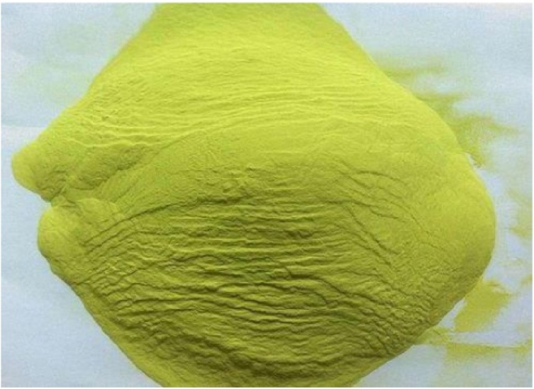

##### Fig. 1WO3 Nanopowder

The practise of WO3 thin film with controlled morphology is a difficult challenge. On this regard, the hyc8-hennal technique presents higher alternatives for W03 size and morphology. Of most of these, WO3 is the most researched because it gives many advantages suGas chemical stability, low fee, non-toxicity, excessive refractive index, lengthy lifestyles, wide band gap. In recent times, WO3 has come to be the maximum crucial useful fabric in many programs which includes photocatalysis, dye-sensitized solar cells, sensors, ion absorbance, Li-ion batteries, dielectrics, ceramics, and so forth.

Experimental:-

Two hundred ml of distilled water was poured into the beaker. Thirteen.Three grams of Na, WO, 2H 2 O (sodium tungstate) had been weighed on a balance, delivered to a beaker containing distilled water and stirred thoroughly until a clean solution changed into acquired.

Hydrochloric acid (HCl) become brought to the solution to form a yellow precipitate; excess HCl became delivered to the comp! Letl&eaction (all dissolved sodium tungstate particles were triggered). The precipitates were then filtered the usage of iifer paper. After filtration, the filtrates have been dried on filter out paper inside the oven so as now not to harm the 1 liter paper via the motion of HCl. The dried precipitates had been then separated in a dish and saved.

**GROWTH AND REACTION MECHANISM**

In the current research work, WO3 nanopowder is synthesized. Here, WO3 is prepared by a simple chemical growth method using sodium tungstate and the precursor is hydrochloric acid. The following reactions take place during the formation of WO3,







Initially, sodium tungstate is a white powder. It is soluble in water and dissociates to form tungsten ion. Another tungsten ion reacts with the hydronium ion to form white tungstic acid. Here, white tugstenic acid yields tugsten oxides on heating. New structural properties of nanomaterials are attributed to the process of their growth. Here, nucleation and particle size control are the main aspects of the growth mechanism.

**X-RAY DIFFRACTION**

 X-ray diffraction research are generally carried out to determine the crystal structure of a stable-kingdom cloth, both nanocrystalline, polycrystalline, or amorphous. In the present research, X-ray diffraction research had been completed the usage of an X-ray diffractometer [Bruker AXS Model D8 Advance X -ray Diffractometer] with a Cu Ka target at a wavelength of one.542 A?. The XRD plot for WO3 thin is proven in parent . The XRD sample of the movie indicates diffractions at 29 (Bragg attitude) = thirteen.10?, 22.23?, 23.63?, 27.60?, 32.Ninety six?, 35.93?, forty nine.24?, 55.01o and fifty seven.900, corresponding to fifty seven.900?, (110), (200), (112), (202), (004), (222), and (312) planes of hexagonal WO3 in line with JCPDS No. Eighty five-2459 for the hexagonal crystal shape. The calculated crystallite length is 72.0 nm.

C:\Users\USER\Desktop\WO3 Project\Picture1.tif

**Fig. 2. X-ray Diffraction Pattern**

**Morphological Study**

Morphology is the maximum vital characteristic of a nanomaterial. Morphology is of unique importance as it reveals the bodily and chemical residences of nanomaterials. SEM analysis is finished to take a look at the morphological aspects of WO3 nanomaterial. SEM photos of the WO3 nanomaterial show a nicely-adherent, uniform formation without holes. The morphological have a look at is carried out at low and high resolution. Low-resolution photomicrographs show a nanoflake-like morphology. Numerous nanoflakes are aggregated collectively to form a dense shape.

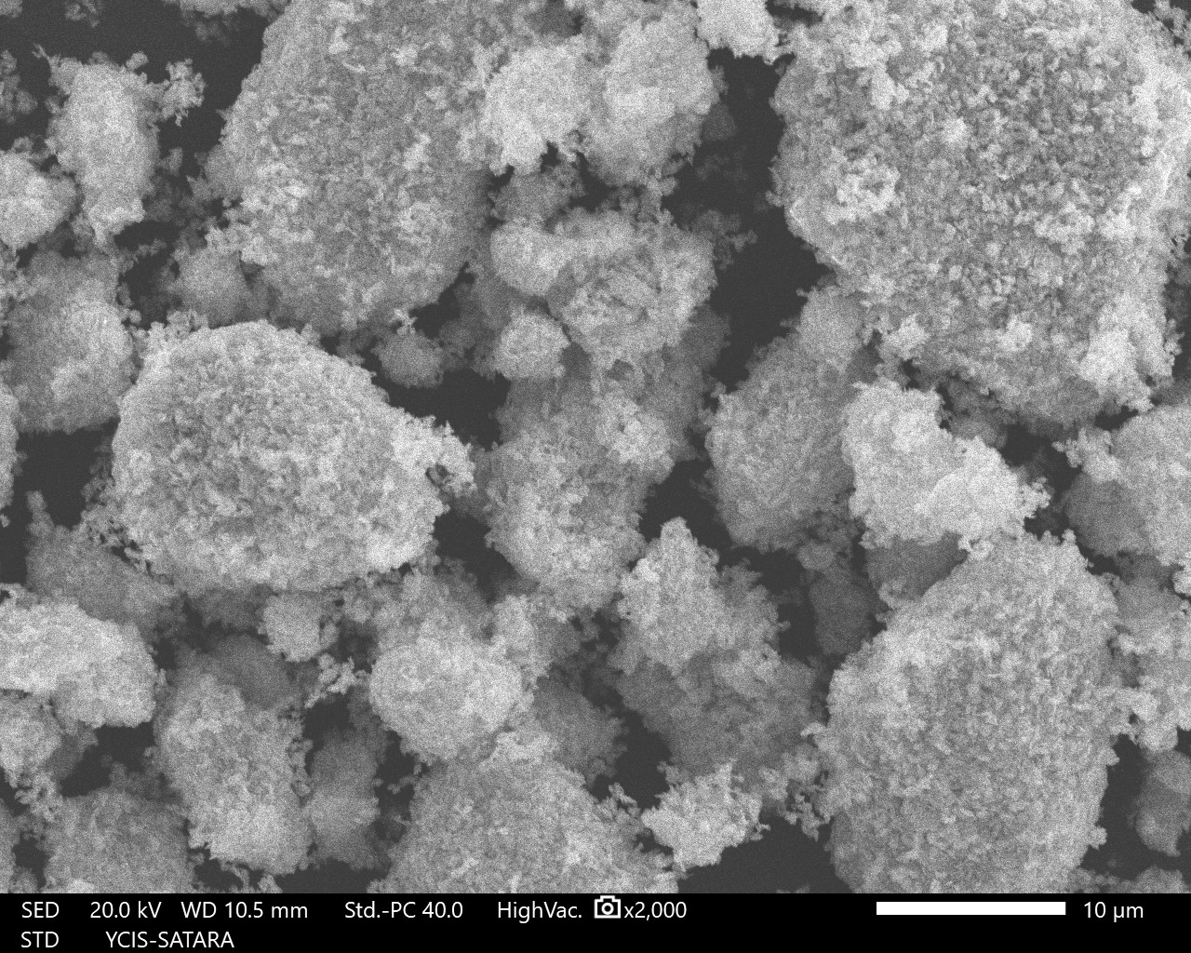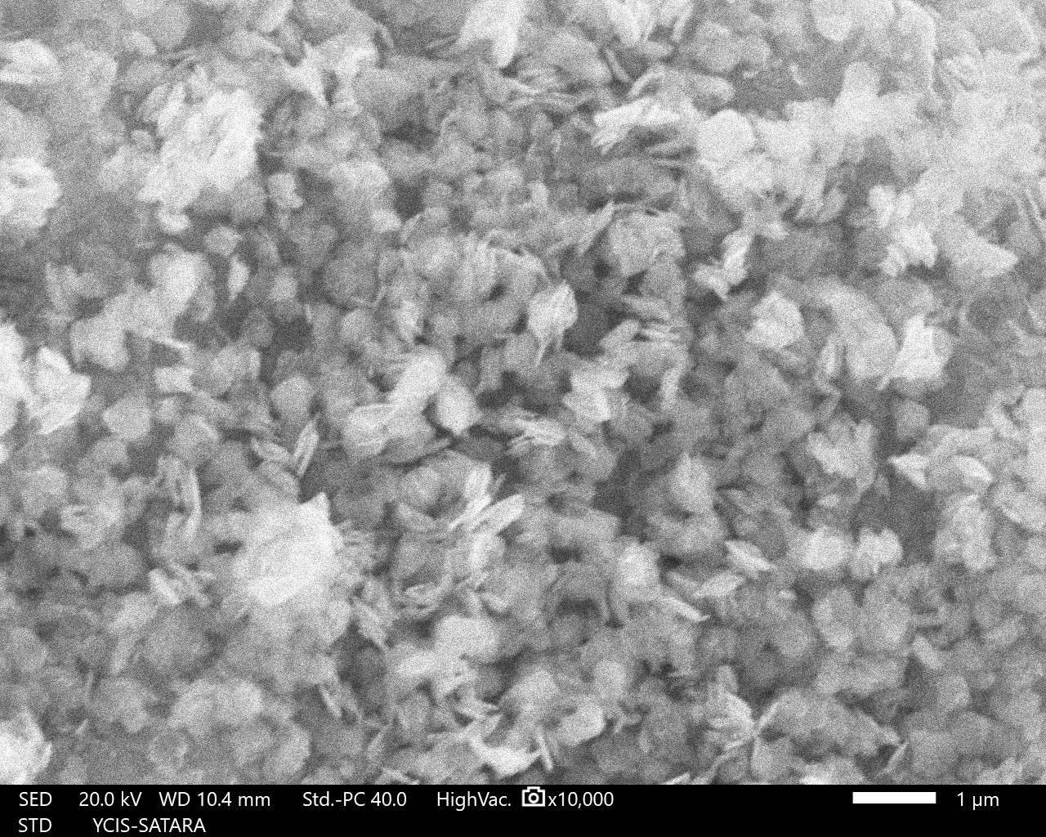

(a)

(b)

**Fig. 3. SEM micrographs of WO3 thin films**

**Compositional analysis**:-

EDS is performed to decide the chemical composition of the nanomaterial within the modern research work. We've synthesized WO3 nanopowder, so EDX evaluation is achieved to affirm the atomic percentage of tungsten and oxygen. The located atomic percent of tungsten is nineteen% and oxygen is 81%. The discovered percent is in right agreement with the usual information. No more peak due to impurities observed in the chemical composition.



**Conclusions:-**

The WO3 nanopowder is synthesized by way of chemical growth technique. The XRD sample confirms hexagonal crystal shape. The SEM snap shots display nanoflake like morphology. The EDS spectra confirms presence of tungsten and oxygen. All these effects exhibits that WO3 is a higher candidate for electrochromic applications.

**References:-**

1. Vanalakar S.A., Kamble A.S., Shin S.W., Mali S.S., Agawane G.L., Patil V.L., Kim J.Y., Patil P.S., Kim J.H., 2015. Simplistic toxic to non-toxic hydrothermal route to synthesize Cu2ZnSnS4 nanoparticles for solar cell applications, 2015, Sol. Ener., 122, 1146-1153
2. . Shendage S.S., Patil V.L., Vanalakar S.A., Patil S.P., Harale N.S., Bhosale J.L., Kim J.H., Patil P.S., S2017. ensitive and selective NO2 gas sensor based on WO3 nanoplates, 2017, Sen. Act. B: Chemical, 240, 426-433.
3. Park, C.Y., Seo, J.M., Jo, H., Park, J., Ok, K.M., Park, T.J., 2017. Hexagonal tungsten oxide nanoflowers as enzymatic mimetics and electrocatalysts. Sci. Rep. 7, 40928.
4. Faudoa-Arzate, A., Arteaga-Dur´an, A., Saenz-Hern´andez, R.J., Botello-Zubiate, M.E., Realyvazquez-Guevara, P.R., Matutes-Aquino, J.A., 2017. HRTEM microstructural characterization of β-WO3 thin films deposited by reactive RF magnetron sputtering. Materials 10, 200.
5. Liu, Q., Wang, F., Lin, H., Xie, Y., Tong, N., Lin, J.J., Zhang, X., Zhang, Z., Wang, X., 2018. Surface oxygen vacancy and defect engineering of WO3 for improved visible light photocatalytic performance. Catal. Sci. Technol. 8, 4399–4406.
6. Calogero, G., Bartolotta, A., Marco, G.D., Carlo, A.D., Bonaccorso, F., 2015. Vegetable-based dye-sensitized solar cells. Chem. Soc. Rev*.* 44, 244. Sreeja, S., Pesala Bala, Co-sensitization aided efficiency enhancement

#### References:-

1. Vanalakar S.A., Kamble A.S., Shin S.W., Mali S.S., Agawane G.L., Patil V.L., Kirn J.Y., Patil P.S., Kim J.H., 2015. Simplistic toxic to non-toxic hydrothermal route to synthesize Cu2ZnSnS4 nanoparticles for solar cell applications, 2015, Sol. Ener., 122, 1146-1153
2. . Shendage S.S., Patil V.L., Vanalakar S.A., Patil S.P., Harale N.S., Bhosale J.L., Kim J.H., Patil P.S., S2017. ensitive and selective NO2 gas sensor based on WO3 nanoplates, 2017, Sen. Act. B: Chemical, 240, 426-433.
3. Park, C.Y., Seo, JM., Jo, **H.,** Park, J., Ok, K.M., Park, T.J., 2017. Hexagonal tungsten oxide nanoflowers as enzymatic rnirnetics and electrocatalysts. Sci. Rep. 7, 40928.
4. Faudoa-Arzate, A., Arteaga-Dur'an, A., Saenz-Hem'andez, RJ ., Botello-Zubiate, M.E., Realyvazquez-Guevara, P.R., Matutes-Aquino, J.A., 2017. HRTEM microstruclural characterization of -WO3 thin films depesited by reactive RF magnetron sputtering. Materials 10, 200.
5. Liu, Q., Wang, F., Lin, H., Xie, Y., Tong, N., Lin, J.J., Zhang, X., Zhang, Z., Wang, X., 2018. Surface oxygen vacancy and defect engineering of WO3 for improved visible light photocatalytic performance. Cata!. Sci. Technol. 8, 4399-4406.
6. Calogero, G., Bartolotta, A., Marco, G.D., Carlo, A.O., Bonaccorso, F., 2015. Vegetable-based

dye-sensitized solar cells. Chem. Soc. Rev. 44,244. Sreeja, S., Pesala Bala, Co-sensitization aided efficiency enhancement