Pro-drug Developments
Keshav Kumar, Dr. Rupali Sharma, Dr. Satish Sardana
Amity Institute of Pharmaceutical sciences
Amity University,
Gurugram, Haryana, INDIA

ABSTRACT
Prodrugs are chemically modiﬁed derivatives introduced in therapy due to their advantageous physico-chemical properties (greater stability,
improved solubility, increased permeability), used in inactive form. Biological effect is exerted by the active derivatives formed in organism
through chemical transformation (biotransformation).
Prodrugs are chemically modiﬁed derivatives introduced in therapy due to their advantageous physico-chemical properties (greater stability,
improved solubility, increased permeability), used in inactive form. Biological effect is exerted by the active derivatives formed in organism
through chemical transformation (biotransformation).
Prodrugs are chemically modiﬁed derivatives introduced in therapy due to their advantageous physico-chemical properties (greater stability,
improved solubility, increased permeability), used in inactive form. Biological effect is exerted by the active derivatives formed in organism
through chemical transformation (biotransformation).
Prodrugs are chemically modiﬁed derivatives introduced in therapy due to their advantageous physico-chemical properties (greater stability,
improved solubility, increased permeability), used in inactive form. Biological effect is exerted by the active derivatives formed in organism
through chemical transformation (biotransformation).
Prodrugs are chemically modiﬁed derivatives introduced in therapy due to their advantageous physico-chemical properties (greater stability,
improved solubility, increased permeability), used in inactive form. Biological effect is exerted by the active derivatives formed in organism
through chemical transformation (biotransformation).
To come out pharmacokinetic & pharmacodynamic limitations of active drugs there is an effective strategy to overcome that is design and developments of prodrugs. A large numbers of prodrugs are already available in market and well established in recent years. Also in recent years there is particular enhance in the use of prodrugs as an advancement of parent drugs for treatment of different types diseases. Prodrugs are modified derivatives of active moiety entered in therapy due to their advantageous physico-chemical properties (greater stability, improved solubility, increased permeability,) used in inactive form. Biological effect occurs by the active derivatives formed in organism through chemical transformation (biotransformation). A prodrug strategy includes changes in active moiety and making different derivatives that provides much advantages over parent moiety like enhancing membrane permeability, overcome pharmacokinetic barriers like poor solubility, absorption, rapid excretion and pharmacodynamic barriers such as toxicity, side effects and poor efficacy. site specification, transporter targeting, improving aqueous solubility and so many. Recently, out of pharmaceutical products 10% are available as prodrugs. 50% of prodrugs changed to the active form by hydrolysis mechanism and majorly by hydrolysis of ester. Now we can identify prodrugs produced by chemical derivatisation, bioprecursors and targeted delivery systems.
INTRODUCTION
One of the eective methods of modern research in the
eld of medicine is the development of prodrugs that have
gained increasingly more importance in current therapy
One of the eective methods of modern research in the
eld of medicine is the development of prodrugs that have
gained increasingly more importance in current therapy
UPDATE
Acta Medica Marisiensis 2016;62(3):356-362 DOI: 10.1515/amma-2016-0032
Prodrug Strategy in Drug Development
Kelemen Hajnal1, Hancu Gabriel1*, Rusu Aura1, Varga Erzsébet2, Székely Szentmiklósi Blanka1
1 Department of Pharmaceutical Chemistry, Faculty of Pharmacy, University of Medicine and Pharmacy, Tîrgu Mureş, Romania;
2 Department of Pharmacognosy and Phytotherapy, Faculty of Pharmacy, University of Medicine and Pharmacy, Tîrgu Mureş, Romania
Prodrugs are chemically modiﬁed derivatives introduced in therapy due to their advantageous physico-chemical properties (greater stability,
improved solubility, increased permeability), used in inactive form. Biological effect is exerted by the active derivatives formed in organism
through chemical transformation (biotransformation). Currently, 10% of pharmaceutical products are used as prodrugs, nearly half of them
being converted to active form by hydrolysis, mainly by ester hydrolysis. The use of prodrugs aims to improve the bioavailability of compounds
in order to resolve some unfavorable characteristics and to reduce ﬁrst-pass metabolism. Other objectives are to increase drug absorption,
to extend duration of action or to achieve a better tissue/organ selective transport in case of non-oral drug delivery forms. Prodrugs can be
characterized by chemical structure, activation mechanism or through the presence of certain functional groups suitable for their preparation.
Currently we distinguish in therapy traditional prodrugs prepared by chemical derivatisation, bioprecursors and targeted delivery systems. The
present article is a review regarding the introduction and applications of prodrug design in various areas of drug development.
Keywords: prodrugs, classiﬁcation of prodrugs, drug development, optimization of bioavailability
Received: 01 October 2015 / Accepted: 04 July 2016
Introduction
Development of prodrugs is one of efficacious methods of latest research work in the field of medical science that gained more importance in present therapy. A prodrug is a pharmacologically inactive substance that becomes active invivo after metabolism or biotransformation and exerts its effects. Prodrug converted to active substance by biotransformation. Biotransformation is a metabolic process occurs in liver through various enzymes or chemical transformation. Biotransformation mechanism may includes oxidation, reduction, hydrolysis etc. The prodrug concept was introduced in late 19th century and aim was to improve undesirable properties of drugs but at the end of 1950s the actual term “prodrug” was introduced by Adrien Albert for the first time for drugs that are inactive but become an active derivative by biotransformation. In 1959 Harper completed the concept who introduced the term drug latentiation means drugs that were specifically designed to require bioactivation.
IUPAC definition which states that: A prodrug is a compound that undergoes biotransformation before revealing pharmacological effects. In fig 1. there is some prodrugs. Medicines that have specific protective groups, can be defined also as prodrugs in sequence to prevent unnecesary properties of the parent molecules. Prodrugs are simply derivatives of chemical that are only one or two enzymatic steps away or chemicals away from parent drug (active). But, some prodrugs have not a carrier or promoiety but result from molecular modification of the prodrug itself, which creates a new active compound. The prodrug concept is different from active drugs that are active of their own, but on biotransformation they form many more active metabolites and the biological effect occurs similar as a same result of metabolites and original drugs and. This type of drugs are called as “limited” prodrugs (e.g. diazepam, carbamazepin). In few cases a prodrug is made up of two pharmacological active moieties that are coupled together with in a molecule and work as promoiety for each. These are known as codrugs. (Eg, sulfasalazine, sultamicillin, benorilate, levodopa-entacapone).
Purpose behind Prodrug design:
Main purpose of prodrug design is to amend physicochemical properties to enhance chemical or metabolic stability, to achieve organized delivery. Below are other purposes for drug design:
- Overcome Pharmacokinetic Limitations of drug like absorption, poor solubility, rapid excretion
- Overcome Pharmacodynamic Limitations like poor bioavailibilty, poor efficacy, side effects,

Purpose regarding improving bioavailability that is due to poor water solubility, low lipophilicity, bitter or unacceptable smell or taste, pain any irritation, chemical instability, poor penetration through biological membrane, slow absorption by parentral route, increased first pass metabolism, lack of specificity in tissues.

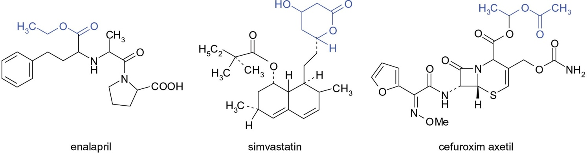

Fig. 1 Some Prodrugs

Prodrug Advantages :
Prodrugs with optimised pharmacokinetic and pharmacodynamic properties have following advantages:

1. Increased absorption from GIT
2. Avoids pain or irritation at injection site
3. Tissue/organ specific drug administration
4. Enhance passage through Blood Brain Barrier
5. Decrease side effects and toxicity profile.
6. Masks unpleasant tastes and odors.
7. More potent, safer and more convenient in administration.

Prodrug Classification :
Prodrugs are classified according to their chemical structure, mechanism of action and modified functional groups.

- By chemical Structure
- Conventional prodrugs : obtained from chemical derivatization, and objective is to optimize transport properties;
called as carrier-linked prodrugs. Some functional groups are added to improve absorption.
- Bio precursors :these are precursor of a biochemical compound which after chemical reactions exerts their physiological role. Eg. Lovastatin, some vitamins B1,B6 on phosphorylation and oxidation (Vit D) acts as prodrugs.
- Drug Delivery Systems : conjugates are formed here like polymers of drug conjugates. Drug is bind to a macromolecule that commends its transport. In case of antibody conjugates, target delivery is performed by antibody.

- By activation Mechanism
- Enzymatic Activation : Drugs that faces enzymatic activation can be planned; but problems may arise due to genetic polymorphism, biological variability between drug interaction potential, species.
- Non- enzymatic Activation : drugs that faces non-enzymatic activation- it is unforced, but unsufficient chemical stability can leads to problems in conservation before use.
Activation mechanism of classification is based on the reactions that results in active form, like hydrolysis (imide, ether ester, amide, etc.); reduction, oxidation; and other reactions.

- By Cellular sites of coversion
- Intracellular or type I : bioactivation location is therapeutic action site eg. Statins, Antiviral phosphorylated nucleoside.
- Extracellular or type II: where no bioactivation occurs in digestive fluids or the systemic circulation. Eg. fosamprenavir, valganciclovir, and virus-directed enzyme, antibody-, gene prodrugs.
This new classification might help in getting drug product’s pharmacokinetics, safety and efficacy.
Bioavailability Optimization
In most cases prodrug synthesis purpose is increasing bioavailability. Drug physicochemical parameters like solubility, good permeability, adequate lipophilicity, are important aspects in drug development which are strongly affected by acid-base properties of the molecules.

Prodrugs with improved lipophilicity
Presence of carboxyl functional group in many medications exists as must function for their pharmacological activity. But, its presence also causes too high polarity in case of oral administration, as in the small intestine at pH 5-7, much ionization occurs, which stops the passage of molecules through membranes by passive diffusion. Carboxyl groups esterification with short or long aliphatic alcohol majorly used method.

ACE inhibitors are ethyl ester prodrugs (enalapril, benazepril, trandolapril, quinapril,)Fig 2. Ethyl esters as a result increases lipophilicity, and thus enhance absorption. Methyl esters occurs more rarely, as on hydrolysis methyl alcohol (toxic) is released. Hence this method of prodrugs design is rarely used in case of low dose medicines, only and in the case of esters with very short duration of action. Several ester type prodrugs made for levodopa, but only methyl esters is found in therapy (Levomet) (Fig 3).

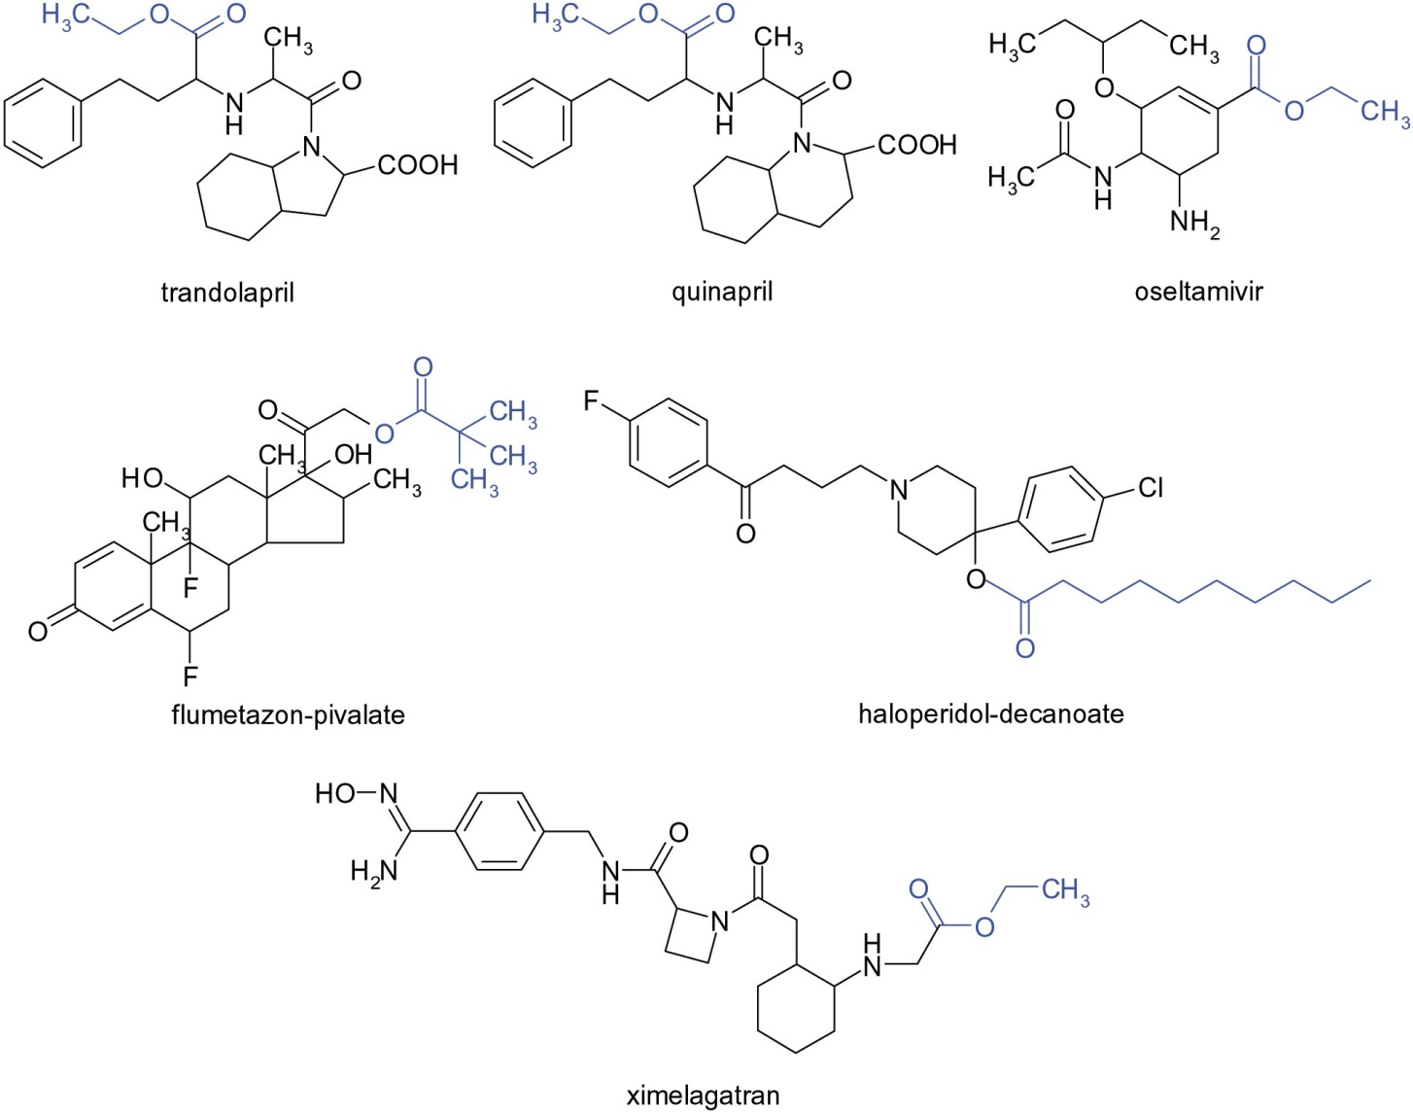

Fig. 2. Ester prodrug Examples

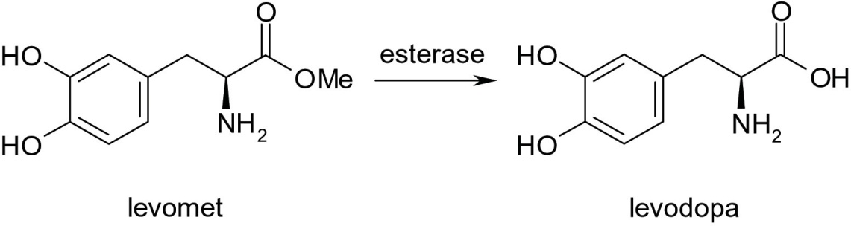
Fig 3. Esterification of Levomet
Some compounds are available where the methyl ester is not a prodrug, and the ester functional group is necessary for pharmacological effect. whereas free acid is without any therapeutic effect. Chemical or metabolic hydrolysis of methyl esters generally ocurs very fast, that is the reason methyl esters have short duration of action For e.g. cocaine or the beta-blocker esmolol with ultra-short effect.
Local anti-inflammatory corticosteroids series has prodrugs clobetasol propionate, clobetasol butyrate, flumeta- sone pivalate), in these C₂₁- OH or C₁₇-OH group is converted to ester. Another example is Terbutaline, a selective ₂-agonist bronchodilator given in high doses orally; while its prodrug form is bambuterol (di- methyl-carbamic acid ester of phenolic hydroxyl group) has increased lipophilicity and low hydrolysis rate converted by cholinesterase enzyme, given in 20 mg once daily because it is sufficient dose and has prolonged effect.
Classical antipsychotics group having depot acting preparations formed by esterification with fatty acids. Eg. prodrugs haloperidol decanoate, fluphenazine enanthate, and zuclopenthixol decanoate oily solutions has decreased the dose and now administered once or twice in a month. These ultra lipophilic esters deposited in fat stores later released slowly slowly and converted into the active form. Effect seen up to even 14-28 days, hence patient adherence is improved.
Improved aqueous solubility Prodrugs
Aqueous solubility can be increased by adding polar structures, thus enable oral or parentral administration. Polar groups may be non ionisable which easily degrades in the body. Eg NSAIDS- Sulfoxide derivatives. See Fig. 4
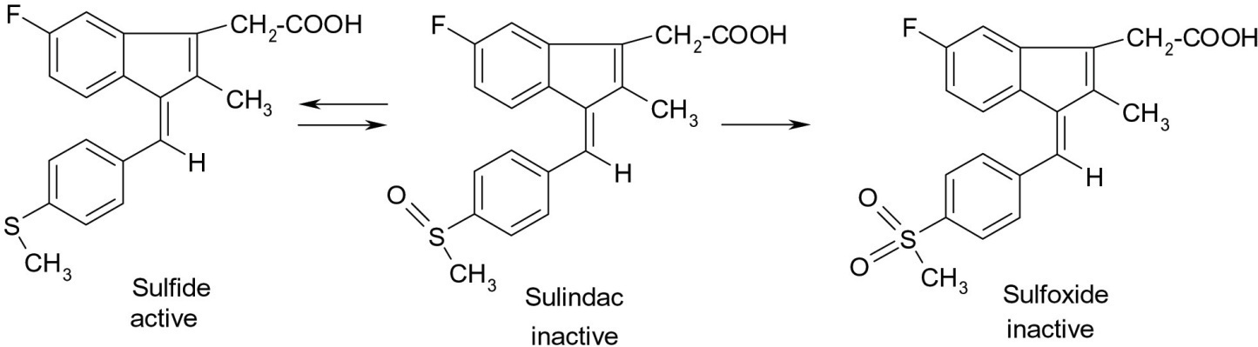
Fig. 4. Prodrugs with improved aqueous solubility

Targeted drug delivery
Site-specific drug delivery is efficacy criterion in some therapies, when site specific drugs are given to act on specific sites. This Prodrug synthesis is a great challenge in research industry. Based on research results we would like to emphasize two directions of utilization of prodrugs: tumor targeting and antigen targeting.

Prodrugs in cancer therapy
Cancer chemotherapy would increase the effectiveness if the active substance reach directly to the targeted tumor cell
without damaging body cells. Hence target sites delivery with prodrugs is now a priority in drug research.

Tumors can be made specific by using enzymes, transporters or development of prodrug-antibody which is selectively recognized by tumor cells. It is advantageous to administer drug orally.

Eg. capecitabine, Prodrug of 5-fluorouracil (5-FU), it requires 3 enzymes cascade for the bioconversion to the active drug. Carboxyl esterase present in liver the first degradation takes place here, and pentyl alcohol of lipophilic character, is eliminated. Cytidine Deaminase present both in liver and tumor cells deaminate by selective release of 5-FU in the tumor cells under the action of thymidine phosphorylase, which shows much higher activity in tumor cells than in normal cells. Absorbtion of prodrug occurs rapidly and almost completely from GIT and provides high concentration of 5-FU in targeted tumor cell. Capecitabine is used orally in treatment of metastatic colon cancer and in combination therapy in other types of cancer (figure 5).
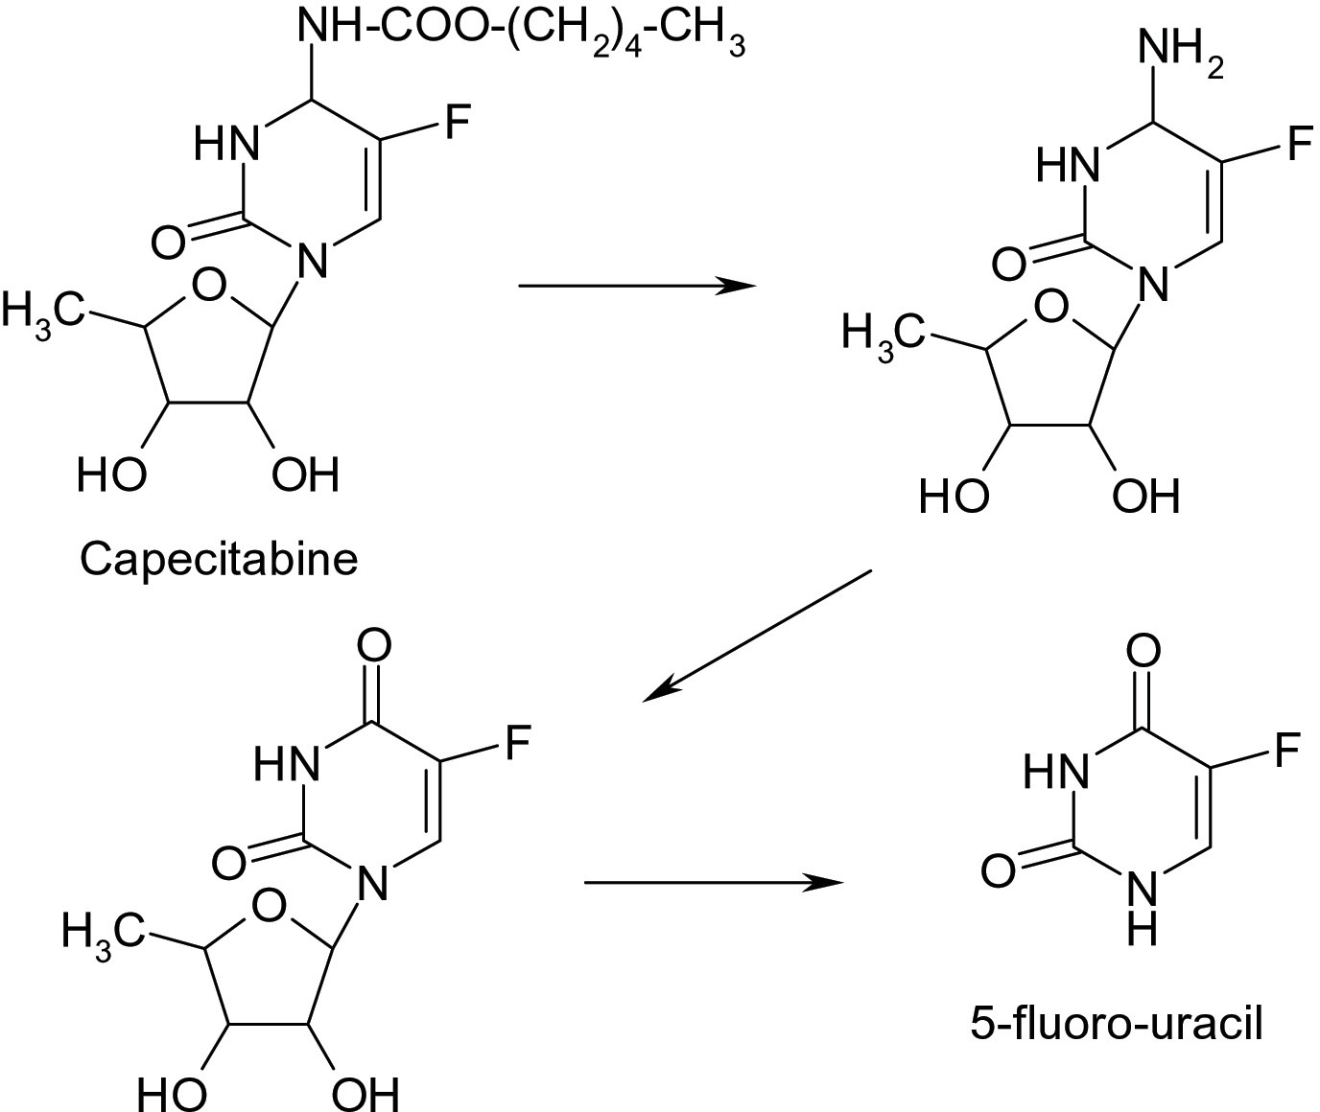

Fig. 5. Capecitabine metabolic conversion

Conclusions

A lot of prodrugs has been designed already to overcome delivery, formulation and toxicity barriers, however development of a prodrug might be very challenging. This prodrug strategy is a simple and easy way to improve the erratic properties of new drugs or drugs already present in market. Prodrug approach is an effective method to improve bioavailability of medicines.
Prodrug synthesis improves pharmacokinetic properties and new compounds can be obtained for oral or parenteral administration.
Obtaining target drug delivery in modern therapy is a great challenge in modern era, especially in cancer therapy, because extensive research on the use of prodrugs is conducted now a days.
In early stages of prodrug development full careful chemical and pharmacological charac- terization must be taken, because toxic active intermediaries may find.
A limitation in prodrug development is that it requires long and expensive syntheses.
Prodrug approach is one of the most promising approaches in drug development to enhance the therapeutic efficacy or to reduce the adverse effects of the pharmacologically active agents via different mechanisms, including, stability, increased solubility, improved permeability and bioavailability, prolonged biological half-life time, and tissue-targeted delivery.
Despite the remarkable progress made in the field of prodrug design, more studies are clearly needed, especially at early stages of the drug discovery, for prodrugs to achieve the desired state of art and take their place in modern pharmacotherapy.

References :
- Testa B, Mayer JB. Hydrolysis in Drug and Prodrug Metabolism: Chemistry, Biochemistry and Enzymology, Wiley-VCH, 2003.
- Ettmayer P, Amidon GL, Clement B et al. Lessons learned from marketed and investigational prodrugs. J Med Chem. 2004;47(10):2393-2240.
- Testa B. Prodrug research: futile or fertile. Biochem Pharmacol. 2004;68(11):2097-2106.
- Rautio J, Kumpulainen H, Heimbach T, et al. Prodrugs: design and clinical applications. Nat Rev Drug Discov. 2008;7:255-270.
- Rautio J, Laine K, Gynther M, et al. Prodrug approaches for CNS delivery. AAPS J. 2008;10:92-102.
- Jilani JA, Idkaidek NM, Alzoubi KH. Synthesis, In Vitro and In Vivo Evaluation of the N-ethoxycarbonylmorpholine Ester of Diclofenac as a Prodrug. Pharmaceuticals (Basel). 2014;7(4):453-63.
- Wohl AR, Michel AR, Kalscheuer S, et al. Silicat esters of paclitaxel and docetaxel: synthesis, hydrophobicity, hydrolytic stability, cytotoxicity, andprodrug potential. J Med Chem. 2014;57(6):2368-2379.
- Liu KS, Hsieh PW, Aljuffali IA, et al. Impact of ester promoieties on transdermal delivery of ketorolac. J Pharm Sci. 2014;103(3):974-986.
- Diez-Torrubia A, Cabrera S, de Castro S, et al. Novel water-soluble prodrugs of acyclovir cleavable by the dipeptidyl-peptidase IV (DPP IV/ CD26) enzyme. Eur J Med Chem. 2013;70:456-468.
- Lai L, Xu Z, Zhou J, et al. Molecular basis of prodrug activation by human valacyclovirase, an alpha-amino acid ester hydrolase. J Biol Chem. 2008;283(14):9318-9327.
- Rautio J, Mannhold R, Kubinyi H, Folkers G. Prodrugs and Targeted Delivery: Towards Better ADME Properties, Volume 47, Wiley-VCH Verlag Gmbh & Co KGA, Weinheim, 2011.
- Chiodo F, Marradi M, Calvo J, et al. Glycosystems in nanotechnology: Gold glyconanoparticles as carrier for anti-HIV prodrugs. Beilstein J Org Chem. 2014;10:1339-1346.
- Vivekkumar K Redasani, Sanjay B. Bari. Prodrug Design: Perspectives, Approaches and Applications. Elsevier London, 2015.
- Albert A. Chemical aspects of selective toxicity. Nature. 1958;182:421- 422.
- Wermuth CG, Ganellin CR, Lindberg P, et al. “Glossaryis of terms used in medicinal chemistry (IUPAC Recommendations 1998)”. Pure and Applied Chemistry. 1998;70(5):1129.
- N’Da DD. Prodrug strategies for enhancing the percutaneous absorption of drugs. Molecules. 2014;19(12):20780-20807.
- Forde E, Devocelle M. Pro-moieties of antimicrobial peptide prodrugs. Molecules. 2015;20(1):1210-1227.
- Wermuth CG, Aldous D, Raboisson P, et al. The practice of Medicinal Chemistry, fourth edition, Academic Press, London, 2015;657-692.
- Vert M, Doi Y, Hellwich K, et al. Terminology for biorelated polymers and applications (IUPAC Recommendations 2012)”. Pure and Applied Chemistry 2012;84(2):377-410.
- Das N, Dhanawat M, Dash M. Codrug: An efficient approach for drug optimization. Eur J of Pharm Sci. 2010;41:571-588.
- Leppänen J, Huuskonen J, Nevalainen T, et al. Design and synthesis of a novel L-dopa-entacapone codrug. Med Chem. 2002;45(6):1379-1382.
- Bodor N, Buchwald P. Soft drug design: General principles and recent applications. Medicinal Research Reviews. 2000;20(1):58-101.
- Takácsné Novák K. A prodrug stratégia a gyógyszerkutatásban: bevált módszerek és új irányok. Gyógyszerészet. 2013;57:451-459.
- Keserű GyM. A gyógyszerkutatás kémiája. Akadémiai Kiadó, Budapest, 2011;539-564.
- Zawilska JB, Wojcieszak J, Olejniczak AB. Prodrugs: a challenge for the drug development. Pharmacol Rep. 2013;65(1):1-14.
- Stella VJ. Prodrugs: some thoughts and current issues. J Pharm Sci. 2010;99:4755-4765.
- Stella VJ, Burchardt RT, Hageman MJ, et al. Prodrugs: Challenges and Rewards. Part 1. Springer, New York, 2007.
- Stella VJ, Nti-Addae KW. Prodrug strategies to overcome poor water solubility. Adv Drug Deliv Rev. 2007;59(7):677-694.
- Kokil GR, Rewatkar PV. Bioprecursor prodrugs: molecular modification of the active principle. Mini Rev Med Chem. 2010;10:1316-1330.
- Wu KM. A new classification of prodrugs: regulatory perspective. Pharmaceuticals. 2009;2:77-81.
- Wu KM, Farrelly J. Regulatory perspectives of type II prodrug development and time-dependent toxicity management: Nonclinical pharm/tox analysis and the role of comparative toxicology. Toxicology. 2007;236:1-6.
- Balendiran GK, Rath N, Kotheimer A. Biomolecular chemistry of isopropyl fibrates. J Pharm Sci. 2012;101(4):1555-1569.
- Lesniewska MA, Ostrowski T, Zeidler J, et al. Ester groups as carriers of antivirally active tricyclic analogue of acyclovir in prodrugs designing: synthesis, lipophilicity-comparative statistical study of the chromatographic and theoretical methods, validation of the HPLC method. Comb Chem High Throughput Screen. 2014;17(7):639-650.
- Chanteux H, Rosa M, Delatour C, et al. In vitro hydrolysis and transesterification of CDP323, an 41/47 integrin antagonist ester prodrug. Drug Metab Dispos. 2014;42(1):153-161.
- Swaan PW, Stehouwer MC, Tukker JJ. Molecular mechanism for the relative binding affinity to the intestinal peptide carrier. Comparison of three ACE-inhibitors: enalapril, enalaprilat and lisinopril. Biochim Biophys Acta. 1995;1236(1):31-38.
- Liu KS, Hsieh PW, Aljuffali IA, et al. Impact of ester promoieties on transdermal delivery of ketorolac. J Pharm Sci. 2014;103(3):974-986.
- Karaman R. Computer-assisted design for atenolol prodrugs for the use in aqueous formulations. J Mol Model. 2012;18(4):1523-1540.
- Wang H, Xie H, Wu J, et al. Structure-based rational design of prodrugs to enable their combination with polymeric nanoparticle delivery platforms for enhanced antitumor efficacy. Angew Chem Int Ed. 2014;53(43):11532- 11537.
- Lang BC, Yang J, Wang Y, et al. An improved design of water-soluble propofol prodrugs characterized by rapid onset of action. Anesth Analg. 2014;118(4):745-754.
- Wozniak KM, Vornov JJ, Mistry BM. Gastrointestinal delivery of propofol from fospropofol: its bioavailability and activity in rodents and human volunteers. J Transl Med. 2015;13:170.
- Sharma SK, Bagshawe KD. Antibody-directed enzyme prodrug therapy (ADEPT) for cancer. Springer 2010;393-405.
- Tietze L, Krewer B. Antibody-directed enzyme prodrug therapy: a promising approach for a selective treatment of cancer based on prodrugs and monoclonal antibodies. Chem Biol Drug Des. 2009;74:205-211.
- Mazzaferro S, Bouchemal K, Ponchel G. Oral delivery of anticancer drugs II: the prodrug strategy. Drug Discovery Today. 2013;18(1-2):93-98.
- Tietze LF, Krewer B. Antibody-directed enzyme prodrug therapy: a promising approach for a selective treatment of cancer based on prodrugs and monoclonal antibodies. Chem Biol Drug Des. 2009;74:205-211.
- Schmoll HJ, Twelves C, Sun W, et al. Effect of adjuvant capecitabine or fluorouracil, with or without oxaliplatin, on survival outcomes in stage III coloncancer and the effect of oxaliplatin on post-relapse survival: a pooled analysis of individual patient data from four randomised controlled trials. Lancet Oncol. 2014;15(13):1481-1492.
- Loke J, Khan JN, Wilson JS, et al. Mylotarg has potent anti-leukaemic effect: a systematic review and meta-analysis of anti-CD33 antibody treatment in acute myeloid leukaemia. Ann Hematol. 2015;94(3):361- 373.
- Gamis AS, Alonzo TA, Meshinchi S, et al. Gemtuzumab ozogamicin in children and adolescents with de novo acute myeloid leukemia improves event-free survival by reducing relapse risk: results from the randomized phase III Children’s Oncology Group trial AAML0531. J Clin Oncol. 2014;32(27):3021-3032.
- Rowe JM, Löwenberg B. Gemtuzumab ozogamicin in acute myeloid leukemia: a remarkable saga about an active drug. Blood. 2013;121(24):4838-4841.
- Singh Y, Palombo M, Sinko PJ. Recent Trends in Targeted Anticancer Prodrug and Conjugate Design. Curr Med Chem. 2008;15(18):1802- 1826.
- Aloysius H, Hu L. Targeted prodrug approaches for hormone refractory prostate cancer. Med Res Rev. 2015;35(3):554-585.
- Schellmann N, Deckert PM, Bachran D, et al. Targeted enzyme prodrug therapies. Mini Rev Med Chem. 2010;10:887-904.
- Osipovitch DC, Parker AS, Makokha CD, et al. Design and analysis of immune-evading enzymes for ADEPT therapy. Protein Eng Des Sel. 2012;25(10):613-623.
- Zhou X, Wang H, Shi P, et al. Characterization of a fusion protein of RGD4C and the -lactamase variant for antibody-directed enzyme prodrug therapy. Onco Targets Ther. 2014;7:535-541.
- Zhang J, Kale V, Chen M. Gene-directed enzyme prodrug therapy. AAPS J. 2015;17(1):102-110.

