The Role of Succession Planning in Continuity of Family Business Firms
Mr. Shaurya A. Shah
Assistant Professor
Agarwal Vidya Vihar English Medium College,
Surat, Gujarat, India.
Sas.acc@avvcollege.org
ABSTRACT
One of the most difficult tasks for family companies is ensuring a smooth transition of power from one generation to the next. However, many family companies lack a clear plan for the future of the company. How a company prepares for the future is through succession planning. This chapter expands our knowledge of this challenging topic by investigating how successors employ succession narratives inside family businesses to justify their claims to power. The success and survival of family companies, which account for a sizable portion of GDP and employment opportunities in the modern economy, is a pressing concern. The findings illustrate the unique qualities of family companies, which make them vulnerable to the experiences and challenges that might threaten their continuity, especially during succession. In addition, family-run businesses typically have a longer-term focus, with decisions made within the family and the company being relatively stable so long as the founder remains at the helm. This study aids in expanding our understanding of family businesses and, more specifically, the challenges that arise during the transition from one generation to the next. This chapter can be helpful to family-owned and operated businesses by providing lessons learned on how to ensure organizational sustainability and develop a successful succession plan.
Keywords:- Family business, Succession planning, Succession Plan.

- INTRODUCTION

“Change is constant in our culture and our communities”. Business continuity refers to an organization's capacity to guarantee that competent and skilled personnel are consistently on hand and prepared to perform their duties. An aging workforce, rising retirement eligibility, potential talent shortages, and internal competency gaps are just some of the HR problems that may be mitigated with careful succession planning. In contrast to other types of organizations, family-run enterprises are distinguished by the special dynamics that arise at the point where the family and the business system converge. A well-thought-out succession plan may help a company's current leader smoothly move to their next role when the time comes. Although creating a succession plan may seem like an overwhelming task at first, it may be simplified by breaking it down into smaller steps. Establishing the worth of the company, resolving tax and debt issues, selecting and integrating the successor(s), and informing stakeholders are just a few of the many tasks involved in developing a comprehensive succession strategy. Having many generations of the same family work together in company is what makes a family business truly special. There are several examples of well-managed family enterprises. Worldwide, family enterprises account for around 35% of the Fortune 500. The vast majority of businesses in India have been run by families for generations, from multinational conglomerates like the Tatas and Birlas to small and medium-sized enterprises (SMEs) and micro- and nano-enterprises (MNEs), and the vast majority of home-based entrepreneurs hope to one day pass on their enterprise to their children. An estimated 70% won't make it to the third generation and 90% won't make it to the fourth.

- DEFINING A FAMILY BUSINESS

"Family business" is defined by R. G. Donnelley as "a firm which has been intimately connected with at least two generations of a family and when this association has had mutual impact on the company policy and on the interests and objectives of the family."
P. Davis described family enterprises as "Businesses where policy and decision are subject to considerable influence by one or more family groups." This control is exercised both via financial investment and, in certain cases, by the direct involvement of family members in the company's management. The family and the business work together to form the foundation of the family business and give it its own identity.
When two or more members of the same family manage the company's finances, the business is said to be a family business. When it comes to economic organizations, family-run firms are among the most common because of their adaptability and tenacity in the face of change.

- WHAT IS FAMILY BUSINESS SUCCESSION?
The term "succession planning" refers to the procedure through which one generation of family members hands over control of the firm to the next. When it comes to the succession of both management and ownership, family members play a vital role in both. Typically, existing company owners and their trusted advisors hammer out the technical details of the family business succession process.
In the event of a departure, retirement, or death of a current leader, it is important to have a plan in place for their eventual replacement. What we mean by "succession" is the passing of the family company and its ownership from one generation to the next. Business continuity planning is an ongoing process that incorporates education, planning, and management to ensure the company survives from one generation to the next. Succession planning ensures that there will always be qualified individuals ready to take over in key positions within an organization.

- NECESSITY OF A SUCCESSION PLAN
When an owner retires, sells the firm, or dies away, it is crucial for bigger organizations to have a succession plan in place, covering all levels of management from entry-level supervisor to the CEO. In this manner, critical leadership individuals may be identified, developed, and retained, and a loss of expertise and experience in the workforce can be avoided both during and after the transition. Business continuity, Key Management Personnel appointment and choice, Conflict Resolution among stakeholders, Separation of ownership and management, Decision-making for growth, Professional approach to business, Emotions vs. professionalism on governance, Value creation for shareholders, employees, investors, lenders, and improvement of environmental, social, and corporate responsibility are all potential benefits for a family-owned business with a well-thought-out succession plan. It's worth noting at this juncture that succession planning is a crucial aspect of every successful family business.

- TYPES OF BUSINESS SUCCESSION

There are majorly eight ways in which business succession can be implemented: You may (a) sell the firm to one or more important employees (perhaps family members), (b) sell to all employees via an Employee Shares Ownership Plan (ESOP), (c) sell to one or more co-owners (possibly family members), (d) sell to an outside third party, (e) conduct an Initial Public Offering (the family may keep the public stock), (f) maintain ownership but become a passive owner, and (g) liquidate. A succession plan that does not include a family member is not considered a failure for the purposes of this research. Any of these methods of transfer do not suggest that the family intends to dissolve as a commercial entity or that the money will not be reinvested inside the family firm (Zellweger et al., 2011).
According to Cabrera-Suárez et al. (2001), succession is not a one-time occurrence but rather a series of steps in which the successor becomes actively engaged in the company and the time spent by the predecessor gradually decreases until a true transfer of power in the organization occurs. Succession planning involves the founder and the next generation of family members in a gradual, evolutionary, and mutual role adjustment process in which the successor joins the organization at a lower level and, after adequate training, acquires top managerial roles. Succession is best executed at a time when the successor is ready, the firm is thriving, and economic volatility is minimal. Important considerations for time include the parties' ages, levels of education, and health (Dyer, 1986). In addition, the company may not be transferred to the next generation at the most advantageous moment if long-term succession dates have been established.

- EFFECT OF FAMILY COMPONENT IN BUSINESS

Harvard Business School professors Renato Tagiuri and John Davis created the Three-Circle Model of the Family Business System in 1978. It is common to use the three-circle model outlined below to explain how family dynamics affect the running of family businesses. The ownership group, the management team, and the family group make up the three circles of the model. Regardless of the kind of business, every organization has two interconnected circles: owners and executives. As opposed to working with partners from outside the family, the close-knit nature of family enterprises is what sets them different. The influence of and participation in wider family networks on company ownership and management is substantial. In many cases, the firm is run by members of the same family who also own it. The ability to successfully handle changes in family makeup becomes even more crucial in such circumstances. Managing the "family makeup" is crucial for family firms to outperform their non-family competitors and effectively pass the company on to the next generation.

Figure:-1 Three Circle Model of Family Business System
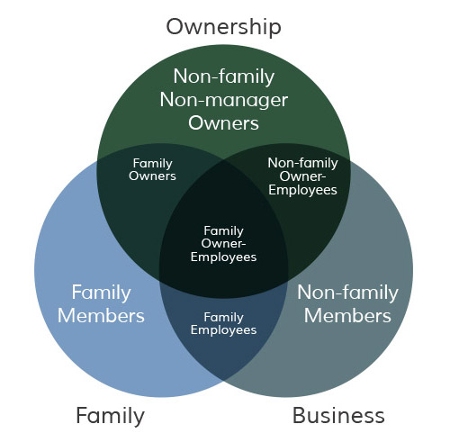

Figure:-1. (Source :- TAGIURI AND DAVIS, 1982)

FAMILY BUSINESS SUCCESSION MODEL WITH FAMILY COMPONENT
The following framework is an example of how to handle the crucial family element or family circle during a transition to new management.

Figure:-2 Family Business Succession Model
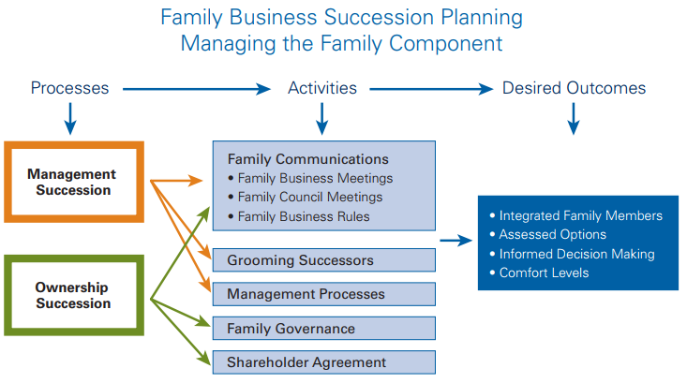

Figure:-2. (Source :- KPMG Enterprise centre for Family Business)

- succession processes

The management succession process and the ownership succession process are the two halves of a family business's succession strategy. Both procedures explain many inheritance operations to accomplish the final inheritance outcome. To ensure that the asset succession plan accurately reflects and supports the management succession process, we advise that it be finalized after the management succession process has been completed.
- Succession Activities
The model depicts a variety of family business inheritance actions that might include family members in succession planning and management. Similarly, events are planned to help relatives feel more at ease with the inheritance procedure and its outcomes. The ultimate goal is for family members to have enough information to make educated choices about their individual and collective futures as managers and owners of a family company. The inheritance process may be facilitated by instituting family communication activities such family business meetings for involved family members, family council meetings for extended families, and family business norms. Preparing potential successors and include engaged family members in important management processes are also part of management succession initiatives.
The model also details the inheritance procedure, complete with a family tree and a list of inheritance actions. The same channels of communication are used for these actions as for the succession plan for leadership. Inheriting property also involves addressing issues of corporate governance and shareholder agreements within a family. In this fourth section, we will go through the many ways in which a property might be inherited. Work related to management and inheritance may be done simultaneously. However, before moving forward with asset inheritance operations, it is advised that the management succession process or plan be undertaken or executed. You'll see that the suggested strategies for managing your family have a few things in common. Management procedures and the passing down of ownership are governed by the same set of family regulations and internal communications (family business meetings, family board meetings, and family rules). What will change is the nature of the inheritance issue that will be discussed and resolved. Any transition in leadership or ownership should begin with conversations among family members.

- Desired Outcomes
The above model describes how inheritance operations may provide the desired results. Involving present and future owners of the family company in the decision-making process and giving them enough information to feel safe can help ensure that the right choices are taken. The present owners are not likely to give up if they are not satisfied with the planned financial arrangements, management succession plans, or property succession plans. The proprietors have put in too much money and time into the family firm to hand it up without the guarantee of future success. Family and essential staff are an extension of the family, and the owners want to make sure they're taken care of, too. That will also be true for the future generation. It's possible that the next generation won't be ready to execute the inheritance plan until they're more familiar with the planned roles and duties of the leadership succession team, remuneration philosophy, wealth distribution, and financing of the ownership transfer. Therefore, it is more probable that each side will construct their own safe zone the sooner rescue efforts begin. The more relaxed the participants were, the less time and effort they had to put into making choices. Success requires establishing a succession process that includes actions that provide family members choices, measure their level of comfort, and let them make educated judgments.

- COMPONENTS OF A SUCCESSFUL SUCCESSION PLAN
The following checklist will act as a guide to things that need to be considered when it is decided to start work on a succession plan for business.
Table :-1 Components of Successful Succession Plan
GOALS AND OBJECTIVES  - Recognize the need of a succession strategy  - Develop a strategy with a vision, goals, and objectives  - Set up your own plans for retirement.  - Create a list of family/stakeholder priorities  - Develop a group of expert consultants. | DECISION MAKING  - Family members should be included in the decision-making process.  - Set up a process for solving conflicts.  - Discuss your plans with loved ones and any interested parties. | SUCCESSOR(S)  - Identify successor(s)  - Ownership  - Management  - The future of the company may be shaped through training.  - Assist in the development of successors
ESTATE PLANNING  - Take into account the seller's and the buyer's tax obligations when a firm is sold or transferred.  - Make a financial and estate plan that benefits the owner, spouse, and subsequent generations.  - Provide specifics about your expected retirement income.  - Ensure the well-being of family members, both active and passive | CORPORATE STRUCTURE AND  TRANSFER METHODS  Is the company going to sell or handed to family members?  - Define each family member's and employee's specific duties.  - Position critical managerial roles  - Consider the role(s) of the retiring owner.  - Restructure the company if needed  - Get expert advice (lawyer, accountant, financial advisor, business broker, appraiser, etc.) | EXIT STRATEGY  - Determine the transmission method.  - Determine a time frame for the succession plan's execution.  - The strategy should be made public so that those who may be affected are prepared.  - Maintain constant contact amongst all involved.  - The Plan should be reviewed often and revised as needed.

Figure:-3. (Source:- Succession Planning 101 Book Community Futures)

- CONCLUSION
The role of family businesses in society has changed radically in recent times. Yesterday was a family business. Today, it's a family-like business. And in the future, this day will be the family's business and the desire for the company and the family. As companies go through different stages of the life cycle, issues of leadership and succession become important. While companies vary in their dynamics, a succession strategy that provides certainty, continuity, and effective leadership – both at the executive and board levels – must be fundamentally Accepted. Despite the importance of succession planning, business enterprises are constantly bogged down by more visible and tangible problems. Therefore, today's business enterprises increasingly require a planned succession to run the organization in the right direction, which in turn will lead the collective and ultimately lead the development of the nation.

REFERENCES
[1] Panjwani, A., Aggarwal, V., & Dhameja, N. (2008). Family business: Yesterday, today, tomorrow. Indian journal of
industrial relations, 272-291.
[2] Moren Lévesque, Annapoornima M. Subramanian,Family firm succession through the lens of technology intelligence, Journal of Family Business Strategy,Volume
13, Issue 2,2022,100485,ISSN 1877-8585, (https://www.sciencedirect.com/science/article/pii/S1877858522000031)
[3] Dutta, S. (1997). Family business in India. SAGE Publications Pvt. Limited.
[4] John A. Davis. 2022. Three-Circle Model of the Family Business System | Davis and Tagiuri. [online] Available at: <https://johndavis.com/three-circle-model-
family-business-system/> Transitioning your business. KPMG. (n.d.). https://home.kpmg/xx/en/home/services/enterprise/transitioning- your-business.html
[5] (n.d.). Https://Www.financialexpress.com/Industry/Sme/Cafe-Sme/Msme-Eodb-Succession-Planning-in-Family-Businesses-Key-Challenges-for-Small-Businesses-to-Address-for-Successful-Transition/2610631/.
[6] (n.d.).https://www.financialexpress.com/industry/india-at-75-family-businesses-that-reform-rethink-and-reinvent-rule/2625086/.
[7] Family business case studies in India kenya - value added coaching. (n.d.). from https://www.valueaddedcoaching.com/resources.html
[8] De Massis, A. V., & Rondi, E. (2020). COVID-19 and the future of family business research. Journal of Management Studies, 57(8), 1727-1731.
[9] Paola Rovelli, Marcos Ferasso, Alfredo De Massis, Sascha Kraus, Thirty years of research in family business journals: Status quo and future directions,
Journal of Family Business Strategy, 2021, 100422, ISSN 1877-8585, https://doi.org/10.1016/j.jfbs.2021.100422.
[10] Habbershon, T. G., & Williams, M. L. (1999). A resource‐based framework for assessing the strategic advantages of family firms. Family business review, 12(1), 1-25.
[11] Lindow, C. M., Stubner, S., & Wulf, T. (2010). Strategic fit within family firms: The role of family influence and the effect on performance. Journal of Family Business Strategy, 1(3), 167-178.
[12] Morris, M.H., Williams, R.W. and Nel, D. (1996), "Factors influencing family business succession", International Journal of Entrepreneurial Behavior & Research, Vol. 2 No. 3, pp. 68-81. https://doi.org/10.1108/13552559610153261

