ISOLATION AND CHARACTERIZATION OF COW DUNG MICROFLORA AND ITS EFFECTIVENESS OF Citrus Limon BIO-ENZYME

*KRISHNAVENI.R¹, SATHYA I¹, AMEERA.S¹, ARTHI.K¹, JANARANJANI.S¹
1. Assistant professor and Head, Department of Microbiology.
Idhaya College for Women. Kumbakonam.
1. Sathya I, Ameera S ,Arthi K, Janaranjani . S, UG Student
Department of Microbioogy. Idhaya College for women. kumbakonam.
Corresponding Author; krishnavenimicro@gmail.com
ABSTRACT:
Cow manure act as a good fertilizer. It contain more nutrients beneficial microbes. It supports growth useful microbes. When it was mixed with soil it improve the soil and maintain moisture. The present studies carried out isolation of cow dung microflora and its antimicrobial properties against bio enzyme citrus limon. The bacterium like shigella species 23mm inhibition and proteous species17 mm inhibition against citrus limon

INTRODUCTION
Cow dung more contain more beneficial microbes and various Nutrional components vitamins, cellulose, oxygen, carbon, mucus, potassium, nitrogen, it is being used in Agricultural and religious purpose.
A micro organisms such as bacilli coccus. According to Ware et al ., 1988 Lactation performance of two large dairy herds fed Lactobacillus acidophilus strain. Saccharomyces corevisiae act as probiotic Ware Funssin D R, Read PL et AL.,( 1988 ) Generally old cow dung has more soil microbes and Actinomices Muhamed and Amusha ( 2003 ). There are many Proofs to confirm that. Nene YL . ( 2001 ) Utilizing traditional knowledge in agriculture. Traditional knowledge system of India and Sri Lanka,.Sharma and Singh, 2015 ) ). Isolation and charactreization of bacteria from cow dung of desi cow breed on different morpho-biochemical parameters in Dehradun. (Randhawa and Kullar, 2011 ) Bioremediation of pharmaceuticals,pesticides and petrochemicals with gomeya and cow dung. ( Fleming et.al., 1929 ) Kardos N and Demain AL. (2011). Cow dung rich in Enterobacter aerogenes, Escherichia coil, Klebsilla oxytoca, Klebsilla pneumonia Morgarella morganii, Pasteurella species,antifungal agent.( Muhamed and Amusha 2003) ( Dhama et al., 2005 ). (Joseph and Sankerganesh 2001) ( Dhama et al., 2013 )cow dung shows antimicrobial properties ( Daviud odemi et al., 2007 )
Microbial Analysis of Compost Using Cow Dung as Booster. Cow dung as booster in the decomposition of organic material (Adgunloye et al., 2007 ). Cow dung act as organic Fertilizer, (V. Muralikrishna et al., 2017 ) Recycling of Organic Wastes in Agriculture: ( B. Sharma et al.,2019)

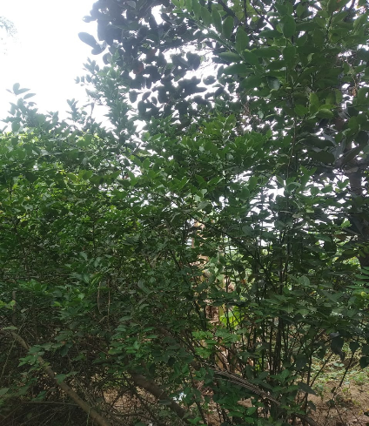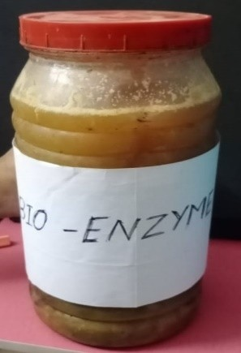
Citrus limon HerbalPlant Bio Enzyme Citruslimon.,

Bio Chemical Charecteristic Of Shigella Species.,
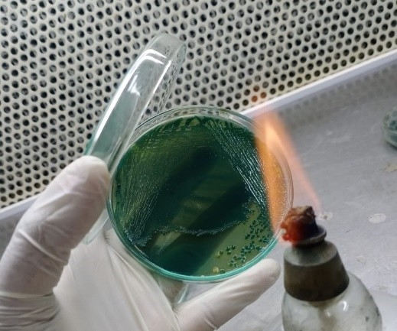
a) Shigella Sp, Hekteon Entric Agar

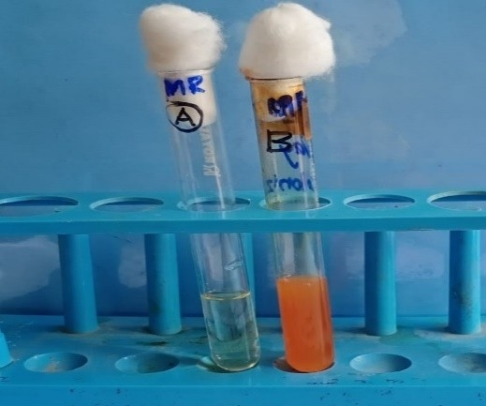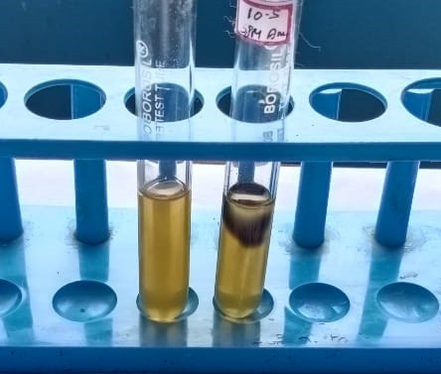b) MR -Positive b) Indole Negative

b )Urease Test-Positive a) Klebisella Pneumoniae Species
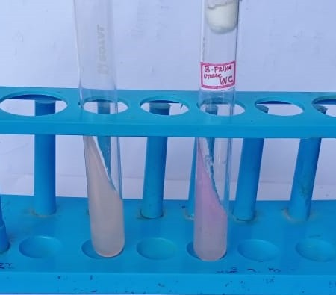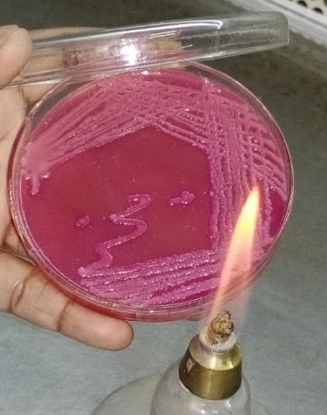

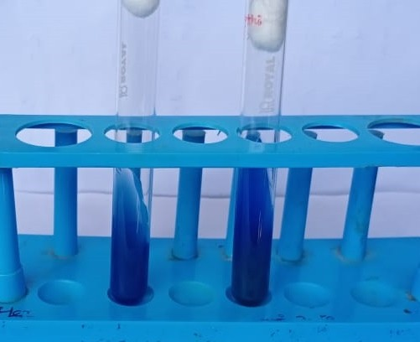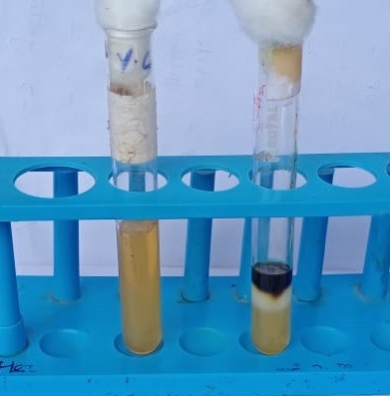 b) Indole NegativeTest Simmon’s Citrate Test- Positive

Biochemical characters of Proteus species.
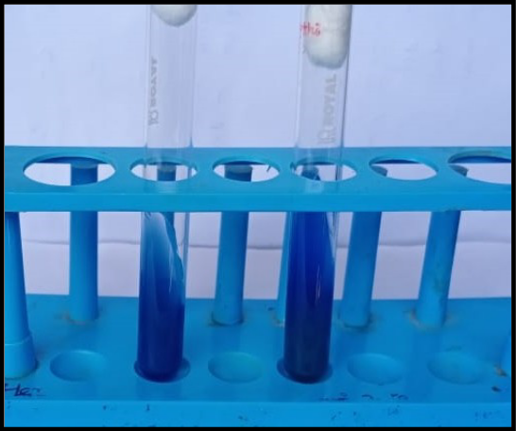
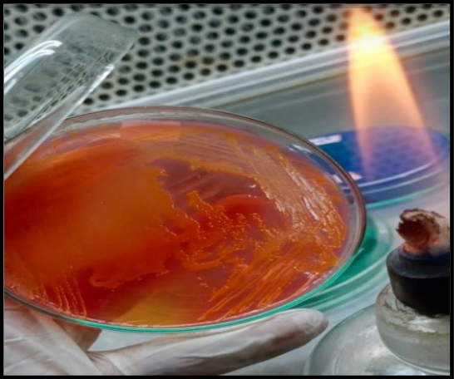

Simmon’s Citrate Test - Positive

Table: 4 Testing Antimicrobial Sensitivity of Isolates Against Bio – Enzyme (Citrus Limon)

S.NO | TESTED ORGANISM | ZONE OF INHIBITION
1. | Klebsiella species | 14mm
2. | Proteus species | 15mm
3. | Shigella species | 17mm

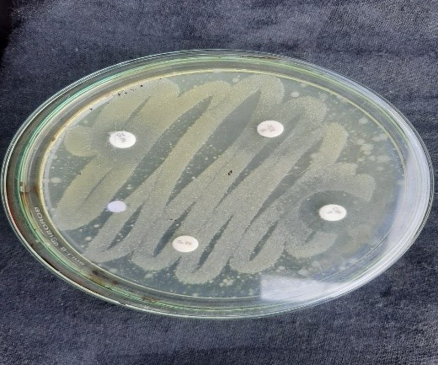Antimicrobial activity of isolated microbes
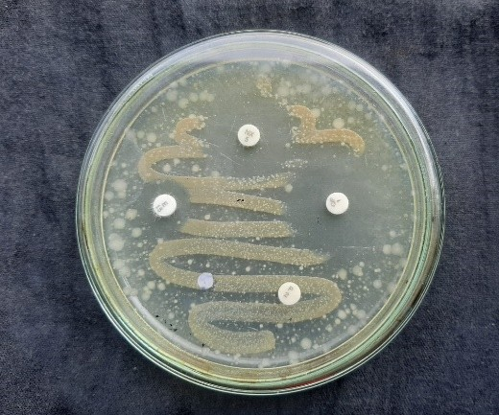Klebisella Pneumoniae Disc diffusion method- Shigella Species.,

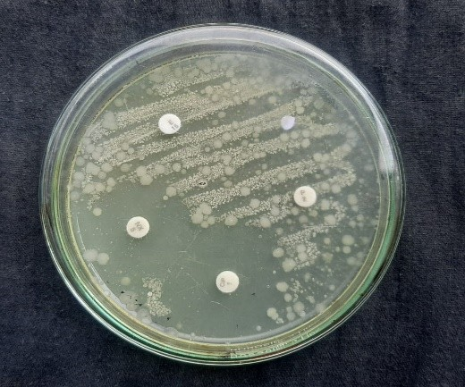Disc diffusion method- Proteus species.,

RESULT AND DISSCUSSION
The microbes like Klebsiella species, shigella species, and Proteus species isolated from cow dung. Testing of antimicrobial activity of isolates with Citrus limon
Klebsiella species 14 mm in zone of inhibition in muller hinton Agar medium. Proteus species
15 mm in zone of inhibition, Shigella species 17 mm zone of inhibition observed.this study concluded Citrus peels bio enzyme is a antimicrobial agent. The present work concluded that the bioenzyme of Citrus limon has antimicrobial properties .it ia used as cleanising solution.
REFERENCES
Abo-State MA, Mahdy HM, Ezzat SM, Abd El Shakour EH and ElBahnasawy MA. (2012). Antimicrobial resistance profiles of Enterobacteriaceae isolated from rosettabranchofriverNile,Egypt.WorldAppliedSciencesJournal.19:1234-1243.

Adegunloye DV, Adetuyi FC, Akinyosoye FA, Doyeni MO (2007). Microbial Analysis of Compost Using Cow Dung as Booster.Pak.J.Nutri.6(5):506-510.

David OM, Odeyemi AT (2007). Antibiotic resistant pattern of environmental isolates of Listeria monocytogenes from Ado-Ekiti, Nigeria. Afr. J. Biotechnol. 6(18):2135-2139

Dhama K, Chakraborty S and Tiwari R. (2013). Panchgavya therapy (Cowpathy) in safeguarding health of animals and humans-a review. Res OpinAnim Vet Sci. 3:170-178.

Fleming A. (1929). On the antibacterial action of cultures of a penicillium, with special reference to their use in the isolation of B. influenzae. Br. J. Exp. Pathol. 10:226–236.

Joseph B and Sankarganesh P. (2011). Antifungal efficacy of panchgavya.
International Journal of PharmTech Research. 3:585-588.

Kardos N and Demain AL. (2011). Penicillin: the medicine with the greatest impact on therapeutic outcomes. Appl. Microbiol. Biotechnol. 92:677–687.

Muralikrishna.V., V. Manickam, I. V. Muralikrishna, V. Manickam,Solid
Waste Management, Environ. Manage. (2017) 431– 462. https://doi.org/10.1016
/B9 78-0-12-811989-1.00016-6.

Randhawa GK, Kullar JS (2011) Bioremediation of pharmaceuticals,pesticides,
and petrochemicals with gomeya/cow dung. ISRN Pharmacol.
doi:10.5402/2011/362459

Sharma, B. and Singh, M. (2015). Isolation and charactreization of bacteria from cow dung of desi cow breed on different morpho-biochemical parameters in Dehradun. International journal of Advances in Pharmacy, Biology and Chemistry, Vol:4(2).

B. Sharma, B. Vaish, Monika, U.K. Singh, P. Singh, R.P. Singh, Recycling of Organic Wastes in Agriculture: An Environmental Perspective, Int. J. Environ. Res. 13 (2019) 409–429.https://doi.org/10.1007/s41742-019-00175-y

Ware Fungsin, D.R., Read, P.L., Mantredi, E.T. (1988). Lactation performance of two large dairy herds fed Lactobacillus acidophilus strain BT 1386. J. Dairy Sci, 71:219-222.

