EXPERIMENTAL INVESTIGATION ON PROPERTIES OF CONCRETE WITH PARTIAL REPLACEMENT OF BORON GLASS POWDER AS CEMENT

Mr. Suluru Yachandra
PhD Research Scholar, Dept. of Civil Engineering, Jawaharlal Nehru Technological University,
Anantapuramu, A.P., India.
Email: suluruyachandra@gmail.com
Dr. Valikala Giridhar
Professor, Department of Civil Engineering,
K.S.R.M. College of Engineering,
Kadapa, A.P., India.
Email: drgiridhar@ksrmce.ac.in

ABSTRACT

Fundamental target of this study is to assess the exhibition and reasonableness of boron glass powder as a trade material for concrete in concrete. The sheet glass cutting enterprises creating waste glass material, which are not reused as of now and as a rule conveyed to landfills for removal. Utilizing glass powder in concrete is a fascinating opportunities for economy on garbage removal destinations and protection of regular assets. Glass is temperamental in the basic climate of cement and could cause pernicious salt silica response issues. This property has been used to advantage by grinding it into a fine glass powder (GLP) for incorporation into concrete as a pozzolanic material. In laboratory experiments it can suppress the alkali-reactivity of coarser glass particles, as well as that of natural reactive aggregates. It goes through useful pozzolanic responses in the substantial and could supplant up to 30% of concrete in a few substantial blends in with good strength improvement. Waste glass powder in suitable extent could be utilized to oppose synthetic assault. The point of the undertaking work is to utilize boron glass powder in the scope of 10% to 30% as substitution of concrete. Substantial 3D shape compressive strength and Cylinder split rigidity was found and contrasted and ordinary substantial 3D squares and chambers. In these work squander glasses is to be utilized so the expense will be similarly low when contrasted and ordinary concrete
Keywords— Boron Glass powder, compressive strength, Split tensile strength

INTRODUCTION

As well as being solid, concrete is helpfully prepared and made from successfully open material and is subsequently used in an extensive variety of essential structure. Since the gathering of substantial produces colossal proportion of CO2 which prompts nursery influence. The test for the primary planning neighborhood instead of later is to recognize projects as one with the possibility of functional development and this incorporates the usage of unrivaled execution materials and things created at reasonable cost with the most un-possible biological impact. The consistent decline of ordinary resources and the normal dangers introduced by the glass has shown up at the upsetting degree. An outline in India says that Mumbai city alone conveys 20,000 tons of waste glass reliably. Along these lines, the use of glass as opposed to concrete is a need than need. The usage glass powder as opposed to concrete is one more perspective since in the past glass has been used in concrete for lovely and a couple of specific purposes in a manner of speaking. Regardless, the strength perspective is reliably an issue of concern. [2][3][4][5]

Scope Of The Study

Currently, one-day reuse and waste reuse also have a more prominent meaning. Against this background, the task is to improve the recycling of waste materials, glass powder in essential structural innovations instead of concrete hazardous substances and to further reduce the development effort through the use of concrete.
Thus, the project yields
- Solution for effective utilization of waste glass powder rather than cement
- To reduce the cost of construction work and maintain the same quality as like in cement mortar

LITERATURE REVIEW

Utilization of borosilicate glass powder in cementitious materials: Pozzolanic reactivity and neutron protecting properties - Mehdi Khanzadeh Moradllo, Chul-Woo Chung. exploratory outcomes demonstrate that The usage of borosilicate glass powder brings approximately a extra noteworthy depth of hydration than that everyday for concrete glue by myself at early ages (notwithstanding the manner that the blended depth discharge changed into dwindled because the substitution of borosilicate glass powder expanded). The maximum intense pozzolanic reactivity of borosilicate glass powder changed into assessed to be 55%, which changed into extra outstanding than a not unusual magnificence F fly debris (≈30%). Borosilicate glass powder delivered approximately a 8% increment withinside the 28 d compressive energy of mortar for the substitution stages of as much as 25% with the aid of using mass. The neutron weakening coefficient of mortar expanded (10-40%) as how lots borosilicate glass powder expanded; nonetheless, it seems to stage whilst the concrete substitution share changed into better than 25%[1]
Effect of recycled fine aggregates on performance of Reactive Powder Concrete - Hammad Salahuddin, Liaqat Ali Qureshi. Different properties were considered, including compressive strength, flexural strength, stiffness, sorption, water assimilation, electrical resistivity, sulfate opposition, and pollution to marine weather. Two types of reused fine sums were used; one was obtained from extinguished normal strength concrete and the second was obtained from crushed RPC. The compressive strength of all tested examples was found to increase when relaxed at 90°C for 48 hours compared to
examples held under typical recovery conditions. Mechanics Organized RPC properties with totals reused increased up to halfway through the substitution, while robustness performance steadily decreased as totals reused increased, but within reasonable limits. [6]

MATERIAL PROPERTIES

Cement
Table 1: Chemical Composition of cement
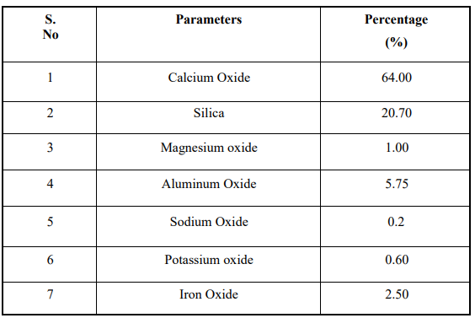

Boron Glass Powder

Waste glass is grinded and sieved below 75 micron and used. The chemical composition of glass powder is below
Table 2: Chemical Composition of Glass Powder
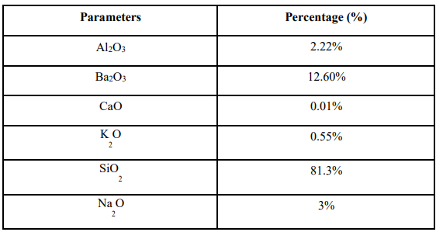

METHODOLOGY AND MIX DESIGN

Table 3: Mix Proportion for Trail Mix 1
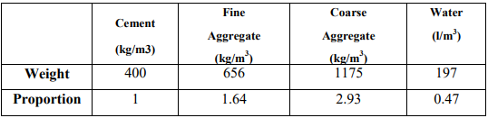

Table 4: Mix Proportion of various mixes containing boron glass waste

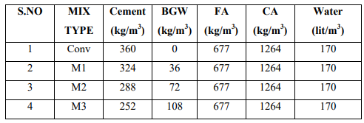

Tests on Fresh Concrete and Hardened Concrete

Workability Test
Table 5: Workability values of Concrete
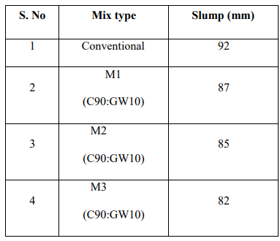

Compressive Strength
The compressive strength calculated in kg/cm² from the maximum load sustained by the cube before failure [6]

Table 6: Compressive Strength of Concrete
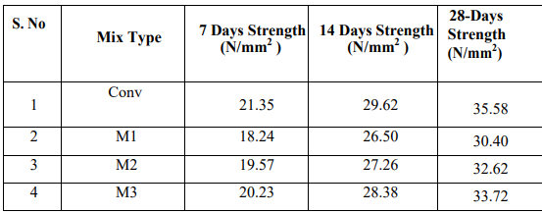

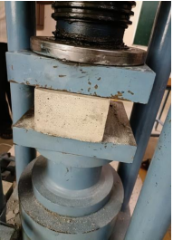
Figure 1: Compressive Strength Test on Concrete Cube
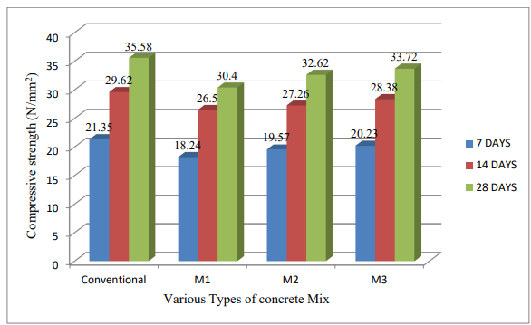
Figure 2: Graph for Compressive Strength of Concrete

Split Tensile Strength
A diametral compressive load is then applied across the cylinder until it fails, since PCC is much weaker in tension than compression, the cylinder will generally fail due to horizontal tension and not vertical compression. The table below shows the different mix ratios Divided Tensile Strength.[7]
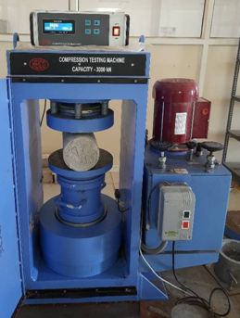
Figure 3: Split Tensile Test
Table 7: Split Tensile Strength for Concrete
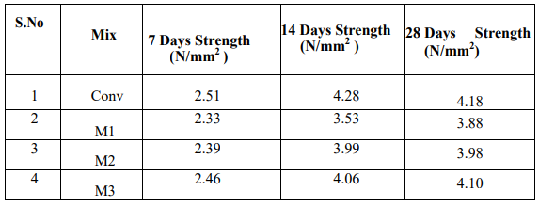
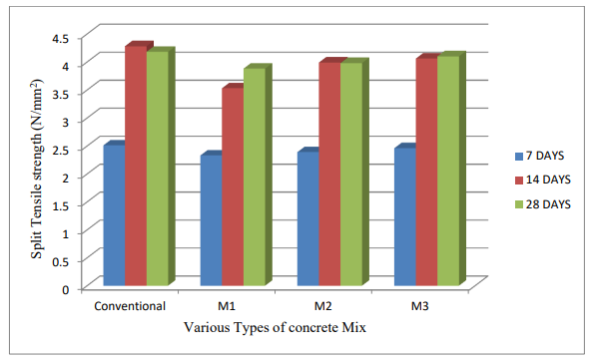
Figure 4: Graph for Split Tensile Strength of Concrete

RESULTS AND DISCUSSIONS

Compressive Strength: Compressive strength of cement with 10% boron glass squander as concrete gives 14% less strength (18.24N/mm²) at 7 days when contrasted with ordinary blend strength (21.35N/mm²). While expanding the level of boron glass squander as concrete to 20% gives 8% less strength (19.57N/mm²) and at 30% supplanting of boron glass squander with concrete the compressive strength nearly matched to the regular blend strength.
Compressive strength of cement with 10% boron glass squander as concrete gives 10% less strength (26.50N/mm²) at 14 days when contrasted with customary blend strength (29.62N/mm²). While expanding the level of boron glass squander as concrete to 20% gives 7% less strength (27.26N/mm²) and at 30% supplanting of boron glass squander with concrete the compressive strength nearly matched to the regular blend strength. At 7 years old days and 14 days the 10%, 20% didn’t arrive at the compressive strength contrasted with ordinary compressive strength, however 30% supplanting of boron glass powder with concrete at both 7,14 days the compressive strength came to the customary compressive strength.30% boron glass squander as concrete is liked to utilize in light of the outcomes acquired.
Split Tensile strength of cement with 10% boron glass squander as concrete gives 7% less strength at 7 days when contrasted with regular elasticity (21.35N/mm²). While expanding the level of boron glass squander as concrete to 20% gives 4% less strength and at 30% supplanting of boron glass squander with concrete the Tensile strength nearly matched to the customary rigidity. Elasticity of cement with 10% boron glass squander as concrete gives 15% less strength at 14 days when contrasted with customary rigidity.
While expanding the level of boron glass squander as concrete to 20% gives 6% less strength and at 30% supplanting of boron glass squander with concrete the Tensile strength nearly matched to the regular rigidity. At 7 years old days and 14 days the 10%,20% didn’t arrive at the Tensile strength contrasted with customary Tensile strength, yet 30% supplanting of boron glass powder with concrete at both 7,14 days the Tensile strength came to the traditional Tensile strength.30% boron glass squander as concrete is liked to utilize in light of the outcomes acquired[8]

CONCLUSIONS

The following conclusions were drawn at the end of this current project
- From the trial results it is seen that the compressive strength of 30 % boron glass powder with 70 % concrete at 7 and 14 days was greatest contrasting C90:GP10 and C80:GP20 blends.
- Likewise, the split Tensile Strength of 30 % boron glass powder with 70 % concrete at 7 and 14 days was greatest contrasting C90:GP10 and C80:GP20 blends.
- 30 % boron glass squander substitution as concrete gives pretty much comparative strength contrasted with customary cement. Along these lines, its reasonable for concrete with most extreme 30 % substitution as concrete.
- So it was found that boron glass powder can be helpful to supplant as concrete in concrete

REFERENCES
- Mehdi Khanzadeh Moradllo, Chul-Woo Chung, Mitchell H. Keys, Antara Choudhary, R. Reese, W. Jason Weiss,Use of borosilicate glass powder in cementitious materials: Pozzolanic reactivity and neutron shielding properties,Cement and Concrete Composites, Volume112,2020.
- Aytaç Levet, Esra Kavaz, Yüksel Özdemir,An experimental study on the investigation of nuclear radiation shielding characteristics in iron-boron alloys, Journal of Alloys and Compounds, Volume 819,2020,152946,ISSN 0925-8388, https://doi.org/10.1016/j.jallcom.2019.152946 .
- Ola A. Mayhoub, El-Sayed A.R. Nasr, Yehia A. Ali, Mohamed Kohail,The influence of ingredients on the properties of reactive powder concrete: A review,Ain Shams Engineering Journal,Volume 12, Issue 1,2021,Pages 145-158,ISSN 2090-4479, https://doi.org/10.1016/j.asej.2020.07.016 .
- Senthil Kumar Kaliyavaradhan, Tung-Chai Ling, Kim Hung Mo,Valorization of waste powders from cement-concrete life cycle: A pathway to circular future, Journal of Cleaner Production,Volume 268,2020,122358,ISSN 0959- 6526,https://doi.org/10.1016/j.jclepro.2020.122358.
- Rui Xu, S. Adrian Gale, Hwidong Kim, Richard Lott, Chad J. Spreadbury, Steven Laux, Timothy G. Townsend,Boron as a contaminant at construction and demolition (C&D) debris landfills, Waste Management,Volume 109,2020,Pages 85-93,ISSN 0956-053X, https://doi.org/10.1016/j.wasman.2020.04.051 .
- Hammad Salahuddin, Liaqat Ali Qureshi, Adnan Nawaz, Syed Safdar Raza,Effect of recycled fine aggregates on performance of Reactive Powder Concrete, Construction and Building Materials,Volume 243,2020,118223,ISSN 0950-0618, https://doi.org/10.1016/j.conbuildmat.2020.118223 .
- Bünyamin Aygün, Erdem Şakar, Esra Cinan, Nergiz Yıldız Yorgun, M.I. Sayyed, O. Agar, Abdulhalik Karabulut,Development and production of metal oxide doped glasses for gamma ray and fast neutron shielding, Radiation Physics and Chemistry,Volume 174,2020,108897,ISSN 0969-806X,https://doi.org/10.1016/j.radphyschem.2020.108897.
- Qi Cai, Jun Xie, Kai Xu, Guanglei Wang, Jianjun Han, Hong Jiang, Song Zhang,Spheroidization of borosilicate glass powder by RF induction coupled plasma, Ceramics International,2021,ISSN 0272-8842, https://doi.org/10.1016/j.ceramint.2021.04.269

