Futuristic Trends in Gastroenterology and Hepatology

Authors:
- Sumaswi Angadi (MD, DrNB)
Assistant Professor,
Department of Gastroenterology,
Nizam’s Institute of Medical Sciences,
Hyderabad, India
sumaswia@gmail.com

- Shivaraj Afzalpurkar (MD, DrNB)
Consultant Gastroenterologist,
Institute of Gastrosciences and Liver,
Apollo Multispecialty Hospital,
Kolkata, India
drshivaraj62@gmail.com

- Dhiraj Agrawal (MD, DM)
Consultant Gastroenterologist,
PACE Hospital,
Hyderabad, India
dhirajagrawal24@gmail.com

- Sushrut Ingawale (MD, DNB)
Assistant Professor,
Department of General Medicine,
Seth G.S. Medical College and KEM Hospital,
Mumbai, India.
sushrutingawale2012@kem.edu

- Suprabhat Giri (MD, DM)
Assistant Professor,
Department of Gastroenterology,
Nizam’s Institute of Medical Sciences,
Hyderabad, India.
supg19167@gmail.com

Part A: Gut Microbiota

I. INTRODUCTION

Microbiota refers to the population of micro-organisms (bacteria, fungi, viruses) that live in a particular niche. Microbiome refers to the genomes of all these micro-organisms. Each person harbors 10-100 trillion symbiotic microbial cells. The genes these cells harbor constitute the human microbiome. Bacteria account for more than 95% of genes. The human microbiome project, an extension of the human genome project was an attempt to study these microbes and the role they play in human health and disease [1]. The composition of intestinal microbiota varies widely between individuals. The microbial density increases progressively ranging from 10⁴ cells in the stomach and duodenum to 10⁸ cells in the distal ileum and 10¹¹ cells in the distal colon (Figure 1) [2]. The predominant bacterial phyla in the gut include Bacteroidetes, Firmicutes, Proteobacteria, Actinobacteria, Fusobacteria, and Verrucomicrobia, of which Firmicutes and Bacteroidetes constitute more than 90% of the bacterial population [3].

II. FUNCTIONS OF GUT MICROBIOTA

Gut microbiota maintains a symbiotic relationship and confers metabolic, immunological, and gut protective functions in a healthy individual. Following are the reported functions as per current understanding [4-7]:
- Fermentation of undigested carbohydrates results in the synthesis of short-chain fatty acids (SCFAs) such as butyrate, propionate, and acetate. These SCFAs act as energy sources for the host and control the release of anorectic hormones such as peptide YY (PYY) and glucagon-like peptide 1 (GLP1) that have a role in appetite control. Other beneficial effects such as anti-cancer effects, anti-inflammatory properties, and changes in gut motility have been reported.
- Gut microbiota suppresses the inhibition of lipoprotein lipase in adipocytes and has a positive effect on lipid metabolism
- Gut microbiota via peptidases and proteinases helps in protein metabolism.
- Synthesis of vitamin K, folic acid, Vitamins B2, and B12.
- Gut microbiota confer protective function by adhering to the attachment sites on the brush border of the intestinal epithelium. They compete with harmful micro-organisms for available nutrients. Further, the synthesis of antimicrobial proteins such as C-type lectins, Cathelicidins, and defensins by Paneth cells is induced by signaling via pattern recognition receptor (PRR) mediated mechanism.
- Intestinal microbiota plays an essential role in immunomodulation via both innate and adaptive immune systems. Microbiota stimulation leads to B cell switch to IgA, regulatory T cell induction, and T cell differentiation into Th 17 cells.
- Gut microbiota play an important role in the bidirectional communication between the central and enteric nervous systems. Gut-brain axis integrates gut functions and further links intestinal functions such as motility, enteric reflex, entero-endocrine signaling, and intestinal permeability to emotional and cognitive centers of the brain.
There are various factors affecting the variability of gut microbiota: Age, sex, genetics, diet, medications and other factors like smoking, alcohol, and psychological stress also contribute to alterations in the gut microbiome [8].

III. METHODS TO STUDY GUT MICROBIOTA

Gut microbiota is analyzed on stool samples of individuals. Though traditionally, culture-based techniques were used, with the advent of next-generation sequencing technology, analysis of gut microbiota is being done using 16S rRNA gene sequencing and bioinformatics analysis. Metagenomics allows the characterization of all genes in a microbial community and metabolomics provides a characterization of metabolites from microbiota using spectroscopic or spectrometric techniques. Fecal metabolomics is being extensively studied to identify the role of gut microbiota in various diseases [9].

IV. COMPOSITION OF NORMAL GUT MICROBIOTA

In a healthy adult, the predominant bacterial phyla include Firmicutes and Bacteroidetes, followed by Actinobacteria, Proteobacteria, and Verrucomicrobia. The distribution of gut microbiota depends on the location of the gastrointestinal tract and also on the health of the host. Dysbiosis refers to a change in the quality and quantity of the gut flora. Several diseases are associated with dysbiosis such as inflammatory bowel disease (IBD), irritable bowel syndrome, metabolic disorders (obesity, diabetes), liver disease (alcoholic liver disease, nonalcoholic fatty liver disease), and neurologic diseases, to name a few [10].

V. MODULATION OF GUT MICROBIOTA

A plausible association exists between dysbiosis and associated disorders. Correction of dysbiosis has been shown to improve the outcome of these disorders. Methods to modulate gut microbiota include dietary modifications, probiotics, prebiotics, and fecal microbiota transplantation (FMT). Westernized patterns of diet containing high fat and sugar have been shown to promote significant alteration in gut microbiota with a reduction in Bacteroides and an increase in clostridium and Enterococcus spp. Diet modification with a plant-based diet promotes healthy gut bacteria [11].
Probiotics are live microorganisms, which when administered in adequate amounts confer a health benefit to the host. Prebiotics are non-digestible food ingredients, which when administered, beneficially affect the host by selectively stimulating the growth and/or activity of one or a limited number of bacteria residents in the colon. Fermentation of these ingredients by gut microbiota results in the synthesis of SCFAs which have a variety of health benefits.
FMT is defined as the infusion of fecal suspension from a healthy individual to a patient with the disease with the aim of treating the disease. It repopulates the depleted gut microbiota, which further ameliorates dysbiosis. FMT is being used in the treatment of recurrent clostridium difficile infection. Super donors are those who have a higher diversity of gut microbiota. Specimen from super donors confers a greater benefit to the recipient. FMT requires stringent donor screening with a questionnaire, which includes proper medical and social history with blood and stool examination to rule out transmissible viral, bacterial, and parasitic infections. FMT can be administered through the nasoduodenal or nasojejunal tube or can be administered through colonoscope [12]. The route and volume of infusate depends on the indication and preference of the physician. (Figure 2) outlines the process of FMT. Currently, FMT for indications other than recurrent CDI is performed only as a part of research [13]. FMT, overall is microbial replacement therapy with few adverse effects that include transient gastrointestinal complaints. Serious adverse events such as bacteremia, ileus, perforation, aspiration, and pneumonia have been rarely reported [14]. However, long term safety and efficacy data are required before it can be widely practiced.

- Recurrent Clostridium Difficile Infection (CDI):
Clostridium difficile is commonly associated with antibiotic- associated colitis and is due to disruption of normal intestinal microbiota as a result of the usage of antibiotics. Treatment of CDI with antibiotics do not correct the basic pathophysiology of CDI, and antibiotic treatment is not effective in preventing relapse. Recurrent CDI is defined by the resolution of symptoms while on therapy, followed by the reappearance of symptoms and a confirmatory positive test within 2-8 weeks after treatment of an initial episode of CDI [15]. Patients who experience one recurrent CDI are at a risk for further recurrences. A systematic review of 45 studies revealed that the clinical effect week 8 following single FMT was 84% and for repeat FMT was 91% [16]. Delivery of FMT through lower GI tract was superior to other delivery methods. Due to the superior efficacy of FMT in treatment of recurrent CDI, guidelines recommend FMT in patients experiencing their second or further recurrence [15, 17]. Also, in severe and fulminant CDI refractory to antibiotic therapy, especially in poor surgical candidates, FMT is considered.

- Inflammatory bowel disease
- Ulcerative colitis:
Dysbiosis is evident in ulcerative colitis by the fact that there is decreased abundance of Bacteroides, firmicutes, and increased proteobacteria and certain clostridium spp. Pathogenesis of UC involves an atypical Th2 response. Inappropriate immune activation due to interaction of host and gut microbiota on a background of genetic susceptibility, environmental factors, and weakened intestinal barrier contribute to UC [18]. The first FMT was performed by Bennet and Brinkman in 1989 with a remarkable improvement for Bennet’s own UC after 7 years of refractory disease [19]. A meta-analysis of 41 studies by Paramsothy et.al. which included 555 patients revealed that clinical remission was seen in 36% of UC patients [20]. Lower GI administration improved remission. In mild to moderately active UC, 32% achieved steroid-free remission at 8 weeks with donor FMT [21]. In active UC, younger age, disease extent E2, and endoscopic Mayo score 2 significantly predicted achievement of clinical remission with FMT [22]. A Cochrane systemic review of 277 participants suggests that FMT increases the rate of clinical remission compared to controls (37% vs 18%) [23]. The role of FMT in the maintenance of clinical remission was studied in a pilot study of 61 patients who were in clinical remission. Though there was no significant difference in steroid-free clinical remission in patients assigned to FMT vs placebo (87.1% vs 66.7 %, p=0.11), endoscopic remission and histological remission were significantly higher in the FMT group compared to the placebo group [24]. In refractory UC, 43% of patients achieved clinical, endoscopic remission at week 12 after FMT [25]. The authors concluded that FMT could be used as rescue therapy in refractory UC before considering surgery. The evidence of FMT is mostly for mild to moderately active UC. The data is limited for severe UC. Further, well controlled randomized studies are needed before FMT is adopted in clinical practice. Currently, guidelines also do not endorse the usage of FMT in UC [26].

- Crohn’s disease:
Multiple factors are implicated in the pathogenesis of Crohn’s disease such as genetics, environmental factors, and gut microbiome alterations. The host and gut microbiome interaction plays an important role in Crohn’s disease. NOD2, an intracellular pattern recognizing receptor for DAMPs and PAMPs (Damage and Pathogen associated molecular patterns) regulates the secretion of cytokines and defensins, which further regulate the composition of the gut microbiome [27]. Non-functioning mutations in NOD2 with a resultant loss of NOD2 function is associated with a disturbed gut microbiome characterized by an increase in Proteobacteria sps and Actinobacteria [28]. The evidence to support FMT in Crohn’s disease is limited. In the meta-analysis by Paramsothy et.al. the pooled remission rate was 50.5.% [20]. A systematic review and meta-analysis of 12 studies that included only one randomized controlled trial revealed that overall clinical remission was 0.62 and the clinical response rate was 0.79 post FMT in CD [29]. The studies were more heterogenous with respect to the disease location, behavior, route, and volume of infusion and also the overall quality of studies was low.

- Irritable bowel syndrome
Irritable bowel syndrome is a functional gastrointestinal disorder with complex pathophysiology that includes disturbed gut microbiota with dysregulation of gut- brain interaction, visceral hypersensitivity, gastrointestinal dysmotility, post-infectious state, increased intestinal permeability, and abnormalities in entero endocrine cells [30]. A meta-analysis showed an increase in the genus Bacteroidetes and family Enterobacteriaceae and Lactobacillaceae in IBS patients. There was a decreased abundance of genus bifidobacterium and faecalibacterium [31]. Rifaximin, a nonabsorbable antibiotic has been approved for treating diarrhea-predominant IBS [32]. Rifaximin reduces the load of gut microbiota and modulates intestinal permeability, thereby exerting its beneficial effects. A recent meta-analysis of 472 patients which included 7 randomised controlled trials showed that FMT was superior to placebo in improving quality of life in IBS patients [33]. However, FMT did not improve global symptoms in IBS. Further, it was seen that FMT using fresh/frozen fecal material was superior to capsules. A randomized controlled trial of 90 patients with moderate to severe IBS showed that there was a significant improvement of symptoms of IBS with FMT(65% vs 43%) [34]. The evidence to support FMT in IBS at present is heterogenous and limited and hence, further research is needed before it is incorporated in general practice.

D. Liver and metabolic diseases
NAFLD is commonly associated with obesity and metabolic syndrome [35]. Gut microbiota studies have revealed less diversity and an abundance of Firmicutes compared to Bacteroidetes in obese individuals. Further, diet-induced weight loss in mice resulted in a corresponding change in the ratio of firmicutes to bacteroidetes, with a decrease in the number of firmicutes [36]. Gut microbiota promote the development of NAFLD through various mechanisms such as altered intestinal permeability, endotoxemia, regulation of bile acid metabolism, modulation of dietary choline metabolism, and an increase in the endogenous ethanol production by bacteria, thereby promoting hepatic fat deposition [37]. The liver receives most of its blood and nutrition supply from the intestine and hence, is the first organ to be exposed to gut-derived metabolites. Metabolic syndrome is a result of the interaction of host factors such as genetics and gut microbiome and other extrinsic factors such as diet and lifestyle. Gut microbiota affects host metabolism and hormone release, promoting insulin resistance [38]. A systematic review of 6 studies with 154 patients evaluating FMT in metabolic syndrome showed that 2 to 6 weeks after the intervention, mean HbA1c was lower in the FMT group [39].
In alcoholic hepatitis, gut dysbiosis, increased gut permeability, with microbial products in portal circulation with further modulation of innate and adaptive immune systems contribute to the pathogenesis [40]. A randomized controlled trial by Bajaj et.al. of 20 patients, of whom 10 were assigned to FMT group analyzed the role of FMT in preventing further episodes of HE compared to standard care [41]. They found that FMT given as a single enema from a rational donor after 5 days of antibiotics improved cognition and also reduced further HE episodes. In another randomized controlled trial by the same author, FMT given as oral capsules resulted in an improvement in duodenal mucosal diversity, dysbiosis, and anti-microbial peptide expression [42]. The improvement in cognition is correlated with the presence of beneficial taxa such as Ruminococcaceae, Verrucomicrobiaceae, and Lachnospiraceae [43]. Further large scale randomized controlled trials are needed to definitively assess the benefit of FMT in HE.

VI. FUTURE PERSPECTIVES

The role of gut microbiome and its association with various diseases indicates a potential role of therapies modulating gut microbiota. FMT has a potential role in many of these diseases. However, apart from recurrent CDI, FMT is not recommended in current guidelines. Further large scale randomized controlled trials are needed to assess the efficacy and safety of FMT.

REFERENCES

- Micah H, Claire FL, Rob K, Gordon Jeffrey I. The human microbiome project: exploring the microbial part of ourselves in a changing world. Nature. 2007;449(7164):804-10.
- Booijink CC, Zoetendal EG, Kleerebezem M, De Vos WM. Microbial communities in the human small intestine: coupling diversity to metagenomics.
- Mitreva M, Human Microbiome Project Consortium. Structure, function and diversity of the healthy human microbiome. Nature. 2012 Jun 14;486:207-14.
- Flint HJ, Scott KP, Louis P, Duncan SH. The role of the gut microbiota in nutrition and health. Nature reviews Gastroenterology & hepatology. 2012 Oct;9(10):577-89.
- Jandhyala SM, Talukdar R, Subramanyam C, Vuyyuru H, Sasikala M, Reddy DN. Role of the normal gut microbiota. World journal of gastroenterology: WJG. 2015 Aug 8;21(29):8787.
- Salzman NH, Underwood MA, Bevins CL. Paneth cells, defensins, and the commensal microbiota: a hypothesis on intimate interplay at the intestinal mucosa. InSeminars in immunology 2007 Apr 1 (Vol. 19, No. 2, pp. 70-83). Academic Press.
- Carabotti M, Scirocco A, Maselli MA, Severi C. The gut-brain axis: interactions between enteric microbiota, central and enteric nervous systems. Annals of gastroenterology: quarterly publication of the Hellenic Society of Gastroenterology. 2015 Apr;28(2):203.
- Capurso G, Lahner E. The interaction between smoking, alcohol and the gut microbiome. Best practice & research Clinical gastroenterology. 2017 Oct 1;31(5):579-88.
- Smirnov KS, Maier TV, Walker A, Heinzmann SS, Forcisi S, Martinez I, Walter J, Schmitt-Kopplin P. Challenges of metabolomics in human gut microbiota research. International Journal of Medical Microbiology. 2016 Aug 1;306(5):266-79.
- Carding S, Verbeke K, Vipond DT, Corfe BM, Owen LJ. Dysbiosis of the gut microbiota in disease. Microbial ecology in health and disease. 2015 Dec 1;26(1):26191.
- Brown K, DeCoffe D, Molcan E, Gibson DL. Diet-induced dysbiosis of the intestinal microbiota and the effects on immunity and disease. Nutrients. 2012 Aug 21;4(8):1095-119.
- Bhutiani N, Schucht JE, Miller KR, McClave SA. Technical aspects of fecal microbial transplantation (FMT). Current Gastroenterology Reports. 2018 Jul;20(7):1-6.
- Gupta A, Saha S, Khanna S. Therapies to modulate gut microbiota: Past, present and future. World Journal of Gastroenterology. 2020 Feb 28;26(8):777.
- Dailey FE, Turse EP, Daglilar E, Tahan V. The dirty aspects of fecal microbiota transplantation: a review of its adverse effects and complications. Current opinion in pharmacology. 2019 Dec 1;49:29-33.
- Kelly CR, Fischer M, Allegretti JR, LaPlante K, Stewart DB, Limketkai BN, Stollman NH. ACG clinical guidelines: prevention, diagnosis, and treatment of Clostridioides difficile infections. Official journal of the American College of Gastroenterology| ACG. 2021 Jun 1;116(6):1124-47.
- Baunwall SM, Lee MM, Eriksen MK, Mullish BH, Marchesi JR, Dahlerup JF, Hvas CL. Faecal microbiota transplantation for recurrent Clostridioides difficile infection: An updated systematic review and meta-analysis. EClinicalMedicine. 2020 Dec 1;29:100642.
- Johnson, S., Lavergne, V., Skinner, A.M., Gonzales-Luna, A.J., Garey, K.W., Kelly, C.P. and Wilcox, M.H., 2021. Clinical practice guideline by the Infectious Diseases Society of America (IDSA) and Society for Healthcare Epidemiology of America (SHEA): 2021 focused update guidelines on management of Clostridioides difficile infection in adults. Clinical Infectious Diseases, 73(5), pp.e1029-e1044.
- Guo XY, Liu XJ, Hao JY. Gut microbiota in ulcerative colitis: insights on pathogenesis and treatment. Journal of digestive diseases. 2020 Mar;21(3):147-59.
- Bennet J, Brinkman M. Treatment of ulcerative colitis by implantation of normal colonic flora. The Lancet. 1989 Jan 21;333(8630):164.
- Paramsothy S, Paramsothy R, Rubin DT, Kamm MA, Kaakoush NO, Mitchell HM, Castano-Rodriguez N. Faecal microbiota transplantation for inflammatory bowel disease: a systematic review and meta-analysis. Journal of Crohn's and Colitis. 2017 Oct 1;11(10):1180-99.
- Costello SP, Hughes PA, Waters O, Bryant RV, Vincent AD, Blatchford P, Katsikeros R, Makanyanga J, Campaniello MA, Mavrangelos C, Rosewarne CP. Effect of fecal microbiota transplantation on 8-week remission in patients with ulcerative colitis: a randomized clinical trial. Jama. 2019 Jan 15;321(2):156-64.
- Sood A, Singh A, Mahajan R, Midha V, Kaur K, Singh D, Bansal N, Dharni K. Clinical Predictors of response to Faecal Microbiota Transplantation in patients with active ulcerative colitis. Journal of Crohn's and Colitis. 2021 Feb;15(2):238-43.
- Imdad A, Nicholson MR, Tanner‐Smith EE, Zackular JP, Gomez‐Duarte OG, Beaulieu DB, Acra S. Fecal transplantation for treatment of inflammatory bowel disease. Cochrane Database of Systematic Reviews. 2018(11).
- Sood A, Mahajan R, Singh A, Midha V, Mehta V, Narang V, Singh T, Singh Pannu A. Role of faecal microbiota transplantation for maintenance of remission in patients with ulcerative colitis: a pilot study. Journal of Crohn's and Colitis. 2019 Sep 27;13(10):1311-7.
- Uygun A, Ozturk K, Demirci H, Oger C, Avci IY, Turker T, Gulsen M. Fecal microbiota transplantation is a rescue treatment modality for refractory ulcerative colitis. Medicine. 2017 Apr;96(16).
- Raine T, Bonovas S, Burisch J, Kucharzik T, Adamina M, Annese V, Bachmann O, Bettenworth D, Chaparro M, Czuber-Dochan W, Eder P. ECCO guidelines on therapeutics in ulcerative colitis: medical treatment. Journal of Crohn's and Colitis. 2022 Jan;16(1):2-17.
- Salzman NH. Paneth cell defensins and the regulation of the microbiome: detente at mucosal surfaces. Gut microbes. 2010 Nov 1;1(6):401-6.
- Frank DN, Robertson CE, Hamm CM, Kpadeh Z, Zhang T, Chen H, Zhu W, Sartor RB, Boedeker EC, Harpaz N, Pace NR. Disease phenotype and genotype are associated with shifts in intestinal-associated microbiota in inflammatory bowel diseases. Inflammatory bowel diseases. 2011 Jan 1;17(1):179-84.
- Cheng F, Huang Z, Wei W, Li Z. Fecal microbiota transplantation for Crohn’s disease: A systematic review and meta-analysis. Techniques in Coloproctology. 2021 May;25(5):495-504.
- Videlock EJ, Chang L. Latest insights on the pathogenesis of irritable bowel syndrome. Gastroenterology Clinics. 2021 Sep 1;50(3):505-22.
- Pittayanon R, Lau JT, Yuan Y, Leontiadis GI, Tse F, Surette M, Moayyedi P. Gut microbiota in patients with irritable bowel syndrome—a systematic review. Gastroenterology. 2019 Jul 1;157(1):97-108.
- Lacy BE, Pimentel M, Brenner DM, Chey WD, Keefer LA, Long MD, Moshiree B. ACG clinical guideline: management of irritable bowel syndrome. Official journal of the American College of Gastroenterology| ACG. 2021 Jan 1;116(1):17-44.
- Xu D, Chen VL, Steiner CA, Berinstein JA, Eswaran S, Waljee AK, Higgins PD, Owyang C. Efficacy of fecal microbiota transplantation in irritable bowel syndrome: a systematic review and meta-analysis. The American journal of gastroenterology. 2019 Jul;114(7):1043.
- Johnsen PH, Hilpüsch F, Cavanagh JP, Leikanger IS, Kolstad C, Valle PC, Goll R. Faecal microbiota transplantation versus placebo for moderate-to-severe irritable bowel syndrome: a double-blind, randomised, placebo-controlled, parallel-group, single-centre trial. The lancet Gastroenterology & hepatology. 2018 Jan 1;3(1):17-24.
- Cusi K. Role of obesity and lipotoxicity in the development of nonalcoholic steatohepatitis: pathophysiology and clinical implications. Gastroenterology. 2012 Apr 1;142(4):711-25.
- Mehal WZ. The Gordian Knot of dysbiosis, obesity and NAFLD. Nature reviews Gastroenterology & hepatology. 2013 Nov;10(11):637-44.
- Aron-Wisnewsky J, Gaborit B, Dutour A, Clement K. Gut microbiota and non-alcoholic fatty liver disease: new insights. Clinical Microbiology and Infection. 2013 Apr 1;19(4):338-48.
- Wang PX, Deng XR, Zhang CH, Yuan HJ. Gut microbiota and metabolic syndrome. Chinese medical journal. 2020 Apr 5;133(07):808-16.
- Proença IM, Allegretti JR, Bernardo WM, de Moura DT, Neto AM, Matsubayashi CO, Flor MM, Kotinda AP, de Moura EG. Fecal microbiota transplantation improves metabolic syndrome parameters: Systematic review with meta-analysis based on randomized clinical trials. Nutrition Research. 2020 Nov 1;83:1-4.
- Shasthry SM. Fecal microbiota transplantation in alcohol related liver diseases. Clinical and Molecular Hepatology. 2020 Jul;26(3):294.
- Bajaj JS, Kassam Z, Fagan A, Gavis EA, Liu E, Cox IJ, Kheradman R, Heuman D, Wang J, Gurry T, Williams R. Fecal microbiota transplant from a rational stool donor improves hepatic encephalopathy: a randomized clinical trial. Hepatology. 2017 Dec;66(6):1727-38.
- Bajaj JS, Salzman NH, Acharya C, Sterling RK, White MB, Gavis EA, Fagan A, Hayward M, Holtz ML, Matherly S, Lee H. Fecal microbial transplant capsules are safe in hepatic encephalopathy: a phase 1, randomized, placebo‐controlled trial. Hepatology. 2019 Nov;70(5):1690-703.
- Bajaj JS, Salzman N, Acharya C, Takei H, Kakiyama G, Fagan A, White MB, Gavis EA, Holtz ML, Hayward M, Nittono H. Microbial functional change is linked with clinical outcomes after capsular fecal transplant in cirrhosis. JCI insight. 2019 Dec 12;4(24).

Part B: Hepatology

I. TREATMENT OF HEPATOCELLULAR CARCINOMA

The development and introduction of new therapeutic options have advanced the management of Hepatocellular carcinoma (HCC) from early to advanced stages over the past decade. The management of HCC is primarily based on the Barcelona Clinic Liver Cancer (BCLC) system because it provides information on survival and guides treatment choices. The BCLC staging is still a good reference for the initial patient stratification, while refinement of selected patient populations with tailored therapy is needed to improve the treatment responses.
The option of surgical intervention should not be overlooked for HCC beyond the early stage based on the concept of therapeutic hierarchy. The performance of liver resection for multifocal HCC with or without tumour-related macrovascular invasion (MVI) has been investigated mainly in Asia. A multicenter study showed that resection resulted in survival benefits over non-surgical therapies for HCC across different BCLC stages, provided that liver dysfunction and performance impairment are absent [1].
The advances in loco-regional therapy (RFA, MWA, TACE, and TARE) and radiation therapy (EBRT/SBRT) provide better local control of the tumour and preserve the liver functional status. TACE can serve as a downstaging therapy for patients beyond Milan criteria; successful downstaging has been associated with excellent post-LT outcomes [2-4].
Sorafenib had been the only standard first-line therapy for advanced HCC for one decade till 2017. Recently, the development of new systemic therapy (molecular targeted agents [MTAs], immune checkpoint inhibitor [ICI] therapy) and new sequential therapies enabled a paradigm shift in the management of advanced or intermediate HCC. In advanced HCC, Lenvatinib has comparable efficacy as sorafenib for the first-line therapy, while regorafenib, cabozantinib, and ramucirumab have been approved as second-line therapy after the failure of sorafenib. Immune checkpoint inhibitors like Nivolumab and Pembrolizumab are approved by the FDA as a second-line agent for HCC after sorafenib as they prolong response rate and survival and enable long-term cure. Combination therapy of Atezolizumab plus bevacizumab is superior to sorafenib as the first-line therapy for advanced HCC. Several emerging regimens by combine various systemic therapies are currently under clinical trials. Systemic therapy should not be limited to patients with advanced HCC. It can be applied as neoadjuvant, adjuvant or initial therapy in intermediate or early HCC because of more prolonged overall survival (OS) and lower toxicity with possible complete remission. The advancement of therapeutic options expands the armamentarium to tackle HCC. In future, the clinical practice of managing HCC patients should consider a personalized therapy based on the hierarchy of efficacy from a multidisciplinary perspective and cost-effectiveness with complete or partial independence from the tumour stage. This new approach based on the 'therapeutic hierarchy' concept conforms to precision medicine and multidisciplinary care principles and widens access to therapies with better outcomes.

II. THE PARADIGM SHIFT FROM ‘NAFLD’ TO ‘MAFLD’

In 2020, a group of international experts reached a consensus to comprehensively revisit the current definition of fatty liver disease, including updating the Nomenclature from non-alcoholic fatty liver disease (NAFLD) to metabolic-dysfunction-associated fatty liver disease (MAFLD) and, more importantly introducing a simple set of 'positive' diagnostic criteria for both adults and children [5-9]. The diagnosis of MAFLD is made if a patient has hepatic steatosis and is overweight or obese, has type 2 diabetes mellitus or two or more of the following: central obesity by ethnic-specific waist circumference cut-offs; blood pressure ≥ 135/85 mmHg or specific drug treatment; plasma triglycerides ≥150 mg/dL or specific drug treatment; plasma HDL-cholesterol <40 mg/dL for men and <50 mg/dL for women or specific drug treatment; fasting plasma glucose ≥100 mg/dL, 2-h post-load glucose ≥140 mg/dL or haemoglobin A1c ≥ 5.7%; homeostasis model assessment of insulin resistance ≥2.5 and plasma high-sensitivity C-reactive protein >2 mg/L [10,11]. The proposed redefinition of MAFLD enables revolutionary simplification in diagnosing and evaluating fatty liver disease and its extra-hepatic associations. The transformational change from NAFLD to MAFLD will undoubtedly lead to improved care in the obesity pandemic.

III. DIRECT ORAL ANTICOAGULANT IN ADVANCED CHRONIC LIVER DISEASE

In the last decade, Direct oral anticoagulants (DOACs) have been increasingly used as an alternative to Vit K Antagonists because they can be orally administered, routine INR monitoring is not required, and they are effective in treating thrombosis. Dabigatran acts by directly inhibiting factor IIa (thrombin), while apixaban, rivaroxaban, and edoxaban inhibit factor Xa.
In a few observational studies which assessed the patients with advanced CLD with atrial fibrillation, VTE, and PVT, DOACs showed similar efficacy and safety profiles with similar rates of bleeding complications as traditional anticoagulants [12,13]. Thus, recent experience with DOACs in patients with cirrhosis is limited to patients with a compensated disease with cirrhosis stage Child-Pugh A or B [14]. DOACs are more expensive and require caution in patients with severe kidney disease (creatinine clearance < 30 ml/min) and impaired liver function (Child-Pugh C patients). Bleeding risk a/w DOACs can be controlled by stopping DOACs and with the use of available and effective reversal agents like idarucizumab (a specific antidote for dabigatran) and andexanet alfa (a reversal agent for the factor Xa inhibitors).
To summarize, current data from observational studies suggest that DOACs may be an effective and safe alternative to traditional anticoagulation for patients with advanced chronic liver disease (ACLD). While additional prospective studies are needed to assess better the efficacy and safety of DOACs in patients with ACLD, their use should be limited to patients with moderate impairment of the liver (Child-Pugh stage A-B) and renal function (creatinine clearance >30 mL/min).

IV. THERAPEUTIC PLASMA EXCHANGE IN LIVER FAILURE

Despite advances in the supportive medical management of acute (ALF) and acute on chronic liver failure (ACLF), these patients have significant morbidity and mortality resulting from the multi-organ failure syndrome mediated by overwhelming systemic inflammation triggered by both microbial and non-microbial factors. Expanded treatment options are needed to bridge critically ill patients to LT or to preserve liver function when LT is either contra-indicated or unavailable.
Therapeutic plasma exchange (TPE) has been proposed as an efficacious treatment modality in both acute and acute-on-chronic liver failure as it removes albumin-bound and water-soluble toxins like cytokines, endotoxins, bilirubin, bile acids, ammonia, and aromatic amino acids which have been proposed as important mediators of both hepatic encephalopathy (HE) and MOFs in ALF and ACLF. The first randomized control trial (RCT) describing the utility of TPE in ALF patients was reported in 2016 by Larsen et al. [15]. Figure 3 outlines the common methods of plasma exchange.
On the other hand, extracorporeal albumin dialysis (ECAD) systems include the molecular adsorbent recirculation system (MARS), single-pass albumin dialysis, and fractionated plasma separation and adsorption. When considering the therapeutic differences between TPE and ECAD, MARS is more costly, and filters molecules of the size of approximately 50 KDa, whereas TPE is capable of removing larger molecular proteins. Another theoretical advantage of TPE over ECAD hinges on the exchange of plasma, which replaces plasma proteins, including clotting factors that may be decreased due to the impaired hepatic synthetic function in both ALF and ACLF.
To date, there is no head-to-head clinical trial comparing TPE vs MARS or any of the ECAD systems. In a retrospective single-center pediatric study of MARS vs the combination of TPE and hemodialysis, TPE and hemodialysis affected a greater reduction in bilirubin, ammonia, and the international normalized ratio [16]. To date, TPE is most favourably employed as a bridge to LT in patients with ALF and ACLF. To conclude, pending a definitive extracorporeal liver replacement therapy, future studies should examine the role of TPE, identify which etiologies of ALF and ACLF are best served by TPE, and confirm the optimal exchange volume, frequency, and duration of treatment.

V. ARTIFICIAL INTELLIGENCE IN HEPATOLOGY

Artificial Intelligence (AI) is a mathematical process of computer mediating designing algorithms to support human intelligence. AI tools such as machine learning, deep learning, and 'big data are in a continuous phase of evolution, presently being applied for clinical and basic research. There are numerous opportunities for AI/ML applications in hepatology. The conglomeration of data, which can be clinical/laboratory, multi-omics, natural language processing (NLP) and Image recognition (both radiology-based and pathology-based), has contributed to the assessment of hepatic fibrosis progression, detection of non-alcoholic fatty liver disease, differentiation focal liver lesions, identification of patients at risk of hepatocellular carcinoma (HCC), prognosticate chronic liver disease and optimization of organ transplant protocols [17,18].
While conventional prediction models use few transparent variables, high-capacity ML algorithms may employ innumerable variables from large volumes of data and identify highly complex non-linear patterns that are less comprehensible—that is, black box models—with the promise of increased predictive accuracy [19].
An upcoming impact of AI is that it forms an essential part of the evolution of precision and personalized medicine. The ultimate goal of this combination is the prevention and early detection of diseases affecting the individual, which could ultimately decrease the disease burden for the public at large, and, therefore, the cost of preventable health care for all. However, there are many hurdles to overcome, which researchers will do soon using validation studies and molecular research.

VI. Alfapump® SYSTEM

The alfapump® (AP) is an implantable device that pumps ascitic fluid from the peritoneal space to the urinary bladder from where it is excreted. It reduces the need for repeated paracentesis in patients with recurrent or refractory ascites. In the initial RCT comparing AP with large volume paracentesis (LVP), AP was found to reduce LVP requirement and improve 6-month quality of life along with nutritional benefits [20]. The present indications for AP system in cirrhotic patients are: (i) refractory ascites due to liver cirrhosis with contraindications to trans jugular intrahepatic portosystemic shunt (TIPSS) and (ii) Recurrent ascites due to cirrhosis that is poorly controlled by diuretics and dietary measures (> 3 paracenteses per year) and contraindications to TIPSS [21]. Implantation of the pump can be done by both surgical and interventional radiological procedure. However, being an implantable device, it is associated with an increased risk of infection requiring antibiotic prophylaxis until explantation [21]. Bacterial peritonitis and urinary tract infection occur in 27% and 20% of patients, respectively. Acute kidney injury also occurs in up to 30% of patients [22]. Thus, future research and studies are required to improve the long-term outcome while reducing adverse events associated with AP system.

References:
- Vitale A, Burra P, Frigo AC, et al. Survival benefit of liver resection for patients with hepatocellular carcinoma across different barcelona clinic liver cancer stages: a multicentre study. J Hepatol. 2015;62(3):617-624.
- Yao FY, Kerlan RK, Hirose R, et al. Excellent outcome following down-staging of hepatocellular carcinoma prior to liver transplantation: an intention-to-treat analysis. Hepatology. 2008;48(3):819-827.
- Ravaioli M, Grazi GL, Piscaglia F, et al. Liver transplantation for hepatocellular carcinoma: results of down-staging in patients initially outside the Milan selection criteria. Am J Transplant. 2008;8(12):2547-2557.
- Mazzaferro V, Citterio D, Bhoori S, et al. Liver transplantation in hepatocellular carcinoma after tumour downstaging (XXL): a randomized, controlled, phase 2b/3 trial. Lancet Oncol. 2020;21(7):947-956.
- Eslam M, Newsome PN, Sarin SK, et al. A new definition for metabolic dysfunction-associated fatty liver disease: An international expert consensus statement. J Hepatol. 2020;73(1):202-209.
- Eslam M, Sanyal AJ, George J. Toward more accurate Nomenclature for fatty liver diseases. Gastroenterology. 2019;157(3):590-593.
- Eslam M, Sanyal AJ, George J. MAFLD: a consensus-driven proposed nomenclature for metabolic associated fatty liver disease.Gastroenterology. 2020;158:1999-2014. e1.
- Eslam M, Alkhouri N, Vajro P, et al. Defining paediatric metabolic (dysfunction)-associated fatty liver disease: an international expert consensus statement. Lancet Gastroenterol Hepatol.2021;6:864-873.
- Eslam M, Sarin SK, Wong VW, et al. The Asian Pacific Association for the Study of the liver clinical practice guidelines for the diagnosis and management of metabolic associated fatty liver disease. Hepatol Int. 2020;14(6):889-919.
- Shiha G, Alswat K, Al Khatry M, et al. Nomenclature and definition of metabolic-associated fatty liver disease: a consensus from the Middle East and North Africa. Lancet Gastroenterol Hepatol.2021;6(1):57-64
- Nagaoki Y, et al.: Efficacy and safety of edoxaban for treatment of portal vein thrombosis following danaparoid sodium in patients with liver cirrhosis. Hepatol Res Off J Jpn Soc Hepatol Jan. 2018, 48:51–58, https://doi.org/10.1111/hepr.12895.
- 17. Hanafy AS, Abd-Elsalam S, Dawoud MM: "Randomized controlled trial of rivaroxaban versus warfarin in the management of acute non-neoplastic portal vein thrombosis. Vascul Pharmacol Feb. 2019, 113:86–91, ttps://doi.org/10.1016/j.vph.2018.05.002.
- Steffel J, et al.: The 2018 European Heart Rhythm Association Practical Guide on the use of non-vitamin K antagonist oral anticoagulants in patients with atrial fibrillation: executive summary. Eur Eur Pacing Arrhythm Card Electrophysiol J Work Groups Card Pacing Arrhythm Card Cell Electrophysiol Eur Soc Cardiol Aug. 2018, 20:1231–1242, https://doi.org/10.1093/europace/euy054.
- "Multicenter Prospective Randomized Trial of the Effect of Rivaroxaban on Survival and Development of Complications of Portal Hypertension in Patients With Cirrhosis - Full Text View -ClinicalTrials.gov." https://clinicaltrials.gov/ct2/show/NCT02643212 (accessed May 01, 2021).
- Larsen FS, Schmidt LE, Bernsmeier C, Rasmussen A, Isoniemi H, Patel VC, Triantafyllou E, Bernal W, Auzinger G, Shawcross D, Eefsen M, Bjerring PN, Clemmesen JO, Hockerstedt K, Frederiksen HJ, Hansen BA, Antoniades CG, Wendon J. High-volume plasma exchange in patients with acute liver failure: An open randomized controlled trial. J Hepatol 2016; 64: 69-78 [PMID: 26325537 DOI: 10.1016/j.jhep.2015.08.018]
- Schaefer B, Schaefer F, Engelmann G, Meyburg J, Heckert KH, Zorn M, Schmitt CP. Comparison of Molecular Adsorbents Recirculating System (MARS) dialysis with combined plasma exchange and haemodialysis in children with acute liver failure. Nephrol Dial Transplant 2011; 26: 3633-3639 [PMID: 21421589 DOI: 10.1093/ndt/gfr115]
- Le Berre C, Sandborn WJ, Aridhi S, et al. Application of artificial intelligence to gastroenterology and hepatology. Gastroenterology 2020;158:76–94.
- Spann A, Yasodhara A, Kang J, et al. Applying machine learning in liver disease and transplantation: a comprehensive review. Hepatology 2020;71:1093–105.
- Nitski O, Azhie A, Qazi-Arisar FA, et al. Long-Term mortality risk stratification of liver transplant recipients: real-time application of deep learning algorithms on longitudinal data. Lancet Digit Health 2021;3:e295–305.
- Bureau C, Adebayo D, Chalret de Rieu M, Elkrief L, Valla D, Peck-Radosavljevic M, et al. Alfapump® system vs. large volume paracentesis for refractory ascites: A multicenter randomized controlled study. J Hepatol. 2017 Nov;67(5):940-949. doi: 10.1016/j.jhep.2017.06.010.
- Aagaard NK, Malago M, De Gottardi A, Thomas M, Sauter G, Engelmann C, et al. Consensus care recommendations for alfapump® in cirrhotic patients with refractory or recurrent ascites. BMC Gastroenterol. 2022 Mar 8;22(1):111. doi: 10.1186/s12876-022-02173-5.
- Lepida A, Marot A, Trépo E, Degré D, Moreno C, Deltenre P. Systematic review with meta-analysis: automated low-flow ascites pump therapy for refractory ascites. Aliment Pharmacol Ther. 2019 Nov;50(9):978-987.

Part C: Endoscopy

I. THIRD SPACE ENDOSCOPY

A. Introduction
First space endoscopy is nothing but performing endoscopy in natural lumen of GI tract and venturing into peritoneal cavity through natural orifice transluminal endoscopic surgery is called as second space endoscopy. Third space endoscopy (TSE) also known as submucosal endoscopy allows to enter the submucosal and deeper layers of gastrointestinal tract and perform the desired procedures like myotomy, tumor resection, etc. This is mainly done by making a mucosal flap after injecting diluted solution of methylene blue or indigo carmine proximal to the area of interest. Therefore, the principal of TSE is to create the tunnel in submucosal space along with maintaining the integrity of the overlying mucosa. An animal experiment of TSE in esophagus as treatment option of achalasia cardia by Pasricha et al in 2007 made the way for the clinical studies [1]. The concept of submucosal endoscopy and mucosal wall safety was introduced by Sumiyama et al in 2008 [2]. Inoue et al. published the first human case and subsequently the case series of endoscopic esophageal myotomy in 2008 and 2010 respectively [3,4]. This esophageal myotomy was called as per oral endoscopic myotomy (POEM) which over a period of time made paradigm shift in the treatment of achalasia cardia (AC).

B. Emerging Techniques for TSE:
- Per oral endoscopic myotomy (POEM)
POEM is most frequently studied and performed procedure for the treatment of AC which is a rare, idiopathic esophageal motility disorder characterised by failure of relaxation of lower esophageal sphincter and aperstalsis of esophageal body. Traditionally AC was treated by pneumatic balloon dilatation and laparoscopic Heller’s Myotomy. With more than 10,000 human cases reported in literature it is sufficient enough to suggest the POEM is the modality of choice in treatment of achalasia cardia. It not only requires short hospital stay as patients can be initiated with clear liquid diet after 24 hours of procedure and subsequently the semisolid diet but also has durable long-term efficacy of >85% [5,6]. It is done under general anaesthesia with patient kept nil per oral for at least 24hrs prior to procedure. With the unprecedented success achieved by POEM procedure further series of indications that can be treated with the submucosal or third space endoscopy were identified (Table 1).
- Gastric POEM (G-POEM) or Per-oral pyloromyotomy (POP)
With the advent of TSE, the treatment of refractory gastroparesis has shifted from laparoscopic pyloroplasty to the incisionless procedure called G-POEM or POP. Following the same principal steps of POEM, the procedure is done in the stomach with beginning of mucosotomy at 4 to 5 cm proximal to pyloric rim. The reported technical success rate for the procedure is 100% and the clinical success rate is variable from 66% to 100% with minimal side effects [7,12-18]. Most of the literature is from non-randomised studies with heterogeneous data hence the results should be interpreted with caution. More robust data is needed to recommend G-POEM as upfront treatment option for refractory gastroparesis.
- Zenker’s-POEM (Z-POEM)
Zenker diverticulum is a rare clinical condition which occurs due to mucosal herniation through a defect in cricopharyngeus muscle leading to a post cricoid esophageal diverticulum which can be managed by endoscopic division of the septum between the diverticular and esophageal lumen. This technique of complete and safe tunneling of the septum performed by endoscopic method is called as submucosal tunneling endoscopic septum division (STESD or Z-POEM) [19]. The reported technical and clinical success rate by an international multi-center study is 97.3% and 92% respectively [20].
- Per rectal endoscopic myotomy (PREM)
Hirschsprung’s disease (HD) is a rare congenital disorder which is seen in 1 in 2000 to 5000 live births is characterised by absence of ganglion cells in myenteric and submucosal plexus of hind gut. This leads to failure of anal sphincter relaxation during defecation. Here mucosotomy is done above the anal verge followed by creating a tunnel slightly upto proximal to the transition zone and myotomy is done till the end of tunnel.
- Submucosal tunneling and endoscopic resection (STER)
Xu et al. first described STER which is a novel technique to resect tumors in muscularis propria layer [10]. It maintains the integrity of digestive tract mucosa as a tunnel is established between muscularis propria and submuocosal layers [21,22]. This procedure has shorter procedure time and hospital stay in comparison to other procedures available for submucosal tumors.
- Per oral endoscopic tunnelling for restoration of esophagus (POETRE)
POETRE is mainly used in situations with complete esophageal stenosis of more than 3 cm to restore the esophageal lumen. Here tunnels are created in antegrade and retrograde fashion across the stricture till the esophageal lumen is visualised followed by placement of fully covered self-expandable stent in the lumen of the neoesophagus.

C. Adverse Events of TSE
The common adverse events are mainly due to insufflation related events as the submucosal plane is close to mediastinum or peritoneum. Bleeding, perforation, capnomediastinum, cardiac arrhythmia, pneumothorax, pneumonia and empyema are few of the reported serious adverse events [23,24].
TSE is a novel method of clinical practice where the submucosal endoscopy is performed by preserving the integrity of the mucosa. Advances and developments in tools and techniques and also with the increasing experience of the endoscopists the complications are getting reduced paving the way for a promising future in TSE.

Table 1. Various conditions that can be treated by third space endoscopy
Sl No | Procedure | Condition | Author
1 | POEM | Achalasia Cardia | Inoue et al [3]
2 | G-POEM or POP | Refractory Gastroparesis | Khashab et al [7]
3 | Z-POEM | Zenker’s diverticulum | Li et al [8]
4 | PREM | Hirschprung’s disease | Bapaye et al [9]
5 | STER | Submucosal tumors | Xu et al [10]
6 | POETRE | Esophageal strictures | Wagh and  Draganov [11]

II. ENDOHEPATOLOGY

A. Introduction:
The role of endoscopy in diagnosis and treatment of liver related diseases was initially restricted to screening and therapy for gastric and esophageal varices. With the evolution in the application of diagnostic and therapeutic endoscopic ultrasound (EUS) the concept of endohepatology has evolved which is reducing the dependency of gastroenterologists and endoscopists on interventional radiologists. The scope of EUS and its potential role in liver diseases (Figure 4) is in liver biopsy, elastography, contrast enhanced EUS, intra-variceal coil/glue, portal pressure measurement and porto-systemic shunt.

B. EUS guided liver assessment and biopsy
Most of the liver parenchyma can be assessed by using a probe with frequencies between 5 and 10 MHz. Along with the liver surface or parenchyma imaging the Doppler studies of surrounding portal and mesenteric circulation can be done. Liver biopsy which is traditionally done by percutaneous approach is the gold standard for the diagnosis and differentiation of different types of liver diseases. Ultrasound or computed tomography are used to guide the needle insertion or tissue sampling [25]. Trans-jugular approach is safer alternative in situations of severe coagulopathy, massive ascites or obesity [26]. The advantage of EUS is that it not only offers detailed evaluation of liver biliary tract, stomach, esophagus and mediastinal structures but also provides three-dimensional view of liver dividing it into eight functional units. EUS guided liver biopsy has got comparatively lower rate of adverse effects in view of close proximity and direct endoscopic visualisation of liver during sampling [27,28]. Endoscopists can take the sample from right or left lobe of liver using fine needle aspiration needle.
The liver parenchymal stiffness can be measured with transient elastography which correlates well with the degree of liver fibrosis. Endoscopic shear wave elastography (SWE) of both the lobes of liver help in assessment of fibrosis. EUS SWE is reliable and feasibly diagnostic modality even in the patients with body mass index of more than 35 kg/m² [29].

C. Assessment of portal circulation
EUS is a very good modality in assessment of esophageal and gastric varices, assessment of azygous vein, perforating veins, left gastric vein and portal hypertensive changes in stomach and rectal mucosa. Portal vein catheterisation and pressure monitoring during EUS is successfully demonstrated in animal models [30] and then recreated in humans in a pilot study. The pressure measured by this method is the direct portal vein pressure rather than the wedge hepatic venous pressure measured by the conventional jugular route. Further studies and expertise are needed to make the EUS guided portal measurement a standard of practice.

D. Gastric varices treatment
The treatment of bleeding gastric varices is challenging due to significant heterogeneity in vascular anatomy, location, bleeding risk and also the response to treatment. The present treatment options for gastric varices are variceal band ligation for gastroesophageal varices (GOV) type 1, injection therapies like cyanoacrylate via endoscopy or EUS for GOV type 2 and isolated gastric varices. Other options include trans jugular intrahepatic portosystemic shunt and balloon-occluded retrograde transvenous obliteration. EUS guided therapy of gastric varices is superior to routine endoscopy guided treatment [31]. Addition of endovascular coils to the glue reduces the risk of embolization [32].
With the further advancement and expertise in interventional EUS the intersection between endoscopy and hepatology will broaden. Therefore, endohepatology is an emerging field in gastroenterology which will have great impact on vascular interventions in future.

III. ARTIFICIAL INTELLIGENCE IN GASTROENTEROLOGY

Artificial intelligence (AI) is a combination of different technologies with wide variety of applications in the field of medicine. In simpler words, AI is nothing but simulating the cognitive abilities of the human brain by teaching a computer. It mimics the human brain due to its ability to perform the tasks like learning and problem solving similar to those of humans [33,34]. It is important for Gastroenterologists to be acquainted with the current status of AI applications in the field of Gastroenterology before utilising it in the diagnosis and treatment of various gastrointestinal (GI) and/or liver disorders. Right utilisation of AI will not only increase the productivity and efficiency but also reduces errors and inter-observer variability eventually enhancing the human capability in optimal patient care. AI is growing in the field of Gastroenterology as both deep learning (DL) technologies and other traditional machine learning (ML) methods are increasingly used. Algorithms based on ML using multiple demographic, clinical, biochemical, and imaging parameters are being developed to predict risk and outcomes for diagnosis and prognosis pf various GI and liver disorders. In this section, we discuss AI and associated various technological terminologies, evolving role in gastrointestinal endoscopy, utilisation in diagnosis and treatment of various digestive diseases, and future possibilities.
Common terminologies used in AI
- Machine learning (ML)- It is a technique of machining a decision in uncertain conditions by using mathematical algorithms which is automatically built from given data.
- Artificial neural networks- Interconnected multi-layered network that consists of input and output layer with a hidden connection between the two.
- Deep learning- It is composed of multiple layered neural network and act as a subset of machine learning
- Convolutional neural networks (CNN)- It consists of convolutional and pooling layers and fully connected layers making it a specific class of artificial neural networks which helps in making overall classification
Applications of AI in GI diseases
- Diagnostic Endoscopy: High quality endoscopy images are uploaded in CNN based AI for the training of the system for its utility in the diagnosis of the diseases related to GI tract. The following areas of AI endoscopy are currently being utilised or under investigation
- Polyp detection (Figure 5) [35]
- Characterisation of polyps [36]
- Histological inflammation in inflammatory bowel disease [37]
- Development of signature biomarkers for diagnosis of paediatric appendicitis [38]
- Diagnosis of colorectal cancer [39]
- Diagnosis of functional GI disorders [40]
- Classification of celiac disease [41]
- Characterization of small intestinal motility [42]
- Detection of gastrointestinal angiectasia [43]
- Capsule endoscopy [44]
- Therapeutic Endoscopy: With the recent advancement in diagnosis of GI and liver diseases the applications of AI in therapeutic endoscopy is expanding. Following are the few applications of AI in therapeutics in GI diseases.
- Classification of biliary strictures and to identify potential biomarkers in human bile [45]
- Prognosis of GI diseases including gastroesophageal reflux disease, atrophic gastritis, acute pancreatitis, carcinoma esophagus, acute lower GI and non-variceal upper GI bleeding [46]
- Predicting the response to neoadjuvant chemoradiotherapy using long non-coding RNA [47]
- Identification of gastric cancer subtype and establishment of therapeutic strategy [48]
- Inflammatory bowel disease: several laboratory parameters like haemoglobin, haematocrit, creatinine, blood urea nitrogen, C-reactive protein, liver enzymes and total leucocyte counts are included in the AI application along with the colonoscopy report for the diagnosis, classification and severity of inflammatory bowel disease [37]
- Liver diseases: AI is being used rampantly for diagnosis and prediction of various liver diseases especially staging of fibrosis in non-alcoholic fatty liver disease, predicting sustained virological remission in viral hepatitis and so on [49,50]. Machine learning uses conventional imaging modalities including ultrasound, CT, MRI and transient elastography which are otherwise limited by inter- and intra-observer variability depending on the stage of fibrosis. ML is also emerging as tools for screening and selection of liver transplant recipients and for prediction of post-transplant outcomes.

The application of AI in diagnosis and treatment of GI and liver diseases is expanding which will help in early diagnosis and treatment of diseases. There still remains some concern in terms of the precision of AI-based diagnosis and the criteria for the therapeutics despite the rapid advances of the application of AI in GI diseases.

References
- Pasricha PJ, Hawari R, Ahmed I, et al. Submucosal endoscopic esophageal myotomy: a novel experimental approach for the treatment of achalasia. Endoscopy 2007;39(9):761–764
- Sumiyama K, Tajiri H, Gostout CJ. Submucosal endoscopy with mucosal flap safety valve (SEMF) technique: a safe access method into the peritoneal cavity and mediastinum. Minim Invasive Ther Allied Technol 2008;17(6):365–369
- Inoue H, Minami H, Satodate H, Kudos E. First clinical experience of submucosal endoscopic esophageal myotomy for esophageal achalasia with no skin incision. Gastrointest Endosc 2009;69(5):AB122
- Inoue H, Minami H, Kobayashi Y, et al. Peroral endoscopic myotomy (POEM) for esophageal achalasia. Endoscopy. 2010;42:265–271.
- Li Q-L, Wu Q-N, Zhang X-C, et al. Outcomes of per-oral endoscopic myotomy for treatment of esophageal achalasia with a median follow-up of 49 months. Gastrointest Endosc 2018;87(6):1405–14e3
- Schlottmann F, Luckett DJ, Fine J, Shaheen NJ, Patti MG. Laparoscopic Heller myotomy versus peroral endoscopic myotomy (POEM) for achalasia: a systematic review and meta-analysis. Ann Surg 2018;267(3):451–460
- Khashab MA, Stein E, Clarke JO, et al. Gastric peroral endoscopic myotomy for refractory gastroparesis: first human endoscopic pyloromyotomy (with video). Gastrointest Endosc 2013;78(5):764–768
- Li Q-L, Chen W-F, Zhang X-C, et al. Submucosal tunneling endoscopic septum division: a novel technique for treating Zenker’s diverticulum. Gastroenterology 2016;151(6):1071–1074
- Bapaye A, Wagholikar G, Jog S, et al. Per rectal endoscopic myotomy for the treatment of adult Hirschsprung’s disease: First human case (with video). Dig Endosc 2016;28(6):680–684
- Xu M-D, Cai M-Y, Zhou P-H, et al. Submucosal tunnelling endoscopic resection: a new technique for treating upper GI submucosal tumors originating from the muscularis propria layer (with videos). Gastrointest Endosc 2012;75(1):195–199
- Wagh MS, Draganov PV. Per-oral endoscopic tunneling for restoration of the esophagus: a novel endoscopic submucosal dissection technique for therapy of complete esophageal obstruction. Gastrointest Endosc 2017;85(4):722–727
- Mekaroonkamol P, Li LY, Dacha S, et al. Gastric peroral endoscopic pyloromyotomy (G-POEM) as a salvage therapy for refractory gastroparesis: a case series of different subtypes. Neurogastroenterol Motil. 2016;28:1272–1277
- Mekaroonkamol P, Dacha S, Wang L, et al. Gastric peroral endoscopic pyloromyotomy reduces symptoms, increases quality of life, and reduces health care use for patients with gastroparesis. Clin Gastroenterol Hepatol. 2019;17:82–89.
- Gonzalez JM, Benezech A, Vitton V, et al. G-POEM with antro-pyloromyotomy for the treatment of refractory gastroparesis: mid-term follow-up and factors predicting outcome. Aliment Pharmacol Ther. 2017;46:364–370.
- Xu J, Chen T, Elkholy S, et al. Gastric peroral endoscopic myotomy (G-POEM) as a treatment for refractory gastroparesis: long-term outcomes. Can J Gastroenterol Hepatol. 2018: doi: 10.1155/2018/6409698
- Dacha S, Mekaroonkamol P, Li L, et al. Outcomes and qualityof- life assessment after gastric per-oral endoscopic pyloromyotomy (with video). Gastrointest Endosc. 2017;86:282–289.
- Kahaleh M, Gonzalez JM, Xu MM, et al. Gastric peroral endoscopic myotomy for the treatment of refractory gastroparesis: a multicenter international experience. Endoscopy. 2018; 50:1053–1058.
- Rodriguez JH, Haskins IN, Strong AT, et al. Per oral endoscopic pyloromyotomy for refractory gastroparesis: initial results from a single institution. Surg Endosc. 2017;31:5381–5388.
- Li QL, Chen WF, Zhang XC, et al. Submucosal tunnelling endoscopic septum division: a novel technique for treating Zenker’s diverticulum. Gastroenterology. 2016;151:1071–1074.
- Yang J, Novak S, Ujiki M, et al. An international study on the use of peroral endoscopic myotomy in the management of Zenker’s diverticulum. Gastrointest Endosc. 2019.
- Mao XL, Ye LP, Zheng HH, et al. Submucosal tunnelling endoscopic resection using methylene-blue guidance for cardial subepithelial tumors originating from the muscularis propria layer. Dis Esophagus. 2017;30:1–7
- Zhou DJ, Dai ZB, Wells MM, et al. Submucosal tunneling and endoscopic resection of submucosal tumors at the esophagogastric junction. World J Gastroenterol. 2015;21:578–583.
- Haito-Chavez Y, Inoue H, Beard KW, et al. Comprehensive analysis of adverse events associated with per oral endoscopic myotomy in 1826 patients: an international multicenter study. Am J Gastroenterol. 2017;112(8):1267-1276
- Du C, Linghu E. Submucosal tunneling endoscopic resection for the treatment of gastrointestinal submucosal tumors originating from the muscularis propria layer. J Gastrointest Surg. 2017;21(12):2100-2109.
- Mogahed EA, Mansy YA, Al Hawi Y, et al. Blind percutaneous liver biopsy in infants and children: Comparison of safety and efficacy of percussion technique and ultrasound assisted technique. Arab J Gastroenterol 2016; 17: 168-175
- Keshava SN, Mammen T, Surendrababu N, et al. Transjugular liver biopsy: What to do and what not to do. Indian J Radiol Imaging 2008; 18: 245-248
- Mohan BP, Shakhatreh M, Garg R, et al. Efficacy and safety of EUS-guided liver biopsy: a systematic review and meta-analysis. Gastrointest Endosc 2019; 89: 238-246.e3
- Johnson KD, Laoveeravat P, Yee EU, et al. Endoscopic ultrasound guided liver biopsy: Recent evidence. World J Gastrointest Endosc 2020; 12: 83-97
- Puigvehí M, Broquetas T, Coll S, et al. Impact of anthropometric features on the applicability and accuracy of FibroScan® (M and XL) in overweight/obese patients. J Gastroenterol Hepatol 2017; 32:1746-1753
- Giday SA, Ko CW, Clarke JO, et al. EUS-guided portal vein carbon dioxide angiography: a pilot study in a porcine model. Gastrointest Endosc 2007;66(4):814–9.
- Bick BL, Al-Haddad M, Liangpunsakul S, et al. EUS-guided fine needle injection is superior to direct endoscopic injection of 2-octyl cyanoacrylate for the treatment of gastric variceal bleeding. Surg Endosc 2019; 33: 1837-1845
- Cheng LF, Wang ZQ, Li CZ, et al. Low incidence of complications from endoscopic gastric variceal obturation with butyl cyanoacrylate. Clin Gastroenterol Hepatol 2010; 8:760-766.
- Liedlgruber M, Uhl A. Computer-aided decision support systems for endoscopy in the gastrointestinal tract: a review. IEEE Rev Biomed Eng 2011; 4: 73-88
- Topol EJ. High-performance medicine: the convergence of human and artificial intelligence. Nat Med 2019; 25: 44-56
- Häfner M, Brunauer L, Payer H, et al. Computer-aided classification of zoom-endoscopical images using Fourier filters. IEEE Trans Inf Technol Biomed 2010; 14:958–970
- Byrne MF, Chapados N, Soudan F, et al. Real-time differentiation of adenomatous and hyperplastic diminutive colorectal polyps during analysis of unaltered videos of standard colonoscopy using a deep learning model. Gut 2019;68:94–100
- Maeda Y, Kudo SE, Mori Y, et al. Fully automated diagnostic system with artificial intelligence using endocytoscopy to identify the presence of histologic inflammation associated with ulcerative colitis (with video). Gastrointest Endosc 2019; 89: 408-415
- Reismann J, Romualdi A, Kiss N, et al. Diagnosis and classification of pediatric acute appendicitis by artificial intelligence methods: An investigator independent approach. PLoS One 2019; 14: e0222030
- Reichling C, Taieb J, Derangere V, et al. Artificial intelligence-guided tissue analysis combined with immune infiltrate assessment predicts stage III colon cancer outcomes in PETACC08 study. Gut 2020; 69: 681-690
- Mukhtar K, Nawaz H, Abid S. Functional gastrointestinal disorders and gut-brain axis: What does the future hold? World J Gastroenterol 2019; 25: 552-566
- Zhou T, Han G, Li BN, et al. Quantitative analysis of patients with celiac disease by video capsule endoscopy: A deep learning method. Comput Biol Med 2017; 85: 1-6
- Seguí S, Drozdzal M, Pascual G, et al. Generic feature learning for wireless capsule endoscopy analysis. Comput Biol Med 2016; 79: 163-172
- Leenhardt R, Vasseur P, Li C, et al; CAD-CAP Database Working Group. A neural network algorithm for detection of GI angiectasia during small-bowel capsule endoscopy. Gastrointest Endosc 2019; 89: 189-194
- Urman JM, Herranz JM, Uriarte I, et al. Pilot Multi-Omic Analysis of Human Bile from Benign and Malignant Biliary Strictures: A Machine-Learning Approach. Cancers (Basel) 2020; 12
- Azer SA. Challenges Facing the Detection of Colonic Polyps: What Can Deep Learning Do? Medicina (Kaunas) 2019; 55
- Ferrando L, Cirmena G, Garuti A, et al. Development of a long non-coding RNA signature for prediction of response to neoadjuvant chemoradiotherapy in locally advanced rectal adenocarcinoma. PLoS One 2020; 15
- Tanabe S, Quader S, Cabral H, et al. Interplay of EMT and CSC in Cancer and the Potential Therapeutic Strategies. Front Pharmacol 2020; 11: 904
- Forlano R, Mullish BH, Giannakeas N, et al. High-Throughput, Machine Learning-Based Quantification of Steatosis, Inflammation, Ballooning, and Fibrosis in Biopsies From Patients With Nonalcoholic Fatty Liver Disease. Clin Gastroenterol Hepatol 2020; 18: 2081-2090.e9
- Leow WQ, Bedossa P, Liu F, et al. An Improved qFibrosis Algorithm for Precise Screening and Enrollment into Non-Alcoholic Steatohepatitis (NASH) Clinical Trials. Diagnostics (Basel) 2020; 10
- Qu H, Minacapelli CD, Tait C, et al. Training of computational algorithms to predict NAFLD activity score and fibrosis stage from liver histopathology slides. Comput Methods Programs Biomed 2021; 207: 106153.

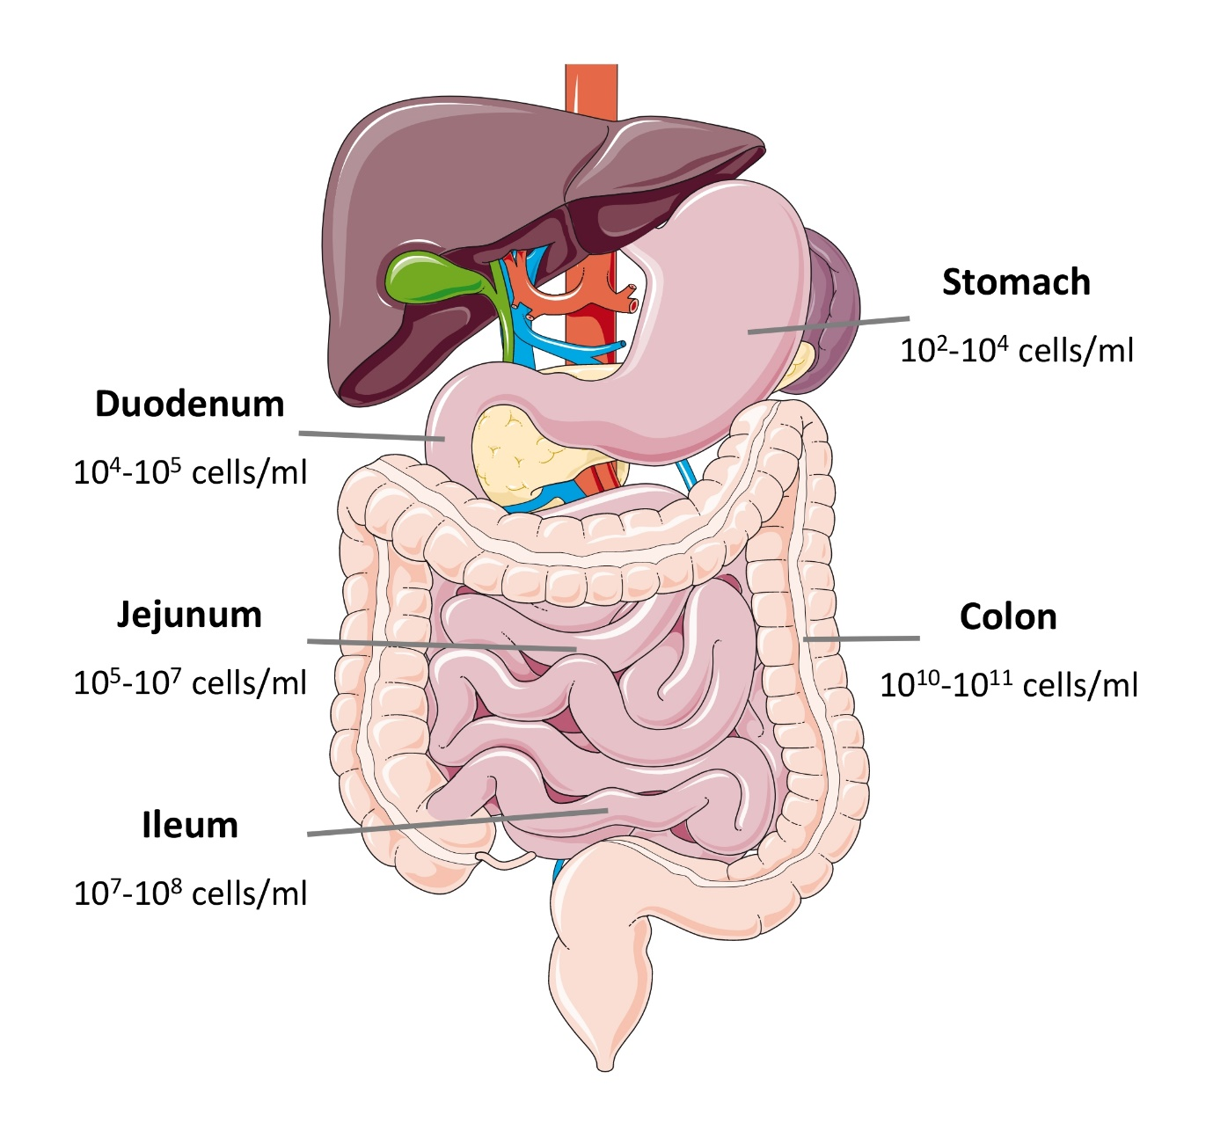

Figure 1: Schematic representation of the density of microbiota in intestinal segments
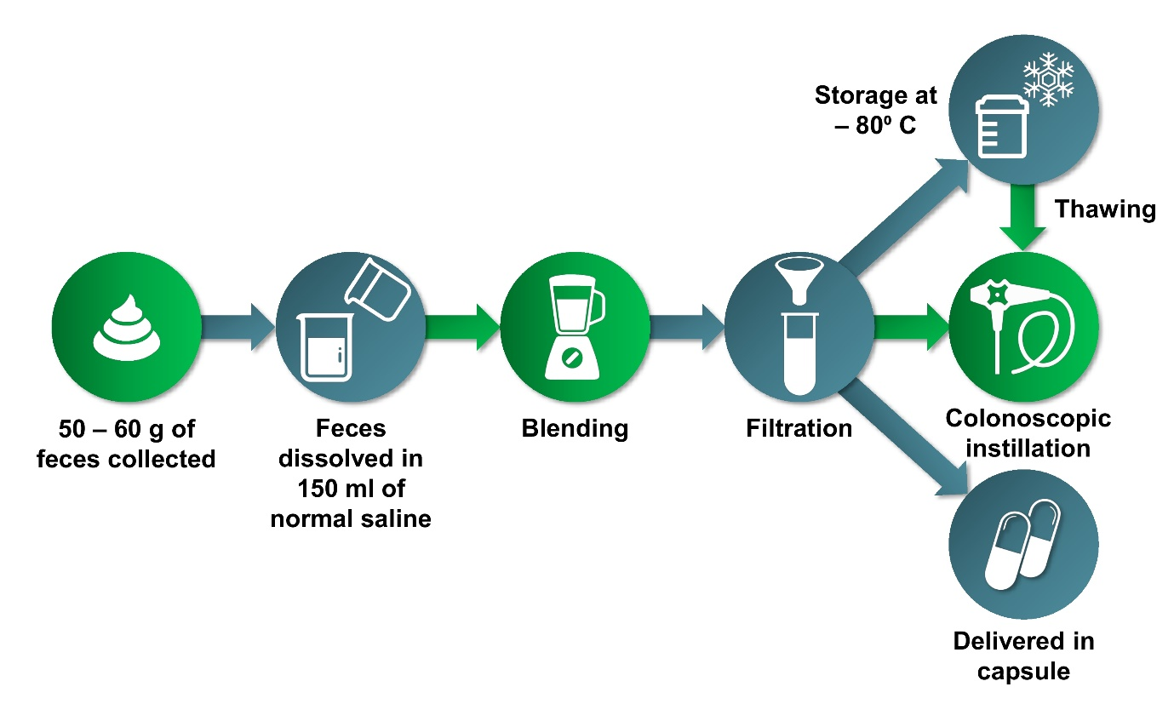

Figure 2: Schematic diagram of the process of fecal microbiota transplantation

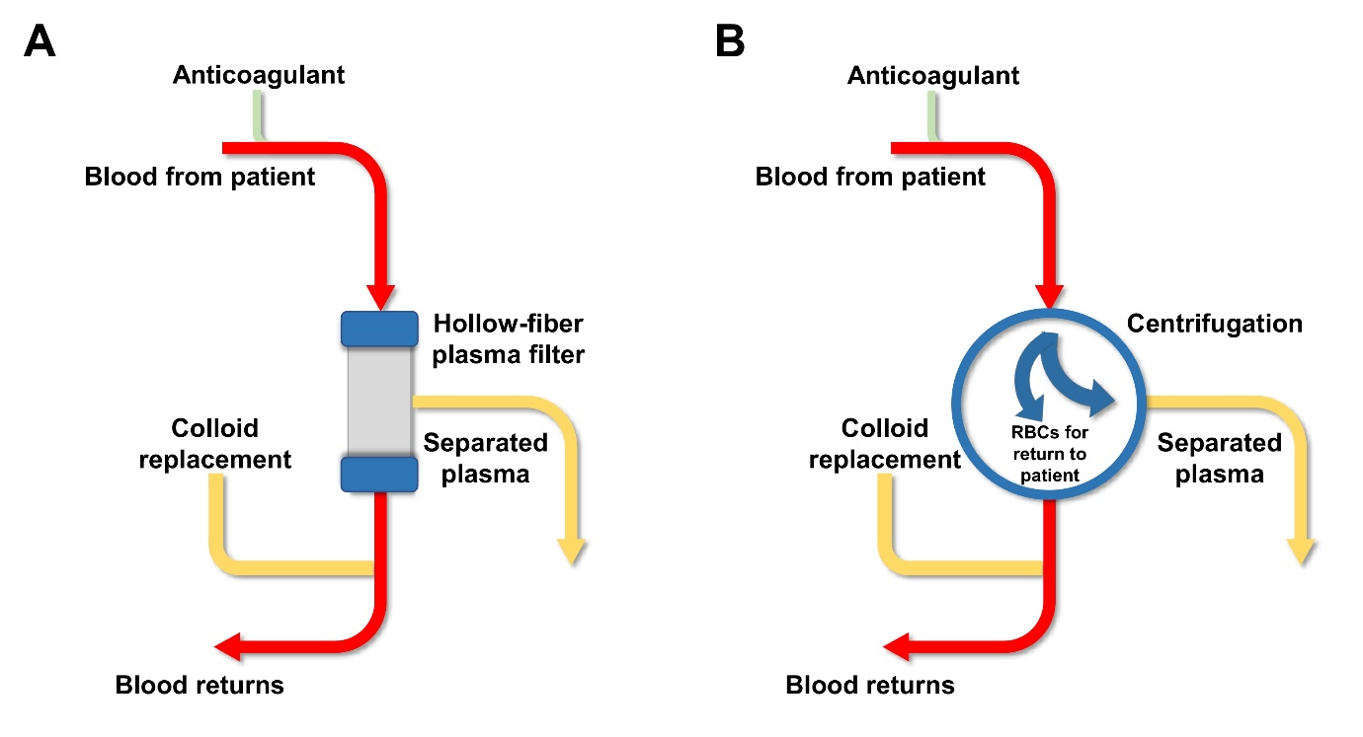
Figure 3: Illustrative examples of (A) membrane filtration therapeutic plasma exchange, (B) centrifugal therapeutic plasma exchange system

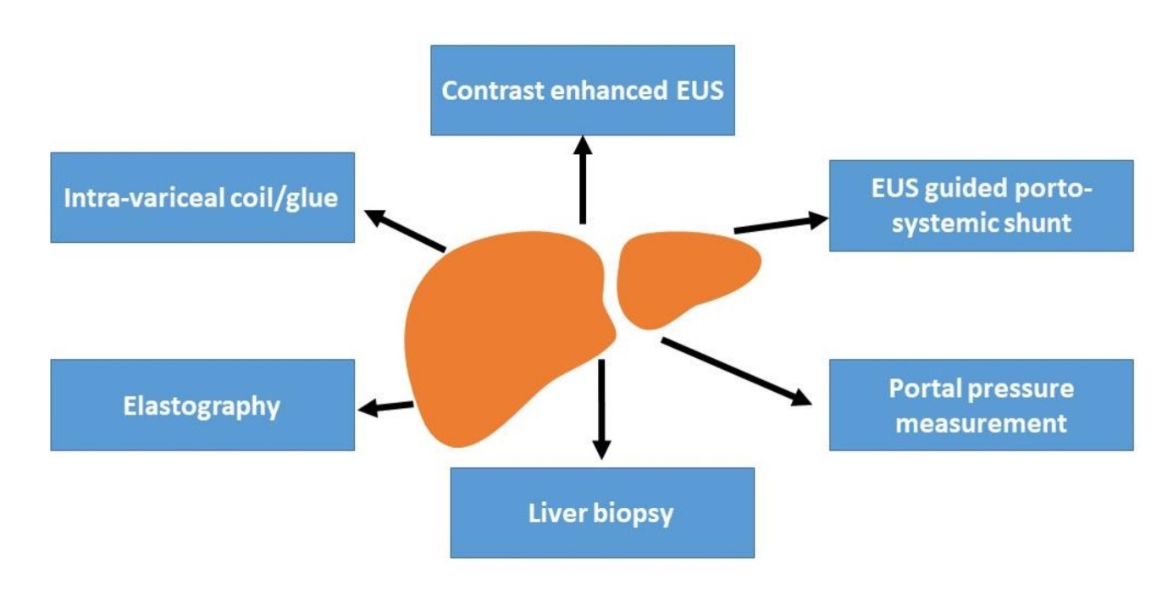
Figure 4: Evolving role of endoscopic ultrasound (EUS) in hepatology

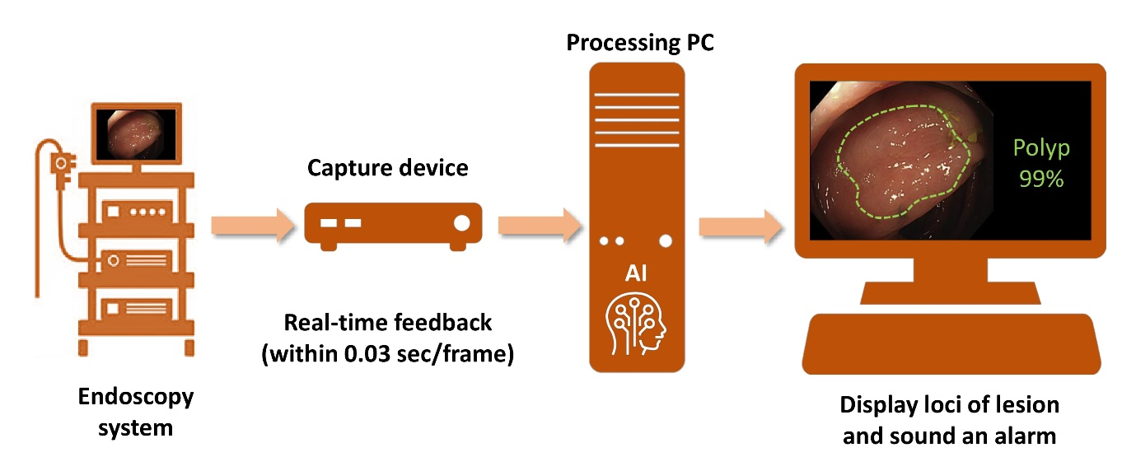
Figure 5: Schematic diagram of use of artificial intelligence for detection and characterization of polyps

