NURSING & MIDWIFERY PRACTICE
Mrs.Rajeswari.V, M.Sc (Nursing), Associate Professor, R.V.S College of Nursing, Kannampalayam,Coimbatore-641 402.
REFERRED BY
DR.S.Muthukumar,
Assistant professor,
Pharmaceutics,
KMCH college of Pharmacy,
Coimbatore.
IIP ID: IIPER1655893677
INTRODUCTION:
Nursing is interpreted in different ways by different people. Nursing has developed different dimensions and has come to mean services to meet the health needs if entire community. Nursing is a service to promote health and prevent diseases as well as giving total care to the sick in the hospital and home setup. The nurse plays very important role in creating such atmosphere which contributes towards patients’ quick recovery from the sick patients.
DEFINITION OF NURSING:
Nursing is a process of meeting the health needs of society of promoting good health for all. Nursing is a Nobel profession to give care to sick or injury person, to promote the standard of life.
N= NOBEL PROFESSION
U= UNITY
R= RESPONSIBLE PERSON
S= SIMPLICITY
E= EFFECTIVE CARE
DEFINITON OF MIDWIFERY:
Midwifery is defined as “skilled, knowledgeable and compassionate care for childbearing women, newborn infants and families across the continuum from prepregnancy, pregnancy, birth, postpartum and the early weeks of life”.
MIDWIFERY CARE:
Midwifery care has included a public health component, although the public health role is more apparent in community – based care. Midwifery person is professionally qualified acknowledges childbirth, provide psychological support to mother and family members. Midwifery care provides short term and long term health of women and their children. She focus the government policy benefits should reach to the pregnant mothers and their family.
NURSING & MIDWIFERY PRACTICE:
Nursing & Midwifery practice to be conducted by certified nurse-midwives and certified midwives is the independent management of women's health care, focusing particularly on antenatal mothers, childbirth, and the post-partum period, care of the newborn and the family planning and gynecologic needs of women.
SCOPE OF NURSE-MIDWIFERY PRACTICE:
- Pregnancy-related care including prenatal care, birth, and postpartum
- Women’s primary care , health promotion & Family planning
- Assessment of the newborn and care of the well, term newborn during the first 28 days of life
- Health promotion, disease prevention, and individualized wellness education and counseling
- Improving breast feeding rates
- Promoting mental health of the pregnant mothers
- Building social support
- Improving nutritional status of the pregnant mothers

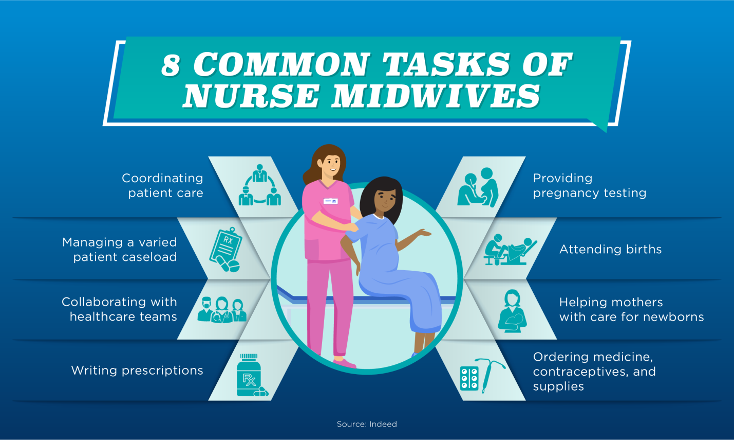

HOW MIDWIFERY HELP TO PREGNANT MOTHERS
- Monitoring pregnancy & baby
- Advising the mother to healthy eating & exercising
- Facilitating to ask questions comfortably
- Caring for women in labour
- Supporting women in 1:1 care in labour
GOALS OF MIDWIFERY NURSING:
- Emphasize the naturalness of pregnancy as a normal part of mature human development.
- Promote the highest welfare for mother & child
- Prepare and educate all expectant mothers’ well-informed participants in care throughout the entire childbearing process from conception to delivery.
- Establish a supportive care environment that makes childbearing a positive experience and encourages the development of wholesome relationship between mother and newborn and within the entire family unit.
HEALTH PROMOTION MODELS AND APPROACHES TO MIDWIFERY CARE:

Medical Centered Approach:
- This approach involves active medical participation to prevent ill-health.
- Physical well-being tends to be the marker used to judge the success of the medical approach, with minimal to the psychological, social or economic aspects of the causes and effect of diseases.
- This approach still used within midwifery e.g: the routine urine analysis and blood pressure checks for eclampsia client.
Behaviour change approach:
- Midwife encourages the pregnant women to adopt a healthier lifestyle e.g. eating the right foods, sensible alcohol intake and stopping smoking.
- This is a prominent feature of current health promotion practice for antenatal mothers.
- Pregnancy, childbirth and parenting provide a time that requires immense psychological development, when pregnant mother acquire a great deal of new information.
Educational approach:
- Educationalist explains to pregnant mothers will give facts and information’s regarding importance diet, medications, exercise, hazards of smoking and alcoholisms etc.
- This information is trusted to use it in their antenatal, intra natal and postnatal periods.
- The educationalist’s responsibility is to raise issues. This a two directional approach,this is midwife will provide information about a health issue and a pregnant women will ask their doubt.
- This approach will help to take decision making process.
Client Centered Approach:
- Pregnant mother herself decided what the issues are and set the agenda to solve the issues.
- This is considered to be a ‘bottom-up’ rather than a ‘top down’ approach.
- The pregnant mother is seen as an equal and the knowledge and skills that she brings to the interaction are valued. The theme of self empowerment is pivotal.
TRENDS IN MIDWIFERY NURSING:

Economic issues trends:
- The cost of having and raising children continues to increase faster than family income as cost has increased and as more women work outside the home.
- Women of childbearing age are employed outside the home than ever before. Because cost of living is high.
- Poorly educated parents are even more likely to experience difficulty coping with the demands.
Trends related to technology:
- Advanced in technology had led to change in every aspects of our lives.it affects us as individuals, our families, our society or culture and may theapproach child bearing.
- Technology allows diagnosing and treating serious deformities and diseases.
- Specific areas where advance in technology affect child bearing family includes:
- Fertility concerns
- Genetic counseling
- Ante partum or intra partum diagnostic testing.
Demographic issues and trends:
- Shift in population distribution large cities provide the greatest number of economic opportunities and convenience.
- Availability of maternity care in cities numbers of hospitals that are staffer and equipped to provide care to high risk maternity clients. Rural areas often lack these facilities.
- Vital statistics include birth rate, maternal mortality &morbidityrates.To effects changes in mortality rated, the focus must shift from high-technology medical interventions to improving access to preventive care.
Trends in health care settings:
- Health care delivery that focuses on reducing the cost of health care through closely monitoring the economic status of personnel.
- Hospitals have responded to consumers demand for a more natural childbirth environment.
- Nursing education curriculums are increasingly community based care.
- Routine hospitalization for mothers and newborn after an uncomplicated delivery is now 2 days or less.
Trends in patient involvements:
Maternity patients are usually well and thus their care focuses on enhancing health and wellness. Visit to health care providers presents opportunity to address topics such as
- Nutrition education
- Stress management
- Smoking cessation
- Alcohol and
- Drug treatment.
CURRENT PROBLEMS:
- Minimum stay in hospital area.
- Decrease facilities in the rural areas
- Lack of interest to provide breast feeding
- Antenatal , intra natal , and postnatal care
- Legal issues in delivery of care
- Ethical issues
- Future trends.
CULTURAL VARIATION IN MATERNAL CARE
- Emotional responses
- Clothing
- Physical activity and rest
- Sexual activity
- Diet
- Cultural aspects of lactation
- Post-partum care
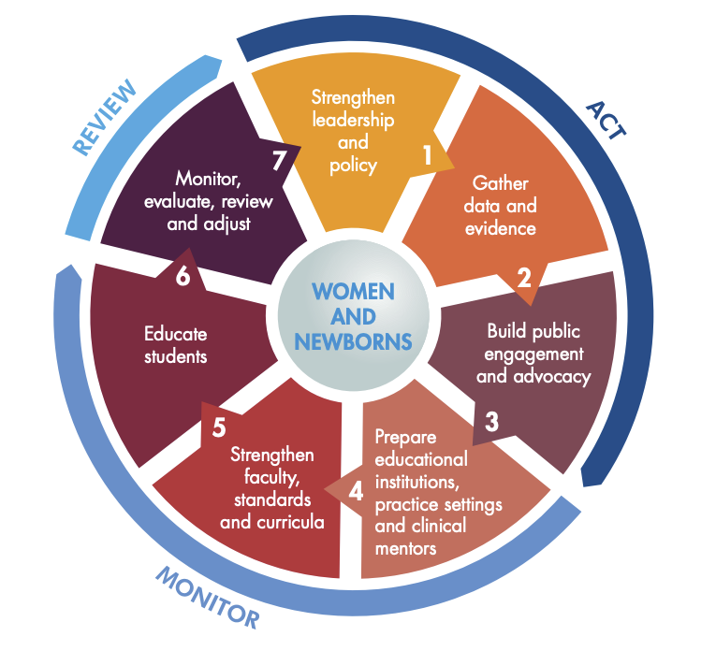

CURRENT POLICY ON MATERNAL HEALTH
- Community focus
- Flexibility of maternity service
- Continuity of care
- Focus of maternity care
- Multidisciplinary working
Community focus:
- National service framework for children, young people and maternity services (NSF) promotes a change in the organization of maternity care services are actively designed to overcome barriers to maternity care.
- It provides proactive service that reaches out to vulnerable women. An expansion of community based care has the potential to help women access services as early, e.g midwives in the children’s centre at the same time as free pregnancy testing at a family planning clinic, both in the same venue.
- Midwives spend most of their time in the community may be in a better position to follow up women who do not attend for antenatal care.
Flexibility of service provision:
- Maternity services could be based around women and their families
- The concept of flexibility in service provision suggested in the NSF extends beyond merely organizational change and has implications for clinical care, especially postnatal care.
- The maternity services include to their individual needs and those of their babies.
- Maternity service integration of maternity support workers, peer support initiatives and sure – start early years services as part of the package of care during the extended period.
Continuity of care
- Midwifery service promotes ‘community- based continuity of care schemes’ that is confidential enquiry in maternal and child health (CEMACH).
- All women should have support of a named “midwife” throughout pregnancy.
- Pregnant women can contact a midwifery service through by phone at a hospital, on either a labour ward 24 hours a day.
Focus of maternity care:
- The provision of maternity care has been to keep mothers and their babies alive and well.
- There has been a huge improvement in outcomes for women and babies medical and midwifery care.
- A growing realization that to reduce maternal mortality.
- The maternity services have to be aware of the relationship between the psychosocial context of a women’s life and her health.
- Pregnant mothers have to engage with issues around poverty, housing, domestic violence and psychological well-being.
- This may involve a change in focus for midwifery care especially in the antenatal and postnatal period.
Multidisciplinary working:
- Working as part of a specialist team, e.g. with women who have drug or alcohol issues.
- Women’s Aid to ensure that support networks are in place for women who disclose domestic violence.
- Managed care networks for antenatal care with delineation between the specialist services provided in the community and hospital setting.
- The woman’s lead career refers directly and acts as gateway and keeps in regular touch with the woman.
- Managed care networks are community partnerships, public health networks, sure-start midwives, specialist midwives and midwifery team leaders.
MATERNAL SCHEMES IN INDIA
- Janani- shishu surasha karyakramanani-
- Janani Suraksha Yojana.
- DAKSHATA implementation package.
- Pradhan Mantri Surakshit Abhiyan yojana.
Janani-Shishu Suraksha Karyakram
Government of India has launched the Janani Shishu Suraksha Karyakaram (JSSK) on 1st June, 2011. The scheme is to benefit pregnant women who access Government health facilities for their delivery.
- Free and cashless delivery
- Free C-Section
- Free drugs and consumables
- Free diagnostics
- Free diet & transport during stay in the health institutions
- Free drop back from Institutions to home after 48 hrs stay
JANANI SURAKSHA YOJANA.(JSY)
JSY is a safe motherhood intervention under the National Rural Health Mission (NRHM) being implemented with the objective of decrease the maternal and neo-natal mortality by promoting institutional delivery among the low economic back ground pregnant mothers.
Role of ASHA or other link health worker associated with JSY would be to:
* Identify pregnant woman as a beneficiary of the scheme and report for antennal registration.
* Assist the pregnant mothers to obtain necessary certifications wherever necessary.
* Provide Iron & Folic Acid tablets including TT injections to antenatal mothers.
* Counsel for institutional delivery.
* Arrange to immunize the newborn till the age of 14 weeks
* Inform about the birth or death of the child or mother to the antenatal mothers.
* Post natal visit within 7 days of delivery to track mother’s health after delivery and facilitate in obtaining care.
* Counsel for initiation of breastfeeding to the newborn within one-hour of delivery and its continuance till 3-6 months and promote family planning.
DAKSHATA IMPLEMENTATION PACKAGE.
District Administration enabled the Dakshata Initiative to find solutions to this multi-pronged problem.
- The Initiative focuses on capacity building for supply side frontline workers,
- Routine tracking of pregnant women to enable safe deliveries,
- Effective decentralization in decision making which allows village level contextual needs to be translated to planning interventions at the Block and District level.
PRADHAN MANTRI SURAKSHIT MATRITVA ABHIYAN (PMSMA)
Pradhan Mantri Surakshit Matritva Abhiyan (PMSMA) was launched to provide fixed-day assured, comprehensive and quality antenatal care universally to all pregnant women on the 9th of every month.
Objectives:
- Antenatal care is routinely provided to pregnant women, special ante natal services are provided by obstetrical and gynecology / Radiologist/ Physicians at government health facilities under PMSMA.
- As part of the campaign, a minimum package of antenatal care services are provided to pregnant women in their 2ndand 3rd trimesters of at Government health facilities ares like primary health center, community health centers, district hospitals.(PHCs/ CHCs, DHs/ urban health facilities etc) in both urban and rural areas.
- Using the principles of a single window system, it is envisaged that a minimum package of investigations and medicines such as iron & folic acid and calcium supplements would be provided to all pregnant women attending the PMSMA clinics.
Conclusion:
Ending preventable maternal death must remain at the top of the global agenda. At the same time, simply surviving pregnancy and childbirth can never be the marker of successful maternal health care. It is critical to expand efforts reducing maternal injury and disability to promote health and well-being. Every pregnant should maintain health, determine knowledge, belief and behaviour related to the promotion, maintenance, and restoration of health. Health promotion incorporates health education, prevention of diseases and health protection.
**********************

