EXPERIMENTAL INVESTIGATION ON PROPERTIES OF CONCRETE WITH PARTIAL REPLACEMENT OF BORON GLASS POWDER AS CEMENT

Mr. Suluru Yachandra
PhD Research Scholar, Dept. of Civil Engineering, Jawaharlal Nehru Technological University,
Anantapuramu, A.P., India.
Email: suluruyachandra@gmail.com
Dr. Valikala Giridhar
Professor, Department of Civil Engineering,
K.S.R.M. College of Engineering,
Kadapa, A.P., India.
Email: drgiridhar@ksrmce.ac.in

ABSTRACT

Main objective of this study is to evaluate the performance and suitability of boron glass powder as a replacement material for cement in concrete. The sheet glass cutting industries producing waste glass material, which are not recycled at present and usually delivered to landfills for disposal. Using glass powder in concrete is an interesting possibility for economy on waste disposal sites and conservation of natural resources. Glass is unstable in the alkaline environment of concrete and could cause deleterious alkali-silica reaction problems. This property has been used to advantage by grinding it into a fine glass powder (GLP) for incorporation into concrete as a pozzolanic material. In laboratory experiments it can suppress the alkali-reactivity of coarser glass particles, as well as that of natural reactive aggregates. It undergoes beneficial pozzolanic reactions in the concrete and could replace up to 30% of cement in some concrete mixes with satisfactory strength development. Waste glass powder in appropriate proportion could be used to resist chemical attack. The aim of the project work is to use boron glass powder in the range of 10% to 30% as replacement of cement. Concrete cube compressive strength and Cylinder split tensile strength was found and compared with conventional concrete cubes and cylinders. In these work waste glasses is to be used so the cost will be comparatively low when compared with normal concrete
Keywords— Boron Glass powder, compressive strength, Split tensile strength

INTRODUCTION

As well as being sturdy, concrete is handily ready and manufactured from effectively accessible material and is hence utilized in a wide range of primary framework. Since the assembling of concrete produces enormous measure of CO₂ which prompts nursery impact. The test for the structural designing local area sooner rather than later is to acknowledge projects as one with the idea of practical turn of events and this includes the utilization of superior execution materials and items fabricated at sensible expense with the least conceivable ecological effect. The constant decrease of normal assets and the natural risks presented by the glass has arrived at the disturbing extent. An overview in India says that Mumbai city alone delivers 20,000 tons of waste glass consistently. In this way, the utilization of glass rather than concrete is a need than want. The utilization glass powder rather than concrete is another aspect since in the past glass has been utilized in concrete for beautiful and a few particular purposes as it were. In any case, the strength viewpoint is consistently a question of concern. [2][3][4][5]

Scope Of The Study

Now a day’s recycling and reuse of waste materials are also given a greater importance. With this in mind, the project is connected with enhancing the use of the waste material, glass powder in concrete building technology in place of the dangerous material cement and also reducing the cost of construction by the usage of cement.
Thus, the project yields
- Solution for effective utilization of waste glass powder rather than cement
- To reduce the cost of construction work and maintain the same quality as like in cement mortar

LITERATURE REVIEW

Utilization of borosilicate glass powder in cementitious materials: Pozzolanic reactivity and neutron protecting properties - Mehdi Khanzadeh Moradllo, Chul-Woo Chung. exploratory outcomes demonstrate that the utilization of borosilicate glass powder brings about a more noteworthy intensity of hydration than that normal for concrete glue alone at early ages (in spite of the way that the combined intensity discharge was diminished as the substitution of borosilicate glass powder expanded). The most extreme pozzolanic reactivity of borosilicate glass powder was assessed to be 55%, which was more prominent than a commonplace class F fly debris (≈30%). Borosilicate glass powder brought about a 8% increment in the 28 d compressive strength of mortar for the substitution levels of up to 25% by mass. The neutron weakening coefficient of mortar expanded (10-40%) as how much borosilicate glass powder expanded; nonetheless, it appears to level when the concrete substitution proportion was higher than 25%.[1]
Effect of recycled fine aggregates on performance of Reactive Powder Concrete - Hammad Salahuddin, Liaqat Ali Qureshi. Different properties including compressive strength, flexural strength, rigidity, sorptivity, water assimilation, electrical resistivity, sulfate opposition and obstruction against marine climate were considered. Two kinds of reused fine totals were utilized; one was gotten from obliterated ordinary strength concrete and second was acquired from wrecked RPC. It was found that the compressive strength of all tried examples expanded when relieved at 90 °C for 48 h, when contrasted with the examples held under typical restoring conditions. Mechanical properties of RPC arranged with reused totals expanded up to half substitution, while solidness execution steadily diminished with an expansion in the reused total substance, yet inside sensible cutoff points. [6]

MATERIAL PROPERTIES

Cement
Table 1: Chemical Composition of cement
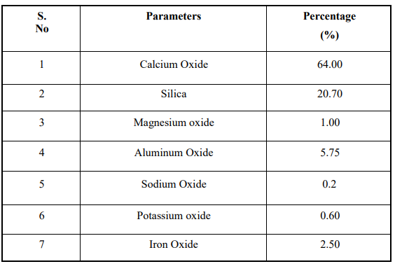

Boron Glass Powder

Waste glass is grinded and sieved below 75 micron and used. The chemical composition of glass powder is below
Table 2: Chemical Composition of Glass Powder
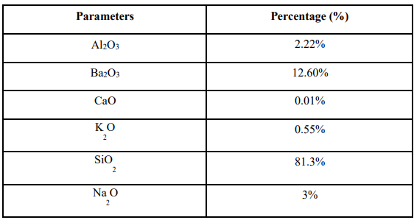

METHODOLOGY AND MIX DESIGN

Table 3: Mix Proportion for Trail Mix 1
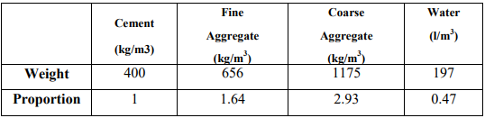

Table 4: Mix Proportion of various mixes containing boron glass waste

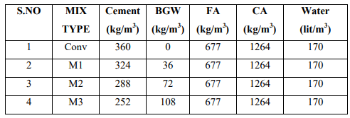

Tests on Fresh Concrete and Hardened Concrete

Workability Test
Table 5: Workability values of Concrete
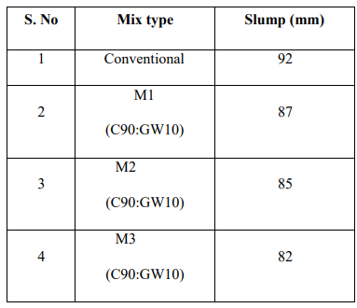

Compressive Strength
The compressive strength calculated in kg/cm² from the maximum load sustained by the cube before failure [6]

Table 6: Compressive Strength of Concrete
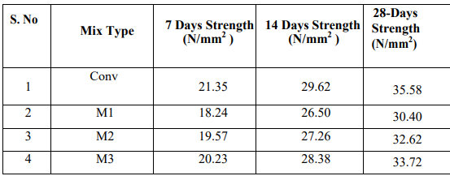

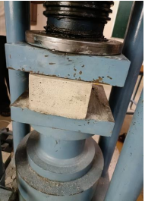
Figure 1: Compressive Strength Test on Concrete Cube
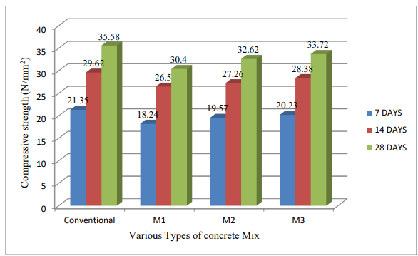
Figure 2: Graph for Compressive Strength of Concrete

Split Tensile Strength
A diametric compressive load is then applied along the length of the cylinder until it fails because PCC is much weaker in tension than compression, the cylinder will typically fail due to horizontal tension and not vertical compression. The following table shows the various mix proportion Split tensile strength.[7]
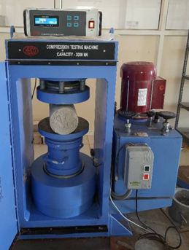
Figure 3: Split Tensile Test
Table 7: Split Tensile Strength for Concrete
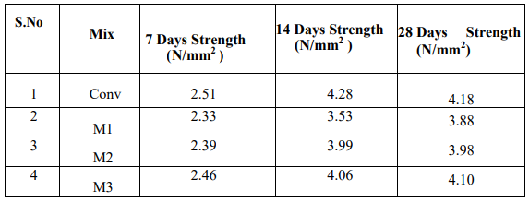
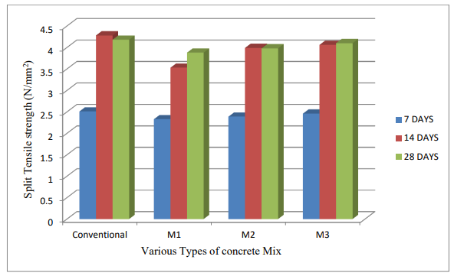
Figure 4: Graph for Split Tensile Strength of Concrete

RESULTS AND DISCUSSIONS

Compressive Strength: Compressive strength of cement with 10% boron glass squander as concrete gives 14% less strength (18.24N/mm²) at 7 days when contrasted with ordinary blend strength (21.35N/mm²). While expanding the level of boron glass squander as concrete to 20% gives 8% less strength (19.57N/mm²) and at 30% supplanting of boron glass squander with concrete the compressive strength nearly matched to the regular blend strength.
Compressive strength of cement with 10% boron glass squander as concrete gives 10% less strength (26.50N/mm²) at 14 days when contrasted with customary blend strength (29.62N/mm²). While expanding the level of boron glass squander as concrete to 20% gives 7% less strength (27.26N/mm²) and at 30% supplanting of boron glass squander with concrete the compressive strength nearly matched to the regular blend strength. At 7 years old days and 14 days the 10%, 20% didn’t arrive at the compressive strength contrasted with ordinary compressive strength, however 30% supplanting of boron glass powder with concrete at both 7,14 days the compressive strength came to the customary compressive strength.30% boron glass squander as concrete is liked to utilize in light of the outcomes acquired.
Split Tensile strength of cement with 10% boron glass squander as concrete gives 7% less strength at 7 days when contrasted with regular elasticity (21.35N/mm²). While expanding the level of boron glass squander as concrete to 20% gives 4% less strength and at 30% supplanting of boron glass squander with concrete the Tensile strength nearly matched to the customary rigidity. Elasticity of cement with 10% boron glass squander as concrete gives 15% less strength at 14 days when contrasted with customary rigidity.
While expanding the level of boron glass squander as concrete to 20% gives 6% less strength and at 30% supplanting of boron glass squander with concrete the Tensile strength nearly matched to the regular rigidity. At 7 years old days and 14 days the 10%,20% didn’t arrive at the Tensile strength contrasted with customary Tensile strength, yet 30% supplanting of boron glass powder with concrete at both 7,14 days the Tensile strength came to the traditional Tensile strength.30% boron glass squander as concrete is liked to utilize in light of the outcomes acquired[8]

CONCLUSIONS

The following conclusions were drawn at the end of this current project
- From the experimental results it is noticed that the compressive strength of 30 % boron glass powder with 70 % cement at 7 and 14 days was maximum comparing C90:GP10 and C80:GP20 mixes.
- Similarly, the split Tensile Strength of 30 % boron glass powder with 70 % cement at 7 and 14 days was maximum comparing C90:GP10 and C80:GP20 mixes.
- 30 % boron glass waste replacement as cement gives more or less similar strength compared to conventional concrete. So, its suitable for concrete with maximum 30 % replacement as cement.
- So it was found that boron glass powder can be useful to replace as cement in concrete

REFERENCES
- Mehdi Khanzadeh Moradllo, Chul-Woo Chung, Mitchell H. Keys, Antara Choudhary, R. Reese, W. Jason Weiss,Use of borosilicate glass powder in cementitious materials: Pozzolanic reactivity and neutron shielding properties,Cement and Concrete Composites, Volume112,2020.
- Aytaç Levet, Esra Kavaz, Yüksel Özdemir,An experimental study on the investigation of nuclear radiation shielding characteristics in iron-boron alloys, Journal of Alloys and Compounds, Volume 819,2020,152946,ISSN 0925-8388, https://doi.org/10.1016/j.jallcom.2019.152946 .
- Ola A. Mayhoub, El-Sayed A.R. Nasr, Yehia A. Ali, Mohamed Kohail,The influence of ingredients on the properties of reactive powder concrete: A review,Ain Shams Engineering Journal,Volume 12, Issue 1,2021,Pages 145-158,ISSN 2090-4479, https://doi.org/10.1016/j.asej.2020.07.016 .
- Senthil Kumar Kaliyavaradhan, Tung-Chai Ling, Kim Hung Mo,Valorization of waste powders from cement-concrete life cycle: A pathway to circular future, Journal of Cleaner Production,Volume 268,2020,122358,ISSN 0959- 6526,https://doi.org/10.1016/j.jclepro.2020.122358.
- Rui Xu, S. Adrian Gale, Hwidong Kim, Richard Lott, Chad J. Spreadbury, Steven Laux, Timothy G. Townsend,Boron as a contaminant at construction and demolition (C&D) debris landfills, Waste Management,Volume 109,2020,Pages 85-93,ISSN 0956-053X, https://doi.org/10.1016/j.wasman.2020.04.051 .
- Hammad Salahuddin, Liaqat Ali Qureshi, Adnan Nawaz, Syed Safdar Raza,Effect of recycled fine aggregates on performance of Reactive Powder Concrete, Construction and Building Materials,Volume 243,2020,118223,ISSN 0950-0618, https://doi.org/10.1016/j.conbuildmat.2020.118223 .
- Bünyamin Aygün, Erdem Şakar, Esra Cinan, Nergiz Yıldız Yorgun, M.I. Sayyed, O. Agar, Abdulhalik Karabulut,Development and production of metal oxide doped glasses for gamma ray and fast neutron shielding, Radiation Physics and Chemistry,Volume 174,2020,108897,ISSN 0969-806X,https://doi.org/10.1016/j.radphyschem.2020.108897.
- Qi Cai, Jun Xie, Kai Xu, Guanglei Wang, Jianjun Han, Hong Jiang, Song Zhang,Spheroidization of borosilicate glass powder by RF induction coupled plasma, Ceramics International,2021,ISSN 0272-8842, https://doi.org/10.1016/j.ceramint.2021.04.269

