AN EFFECTIVE INVESTIGATION ON RESOURCE MANAGEMENT OPTIMIZATION AND CASE STUDY ON SMART IOT AGRICULTURE

Dr. B. Nageshwar Rao¹, V Vijayakumar Dasari²

¹Associate professor, Dept. of IoT, School of Engineering, Malla reddy University, dhulapally, Hyderabad
²Assistant professor, Dept. of CS, School of Engineering, Malla Reddy University, Dhulapally, Hyderabad

¹nageshwarb@mallareddyuniversity.ac.in, ²vijaydasari@mallareddyuniversity.ac.in

ABSTRACT

The use of Resource Management Layer Manages limited resources of IoT devices such as Storage, energy, processing, bandwidth, Deployment of various IoT protocols and algorithms in the IoT framework model, also with the usage of Fundamental functions of the resource management layer such as Discovering resources, Estimating resources, Monitoring resources Allocating resources leads to final Optimization in IoT system. In this paper, detailed case study of utilization of these resources in smart IoT agriculture using various nodes and detailed result discussion are executed using MATLAB

Key words: Application layer, Processing layer, Perception layer, communication layer, Cloud layer, Edge layer, IoT layer.

I. INTRODUCTION

Internet of Things is complex environments encompassing many heterogeneous components. IoT embodies a vision of merging heterogeneous smart things utilizing Internet as a backbone of communication. IoT is a platform Everyday device become smarter Processing becomes intelligent Communication becomes informative. Huge number of things connects to the Internet, IoT applications fall in two categories into Resourceful and Resource constrained Resourceful IoT applications. A lot of work is done Most work is to improve the services offered in such applications Resource-constrained IoT applications. A lot of issues and challenges are yet to be taken for research especially in resource constrained IoT applications Resource constraints at different levels Challenges in Implementation. Data aggregation, Heterogeneity, Node Deployment, Resource Allocation, Data Management ,Resource optimization in IoT at Node and Network level

Challenges in resource management
IoT environment
Heterogeneity Management
Limited Communication
Limited Computational Power
Energy Management
Device Management
Resource Allocation
Scalability
Data Abstraction
Data Management

IoT resource management at the architectural level addresses real-time constraints of pervasive applications. Emphasis is on Optimizing resource management and allocation. Multiple factors are considered to ensure proper resource management: Energy, Bandwidth, and Latency Considerable work includes: Fog based architectures IoT architectures for pervasive applications like smart cities Cluster based IoT architecture No standard solutions has been proposed for IoT resource management

II.MOTIVATION

IoT applications fall in two categories into Resourceful and Resource constrained
Resourceful IoT applications:
A lot of work is done
Most work is to improve the services offered in such applications
Resource-constrained IoT applications:
A lot of issues and challenges are yet to be taken for research
Especially in resource constrained IoT applications
Resource constraints at different levels
Challenges in Implementation:
Data aggregation, Heterogeneity, Node Deployment, Resource Allocation, Data Management
Resource optimization in IoT at Node and Network level

III.DESIGN AND MODELING OF RESOURCE-CONSTRAINED EDGE-IOT APPLICATIONS

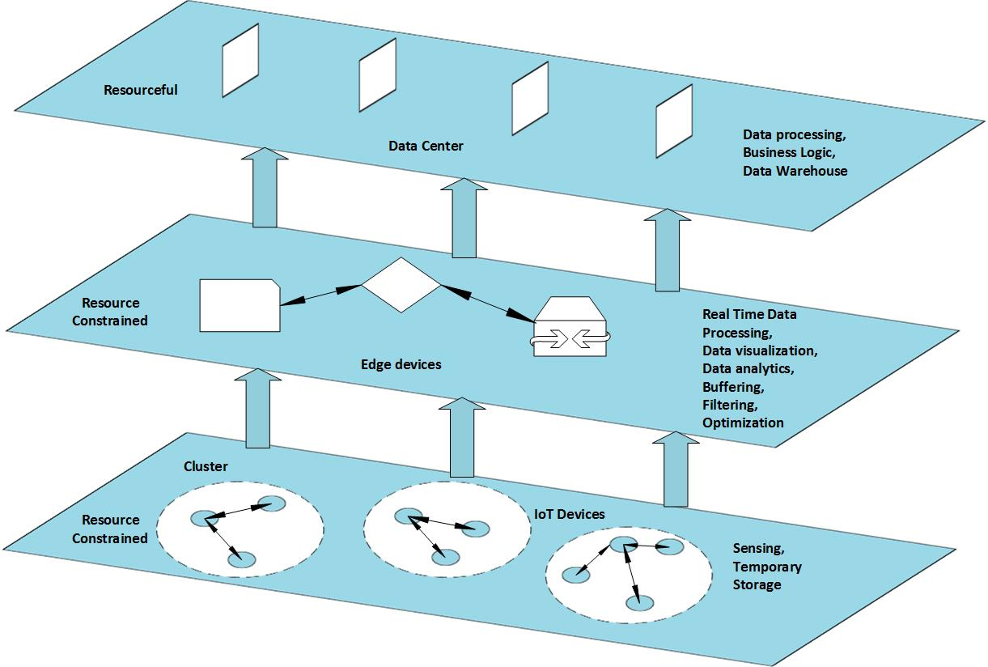

Figure 1: Edge-IoT Layered Architecture

A. Resource Management IoT

Figure 2; Resource Management IoT Architecture

B.Perception Layer

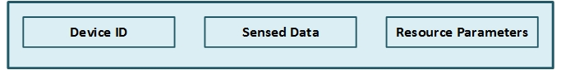

C.Communication Layer
How data has to be shared within its cluster or outside

D.Processing Layer
Min-profiles are combined into profile

E.Application Layer
Profile combined into compound profiles to give services or recommendations

IV.PROPOSED RESOURCE MANAGEMENT IOT ARCHITECTURE

Resource Management Layer
Manages limited resources of IoT devices
Storage, energy, processing, bandwidth
Deployed as protocols and algorithms in the IoT framework
Fundamental functions of the resource management layer
Discovering resources
Estimating resources
Monitoring resources
Allocating resources
Optimizes the utilization of the available resources in IoT system

A. Design and Modeling of Resource Management Edge-IoT Architecture
IoT nodes and Edge nodes in the network Cluster formation
Dedicated set of IoT nodes assigned to edge node
Sensing, processing and communication of data incurs workload Such as sense, process and transmit
Interpreted as resources needed to accomplish specific application tasks
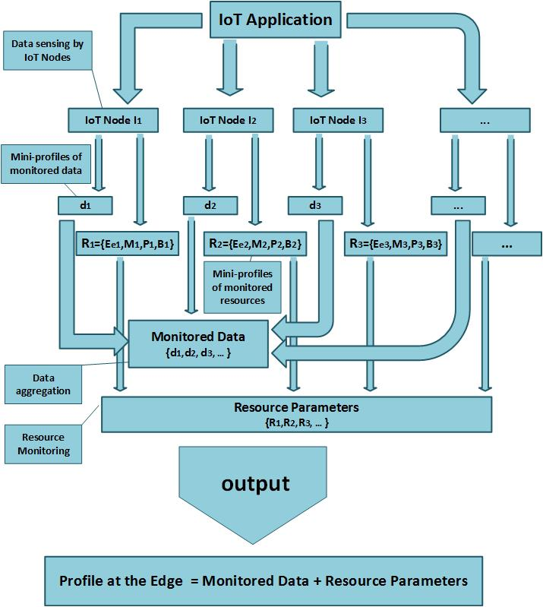

Figure 2; Resource Management Edge IoT Architecture

B.Edge-IoT Scenarios

Static IoT and Edge nodes
Static IoT and Random Edge nodes
Random IoT and Static Edge node
Random IoT and Edge Nodes
Static IoT and Edge Nodes
Location of all nodes is pre-determined
Fixed number of IoT nodes associated to a particular Edge node in each cluster
Resource consumption:
Processing and transmission of data
One-time processing in calculating parameters
such as position of nodes, distance among nodes
Static IoT and Mobile Edge Nodes
IoT nodes have fixed locations
Fixed number of IoT nodes are associated to any Edge node
Frequent calculations involved
Position and distance of random Edge nodes
Mobile IoT and Static Edge Nodes
Mobile IoT nodes are assigned to a particular Edge node
Mobile behavior of IoT nodes drains the resources more quickly
Mobile IoT and Edge Nodes
Any IoT node can be assigned to any Edge node
Nearness of distance between the IoT node and an Edge node
Resource consumption is highest

V.CASE STUDY: SMART IOT AGRICULTURE
Node Programming
For programming of IoT and edge nodes, MoteConfig application is used.
MoteConfig is windows based GUI utility for programming IoT and edge nodes.
We can configure node's ID, RF channel and RF power using MoteConfig.

In Smart IoT Agriculture, IoT nodes were randomly distributed in an agricultural field to monitor the environmental and agricultural parameters such as air temperature (in Celsius), air humidity (in %), soil temperature (in Celsius) and soil moisture (in %).

Node Configuration
The IoT node consists of an IRIS mote fitted on MTS 420 sensor board.
20 IoT nodes are randomly deployed in which 16 IoT nodes act as sensing nodes and 4 IoT nodes act as aggregator nodes.
The edge node consists of an IRIS fitted on MIB520.

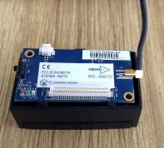

Figure 3.IoT Device

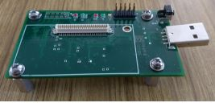
Figure 4.Edge Device

VI RESULT&DISCUSSION
A.IoT Node programming successful

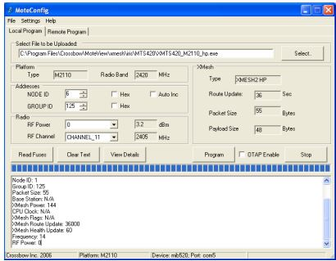
Figure 5

B.Edge Node Programming Successful

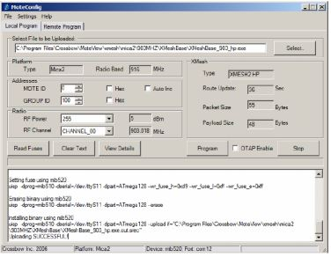
Figure 6
C.Data Collection

After the IoT nodes were successfully programmed, data was sensed and collected about a selected agricultural field for a period of 30 days. The sensed data from the IoT nodes was easily logged into the database by MoteView

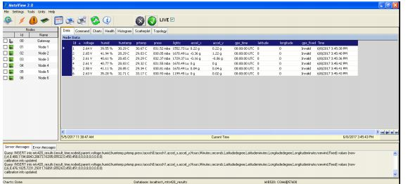
Figure 7

D.Data Analysis

Figure 8.Temperature (In Celsius) versus Time (In hours)

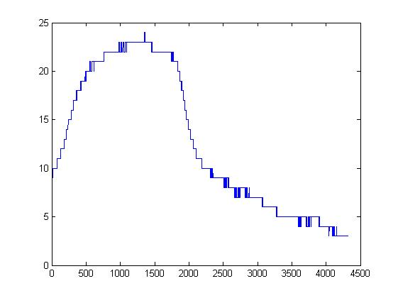

Figure 9.Humidity (In %) versus Time (In hours)

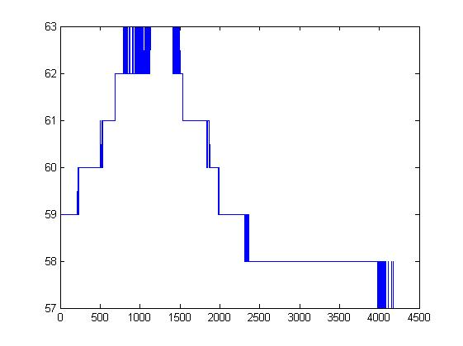

Figure 10.Soil Temperature (In Celsius) versus Time (In hours)

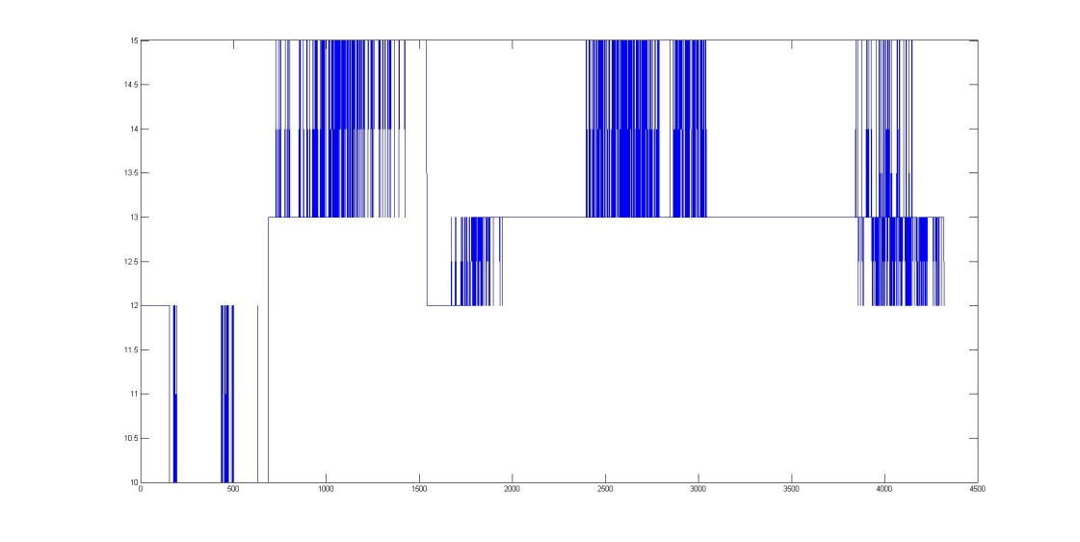

Figure 11.Moisture (In %) versus Time (In hours)

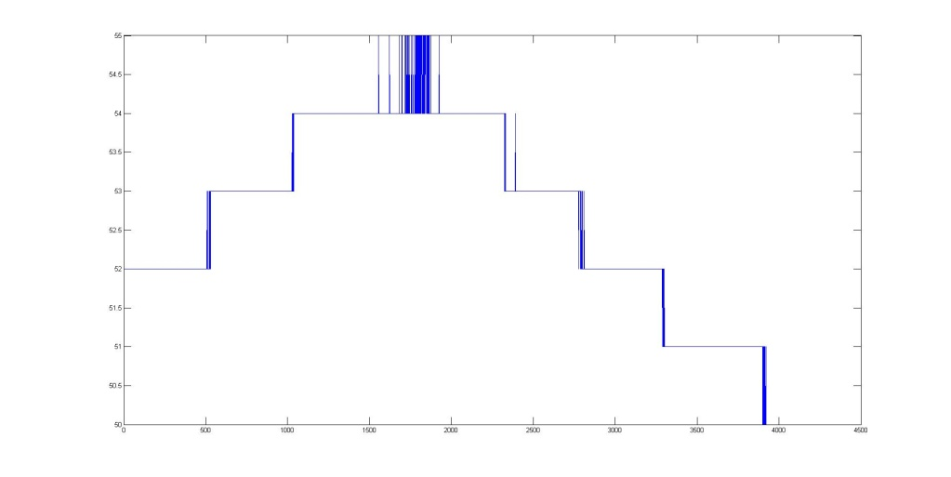

REFERENCES

[1] [Bandyopadhyay, D. and Sen, J., 2011. Internet of things: Applications and challenges in technology and standardization. Wireless Personal Communications, 58(1), pp.49-69.
[2] Ray, P.P., 2016. A survey on Internet of Things architectures. Journal of King Saud University-Computer and Information Sciences. Delicato, F.C., Pires, P.F. and Batista, T., 2017.
[3] The Resource Management Challenge in IoT. In Resource Management for Internet of Things (pp. 7-18). Springer, Cham. Das, S.K. and Ammari, H.M., 2009.
[4] Routing and data dissemination. A Networking Perspective, p.67. Rachidi, H. and Karmouch, A., 2011, April. A framework for self-conguring devices using TR-069. In Multimedia Computing and Systems (ICMCS), 2011 International Conference on (pp. 1-6). IEEE.
[5] Ruta, M., Scioscia, F., Di Sciascio, E. and Loseto, G., 2011. Semantic-based enhancement of ISO/IEC 14543-3 EIB/KNX standard for building automation. IEEE Transactions on Industrial Informatics, 7(4), pp.731-739.
[6] Shan, Y. and Wang, H., 2010, March. Research on eld device integration model. In Measuring Technology and Mechatronics Automation (ICMTMA), 2010 International Conference on (Vol. 3, pp. 79-82). IEEE.
[7] Montenegro, G., Kushalnagar, N., Hui, J. and Culler, D., 2007. Transmission of IPv6 packets over IEEE 802.15. 4 networks (No. RFC 4944).
[8] Jaey, T., 2014. Mqtt and coap, IoT protocols. Feb-2014.[Online].
[9] Shelby, Z., Hartke, K. and Bormann, C., 2014. The constrained application protocol (CoAP).
[10] Shelby, Z., 2010. Embedded web services. IEEE Wireless Communications, 17(6).
[11] Bergmann, O., Hillmann, K.T. and Gerdes, S., 2012, January. A CoAP-gateway for smart homes. In Computing, Networking and Communications (ICNC), 2012 International Conference on (pp. 446-450). IEEE.
[12] Albano, M., Chessa, S., Nidito, F. and Pelagatti, S., 2011. Dealing with nonuniformity in data centric storage for wireless sensor networks. IEEE Transactions on parallel and distributed systems, 22(8), pp.1398-1406.

