APPLICATIONS OF EDGE COMPUTING
IN HEALTH CARE
S.Binny
Associate professor
Department of computer Application,
Kristu Jyoti college of management and technology
,Kottayam, Kerala
binnylatheesh@gmail.com

Abstract– Edge computing is the major field and technology that can allow the huge data to transfer in a faster and secured manner which cannot be accessed by the third- parties. The existing research used by edge computing is capable of enhancing the time of transmitting the data and improved security using cloud. The 5th generation technology has higher transmission speed for communication for data transmission with reduced latency and hiked bandwidth. It is the sufficient method to extract the features of data for protecting the huge amount of data with higher transmission speed along with the cloud computing technology implemented to process the data with various developed algorithms and edge computing technology has improved the user quality by reducing the time and quality of life (QoL). It is the most important feature in a healthcare field to offer real time monitoring of the patient status as well as produce the data and its feedback for easy and faster recovery. Edge computing has better energy efficiency and electricity cost was reduced which helps the people to support their living.
Keywords: Edge computing; Cloud computing; Health care; Data protection.

- INTRODUCTION
Edge computing has a better power consumption and more response time for next generation health care service providers which created a unique set of requirements in order to have the ability of few innovative devices for shifting and energy efficient computing for huge storage space with awareness among the people locations using cloud computing technologies. It is the major improvised technology for referring the computing of the network and characterized by the data transmission is too high with larger response times with shorter coverage. The computing technologies like edge, cloud and mobile computing models are used for providing the services with quality and it has failed to secure the devices using limited wifi coverage. The latency, mobility and efficiency of energy is fulfilled with modern technology using edge and mobile based computing technologies. Video analytics is one of the major processes in cloud based computing by comparing the client only computing. The performance is improved in edge based computing technologies by comparing the existing cloud computing technology used mainly for health care industries. Edge solutions are offered to reduce the framework of latency and it helps to provide security to the data by comparing the cloud computing technology for allowing the access of heart rate, history of patient health through the connected cloud based systems. The enhanced results are produced and people with illness and having their treatments on their own are monitored by the doctor through connected cloud based technologized smart devices using the internet. Data can be identified with some operation techniques for performing the quality services based on the health history is the major goal of this survey and information collected and provided enhancement are implemented for some techniques like encryption, reduction of data, classification, etc., using edge devices.
- EDGE COMPUTING
Edge computing is a distributed information technology (IT) architecture in which client data is processed at the periphery of the network, as close to the originating source as possible. Data is the lifeblood of modern business, providing valuable business insight and supporting real-time control over critical business processes and operations. Today's businesses are awash in an ocean of data, and huge amounts of data can be routinely collected from sensors and IoT devices operating in real time from remote locations and inhospitable operating environments almost anywhere in the world. But this virtual flood of data is also changing the way businesses handle computing. The traditional computing paradigm built on a centralized data centre and everyday internet isn't well suited to moving endlessly growing rivers of real-world data. Bandwidth limitations, latency issues and unpredictable network disruptions can all conspire to impair such efforts. Businesses are responding to these data challenges through the use of edge computing architecture. In simplest terms, edge computing moves some portion of storage and compute resources out of the central data center and closer to the source of the data itself. Rather than transmitting raw data to a central data center for processing and analysis, that work is instead performed where the data is actually generated -- whether that's a retail store, a factory floor, a sprawling utility or across a smart city. Only the result of that computing work at the edge, such as real-time business insights, equipment maintenance predictions or other actionable answers, is sent back to the main data center for review and other human interactions. Thus, edge computing is reshaping IT and business computing. Take a comprehensive look at what edge computing is, how it works, the influence of the cloud, edge use cases, tradeoffs and implementation considerations
2.1 Edge Computing In Health Care
The gradual but steady move towards 5G coupled with edge computing has the potential to revolutionize healthcare. In that sense, the industry is perched on the edge of creating a safe environment for healthcare devices and removing the dependence on cloud or centralized locations that can generally cause latency.
Technologies like IoT, AR/VR, robotics etc. are incrementally playing a major role in virtual care and value-based care. That means we can no longer depend only on the cloud, with issues like downtime, bandwidth congestion, and high latency for the devices to work properly and provide live data without latency. Any data-related delays can literally mean a life or death situation, and this is where edge computing can truly be a game changer.
Edge computing refers to a set of enabling technologies that move storage, computing, and networking closer to the point of data generation and consumption, which is helpful in cases where immediate results are needed such as for critical care and life-threatening cases. Edge computing can prove to be crucial in times such as the pandemic, where doctors can monitor the vitals of patients from remote locations and come up with an action plan.
Some of the main advantages of healthcare in edge include: Real-time data processing and analytics More control over the data and its security to detect breaches earlier Monitoring and subsequent action on critical vitals even in areas with poor connectivity Meeting regulatory compliance as using edge capabilities in IoMT and services aim to keep patient data close to the source, hence limiting the risk of privacy breach during transition Handling downtimes and latency, Cost savings as wearable devices and IoT can help healthcare organizations save up to 25% of their business costs which is mainly incurred due to security and surveillance
Gaining the Edge
Here’s how edge computing in healthcare delivery works: Edge devices like IoT and smart wearables that are carried by patients constantly record their vitals Through customer premises equipment (CPE), virtual customer premises equipment (VCPE), fixed switches, and gateways, this data is sent to the nearest edge servers for processing and the results are provided immediately to the patients The data that resides on edge servers is synced with the cloud on a fixed periodic basis In some cases, the edge computation device can also be deployed on the edge device directly for analysis and results The future of healthcare delivery through edge computing promises better and immediate care, with cost savings to both patients and providers. However, there are some challenges that the healthcare continuum needs to address before full-fledged adoption. Firstly, the cost to build and buy the infrastructure requires high initial investments. In particular, for remote areas where basic connectivity is still an issue, deployment and coverage of edge can be more challenging. Further, security issues in green storage technologies may allow attackers to add unauthorized software or hardware to edge nodes and inject malicious inputs into edge servers. Healthcare regulations can also be a limitation as edge devices and the corresponding software should follow the geography-specific compliance – be it HIPAA for US or GDPR for Europe – failing which, healthcare organizations may face heavy penalties. In time, we believe, a well-planned execution that adheres to the security requirements and regulatory mandates can overshadow the challenges and demonstrate high RoI. The future of healthcare looks bright as the real meaning of virtual, value-based, and ondemand care can be truly realized. Edge computing will act as a crucial enabler in utilizing technologies like IoT and AR/VR to their fullest.
2.2. Edge in the early stages, but growth ahead
According to IDC’s June 2021 Edge Spending Guide, healthcare provider spending on edge computing (hardware, software, and services) will reach $10.3 billion in 2025, with a five-year compound annual growth rate of 17%. Despite that seemingly large dollar amount, health IT leaders say the use of edge computing in healthcare is still in its early stages. Furthermore, they note that much of the computational power that exists on the edge in healthcare today is embedded in the end devices themselves. “If you walk into a hospital room, there are four or five devices such as cardiac monitors that are edge computing devices. They all take patient data and visualize it at the endpoint. We’ve blurred the lines between medical equipment and IT equipment,” says Steve Hess, CIO of UCHealth , a Colorado-based network of hospitals, clinics, and healthcare providers.
Health IT experts expect investments in edge technology to grow in coming years — and with that growth, some say edge will help transform how, where, and how quickly care can be delivered
Angelakos points to one pilot project as a case in point. Geisinger is testing a platform that uses automation and facial recognition technologies so that patients can register for clinical visits via their smartphones and receive messages from clinical staff in advance of their exams.
“In this case, the patient’s smartphone would become the edge computing device. It will help streamline the experience from the patient perspective — and streamline it from the operational standpoint, too,” Angelakos says, adding that the platform will help limit physical touchpoints within the registration process (which reduces the spread of germs) and cut back on paper use (which saves resources) “In this case, the patient’s smartphone would become the edge computing device. It will help streamline the experience from the patient perspective — and streamline it from the operational standpoint, too,” Angelakos says, adding that the platform will help limit physical touchpoints within the registration process (which reduces the spread of germs) and cut back on paper use (which saves resources)
“The way we think about patient care, it’s really going to be in the future about keeping you healthy,” he continues. “If we can figure out what your normal health is, and where you’re deviating, we can intervene appropriately. All of that requires some edge computing — we need data from you, data that’s going to an intelligence layer on the edge.”
2.3. Related study
Literally, edge computing plays a major role in the healthcare industry and the data is transferred with huge records and history of every patient of various hospitals over an extended period of time. and the health care domain becomes the most highly performed architect for testing the regular servers. The edge computing helps to encrypt and decrypt the data for offloading the data processing to explore the patient data securely with a computing based framework. The RPN task helps to perform the optimization of the real time data for achieving the highest result based on graph optimization techniques for proving the workflow using graph theory. Fly optimization data offloading techniques are used to monitor the health care system and clouds are used by smart devices with low resource capacity.

- HEALTHCARE EVOLUTION USING COMPUTING TECHNOLOGY
Evolution of computing based on health care system which progres for centralized cloud computing with distributed architecture for edge based fog computing and it will be discussed for health care with cost, efficiency of energy and experience in quality. There are some types of applications with health care like real time monitoring systems, emergency management systems and awareness of health care mobile devices. Health care monitoring systems can utilize the different platforms randomly and emergency health monitoring systems can be done using smartphones for monitoring the real data by maintaining the threshold using sensors. Data privacy is achieved with ease of usability because the sensors are used for untrained data to transmit accurate information by next generation medical smart devices. There are some parameters that are followed to enhance the model such as Price, Privacy of data, Latency is lower, Flexible energy efficiency and usability.
4.1. Healthcare using edge computing
An architecture of edge computing consists of smart devices and sensors using IoT devices using computing capacity with distributed devices and the cloud is an important factor with some challenges which focus on intervention with benefits of cloud on long term data. the components using fog computing environment using outlined as following figure,
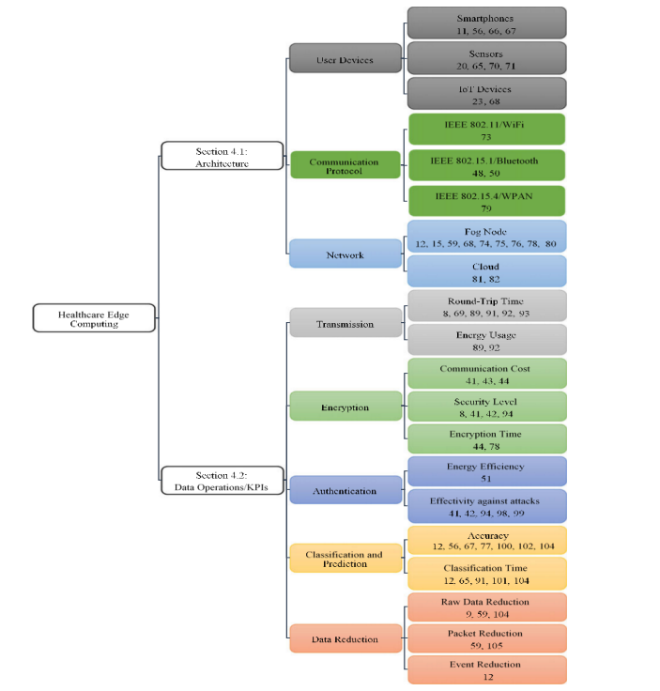
4.2. Operations of Data
Edge computing used for health care which focuses on measuring the performance of key indicators for progression of health services and the response time, efficiency of energy and cost of bandwidth. The major focus on edge devices to retrieve, encrypt, classify and authenticate the data collected by smart devices and sensors with low latency using higher security using some protocol were discussed.
- CHALLENGES OF FUTURE RESEARCHES
The fifth generation technology paradigm to support the edge computing based health care system to realize the community of research challenges to overcome the enhanced model.
5.1. Health care using Large scale data
Edge computing solutions are used for health care monitoring using a small scale environment and the proposed model has delayed about the second half 0.003 kWH with consumption of power for 50 clouds and the huge number of users can make decisions for healthcare workers to notice the spread of the disease. Therefore the proposed study implements the huge amount of user data that can be compared with the actual need of the large medical community and the system for health care monitoring of patients treated in the hospitals.
- CONCLUSION
Edge computing is the interesting domain used through networks of smart devices which aims to support the devices like multimedia on IoT through low processing of latency and the proposed model focuses on study work with applications on health care system which to fulfill the gap of health care surveys done so far and the architecture and applications are studied to maximize the QoS to operations of data. The study has a prospective model to qualify the edge computing which includes the cost and security level of data and energy efficiency are discussed. Based on the literature survey, the future study addresses the challenges and compatibility of the data using artificial intelligence and the limitations and comparative analysis of each and every data are discussed with edge computing used for cloud computing to monitor the health care patient.
REFERENCES
- Liu L, Yang Y, Zhao W, Du Z. Semi-automatic remote medicine monitoring system of miners. In: Adjunct Proceedings of the 2015 ACM International Joint Conference on Pervasive and Ubiquitous Computing and Proceedings of the 2015 ACM International Symposium on Wearable Computers (UbiComp/ISWC); 2015; Osaka, Japan
- Kumar K, Lu YH. Cloud computing for mobile users: can offloading computation save energy? Computer. 2010;43(4):51-56. https://doi. org/10.1109/MC.2010.98
- Bonomi F, Milito R, Zhu J, Addepalli S. Fog computing and its role in the internet of things. In: Proceedings of the First Edition of the MCC Workshop on Mobile Cloud Computing (MCC); 2012; Helsinki, Finland.
- Maitra A, Kuntagod N. A novel mobile application to assist maternal health workers in rural India. Paper presented at: 2013 5th International Workshop on Software Engineering in Health Care (SEHC); 2013; San Francisco, CA.
- Yi S, Hao Z, Zhang Q, Zhang Q, Shi W, Li Q. LAVEA: Latency-aware video analytics on edge computing platform. In: Proceedings of the Second ACM/IEEE Symposium on Edge Computing (SEC); 2017; San Jose, CA.
- Jackson KR, Ramakrishnan L, Muriki K, et al. Performance analysis of high performance computing applications on the Amazon web services cloud. Paper presented at: 2010 IEEE Second International Conference on Cloud Computing Technology and Science; 2010; Indianapolis, IN.
- Bhunia SS. Sensor-cloud: Enabling remote health-care services. In: Proceedings of the 2015 on MobiSys PhD Forum (PhDForum); 2015; Florence, Italy.
- . Thiyagaraja SR, Dantu R, Shrestha PL, Thompson MA, Smith C. Optimized and secured transmission and retrieval of vital signs from remote devices. In: Proceedings of the Second IEEE/ACM International Conference on Connected Health: Applications, Systems and Engineering Technologies (CHASE); 2017; Philadelphia, PA.
- Althebyan Q, Yaseen Q, Jararweh Y, Al-Ayyoub M. Cloud support for large scale e-healthcare systems. Ann Telecommun. 2016;71(9-10):503-515.
- Miettinen AP, Nurminen JK. Energy efficiency of mobile clients in cloud computing. In: Proceedings of the 2nd USENIX Conference on Hot Topics in Cloud Computing (HotCloud); 2010; Boston, MA.
- Cao Y, Hou P, Brown D, Wang J, Chen S. Distributed analytics and edge intelligence: Pervasive health monitoring at the era of fog computing. In: Proceedings of the 2015 Workshop on Mobile Big Data (Mobidata); 2015; Hangzhou, China.
- Bhargava K, Ivanov S. A fog computing approach for localization in WSN. Paper presented at: 2017 IEEE 28th Annual International Symposium on Personal, Indoor, and Mobile Radio Communications (PIMRC); 2017; Montreal, Canada.
- Imran A, Zoha A, Abu-Dayya A. Challenges in 5G: how to empower SON with big data for enabling 5G. IEEE Network. 2014;28(6):27-33. https://doi.org/10.1109/MNET.2014.6963801
- Hashmi US, Darbandi A, Imran A. Enabling proactive self-healing by data mining network failure logs. Paper presented at: 2017 International Conference on Computing, Networking and Communications (ICNC); 2017; Santa Clara, CA.
- Muhammad G, Alhamid MF, Alsulaiman M, Gupta B. Edge computing with cloud for voice disorder assessment and treatment. IEEE Commun Mag. 2018;56(4):60-65. https://doi.org/10.1109/MCOM.2018.1700790
- Hossain MS, Muhammad G. Emotion-aware connected healthcare big data towards 5G. IEEE Internet Things J. 2018;5(4):2399-2406. https://doi.org/10.1109/JIOT.2017.2772959.

