Anti-Hypertensive Drug induced Oxidative Stress

Dr. Sinchan Das
Author1
Director
Humanity, Institute for Advanced Medical & Cultural research
Priyankesh Mishra
Author 2
Research Scholar
Humanity, Institute for Advanced Medical & Cultural Research, India

J-40, Banerjee Para, Kamdahari, Garia, Kolkata-84
Kolkata, India
drsinchandas@gmail.com

J-40, Banerjee Para, Kamdahari, Garia, Kolkata-84
Kolkata, India
impriyankesh@gmail.com

Abstract
In this fast modern lifestyle, human beings are somewhat stuck in the act of maladies d'origine humaine where total dependence on material have corresponded to the eruption of such a massive issue. However, the current scientific world are trying to provide more excuses in the name of management rather than considering the fate of such issues and properly understanding the need for change. This chapter hence brings one such facts of the application of anti-hypertensive drugs that are being daily prescribed or even directed to the people without considering the fate of such drugs. Moreover, the correlated pathologies such as diabetes mellitus, Long QT syndrome and many more have been focused that are induced oxidative stress by drugs.
Keywords: Oxidative stress, health, society, pharmacy, drug, anti-hypertensive, thiazide, diuretics, telmisartan, liver, diseases
I. Introduction
Health, disease, drug, medicine, remedy and damage-repair have always been a matter of concern for the living system. However, the true definition of health and disease have been somewhat changing with the diverse maladies d'origine humaine (human-produced disease); where, drugs specifically drug ought to have curative or preventive measures taken places instead of actual life-leading techniques or food. In a survey of CDC, it has been found that four in five adults’ approximately around 86% people takes supplements instead of taking actual fruits or natural vitamins (Mishra et al., 2021). The report even surveyed that this supplement has been mainly found within the people between the ages of 20-39 years old. So, the health development in current scenario has been totally a part of the drug administration where not only drug induced issues rather it could be better said that the current health is drug oriented for instance drug-oriented health.
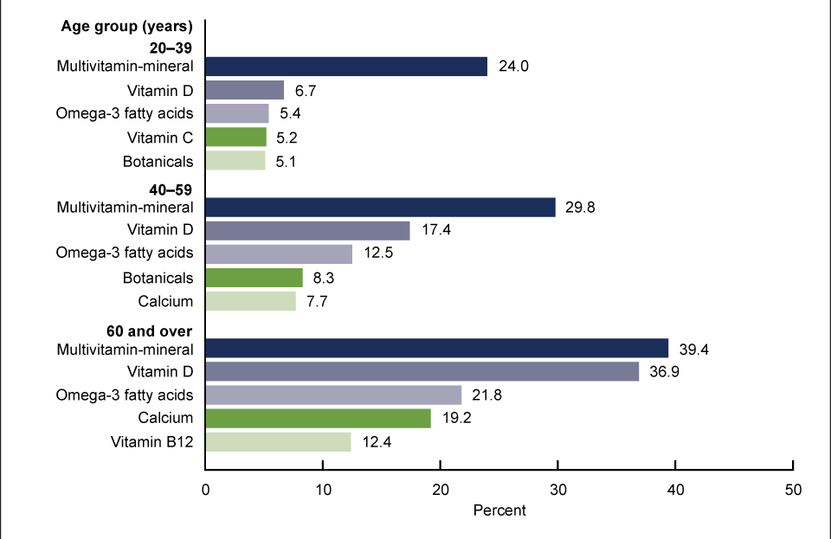
Figure 1: Ratio of people taking dietary supplements above the age of 20
(Source: Mishra et al., 2021)
Medicine or drug administration has been one of the potential points that have been truly applied in the current chasing world; in hope to get a better response within a short term instead of focusing about the issues that future has been waiting with. This modernised world guarded by the pharmaceutical lords is somewhat one-directional where the focus is just like the mare tied around to look forward. However, the additional issues that are correlated with the human physiology cannot be ignored as classification or one-directional focus is not a part of natural thoughts. One such major issue that an individual has correlatively facing is the increasing blood pressure that accounts to several psycho-somatic stimulus of human living. The Blood pressure management is nothing just a mechanism of the body to control the resistance that the blood vessels exerts while transferring the blood all over the body where variation in the resistance may affect the cardiac output and relatively affecting the transportation of energy or particles all across the body. Here, in physiological system of body there are four major keys that define all the operations of human body such as Hypthalamo-pituitary-ovarian axis (HPO axis), Hypthalamo-pituitary-testicular axis (HPT axis), Hypthalamo-pituitary-thyroid axis (HPTh axis), and Hypthalamo-pituitary-adrenal axis (HPA axis). Not only, the physiological aspects such as cardiac output, Peripheral vascular resistance, circulatory blooded volume, blood viscosity, and vessel wall elasticity; psychological proportion such as stress, anxiety, expectation-performance mismatch, natural changes, and damaged circadian rhythm are also the hidden factors that affects the blood pressure and health of an individual. But, the lords at the drug administration has compounding to invest only on the expansion of antihypertensive drugs majorly Diuretics, beta-blockers, angiotensin-converting enzyme inhibitors, angiotensin-II receptor blocker, and Calcium channel blockers. These drugs are highly administered across the world without the conscious thought related to co-relative issues an individual could face increasing the ROS, RNS, and RCS for the oxidative changes.
Drug is any chemical substance that causes a change in the organism’s physiology or psychology when consumed. In pharmacy, this drug is typically distinguished from food and substances that provide nutritional support. For the management of hypertensive state where the systolic blood pressure is ≥140 mmHg and the diastolic blood pressure is ≥90mmHg with suggestive tests including serum electrolytes and creatinine, lipid panel and ECG for co-morbidity screening; a pharmacological anti-hypertensive treatment could be administered as guided by the World Health Organisation. On the other, a serious acute management for time-being could be administered if the systolic blood pressure is ≥ 160mmHg and diastolic blood pressure is ≥100 mmHg [or if the increased blood pressure is the co-relational pathology of any life-threatening disease]. Anti-hypertensive drugs has been the major drugs that are being either orally or invasively supplied to the people at any instance where the practical medical experts evidences a alteration in the BP above 120/80mm of hg without going on the clinical intervention related the co-morbid/aetiological identification arguing with the guideline framework of the WHO.
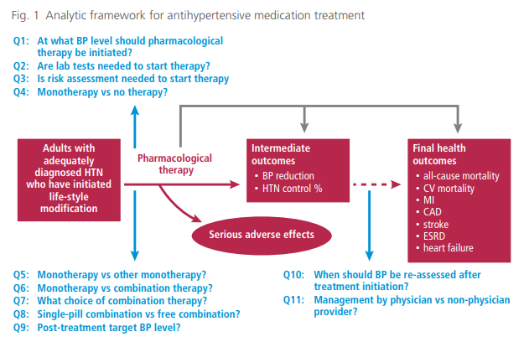
Figure 2: Framework for Anti-hypertensive medication Treatment
(Source: WHO Geneva Confederation, 2019)
Thus, the above chart suggests that the framework for the anti-hypertensive medication treatment are remained on the aspects of direct prescription and not via the guidelines as laboratory findings are not relative with the aspects; as well as, severe adverse affects have been commonly kept aside while doing the business of an individual health. In this sense, one of the major anti-hypertensive drugs the classes of Diuretics [ATC code: C03] have been designed for the acute management through dieresis rather it has been the common and even recognised to be the safest medication. Apart from these ATC classes of anti-hypertensive, the modern system of medicine even classifies the essentialities of applying the sense of either monotherapy or the combination system. However, in monotherapy system only medicine or a vaccination is thought to cure any condition that has been especially applied within the treatment of cancer through genetic modification. On contrary, pathophysiology and pharmacokinetics of such system have been still a mystery for the millions.
Stress better to define as oxidative stress where production and accumulation of oxygen reactive species or ROS in cells and tissues as well as the ability of the biological system in order to detoxify these reactive products comes under such phenomena. This oxidative stress reflects an imbalance between the systemic manifestation of the ROS and a biological system ability to readily detoxify the reactive intermediates or to repair the resulting damage. In more clear words, any disturbances occurring within the normal redox (reduction-oxidation reaction) state of cells can cause toxic effects through the production of peroxides and free radicals that damage all the components of the cell including proteins, lipids, and DNA. On contrary, oxidative stress developed due to the oxidative metabolism or the cellular respiration leads to base damage as well as denaturation of DNA from its base or phospholipid bonds. Similarly, with the application of anti-hypertensive drugs several ROS have been generated majorly constituting to O₂⁻ (superoxide radical), OH. (Hydroxyl radical), and H₂O₂ (hydrogen peroxide). The overall pathways and other ROS/RNS will be clearly focused in the latter section of the overall chapter.
In order to better understand the implication of oxidative stress, it is essential to correlate with the function of electron transport chain reaction and other classified biochemical reaction. But, it is also a fact that is witnessed by several authors that every biochemical reaction are co-related with each other and these reactions are then co-related with the environment in such a way that carbon cycle, oxygen cycle, and nitrogen cycle affects the potential differences within the body causing various changes within the cellular structure.
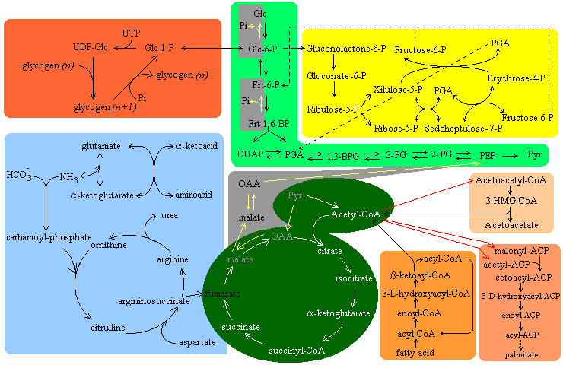
Figure 3: Metabolic pathway of a cell and intercellular communication properties
Thus, the action of a drug to any single receptor could be tough due to the interlinkage between each component of the cells. The reality related to co-morbidities such as hypokalemia, hypomagnesia, hyperglycemia, nausea, neuropathology, increased ROS, e.t.c. has been confidently omitted from this theory. Thus, various issues and rationale could be calculated from the introduction highlighting the following question:
- What are hypertension, aetiology and its associated co-morbidities?
- Is human body capable enough to maintain its blood pressure?
- What are the prospects that are correlated with the anti-hypertensive drugs?
II. Hypertension
The current scenario of fast-chasing life has been a major proportion for the dramatic health degradation where not only lifestyle diseases, infection, and psychological diseases; but, major issues of genetic diseases are also being prevalent. One such common and serious issue for the people have been related with the increase in arterial blood pressure that gives various signs and symptoms including risk related to chronic heart disease. Hypertension is the common condition of increased arterial pressure that has been evident in the current scenario at high proportion. However, this common condition can lead to serious issue in the health aspect of an individual. As suggested by World Health Organisation, around 1.28 billion adults between the ages of 30-79 years worldwide have been suffering from hypertension. However, 46% of the population are unaware about the condition and hence remain untreated.

Figure 4: Top 10 countries with Highest HTN prevalence in Women
(Source: World Health Organisation, 2019)

Figure 5: Prevalence of HTN as % of population in Men
(Source: World Health Organisation, 2019)
The above chart has been focusing on the prevalence as per the population and not on the ratio of treated proportion.

Figure 6: Correlation of increased treatment of HTN with DM prevalence, neuropathy, and CKD
(Sources: WHO, World Life Expectancy organisation, IDF, CCD, CIHI, NHM)
As directed by several pathological and medical experts, hypertension has been referred to as a state of relative elevation of the blood pressure exceeding 140 over 90 mmHg; a systolic pressure above 140mmHg or a diastolic pressure over 90 mmHg. Elevated arterial blood pressure is the major physiological cause of premature vascular disease that may lead to the cardiovascular issues.
Common aetiologies:
- Expectation-performance mismatch
- Behavioural changes
- Unscientific lifestyle
- Alcohol and other stimulants
- Disarranged circadian rhythm
- Stress
- Anxiety
- Genetic predisposition
- Heavy workout
- Dis-balanced work-life cycle
- Frustration
- Suppressed Grief

II.I Blood Pressure
It is the lateral pressure exerted by the blood on the vessel walls flowing through it.
Table 1: Average Blood Pressure and deviation in apparently healthy Person
Age Group | Males |  | Females
 | Systolic | Diastolic | Systolic | Diastolic
20-29 | 124.0±13.2 | 77.0±9.5 | 116.5±11.6 | 73.0±9.4
30-39 | 126.5±13.9 | 79.5±10.0 | 122.0±14.0 | 76.5±10.4
40-49 | 129.5±16.0 | 81.5±10.2 | 129.0±18.3 | 81.0±11.1
50-59 | 136.5±19.0 | 83.5±11.4 | 138.0±21.4 | 84.0±12.0
60-69 | 142.5±23.5 | 84.0±11.2 | 149.0±25.7 | 85.0±13.4
70-79 | 145.5±24.0 | 81.5±14.1 | 158.5±26.0 | 84.5±14.2
80-89 | 145.0±25.0 | 80.5±12.4 | 155.5±28.0 | 82.5±15.2

(Source: Chatterjee and Raymahasaya, 1956)
The above table suggests that blood pressure is somewhat dependent upon the age criteria where deviation in the blood pressure should be tallied as per the stated findings. However, the human body has been considered as irresponsive of the increased blood pressure; although, simple alterations within the blood pressure could be managed by the body itself through several short-term, intermediate, and long-term regulatory pathways of blood pressure.
Blood Pressure
Short-term
Intermediate
Long-term
- Baroreceptor Reflex
- Chemoreceptor Reflex
- CNS Ischemic response
- Stress Relaxation of Vasculature
- Capillary Fluid Shift Mechanism
- RAAS (Renin-Angiotensin-Aldosteron Mechanism)
Figure 7: Major Mechanism to control Blood Pressure
Apart from the above chart, hormone such as ADH or Vasopressin, vasoconstrictor and vasodilators correspondingly regulates the physiological changes in the blood pressure.
1. Short-term Regulating Mechanism
The human body regulates the blood pressure through three major pathways baroreceptor reflex, chemoreceptor reflex, and CNS ischemic response
Baroreceptor Reflex
Baroreceptors are the characterized mechanoreceptor type of sensory neurons that on activation stretches the blood vessel in order to control the blood supply. Every inch increase in the blood pressure leads to cause the pressure on the receptors located at aortic arch and carotid sinuses. This receptor stimulation increases the frequency of action potentials that aids in monitoring the cardiac output and peripheral resistance.
Increased BP
Signal to Vasomotor centre
Stimulate cardio-inhibitory centres
Sympathetic Response
Para Sympathetic Response
Vasodilatation
↓Heart Rate
↓Cardiac Output
&
↓Blood Pressure
↓TFR
Figure 8: BP maintenance through baroreceptors
Chemoreceptor Reflex
Chemoreceptor are the receptors located in the carotid and aortic branches that are stimulated by chemical changes in the blood mainly due to the hypoxia (↓O₂), hypercapnia (↑CO₂), pH changes. Chemoreceptor maintains the blood pressure by exciting the vasomotor centre that elevates the arterial pressure (AP). If the pCO₂ > 40mmHG or pH decreases below 7.4, then the chemoreceptors are stimulated. They send appropriate signal to respiratory centre and respiratory activity increases in response to the chemoreceptor reflex. This increases the sympathetic activity stimulating both heart and vasculature increasing the arterial blood pressure also.
Figure 9: BP maintenance through Chemoreceptors
↓Arterial Blood Pressure
↓Blood flow to chemoreceptors
Hypoxia & hypercapnia
Chemoreceptors stimulated
VMC Stimulated & inhibition of vagal nucleus
↑ Heart Rate & Vasoconstriction
(↑Peripheral Resistance)
↑Arterial Blood Pressure
CNS Ischemic Response
If the blood flow has been decreased to the vasomotor centre in the lower brainstem and CO2 accumulates in the CNS, then the CNS ischemic response is initiated. The very strong sympathetic stimulator causes major vasoconstriction and cardiac acceleration; sometimes referred as the “last ditch stand”

Severe Decrease Blood Flow to Brain
Cerebral hypoxia
Vasomotor centre stimulated
↑BP & Blood Flow
Figure 10: BP Maintenance through CNS Ischemic Response
2. Intermediate Regulating Mechanism
The intermediate regulating mechanism crucially applies two pathways through stress relaxation of the vasoculture and capillary fluid mechanism to manage the disturbances that could be encountered during the blood pressure change.
Stress Relaxation of the Vasoculture
The increase in the arterial pressure could stretch the arterial vessels and the vessel response by the relaxation as a normal vascular response and hence focuses on decreasing the blood pressure. Alternatively, the reverse stretch relaxation is tightening the vessels based on the responses to lowered blood pressure. Thus, in that case, the following mechanism highlights the pathway for vascular adjustment that could restore the normal blood pressure in the body.
Abrupt increase of Blood Pressure
Distension of Blood Vessels
Acute stretch of vessel walls
Vascular Tone ↓
↓ Blood Pressure
Figure 11: Intermediate blood pressure regulating mechanism through
Capillary Fluid Shift Mechanism
Fluid shift across the capillary wall could focus on maintaining the blood pressure through the hydrostatic pressure generated within them. In this sense, increase in the blood pressure can even increase the capillary pressure that releases to shift fluid from the capillaries to the interstitial region. This decreases the blood volume and hence restores the blood pressure. Similarly, if the blood pressure decreases than the hydrostatic pressure could focus on maintaining blood pressure.
↑ Blood Pressure
↑ Vascular Tone
↓Blood volume within the vessel
Blood Pressure ↓
↑interendothelial spaces
↑Capillary permeability
Fluid traverse across the vein
Figure 12: Capillary Fluid Shift Mechanism to control BP

3. Long-term Regulating Mechanism
Renin-Angiotensin Aldosterone System:
Commonly referred as the RAAS, this has been known as the long-term regulator of arterial pressure that primarily maintains the blood pressure with the actions of Kidney, hypothalamus, liver, and other organs of the body. Hormones such as rennin secreted from kidney, angiotensin secreted by the liver, and aldosterone has been secreted by zona glomerulosa {the outer layer of the adrenal cortex}.
The pathway is linked all across the body that aids on controlling the crucial scenario of slight difference in the blood pressure. The pathway begins from the kidney where rennin is released that activates angiotensinogen releasing angiotensin-I. [Note: Angiotensin in presence of Kalikrien produces Angiotensin (1-12) whereas in presence of Renin releases Angiotensin (1-10).]
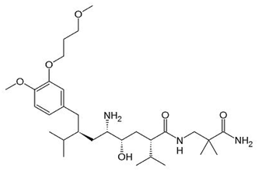
Rennin has been secreted by pericytes in the afferent arterioles and similar microvessels of the kidney from the juxtaglomerular cells in response to three receptor baroreceptors (pressure-sensitive cells [short-term regulatory mechanism]), decreasing Na⁺ load measured by macula densa of Juxtaglomerular apparatus and the sympathetic nervous system (ꞵ₁ adrenergic receptors)
It is secreted by at least two cellular pathways: a constitutive pathway for the secretion of the precursor pro-renin and regulatory pathway for the secretion of mature rennin.
Renin
Renin also known as the angiotensinogenase is an aspartic protease protein and enzyme that has been secreted by the kidneys that mediated the volume of extracellular fluid [blood plasma, lymph and interstitial fluid] and arterial vasoconstriction.
Structure: primary structure of rennin precursor is of 406 amino acids with a pre- and pro-segment of 20 and 46 amino acids

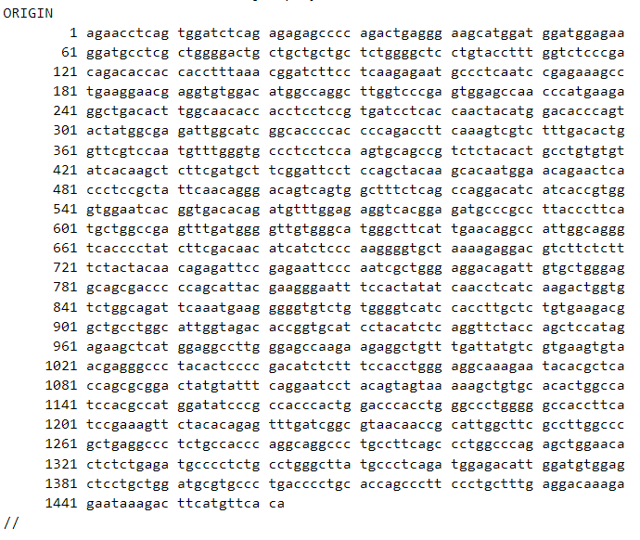
Figure 13: mRNA sequence of Renin {Homo sapiens (Locus: NM_000537)}
The above nucleotide sequence of 1463 nucleotide relates to the sequence for Humans collected directly from human cells. This precursor nucleotide secreted the production of pro-renin that could synthesize and then secrete the rennin directly into the juxtaglomerular renal cells that function not only cleaves the angiotensinogen into Angiotensin I maintaining the levels of sodium and potassium in the body. Additionally, this enzyme even controls the production and secretion of aldosterone that regulates salt and water balance, metabolizes effects of fats, carbohydrates, and proteins.
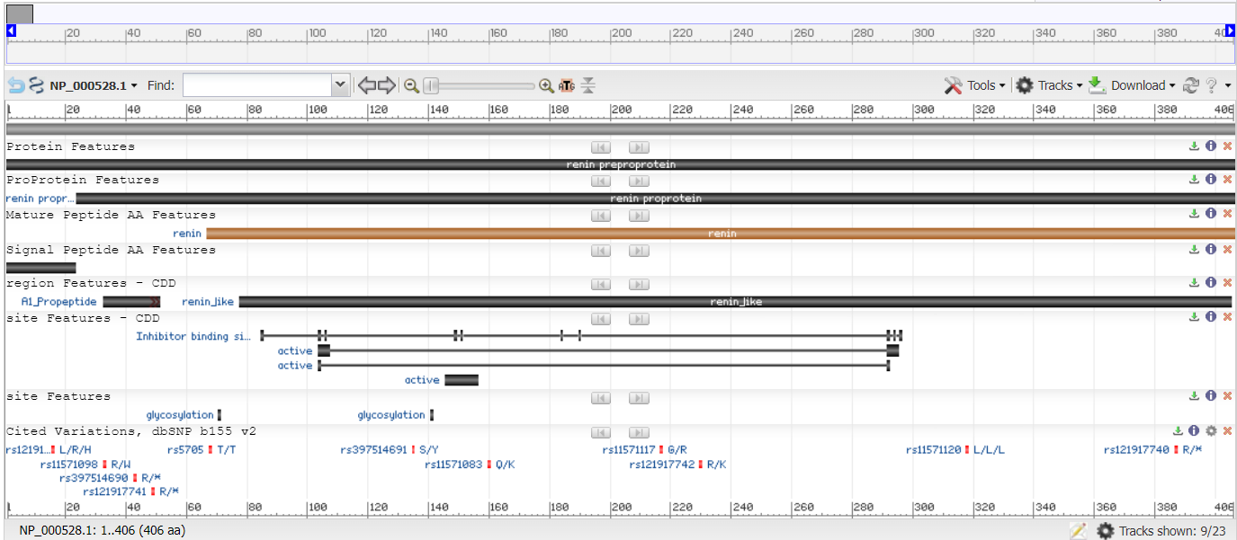
Figure 14: Renin Preproprotein [Homo sapiens]
{NCBI Reference Sequence: NP_000528.1}
51.51kb from both forward and reverse strand of the DNA in the juxtaglomerular renal cells from the chromosome number 13 releases REN with a regulatory build of protein coding. However, Renin mRNA produces Prepronenin in inactive forms, which are translocated to endoplasmic reticulum. Preporenin is activated by low pH releases prorenin with the aid of nitric acid and phosphate in an inactive form.

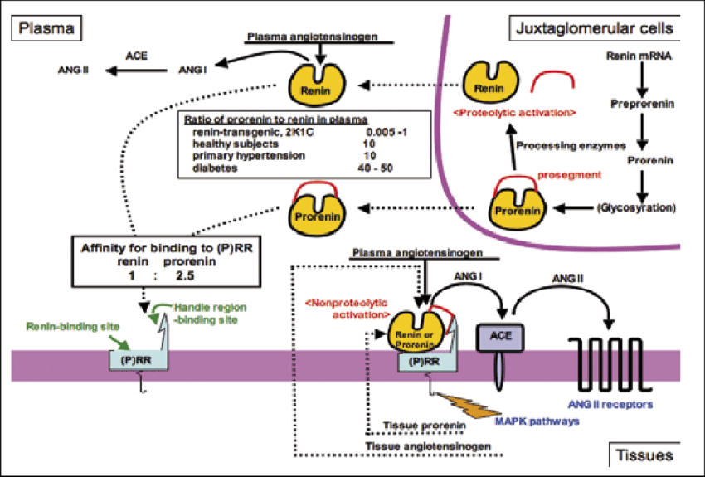
Figure 15: secretion of rennin in humans
Angiotensinogen
Angiotensinogen (AGT) is the sole precursor of the all the angiotensin peptides. The Human angiotensinogen has been made up of 485 amino acids that mainly include a set of 33 amino acids of signal peptide. They are a member of non-inhibitory serpin or the serine protease inhibitor superfamily. Other than angiotensinogen, serpin family even includes alpha 1 antitrypsin (protects the body tissues from the damages by infection-fighting agents within the sensitive lung tissue), alpha 1 antichymotrypsin (globulin glycoprotein that inhibits the activity of certain proteases for instance cathepsin G in neutrophils, chymases in mast cells, and lower respiratory tract), and antithrombin-III (blocks the abnormal blot formation keeping healthy balance between bleeding and clotting).
The 10N-terminal amino acids have been cleaved by rennin providing angiotensin peptides as well as the protein des(Ang-I) AGT. AGT cleaving by rennin has been the rate-limiting step in order to release the Ang-I (angiotensin-I). The initial structural study implicates that rennin cleavage efficiency could be facilitated through the application by interactions domains beyond N-terminal amino acids of the angiotensinogen. Angigotensinogen hence leads to the AngI (1-10) that then splits into Ang-II (1-8) with the help of ACE controlling the other functions of all the alpha receptors or the serpine family within the pancreas, liver, and lungs.
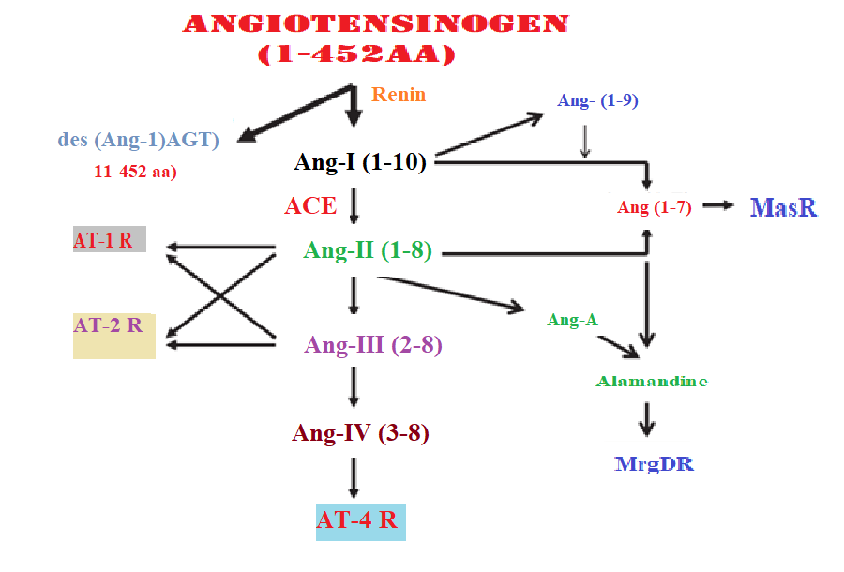
Figure 16: Cleavage of AGT into the Ang I and AngII as well as other derivates
Angiotensinogen is produced in the liver and found continuously in the plasma. Renin is the cleaving agent of AGT into AngI that performs various function including the maintenance of long-term blood supply within the body. This angiotensinogen is expressed by encoding of angiotensinogen precursor or the pre-angitensinogen that physiologically forms the active hormone of AGT. Apart from the liver, the NCBI even reported that high grade of AGT have been even found within the heart, fat, and colon. Thus, a correlation in the function of AGT can be found in multiple organs leading to several issues of hypertensive, renal tubular dysgensis.
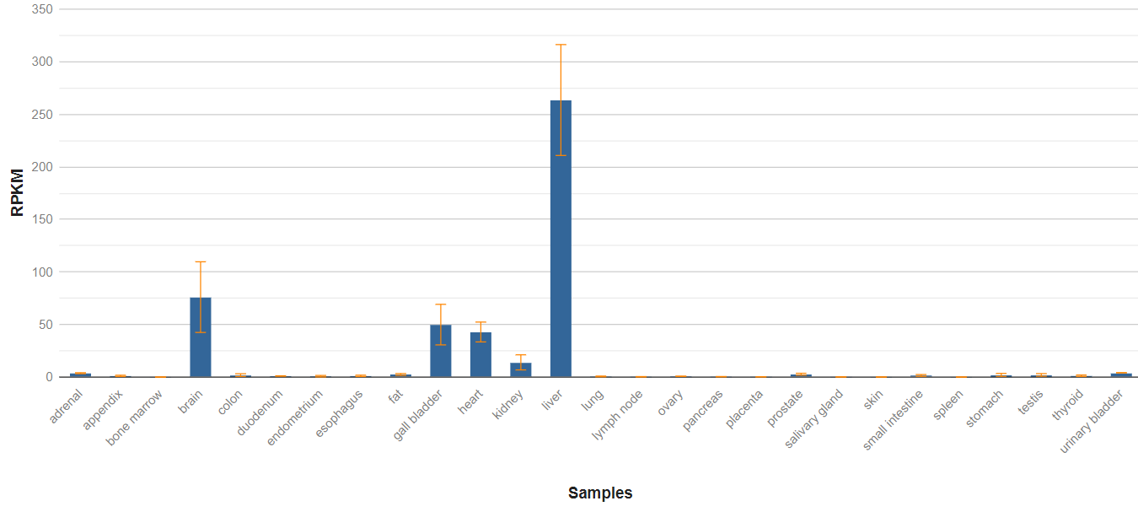
Figure 17: Existence of AGT within different organs of body
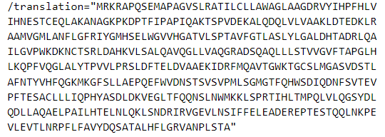
Figure 18: amino acid chain of angiotensinogen
Angiotensin
This Angiotensin (Ang) has been an oligopeptide hormone in the blood plasma that could increase the blood pressure by vasoconstriction. Additionally, the rennin angiotensin aldosterone system (RAAS) is majorly monitored through the management and usage of this angiotensin and its derivative. The formation of angiotensin has been totally engraved with the function and response of rennin on the precursor molecule of angiotensinogen liberating various types of angiotensin. Mainly in terms of blood pressure management, only AngI and AngII are required that constitutively liberates from the liver and releases to the blood circulation.
Angiotensin I (Ang-I)
It is also referred to as the proangiotensin that is a decapeptide (DRVYIHPFHIL) directly derived from the actions of rennin on the angiotensin. This angiotensin-I has not direct activity rather than activating several other angiotensin including Ang-I.
Angiotensin-II (Ang-II)
This octapeptide (DRVYIHPF) has been potent and biologically active form of angiotensin that has been produced in order with the process of removing two C-terminal residues from AngI through the activation supported by ACE or the Angiotensin converting enzyme. This octapeptide enzyme has various functions and role including the following:
- It acts on the CNS in order to stimulate the production of vasopressin
- Vasoconstriction is stimulated through the actions on smooth muscles of the blood vessels
- This activates the adrenal cortex for the release of aldosterone in order to balance Na+ and lose K+ in kidney
- It also acts on the Na+/H+ exchanger within the proximal tubule of the nephron in the kidney
- The role of AngII on kidney controls the reabsorption of sodium and proton excretion. This is even linked with the sodium bicarbonate reabsorption that impacts on the pH balance, blood pressure management, homoeostasis development and control the tissue redox reaction of the body.
Apart from these two common angiotensin that have been stated in the classical RAAS pathway, other angiotensin are even found such as Ang (1-7), Ang (1-21), and Ang III and Ang IV. Angiotensin II has been a heptapeptide (RVYIHPF) and produced by the N-terminal degradation of Ang II and controls the vasoconstriction pathway through the neural circuits of CNS. Additionally, it even progresses the secretion of vasopressin and is correlated with the functioning of various physiological axes.
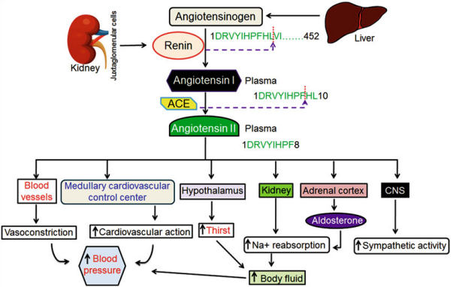
Figure 19: Renin-angiotensin-aldosterone system
The above image suggests that the Angiotensin-II is interconnected to several regions of the body and it even serves other functions apart from controlling the blood pressure. Additionally, the sympathetic activity from CNS determines the body’s rapid involuntary responses to dangerous or stressful situations. It could be even related with the situational management via physiological flight-fight-fright reaction accompanied by the catecholamine group of drugs such as epinephrine and nor-epinephrine. Even in one of the research done by Dendorfer et al. (1998), suggested that Ang-II has been able to modulate both the presynaptic sympathetic system and the adrenal medulla the leads to the release of noradrenaline and adrenaline. In consequence to this, the inhibition of Angiotensin converting enzyme with the aids of ACE inhibitors such as Losartan or telmisartan decreases the production of nor-epinephrine and epinephrine from the adrenal medulla. Thus, Ang-II is correlated with the HPA axis affecting the stress response system of the body.
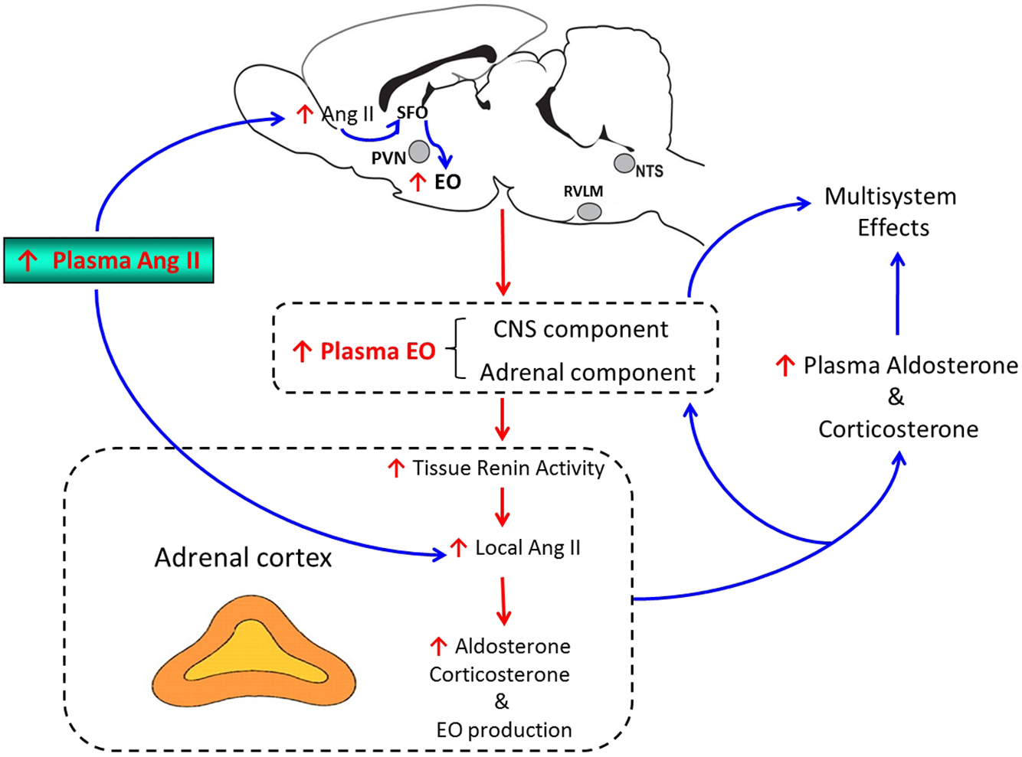
Figure 20: Ang-II affecting the response of different hormones
AngII is not only related with the classical and fundamental RAAS rather it signifies to the study at various angles within the classical view of the role of CNS in order to regulate the central cardiovascular homoeostasis in the short, long, and emergency control of body blood pressure. Here, a variety of reflexes sends afferent information to the brain in order to control the sympathetic nerve traffic within the arteries and veins, heart and kidneys. The classical views of Guytonian view of circulation suggests that these reflexes reset and the CNS as well as the sympathetic activity are only limited within the involvement of the chronic regulation of the cardiovascular homoeostasis. On contrary, the recent reviews have opined that endocrine affects and efferent connection to and from the brain even plays an important role in the circulation of blood as well as an important factor to control the blood pressure. Additionally, the stress management via the mechanism of Ang-II to catecholamine opines within the survey to control the activity of stress management providing a pathway for the body to release stress via fight-fright-flight mechanism. Thus, the Ang-II and other angiotensin are one of the major and important parts of human body that regulates several biochemico-endocrinological pathways within the body to maintain homoeostasis.
Aldosterone
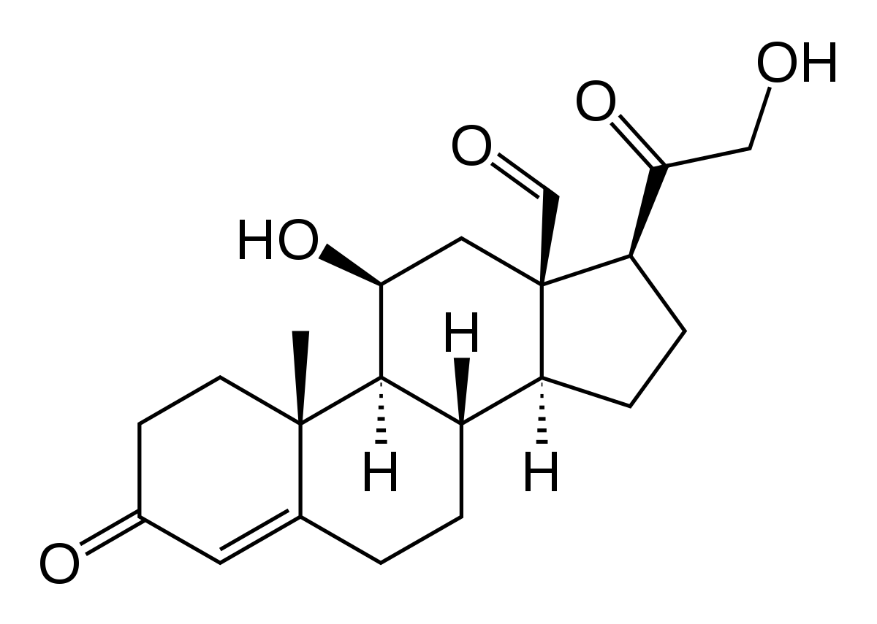
Figure 21: Structure of Aldosterone
Aldosterone is a steroid hormone that has been primarily secreted from the cortical region of the adrenal glands. This serves as the principal regulator of the salt and water balance of the body and thus has been categorised as the mineralcorticoid. This aldosterone even plays a vital role in the metabolism of fats, carbohydrates, and proteins.
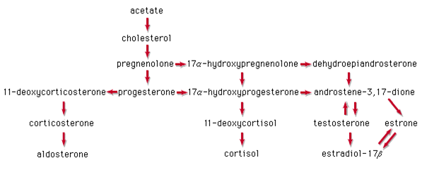

III. Antihypertensive Drugs
They are a class of drugs that have been used to treat hypertension preventing the complications of high blood pressure and other associated cardiovascular diseases such as stroke, and myocardial infarction.
Thus, Anatomical therapeutic Clinical Classification system classifies antihypertensive drugs under C02 section of the circulatory system class. Currently, various types of antihypertensive drugs has been prescribed and marketed. This classification has been based on the region of attack or inhibition the drug may be focusing on. However, this primary target location has not only the major place of attack rather correlative places such as exocrine glands, brain barriers, GABA, e.t.c.

Figure 22: Major Classification of Anti-HTN drugs
Following are the common antihypertensive drugs used hugely:
Table 2: Major Anti-hypertensive Drugs
Classes |  | Sub-Classes | Drugs | Drug bank and Pharmacokinetic Detail
Major Classes of Anti-HTN Drugs | Beta-blocker | Non-vasodilating with beta-1 selectivity | - Acebutolol [ATC Code: C07AB04]  Beta-1 receptor antagonist  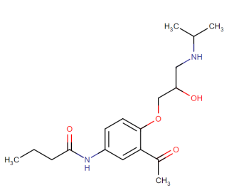 | Acc. No.: DB01193  Ch. Formula: C₁₈H₂₈N₂O₄  Wt. 336.46  Half-Life: 3-4 hrs  Route of elimination: 30-40% {renal excretion and 50-60% {non-renal mechanism}  Protein Binding: 26%
 |  |  | - Atenolol [ATC Code: C07CB53]  Cardioselective beta Blocker  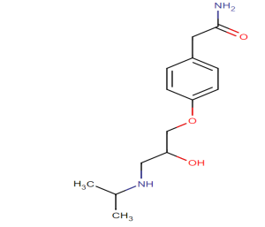 | Acc. No.:DB00335  Ch. Formula: C₁₄H₂₂N₂O₃  Wt.: 266.3361  Half-Life: 6-7hrs  Route of Elimination: 85% {Kidney elimination} and 10% appearing in the feces.  Protein Binding: 6-16%
 |  |  | - Betaxolol [ATC Code: C07AB05]  Cardioselective beta blocking agent  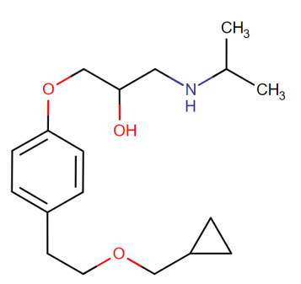 | Acc. No.: DB00195  Ch. Formula: C₁₈H₂₉NO₃  Wt.: 307.4278  Half-Life: 14-22 hours  Route of Elimination: Not Known  Protein Binding: 50%
 |  |  | - Bisoprolol [ATC Code: C07AB07]  Cardioselective beta-1 adrenergic blocking agent  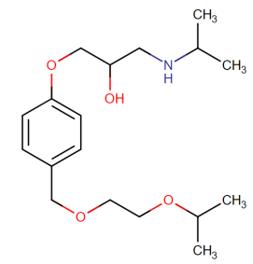 | Acc. No.: DB00612  Ch. Formula: C₁₈H₃₁NO₄  Wt.: 325.443  Half-Life: 10-12 hours  Route of Elimination: Renal and hepatic pathways  Protein Binding: 30% on serum proteins
 |  | Non-Vasodilating without beta-1 selectivity | - 1. Carteolol [ATC Code: C07AA15]  Beta-adrenergic antagonist  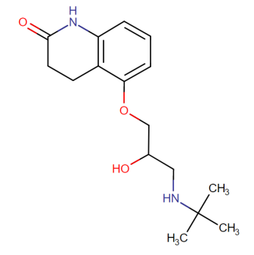 | Acc. No.: DB00521  Ch. Formula: C₁₆H₂₄N₂O₃  Wt.: 292.3734  Half-Life: Unknown  Route of Elimination: Unknown  Protein Binding: Unknown
 |  |  | 2. Esmolol [ATC Code: C07AB09]  Cardioselective beta-adrenergic blocker  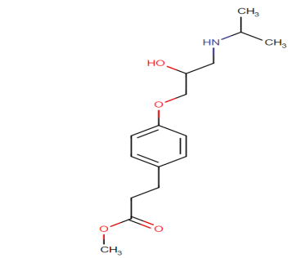 | Acc. No.: DB00187  Ch. Formula: C₁₆H₂₅NO₄  Wt.: 295.374  Half-Life: 2 minutes  Route of Elimination: 2% of the drug is excreted through urination  Protein Binding: 55% to Human Plasma Protein and 10% with acid metabolite
 |  |  | 3. Metoprolol [ATC Code: C07FB02]  Selective beta-1blocker  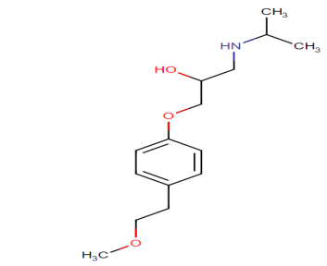 | Acc. No.: DB00264  Ch. Formula: C₁₅H₂₅NO₃  Wt.: 267.3639  Half-Life: 3-7 hours  Route of Elimination: Excreted via kidneys  Protein Binding: 11% to serum albumin
 |  |  | 4. Nadolol [ATC Code: C07AA12]  Non-Selective beta-adrenergic antagonist  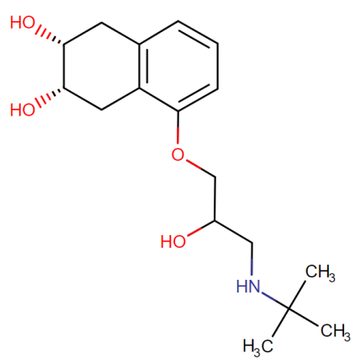 | Acc. No.: DB01203  Ch. Formula: C₁₇H₂₇NO₄  Wt.: 309.4006  Half-Life: 20-24hours  Route of Elimination: 60%{renal excretion}; 15% {feces after 72 hours}  Protein Binding: 30% bound to plasma proteins
 |  |  | 5. Oxprenolol [ATC Code: C07AA12]  Non-selective beta-adrenergic antagonist  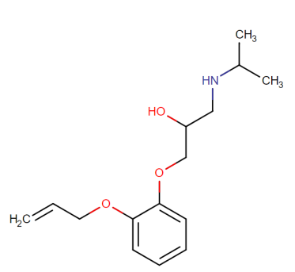 | Acc. No.: DB01580  Ch. Formula: C₁₅H₂₃NO₃  Wt.: 265.348  Half-Life: 1-2 hours  Route of Elimination: unknown  Protein Binding: Unknown
 |  |  | 6. Penbutolol [ATC Code: C07AA23]  Binds to both beta-1 and 2 adrenergic receptors  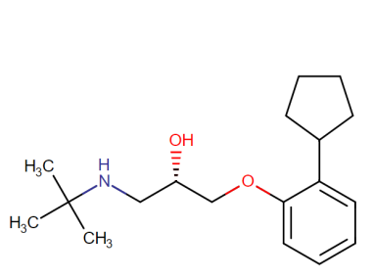 | Acc. No.: DB01359  Ch. Formula: C₁₈H₂₉NO₂  Wt.: 291.424  Half-Life: Plasma=5hours, conjugated 20h in healthy person; 25hours in elderly healthy person and 100 hours in patients with renal dialysis  Route of Elimination: principally through urine  Protein Binding: 80-98%
 |  |  | 7. Propanolol [ATC Code: C07AA05]  Racemic Mixture of 2 enantiomers  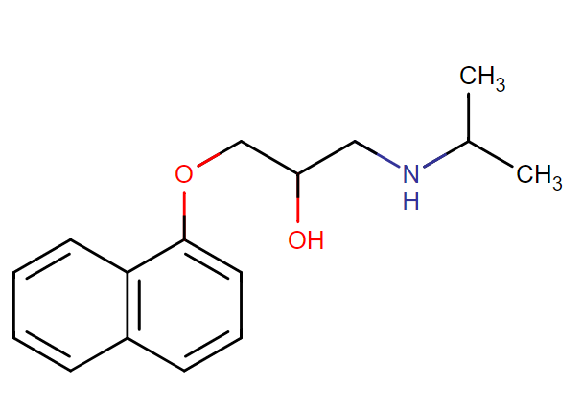 | Acc. No.: DB00571  Ch. Formula: C₁₆H₂₁NO₂  Wt.: 259.3434  Half-Life: approx 8 hours  Plasma half-life= 3-6 hours  Route of Elimination: 91% {metabolites in the urine}  Protein Binding: 90% binds to plasma
 |  |  | 8. Timolol [ATC Code: C07AA06]  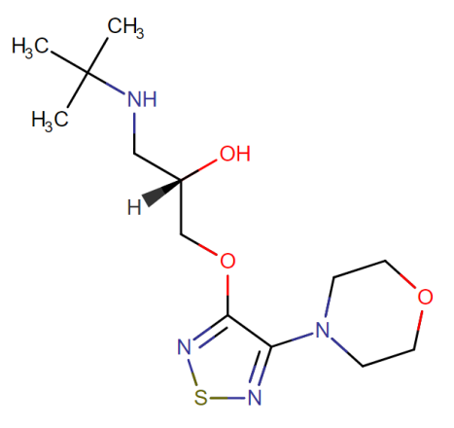 | Acc. No.: DB00373  Ch. Formula: C₁₃H₂₄N₄O₃S  Wt.: 316.42  Half-Life: 2.9±0.3 hours  Route of Elimination: excreted through urine  Protein Binding: Not extensive 10% with plasma protein
 |  | Vasodilating | 1. Celiprolol [ATC Code: C07AB08]  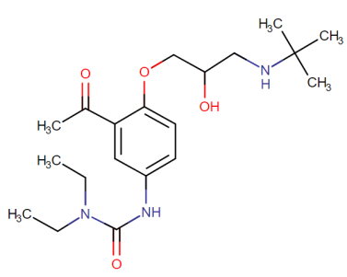 | Acc. No.: DB04846  Ch. Formula: C₂₀H₃₃N₃O₄  Wt.: 379.501  Half-Life: 5hours  Route of Elimination: Unknown  Protein Binding: 25-30%
 |  |  | 2. Carvedilol [ATC Code: C07AG02]  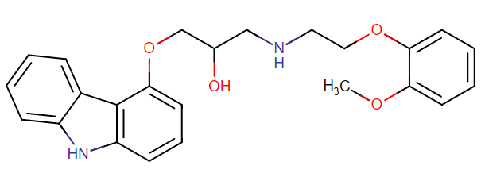 | Acc. No.: DB01136  Ch. Formula: C₂₄H₂₆N₂O₄  Wt.: 406.4742  Half-Life: 7-10 hours  Route of Elimination: 16% {urine} and <2% {unmetabolized drug through feces}  Protein Binding:  98% Plasma  95% in serum albumin
 |  |  | 3. Labetolol [ATC Code: C07AG01]  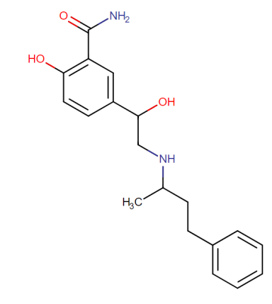 | Acc. No.: DB00598  Ch. Formula: C₁₉H₂₄N₂O₃  Wt.: 328.4055  Half-Life: 1.7-6.1hours  Route of Elimination:55-60% {urine} and 12-27%{feces}  Protein Binding: 50% in serum
 |  |  | 4. Nebivolol [ATC Code: C07AB12]  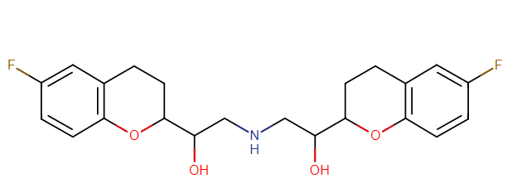 | Acc. No.: DB04861  Ch. Formula: C₂₂H₂₅F₂NO₄  Wt.: 405.435  Half-Life: 12 hours in extensive metabolizers  19hours in poor metabolizers  Route of Elimination: 38% {urine}; 44% {feces}  Protein Binding: 98%
 |  |  | 5. Pindolol [ATC Code: C07AA03]  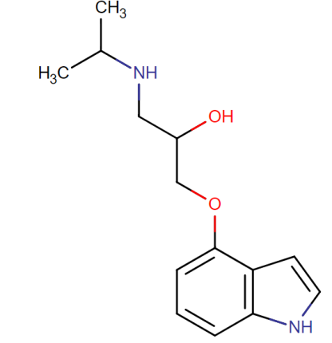 | Acc. No.: DB00960  Ch. Formula: C₁₄H₂₀N₂O₂  Wt.: 248.3208  Half-Life: 3-4 hours in app. Healthy person  30 hours in liver cirrhosis case  Route of Elimination: 80% {urine}; 40% {unchanged}; intravenous dose eliminated by feces  60-65% with glucuronide and sulfate metabolites  Protein Binding: 40% plasma {alpha-1-acid glycoprotein}
 | Diuretics | Loop Diuretics | 1. Furosemide [ATC Code: C07CA01]  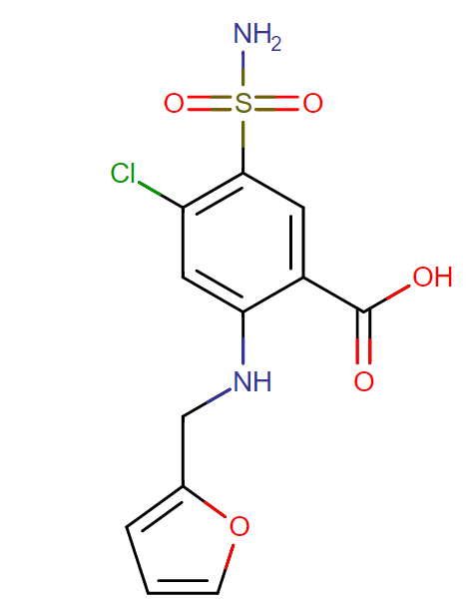 | Acc. No.:DB00695  Ch. Formula: C₁₂H₁₁ClN₂O₅S  Wt.: 330.744  Half-Life: 40mg oral administration= 4 hours  Intravenous administration= 4.5 hours  Route of Elimination: 85% {kidney}; 53% {renal excretion} 50%{remains unchanged}  Protein Binding: 91-99% in plasma {healthy individuals}  Unbound fraction=2.3-4.1%
 |  |  | 2. Bumetanide [ATC Code: C07CA02]  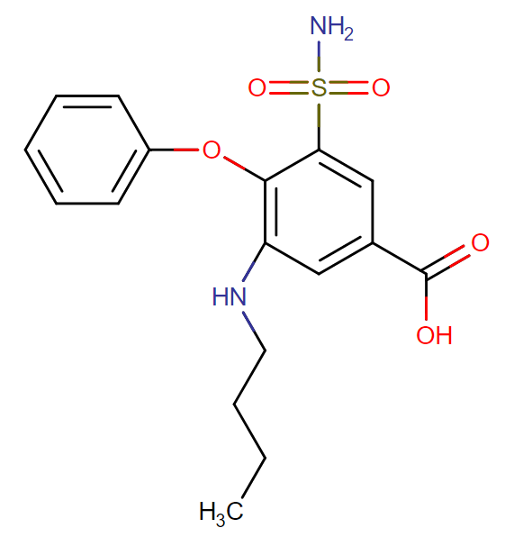 | Acc. No.: DB00887  Ch. Formula:  C₁₇H₂₀N₂O₅S  Wt.: 364.416  Half-Life: 60-90 minutes  Route of Elimination: 81% {urine} 45% {unchanged drugs}; 2% {biliary excretion}  Protein Binding: 97%
 |  |  | 3. Torsemide [ATC Code: C07CA04]  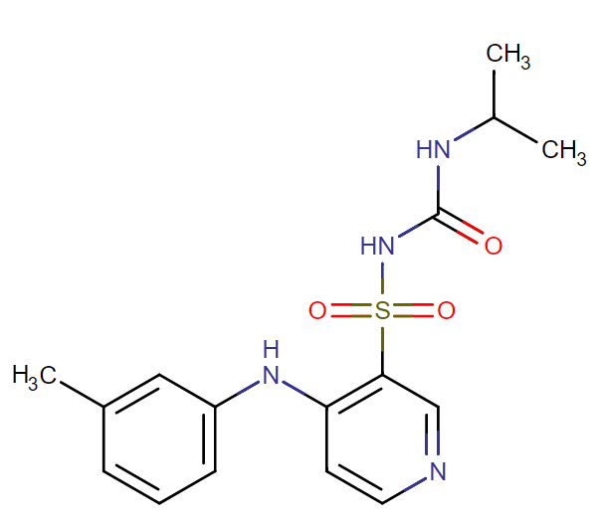 | Acc. No.: DB00214  Ch. Formula:  C₁₆H₂₀N₄O₃S  Wt.: 348.42  Half-Life:3.5 hours  Route of Elimination: 70-80% {feces}; 20-30% {urine}  Protein Binding: 99% in plasma proteins
 |  | Thiazide Diuretics | 1. Bendroflumethiazide [ATC Code: C07AA01]  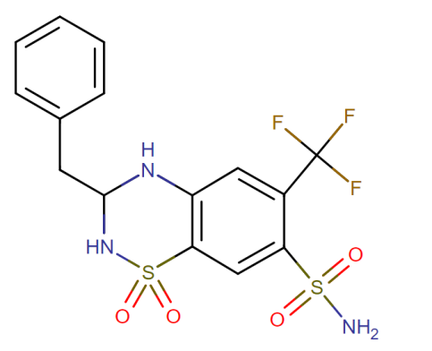 | Acc. No.: DB00436  Ch. Formula:  C₁₅H₁₄F₃N₃O₄S₂  Wt.: 421.415  Half-Life: 8.5 hours  Route of Elimination: unknown  Protein Binding: 96%
 |  |  | 2. Chlorothiazide [ATC Code: C07AA04]  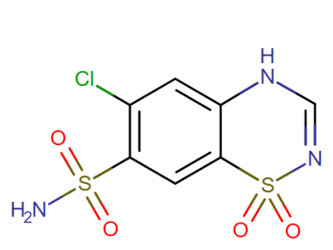 | Acc. No.: DB00880  Ch. Formula:  C₇H₆ClN₃O₄S₂  Wt.: 295.273  Half-Life: 45-120 minutes  Route of Elimination: 10-15% {unchanged through urine}  Eliminates through placenta and even excreted in breast milk  Protein Binding: 40% {plasma Proteins}
 |  |  | 3. Chlortalidone [ATC Code: C07BA04]  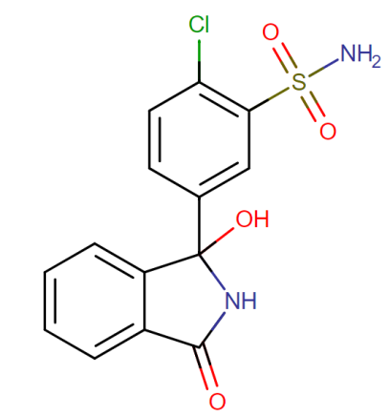 | Acc. No.: DB00310  Ch. Formula:  C₁₄H₁₁ClN₂O₄S  Wt.: 338.766  Half-Life: 40-50 hours  Route of Elimination: 50% unmetabolized through kidney  Biphasic elimination with a rapid phase followed by slow secretary phase  Protein Binding: 70% bounds to plasma proteins  58% bounds to albumin
 |  |  | 4. Hydrochlorothiazide[ATC Code: C03AA03]  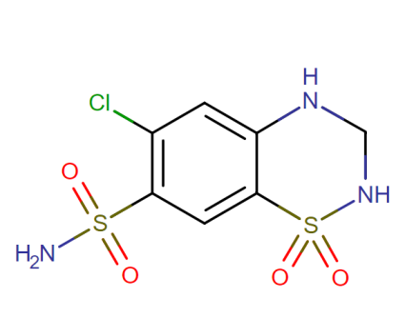 | Acc. No.: DB00999  Ch. Formula: C₇H₈ClN₃O₄S₂  Wt.: 297.739  Half-Life: 5.6-14.8 hours  Route of Elimination: Urine as unchanged hydrochlorothiazide  Protein Binding: 40-60% {plasma proteins}
 |  |  | 5. Indapamide [ATC Code: C03BA11]  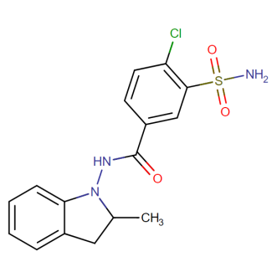 | Acc. No.: DB00808  Ch. Formula: C₁₆H₁₆ClN₃O₃S  Wt.: 365.835  Half-Life: Biphasic elimination leading to 13.9 to 18 hours on once-daily dosing only  Route of Elimination: 60-70% {urine}, 16-23% {feces}  Protein Binding: 76-79% protein bound
 |  |  | 6. Polythiazide [ATC CODSC03AA05]  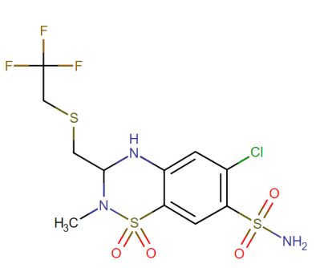 | Acc. No.: DB01324  Ch. Formula:  C₁₁H₁₃ClF₃N₃O₄S₃  Wt.: 439.882  Half-Life: Unavailable  Route of Elimination: Unavailable  Protein Binding: Unavailable
 |  |  | 7. Trichlormethiazide [ATC Code: G-1AWIO]  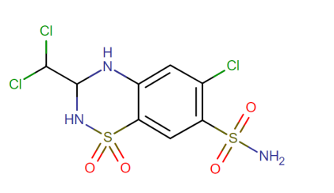 | Acc. No.: DB1021  Ch. Formula:  C₈H₈Cl₃N₃O₄S₂  Wt.: 380.656  Half-Life: Unavailable  Route of Elimination: Unavailable  Protein Binding: Unavailable
 |  | K-Sparing Diuretics | 1. Amiloride [ATC Code: G01AE10]  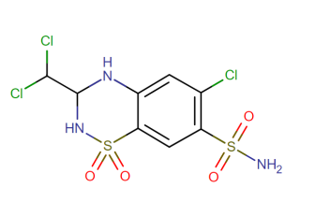 | Acc. No.: DB 01021  Ch. Formula:  C₈H₈Cl₃N₃O₄S₂  Wt.:  Half-Life: Unavailable  Route of Elimination: Unavailable  Protein Binding: Unavailable
 |  |  | 2. Eplerenone [ATC Coder: C03DA04]  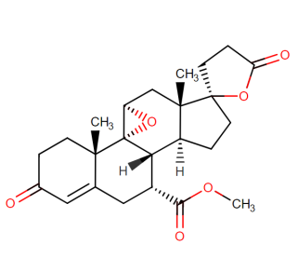 | Acc. No.: DB00700  Ch. Formula:  C₂₄H₃₀O₆  Wt.: 414.4914  Half-Life: 4-6 hours  Route of Elimination: Unavailable  Protein Binding: 50%
 |  |  | 3. Spironolactone [ATC Code: C03DA01]  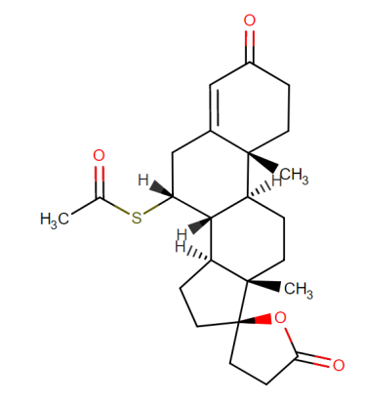 | Acc. No.: DB00421  Ch. Formula:  C₂₄H₃₂O₄S  Wt.: 416.573  Half-Life:1.4 hours  Route of Elimination: 42-56% {Urine}, and 14.2-14.6% {feces}  Protein Binding: 98%
 |  |  | 4. Triamterene [ATC code: C03DB02]  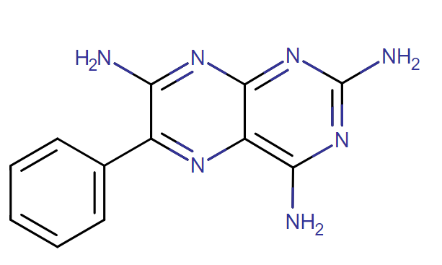 | Acc. No.: DB00384  Ch. Formula:  C₁₂H₁₁N₇  Wt.: 253.26  Half-Life: 1.5-2 hours  Route of Elimination: 50% reaches urine and 20% remains unchanged.  Protein Binding: 67%
 | ACE-inhibitor |  | 1. Benazepril [ATC Code: C09BA07]  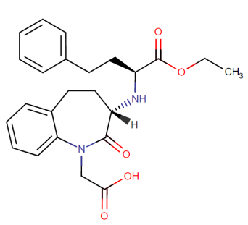 | Acc. No.: DB00542  Ch. Formula:  C₂₄H₂₈N₂O₅  Wt.: 424.4895  Half-Life: 2.7±8.5h  Route of Elimination: predominately through renal excretion; 11-12% {biliary subjects}  Protein Binding: 96.7%
 |  |  | 2. Captopril [ATC Code: C09AA01]  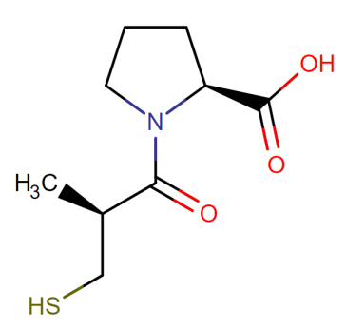 | Acc. No.: DB01197  Ch. Formula:  C₉H₁₅NO₃S  Wt.: 217.285  Half-Life: 2 Hours  Route of Elimination: unavailable  Protein Binding: 25-30%
 |  |  | 3. Cilazapril [ATC Code: C09BA08]  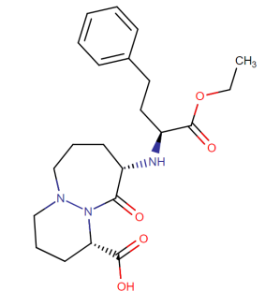 | Acc. No.: DB01340  Ch. Formula:  C₂₂H₃₁N₃O₅  Wt.: 417.4986  Half-Life: 1-4 hours  Route of Elimination: Unchanged by urine, 2.5mg  Protein Binding: 90%-1-5mg  70-80% after 0.5mg
 |  |  | 4. Fosinopril [ATC Code: C09BA09]  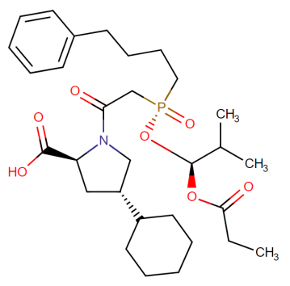 | Acc. No.: DB00492  Ch. Formula:  C₃₀H₄₆NO₇P  Wt.: 563.672  Half-Life: 12 hours  Route of Elimination: Urine and feces  Protein Binding:≥95%
 |  |  | 5. Imidapril [ATC Code: C09AA16]  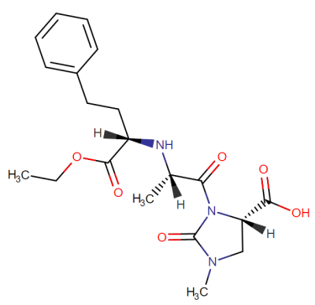 | Acc. No.: DB11783  Ch. Formula:  C₂₀H₂₇N₃O₆  Wt.: 405.4449  Half-Life: Unavailable  Route of Elimination: Unavailable  Protein Binding: Unavailable
 |  |  | 6. Lisinopril [ATC Code: C09BA03]  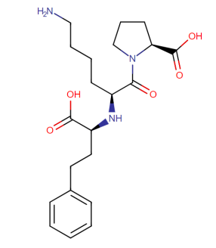 | Acc. No.: DB00722  Ch. Formula:  C₂₁H₃₁N₃O₅  Wt.: 405.4879  Half-Life: effective half-life-12.6h and terminal half life- 46.7h  Route of Elimination: Urine  Protein Binding: No binding evident
 |  |  | 7. Moexipril [ATC Code: C09AA13]  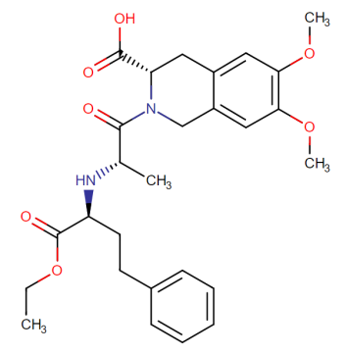 | Acc. No.: DB00691  Ch. Formula: C₂₇H₃₄N₂O₇  Wt.: 498.5681  Half-Life: 1 hour  Route of Elimination: Renal elimination  Protein Binding: 50%
 |  |  | 8. Perindopril [ATC Code: C09BX01]  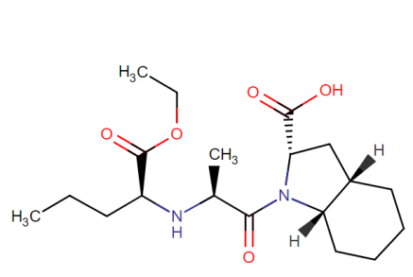 | Acc. No.: DB00790  Ch. Formula: C₁₉H₃₂N₂O₅  Wt.: 368.4678  Half-Life: 1.2 hours to 30-120 hours  Route of Elimination:4-12% only eliminates  Protein Binding: 10-20%
 |  |  | 9. Quinapril [ATC Code: C09AA06]  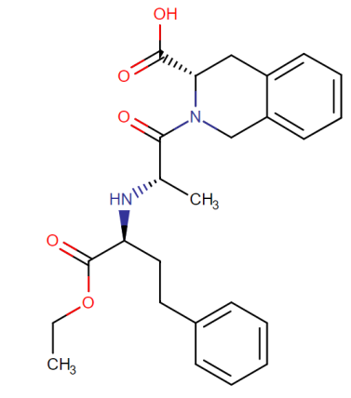 | Acc. No.: DB00881  Ch. Formula: C₂₅H₃₀N₂O₅  Wt.: 438.52  Half-Life: 2.3 hours  Route of Elimination: 96% Urine  Protein Binding: 97%
 |  |  | 10. Ramipril [ATC Code: C09BX03]  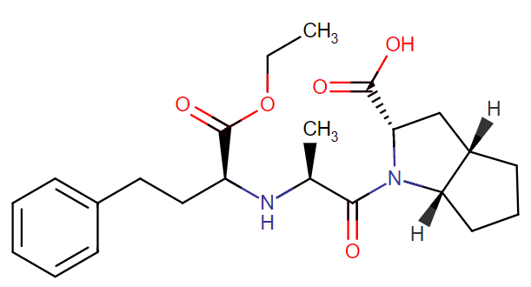 | Acc. No.: DB00178  Ch. Formula: C₂₃H₃₂N₂O₅  Wt.: 416.5  Half-Life: Decline is in triphasic manner with half life of 2-4 hours, >50hours, and slow dissociation on ACE ranging from 13-17 hours  Route of Elimination: 60% of drug is eliminated unchanged by urine and 40% by Feces  Protein Binding: 73% with a concentration ranging between 0.1ug/mL to 10ug/mL
 |  |  | 11. Trandolapril [ATC Code: C09AA10]  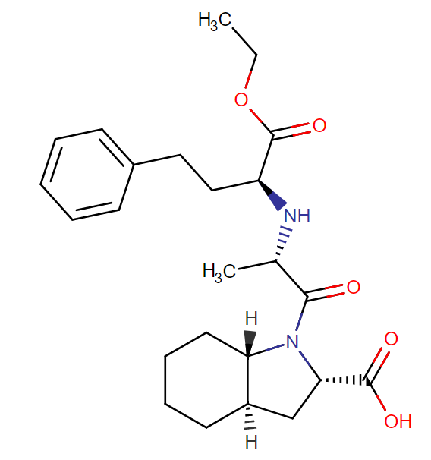 | Acc. No.: DB005109  Ch. Formula: C₂₄H₃₄N₂O₅  Wt.: 430.54  Half-Life: 6-10 hours  Route of Elimination: 33% parent drug and metabolites are recovered in urine and 66% in faeces  Protein Binding: 80%
 |  |  | 12. Zofenopril [ATC Code: C09BA15]  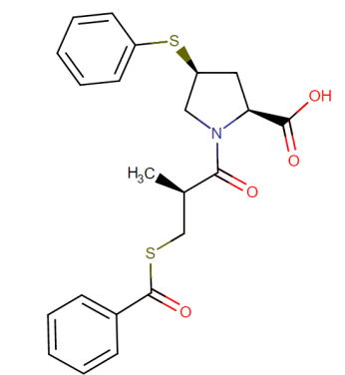 | Acc. No.: DB13166  Ch. Formula: C₂₂H₂₃NO₄S₂  Wt.: 429.56  Half-Life: Unavailable  Route of Elimination: Unavailable  Protein Binding: Unavailable
 | Ang-II receptor Blocker |  | 1. Candesartan [ATC Code: C09DA06]  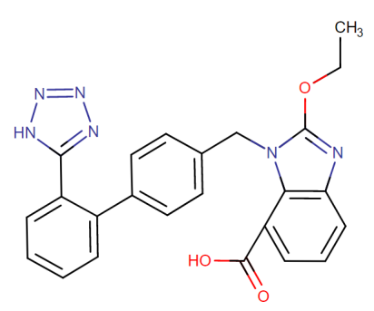 | Acc. No.: DB13919  Ch. Formula: C₂₄H₂₀N₆O₃  Wt.: 440.45  Half-Life: Unavailable  Route of Elimination: Unavailable  Protein Binding: Unavailable
 |  |  | 2. Eprosartan [ATC Code: C09CA02]  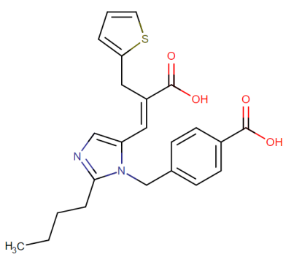 | Acc. No.: DB00876  Ch. Formula: C₂₃H₂₄N₂O₄S  Wt.: 424.51  Half-Life: 5-9hours  Route of Elimination: Unavailable  Protein Binding: 98%
 |  |  | 3. Irbesartan [ATC Code: C09CA04]  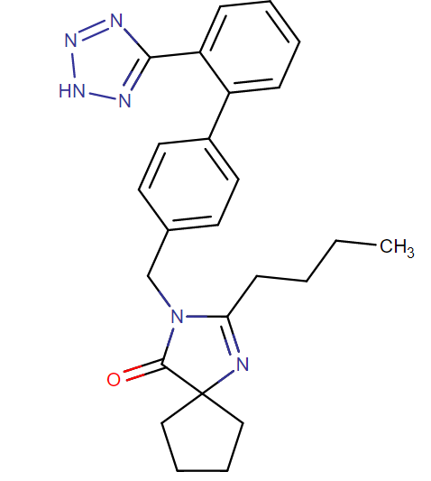 | Acc. No.: DB01029  Ch. Formula: C₂₅H₂₈N₆O  Wt.: 428.53  Half-Life: 11-15 hours  Route of Elimination: 20% radiolabelled oral dose recovered in urine  Rest by feces  Protein Binding: 90%
 |  |  | 4. Losartan [ATC Code: C09CA01]  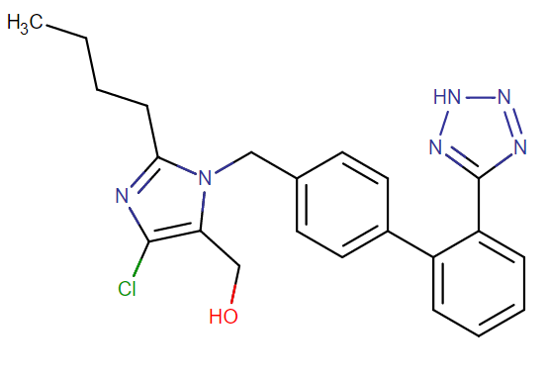 | Acc. No.: DB00678  Ch. Formula: C₂₂H₂₃ClN₆O  Wt.: 422.91  Half-Life: 1.5-2.5hours  Route of Elimination:  60% feces  35% recovered via urine  4% unchanged urine  6% active metabolites in urine  Protein Binding: 98.6-98.8%
 |  |  | 5. Olmesartan [ATC Code: C09DA08]  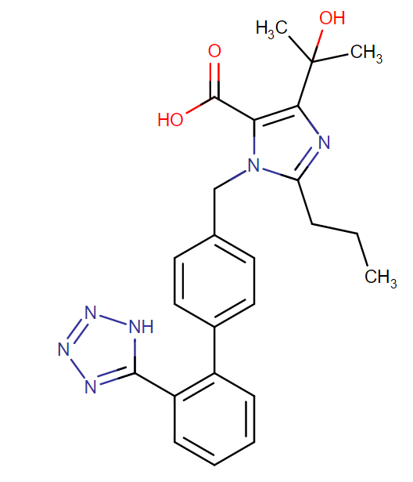 | Acc. No.: DB00275  Ch. Formula: C₂₄H₂₆N₆O₃  Wt.: 446.5  Half-Life: 10-15 hours  Route of Elimination: 10-16%  Protein Binding: 99%
 |  |  | 6. Telmisartan [ATC Code: C09DB04]  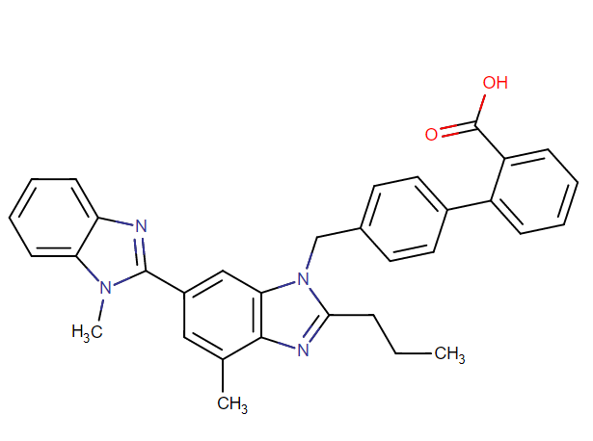 | Acc. No.: DB0096  Ch. Formula: C₃₃H₃₀N₄O₂  Wt.:514.62  Half-Life: 24hours [biexpoential decay kinetics with terminal half-life]  Route of Elimination: >97% is eliminated unchanged through feces via biliary excretion  Protein Binding: >99.5%
 |  |  | 7. Valsartan [ATC Code: C09DX05]  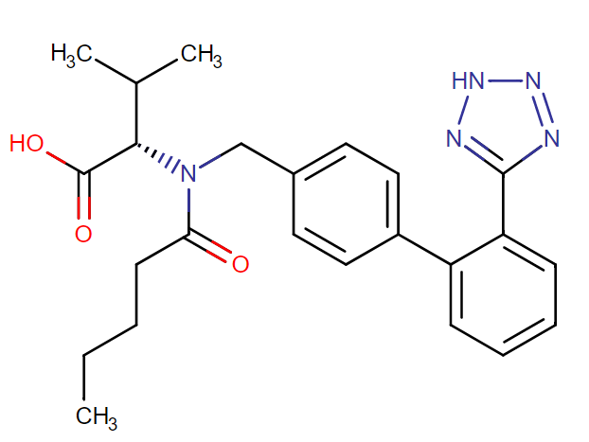 | Acc. No.: DB00177  Ch. Formula: C₂₄H₂₉N₅O₃  Wt.: 435.5  Half-Life: 6 hours  Route of Elimination: 83% by feces and 13% by urine. 20% remains unchanged as metabolites  Protein Binding: 95% to serum proteins
 | Ca2+-Channel Blockers | Non-dihydropyridines | 1. Diltiazem [ATC Code: C08DB01]  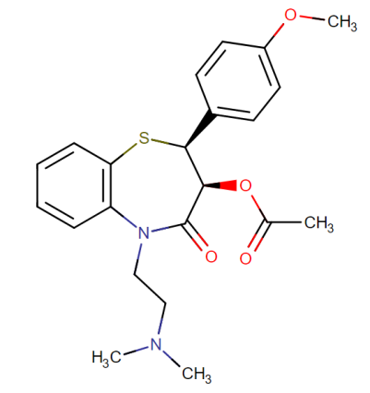 | Acc. No.: DB00343  Ch. Formula: C₂₂H₂₆N₂O₄S  Wt.: 414.518  Half-Life: single and multiple oral doses=3.0-4.5 hours  Elimination half-life= 6-9 hours following intravenous injection to stabilize active metabolites=3.4 hours  Route of Elimination: 2-4% unchanged drug through urine  Protein Binding: 70-80% binds to plasma proteins  40% to alpha-1-glycoprotein  30% to serum albumin
 |  |  | 2. Verapamil [ATC Code: C08DA01]  Administered as a racemic mixture  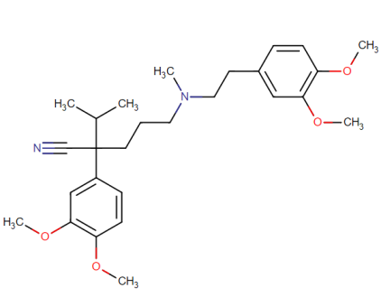 | Acc. No.: DB 00661  Ch. Formula: C₂₇H₃₈N₂O₄  Wt.: 454.6016  Half-Life: Single dosage= 2.8-7.4 hours  Repetitive dosage= 4.5-12.0 hours  Repetitive dosage on patients with hepatic insufficiency 14-16 hours and for elderly adult’s app. 20 hours.  Route of Elimination: 70% {metabolites in the urine}  16% {feces within 5 days}  3-4% {unchanged drug through urine}  Protein Binding: 94% to the serum albumin
 |  | Dihydropyridines | 1. Amlodipine [ATC Code: C08CA01]  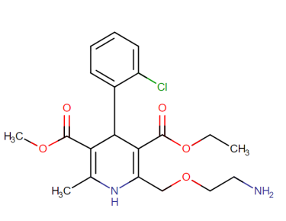 | Acc. No.: DB00381  Ch. Formula:C₂₀H₂₅ClN₂O₅  Wt.: 408.876  Half-Life: 30-50 hours  Route of Elimination: 10% unchanged drug from haemoglobin  Protein Binding: about 98%.
 |  |  | 2. Felodipine [ATC Code: C08CA02]  Acts on Vascular smooth muscle cell  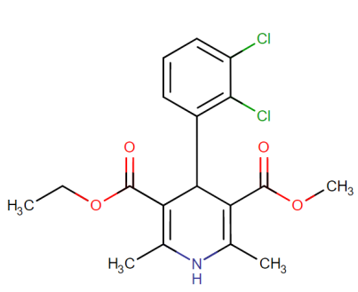 | Acc. No.: DB01023  Ch. Formula:C₁₈H₁₉Cl₂NO₄  Wt.: 384.254  Half-Life:17.5-31.5 Hours= HTN pt.  19.1-35.9 hours = elderly HTN pt.  8.5-19.7 hours= healthy volunteers  Route of Elimination: Plasma  Protein Binding: 99% primarily to the albumin proteins
 |  |  | 3.Isradipine [ATC Code: C08CA03]  Calcium channel blocker  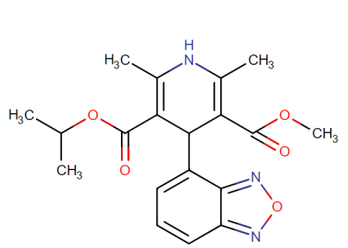 | Acc. No.: DB00270  Ch. Formula: C₁₉H₂₁N₃O₅  Wt.: 371.3871  Half-Life: 8hours  Route of Elimination: 60-65% {urine}; 25-30% {feces}  Protein Binding: 95%
 |  |  | 4. Lacidipine [ATC Code: C08CA09]  Slow onset of action used to treat hypertension  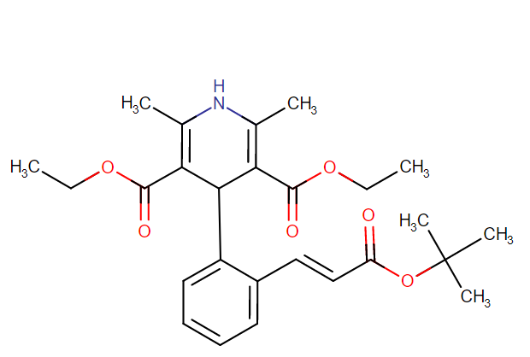 | Acc. No.: DB09236  Ch. Formula: C₂₆H₃₃NO₆  Wt.: 455.551  Half-Life: 13-19 hours  Route of Elimination: 70% eliminated as metabolites in feces  Protein Binding: >95% albumin and lesser to alpha-1-glycoprotein
 |  |  | 5. Lercanidipine [ATC Code: C08CA13]  Calcium channel blocker for HTN  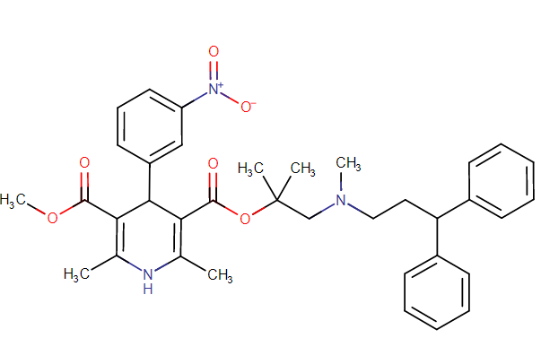 | Acc. No.: DB00528  Ch. Formula: C₃₆H₄₁N₃O₆  Wt.: 611.7272  Half-Life: Unknown  Route of Elimination: Unknown  Protein Binding: Unknown
 |  |  | 6. Manidipine [ATC Code: C08CA11]  Calcium Channel Blocker  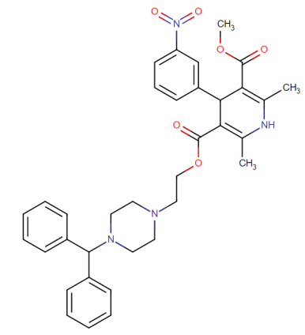 | Acc. No.: DB09238  Ch. Formula: C₃₅H₃₈N₄O₆  Wt.:610.711  Half-Life:  5mg dose=3.94hours  10mg dose=5.02 hours  20mg dose= 7.95hours  Route of Elimination: Extensive metabolism; 63%{feces}; 31%{urine}  Protein Binding: 99% {human Plasma Proteins}
 |  |  | 7. Nicardipine [ATC Code: C08CA04]  Calcium Channel Blockader with marked vasodilator action  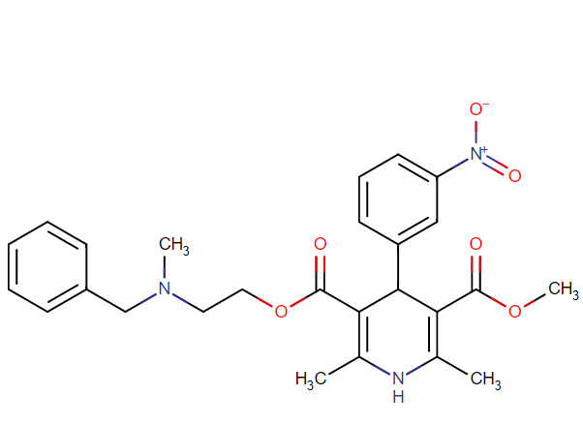 | Acc. No.: DB00622  Ch. Formula: C₂₆H₂₉N₃O₆  Wt.: 479.525  Half-Life: 8.6 hours  Route of Elimination: rapidly and extensively through metabolism by the Liver  Protein Binding: >95%
 |  |  | 8. Nifedipine [ATC Code: C08CA05]  1st generation L-type Calcium Channel Blocker  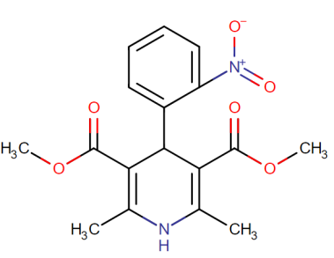 | Acc. No.: DB01115  Ch. Formula: C₁₇H₁₈N₂O₆  Wt.: 346.3346  Half-Life: 2hours  Route of Elimination: 60-80% {urine as inactive water soluble metabolites}  Protein Binding: 92-98% in blood serum  97±12% in a 40g/L solution of albumin  51.4±5.9% protein bound in 50mg/100mL solution of alpha-1-acid glycoprotein  75.5±3.5% protein bound in 150mg/mL solution
 |  |  | 9. Nitrendipine [ATC Code: C08CA08]  Calcium channel blocker with vasodilator Action  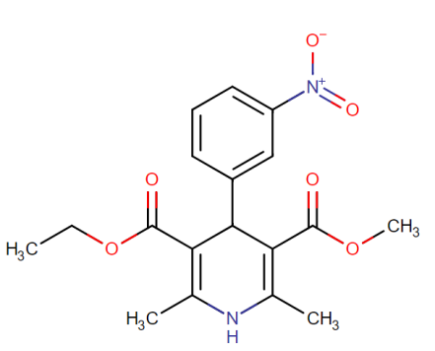 | Acc. No.: DB01054  Ch. Formula: C₁₈H₂₀N₂O₆  Wt.: 360.3612  Half-Life: Unknown  Route of Elimination: Unknown  Protein Binding: >99%

(Source: Drug Bank of Canada)
The above table illustrates the major pharmacokinetics that has been proposed following to the application of various anti-hypertensive drugs that have been continuously prescribed to the people. In this section, thiazide diuretics has been proven to be the first choice of the people that directly coincides to the action of NKCC (Na⁺ K⁺Cl⁻ Cotransporter) present in the kidney at other exocrine organs of the body in order to control the blood pressure by passing the urine out of the body.
However, additional signs that have been correlated with these thiazide diuretics or other anti-hypertensive drugs such as during the cross-sectional studies on several patients; it has been evident that CKD, proteinurea, mild ascitis, and pitting oedema are constantly present reducing the total homoeostasis of the body. In order to better understand the sense of contraindications and correlated pathologies associated with the drug-induction; it is better to focus on the barrier or cellular transporters that have been harshly affected by these groups of anti-hypertensive drugs.
Every drug have different mechanism of action and pharmacodynamics; however, these drugs not only remain specific towards their action rather move to different other receptors or even blockade or antagonism activity causes a relative changes within different parts. Here, it is important to understand that classification of the human body is only a colloquial terminology where the whole body is co-related with each organs, tissues, cells, and energies. This creates a negative regulation due to blockade, antagonism, or biotransformation activity that the organ of the body faces.

IV. Mechanism of action of different anti-HTN drugs and relative oxidative stress mechanism
Classifying the operations of different drugs could be found within the mechanism of actions and the pharmacodynamics of its application. However, the rate of absorption and its medium describes the major pathways of biotransformation based on which the correlative or thought to be negligible could be found. For instance, application of chlorothiazide not only affects the renal function during hypertension management rather it owns the capacity to cross the placental barrier as well as appears within the breast milk that have shown evident issues within the suckling reflex and deformities during neonatal development. On contrary, no controlled data for human studies have been done rather the case studies have found that there has a risk of malformations associated with these classes of thiazide diuretics especially causing issues in neonatal and foetus with the generation of ROS playing an important role in producing liver damage as well as initiating hepatic fibrogenesis leading to disrupt lipid metabolism and jaundice, thrombocytopenia, and electrolyte abnormalities.
Similarly, various drugs have different site of actions other than the specified site as declared by the modern medicine causing lack of specificity and additional issues in relative with the reactions. For example, blocking the angiotensin-II receptor or ACE receptor impacts on the noradrenaline, adrenaline, and mineralcorticoid release reduced the capacity of body to fight against the pathogens. This blocking incidence could be evident from the major pandemic of CoVID-19 where ACE has been found to be the major role player in the infection. However, blockage of ACE due to huge boasted sale of ACE inhibitor drugs lead to the increase in the infection rate as well as mortality rate due to the liver and lung injury (M3 receptor damage) found in them.
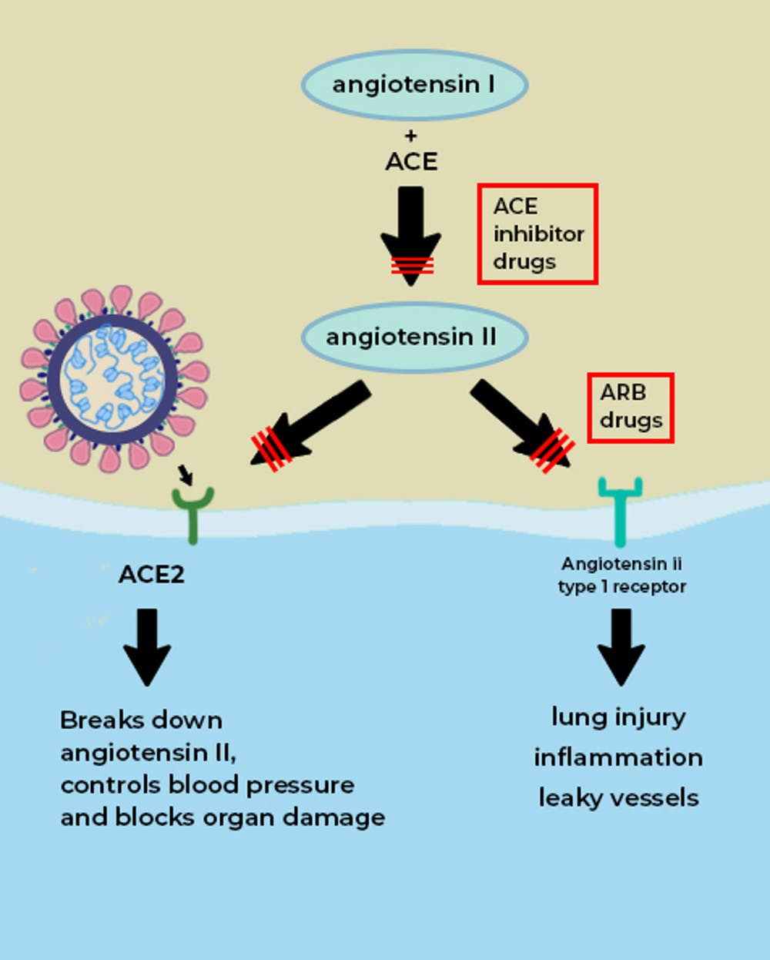
Figure 23: ARB and ACE inhibitors leading to infection and major organ damage in Covid-19 pandemic
In relation to the above pathway, it could be found that NCBI states that around 2 million deaths per year in the world is due to liver related issues whereas around 1.28 billion people have been taking drugs having biotransformation pathway through the liver. Thus, there liver degeneration and other mechanism have been correlatively found within them that could be even better justified by analysing target of action as well as the consecutive relative pathways. It must be noted that classification of pathways or the classification of human body is always colloquial whereas the human body participates or functions in a correlative manner where function of each organ is not independent.
Similarly, oxidative stress has been an important factor for the production of different cellular pathologies where in the current state drug has been one of the major factor. Thus, in following approach oxidative stress could be elaborated:
Oxidative Stress
Oxidative stress reflects an imbalance between the systematic manifestation of the reactive oxygen species as well as biological system ability in order to readily detoxify the reactive intermediates or to repair the resulting damage from the ROS release. Moreover, any disturbances occurring within the normal redox reaction (reduction-oxidation reaction) state of the cell could lead to the toxic effects through the peroxidation as well as generation of free radicals that could damage all the components of the cell, including the proteins, lipid, and DNA. In figure 3, the normal metabolic redox reactions have been clearly stated that provide evidences that a single change within the reaction could lead to different damages due to any reactive oxygen species reaction. Thus, in following way, the ROS generation and oxidative stress could be defined.
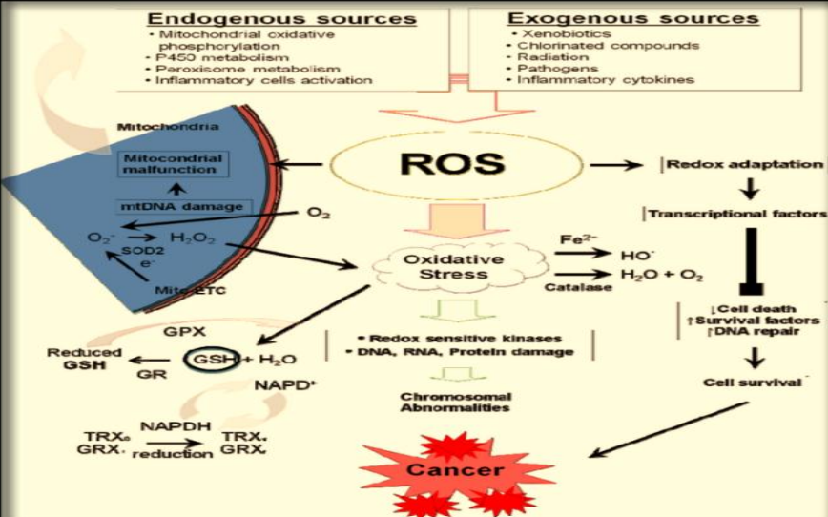
Figure 24: Oxidative Stress and ROS
The endogenous and the exogenous sources such as mitochondrial oxidative phosphyrlation that could be due to the cAMP or ATP blockade/antagonist drugs such as oxepronolol and penbutolol, xenobiotics, P450 metabolism, inflammatory activation, and many more have been affecting the ROS generation. In biochemical activities, oxidative stress has been associated with the increased production of oxidising species or a significant decrease within the effectiveness of antioxidant defences such as Glutathione. Thus, following oxidants have been generated by different aetiologies such as the antihypertensive drugs in this case.

Oxidants | Description
O₂⁻ (Superoxide anion) | One electron reduction state of the dioxygen formed in many auto-oxidation reactions and by the electron transport chain this leads to the autophagy affecting the autoimmune system of each cell.
H2O2 (Hydrogen peroxide | Two electron-reduction state have been formed by the dismutation of oxide anion or by the direct reduction of the superoxide that diffuses across different membranes.  This ROS is mainly found whenever the transporter pathways such as Na+/K+ transporter.
OH- (Hydroxyl radical ) | Three-electron state formed by the Fenton Reactions (usually due to the introduction of metal ions due to injection, drug or the contaminated food) leading to the decomposition of peroxynitrite. This is extremely reactive, that mainly attacks the cellular components
ROOH (organic hydroperoxide) | These are formed by the radical reactions with the cellular components such as Lipids and nucleases (Lipid peroxidation)
RO* (alkoxy) and ROO*, (peroxy radicals) | These are mainly oxygen centred radicals where lipid peroxidation has been a major role playing pathway.  It is produced in the presence of oxygen by radical addition to double bonds or the hydrogen obstruction
HOCl. (Hypochlorous acid) | Formed by hydrogen peroxide through the pathways of lipid-soluble and highly reactive transport activity.  They have the properties to readily oxidise the protein constituents including the –oic groups, amino groups, and methionine
ONOO⁻ (Peroxynitrite) | These are formed within a rapid reaction between superoxide anion and the nitrous oxide.  They are lipid soluble and similar in reactivity to the hypochlorous acid.  Protonation of any drug could lead to the formation of peroxynitrous acid, which can undergo homolytic cleavage in order to form hydroxyl radical and the nitrogen oxide.
Table 3: ROS
Thus, these ROS could be classified in different section by focusing on the relation of the pharmacodynamics as well as mechanism of actions of different anti-HTN drugs that have been commonly used by the people. Additionally, this study severely relates the fundamental modus operandi and the relative biochemical pathways that have been neglected by the modern medicine creating a sense of damage through the production of ROS and other oxidants.
In terms of different classes of Anti-HTN drugs, beta blockers have been thought to be at major use other than the emergency management by thiazide diuretics. However, the mechanism of action of beta blockers have been always been a mystery and a matter of debate; especially, for the cases of beta-selective drugs as they have been thought to have a single blocking activity rather shows their appearance at different places. The mechanism of action of these beta-blockers begins from the actions of beta-1 or beta-2 receptors present at the adrenal medullary region for catecholamine release and at the smooth muscles respectively.
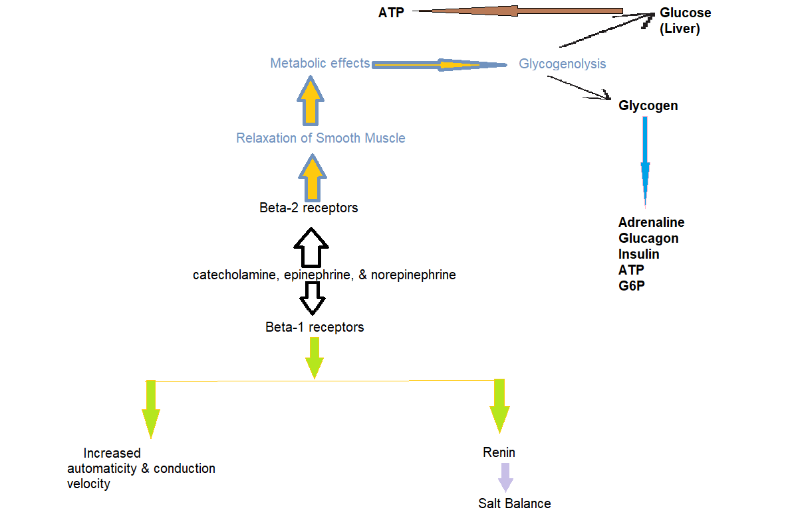
Figure 25: Beta receptor physiology
The above figure 24 has clearly focused on the actual functioning of beta receptors that have been present within the physical body; however, the action of the anti-HTN beta-blocker group of drugs could not segment itself to remain within the anti-hypertensive properties. This creates an increase in the Lipid peroxidation and generation of ROS due to misbalanced salt-mineral balance as created by the drug while controlling the normal functioning. Additionally, the beta receptor affects the short-term blood pressure management pathways through epinephrine and norepinephrine that has been an essential hormone released from the HPA axis.
However, beta blockers such as acebutolol even block the functioning of M3 receptors (muscarinic receptors) present in the bronchus of the lungs. This hence disrupts the normal contractibility during breathing causing major issues such as bronchial constriction, reverse impact of epinephrine and even disruption in the hepatic activity. On the other hand, drugs like drugs like Bisoprolol, Carteolol, Metoprolol, and Propanolol have shown evidences of blockade within the broncho-receptors leading to issues in O₂ intake. On contrary, an approved drug like Esmolol currently lacks the actual pathway or pharmacodynamics that creates a risk relative to the unknown reaction or oxidative stress of unknown origin.
Apart from the expression of beta-blockers affecting the normal physiology, drugs such as diuretics that have been termed as the essential emergency management of the hypertension are more aggressively creating a pressure on the urinary bladder and the renal function. This has been evident that diuretics of every origin not only affect in the preliminary or peripheral aspects rather they leads to the damage of anatomically structure of cells and human major organs. The action of diuretics begin from the major activity of water excretion and this impactsa the functioning of PCT and DCT as well as inhibits Na+, Cl-, and K+ re-absorption.
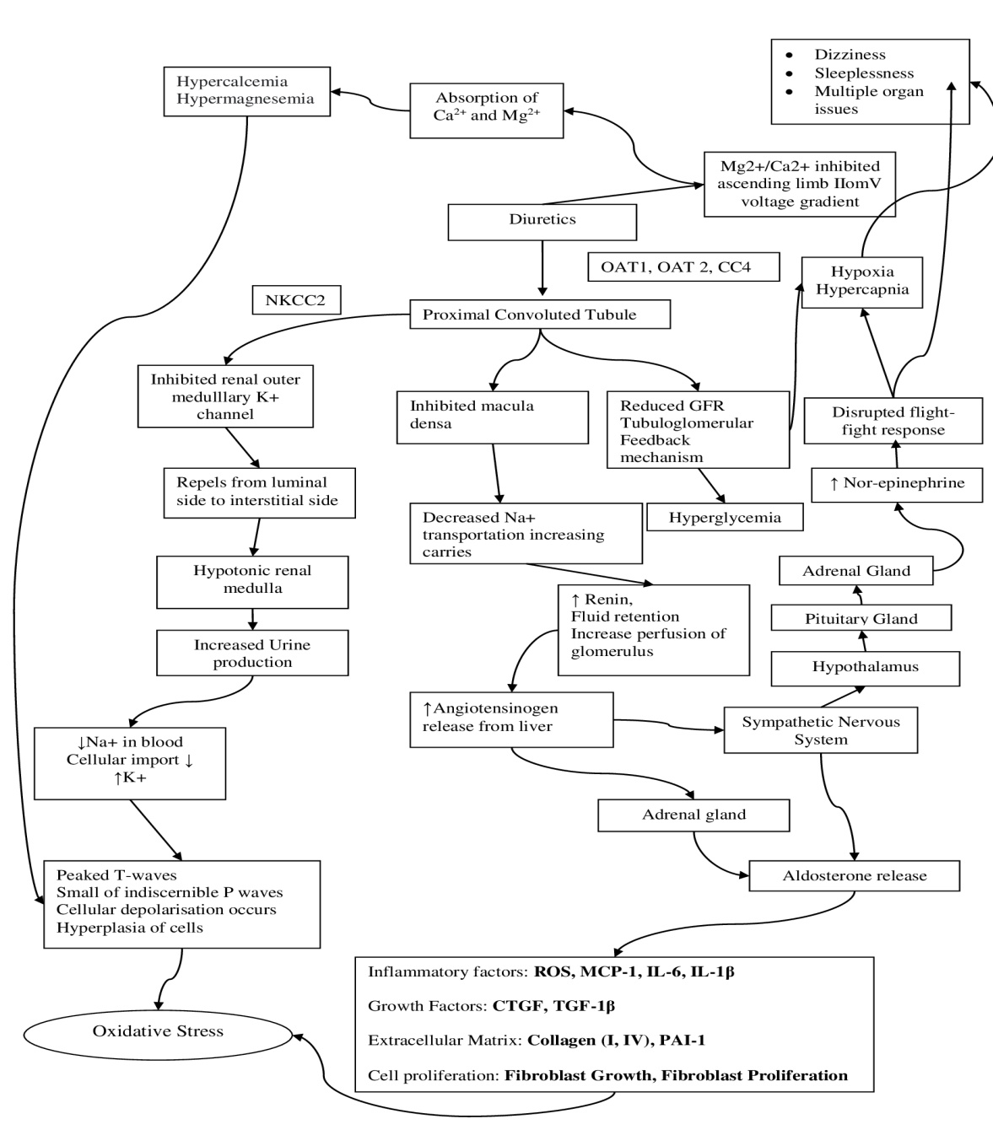
Figure 26: ROS generation within the application of Diuretics
Thus, drugs like diuretics that could be classified into four main categories of loop, thaizide, K-sparing, and Ca2+ blocker diuretics. These classifications have more or less similar mechanism of actions. However, the extra burden on the renal function especially at the convulated tubules has been severely affecting the actions of magnesium and calcium within the body. Moreover, the cardiac output reduces that leads to shortening of Oxygen with cells increasing ROS and RNS generation. Apart from this, the thiazide diuretics as chlorothiazide have been evident to cross the placental barrier as well as the breast lining. This suggests that the drugs affect the renal functionality during the natal period creating a major oxidative stress within the neonatal stages. It could be even found from that reports of CDC that currently 0.2 to 0.3% of the neonatal baby have been evident with the hypertension. This ratio has been increasing with the increase in supply of antihypertensive drugs. Thus, these activities of the drugs have created an immense pressure on the relative cellular pathways leading to the generation of different ROS. Similarly, it has been evident that a disturbed QT syndrome has been increasing as the drugs especially of the gradation of beta-blockers, AT receptor blockers and the Ca2+ blockers where the potential difference between the SA anodes of the heart has been found to be changing creating a sense of major damage in the heart affecting the cardiac output. Moreover, displacement in the ionic transfer even created a similar impact on the disturbance in bowel movement, appetite less, hearing impairment, insulin resistance, and disturbed mental state. Apart from this, other classes of drugs such as ACE inhibitors reflect on the blockade of other mechanical pathway creating a endogenous source for the mitochondrial disruption as reduced ATP formation is evident in this case. Hence, dizziness accompanied with sleeplessness in hypertensive patient is one of the major issues that have been evident due to the continuous expulsion of the Na+ ion from the body creating damage in the thrust of the body balance.
Similar to the mechanism of actions for the diuretics of any class, drugs of different classes such as ACE inhibitor, Ang-II receptor blocker, and Calcium Channel blockers are majorly focusing on the actions of either block or antagonise any hormone in order to reduce the sodium concentration within the blood. However, the single blockade could even lead to different changes within the body such as deduced within the figure 26 stating about the changes of angiotensin within the body and issues related with the hypothalamus. This changes in the hypothalamus affects the major area of axes such as the HPT, HPO, and HPA axis causing the generation of reactive oxygen species.
Hence, the overall analysis justifies that application of different drugs could be beneficial although it require affirmative action where specific organ action is hypothetical since body parts are not found different from each other. As well as ROS generation is not a part of spontaneous action rather has been a result of such pressures created on the body due to the foreign means such as drugs. Thus, related issues of COPD, QT syndrome, dizziness, appetite loss, thirst loss, and insulin resistance are not the adverse effects rather these bodily mechanism to restore the homoeostasis effectively. Apart from this, it should be noted that hypertension is not a disease rather a state of body with increased diastolic/systolic blood pressure due to different causes that needs to be optimised and managed. Increasing use of drugs to suppress has increased the risk of oxidative stress whereas lifestyle management by controlling mental stress and other aetiologies of hypertension could aid to restore the health of an individual.

References
Brunier, A. and O’Hare, R., 2021. More than 700 million people with untreated hypertension. [online] Who.int. Available at: <https://www.who.int/news/item/25-08-2021-more-than-700-million-people-with-untreated-hypertension> [Accessed 26 June 2022].
Chatterjee, C.C. and Raymahasaya, D., 1956. Human physiology. Book Concern.
Dendorfer, A., Raasch, W., Tempel, K., and Dominiak, P. 1998. Interactions between the renin-angiotensin system (RAS) and the sympathetic system. Basic research in cardiology, 93 Suppl 2, 24–29. https://doi.org/10.1007/s003950050202
Drug Bank of Canada, 2022. Acebutolol: Uses, Interactions, Mechanism of Action | DrugBank Online. [online] Go.drugbank.com. Available at: <https://go.drugbank.com/drugs/ DB01193> [Accessed 26 June 2022].
Drug Bank of Canada, 2022. Amiloride: Uses, Interactions, Mechanism of Action | DrugBank Online. [online] Go.drugbank.com. Available at: <https://go.drugbank.com/drugs/DB001021> [Accessed 26 June 2022].
Drug Bank of Canada, 2022. Atenolol: Uses, Interactions, Mechanism of Action | DrugBank Online. [online] Go.drugbank.com. Available at: <https://go.drugbank.com/drugs/DB00335> [Accessed 26 June 2022].
Drug Bank of Canada, 2022. Bendroflumethiazide: Uses, Interactions, Mechanism of Action | DrugBank Online. [online] Go.drugbank.com. Available at: <https://go.drugbank.com/drugs/DB00436> [Accessed 26 June 2022].
Drug Bank of Canada, 2022. Betaxolol: Uses, Interactions, Mechanism of Action | DrugBank Online. [online] Go.drugbank.com. Available at: <https://go.drugbank.com/drugs/DB00335> [Accessed 26 June 2022].
Drug Bank of Canada, 2022. Bisoprolol: Uses, Interactions, Mechanism of Action | DrugBank Online. [online] Go.drugbank.com. Available at: <https://go.drugbank.com/drugs/DB00612> [Accessed 26 June 2022].
Drug Bank of Canada, 2022. Bumetanide: Uses, Interactions, Mechanism of Action | DrugBank Online. [online] Go.drugbank.com. Available at: <https://go.drugbank.com/drugs/DB00887> [Accessed 26 June 2022].
Drug Bank of Canada, 2022. Cartelol: Uses, Interactions, Mechanism of Action | DrugBank Online. [online] Go.drugbank.com. Available at: <https://go.drugbank.com/drugs/DB00521> [Accessed 26 June 2022].
Drug Bank of Canada, 2022. Carvedilol: Uses, Interactions, Mechanism of Action | DrugBank Online. [online] Go.drugbank.com. Available at: <https://go.drugbank.com/drugs/DB01136> [Accessed 26 June 2022]
Drug Bank of Canada, 2022. Celiprolol: Uses, Interactions, Mechanism of Action | DrugBank Online. [online] Go.drugbank.com. Available at: <https://go.drugbank.com/drugs/DB04846> [Accessed 26 June 2022].
Drug Bank of Canada, 2022. Chlorothiazide: Uses, Interactions, Mechanism of Action | DrugBank Online. [online] Go.drugbank.com. Available at: <https://go.drugbank.com/drugs/DB00880> [Accessed 26 June 2022].
Drug Bank of Canada, 2022. Chlortalidone: Uses, Interactions, Mechanism of Action | DrugBank Online. [online] Go.drugbank.com. Available at: <https://go.drugbank.com/drugs/DB00310> [Accessed 26 June 2022].
Drug Bank of Canada, 2022. Eplerenone: Uses, Interactions, Mechanism of Action | DrugBank Online. [online] Go.drugbank.com. Available at: <https://go.drugbank.com/drugs/DB00700> [Accessed 26 June 2022].
Drug Bank of Canada, 2022. Esmolol: Uses, Interactions, Mechanism of Action | DrugBank Online. [online] Go.drugbank.com. Available at: <https://go.drugbank.com/drugs/DB00187> [Accessed 26 June 2022].
Drug Bank of Canada, 2022. Furosemide: Uses, Interactions, Mechanism of Action | DrugBank Online. [online] Go.drugbank.com. Available at: <https://go.drugbank.com/drugs/DB001136> [Accessed 26 June 2022].
Drug Bank of Canada, 2022. Hydrochlorothiazide: Uses, Interactions, Mechanism of Action | DrugBank Online. [online] Go.drugbank.com. Available at: <https://go.drugbank.com/drugs/DB00999> [Accessed 26 June 2022].
Drug Bank of Canada, 2022. Indapamide: Uses, Interactions, Mechanism of Action | DrugBank Online. [online] Go.drugbank.com. Available at: <https://go.drugbank.com/drugs/DB01324> [Accessed 26 June 2022].
Drug Bank of Canada, 2022. Labetolol: Uses, Interactions, Mechanism of Action | DrugBank Online. [online] Go.drugbank.com. Available at: <https://go.drugbank.com/drugs/DB00598> [Accessed 26 June 2022].
Drug Bank of Canada, 2022. Methyclothiazide: Uses, Interactions, Mechanism of Action | DrugBank Online. [online] Go.drugbank.com. Available at: <https://go.drugbank.com/drugs/DB00232> [Accessed 26 June 2022].
Drug Bank of Canada, 2022. Metoprolol: Uses, Interactions, Mechanism of Action | DrugBank Online. [online] Go.drugbank.com. Available at: <https://go.drugbank.com/drugs/DB00264> [Accessed 26 June 2022].
Drug Bank of Canada, 2022. Nadolol: Uses, Interactions, Mechanism of Action | DrugBank Online. [online] Go.drugbank.com. Available at: <https://go.drugbank.com/drugs/DB01203> [Accessed 26 June 2022].
Drug Bank of Canada, 2022. Nebivolol: Uses, Interactions, Mechanism of Action | DrugBank Online. [online] Go.drugbank.com. Available at: <https://go.drugbank.com/drugs/DB00960> [Accessed 26 June 2022].
Drug Bank of Canada, 2022. Oxprenolol: Uses, Interactions, Mechanism of Action | DrugBank Online. [online] Go.drugbank.com. Available at: <https://go.drugbank.com/drugs/DB01580> [Accessed 26 June 2022].
Drug Bank of Canada, 2022. Penbutolol: Uses, Interactions, Mechanism of Action | DrugBank Online. [online] Go.drugbank.com. Available at: <https://go.drugbank.com/drugs/DB01359> [Accessed 26 June 2022].
Drug Bank of Canada, 2022. Pindolol: Uses, Interactions, Mechanism of Action | DrugBank Online. [online] Go.drugbank.com. Available at: <https://go.drugbank.com/drugs/DB00695> [Accessed 26 June 2022].
Drug Bank of Canada, 2022. Polythiazide: Uses, Interactions, Mechanism of Action | DrugBank Online. [online] Go.drugbank.com. Available at: <https://go.drugbank.com/drugs/DB1021> [Accessed 26 June 2022].
Drug Bank of Canada, 2022. Propanolol: Uses, Interactions, Mechanism of Action | DrugBank Online. [online] Go.drugbank.com. Available at: <https://go.drugbank.com/drugs/DB00571> [Accessed 26 June 2022].
Drug Bank of Canada, 2022. Sprionolacetone: Uses, Interactions, Mechanism of Action | DrugBank Online. [online] Go.drugbank.com. Available at: <https://go.drugbank.com/drugs/DB00421> [Accessed 26 June 2022].
Drug Bank of Canada, 2022. Timolol: Uses, Interactions, Mechanism of Action | DrugBank Online. [online] Go.drugbank.com. Available at: <https://go.drugbank.com/drugs/DB00373> [Accessed 26 June 2022].
Drug Bank of Canada, 2022. Torsemide: Uses, Interactions, Mechanism of Action | DrugBank Online. [online] Go.drugbank.com. Available at: <https://go.drugbank.com/drugs/DB00214> [Accessed 26 June 2022].
Drug Bank of Canada, 2022. Triamterene: Uses, Interactions, Mechanism of Action | DrugBank Online. [online] Go.drugbank.com. Available at: <https://go.drugbank.com/drugs/DB00384> [Accessed 26 June 2022].
Fryer, A.D. and Jacoby, D.B., 1998. Muscarinic receptors and control of airway smooth muscle. American journal of respiratory and critical care medicine, 158(supplement_2), pp.S154-S160. Available at: https://www.atsjournals.org/doi/10.1164/ajrccm.158.supplement_2.13tac120#:~:text=The%20upper%20trachea%20and%20bronchi,receptors%20(5%2C%207).
https://ec.bioscientifica.com/view/journals/ec/6/7/EC-17-0161.xml
Kudlak, M. and Tadi, P., 2021. Physiology, Muscarinic Receptor. In StatPearls [Internet]. StatPearls Publishing. Available at: https://www.ncbi.nlm.nih.gov/books/NBK555909/#:~:text=Muscarinic%20receptors%20are%20G%2Dcoupled,of%20the%20sympathetic%20nervous%20system.
Leenen, F. H. H., Blaustein, M. P., and Hamlyn, J. M. 2017. Update on angiotensin II: new endocrine connections between the brain, adrenal glands and the cardiovascular system. Endocrine Connections 6, 7, R131-R145, available from: < https://doi.org/10.1530/EC-17-0161> [Accessed 21 June 2022]
members, R., 2022. Members. [online] Idf.org. Available at: <https://idf.org/our-network/regions-members/europe/members/143-kazakhstan.html#:~:text=Kazakhstan&text=Kazakhstan%20is%20one%20of%20the,will%20rise%20to%2069%20million.> [Accessed 26 June 2022].
Mishra, S., Stierman, B., Gahche, J. and Potischman, N., 2021. Dietary Supplement Use Among Adults: United States, 2017–2018. [online] Available at: <https://www.cdc.gov/nchs/products/databriefs/db399.htm> [Accessed 20 June 2022].
World Health Organisation, 2022. Guideline for the pharmacological treatment of hypertension in adults. [online] Apps.who.int. Available at: <https://apps.who.int/iris/bitstream/handle/10665/344424/9789240033986-eng.pdf> [Accessed 26 June 2022].
World Health Organisation, 2022. Hypertension. [online] Who.int. Available at: <https://www.who.int/news-room/fact-sheets/detail/hypertension> [Accessed 26 June 2022].
World Life Expectancy, 2022. ALZHEIMERS &AMP; DEMENTIA DEATH RATE BY COUNTRY. [online] World Life Expectancy. Available at: <https://www.worldlifeexpectancy.com/cause-of-death/alzheimers-dementia/by-country/> [Accessed 26 June 2022].

