MAGNETITE NANOPARTICLES: ENVIRONMENTAL REMEDIATION AND BIOMEDICAL APPLICATIONS
Jagriti, Thapar Institute of Engineering & Technology; 147004, jagritigarg846@gmail.com
Abstract
Nanotechnology has wide applications in medical science and for environmental friendly process. The co-precipitation method for the synthesis of magnetite nanoparticles is reviewed. Three factors which are temperature, pH and size plays an important role during this synthesis. Some of the future perspectives are presented in the next part of this review, which tells that iron-based nanoparticles can be used to generate green energy. Magnetite nanoparticles can be used for the detection and decontamination of inorganic and organic contaminants to counter the environmental pollution. The in vivo and in vitro applications in the biomedical world are enlighten. In particular, magnetite nanoparticles are widely used due to their chemical stability, high magnetic susceptibility, high saturation magnetisation. Magnetite shows superparamagnetic behaviour as its size is around 20nm, which is an important property for use in biomedical applications.
- Synthesis
1.1 Synthesis of Magnetite
Co-precipitation method is one of the simplest and efficient method for the synthesis of aqueous phase [1]. A typical example of magnetite formation (Fe₃O₄) is described in given equation [2].
Fe²⁺ + 2Fe³⁺ + 8OH⁻ Fe (OH)₂ + 2Fe (OH)₃ Fe₃O₄ + 4H₂O
Goethite
(α-FeO.OH)
The co-precipitation method takes place mainly through a topotactic stage conversion root: akageneite stage (crystal nucleus formation) to goethite stage (narrow-shaped nanoparticle formation).

Hematite
(α-Fe₂O₃)
Maghemite
(γ-Fe₂O₃)
Magnetite
(Fe₃O₄)
catalysis
Akageneite
Fe³⁺

⁺
Fe²⁺

Figure 1: Formation root of MNPs via co-precipitation approach
Goethite (α-FeO·OH) is found in soils. The intermediate stage is the goethite stage [3]. From this stage magnetite converts into maghemite undergoes an oxidation process. Also, the annealing of maghemite converts it into hematite.
Iida et al. synthesised MNPs via hydrolysis in an aqueous solution consisting of Fe²⁺ and Fe³⁺ salts at varying ratios and 1,6-hexanediamine was utilised as the base [4]. When the ratios of Fe²⁺: Fe³⁺ were increased, huge OH (hydroxide) particles were formed as the precursor of magnetite was promoted. When the diameter ranges from ~9 nm to ~37 nm the size of the MNPs increased. Also, by altering the ratio of Fe²⁺ and Fe³⁺ salts the magnetisation saturation value of the magnetite could be controlled.
During this synthesis, if the precipitation is below 60 °C it leads to the production of amorphous hydrated oxyhydroxide, which easily oxides into maghemite. The temperature should be above 80 °C to stimulate the formation of MNPs [5].
A suitable pH, excess amount of base addition was achieved for fast magnetite formation [6]. However, in this scenario, rapid formation of magnetite could also be attained with the usage of a strong base [7]. By modifying the concentration of the base (e.g., NaOH) and the pH values the diameter of MNPs can be controlled.
At fixed pH:
Size of the MNPs α Concentration of NaOH.
At fix NaOH:
Size of the MNPs α 1 / pH values. So, at higher value of pH and lower concentration of NaOH, MNPs below the size of 3 nm were achieved [8].
- FUTURE PERSPECTIVES OF MAGNETITE NANOPARTICLES (M-
Tuning of Electrochemic-al and Magnetic characteristics
NPs)
Solar Energy Harvesting

M-NPs
(Future Outlook)

Tuning of optical properties for photocatalysis
Deep mechanistic insight of M-NPs based reactions

Toxicity and environmental Assessments

Figure 2: Future Perspectives for Magnetite Nanoparticles
Here we will discuss about Deep mechanistic insight of M-NPs based reactions and Toxicity and environmental Assessments.
2.1 ENVIRONMENTAL REMEDIATION BY MAGNETITE
2.1.1 Green and Renewable Energy Harvesting
To fulfil the energy requirements M-NPs are applied for renewable energy harnessing. It also substitutes CO₂ emission with more reasonable and environmental friendly by-products. These NPs have been applied are discussed as follow.
2.1.2 CO₂ Remediation
Greenhouse gases, especially CO₂, continuously promote the greenhouse effect and hence create environmental misbalance. Therefore, to resolve this issue, researchers are trying to capture CO₂, convert it into CO, and lower and higher molecular weight hydrocarbons [9,10,11-12] via photocatalytic [13,14], electrocatalytic [11,15] and photo electrocatalytic [16,17] conversion. M-NPs are found useful for CO₂ conversion due to adequate interfacial interaction of CO₂.
Spinel-shaped magnetite, having {001} and {111} facets, and its isostructural Fe₃S₄ are useful for the catalytic activation of CO₂, as they possess 2+/3+ mixed states. While the former is found to be significantly active in CO₂ activation, the latter showed an insignificant tendency toward the same [18]
2.1.3 Fossil Fuel Substituted Technologies for Sustainable Environment
For environmental sustainability Photovoltaic (PV) cells are best for the solar-induced energy harnessing to replace traditional fossil fuel consumption. Recently, PV technology gained significant attention due to dye-sensitized solar cells (DSSCs) [19]. A PV cell is composed of inorganic and organic counterparts. M-NPs-based electrodes are useful to complete the cell and to improve the overall energy generation capacity of the system [20-22]. Basically, DSSC consists of photoanode, electrolyte, the dye-sensitized counter electrode. Different modifications of anatase TiO₂ photoanodes were formerly utilized for DSSCs but due to high bandgap limits their efficiency [20,21,23]. Therefore, several semi- conductor counterparts were investigated for the substitution of TiO₂. M-NPs based materials which have smaller bandgap show decent photovoltaic performances in DSSCs.
2.1.4 Detection and Removal of Inorganic Contaminants
Use of heavy metals in industries has induce hazardous impacts. Researchers are trying to develop techniques which not only detect the ppm and ppb level of contaminants in the environment but also their removal. For the removal of copper (Cu(II)) [24], arsenic (As(III)) [25], mercury (Hg-(II)) [26], lead (Pb(II)) [27]etc. the effective use of iron oxide NPs has been widely reported. Magnetite acts as a good detector due to its dominant magnetic properties.
Magnetic ionic oxide coated NPs cross-linked to glyoxal and chitosan (Fe₃O₄/glyoxal/chitosan) absorbs 80−90% of toxic Cr (VI) from water [28]. At low pH (∼4), toxic Cr (VI) exists as HCrO⁴⁻and reacts electrostatically with the NH³⁺ group on chitosan. The complex can be separated by the application of an external magnet, and the magnetite can be reused for further separation [28].
Similarly, 3-aminopropyl triethoxysilane (APTES) coated magnetite removed very toxic metals such as Cu (II), Cd (II), Ni (II), and Pb (II). The pH plays an important role in magnetite recyclability. When the pH reached 4, most magnetite was recovered [29]. The covalent thiosalicyl hydrazide/Fe₃O₄ magnetic nano adsorbents detect Cu (II), Zn (II), Pb (II), Cd (II), and Co (II) from industrial wastes with adsorption capacities of 76.9, 51.3, 188.7, 107.5, and 27.7 mg/g, respectively. These nanosorbents are reusable and environmental friendly [24].
Fan et al. reported the use of magnetic Fe₃O₄/chitosan NPs (Fe₃O₄/CS NPs) for the efficient removal of heavy metal ions, i.e., Pb (II) and Cd (II) (79.24 and 36.42 mg/g, respectively), from the aqueous solution.

2.1.5 Detection and Removal of Organic Contaminants
Organic contaminants (OCs) consist of group of hazardous chemicals found in various items like water disinfection by products, personal care products, pharmaceuticals, etc. Their continuous discharge leads to malfunctioning of various ecosystems, including human health. Here presents different ways by which the OC wastes can be removed.

Oil- spill

In situ chemical oxidation
Nano-particles
Bio Remediation
Organic
Contaminants

Surfactants
Co-Solvents
Phyto
Remediation

Figure 3: Common organic contaminants (OCs) remediation
Iron-based sensors are used for this purpose [30-34]. Azo dyes (reactive yellow and reactive black) are degraded by ferrous oxalate with surface-modified magnetite NPs in the presence of hydrogen peroxide [35].
Also Magnetite can effectively remove halo-genated organic compounds (HOCs) and polycyclic aromatic hydrocarbons (PAHs) [36]. Recently, adsorbents based on magnetic NPs in a silica mesoporous were found cost- effective and efficient for the removal of metal contaminants [1mg/L] and organic PAHs [1 mg/L]. The overall scheme is provided in Figure 4.
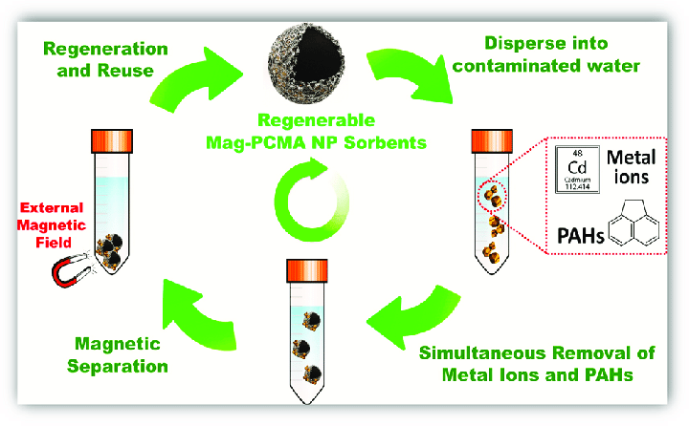
Figure 4: Removal of polycyclic aromatic hydrocarbon (PAH) OCs via magnetic NPs.
Another serious environmental problem is unwanted oil spills that disturb the ecological stability and destroy aquatic life. Modified asphaltene was used for the capping of magnetite, which disperse NPs, induces hydro-phobicity, and hence used for asphaltene separation. As a result heavy crude oil can be collected [37].
By a single-step solvothermal method, Shahid et al. successfully synthesized hydrophilic and hydrophobic iron oxide nanoparticles (SPIONs). The SPIONS functionalized with oleylamine (OLA) and polyethylene glycol (PEG-400) were found to highly stable in the Arabian seawater (ASW) [38] Figure 10 shows the demonstration of oil−water separation by using a magnet, while the graphs on the left show the T2 values.

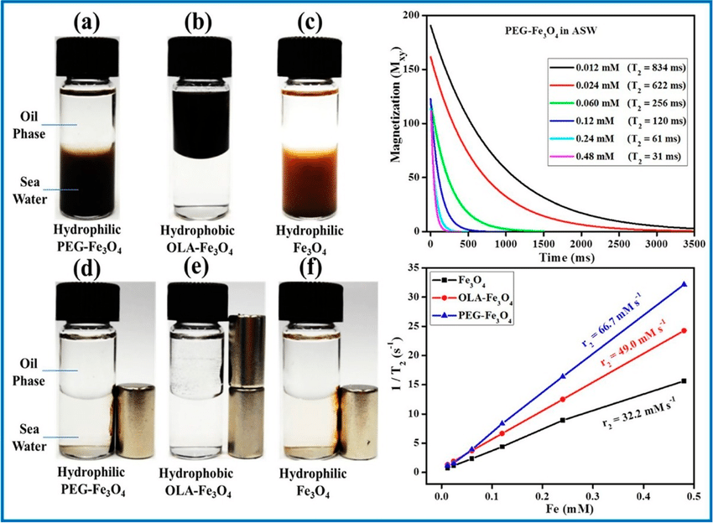
Figure 5: Functionalized magnetite NPs and their stability in oil-DI and oil sea water phases,with T₂ and 1/T₂ relaxation curves.

- Biomedical Applications of Magnetite (Fe₃O₄) Nanoparticles
MNPs have a great potential in the biomedical field (i.e., diagnosis). The biomedical applications of MNPs can be divided according to its applicability, they are inside the body (in vivo) or outside the body (in vitro). In vivo applications divided into diagnostic (MRI) and therapeutic (hyperthermia and TDD) applications. In vitro applications deal with magneto relaxometry and diagnostic separation, selection [6,39].
3.1 In Vivo Applications
Size and Surface modification are the two main factors in In vivo applications. In vivo can be classified into three categories; (i) magnetic vectors (ii) magnetic CAs in MRI; and (iii) magnetic hyperthermia [8]. Due to the advancement of technology in the biomedical field, there is a combination of in vivo applications simultaneously, like the usage of both TDD and MHT [40] and also MHT and MRI [41]. This section discussed about TDD, MRI, and magnetic hyperthermia.
3.1.1 TDD
Traditional TDD includes intravascular injection and chemotherapy, distribute anticancer drugs throughout the body, especially tumour tissues. Only a small amount of dosage reaches these tissues. But the toxicity of drug attack in healthy tissues are present. Therefore, TDD has been introduced as a replacement for the traditional chemotherapy treatment [42,43].
In cancer therapy, TDD has become the most advanced technologies. It focuses the loaded drugs on the cancer site, controls the amount of drug flow towards the tissues and reduces the side effects [42,44,45]. In TDD the application of MNPs has increased very much over the years [46]. MNPs are functionalised with polymers or gold. Functionalisation is done to check whether the anticancer drug could be loaded within the MNPs or conjugated on the surface of MNPs, as shown in Figure 6 [47]. Once the drug is loaded (drug-loaded MNP), an external magnetic field is applied to guide the drug-loaded MNP to the desired cancer site.
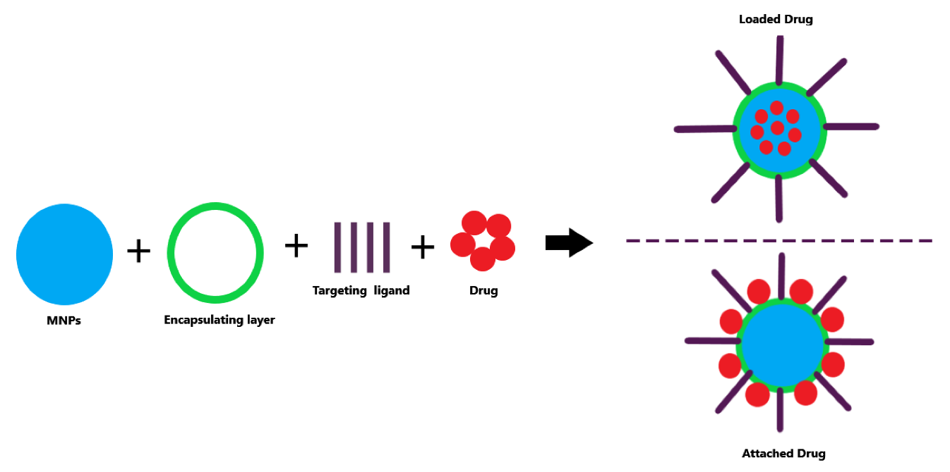
Figure 6: Illustration of drug loading roots in TDD.
3.1.2 MRI
In diagnostic medicine MRI is well-known biomedical imaging techniques. To generate high-resolution images of human tissues in 2D and 3D spaces it is applied. For the detection of pathological processes, it requires a CA to increase its sensitivity sharpness. MNPs are good and reliable CA in in vivo applications due to T1 and T2 relaxation time and a high proton magnetic moment alignment time that results in a much-improved MRI image [48]. When external magnetic field applied, MNPs produce gradients with large microscopic area. The microscopic field gradient reduces the relaxation time (T2*, T1 and T2), which results in a negative or dark contrast in T2-weighted images.
In the field of MRI, Specific cell labelling or cell tracking is another niche possessed by MNPs. When the cells are loaded with highly sufficient amounts of MNPs MRI provides resolution as small as the size of the cell
Gonzalez-Rodriguez et al. For MRI, magnetite nanocrystals are synthesised into hollow silicon nanotubes (SiNTs) as CA [49]. MNPs of 5-nm and 8-nm in average size were loaded into SiNTs of 40 and 70 nm-wall thicknesses as shown in Figure 7. To attain colloidal stability, the nanocomposites were functionalised through an aminopropyl linkage with PEG-diacid (600).

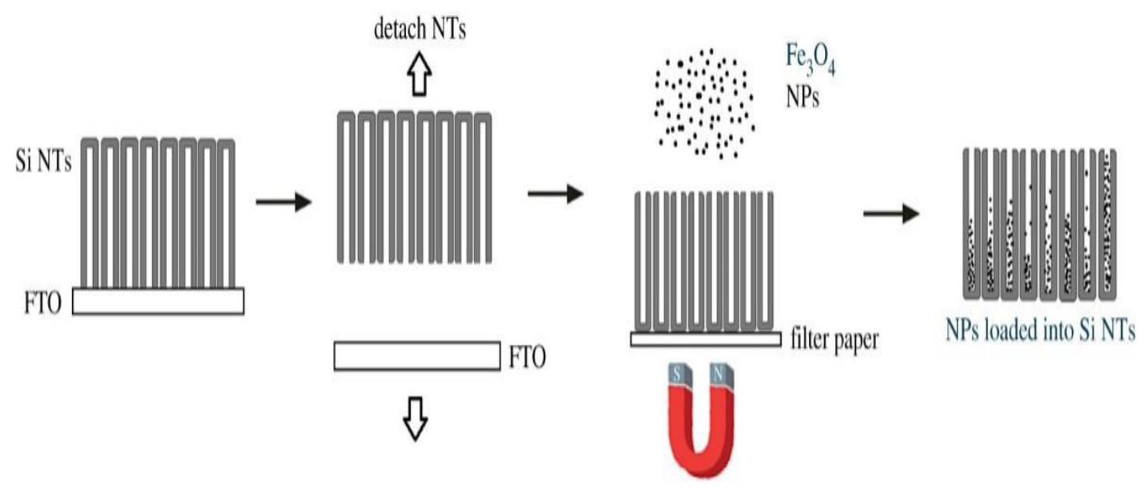
Figure 7: Schematic of MNPs being loaded into SiNTs
3.1.3 MHT
In cancer therapy Hyperthermia is another biological application of MNPs. It is a remedial approach where heat is induced to kill tumours [50,51]. MNPs act as thermal seeds. Once an external magnetic field is applied on MNPs, they heated up under a high frequency alternating magnetic field (AMF) at ~1 MHz [3] due to hysteresis loss. Due to higher heat of the cancer cells than the normal cells by not affecting the healthy ones, the temperature of the tumour cells is increased to 42–45 ◦C to destroy tumour tissues. When the heating reaches around 42–45 ◦C, the cancerous cells undergo cell apoptosis (i.e., hyperthermic effect). If the heating reaches >48 ◦C, the tissues undergoes necrosis (i.e., thermo-ablation) [42,50,51].
Local, regional, and whole-body hyperthermia are the three types of hyperthermia therapy. Local hyperthermia therapy focuses on a specific targeted site of the body part, regional hyperthermia therapy focuses on large tissue areas (e.g., limbs and organs) and the whole-body hyperthermia therapy treats with metastatic cancer which spread throughout the body. Figure 8 shows the process of MHT.
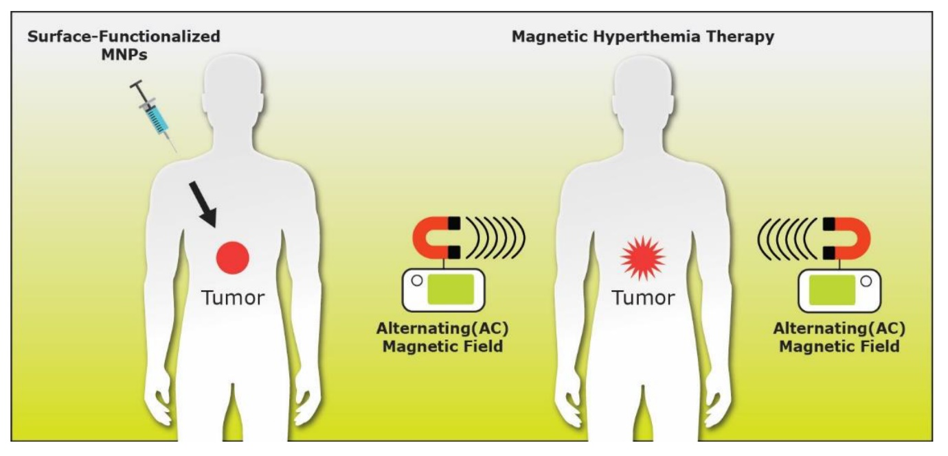
Figure 8: Illustration of typical magnetic hyperthermia therapy process.

In MHT, Superparamagnetic MNPs are the best materials. They are able to give a preliminary rise in temperature of 5 ◦C in just around 10 min [52].
3.2 In Vitro Applications
In vitro application is another type of MNP application. In this section, Bioseparation and Biosensors were discussed.
3.2.1 Bioseparation
MNPs can be successfully applied in Bioseparation because it is a crucial type of in vitro antibody, cell, DNA, enzyme, gene, bacterial and viral separation [53,54]. Surface-modified MNPs with proper intermediates are normally used for surface enhacement. For surface functionalisation, ligands, polymers and surfactants are used to introduce functional groups (e.g., −COOH, −NH2, −OH and −SH) on the target biomolecules via selective adsorption [7].
On the surface of MNP@SiO2 at different pH levels and alkyl groups it is investigated the efficiency of separating bovine serum albumin (BSA) via functionalisation of hydrophobic pockets. By controlling the alkyl chain length, pH levels, salt concentration and size of the hydrophobic pocket they observed efficient magnetic separation and achieved strong magnetic separation [55].
    - Biosensors

For the detection of bacteria, biomolecules, cells, DNA, glucose, and viruses biosensing is an efficient platform [44,56-58]. In the biomedical field, Biosensors are analytical devices. Their main function is to convert biological, chemical, or biochemical response into electrical signals [59,60]. For the detection of molecular interactions, the surface functionalisation of MNPs is advantageous and for targeted biomolecule interactions, the large surface area of MNPs permits efficient functionalisation [7,44].
References:
[1] Sheng-Nan, S.; Chao, W.; Zan-Zan, Z.; Yang-Long, H.; Venkatraman, S.S.; Zhi-Chuan, X. Magnetic iron oxide nanoparticles: Synthesis and surface coating techniques for biomedical applications. Chin. Phys. B 23, 037503 (2014).
[2] Majewski, P.; Thierry, B. Functionalized Magnetite Nanoparticles—Synthesis, Properties and Bio-Applications. Crit. Rev. Solid State Mater. Sci. 32, 203–215 (2007).
[3] Kandasamy, G.; Maity, D. Recent advances in superparamagnetic iron oxide nanoparticles (SPIONs) for in vitro and in vivo cancer nanotheranostics. Int. J. Pharm. 496, 191–218 (2015).
[4] Davoudi, Z.; Akbarzadeh, A.; Rahmatiyamchi, M.; Movassaghpour, A.A.; Alipour, M.; Nejati-Koshki, K.; Sadeghi, Z.; Dariushnejad, H.; Zarghami, N. Molecular Target Therapy of AKT and NF-kB Signaling Pathways and Multidrug Resistance by Specific Cell Penetrating Inhibitor Peptides in HL-60 Cells. Asian Pac. J. Cancer Prev. 15, 4353–4358 (2014).
[5] Govan, J.; Gun’Ko, Y.K. Recent Advances in the Application of Magnetic Nanoparticles as a Support for Homogeneous Catalysts. Nanomaterials 4, 222–241 (2014).
[6] Sukumaran, S.; Neelakandan, M.S.; Shaji, N.; Prasad, P.; Yadunath, V.K. Magnetic Nanoparticles: Synthesis and Potential Biological Applications. JSM Nanotechnol. Nanomed. 6, 1068 (2018).
[7] Wu, W.; Wu, Z.; Yu, T.; Jiang, C.Z.; Kim, W.-S. Recent progress on magnetic iron oxide nanoparticles: Synthesis, surface functional strategies and biomedical applications. Sci. Technol. Adv. Mater. 16, 023501 (2015).
[8] Blaney, L. Magnetite (Fe₃O₄): Properties, Synthesis, and Applications. Lehigh Univ. Lehigh Preserv. 15, 5 (2007).
[9] Ning, W., Wang, T., Chen, H., Yang, X., and Jin, Y. The Effect of Fe₂O₃ Crystal Phases on CO₂ Hydrogenation. PLoS One 12 (8), No. e0182955 (2017).
[10] Guo, H., Xu, H., and Barnard, A. S. Can Hematite Nanoparticles Be an Environmental Indicator? Energy Environ. Sci. 6 (2), 561−569 (2013).
[11] Gao, D., Zhang, Y., Zhou, Z., Cai, F., Zhao, X., Huang, W., Li, Y., Zhu, J., Liu, P., Yang, F., et al. Enhancing CO₂ Electroreduction with the Metal−Oxide Interface. J. Am. Chem. Soc. 139 (16), 5652−5655 (2017).
[12] Hanusch, J. M., Kerschgens, I. P., Huber, F., Neuburger, M., and Gademann, K. (2019) Pyrrolizidines for Direct Air Capture and CO₂ Conversion. Chem. Commun. 55 (7), 949−952 (2019).
[13] Lee, Y. Y., Jung, H. S., Kim, J. M., and Kang, Y. T. Photocatalytic CO₂ Conversion on Highly Ordered Mesoporous Materials: Comparisons of Metal Oxides and Compound Semi- conductors. Appl. Catal., B 224, 594−601 (2018).
[14] Das, S., and Wan Daud, W.M. A. A Review on Advances in Photocatalysts towards CO₂ Conversion. RSC Adv. 4 (40), 20856 (2014).
[15] Browne, M. P., Sofer, Z., and Pumera, M. Layered and Two-Dimensional Metal Oxides for Electrochemical Energy Conversion. Energy Environ. Sci. 12 (1), 41−58 (2019).
[16] Zhang, L., Zhao, Z.-J., Wang, T., and Gong, J. Nano-Designed Semiconductors for Electro- and Photoelectro-Catalytic Conversion of Carbon Dioxide. Chem. Soc. Rev. 47 (14), 5423−5443 (2018).
[17] Chu, S., Ou, P., Ghamari, P., Vanka, S., Zhou, B., Shih, I., Song, J., and Mi, Z. Photoelectrochemical CO 2 Reduction into Syngas with the Metal/Oxide Interface. J. Am. Chem. Soc. 140 (25), 7869−7877 (2018).
[18] Santos-Carballal, D., Roldan, A., Dzade, N. Y., and de Leeuw, N. H. Reactivity of CO₂ on the Surfaces of Magnetite (Fe₃O₄), Greigite (Fe₃S₄) and Mackinawite (FeS). Philos. Trans. R. Soc., A 376 (2110), 20170065 (2018).
[19] Anastasova, E. I., Prilepskii, A. Y., Fakhardo, A. F., Drozdov, A. S., 981 and Vinogradov, V. V. Magnetite Nanocontainers: Toward 982 Injectable Highly Magnetic Materials for Targeted Drug Delivery. ACS 983 Appl. Mater. Interfaces 10, 30040 (2018).
[20] Gurudayal, Bassi, P. S., Sritharan, T., and Wong, L. H. Recent Progress in Iron Oxide Based Photoanodes for Solar Water Splitting. J. Phys. D: Appl. Phys. 51 (47), 473002 (2018).
[21] Rashid, N. M., Kishi, N., and Soga, T. Effects of Nanostructures on Iron Oxide Based Dye Sensitized Solar Cells Fabricated on Iron Foils. Mater. Res. Bull. 77, 126−130 (2016).
[22] Motley, T. C., and Meyer, G. J. Are We on a Path to Solar Cells That Utilize Iron? NPG Asia Mater. 8 (4), e261 (2016).
[23] Manikandan, A., Saravanan, A., Antony, S. A., and Bououdina, M. One-Pot Low Temperature Synthesis and Characterization Studies of Nanocrystalline α-Fe2O3 Based Dye Sensitized Solar Cells. J. Nanosci. Nanotechnol. 15 (6), 4358−4366 (2015).
[24] Zargoosh, K., Abedini, H., Abdolmaleki, A., and Molavian,M. R. Effective Removal of Heavy Metal Ions from Industrial Wastes Using Thiosalicylhydrazide-Modified Magnetic Nanoparticles. Ind. Eng. Chem. Res. 52 (42), 14944−14954 (2013).
[25] Parida, P., Lolage, M., Angal, A., and Rautaray, D. Iron Oxide Nanoparticles to Remove Arsenic from Water, in Sustainable Agriculture Reviews, Springer, Cham, pp 279−299. DOI: 10.1007/978-3- 319-53112-0_10 (2017).
[26] Ambashta, R. D., and Sillanpaa ,̈ M. Water Purification Using Magnetic Assistance: A Review. J. Hazard. Mater. 180 (1−3), 38−49 (2010).
[27] Ahmed, M. A., Ali, S. M., El-Dek, S. I., and Galal, A. Magnetite Nanoparticles Prepared by Green Methods for Heavy Metal Ions Removal from Water. Mater. Sci. Eng., B 178 (10), 744−751 (2013).
[28] Mahdavian, A. R., and Mirrahimi, M. A.-S. Efficient Separation of Heavy Metal Cations by Anchoring Polyacrylic Acid on Superparamagnetic Magnetite Nanoparticles through Surface Mod- ification. Chem. Eng. J. 159 (1−3), 264−271 (2010).
[29] Nadejde, C., Neamtu, M., Schneider, R. J., Hodoroaba, V.-D., Ababei, G., and Panne, U. Catalytical Degradation of Relevant Pollutants from Waters Using Magnetic Nanocatalysts. Appl. Surf. Sci. 352 (352), 42−48 (2015).
[30] Cameselle, C., and Gouveia, S. Electrokinetic Remediation for the Removal of Organic Contaminants in Soils. Curr. Opin. Electrochem. 11, 41−47 (2018).
[31] Li, Z., Undeman, E., Papa, E., and McLachlan, M. S. High-Throughput Evaluation of Organic Contaminant Removal Efficiency in a Wastewater Treatment Plant Using Direct Injection UHPLC-Orbitrap-MS/MS. Environ. Sci. Process. Impacts 20 (3), 561− 571 (2018).
[32] Farhat, A., Keller, J., Tait, S., and Radjenovic, J. Removal of Persistent Organic Contaminants by Electrochemically Activated Sulfate. Environ. Sci. Technol. 49 (24), 14326−14333 (2015).
[33] Nuń ̃ez, M., Borrull, F., Pocurull, E., and Fontanals, N. Sample Treatment for the Determination of Emerging Organic Contaminants in Aquatic Organisms. TrAC, Trends Anal. Chem. 97, 136−145 (2017).
[34] Lv, S.-W., Liu, J.-M., Wang, Z.-H., Ma, H., Li, C.-Y., Zhao, N., and Wang, S. Recent Advances on Porous Organic Frameworks for the Adsorptive Removal of Hazardous Materials. J. Environ. Sci. 80, 169 (2019).
[35] Khataee, A., Taseidifar, M., Khorram, S., Sheydaei, M., and Joo, S.W. Preparation of Nanostructured Magnetite with Plasma for Degradation of a Cationic Textile Dye by the Heterogeneous Fenton Process. J. Taiwan Inst. Chem. Eng. 53, 132−139 (2015).
[36] Zhang, L., and Fang, M. Nanomaterials in Pollution Trace Detection and Environmental Improvement. Nano Today 5 (2),128−142 (2010).
[37] Abdullah, M. M. S., Al-Lohedan, H. A., and Atta, A. M. Novel Magnetic Iron Oxide Nanoparticles Coated with Sulfonated Asphaltene as Crude Oil Spill Collectors. RSC Adv. 6 (64), 59242−59249 (2016).
[38] Ali, S., Khan, S. A., Eastoe, J., Hussaini, S. R., Morsy, M. A., and Yamani, Z. H. Synthesis, Characterization, and Relaxometry Studies of Hydrophilic and Hydrophobic Superparamagnetic Fe₃O₄ Nanoparticles for Oil Reservoir Applications. Colloids Surf., A 543, 133−143 (2018).
[39] Sandler, S.E.; Fellows, B.D.; Meord, O.T. Best Practices for Characterization of Magnetic Nanoparticles for Biomedical Applications. Anal. Chem. 91, 14159–14169 (2019).
[40] Oltolina, F.; Peigneux, A.; Colangelo, D.; Clemente, N.; D’Urso, A.; Valente, G.; Iglesias, G.R.; Jiménez-Lopez, C.; Prat, M. Biomimetic Magnetite Nanoparticles as Targeted Drug Nanocarriers and Mediators of Hyperthermia in an Experimental Cancer Model. Cancers 12, 2564 (2020).
[41] Vuongaf, T.K.; Le, T.T.; Do, H.D.; Nguyen, X.T.; Vu, T.T.; Le, T.L.; Tran, L.D. PMAO-assisted thermal decomposition synthesis of high-stability ferrofluid based on magnetite nanoparticles for hyperthermia and MRI applications. Mater. Chem. Phys. 245, 122762 (2020).
[42] Bhuiyan, M.T.H.; Chowdhury, M.N.; Parvin, M.S. Potential Nanomaterials and their Applications in Modern Medicine: An Overview. ARC J. Cancer Sci. 2, 25–33 (2016).
[43] Estelrich, J.; Escribano, E.; Queralt, J.; Busquets, M.A. Iron Oxide Nanoparticles for Magnetically-Guided and Magnetically-Responsive Drug Delivery. Int. J. Mol. Sci. 16, 8070–8101 (2015).
[44] Abdullah, N. Surface Functionalization of Magnetic Nanoparticles Towards Biomedical Applications. Master’s Thesis, School of Mechanical, Materials, Mechatronic and Biomedical Engineering, University of Wollongong, Wollongong, Australia, 2018.
[45] Estelrich, J.; Escribano, E.; Queralt, J.; Busquets, M.A. Iron Oxide Nanoparticles for Magnetically-Guided and Magnetically-Responsive Drug Delivery. Int. J. Mol. Sci. 16, 8070–8101 (2015).
[46] Malumbres, A.; Martínez, G.; Mallada, R.; Hueso, J.L.; Bomati-Miguel, O.; Santamaría, J. Continuous production of iron-based nanocrystals by laser pyrolysis. Effect of operating variables on size, composition and magnetic response. Nanotechnology, 24, 325603 (2013).
[47] Eremin, A.V.; Gurentsov, E.V.; Mikheyeva, E.Y.; Musikhin, S.A. Binary iron–carbon nanoparticle synthesis in photolysis of Fe (CO)₅ with methane and acetylene. J. Phys. Conf. Ser. 774, 012127 (2016).
[48] Wallyn, J.; Anton, N.; Vandamme, T.F. Synthesis, Principles, and Properties of Magnetite Nanoparticles for In Vivo Imaging Applications—A Review. Pharmaceutics 11, 601 (2019).
[49] Gonzalez-Rodriguez, R.; Granitzer, P.; Rumpf, K.; Coffer, J.L. New MRI contrast agents based on silicon nanotubes loaded with superparamagnetic iron oxide nanoparticles. R. Soc. Open Sci. 5, 180697 (2018)
[50] Moradiya, M.A.; Ladani, A.; Ladani, J.; Raiyani, C.; Markna, J.H. New Way to Treat Cancer: Magnetic Nanoparticle based Hyperthermia. J. Chem. Sci. Eng. 2, 58–60 (2019).
[51] Estelrich, J.; Busquets, M.A. Iron Oxide Nanoparticles in Photothermal Therapy. Molecules, 23, 1567 (2018).
[52] Surowiec, Z.; Miaskowski, A.; Budzy´ nski, M. Investigation of magnetite Fe3O4 nanoparticles for magnetic hyperthermia. Nukleonika, 62, 183–186 (2017).
[53] Fatima, H.; Kim, K.-S. Magnetic nanoparticles for bioseparation. Korean J. Chem. Eng. 34, 589–599 (2017).
[54] Denison, M.I.J.; Raman, S.; Duraisamy, N.; Thangavelu, R.M.; Riyaz, S.U.M.; Gunasekaran, D.; Krishnan, K. Preparation, characterization and application of antibody-conjugated magnetic nanoparticles in the purification of begomovirus. RSC Adv. 5, 99820–99831 (2015).
[55] Chang, J.H.; Lee, J.; Jeong, Y.; Lee, J.H.; Kim, I.J.; Park, S.E. Hydrophobic partitioning approach to efficient protein separation with magnetic nanoparticles. Anal. Biochem. 405, 135–137 (2010).
[56] Hosu, O.; Tertis, M.; Cristea, C. Hosu Implication of Magnetic Nanoparticles in Cancer Detection, Screening and Treatment. Magnetochemistry 5, 55 (2019).
[57] Saylan, Y.; Erdem, Ö.; Ünal, S.; Denizli, A. An Alternative Medical Diagnosis Method: Biosensors for Virus Detection. Biosensors 9, 65 (2019).
[58] Vidic, J.; Manzano, M.; Chang, C.-M.; Jarezic-Renault, N. Advanced biosensors for detection of pathogens related to livestock and poultry. Veter Res. 48, 1–22. (2018).
[59] Vieira, A.P.M.; Arias, L.S.; Neto, F.N.D.S.; Kubo, A.M.; Lima, B.H.R.; De Camargo, E.R.; Pessan, J.P.; Delbem, A.C.B.; Monteiro, D.R. Antibiofilm effect of chlorhexidine-carrier nanosystem based on iron oxide magnetic nanoparticles and chitosan. Colloids Surf. B Biointerfaces 174, 224–231 (2019).
[60] Mehrotra, P. Biosensors and their applications—A review. J. Oral Biol. Craniofacial Res. 6, 153–159 (2016).

