Antimicrobial Resistance and Human-Microbe Symbiosis
Analyzing through One Health Perspective
Srijan Goswami*
Indian Council of Complementary Therapy and Allied Sciences, Provaspally, Ichapur. 743144, Dist. 24 Parganas (N). W.B. India.
Email: srijangoswamiigmgs@gmail.com
Chiranjeeb Dey
Department of Zoology for UG and PG Studies, Serampore College, 9 William Carey Road, Serampore, 712201, Dist. Hooghly, W.B. India
Email: chiranjeeb123@gmail.com
Ushmita (Gupta Bakshi) Goswami
NIVA Homoeo Pharmacy and Laboratory (P) Ltd. Patulia, Titagarh, 700119
Dist. 24 Parganas (N). W.B. India.
Email: ushmitaguptaisctas@gmail.com
*Corresponding Author: Email: srijangoswamiigmgs@gmail.com
Abstract
Antimicrobial Resistance (AMR) is one of the major concern for global health development and safety. The emergence and spread of drug-resistant pathogens (Superbugs) that have acquired new resistance mechanisms, leading to antimicrobial resistance, continues to threaten our abilities to treat common and advanced (life threatening) infections. Globalization has led to unprecedented increases in the movements of people, animals, and food commodities which provide opportunities for global spread of resistant organisms. Combatting the rising threat of AMR therefore requires global concerted actions and commitment of everyone. The present paper points out some of the conceptual mismatches, and one-sided approaches that gave birth and nurtured the crisis called “Antimicrobial Resistance. Also attempts to answer fundamental questions as, where did we go wrong? And how did we end up creating a global crisis instead of minimizing it?”
Keywords: One Health Concept, Human Microbiome, Evolutionary Medicine, Rudolf Virchow, Germ Theory, Whole Person Healing, Public Health, Environmental Health, Holistic Science, Reductionistic Science, Evidence Based.

Introduction
In year 1945, Sir Alexander Fleming mentioned in The New York Times that, “In such a case the Thoughtless Person playing with Penicillin treatment is morally responsible for the death of man who finally succumbs to infection with the Penicillin-Resistant Organism”. Blinded by little knowledge about Nature and access to technology at our hand to manipulate it, we have become the “Thoughtless Person” that Sir, Alexander Fleming mentioned. We are facing a formidable threat in that many microorganisms which were initially sensitive to antibiotics has now become resistant and this is a matter of serious concern (Calderone, 2015). Our ability to treat common and advanced (life threatening) infections have been severely compromised by the drastic gain of novel resistance mechanisms by pathogenic microorganisms and their uncontrolled spreadibility. Existing antimicrobial drugs are failing to treat or halt the spread of multi- and pan resistant microorganisms (called Superbugs). Conventional science have introduced several disciplines and technological advancements to address the threat of AMR. But the reality is, the spread and impact of AMR increased exponentially with the rise in advancement of modern technologies (Abramson, 2008) (Hegde, 2014) (Antimicrobial Resistance, 2020). This brings us to a very fundamental question “if we are practicing evidence based science, then where did we go wrong? And how did we end up creating a global crisis instead of minimizing it?”
The answer lies in the way we use “Science” to understand “Nature”. Through reductionistic approach, at present date we may have achieved great technological advancements, but, in the process we have severely crippled the quality of public health and the surrounding environment. This chapter points out some of the conceptual mismatches, and one-sided approaches that gave birth and nurtured the crisis called “Antimicrobial Resistance”. It has become our common practice to put all the blame of diseases and associated health concerns solely on microorganisms, inherited genes and abnormal physical parameters. In pursuit of proving ourselves superior and establish global medical monopoly we have endangered the fate of mankind. We, the members of scientific community, have a moral responsibility of safeguarding the future of mankind by ethically deciding what is right and what is easy.

Current Scenario of Antimicrobial Resistance (AMR)
“We are speeding up the development and spread of resistance dramatically by using antibiotics too much and often in the wrong contexts”… WHO | Commentaries-2015, November 20
In the Antibiotic Resistance Threat Report (-USA), 2019, presented by the Centers of Disease Control and Prevention (CDC), Antimicrobial Resistance (AMR) is categorized as high priority global health concern based on parameters like clinical impact, economic impact, incidence, 10-year projection of incidence, transmissibility, availability of effective antibiotics, and barriers to prevention. AMR has been known to negatively impact healthcare, veterinary, food safety and agricultural aspects (What Exactly Is Antibiotic Resistance?, 2020) (Antibiotic-Resistant Germs: New Threats, 2021). Annually in the United States, more than $4.6 billion is the estimated national cost for addressing infections caused by multi-drug resistant germs identified in the report (Nelson et al., 2021). In United States around 30 million pound of antimicrobial agents are used in animal husbandry for disease prevention and improvement of growth, and only 2 million pounds are given for specific animal infections. The researchers found and measured low concentration of antibiotics in foods and in various waterways and reported that overuse and misuse of antibiotics results in food-borne infections that are resistant to antimicrobials (Agger, 2002) (Null, 2011). Depending on the level of threat microorganisms are classified as “Urgent”, “Serious”, and “Concerning”. The table 1.1 represents the names of microorganisms classified under these categories (Antibiotic-Resistant Germs: New Threats, 2021).
Category | Names of Microorganisms
Urgent | - Carbapenem-resistant Enterobacteriaceae (CRE), Clostridium difficile.  - Drug-resistant Neisseria gonorrhoeae.
Serious | - Multidrug-resistant Acinetobacter,  - Drug-resistant Campylobacter,  - Fluconazole-resistant Candida (a fungus),  - Extended spectrum beta-lactamase-producing Enterobacteriaceae (ESBLs),  - Vancomycin-resistant Enterococci (VRE),  - Multidrug resistant Pseudomonas aeruginosa,  - Drug-resistant non-typhoidal Salmonella,  - Drug-resistant Salmonella Typhimurium,  - Drug-resistant Shigella, Methicillin-resistant Staphylococcus aureus (MRSA),  - Drug-resistant Streptococcus pneumoniae  - Drug-resistant tuberculosis
Concerning | - Vancomycin-resistant Staphylococcus aureus (VRSA)  - Erythromycin-resistant Group A Streptococcus  - Clindamycin-resistant Group B Streptococcus
Table 1.1 – Classification of Microorganism based on Level of Threat.
The concerns relating to antimicrobial resistance is so vast, that it is not possible to include all the details in a small article. Though the data mentioned is just the tip of the iceberg, but through that we still can realize the seriousness of the present crisis.
Antimicrobial Resistance (AMR): How did we get there?
Contributing Factor 1: Our Fascination towards “Germ Theory”.
“Knowledge advances not by repeating known facts, but refuting false dogmas”
…Karl Popper, n.d.
The prevailing ideology of Germ Theory.
The concept of using antimicrobials for treating diseases, began with the introduction of “Germ Theory” by Girolamo Fracastoro (in 1546), Louis Pasteur (in 1850s), and Robert Koch (in 1880s). The “Germ Theory” states that, human diseases are caused by germs (or microbes), which is specific for that disease and one must be able to isolate the microbe from the diseased human being. For example, the bacteria Mycobacterium tuberculosis is attributed as the organism responsible for causing the disease tuberculosis because when the biological sample of the suspected patient is tested, Mycobacterium tuberculosis is obtained. If the microorganism causes illness, then the ideal approach would be to synthesize medications that neutralizes or eliminates the microorganism under consideration. Thus, the “Antimicrobial” group of drugs were introduced consisting of four basic categories, antibacterial/antibiotics, antivirals, antifungals, and antiparasitic agents. And through dedicated research, the scientific community isolated and acquired a range of antimicrobial agents, both natural as well as artificial, that can be used to protect ourselves from disease causing microorganisms (Goswami & Bakshi, 2020) (Calderone, 2015) (Hegde, 2014) (Moynihan & Cassels, 2006).
Analyzing why “blindly following Germ Theory” is not right?
The Father of Pathology, Rudolf Virchow explained that “germs seek their natural habitat, the diseased tissue, rather than being the cause of the diseased tissue”. That means germs are the result and not the cause of pathological change that have occurred previously. Unfortunately this concept is not taught in conventional curriculum and are considered as non-evidence based ideology. If observed and analyzed carefully, the present day “Epidemiological Triad” scientifically validates the explanation given by Rudolf Virchow. As per the official website of CDC, the Epidemiological Triad (also known as Disease Triangle) is the traditional model for assessment of the cause of “Infectious Diseases” (CDC, 2012). Infectious Diseases are illness caused by germs (microorganisms) that enter the body, and multiply, by a process called “Infection” (Who We Are | NCEZID | CDC, 2017). The Disease Triangle emphasizes on the complex interplay between the host, pathogen and environment as the fundamental cause of infectious diseases (CDC, 2012). The host, the pathogen and the environment are three pillars of Disease Triangle. Infectious diseases manifest if and only if all the three factors mentioned are in synchronization (refer to Figure 1). Thus from the perspective of evidence based science it is clear that only pathogens can never cause infectious diseases. Thus, considering them as the sole cause of any disease condition and using antimicrobial chemotherapeutics as mainstream treatment is not only unscientific but a very dangerous practice. This is one of the fundamental reason behind the AMR crisis that we are facing globally.
If our existing treatment protocol based on “Germ Theory” holds true, then the concept of “Epidemiological Triad” for infectious diseases need to be updated. And if the “Epidemiological Triad” holds true, then our conventional treatment protocol based on ‘Germ Theory” needs to change, as both of them are contradictory.

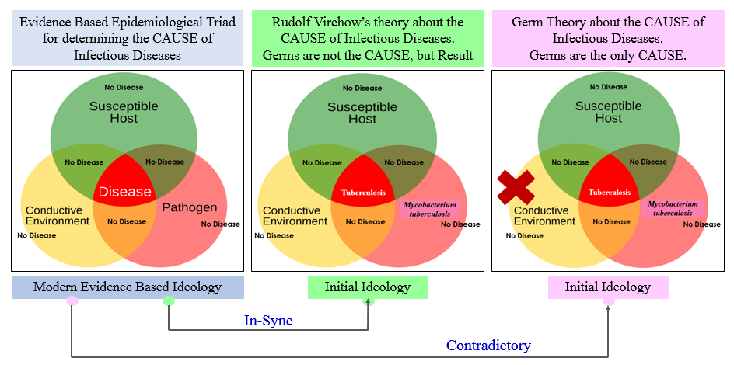
Figure 1: Relation between Modern Science, Germ Theory, and Theory given by Rudolf Virchow.
Contributing Factor 2: Selective promotion of “Reductionistic Approach” as the only way of Scientific Studies.
“Major weakness of reductionism is that the controlled setting may not reflect real life.”
Analyzing why “biased application of Reductionism to understand Nature” is not right?
Science can be considered as a means used for understanding Nature. There are two distinct approach for this, one is Reductionism and the other one is Holism. In conventional science, it is our tendency to break a component into small bits and pieces and study everything discretely. And depending on the data obtained from bits and pieces we superimpose it on the whole structure, and this is the fundamental error we perform in understanding Nature. For example, water, if studied through reductionism, should behave as “highly combustible substance” because the components hydrogen is highly combustible and oxygen promotes combustion when studied in isolation. But we all know this is not the case, instead, when hydrogen and oxygen forms water molecule (i.e. becomes whole) the reacting elements loses their identity and starts acting completely different. Instead of behaving as combustible chemical, water helps bring down the temperature of combustible substance below its ignition range, thus used to control fire. Figure 2 represents the concept that whole is more than sum of its parts. This is fundamental chemistry that does not go by the ideology of reductionism, and unfortunately we never felt the need to question the legitimacy of the approach (Goswami & Bakshi, 2020) (Hegde, 2014) (Lipton, 2016, 2017) (Null, 2011).
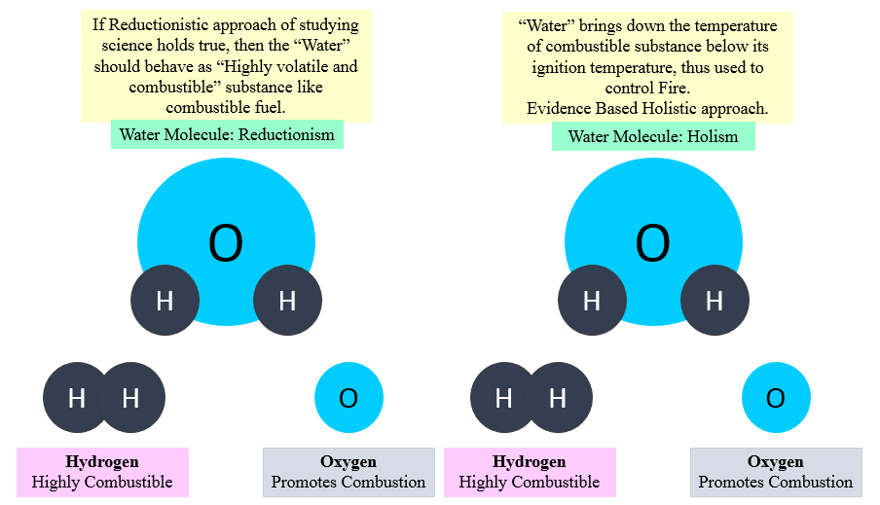
Figure 2: The whole is more than sum of its parts.
The “Germ Theory” is the result of this reductionistic approach, in which we assumed that curative treatment for infectious diseases and subsequent restoration of health can be achieved by killing suspected microorganisms with selected antimicrobial agents. Form reductionistic perspective using antimicrobial agents for killing suspected microorganisms may seem a logical thing to do. But by doing so we have ignored the environmental aspects that led to development of conditions favorable for the proliferation of microorganism under consideration, the effect of artificial antimicrobials on host microbiome, the effect on inherent defense mechanism of host as well as effect on natural immunomodulatory responses of the host. Figure 3 and 4 presents the “Germ Theory” and use of antimicrobial drugs from reductionistic as well as holistic perspective respectively (Goswami & Bakshi, 2020) (Hegde, 2014) (Lipton, 2016, 2017) (Null, 2011).

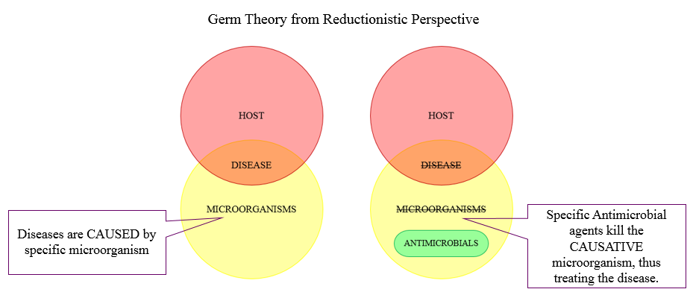
Figure 3: The Germ Theory and effect of Antimicrobial agents from Reductionistic perspective.
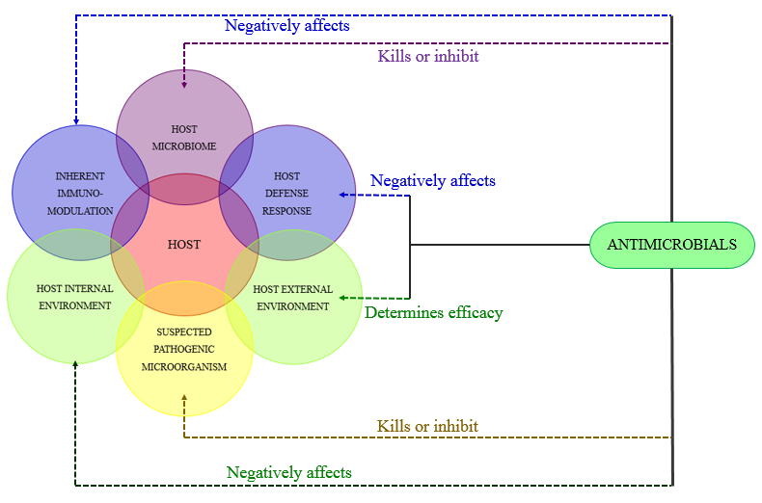
Figure 4: The Germ Theory and effect of Antimicrobial agents from Holistic perspective.
In order to establish scientific and unbiased studies, considering both reductionism and holism are equally important. It is to be understood that Nature is not going to change its ways, no matter how forcefully we try to manipulate laboratory data for our vested interests. This is the basis of understanding Science and it is time to implement this mindset practically before it’s too late.
Contributing Factor 3: Lacking the basic Understanding of Health
Correct outcome can never be achieved with incomplete understanding,
Even if the intention is good and pure.
Definition of “Health” and Conventional Treatment Protocol (w.r.t. Antimicrobial Drugs)
Global governance of health and diseases are regulated by the World Health Organization through establishing, monitoring and implementing global guidelines and synchronizing various factors towards common objectives (Ruger et al, 2009). As per the World Health Organization (WHO, 1948), the definition of “Health” is “a state of complete physical, mental and social wellbeing and not merely the absence of any disease or infirmity”. But conventional science being based on reductionistic approach, consider “Health” to be limited only to physical body along with associated diseases and infirmities. In conventional science the organs of human body are considered as separate units working in isolated manner in relation to other components of the body. Because of these reason, for any kind of pathological state treatment procedures are prescribed with purpose of addressing only the complications of physical body. So, based on this reductionistic ideology, specific microorganisms are identified as the cause of disease (as evident in physical body) and addressed with the use of one or combination of antimicrobial drugs (believing the antimicrobial drugs only destroys the microorganism under concern) (Goswami & Bakshi, 2020) (Hegde, 2014).
Analyzing how “Incomplete understanding of Health is related to rise in AMR”
We believe that diseases are caused by pathogenic microorganisms, our inherited genes and disturbed physical parameters. Based on the 1948 definition of Health, four dimensions are attributed, the Physical Dimension, Mental Dimension, Social Dimension and Spiritual (Environmental) Dimension (Goswami & Bakshi, 2020).
- Physical Dimension - Physical dimension is the only visible dimension of health. It represents the actual physical body. All the normal physiological processes and pathological states comes under the physical dimension. Derangement that are observable in the physical body comes under physical dimension (Hegde, 2014) (Lipton, 2016, 2017).
- Mental Dimension – First of all we must not confuse “mind” with “brain”. One should realize that mind is not the brain, or not present inside the brain. Brain is a component of physical dimension. It is believed that mental or psychological aspects are the result of co-ordination between genetics, neuro-endocrine system, but this idea is not completely true. In fact, it is one’s thought, intellect, emotions, perception etc. together constitutes mental dimension. Healthy mental state have positive influential effect on physical body, while unhealthy mental state have negative influential effect on human body (Hegde, 2014) (Lipton, 2016, 2017).
- Social Dimension – It refers to the way every individual interacts with each other based on their psychological conditioning, perception and creating a unified ideology called society. The factors that constitute social dimension which have both positive and negative influential effect on mental dimensions and by extension affects the physical dimension. So, in many pathological states that are evident in the physical body, their actual cause might be present at the social dimension. In such cases just addressing the physical body will not suffice (Hegde, 2014) (Lipton, 2016, 2017).
- Spiritual / Environmental Dimension – The first thing we have to understand that spirituality has nothing to do with religion. The term spiritualty is derived from the word “spirit” which means “to breathe”. Spiritual dimension represents a person’s interconnectedness with the environment he lives in. It represents believing in the fact that we human beings are intricate part of the nature. Each and every action that we make have influential effects on fellow organisms and the environment we live in. Similarly, the environment we live in and the fellow organisms those are present around us also influences our existence. So, our interaction with the environment we live in, our response to climatic conditions, our interaction with other organisms in the environment and response to natural energies or natural forces guides our life. This universal interconnectedness strongly influences the social dimension, which as a result modulates one’s mental sphere and consequently the effect is observed on the physical body (Hegde, 2014) (Lipton, 2016, 2017).

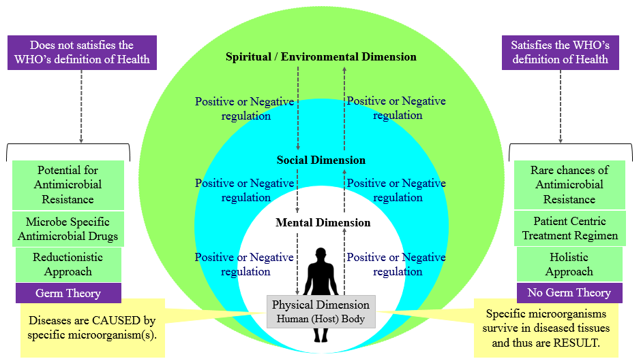
Figure 5: Reductionistic Germ Theory, the meaning of Health, and the Crisis of Antimicrobial Resistance.
In conventional practice, when we administer antimicrobial agents to destroy the suspected pathogenic microorganisms present in the host’s body (physical level), based on “Germ Theory”, we are only considering the physical wellbeing along with associated infirmities. As shown in figure 4, the host, even if we consider the physical dimension as everything, then also there exists critical factors like the host’s microbiome, host’s defense response, host’s inherent immunomodulatory capabilities, host’s internal and external environment and lastly the suspected pathogenic microorganism(s). Not considering these factors while designing treatment protocols leads to rise in disasters like the crisis of Antimicrobial Resistance (Lazar, 2018) (Hegde, 2014).
So, from the discussion it is clear that reductionistic “Germ Theory” does not satisfy the definition provided by WHO in reference to restoration of Health, but the theory of Rudolf Virchow is in sync with the definition. Thus, if the WHO (1948) definition of Health holds true, then the existing protocol of treating infectious diseases with antimicrobial agents needs modification. And if the existing protocol of treating infectious diseases with antimicrobial agents holds true, then the WHO (1948) definition of Health need modification, as they are contradictory.

Contributing Factor 4: Keeping Evolutionary Biology out of Medical Curriculum – The reason of Conceptual Mismatch
“Seen in the light of evolution, biology is perhaps, intellectually the most satisfying and inspiring science. Without that light it becomes a pile of sundry facts --- some of them interesting or curious but making no meaningful picture as a whole”.
…Theodosius Dobzhansky
The fundamental answer to why so many humans are now getting sick from previously rare illnesses is that many of the body’s features were adapted in environments from which we evolved, but have become maladapted in the modern environment we now have created. This idea known as Mismatch Hypothesis, is the core of new emerging field of Evolutionary Medicine, which applies evolutionary biology to health and disease.
…Daniel E. Lieberman, Paleoanthropologist, Harvard University
Meaning of Health, legitimacy of reductionistic Germ Theory and antimicrobial drugs in absence of Holistic Evolutionary Biology.
From studying evolutionary biology we get to know that during the course of time the primitive organisms proliferated, evolved, and achieved greater structural and functional complexity, starting from bacteria and amoeba sequentially up to the mammals. In the field of Lifesciences emphasis is made on studying the Evolutionary Lineage (Reductionistic Approach) and unfortunately, the underlying Evolutionary Pattern (Holistic Approach) has been overlooked. This is why in conventional medical science we only consider the physical dimension and do not acknowledge the mental and social dimensions. Also, in physical dimension, human body is only considered as a combination of human cells, organs and tissues. Thus, a suspected microorganism(s) which does not seems to be a part of human body, when found in the diseased tissue are attributed as the cause of the disease. Since, according to conventional treatment protocol, human body is only made up of human cells, using antimicrobial chemicals to destroy the suspected microorganism(s) appears to be scientific and safe. In healthcare, animal farming, agriculture and food industry the antimicrobial chemicals are being used everywhere and in every aspect. This has led to uncontrolled overuse and misuse of medically important antimicrobial agents resulting in formidable crisis called antimicrobial resistance (Sahtouris, 2000, 2018) (Lipton, 2016, 2017) (Hegde, 2014).
Analyzing why including holistic Evolutionary Biology in basic Medical curriculum help understand the multidimensional concept of Health
The approach of the practice of medicine is deeply linked to our understanding of evolutionary biology. When one understands the evolutionary patterns along with the evolutionary lineage the relation between the dimensions of health becomes evident. Let us now understand this evolutionary pattern in brief. The process starts with the emergence of a new organism (for example: Organism A). Organism A proliferates for billions of years and during that process, they mature, mutate, and achieves the highest level of intelligence and functioning. Once the Organism A has achieved its maximum level of functional potential, it enters the next level where the individual cells start coming together and form a colony. They start sharing awareness and information and learns to live together. Then various colonies integrate to form a community that eventually becomes a new organism itself. This entire process makes up the first cycle (Hegde, 2014; Hegde, 2015; Lipton, 2015; Lipton, 2016). The cycle 2 is the repetition of the entire process where the new organism (Organism B) proliferates and starts to maximize its intelligence and functional capabilities then starts forming a colony and subsequently integrates and forms community. This processes progresses as evolving spiral and we go each turn of the loop we get a higher level of organization and higher level of evolution (Figure 6.A.) (Sahtouris, 2000, 2018) (Lipton, 2016, 2017) (Hegde, 2014). Let us now relate this pattern with the real life example (Figure 6.B.). The Organism A is the Bacterium, the simplest form of life (a single cell) proliferated, mutated and achieved its maximum intelligence and functional capabilities. Then each of these single cells came together and formed colonies. As a colony each cells communicated with each other and shared their awareness and after a certain time they integrated and formed a structure called biofilm. Biofilm created a boundary for the integrated colonies, where they started sharing and working with each other, specializing their functions and integrating their activities. Through this process they evolved into a completely new organism, Organism B (Amoeba like advanced cells). Amoebas then for next billions of years proliferated, mutated, and achieved its maximum intelligence and functional capabilities. Amoebas evolved from colony of bacteria but it is now an individual organism. After reaching its full potential, each Amoeba came together and formed colonies, integrated to form community and the process continued. This evolutionary spiral is progressive in nature. As shown in figure 6B the first twist of the spiral was the Bacterium, the first single celled organism on the planet. The next twist represents the Amoeba (or cells with higher functional complexity), a community of Bacterium living under one membrane called biofilm. Each of these cells proliferated, formed colonies and integrated itself to form Human Beings. Human body is composed of ~ 60 trillion individual cells that formed organized community and through time achieved highest intelligence and functional capabilities. In the next twist of the spiral we, the human beings came together and formed communities where we work together with each other and share our intelligence and awareness. The individuals of various communities comes together and forms a functional society. Society is the result of collective intelligence and awareness (psychology) of each and every individual who are part of it. So even if from the reductionistic point of view we may consider ourselves as individuals but in reality we are part of the society (the super organism) (Sahtouris, 2000, 2018) (Lipton, 2016, 2017) (Hegde, 2014).
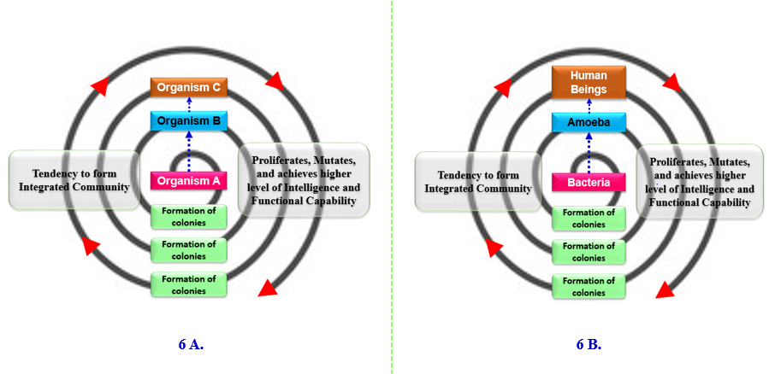
Figure 6 (A and B): Evolutionary pattern describing origin of symbiotic association between human and microorganisms (The Human Microbiome Symbiosis).
When holistic evolutionary biology is included with the conventional medical science, the complete meaning of WHO definition of Health becomes easily understandable and relatable. The evolutionary pattern not only provides the link between different dimensions of health but also validates that the physical body of human being in itself is multifactorial. By including the science of evolutionary biology in medicine it can be realized that the complete understanding of health and disease is possible only through integrated approach, in that human body is made up of approximately 10 ⁻¹⁴ human cells (~23000 human genes) and 10 ⁻¹⁴ million microorganisms (called human microbiome comprising of ~9 million germ genes). These human microbiome have a symbiotic relationship with the human beings and is equally important as any vital organ of the body. Disturbance in the balance between the human microbiome and human cells lead to life threatening complications. So the “Germs” are not our enemy, but friends, essential for survival. The 23000 human genes won’t function without the influence of these host microbiome. Antimicrobials belongs to group of chemotherapeutic agents intended to kill or inhibit the growth of microorganisms. Antimicrobial agents when enters human body does not discriminate between host microbiome and suspected pathogenic microorganism, it destroys all equally. It is like bombing an entire city full of innocent citizens in order to eliminate one suspected criminal hiding there. The suspected microorganism is destroyed by the action of selected antimicrobial agent, so are the significant section of host microbiome, creating sure possibility of unwanted, unpredictable and uncontrollable iatrogenic conditions (Appanna, 2018) (Goswami, 2008) (Goswami & Bakshi, 2020) (Meyer, 2014) (Sahtouris, 2018). Figure 7 demonstrates the importance of including evolutionary biology in practice of medicine.
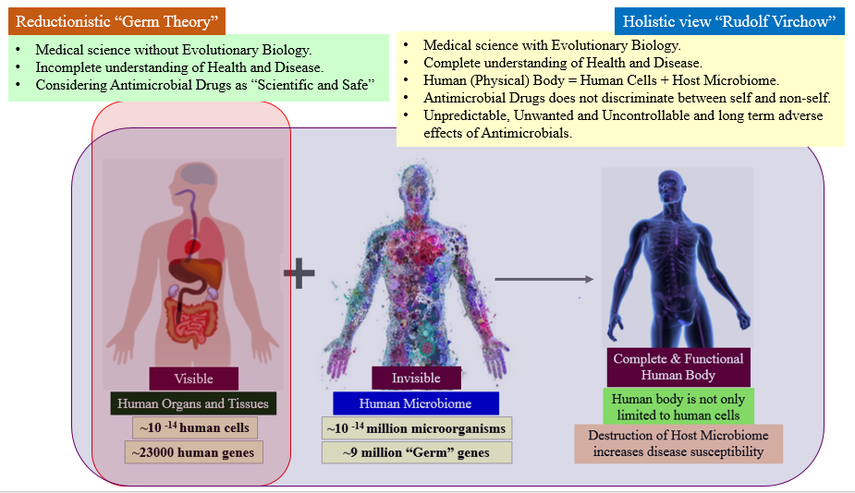
Figure 7: Importance of including Holistic Evolutionary Biology in Medicine
Contributing Factor 5: Considering Genetic Mutations as the Cause of Antimicrobial Resistance.
The Expression of a given Gene results from the synchronized action of Multidimensional Factors that are beyond the control of the Gene itself.
Analyzing why considering Genetic Mutation as the Cause of AMR from Reductionistic Perspective leads us to an incomplete and faulty conclusions
Analysis of genetic mutations are the fundamental aspect of AMR related research. The slightest change in the genetic sequence of microorganism can make it resistant against a range of antimicrobial substances. The scientific community has identified and documented wide range of medically important mutations associated with AMR. On top of that, the ability of microorganisms to transfer the antimicrobial resistance (AR), through mobile genetic elements (MGEs) among themselves, adds on to the rapid outspread of multidrug resistance (MDR) (McMillan et al. 2019). During the initial stages of introduction, the scientific community did not realize the importance of the prediction made my Sir Alexander Fleming in relation to antimicrobial resistance. Conventionally whenever a microorganism is found to survive a group of antimicrobial agents to which it was previously sensitive, the genetic sequence of that microorganism is thoroughly studied. The comparative analysis of genes reveals single or multiple changes in the sequence that can be traced to their gain in resistance capability. Since the mutation in the genetic sequence are found only in the microorganisms showing resistance, thus leads us to the assumption that genetic mutations are the cause of AMR. If considered from reductionistic perspective, the assumption appears to be logical. And based on that assumption advanced concepts are formed and sophisticated technologies are implemented to address and overcome the crisis of AMR. But despite of all efforts, the situation is constantly getting out of our control. This brings us to an important question, why did the gene mutate? Or what are the factors that favored the genetic mutation?
The answer becomes clear if the scenario is considered from holistic perspective of Epigenetics. What if, the genetic mutation that are observable through sequence analysis are the result and not the cause. The actual cause of antimicrobial resistance is multidimensional or multifactorial. The first question to be asked is “Why or what forced the genetic sequence to change?” We have to understand that the Darwin’s law of survival of the fittest and struggle for existence applies to all living organism. Just like any other organism on this planet, the microorganisms also thrive, adapt and evolve in response to the environment they are living in. We, the human beings, in order to ensure our existence and protect ourselves from existing natural threats (let’s say microorganisms), we have manipulated and exploited nature in wrong contexts. In doing so we have misused one of the limited and valuable natural resource called antimicrobial substances. When we expose or pollute or surrounding environment with too much of antimicrobial chemicals, we create a state of challenge for the microorganisms that cohabit the same environment. In order to survive, the microorganisms need to reshuffle their genetic sequence based on the signals received from their surroundings. The microorganisms that did not receive the signal of environmental stress, did not feel the need to change their genetic sequence. Thus, the genetic mutation that are observable are in fact the result or outcome of the environmental degradation. And these external factors that triggers a series of chemical changes inside the cytoplasm and nucleus of the microorganism, thus forcing the gene(s) to mutate, is not under the control of the gene itself. So this brings us to the theory given by Sir, Rudolf Virchow, that germs are not the cause of the disease, instead, the germs are the result.
For easy understanding let us first consider the existing approach, where Mutated DNA Sequences are considered as the cause of antimicrobial resistance. As represented in figure 8, if Mutated DNA Sequences are considered as the cause of AMR, then it becomes a logical approach to isolate and sequence the mutated gene so that information can be gathered about the change that has happened. The genetic sequencing helps in performing the study and analysis at proteomic level. The knowledge base gathered from genetic and proteomic sequence analysis are then applied in developing novel genetically engineered antimicrobial chemicals, designing broad range drug based therapeutics, and strategizing and implementing public health protocols. These information are also implemented in epidemiological studies, agricultural and animal farming, food processing and safety to name a few. If Mutated DNA Sequences are the real cause then AMR can be effectively addressed by applying these approaches in regulated manner. But if considered from one-health or holistic perspective, as shown in figure 9, the entire outcome becomes different. What if the Mutated DNA Sequences are the result and not the cause?
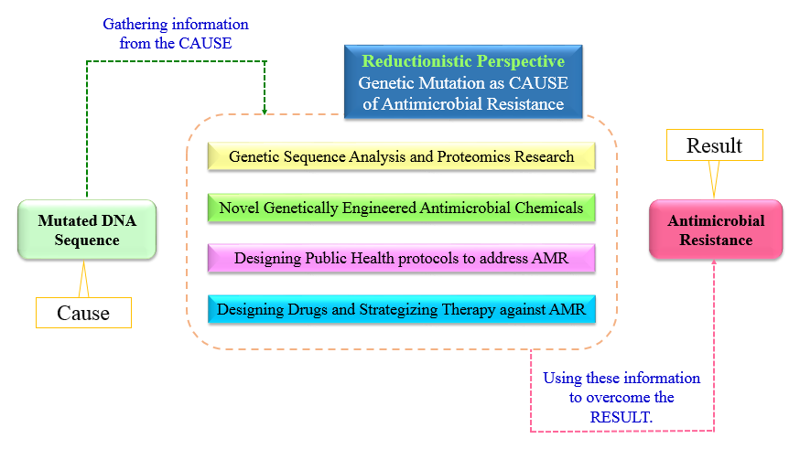
Figure 8: Genetic Mutations as a Cause of Antimicrobial Resistance – Reductionistic Perspective
As shown in figure 9, the normal microbial gene(s) are forced to mutate in response to constantly increasing environmental stress factors like antimicrobial chemicals from food processing industries, anthropogenic antimicrobial chemicals in the environment, the microflora of the host’s body, defense and immunomodulatory capability of host, antimicrobial chemicals in agriculture and animal farming industries and the list goes on. These multidimensional environmental stress factors are the actual cause of AMR crisis. So, if this is the case then gathering information from the Mutated DNA Sequences (The Result) and implementing the same information obtained from the result on the result itself is not going to address the AMR crisis (The Effect), because the Epigenetic Factors (The Cause) remains unaddressed. Just treating the results with novel antimicrobial chemicals or technologies may provide momentary satisfaction to our scientific minds but in long run it will definitely generate more and more deadly, unpredictable and uncontrollable AMR crisis. It is high time to redefine the “Cause”, “Result”, and “The Effect” and realize the environment is the key role-player and not the germs.

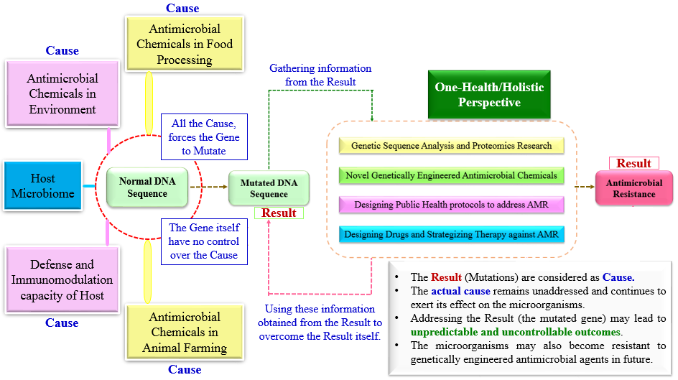
Figure 9: Epigenetic Factors [The Cause] forces Microbial Genes to Mutate [The Result] and thus leading to Antimicrobial Resistance [The Outcome]: One-Health / Holistic Perspective
Contributing Factor 6: Neglecting the Human body’s Intelligence
“Whenever the immune system successfully deals with an infection, it emerges from the experience stronger and better able to confront similar threats in future. Our immune system develops with natural infections. If at the first sign of infection, we jump in with antibiotics, we do not give immune system the chance to grow stronger”…Andrew Weil, MD.

“Man would have been extinct long ago, if we were to believe that drugs, preventive screening of apparently healthy population and our hi-tech interventions are the ones that keep people alive on this planet. Evolutionary changes, based on our environment, kept us going for so long and not any modern day stuff. This is the intelligence of the body" …Dr. B. M. Hegde.
Analyzing why these “Negligence” is responsible for present Crisis of Antimicrobial Resistance
Similar to the Germ Theory, we also have fascination for Darwinian ideology of “Struggle for Existence” and the “Survival of the Fittest”. But as mentioned in earlier section, rarely do we implement these concepts in conventional medical science. Nature have provided bacteria and fungus the ability to synthesize and secrete antimicrobial chemicals. The ability helps the microbes achieve two major functions, survival (in Nature) and protection (from the competitive species of microbes). Thus the antimicrobial agents helps bacteria and fungus in their survival by protecting them from other kind of microorganisms. The functions are achieved either by killing the competitive microorganisms or by stopping their growth. Thus, the antimicrobial agents are defense system of the microorganisms. Just like Nature provided microorganisms with antimicrobial chemicals, human beings are bestowed with robust and sophisticated immune system. In the course of evolution human beings struggled with the adversities, adapted and developed sophisticated organ systems, specific cells and a diverse range of antimicrobial chemicals capable of protecting against all kinds of foreign microbial threats. Through the course of evolution, human system acquired ~60 trillion symbiotic microorganisms, in the form of human microbiome, that are crucial for survival (Ursell, 2012). These microorganisms not only protects the human body from invading pathogenic microorganisms but also helps maintain the homeostasis (Hegde, 2014) (Lipton, 2016, 2017). The various component of innate and adaptive immune response of host is coordinated by host-microbe symbiosis (Zheng et al, 2020). The evolution of human immune system is the direct result of symbiosis between host and its microbiome (Belkaid et al, 2014). The diverse community of bacteria, fungus, archaea, viruses and protozoa constitute the host microbiota. Human gut, and other non-sterile cavities contain complex range of microorganisms that directly regulates host’s immune system and homeostasis (Lazar et al., 2018). However, in present time overuse of antimicrobial and chemotherapeutic agents, disease promoting dietary habits, environmental degradation, has promoted the growth of microbiota lacking the resilience and capability needed for mounting balanced immune response (Belkaid et al, 2014). In spite of being clinically beneficial, there are huge evidences establishing the detrimental effect of antimicrobial chemotherapeutic agents on host-microbiome symbiosis, thus contributing exponentially to the crisis called Antimicrobial Resistance (AMR) (Shekhar & Petersen, 2020). Studies have shown that antibiotics alter the host’s microbiome in such a way that are able to reduce the ability of immune cells to eliminate foreign pathogens (Zusi, 2017). Continuous exposure to antimicrobial drugs, leads to dysbiosis in the host’s body. This iatrogenic dysbiosis has led to rise in cases of antimicrobial resistance, autoimmune and chronic inflammatory disorders, hypersensitivity reactions, and even cancer (Zheng et al, 2020) (Belkaid et al, 2014) (Lazar et al., 2018) (Shekhar & Petersen, 2020) (Zusi, 2017).
Antimicrobial Drugs: The Life Saving Natural Resource
Widespread use of antibiotics promote the spread of antibiotic resistance. Smart use of antibiotics is the key to controlling its spread…Dr. A.P.J. Abdul Kalam
The antimicrobial drugs have undoubtedly saved people from life threatening diseases, time after time. The beginning of antibiotic revolution was marked by the introduction of penicillin in 1928 by Sir Alexander Fleming. Unfortunately after 1950s and 1970s, marked the end of golden era of antibiotic discovery, as no new classes of antibiotics have been discovered since then. There is no doubt that antibiotic era revolutionized the treatment of infectious diseases worldwide, however our inclination towards reductionistic approach and greed to prove our superiority over Nature, we have developed and nurtured the global crisis called Antimicrobial Resistance. Shortly after the introduction of penicillin, and because of our lack of scientific understanding, the usefulness of these natural resources (like antimicrobial agents) have now become compromised (Adedeji, 2016) (Calderone, 2015) (Gotzsche, 2013) (Ventola, 2015).
Nature have provided human beings with their inbuilt doctor that in modern day known as the immune system or healing mechanisms of the body. As explained in earlier section that each and every cell has their own intelligence, gathered from their ancestors based on their environment and associated evolutionary changes (Lipton, 2017) (Sahtouris, 2018). Human cells have survived on the planet from millions of years and possesses huge amount of information about the Nature that is around them. Each and every cell that makes up a human body have their own individual consciousness which can be termed as the intelligence of the body. So each and every cell’s own wisdom is much greater as compared to all the amount of knowledge gathered by human from literatures and media combined. Body knows how to defend itself from threats found in nature, how to adjust itself according to the environment and knows very well how to heal itself. Human body is well equipped to protect itself from diverse array of threats. But there comes a time when the body’s natural healing ability needs some extra push. This is where outside intervention in the form of drugs (in this context antimicrobial drugs) are required. Drugs are just like a tool that helps in achieving the healing processes by up-regulating or down-regulating certain biochemical pathways, and should only be used when body’s healing system requires help in form of external intervention. Antimicrobial drugs are excellent in addressing emergency, critical and surgical cases where immediate quick fixes are important (Goswami & Bakshi, 2020) (Hegde, 2014).
Antimicrobial Resistance and One Health: Need for coordinated action.
“Between animal and human medicine there are no dividing lines, nor should there be. The object may seem different but the experience obtained constitutes the basis of all medicine.”
…Rudolf Virchow, Father of Pathology
“The only effective way to address the global issues such as Antimicrobial Resistance, Foodborne Zoonoses, and Emerging Threats is through open, inter-sector collaborations, including experts and authorities from animal health, public health, food safety and the environment, i.e. One Health”
…Hein Imberechts, One Health EJP Scientific Coordinator
Integrated multisectoral and multidimensional approach is required to contain the anthropogenic crisis called Antimicrobial Resistance (AMR). Recognizing that human health and the environment are interrelated and inseparable, the scientific community recognizes the multiple sectors and interests involved in human, terrestrial and aquatic animal and plant health, food and feed production, and the environment. This ideology brought people together, communicated with each other, and collaborated on the design. Implementing programs, policies, legislation and research to achieve better public health outcomes by addressing global health crises. This coordinated, collaborative approach is termed as One Health, which states that the health of people is connected to the health of animals and the environment. In past few years, the concept of One Health has received remarkable momentum. The World Health Organization (WHO), the Food and Agriculture Organization (FAO) and the World Organization for Animal Health (OIE) are working together to minimize the incidence and spread of AMR. The goal is to ensure that antimicrobials remain effective and useful in curing human and animal disease. Promote the prudent and responsible use of antimicrobials. Ensure global access to quality medicines. Initiatives such as the Antimicrobial Resistance Multi-Partner Trust Fund (AMR MPTF), the Global Antibiotic Research and Development Partnership (GARDP), the AMR Action Fund, and other funds and initiatives are designing and implementing strategic intervention frameworks to reduce emergence. established to carry out. Slows down and reduces the spread of AMR. WHO will work closely with FAO and OIE on a 'One Health' approach to promote best practices that can reduce AMR levels and slow its progression (Guardabassi et al., 2020) (Antimicrobial resistance, 2020) (McEwen et al, 2018).
The Conclusion
“The whole structure of science gradually grows, but only as it is built upon a firm foundation of past research”…Owen Chamberlain
The antimicrobial resistance is an anthropogenic crisis. Because of bias in knowledge and incomplete understanding of Nature, we have nurtured the crisis that have become a global concern. Like other natural resources, through overuse and misuse, we have overexploited a group of life-saving drugs known as antimicrobials. To combat this crisis the scientific communities are developing strategies to understand the mechanisms of antimicrobial resistance, alternative strategies to overcome antimicrobial resistance, ways to control resistant infection, novel drug development, and genetic and proteomic studies. But all these efforts will be of no use if we continue to approach the scientific studies based on reductionistic Germ Theory. Time after time, scientific evidence have proved the inadequacy of the reductionistic Germ Theory, but unfortunately we are still holding on to this ideology. The traditional "epidemiological triad", the WHO definition of health, holistic evolutionary medicine, and the recent "One Health Initiative" all collectively provides a strong scientific basis for Virchow's theory of diseased tissue. That means germs are the result and not the cause of pathological change that have occurred previously. This One Health concept is supported by the European Commission, the US Department of State, the US Department of Agriculture, the US Centers for Disease Control and Prevention (CDC), the World Bank and the World Health Organization (WHO). ), the Food and Agriculture Organization of the United Nations (FAO), the World Organization for Animal Health (OIE), the United Nations Influenza Coordination Organization (UNSIC), various universities, NGOs and many others. So, it is high time that a holistic and multisectoral approach should be implemented in addressing the rising threat of Antimicrobial Resistance along with promotion of improved infection prevention and control measures thereby progressively reduce the usage of antimicrobial agents, because AMR does not recognize the human-animal-environment border. Finally we need to remember that:
Antimicrobial substances are Life Saving Natural Resource, limited in quantity and type, thus should be used responsibly and to be preserved for appropriate situations.

References
- Abramson, J. (2008). Overdosed America: The Broken Promise of American Medicine (Illustrated ed.). Harper Perennial.
- Adedeji W. A. (2016). THE TREASURE CALLED ANTIBIOTICS. Annals of Ibadan postgraduate medicine, 14(2), 56–57.
- Agger, W.A. (2002). Antibiotic resistance: unnatural selection in the office and on the farm. WMJ 101 (5): 12-3.
- Antibiotic-resistant Germs: New Threats. (2021, March 2). Centers for Disease Control and Prevention. https://www.cdc.gov/drugresistance/biggest-threats.html0.
- Antibiotics alter the infectious microenvironment and may reduce the ability of immune cells to kill bacteria. (2017, November 30). Wyss Institute. https://wyss.harvard.edu/news/antibiotics-alter-the-infectious-microenvironment-and-may-reduce-the-ability-of-immune-cells-to-kill-bacteria/
- Antimicrobial resistance. (2020, October 13). World Health Organization. https://www.who.int/news-room/fact-sheets/detail/antimicrobial-resistance
- Appanna V.D. (2018) The Human Microbiome: The Origin. In: Human Microbes - The Power Within. Springer, Singapore. https://doi.org/10.1007/978-981-10-7684-8_1.
- Belkaid, Y., & Hand, T. W. (2014). Role of the microbiota in immunity and inflammation. Cell, 157(1), 121–141. https://doi.org/10.1016/j.cell.2014.03.011
- C.D.C. (2012). Principles of Epidemiology | Lesson 1 - Section 8. Deputy Director for Public Health Science and Surveillance, Center for Surveillance, Epidemiology, and Laboratory Services, Division of Scientific Education and Professional Development. https://www.cdc.gov/csels/dsepd/ss1978/lesson1/section8.html.
- Calderone, J. (2015, August 7). Penicillin’s discoverer predicted our coming post-antibiotic era 70 years ago. Business Insider. https://www.businessinsider.in/latest/penicillins-discoverer-predicted-our-coming-post-antibiotic-era-70-years-ago/articleshow/48393377.cms
- Goswami, A. (2008) Creative Evolution: A Physicist’s Resolution between Darwinism and Intelligent Design. Quest Books. U.S.
- Goswami, S., & Bakshi, U. G. (2020, November 24). Understanding Classical Naturopathy: The Hippocratic Way of Healing | Taylor & Francis Group. Taylor & Francis. https://www.taylorfrancis.com/chapters/edit/10.1201/9781003003182-11/understanding-classical-naturopathy-hippocratic-way-healing-srijan-goswami-ushmita-gupta-bakshi
- Gotzsche, P. (2013) Deadly Medicines and Organized Crime: How Big Pharma has Corrupted Healthcare. Paperback Edition. CRC Press.
- Guardabassi, L., Butaye, P., Dockrell, D., Fitzgerald, J. R., & Kuijper, E. (2020). One Health: a multifaceted concept combining diverse approaches to prevent and control antimicrobial resistance. Clinical Microbiology and Infection, 26(12), 1604–1605. https://doi.org/10.1016/j.cmi.2020.07.012
- Hegde, B.M. (2014) What Doctors Don’t Get to Study in Medical School. India, Paras Medical Publisher.
- Lazar, V., Ditu, L. M., Pircalabioru, G. G., Gheorghe, I., Curutiu, C., Holban, A. M., Picu, A., Petcu, L., & Chifiriuc, M. C. (2018). Aspects of Gut Microbiota and Immune System Interactions in Infectious Diseases, Immunopathology, and Cancer. Frontiers in Immunology, 9. https://doi.org/10.3389/fimmu.2018.01830.
- Lipton, B.H. (2016) The Biology of Belief, Unleashing the Power of Consciousness, Matter & Miracles. 18th Reprint. India: Hay House Publishers.
- Lipton, B.H. and Bhaerman, S. (2017) Spontaneous Evolution: Our Positive Future and A Way to Get There from Here. First Indian Paperback Edition. Hay House Publishers.
- McEwen, S. A., & Collignon, P. J. (2018). Antimicrobial Resistance: a One Health Perspective. Microbiology spectrum, 6(2), 10.1128/microbiolspec.ARBA-0009-2017. https://doi.org/10.1128/microbiolspec.ARBA-0009-2017
- McMillan et al. (2019). Antimicrobial Resistance Genes, Cassettes, and Plasmids Present in Salmonella enterica Associated with United States Food Animals. Front. Microbiol. https://doi.org/10.3389/fmicb.2019.00832.
- Meyer, S. (2014) Darwin’s Doubt: The Explosive Origin of Animal Life and the Case for Intelligent Design. Paperback Edition. HarperOne.
- Moynihan, R. and Cassels, A. (2006) Selling Sickness: How the World's Biggest Pharmaceutical Companies Are Turning Us All into Patients. Paperback Edition. Nation Books.
- Nelson, R. E., Hatfield, K. M., Wolford, H., Samore, M. H., Scott, R. D., Reddy, S. C., Olubajo, B., Paul, P., Jernigan, J. A., & Baggs, J. (2021). National Estimates of Healthcare Costs Associated With Multidrug-Resistant Bacterial Infections Among Hospitalized Patients in the United States. Clinical Infectious Diseases, 72(Supplement_1), S17–S26. https://doi.org/10.1093/cid/ciaa1581
- Null, G. (2011) Death by Medicine, Revised Paperback Edition, United States, Praktikos Books.
- Ruger, J. P., & Yach, D. (2009). The Global Role of the World Health Organization. Global health governance : the scholarly journal for the new health security paradigm, 2(2), 1–11.
- Sahtouris, E. (2000) EarthDance: Living systems in Evolution. Paperback Edition. iUniverse.
- Sahtouris, E. (2018) Gaia’s Dance: The Story of Earth and Us. Paperback Edition. Createspace Independent Pub.
- Shekhar, S., & Petersen, F. C. (2020). The Dark Side of Antibiotics: Adverse Effects on the Infant Immune Defense Against Infection. Frontiers in Pediatrics, 8. https://doi.org/10.3389/fped.2020.544460.
- The History of Antibiotics. (n.d.). HealthyChildren.Org. Retrieved July 29, 2021, from https://www.healthychildren.org/English/health-issues/conditions/treatments/Pages/The-History-of-Antibiotics.aspx.
- The History of Antibiotics. (n.d.). HealthyChildren.Org. Retrieved July 29, 2021, from https://www.healthychildren.org/English/health-issues/conditions/treatments/Pages/The-History-of-Antibiotics.aspx.
- Ursell, L. K., Metcalf, J. L., Parfrey, L. W., & Knight, R. (2012). Defining the human microbiome. Nutrition reviews, 70 Suppl 1(Suppl 1), S38–S44. https://doi.org/10.1111/j.1753-4887.2012.00493.x.
- Ventola C. L. (2015). The antibiotic resistance crisis: part 1: causes and threats. P & T : a peer-reviewed journal for formulary management, 40(4), 277–283.
- What Exactly is Antibiotic Resistance? (2020, March 13). Centers for Disease Control and Prevention. https://www.cdc.gov/drugresistance/about.html.
- Who We Are | NCEZID | CDC. (2017, August 28). Centers for Disease Control and Prevention (CDC). https://www.cdc.gov/ncezid/who-we-are/index.html.
- Zheng, D., Liwinski, T. & Elinav, E. Interaction between microbiota and immunity in health and disease. Cell Res 30, 492–506 (2020). https://doi.org/10.1038/s41422-020-0332-7.

