ROLE OF TECHNOLOGY IN TRANSFORMING ONLINE LEARNING
Ms. Bhawna Jain (PHD Scholar – ASU)
School of Management Studies (SOMS),
Apeejay Stya University, Sohna - Palwal Road, Sohna, Gurugram, Haryana - 122013

ABSTRACT

The paper seeks to showcase the role of technology in online learning. Starting with the advancement in technology over the past few decades starting from 1950 and till date and its role in online learning. Rapid changes brought in online education due to the introduction of internet in the system. How the changes in the hardware and software advancements have impacted the online learning. Hardware advancements like moving from fixed network devices to mobile devices (laptops, cellphones and I-pads) coupled with faster processing chips and use of light weight material. Software advancements like e-books, education platforms catering to the current education needs etc. Highlighting the various advantages of online learning enabled by the advancement in technology. How the various stakeholders like students, teachers and parents are benefiting with the use of the latest technology. What are the few transformative technologies for the future that will impact online learning and take online learning to the next level with a view of enhancing the learnings. Lastly what are the challenges associated with the current technologies that the various stakeholder should be aware.

Key Words: Technology; Online Education; Mobile Devices; Transformative; Software and Hardware Advances

1.0 INTRODUCTION

In most areas of the economy, technology has changed the way people communicate, access information, work, and even play; yet, this impact has been much more muted when it comes to schools, teaching, and learning. We believe that the main reason for this limited impact is that technology was used to replace analogue equipment without enough consideration being paid to utilizing technology's competitive advantages. These comparative advantages include the capacity to scale up standardized instruction, encourage differentiated learning, expand practise opportunities, and boost student interaction in comparison to conventional "chalk-and-talk" classroom instruction. When schools use technology to improve the work of teachers and raise the standard and quantity of educational material, learners will flourish. (Alejandro J. Ganimian, Emiliana Vegas, and Frederick M. Hess, 2020)
Students, technology, and online education are all transforming. When technical innovation evolves with the help of the Internet and computer software, one needs to appreciate the new advancements for online education. Keeping this understanding, educators must provide each online student with a favorable and creative experience. Educators / teachers must examine a variety of mobile-responsive approaches to web design and development. The objective is to offer a visual foundation that is mobile-friendly and allows for full viewing across all web environments. The popularity of mobile devices could usher in a new era of online education, keeping in mind that it can occur anytime, anywhere. With this method, collaboration tools enable visible communication between instructors, students, and remote experts.

Today's corporate world and educational campuses both make extensive use of the World Wide Web (Web). The Internet and the online environment have changed the way people entrusted with training and teaching – as well as those who stand to gain from novel online experiences. This change will allow for a more active and collaborative learning environment for teachers, coaches, and students. First, we must determine which technologies are now shaping our internet landscape. Second, one must examine the vested partners in the online landscape. Higher education, government, and business are some of the invested partners. Everyone's interest will be piqued by the design, modelling, and construction of novel training, teaching, and learning paradigms (Berners-Lee, 1992; Berners-Lee & Fischetti, 1999; Bates, 2012).

1.1 TECHNOLOGY AND MOORE’S LAW

When talking about technical innovations, it is appropriate to have a brief overview of how technology has changed over the years. Currently, technological development is advancing quickly. This rate demonstrates the short-term potency of our current technology. A 1965 theory about computing technology called Moore's Law said that integrated circuit transistor counts will double every two years. Since Moore's prediction in 1965, the law has served as a guiding concept for advancement in electronics and computing. Chips had 200 transistors in the late 1950s. By 2005, Intel had produced chips with 1 billion transistors. (1965 Moore; 2003 Kanellos).,
We need to investigate the technologies that are present in the current online learning environment while keeping Moore's Law in mind. For more than 35 years, the global world has been with us. The growth of a global connected world were made possible by the Internet, the Web, mobile devices, and all types of computers, as well as the related applications.
Our technologies have altered how people communicate and collaborate with one another during the previous 35 years, and especially in the last ten years. Our technological advancements have changed the way we consume services and resources. Last but not least, contemporary technology have altered how international institutions like business, government, and education function.

1.2 TECHNOLOGY INNOVATIONS BETWEEN 1950 AND 2010

It is possible to date the creation of electrical computers to the late 1950s. The Advanced Research Projects Agency Network, which was formed in the Defense Department, brought early networking ideas from Cold War think tanks to life (ARPANET)( Roberts, 1967; Abbate, 1999).Five reasons are offered by Roberts, 1967 for building a network that would enable several computers to interact with one another and exchange and execute programmes or information: message service, data sharing.

According to Bower & Christensen (1995) and Spencer and Rosenbloom our technology has advanced more quickly than societal demands (1996). Technologies create services for the market that are initially complex, expensive, and high-end. These are long-term technological developments geared for the top strata of their markets, which are home to the pickiest customers.

1960 -1980 (Phase I – Incremental) - Supercomputer sites for academic and research institutions were created after the introduction of the Internet.

1990 - 2010 (Phase II -Radical) - advancements in information storage, communication, computation, tracking and digital technology

2010 - present (Phase III – Disruptive) - The digital format is used in telecommunications and technical space

An illustration of disruptive innovation can be seen when comparing the face-to-face higher education learning to online learning environment with conventional. Many disruptive technologies are already offering students alternatives to traditional higher education on the ground. Students have a variety of options, including blended learning, online courses, and structured career-focused learning. Students are causing a disruption in traditional higher education by opting for these online options. Technology innovation is critical because it generates value. The process of applying knowledge to human activities in order to produce goods and services for online education more effectively is known as value creation (Shane, 2009)

1.3 TECHNOLOGY CHANGES FROM 2010 TO THE PRESENT

Today, online learning is carried out through portable wireless devices like computers, tablets, and cell phones. The advantages of these devices are their portability and quickness. This new online environment must meet the expectations of both instructors and students, as well as specialized (technical) drivers. Current online practices and the method used to deliver online learning experiences will both be put to the test by the challenges in this expanding direction. Emerging technological advancements like mobile computing and synchronous lecture engagement activities must evolve in order to suit the needs of all future online users (Balakrishnan & Lay, 2013; Yates, 2013).

1.4 INTERNET COMMUNICATION TOOLS 1990-2010

Our way of communicating has been and will continue to be revolutionized by increasingly complicated technologies. (Baset & Schulzrinne, 2004; Biondi & Desclaux, 2006; Daft & Lengel, 1986),,. Printing, radio, telephone, and cell phones were all forms of communication before moving on to the Internet, digital technologies, videoconferencing, and Skype peer-to-peer Internet telephony protocols. As a result, more people now have access to more information. As an outcome, the Internet has become more significant as a means of international communication.

Tools for Business, Training, and Online Education on the Internet
- Electronic Mail
- World Wide Web (Web)
- Participatory video conferences
- Skype
- Mobile/Smartphones
- Social Networks

2.0 TECHNOLOGY AND ONLINE LEARNING

Prior to Web learning, students and corporates might receive instruction via mail or telegraph. In the 1980s, as the computer industry grew, online learning emerged as a viable option. Companies began providing new employees with online training and employed multimedia applications to enhance presentations aesthetically. The millennium brought new technology to the computer industry as the 1990s came to a close. With the growth of the computer industry, e-learning and multimedia became more widely available. In the mid-1990s, the first sort of online education emerged as a result of these technical advancements. The development of online education programmes and their adaptation for online learning would usher in a new era for technology in the new millennium. Online education courses using e-learning are becoming more and more common in both colleges. Streaming media, online video access, and rapid website servers all quickly enhanced online learning. As a result, online training and education have renewed people's enthusiasm to learn (Aranda, 2006). The technological advancements between 1950 and 1960 are listed in Table 1.
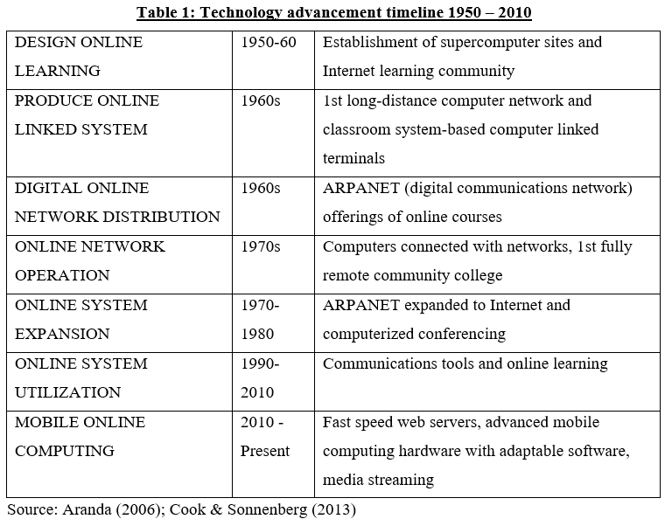
Source: Aranda (2006); Cook & Sonnenberg (2013),

2.1 EVOLUNTIONARY TRENDS AND MOBILE LEARNING

The biggest shift in the business world today must be seen as the rise of mobile technology. Why not with online education? is a question that must be asked. Due to the growing use of mobile devices, teachers must take advantage of the willingness of their students to use their own devices for academic purposes. Schools can interact with online students and develop a closer relationship by utilizing mobile awareness. The student may be able to download dynamic learning from digital displays thanks to this interaction. Mobile phones, notebooks, and tablets are examples of digital screens.
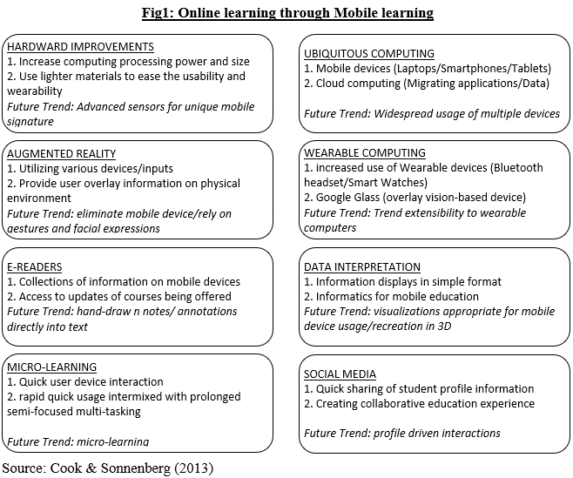
Source: Cook & Sonnenberg (2013)

3.0 TRANSFORMATIVE TECHNOLOGIES
As downsizing and nanotechnology advance, mobile devices' capabilities and potential as tools for mobile learning will also advance. The tendency of producing smaller mechanical, optical, and electrical devices and goods is known as miniaturization defined nanotechnology as the creation of functional structures at the atomic or molecular level with at least one characteristic dimension measured in nanometers and their application. Because it disclosed information about materials and devices that might be used for a number of reasons, such as the creation of new generations of biological sensors and mechanical qualities, nanotechnology was essential. The next section looks at future developments that might happen over the next 10 years and beyond as brand-new, mind-blowing discoveries replace technological constraints and cost restrictions.

New technological developments are now becoming visible on the internet. To promote a more consistent user experience, devices are becoming increasingly interconnected. Our technological, media, and telecommunications ecosystems are likely to alter. Finally, the potential for mobile technology will continue to be driven by hardware advancements.

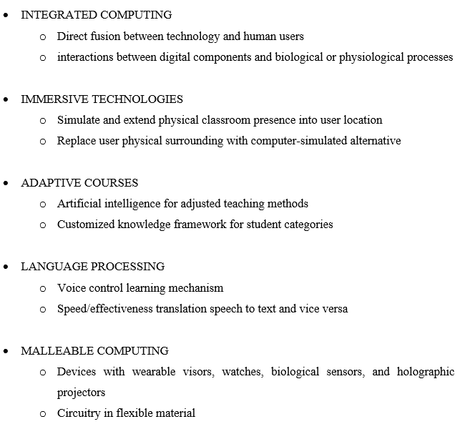
4.0 IMPROVEMENT IN EDUCATION THROUGH USE OF TECHNOLOGY

Rarely do we hear about the amazing ways that technology can enhance our lives, particularly when it comes to learning, despite the fact that we constantly hear about the bad effects of excessive screen time and the dangers of social media. Technology may help instructors, parents, and students all improve their education when used appropriately.
Pencil and paper are still the "conventional" way to learn in the classroom. However, a wide range of helpful tools have been made available by technology to help students study more efficiently.

4.1 TECHNOLOGY HELPS LEARNERS / STUDENTS LEARN MORE AND BETTER

Students are taught through a variety of ways. The teacher presents the content in a regular class, and each student interacts with it in the same way. Every student in the class is expected to advance through the material at the same rate. As one might expect, when teaching thirty kids the same subject in the same way for the same amount of time, there isn't much room for innovation. However, it is not need to be that way.

Online technologies provide for more flexible learning for students. Some students may watch an instructional video on YouTube to help them understand a concept better. Others may play a game or workout online that provides them with rapid feedback to determine whether they are on track. While individuals who grasp the material quickly can advance their knowledge with increasingly challenging puzzles or assignments, those who require more practice should select an activity that allows for more reiteration. In other words, in a way that a traditional lecture cannot, technology provides pupils with variety.

Technology-based learning encourages students as well. Their devices will be used to explore the world and learn new things using websites, videos, apps, and games. The ability to learn while having fun encourages students to remain engaged with the material.

4.2 TECHNOLOGY HELPS PARENTS, TEACHERS, AND STUDENTS STAY CONNECTED AND ASSIST THEIR KIDS

Parents had little access to information about what was happening in their children's classrooms prior to what they learnt from the student or during the parent teacher meeting. Parents may be significantly more aware about and involved in their children's educational experiences thanks to the usage of technology. Students are more likely to succeed and be motivated to learn when their parents are concerned about their education.

Technology improvements have greatly increased communication between parents and schools. Parents can receive real-time information on their children's academic progress, attendance, and even classroom behavior. In case they need to, parents can use the school's LMS (Learning Management System) to send a fast email or message to a teacher or administrator.

Technology may be a tremendous help for parents who are struggling to help their kids with their schooling. For instance, an online learning platform can offer step-by-step tutorials on a range of topics. For instance, the website offers visitors the chance to practice a range of mathematical ideas, from arithmetic to calculus. If a person is stuck, the programme provides clues and explanations to help them figure out what went wrong. It also includes a number of sample problems that students can use to practice the same subject.

For pupils, gamification can help develop individualized learning opportunities. For instance, using a Quest that the instructor has established, students can complete a lesson plan at their own pace. After completing a quest, students can also receive rewards and unlock character points, which keeps them engaged and motivated.

Furthermore, the majority of teachers have their own websites with a plethora of material. These are freely accessible by parents, who can use them to assist their children in comprehending the subject provided in the classroom.

4.3 TECHNOLOGY GIVES EDUCATORS QUICK ACCESS TO RESOURCES AND OPPORTUNITIES

Teachers value technology because it gives them a wealth of (mostly free) tools to enhance student learning in the classroom, parent communication, and their own professional growth. Both items to gift pupils and websites that might help them practice new subjects can be found by teachers. There are an unlimited amount of teacher materials accessible to support instruction.

Parents and teachers both gain a lot from technology. They can instantly SMS all of the parents at once or email the whole class using Remind.com. A teacher merely takes a few clicks to get in touch with a specific parent if they need to. When a teacher needs assistance from her colleagues, she can email them or join an online forum to ask questions and share ideas.

Don't assume that the benefits of technology are limited to students; they also extend to teachers, who may now further their professional development from the comfort of their homes. Today, students can complete all of their university coursework and degree programmes online. There are extra places where educators may help and encourage one another. To keep up with the latest in education and learn about some of the best practices from around the world, they have access to thousands of articles.

4.4 TECHNOLOGY INTRODUCES VARIETY OF TEACHERS FOR LEARNING

Technology provides a way to appear smaller and more manageable as the size of the typical classroom increases. Even when the teacher isn't present in the classroom for the full class period, students can still obtain prompt feedback through online tools.

Depending on their individual learning needs, students can obtain varied degrees of education via computers. A instructor could differentiate tailored instruction for each pupil when classes were smaller. In larger classes, technology can assist professors in differentiating instruction for every student. Whether they are at home or at school, there are many resources available to youngsters, including tools, websites, and lessons. These give teachers the chance to conduct specialized instruction and one-on-one time with students, while others use online resources to advance at their own pace.

There are websites that are great for practicing vocabulary and getting quick feedback. Since the Learn mode notifies pupils if they mix up one sentence with another, it is especially beneficial for long-term retention and learning from mistakes. For students to complete online, teachers can create quizzes, games, and activities. The students receive quick feedback, and the teacher is provided a summary of the data and outcomes for each student.

Classmates can tutor their fellow students using technology. They can communicate and ask questions in real time at home and at school using Slack channels or online discussion boards that their teachers have set up. Students can use technology to collaborate and assist one another in order to more successfully study the content. Individuals occasionally have the capacity to act as (supervised) instructors, given the effectiveness of teaching as a method of learning and problem-solving.

4.5 TECHNOLOGY OFFERS PLENTY OF OPPORTUNITIES FOR ENGAGEMENT- LEARNING

The days of carrying a bulky school bag from one workplace to the next are long gone. Students can now participate in project-based and inquiry-based learning thanks to technological advances. Professors and other group members can participate and provide rapid feedback to students working alone or in groups using platforms like Google Classroom. Students can work together in real time while creating presentations or group papers on Google Docs and Slides.

Instead, then teaching students to memorizes facts, these projects teach them to think critically. Students have access to free resources for researching and learning about any topic. Rather than putting together a poster board with recycled information, they may use their skills to provide answers to actual situations. With the help of technology, students can also decide how they want to complete a task, such as by making a blog, website, video, or other type of medium.

4.6 MONEY SAVED THROUGH TECHNOLOGY

Even though laptops, iPads, and Chromebooks are all pricey, their advantages make them well worth the investment. These technologies provide so many tools in the long run that their expenses are more than offset.

By adopting more electronic paperwork, districts can spend less on paper. Many of the paperwork that were previously sent home to parents can now be replaced by emails. Instead of printing packets of materials, teachers can assign homework using Google Classroom or another learning management system.

Teachers can spend less money on supplementary resources because there are so many free options available online. Because they are handier for students and don't require maintenance or storage, e-books are growing in popularity among educational institutions. Teachers can also save time and money by sending their pupils on virtual field trips utilizing free online virtual reality programmes.

Technology is now more important than ever. There are several ways that technology can help to improve education. Free online resources, specialized learning materials, and opportunities for further study can all be helpful to teachers, students, and parents. Since school districts are investing in the future of their children, they can implement new technologies with confidence. After all, technology is a necessary and permanent part of any modern classroom.

5.0 CHALLENGES

In the near future, mobile technology will encounter key difficulties that must be understood and resolved to ensure that usage of mobile devices are efficiently handled. The constraints of wireless networks are one of the most pressing concerns confronting mobile networks. Majority of mobile bandwidth is handled by cellular networks, which are designed specifically for mobile data and are different from desktop-based networking. LAN or Wired networks have a considerably more robust infrastructure that is designed to handle large amounts of data. With extensive usage users have come to a habit of expecting a particular level of network speed when browsing on desktops, and they expect the same level of browsing speed for mobile. The issue of mobile web traffic is growing at a tremendous rate compared to the infrastructure advancement. The solutions for ensuring that same level of browsing speed is too large to solve and an expensive one.

Additional problems plaguing the mobile market include privacy concerns and usability challenges. Usability is the ability of a mobile device to be intuitively operated; more specifically, how easy it is for users to understand and interact with it. The protection and confidentiality of student data and information are referred to as privacy. In the past, gadget development has trailed behind research on Human-Computer Interaction (HCI) and security concerns.

Usability and reliable data processing will be crucial in deciding the acceptance rate and success of emerging technologies like augmented reality and wearable computing as mobile learning expands to a wider range of devices.

CONCLUSIONS

Advanced online education is changing due to technology. An extensive study from 1950 related to technologies, online education platforms and literature for mobile devices. This helped in the development of an image of the past, present, and future trends for online learning and technological changes. The implementation of this technique led to a more precise definition of mobile awareness and greater online exposure when the appropriate model criteria and needs were chosen. In order to design mobile awareness that highlighted borderless networks for the advantage of online teaching and learning groups, a number of models were developed to demonstrate hardware and software developments.

The delivery of education through online and mobile platforms is rapidly changing as a result of technology. Today's online learning environment differs significantly from the traditional classroom in many ways. Online learning creates models of vast online networks using state-of-the-art collaborative tools and their applications. We can create engaging online learning possibilities by utilizing cutting-edge hardware, software, and international web networks. More people have access to greater areas of information thanks to sophisticated technologies. The ability of educators to communicate on a worldwide basis has dramatically grown because to the internet. With the ability to access their classroom from anywhere, mobile devices have also offered online instructors the ability to communicate with students personally.

The creation of hardware is perhaps the main force behind innovation. How well resource management, power consumption, and downsizing technologies advance will influence how well mobile technology adoption proceeds in almost every other industry. Each of the highlighted elements is described in detail in the models that are attached, along with examples of tools and infrastructure that may be necessary for online education. Educators will have much better insight into the future by putting these models into practice, and they might even be able to influence or progress those futures.

What might we envision for online education and beyond as we transition from virtual reality to online education? Is it unrealistic to imagine immersive media and a holodeck in an online classroom? Imagine connected gadgets offering seamless overlays over virtual surroundings, allowing us to interact with the newest advancements in online learning with just the touch of a floating screen. A limitless degree of interactivity and dynamic matter formation and conversion may be possible with malleable devices and 3D printers. This goal is not too far out of our reach. We advise more research into these methods for the future of online education.

https://www.brookings.edu/essay/realizing-the-promise-how-can-education-technology-improve-learning-for-all/ - Alejandro J. Ganimian, Emiliana Vegas, and Frederick M. Hess
Berners-Lee, T. J. (1992). World-Wide Web: Information universe. Electronic Publishing: Research, Applications and Policy.
Berners-Lee, T., & Fischetti, M. (1999). Weaving the web: The Original design and ultimate destiny of the World Wide Web by its inventor. San Francisco, CA: Harper San Francisco.
Bates, T. (2012). A timeline of early online education pioneers. Retrieved 6/24/2013 from Physics.illinois.edu; ourroots.ca; web.njit.edu; eric.ed.gov; coastline.edu
Moore, G. (1965). Cramming more components onto integrated circuits (PDF). Electronics Magazine, 38(8), 4
Kanellos, M. (2003). Moore’s law to roll on for another decade. Retrieved 6/25/2013 from http://news.cnet.com/2100-1001-984051.html
Hobbes, R. (2011). Hobbes' internet timeline 10.2. Retrieved 6/26/2013 from http://www.zakon.org/robert/internet/timeline/
Abbate, J. (1999). Inventing the internet. Cambridge, MA: MIT Press.
Bower, J., & Christensen, C. (1995). Disruptive technologies: Catching the wave. Harvard Business Review, January–February 1995
Shane, S. (2009). Technology strategy for managers and entrepreneurs. Upper Saddle River, NJ: Pearson/Prentice Hall
Balakrishnan, V., & Lay, G. (2013). Mobile wireless technology and its use in lecture room environment: An observation in Malaysian institutes of higher learning. International Journal of Information and Education Technology, 3(6), 634-637. doi: 10.7763/IJIET.2013.V3.351
Baset, S., & Schulzrinne, H. (2004). An analysis of the Skype peer-to-peer internet telephony protocol. New York, NY: Department of Computer Science, Columbia University.
Biondi, P., & Desclaux, F. (2006). Silver needle in the Skype. EADS Corporte Research Center - DCR/STI/C: Suresnes, France.
Daft, R., & Lengel, R. (1986). Organizational information requirements, media richness and structural design. Management Science, 32(5), 554-571.
Aranda. N. (2006). A brief history of online education. Retrieved 6/24/2013 from http://ezinearticles.com/?A-Brief-History-of-Online-Education&id=248882
Aranda. N. (2006). A brief history of online education. Retrieved 6/24/2013 from http://ezinearticles.com/?A-Brief-History-of-Online-Education&id=248882
Cook, C., & Sonnenberg, C. (2013). Technology and online education: Models for change. Melbourne, FL: Nathan M. Bisk College of Business
Cook, C., & Sonnenberg, C. (2013). Technology and online education: Models for change. Melbourne, FL: Nathan M. Bisk College of Business

