Futuristic trends in agriculture engineering & food sciences

Bansi Sonpal
Department: Finance
Gandhinagar, India
The future trends of agriculture is as we see there is growing increase in the AI/ML
Agriculture Technology Trends: Collaborating Tech with Agriculture

ABSTRACT

Get amazed by technology’s superpower in the agriculture sector and witness how humankind has emerged from the tedious farm jobs to the exciting Agriculture Technology Trends in 2022.
This article is about the top 7 agriculture tech trends that have propelled the global agriculture stake.
The Prime Minister also released the 11th instalment of financial benefit under the Pradhan Mantri Kisan Samman Nidhi (PM-KISAN) scheme. This will enable the transfer of an amount of around ₹21,000 crore to more than 10 crore beneficiary farmer families.

Table of Index

1. Introduction

2. Food & Agriculture Organization Statistics

3. Agricultural Revolution in 20th Century

4. 7 Disruptive Agriculture Technology Trends for 2022

IoT in Agriculture
Geographic Information System (GIS) in Agriculture
AI/ML & Data Science in Agriculture Technology
Blockchain
Automation
Regenerative Agriculture
Controlled Environment Agriculture
5. Conclusion

6. FAQs

Introduction
Modern-day farming and agriculture are no more a reminder of the laborious sweat-intensive field-work for farmers and slow growth patient process. With the advancement of agriculture trends 2022, the past decade has seen a thriving hike in agricultural yields, excellent examples of contemporary farming, and many more.

In this blog, we will envision the latest technology trends in agriculture technology that have resulted in the welfare of farmers and global agriculture produce.

Food & Agriculture Organization Statistics
As per the Food and Agriculture Organization (FAO) report, the primary crop production has increased 50% in the last ten years. Parallelly, the world population will tentatively reach 9.3 billion by 2050, hence imbibing the demand for more food to feed the human population. On the charts of ‘Rise in Hunger,’ currently, there are 60 million more people than in 2014 who remain undernourished globally. This matter is a rousing affair for the agricultural industry.

People are living an undernourished life, mainly in Asia and Africa. Economically, the share of Agriculture in the world GDP has gone up by 68%, but comparing it with the growing population has been a stable 4% share since 2000.

Agricultural Revolution in 20th Century
Today, farmers worldwide are adapting to the technical aids to improve their farming efficiencies and gain better yields. Lance Donny, the new technology agriculture leader, says that we need to increase crop production with scarce resources-land, water, and fertilizers. Some of the state-of-the-art farming tools and technologies are crop monitoring drones, livestock measuring sensors, farm management software, driverless tractors, and many more.

Agriculture has drastically changed since the birth of human civilization. It has moved from being a labor-intensive industry to a smart and logical decision-making one. Today’s farmers are educated, and they make intuition-based decisions. However exciting this might sound, there’s a hidden risk behind it. To cost-effective and proven solutions.

Soil Health and Fertilizer:
Healthy soil is vital for agricultural productivity. Disproportionate use of fertilisers has affected soil health. Hence our government decided to combat it by educating farmers about the importance of soil health. A soil testing kit was developed for quick analysis of soil samples to optimise the use of fertilisers and provided to 650 Krishi Vigyan Kendras (KVKs). More than 6 crore soil health cards have been printed and distributed to farmers.

We have seen the magnificent galore of trending new technology in agriculture 2020. Be an early adopter of these technologies to bring a drastic improvement in your agriculture business.

Five Disruptive Agriculture Technology Trends for 2022
Let’s have a look at emerging trends in agricultural technology for 2022.

(1) IoT in Agriculture

The use of the Internet of Things in intelligent farming is aided with various sensors implanted in the agricultural farm. The different sensors used are light, humidity, soil moisture, temperature, crop health monitoring, etc.

Some of the prime use-cases of IoT in Agriculture are:

Data Collection by farm sensors like autonomous vehicles, wearables, button cameras, robotics, control systems, etc.
Aerial and ground-based drones for irrigation, assessing crop health, spraying, monitoring & field analysis.
Geofencing using wireless IoT sensors and livestock tracking to monitor cattle healthcare.
Predictive analytics for rainfall, temperature, soil, humidity, etc.
Innovative Greenhouse with the aid of IoT devices and monitors, which doesn’t require human intervention.
Eager to opt for AI/ML development services for your Agro-business?
Get in touch with our AI consultant and get the best AI/ML development services now

Farmers have accounted that IoT is a cost-efficient way to increase agro production, and hence agro-entrepreneurs like yourself must invest in fascinating IoT app development for your business.

(2) Geographic Information System (GIS) in Agriculture

GIS is a technology that represents any geographical entity in the spatial representation using hardware, software, and data. The hardware used in satellites, drones, GPS systems to locate data points and fetch information from them for analysis.

In the agricultural domain, farmers can use GIS to analyze complex spatial data like rainfall amount, topography, soil elevation, slope aspect, wind direction, flooding, erosion, etc., and so much more. Several satellites are already launched by the government or universal bodies, e.g., Landsat 8, where you need to pay a specific fee for accessing your geography data.

Some excellent use-cases of GIS in the agriculture industry trends 2022 are:

Irrigated landscape mapping
Crop health assessment
Irrigation amendment analysis
Land degradation assessment studies
Erosion remediation
Efficient drainage elevation models
GIS and its generous usage have led to its other names- satellite farming or precision agriculture for all the wonders that offer. Moreover, with the advancements in GPS, robotics, and unnamed aerial vehicles, various farming operations are now computerized.

(3) AI/ML & Data Science in Agriculture Technology

Artificial intelligence is the application of human intelligence via a machine body where instructions are fed into the machine, and hence you get clever work without effort. The entire lifecycle of agriculture involves preparing the soil, seed sowing, adding fertilizers, irrigation of water, protections from weed, harvesting, and storing. At every stage, growers or farmers need to rely on their instincts, calculations, and risks based on the right time and other factors. AI and ML can contribute devastatingly and benefit from their proven data analysis and predictions.

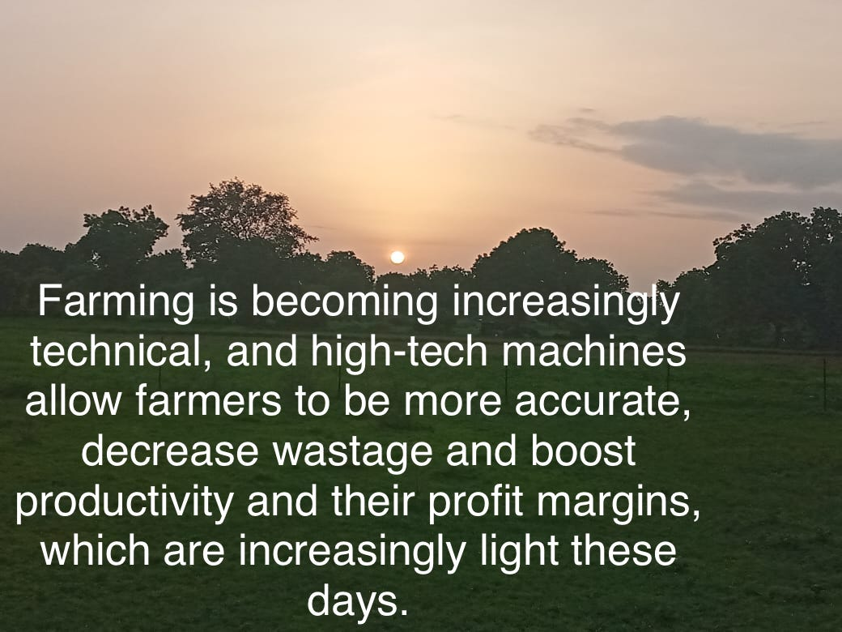
All the crucial agricultural data collected by IoT devices and ML algorithms are processed and channelized with data science. Farmers cannot use the raw data, and hence data science developers are changing farmers’ lives in making vital decisions.

Real-time use cases of AI/ML and data science in agriculture are:

- Predicting yield and quality assessment
- Predictive analytics for crop sustainability
- Using ML to eliminate weed by recognizing species of plants/crops
- Detection of crop infections and diseases
- Intelligent harvesting & pricing decisions
- Prevention of wastage and meeting demands
- Autonomous robots for herding cattle

(4) Blockchain

Once the crops and produce are ready, farmers dive into the troubles of fair trading, selling, marketing, and proving the authenticity of their produce. Hire Blockchain developer helps farmers ensure the safety of their crops, preventing theft and fraud, efficiently managing the supply chain, and balancing the food ecosystem.

The real-time use cases of Agriculture Blockchain technology are:

- Food Traceability
- Transparency in the food supply chain
- Agricultural insurance for farmers
- E-commerce for agro-trades
- Agricultural subsidies
- Are you running short of time and resources?
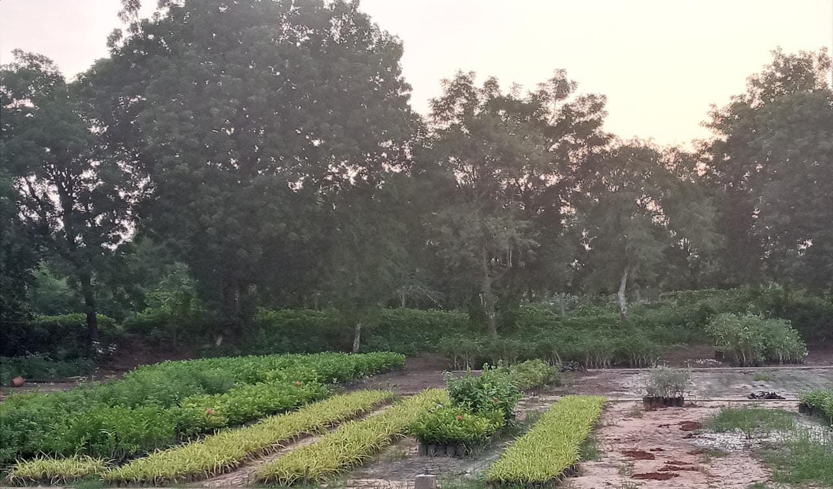
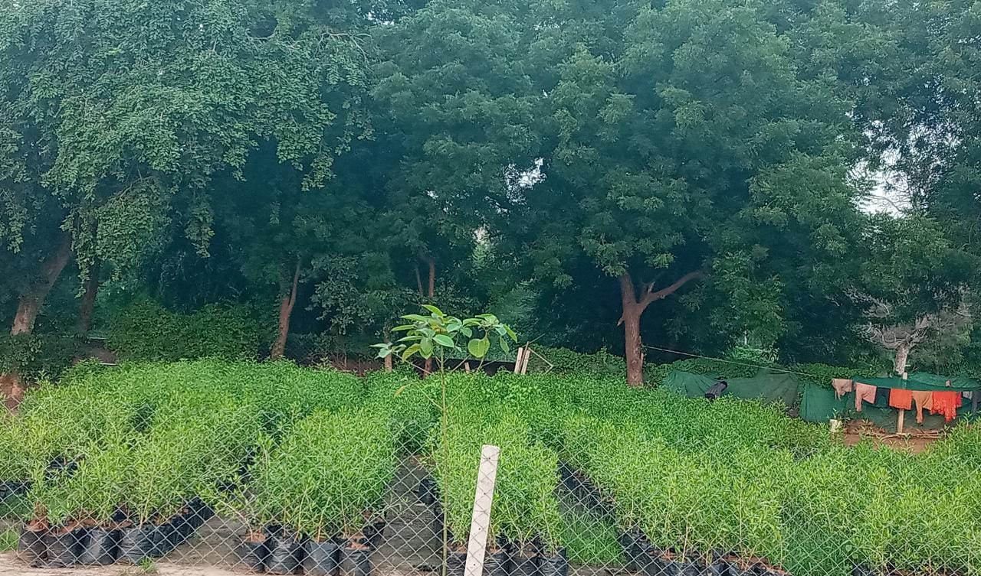
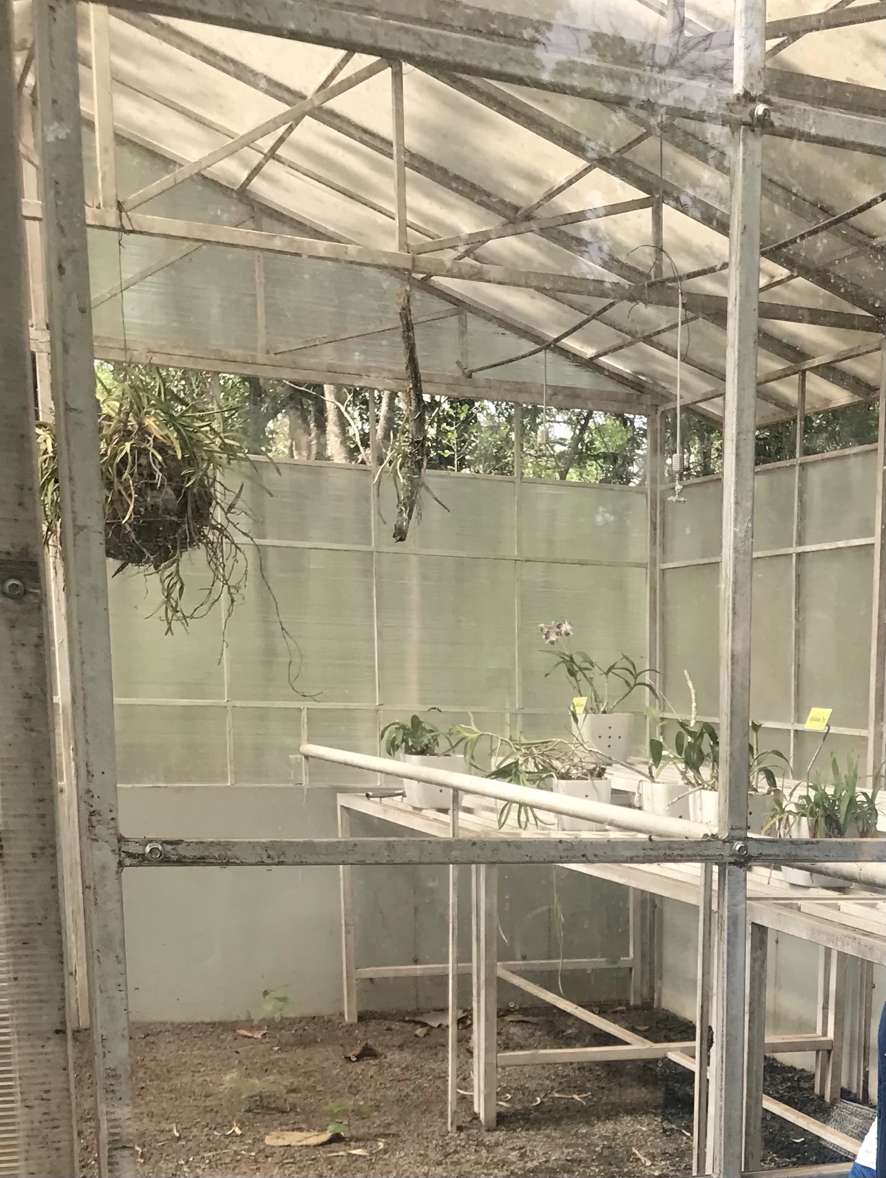
- Partner with us and go for IT staff augmentation as our proficient developers will bridge the gap and take you to your project goals.

(5) Automation

Robotics has evolved handsomely, and we aren’t surprised when machines are doing farming jobs. It has acknowledged farm automation, or so-called smart-farming, by easing the workload on human resources.

Thus, you can meet the international promise of meeting the rising population’s demand by producing much-needed agro-produce with less human intervention and faster. Drones, custom tractors, watering motors, harvesters, and more modern-technology blessings for agriculture automation.

(6) Regenerative Agriculture

Regenerative agriculture lays attention on the rejuvenation and biodiversity of soil and soil distribution. It revives the soil for the upcoming cropping period.
Farmers undertake the following practices while implementing regenerative agriculture:

- Reducing tillage
- No-till farming
- Crop rotation
- Planting cover crops to retain soil fertility
- These methods enable sequestration and make your fields act as a carbon-sink.

Modern greenhouses
Modern greenhouses are increasing day by day.

Increasing trend in horticultural output
The diversity of climate and soil characteristics enable the growth of a large variety of horticultural crops.

Livestock farming technology
Nutritional technologies, genetics, digital technology, Sensor and data technology have advantages for the current livestock Industry. It can improve productivity of livestock by carefully detecting sick animals and intelligently recognising room for improvement.
(7) Controlled Environment Agriculture

These days conventional farming practices aren’t easy to attain owing to the climatic fluctuations and extremities. Also, with growing urbanization, growing crops in populated cities along with population hike isn’t favorable.

A solution to the above situation is controlled environment agriculture (CEA) where we subject the plants to a controlled potion of light, humidity, nutrients, and water. Some of the planned indoor settings available to attain CEA are vertical farming, indoor farming, greenhouses, etc.

A few new techniques are found to attain a balanced equilibrium for plants- aeroponics, hydroponics, aquaponics, and more.

Use Cases of Modern Agriculture Technology 2022
Exclusive use-cases of Automation in Agriculture Technology are:
Agrobot is a real-time example that harvests strawberries, accessible from a mobile platform, by meeting farmers’ standards.
Apple harvesting using vacuum by Abundant Robotics.
Autonomous tractors that are programmed in advance to perform driverless control.
Using computer vision for seeding and sprinkling pesticide where required.
Conclusion
Advancing in all the fulcrums of life is equitable development and growth for humanity. Imbibing technology in the agriculture sector is a but-obvious facet that you must consider for expanding your agro-enterprise. Bacancy technology is the best place to get excellent tech-expert advice and consulting for marching with emerging trends in agribusiness.

Foundation stone has been laid for the National Institute of Bio-Technology at Ranchi, Jharkhand to promote technological research in the field of agri-bio technology. We have made provisions to establish two new centres of National Agriculture Research Institutes - one each in Assam and Jharkhand.

FAQs
1. What challenges is the agriculture industry facing in 2022?
The modern agriculture industry is facing issues such as pesticides in the cross-hair, slow recovery, and trading/money concerns.

2. What are the benefits of using technology in agriculture?
The major advantages of using technology in agriculture are increased crop productivity, diminished impact on the environment/ecosystems, minimal use of water, energy, pesticide to turn down food prices, reduced water pollution, etc.

3. Name famous companies using technology in agriculture industry.
John Deere, Nature Sweet, Bowery, Plenty, Camposeven, etc. are using agricultural technology trends.

4. What are the modern farming methods?
Intensive farming, Sustainable agriculture, Organic farming, and Agribusiness.

5. Name some modern farming machines.
Rotavator, Power Harrow, Ripper machine, Leveler, Combine harvester, and more.

6. Based on current developments, experts predict dramatic changes in agriculture by 2050.

These predictions come from experts who study food and farming trends. Here’s a look at what they think life on the farm will look like in 33 years.

Food Demand Increases

The two big drivers of food demand—population and income—are on the rise. The world’s population is expected to reach 9.1 billion people in 2050, up from 7.4 billion in 2016. Farmers globally must increase food production 70 percent compared to 2007 levels to meet the needs of the larger population, according to a report from the Food and Agriculture Organization of the United Nations.

Also driving food demand is an increase in global income levels, especially those in developing countries. As a result, these countries will be able to expand diets with more protein.

“As incomes rise, consumer preference moves from wheat and grains to legumes, and then to meat, including chicken, pork and beef,” says David Widmar, Purdue University ag economist.

A different trend is emerging in highly developed countries with more health-conscious populations. The focus on starch-based crops like corn will shift to more plant-based proteins like soybeans and other legumes, says Derek Norman, head of Corporate Venture Capital at Syngenta Ventures, which helps support other companies that share its vision of producing more crops with fewer resources.

Consolidation Accelerates

When older growers exit the business, there are fewer younger growers to replace them. As a result, farm consolidation will be significant and quick. The consolidation will change farm dynamics to larger, more managerial complexities.

Farming will go “from a one-man show to something resembling a medium- to large-size business,” he says. “As a farmer, it will be very complicated, with a mix of multigenerational family members and hired employees.”

High-Tech Solutions Evolve

Farm consolidation will drive the need for more outside labor. Expect high-tech solutions like robotics to come to the rescue.

Already, dairy farmers use robotic milkers as a substitute for labor. And farm equipment manufacturers are testing prototypes of robotic tractors and sprayers to handle fieldwork without human drivers.

The leap from prototype to commercial operation of robotic machinery may be short. Many new machines are currently equipped with the electronics to control operations with very little human interaction. However, the legal and regulatory issues surrounding robots must be bridged first.

With its regulations already in place, drone technology is poised for a boom in farm usage. In the next 10 years, the agricultural drone industry will generate 100,000 jobs in the U.S. and $82 billion in economic activity, according to a Bank of America Merrill Lynch Global Research report. Potential use of on-farm drones by 2050 is huge, from imagery and product application to transporting supplies and jobs not yet imagined.

As farming relies more on complex equipment with lots of electronics, data collection will play an increasingly larger role in farm management.

Gene Editing Booms

“By 2050, there will be gene-edited crops, and it will trigger a much wider variety of crops being grown,” says Norman.

Experts anticipate major changes in the #ag industry over the next 30 years.

By-the-Plant Crop Management

Water availability, environmental impacts and soil health will continue to challenge growers in the future. But new technologies will help them deal with these issues more efficiently.

A Clue to the Future

While predictions can shed light on the future, we are still 33 years away from 2050. A whole new generation of growers, who are not yet born, will be farming midcentury, and much will happen between now and then that we cannot predict.

But if the past is a clue to the future, U.S. growers will continue to seek better ways to produce crops by embracing innovation.

1 “Global Agriculture Towards 2050”
2 “Farm Demographics—U.S. Farmers by Gender, Age, Race, Ethnicity, and More”

Biggest Trends That Will Shape The Agriculture Industry

IoT, Machine Learning and Digital Twin – the three technologies that are at the center of every industry’s “hype” circle. But is it all just hype, or do these concepts truly have something foundational to offer? What are the best implementations these technologies have to offer for the agriculture industry? These questions are bound to be answered as time goes by, but the pressure of a rising population and their demands for more food have to be addressed, or we will soon face one of the biggest potential problems that have ever faced humanity – lack of food and resources. In today’s article, we are going to talk about how these 3 concepts can contribute to the average farmer’s workflow and what will be the future trends in farming that will be created by these concepts.

Millennials – The Biggest Innovators Driving The Adoption of Technology
Most people are aware that the age of the average farmer tends to extend towards the end of the spectrum (around 50 to 58 years), but we can see that the average trend that involves farming and millennials is starting to grow as they consist of more than 8% of farmers in the US and the numbers are growing. Some expert agronomists believe that millennials will drive the agriculture industry forward and help it incorporate the newest emerging innovations we hear about all the time, namely the Internet of Things. Since the overall amount of knowledge about technology and its uses is sparse in the circle of the older demographics, we must encourage the youth to participate and take interest in professional farming as this will help bridge the gap between innovation and one of the oldest industries out there. Moreover, with the constant and continuous investments in AgTech, this becomes a great opportunity to make farming an attractive and sensible choice for the young generation.

The Impact of Precision Ag Technology
Young millennials who are effectively introduced to farming can put their focus and use their good understanding on technology to help precision agriculture develop itself. One of the biggest trends that are seen thus far is the implementation of automatic machinery that serves mainly two purposes – reduce manual workload and increase efficiency by automating crucial farming processes. The kind of knowledge we have now cannot be successfully utilized due to the simple fact that precision Ag hasn’t reached the stage of full maturity and mass adoption yet – millennials can help solve this. If precision agriculture will reach the stage of mass adoption, the Internet of Things (IoT) will be the main trend that will pave us the way towards successfully increasing food production, whilst reducing field sizes and the negative impact to the environment at the same time.

The Biggest Trends That Will Impact Food Production – The Internet of Things
Besides fully automating the most labor-intensive processes we have in agriculture such as planting and harvesting, IoT will open new doors to opportunities that will involve effortless crop health monitoring, plant maintenance and the ability to make the produce disease-proof. Technology that will be capable of achieving these objectives is estimated to be worth billions of dollars, thus the trend of merging IoT and farming is quite apparent.

Some seed treatment offers are separately registered products applied to the seed as a combined slurry.
To feed the growing global population, estimates suggest we’ll have to increase food production by as much as 68 percent by 2050. And that’s not the only challenge; there’s also the fact that the middle-class population is growing, which generally brings with it increased demand for meat over grains, legumes, and wheat. Satisfying this demand for more food – and, most likely, more meat – presents a huge challenge for our already struggling planet, especially when you consider that the food system accounts for 26 percent of total global greenhouse gas emissions. (Agriculture, forestry, and land use make up 18.4 percent of this, while the rest is down to things like packaging, refrigeration, and transport.)

Trend 1: Reimagining farming methods

Embracing new farming methods could help the agriculture industry reduce its environmental impact while still increasing productivity. While previous evolutions in farming have largely been driven by mechanical improvements (namely, bigger, better machinery) or genetic advances (better seed, more effective fertilizers, etc.), the next big transformation is being driven by digital tools. For example, we have:

· Automation – including the use of robots, drones, and autonomous tractors to make farming more efficient.

· Precision farming – which involves applying irrigation, fertilizers, and pesticides at variable rates, depending on the needs of crops, rather than uniformly applying them at set times, quantities, and frequencies.

A good example of precision farming comes from a collaboration between Israeli company Phytech and Swiss agrichemical company Syngenta. Together, they have developed a monitoring system that includes plant growth sensors and soil moisture sensors to help farmers continually monitor crop growth and soil health and take action when and where it’s needed.

Other key trends to watch in farming methods include:

· More localized, urban farming – i.e., producing food closer to the people who need it, thereby reducing food miles.

· Vertical farming (the practice of growing crops in vertical layers) and hydroponics (growing plants in nutrient-rich water) – are both methods that generally use less water, soil, and space than traditional field farming methods. If this sounds niche, think again; the world’s largest vertical farm, located in Newark, New Jersey, shows that vertical farming can be done on a huge scale and with impressive results. Creators AeroFarm say the vertical farm is 390 times more productive per square foot than a field farm.

India as loyal Consumer of this spice

Despite not being a producer of Asafoetida (Hing), India consumes 40 percent of world's total production each year. So far Hing is produced only in Afghanistan, Turkmenistan, Baluchistan, Iran and Iraq. India imports near about 1000-1200 MT of asafoetida annually. During 2015-16, India imported 1199 MT of asafoetida valued at Rs 527.42 crores. After processing the raw product, India exported 885 MT of asafoetida valued at Rs 46.27 crores during the same period.

Institute of Teaching & Research in Ayurveda

Established in 1967, Institute of Teaching & Research in Ayurveda or Gujarat Ayurved University is the first university to offer education and training in the field of Ayurveda across the world. The institution was formed by an act approved by Gujarat State legislative Assembly in the year 1965. Located in Jamnagar city of Gujarat, the university is devoted to Ayurvedic studies and Research and is administratively associated with the Health Ministry at State and Centre level. This university is a self-governing institution supported by the Government of Gujarat State.
The university houses three wings and offers more than thirty-five different programs that include Yoga and Naturopathy. Moreover, it manages the college and institutes in the campus and awards certified degrees/diplomas in the relevant field. Also, it offers a full-time Bachelor of Ayurvedic Medicine and Surgery (BAMS) program for qualified overseas students. An International Centre for Ayurveda Studies is made to deal with issues related to the foreign students. In addition to this, the University has signed MoU with various national and international Institutions.
Other than this, the university houses a well-maintained library that holds a collection of over 30,000 books on a variety of subjects. It also contains a collection of manuscripts in diverse languages. The university has designed programs like ‘Ayurveda e-learning’ to sensitize modern medical researchers and scholars.
The institution boasts of its well-established research laboratories and animal homes. Every research that takes place in the university goes through the institutional ethical bodies for clinical and experimental studies. Also, the university is home to several herbal gardens that are used to teach and train students.
Apart from this, the university maintains hospitals equipped with contemporary facilities to offer better treatment to patients and clinical training to students and researchers. With its OPD facility, the university hospital attends a large number of patients to provide specialized Ayurvedic treatment like Kriya Kalpa, Panchakarma, etc. The hospital has qualified staff and experienced Ayurveda specialists who can treat diseases related to skin, neurological disorders, paralysis, immune-related disorders, arthritic problems and many more.

Water experiments
Water has various forms. Human body consists of 70% of water. The water in our body stays in contact with the atmosphere around us. The main aim is to remain balanced in every situation.
Dr Masaru Emoto of Japan had made a research on water. He had made the first impression on water by providing it various form of good thoughts and prayers. The water he then converted to crystalline and then he observed on microscope. The water showed good crystals. Hence it was observed that what one thinks and what one observes has positive and negative impact on their body.
If the negative thoughts and bad words used in front of crystals then the water crystals also turns out bad and by listening rock songs the water crystals turns scattered. Which can be seen in images. Similarly for plants when they’re planted if water is sprinkled after praying or after getting vibrated they grow faster.

References
Modi’s Mission: empowering farmers
Institute of teaching and Research in Ayurveda

