A Framework of Media Metrics designed on Internet of Things

Abstract
With the spread of internet and the emergence of diverse smart devices along with a plethora of media applications, the media measurement and monitoring system have witnessed a paradigm shift. Gradually new technologies have a strong influence on the market forces and given a new way to media metrics. The metrics and methods applied to measure the popularity index of old form of media is completely different from the new form of online news monitoring system.
Internet of things have designed a framework of analytical tools, methods, and metrics that identify the impact factor of new media ecosystem by analyzing media impact measurement. It is also important to emphasize that the focus here is on more recent changes in methods of measurement to media metrics, although it doesn’t encompass readership, circulation or TRP rather reflects the impression. The current static and portable-based audience rating measuring techniques are rarely being used to evaluate the media metrics. A plethora of interdisciplinary methods encapsulating data mining, text mining, social network analysis, trend analysis, and sentiment analysis.
In this chapter, we put forth the idea of a Machine-type Media Measurement System, which can cite and visualize media measurement data using Machine-type People Meters and Big Data platforms. Through a dispersed M2M network, this system may gather information from users about their media usage.
The measure like online viewership and circulation are not the major forces of popularity index because these don’t exist in cyber world. The services such as ComScore and Alexa developed methods to measure traffic on web sites. Thus, this paper seeks to identify relevant analytical approaches, methodologies, and metrics for assessing media impact in the age of online media.
The metrics like online viewing and circulation aren't the main drivers of the popularity index. Methods for measuring website traffic have been developed by businesses like ComScore and Alexa. Therefore, the purpose of this chapter is to establish pertinent analytical strategies, frameworks, and metrics for measuring media impact in the era of online media.

Keywords: Media measurement, Machine-type communication, IoT application, Smart media.

Introduction

With the advancement in technology the infrastructure of Internet of things are developed on the model of connected things with network technologies, systems, and applications built upon underlying layer. Theoretically, anything may be connected to the Internet via IoT technologies, including inanimate objects and live things like humans and animals. Through the Internet of Things, everything or the interconnected parts of more complicated physical objects can be uniquely identified and addressed.
The inevitable move of IT towards a convergence with several industrial sectors and creatively improving these areas with innovation. Such a synch and harmonization are beyond any static techniques and formats and is constantly evolving. Thus, the integration of two or more separate technologies into a single device or system is known as convergence, which is defined as the coming together of two disparate entities. A notable illustration of the convergence of two unrelated technologies is the ability of a mobile device to make calls and snap photographs while also combining communication and imaging technology.
he IoT is swiftly transforming the digital space with its centralized architecture designed with internet things, gateways, network infrastructure and cloud infrastructure. Things are different connectivity techniques used as distinctively identifiable nodes, mainly sensors are used to communicate without human intervention. Gateways serve as a bridge between objects and the cloud, supplying the connectivity, security, and manageability required and the Network infrastructure consists of equipment that manage, and safeguard data flow the fourth major part is cloud infrastructure contains large pools of virtualized servers and storage that are networked together with computing and analytical capabilities.
The architectural infrastructure of IoT is designed on four major components.

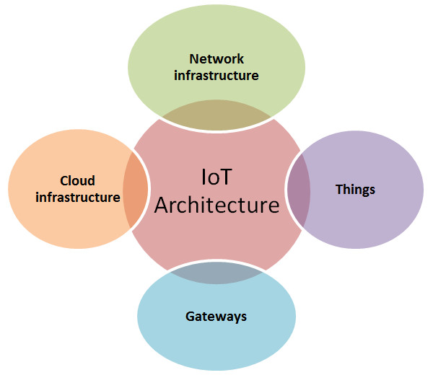
Figure 1. IoT Architectural Infrastructure

The advancement of information and communication technology, internet of things, wider connectivity is swiftly transforming the news and media industry. Conventional newsroom practices have changed and converged digital news and media industry has emerged. As Silverman (2011) states, “the distance between media worlds of 1992 and contemporary times is like the distance between travel before and after Wright Brothers’ flight invention. The media industry would witness a drastic change with technology advancement and the proliferation of mobile devices. Thus, in general the media industry is adapting the technological transformation with the unfolding changes and challenges of media functioning along with mapping and monitoring the audience. With substantial growth in digital media landscape a rapid transformation has been witnessed in audience measurement model and ample initiatives of media metrics are evolved. Audience measurement refers to a comprehensive picture of who is watching, when, and makes it conspicuous to determine the most effective ways to connect with the audiences across touchpoints with that kind of information. It proffers the insight of audience mapping reflecting consumers behavior based on the target audience and their engagement with the content. IoT devices are those with the capability to read, share, and act on the information accessed. IoT enables connecting with target audiences. Consumer behaviour and context can be revealed by tracking them across devices thanks to technology. Sensors can keep an eye on and record proximity, biometrics, sound, and light. Then, this information can be transmitted to mobile devices, wearables, smart TVs, or game consoles so that the inputs can be processed. It can map consumers interaction with media on TV and online with the help of insights including demographics, content preferences and consumer behavior. The smarter processing of internet of things has a paved a way to map and monitor the media metrics. Over the decade social media platforms (SMPs) like Facebook, Twitter, YouTube, and Instagram have grown in popularity among people and different organizations of the social web ecosystem. Social media platforms enable communication, participation in the production of material, as well as engagement and interaction with the published content.
The goal of the Internet of Things (IoT) is to connect all the world's items under a single, shared infrastructure, allowing people to control them and get timely, frequent updates on their status. It may not be inaccurate to say that the phrase "Internet of Things" (IoT) has become a benchmark for establishing communication among items since it was first presented a few years ago. A thorough analysis of the literature has been conducted on numerous IoT elements, such as technologies, applications, problems, etc., considering the current state of the field.
The media has also entered a period in which many consumers communicate with one another via various gadgets, including smart watches, smart phones, smart TVs, smart pads, and personal computers. As a result, users can freely interact with media across devices, and media can now be contacted continuously by users. The variety of venues in which to consume media, combined with the variety of users' devices, has resulted in a wider range and greater complexity when it comes to gathering and utilizing media usage data. Of course, the rise of the Viewer Behavior Monitor (VBM), the Portable People Meter (PPM), and Touchpoint can be attributed to the proliferation of smart terminals and media diversity.

The number of viewers for a certain broadcast programme during a specified time period is indicated by audience ratings. They are shown as percentages. Show ratings are the proportions of households having TV sets in the viewing areas of the relevant programme that are tuned into a specific channel at a given time. Audience shares, or the proportion of households utilizing a particular channel among those tuning in to broadcast programming at a particular time, are also included in audience ratings. Only current trends in live broadcast channel viewership can be determined using these audience rating computation approaches an opinion meter for smart devices. The analysis of viewing information via the VBM should be interoperated with set-top boxes, which provide certain collection equipment or broadcasting. Thus, VBM is insufficient in terms of collecting overall viewing information within a diverse media environment. Although tools intended to collect information and opinions, such as TouchPoint, have emerged and their usefulness and usability in advertisement have increased, they have some limitations in terms of supporting the active collection of diverse viewing information.

Set-top boxes that offer specific gathering equipment or broadcasting should be able to interoperate with the analysis of viewing data provided by the VBM. As a result, VBM is inadequate for gathering comprehensive viewing data in a multifaceted media environment. Although information and opinion gathering solutions like TouchPoint have evolved and have become more helpful and usable in advertising, they have certain limitations in terms of actively collecting a variety of viewing data.

The phrase "Internet of Things" (IoT) has gained popularity in recent years. One approach to implementing IoT is using machine-type communications, which refers to a technology that gives all objects the ability to act as sensors and channels of communication as well as form networks with one another, allowing for the intelligent collection of data and its exchange with other technological systems. In other words, it is an intelligent technology that enables all of the devices in our environment to transmit and receive data collected by sensors through networks, improving the convenience of human existence.
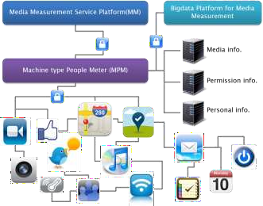
Figure 2. Framework of Machine-type Media Measurement System

In this chapter, as shown in Fig.2, a machine-type media measurement system is discussed that uses a distributed M2M network to collect various forms of media usage from users and extract or visualize such usage statistics by utilizing Bigdata platform and machine-type people meters. The machine-type media measurement system has been acquired as a system of information analysis on a variety of media usage in conjunction with a variety of sensor data, social data, and personal data to grasp human intention and preference more actively and autonomously.
Additionally, more generalized data from all users could be collected as more devices with machine-type communications are made available, increasing the possibility that audience ratings data will be reliable.

Earlier Techniques of Media Metrics

The People Meter approach was first established in 1987 by American survey company A.C. Nielson. As a result, the personal watching habits of panel family members might be examined. The People Meter approach worked well in the context of terrestrial broadcasting and analogue cable TV, but during the 2000s, as changes in the media environment have transformed TV use patterns from widespread use to segmented individual use, a new difficulty has developed.
In order to adapt to a market environment where changes in TV viewing habits, particularly increases in the viewing of Internet videos, were noticeable, the U.S. media industry, which had relied on results provided by audience rating survey agencies represented by A.C. Nielson, established the Coalition for Innovative Media Measurement (CIMM) in October 2009. To enhance audience rating survey techniques, CIMM conducts cross-platform audience rating surveys and set-top-box-related research using viewer behaviour measurement (VBM). By doing this, it is anticipated that audience rating survey methods based on current set-top box recordings will become more accurate and valuable.
Additionally, CIMM will collect information from survey participants as well as set-top-box records to examine how broadcasting and advertising content is viewed on a variety of terminals, including TVs, laptops, and mobile devices. The Portable People Meter is another representative measurement technique for new media usage trends in addition to VBM.
The PPM is a portable media use measurement tool that uses the sound detection methodology invented by Arbitron [8] to get over the drawbacks of earlier surveys of media usage that made use of the People Meter. It is a transmission technique in which, while broadcasting or creating content, signal noises for certain channels (or content) are introduced. The PPM, which is carried by panels, uses an auditory detection mechanism to recognize and broadcast the channel (or content) that the panels are exposed to. The PPM can detect any broadcasting content, including analogue and digital TV and radio, over ground waves, satellite, or cable at any time. It can also recognize signal noises by channel when they are inserted into satellite or new media, as well as broadcasting viewing over the Internet. Therefore, the fact that measurement accuracy still needs to be improved could be a barrier.
In the early 1990s, Britain started utilising single source data. It is a quantitative or qualitative marketing research technique intended to ascertain consumer preferences for commercials or products, the extent of their level of desire for consumption, and the lifestyle of panels who do audience ratings surveys. Thus, marketing survey data are merged and used with demographic characteristics, viewing habits, and the actual status of advertisement contacts, more delicately measuring advertisement effects and enabling more precise linkages with actual product sales via consumer behaviors.

Machine-to-Machine (M2M) communications

A form of data interchange known as M2M involves little to no human participation. It describes a technology that can be applied to a variety of tasks, including smart metering, remote control, healthcare, and financial activities. In this context, "communications" includes both inter-device and inter-object communication. The daily activities of people would be engulfed in such transmissions by various objects and technologies within a media-rich, intelligent environment. Users will also be able to collaborate, develop new applications, and interact with a variety of smart items without the need for specialized technology. Access to and use of such information will be made simpler with the development of such M2M technologies, which will enable a variety of information and events to be interoperated with several users.

Design of Machine-type Media Measurement System
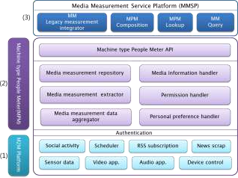
Figure 3. Architecture of Machine-type Media Measurement System

The Fig.3 reflects various media viewers' equipment deployed with the measurements and M2M communications support applications. Each application transmits media usage data to the service platform that has been gathered through M2M communications or that has been generated by the device itself. When users begin watching a particular broadcast, the M2M application regularly sends the pertinent media usage data (channel, title, start time, current time, etc.) from the terminal to the service platform. All types of sensor data, information about how users use social media, details about news snippets, information about RSS subscriptions to which users have given access, and data sent to service platforms are all collected and delivered by the application.
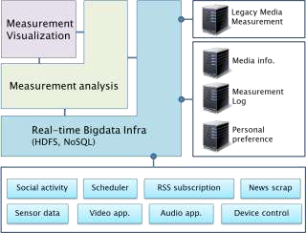
The Machine-type People Meter (refer Fig 3) collects such media and additional data from distributed smart terminals using data aggregators, and then uses extractors to turn that detailed media information, along with data on users' preferences and the extent of their disclosure, into audience rating information. MapReduce-based parallel time data mining can be used to analyze and visualize such decentralized network-based data in close to real-time in order to assess each user's personal history and forecast changes in their life recording and watching patterns.
Figure 4. A Framework of Bigdata platform's architecture designed on a machine-type media measurement system.

The Media Measurement Service Platform (refer fig 4) combines audience rating data gathered traditionally with data gathered via MPMs, or Machine-type People Meters. Additionally, all types of queries are made and delivered, and MPM offers the lookup or service composition function, which combines the viewing data of specific groups or an unknown number of users.
The following are the specific media delivery and collection processes:
- The Management Module Service Platform (MMSP) creates the request query based on the pertinent information sought and sends it to the MPM when a request for a media measurement is made from the outside. Additionally, the MPM creates a collection MPM application and sends the request to the M2M platform after constructing specific request composition metadata that matches the pertinent inquiry order delivers it to the upper order symmetrically or asymmetrically.
- All response data is received by the M2M Platform, which then sends it to MPM. The relevant user's disposition information, specific media information, and item information that the relevant user approved sharing is all identified by the MPM, which then sends the refined data to the MMSP. As shown in Fig.4, the MMSP gathers the necessary data, uses the Bigdata platform to evaluate it, including visualised data, and then provides it to the required application.

Conclusion

This chapter underlines a method for gathering various data based on machine-type communications and providing additional information for universal viewing in this way. It reflects a complementary resolution in terms of assessing and employing integrated media, even though it is impossible to fully analyze viewing trends, including audience ratings, in the current reality as many kinds of media emerge.

References

- Namjun Kang, Eun-mee Kim.: The Emerging Concepts and Measurements of Multiple Media Use, In: ICRJ 47(2), pp.5--39. (2010)
- Audience Measurement, http://en.wikipedia.org/wiki/Audience_measurement
- Media Behavior Institute, http://www.mediabehavior.com/
- J.Y. Lee.: Limitation of People Meter based audience measurement and alternative methods, In: DMT Report, December, http://mfi.re.kr (2011)
- S.K Yoo, Y.G. Hong, H.J. Kim.: Smart Mobile Services – M2M Technology and Its Standardization Trends, In: ETTREND, 26(2), pp.50--60. (2011)
- Coalition for Innovative Media Measurement, http://cimm-us.org/
- Portable People Meter, http://en.wikipedia.org/wiki/Portable_People_Meter
- Arbitron, http://www.arbitron.com/
- Single Source Data, http://en.wikipedia.org/wiki/Single-source_data
10.J.W. Cha.: Single Source Data based advertising impact research, In: Voice of Korea Advertiser, Korea Advertisers Association, pp.14--15. (2005)
11.Kim Chang Soong, A. Tseng, M. Zhixian Xiang.: Global Wireless Machine-to-Machine Standardization, In: IEEE Internet Computing, Vol.15, Issue: 2, pp.64--69. (2011)

