FRAGMENT BASED DRUG DISCOVERY-A NEW PARADIGM.
Pinkal Patel*, Sakshi Bhatele, G.S. Chakraborthy

Affiliation Address: Department of Pharmaceutical chemistry, Parul Institute of Pharmacy and Research, Faculty of Pharmacy, Parul University, At. Po Limda, Ta. Waghodiya-391760, Dist.Vadodara, Gujarat, India.
Email id:pinkpharmacy@gmail.com
Contact no: +91-9978925545

ABSTRACT
The era of molecules has been significant since the world’s existence because of its effectiveness and computability. In this approach many pharmaceutical industries focus on moiety, which will target the principle disease and prove its therapeutic effect. So a lead molecule from an entity will be beneficial in this aspect as they are considered as the target sites. This becomes important, and the evolution of High throughput screening (hits) has been seen. The increase in combinatorial chemistry and Hits has led to the development of many screening libraries of compounds. The fragment-based method needs significantly lesser compounds for screening and synthesis because of their owing demand, and there by possess a higher success rate in the market. In reference to the traditional screening, the starting material of fragments have considerable lower molar mass and maintains lesser binding interactions with the target proteins, which are weaker. Hence the structure taken into it is by NMR or X-ray crystallography, leading to significantly more ligand binding. Thus in this article, we will discuss the various newer approaches used in fragmented drug discovery, which in turn will reduce the time and effort for identifying more unique molecules.
Keywords: Fragment-based drug design; fragment screening; Nuclear magnetic resonance; X-ray crystallography; Fragment library

INTRODUCTION
In pharmaceutical industries, fragment-based method for the discovery of drug becomes a technique with measurably high potential that aids in finding a suitable hit molecule when traditional methods like the High-throughput screening (HTS) fails. Because there are no good small-molecule starting points in the collection, about half of the HTS campaign fails [1]. For compounds such as protein-protein interactions, failure is more common for newer targets or classes of targets for which there may not be many historical compounds [2-4].
Fragments are small molecules that may become parts of a larger molecule, but in some cases fragments of known drugs, that have been used as starting points to find new inhibitors for different biological targets. Fragment (additionally referred to as needles, shapes, binding elements, seed templates or scaffolds) is a diminutive, typically aromatic, lesser molar mass organic molecule (~120-250Da) suitable for high concentration screening process. Generally the fragment-based compounds are weaker inhibitors (10μm-Mm) and possess significantly more ‘ligand efficiency’ and hence are highly potent for optimization into clinical subjects with good drug-likeness properties.
In addition to recognizing the vastness of chemical space, HTS does not always give a result with potent hits. This gives rise to the concept of fragment-based drug design. Rudimentary assumption is that, in lieu of probing immensely colossal amassments of drug-sized molecules, one could analyze more minute accumulations of more minute fragments (or molecules),and then either grow a part or amalgamate two components to get the kind of potency as of HTS.
The tardy William Jencks of Brandeis University first gave the theory behind FBDD around 30 years ago [6]. In context to the "intrinsic binding affinity" of A and B, Delta GAi and Delta GBi, and a "connection Gibbs energy," Delta Gs derived mainly from alterations in rotational and translational entropy, it may be helpful to define the Gibbs free energy alterations for attachment to a protein of a molecule, X–Y, and its fragments, X and Y.
These conceptions can be demonstrated graphically as shown in Fig. 1[5]. The peak panel is the easiest representation of a high-throughput screen: to identify a hit that even though binds imperfectly, multiple compounds are screened against a target or a protein. Through medicinal chemistry, this is then optimized.
The centre panel represents the linking part as defined by Jencks: two fragments that are chemically linked together at nearby sites. Similar to HTS, further improvement of the molecule requires subsequent medicinal chemistry. The concept of linking was employed to practice in 1996 in a high-profile Abbott Laboratories science publish [7].
However, after that, multiple groups discovered that linking is far more challenging than expected X component of arduousness is that chemical bonds have stringent geometric and length requisites, so if the two parts are not impeccably situated more of the gained potency expected will be disoriented because of stress in the linker [8, 9]. As a result, fragment growth is a often alternative to the fragment linking, as shown in Fig's lower panel. 1. In this approach, to make further interactions with the protein, a single fragment is gradually grown.
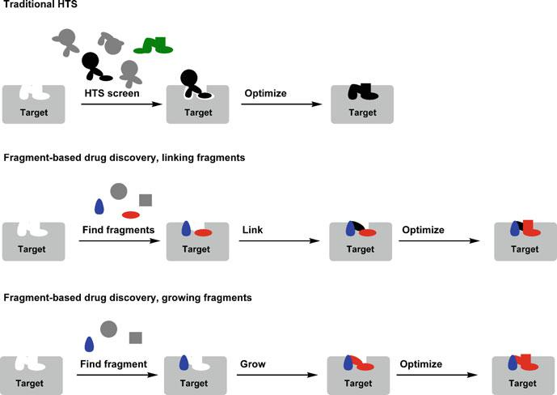
Fig. 1 Comparison of high-throughput screening (HTS, top) with fragment linking (middle) and fragment growing (bottom) [5].

CONCEPTS.
Afore giving comments on a discussion of FBDD, the essential concepts and challenges related to this drug discovery method should be identified. This will make it clear how FBDD can aim to alleviate the high rates of attrition of the usual conventional methods to drug discovery.
Concept 1: incongruous physical properties for small molecule drugs are a major cause of problem.
In a milestone journal [10], Lipinski described that oral drugs that have low molar mass, conventionally complied with Lipinski’s rule of five {molar mass <500 Da; calculated logP (lipophilicity/hydrophobicity) <5, where P is the ratio of solubility of octanol with that of waters’; the number of hydrogen bond donar ≤ 5; the number of hydrogen bond acceptors ≤ 10} and recommended that molecules that does not follow this range were more averse assimilated orally. All the more as of late, others have noted that the mean molar mass and lipophilicity of compounds from phase-1 studies with reference to the approved drugs is gradually decreasing, indicating that high molecular weight and high lipophilicity are significant cause of problem through their influence on the properties of absorption, distribution and metabolism[11-15].
In addition, an increased fashion of toxic encounters for more lipophilic and less polar compounds has been reported, designating the paramountcy of the total polar surface area as well as lipophilicity on problem [16]. This influenced the pharmaceutical organization to give more preponderant attention to simple physical properties during lead identification and lead optimization and has induced companies to reduce their screening collections molar mass and lipophilicity. The optimization process in FBDD commences from a minute and productively binding part in which every atom in the molecule participates in the desired binding interactions (e.g., MW ~150; the binding affinity of μM order). Thus, the molecule's shape and size, intricacy and physical characteristics can be controlled better and effortless than when starting from a hit with a higher-affinity HTS that comprises groups not vital to the intended binding (e.g., MW ~400; binding affinity ~nM).
Concept 2: although weak in potency, fragments form interactions of high quality.
Initially, Jencks called attention to this when a tiny molecule interacts to a macromolecule, enough amount of its rigid-body entropy related to translation and tumbling in solution is expected to be lost by the diminutive molecule [17, 18]. This energy loss was estimated to be about three orders of binding energy magnitude (i.e., 15–20 kJ mol–1) [19] and was debated to be independent of molar mass [20]. Therefore, if a fragment associates with a free energy of –22.8 kJ mol–1 (i.e., an affinity of 100 μM), it actually forms desirable interactions between –42.8 and –37.8 kJ mol–1 after the rigid-body entropy term has been subtracted. Likewise, a molecule of drug size with 3 nM affinity has to overthrow the same entropic barrier and thus forms desirable interactions between –68.6 and –63.6 kJ mol–1. Consequently, if the weak portion forms a part of this potent drug (and still forms the same interactions with the protein), then that portion genuinely contributes over half the propitious energy despite being 33,000 times more impuissant in affinity. This significant binding energy relative to that part's small size is essential to the binding interaction's quality.
Concept 3: ligand efficiency (LE) is a means of assessing the relative optimizability of molecules of varying sizes.
Ligand efficiency (LE) [21–23] is merely the free binding energy divided per heavy atom, LE= pIC50/N, where IC50 is the required inhibitor concentration to inhibit 50% of an in-vitro enzyme, and N the number of heavy atoms present in the molecule. When comparing compounds of varying sizes, it is a much more utilizable measure than affinity alone. LE > 0.3 kcal per heavy atom values indicates that meticulous optimization should result in rule-of-five inhibitor of 10 nM. A' rule-of-three,' similar to the Lipinski rule-of-five, is widely used to help differ the physicochemical properties between a lead fragment and the final drug candidate [24]. In addition to molecular weight, the LE concept has been broadened to include other pertinent chemical characteristics [12, 25]. Many reported examples that show that a fragment's LE can be conserved during a fragment-to-lead chemical campaign (IC50 enhanced from mM to nM) given structural information is available on binding interactions[21,26]. Therefore, it can be accomplished by synthetically building the fragment to a proximal binding site, or by linking two fragments together. Because of the requirements to identify optimal linking groups, linking a fragment can be much more problematic than fragment building.
Concept 4: The sampling of chemical space requires relatively small libraries of fragments.
While it can be assumed that, quantifying stringently is not straightforward. A basic model of ligand-receptor interactions [27, 28] was used to represent that moieties of lesser complexity (i.e., fragments) yield better hit rates than more complex scaffolds (i.e., molecules of drug size). This is because more complex molecules are more likely to form discrepancies with the receptor by suboptimal interactions or clashes. It has also been demonstrated that there are approximately 109 'drug-like' compounds with 11 or fewer bulky atoms[29,30 ], whereas the number of rule-of-five compounds estimates range from 10²⁰ to 10²⁰⁰[31,32 ].These models shows that screening 1,000 fragments (< 16 heavy atoms per molecule) could be more efficacious in sampling total chemical area than screening 1,000,000 more typical HTS compounds (< 36 heavy atoms per compound). Such high-level chemical sampling is expected to raise the probability of multiple potential compounds with better ligand efficiency.
Discovering fragments
Customarily (that is, more than a few decades before) active compounds have generally been found merely by evaluating them in a biological assay, sometimes in cell cultures or on animals. As this construal of biology and potential to separate proteins improved, a reductionist and more effective approach and testing of compounds in functional assays against separated enzymes or proteins became standard practice with HTS. On a basic level, it should be able to do this with fragment parts. However, various downfalls can arise: ability to solubilize, molecular reactivity, and aggregation.
- Down to the Rabbit hole: downfalls when working with Binders of Lower Affinity.
- Solubility:
Initial stumbling block in finding parts is solubility: several parts bind to proteins with 1 mM or even higher dissociation constants, but at these concentrations, several organic molecules are not soluble. Afore screening, it is therefore essential to check the fragment's solubility in the suitable biological buffer. While obviously there is a need of precaution, it is mostly disregarded, especially when for the first time, researchers set up fragment screening.
- Reactive Molecules:
The next issue is reactive molecules–not only the fragments themselves, but impurities at lesser levels. For example, if a molecule is contaminated with 1% of a reactive intermediate in a HTS conducted at concentration of 1 mM, the reactive intermediate will occur at just 10 nM concentration and might not cause any problem.
But, if the same compound is subjected and evaluated at 1 mM concentration in a fragment screen, the reactive intermediate will be present at 10 mM (considerably more concentration than the protein target itself) and therefore could cause a wrong positive signal by reacting and inactivating the protein. Numerous sorts of molecules that are reactive have been well recognized to medicinal chemists: aliphatic esters, aliphatic ketones, alkyl halides, acyl halides, anhydrides, aldehydes, aziridines, 1,2-dicarbonyl compounds, epoxides, halopyrimidines, imines, Michael acceptors and b-heterosubstituted carbonyl compounds, to give some examples [33]. It is not necessarily the case that these groups are not helpful –few of them have even appeared in approved drugs–but all of them can covalently react with proteins and should therefore be considered suspiciously. In any case, molecules can react covalently with proteins regardless of whether they don't contain groups that raise the alert. Jonathan Baell referred to them as pan-assay interference compounds, or PAINS, and published a rundown of scaffolds and techniques for detecting them [34, 35].
The probability of molecules that may not react directly with proteins but act as oxidizers are comparatively less, e.g., by producing hydrogen peroxide, that may inactivate proteins in turn. Examples of such compound types are presented in Fig. 2[5]: these molecules are tiny, fragment-like. Molecule 1, 2 and 3 have all been reported for inhibition of PTP1B by producing hydrogen peroxide in the presence of buffers having reductants, a prevalent and usually sagacious process to keep proteins in the reduced state [36, 37]. The quandary is that compounds 1, 2 and 3 can be reduced employing ambient oxygen and subsequently re-oxidized, producing hydrogen peroxide in the further process. Lamentably, this type of process can be arduous for tracking. For instance, when compound 4 was accounted for as a novel inhibitor for protein-protein interaction [38], there was not endeavor to rule out the generation of hydrogen peroxide rather than the close resemblance between compounds 2 and 4 and the reality that the buffers used have reducing agents. Compound 4 and various analogs produce hydrogen peroxide, which is responsible for the observed action [39–41]. As novel chemical classes of molecules are summed up to the screening groups, watchfulness for such problems is vital.
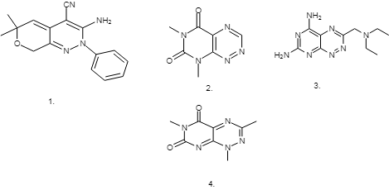
Fig.2 Examples of molecules demonstrated to generate hydrogen peroxide under standard biochemical assay conditions (1-3), and a similar molecule (4) reported without testing for redox activity [5].
- Aggregators:
Reactivity and solubility of molecules is a serious issue, but the aggregation phenomenon is an even more insidious stumbling block. Many small molecules at relatively high concentrations might form aggregates in an aqueous solution, which can inhibit proteins in a non-specific manner and intervne with bio-chemical assays [42]. The result seems to be based on concentration. This increases the likelihood of aggregation as more concentration is needed to detect binders of less affinity. Sometimes aggregate compounds are extended, long, planar "ugly" molecules, but even tiny molecules of fragment size and approved drugs can aggregate. Figure3 [5] shows an example of two drugs of fragment size (5 and 6) falling within this class [43]. A screen of 70,563 molecules can recognize the degree to which this is a quandary to discover enzyme inhibitors AmpC b-lactamase [44]. Out of 1,274 hits, 1,213 were aggregators–above the range of 95%. Far worse, these compounds often show strucure-activity relationships (SARs), and the influence may sustain even at relatively lesser levels. A range of cruzain inhibitors with IC50 values as low as 200 nM have already been reported, but further studies have found that they are aggregators and their medicinal chemistry effort has probably without evaluation, been optimized for aggregation [45]. How serious this problem can be is difficult to understate. Most of the big pharmaceutical firms are now cognizant of it and use steps to avert it, but academic laboratories and tiny firms may not be that rigid. Luckily, aggregate formation can usually be prevented by incorporating small amounts of non-ionic surfactants to the test buffer [46].

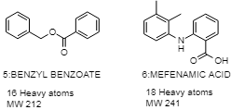Fig. 3 Two approved drugs that can form aggregates at high concentrations [5].
Other measures include increment in the concentration of proteins; which should not customarily affect the IC50 values quantified. Centrifuging the subjects will eradicate aggregates and the presence of aggregators might also be revealed by flow cytometry or dynamic scattering of light. Finally, a tell-tale marker of aggregators can be an exceptionally steep dose-response curve [47].
So rather one reason, fragment-based methods have been slow to take off is attributable primarily to all these issues. Fortunately, we now have sufficiently advanced tools to pursue fragments successfully, and a better sense of what can go wrong.
- Techniques for fragment detection.
As Pitfalls’ described in the previous section, it is not remarkable that bio-physical techniques have heavily influenced FBDD, and in reality the increment in sensitivity and efficiency of bio-physical techniques are primarily responsible for the strategy's success. Tools for discovering fragments are briefly considered in this portion; each has been further reviewed elsewhere, and references are provided to these reviews.
- Nuclear Magnetic Resonance(NMR):
It is opportune to commence a discussion with nuclear magnetic resonance (NMR) fragment-finding approaches as “SAR using NMR” was the method that comprehensively showed that fragment-based techniques were possible [48]. In this method, in the presence and absence of fragments, 2D-NMR spectra are extracted from the protein. Alterations in chemical shifts of protein in the presence of a fragment indicate binding, and the location of binding can be ascertained if the assigning of chemical shifts has been on particular protein leftovers. This is an illustration of NMR i.e. "protein-detected," based on alterations in the protein's NMR signal. SAR using NMR is a strong strategy, giving rise to clinical compounds. However, it is restricted to comparatively tiny proteins (nearby 30–40 kD) since it depends on alterations in protein chemical shifts. There have been numerous methods in use [49]: one of the most prominent is saturation transfer difference (STD) that is solely focused on the divergence in relaxation between small molecules and big macro-molecules [50]. This certainly requires less protein than SAR by NMR and is appropriate for bigger proteins, though does not provide binding site information.
An impressive ligand-detected method based on inter-ligand nuclear over-hauser effects (SAR by ILOE) identifies 2 ligands binding nearby to each other on the surface of protein, making it easier to link [51, 52]. However it is necessary to be careful to avoid wrong positives because of compound aggregation [53]. Abbott Laboratories was the pioneer company to give NMR for screening fragments, but the method in present is extensively used notably ligand-detected techniques. There are Abbott Laboratories, Astex Therapeutics, Evotec, Schering-Plough (now Merck) and Vernalis companies known to use NMR. NMR techniques have been comprehensively reviewed [49, 54–63] and are also reported by Wyss and colleagues in greater depth [64].
- X-Ray Crystallography:
Crystallography and protein-detected NMR are peculiar in providing detailed empirical information about how the ligand binds to the proteins. Unlike NMR, crystallography, may be used for bigger proteins and may give stats with very better resolution. Drug-discovery based on fragments owes a lot to the sudden increment in throughput of crystallography for more than last 15 years. Most firms that use FBDD presently utilize X-ray crystallography. Few firms utilize crystallography as their standard screening technique, and various pursue just fragments that may be identified crystallo-graphically. Organizations that do contract research like Emerald bio-structures give smaller companies with access to crystallography that may not have in-house capabilities.
Addition to its sensitivity, there are several other advantages in employing crystallography as a screening method over alternative methods. The provision of reliable structural information on the interaction between fragment molecule and the protein is of great importance in a screening cascade at the earliest possible phase. Therefore, this method not only provides an efficient way of detecting weak binders, but also permits the fastest and most efficient evaluation of molecules in terms of their flexibility and usefulness in medicinal chemistry, especially in terms of synthetic subjects that are liable to provide the modification by structure-based design techniques (SBDD).
A flow diagram for a standard fragment-screening practical with crystallography is shown in Fig. 4. [65]. In particular, it includes soaking crystals with desired fragments, followed by X-ray data collection and processing, placing aqueous molecules in electron density and screening of the ligand-free complex to effectively show the change in electron density linked with the bound ligand. The electron density is then perceived, optimized and refined to give final protein-ligand structure.
There has been a comprehensive revise of the use of X-ray crystallography in FBDD [59, 61, 63, 66, and 67].
- Surface Plasmon Resonance:
Utilization of surface Plasmon resonance (SPR) to interpret fragment binding used years ago, but as a primary screening technique it has only recently become prominent. In most cases, on a metal-coated chip, a protein is immobilized, and ligands are then flowed around it. The ligand binding to the target lead to alteration in the metal's reflectivity characteristics associated with the ligand mass and the protein mass. Association and dissociation rates can be accessed directly, although these are usually too fast to be measured in fragments.SPR experiments are reasonably quick and easy to set up and take less training to run than NMR or X-ray crystallography. When appropriately executed, surface Plasmon resonance can be a precious tool: just not offer dissociation constants; it also gives stoichiometry [68–70].
Finally, while the immobilization of protein is done, the feasibility of immobilization of ligands becomes possible themselves and the evaluation of protein binding [71], a method adopted by Graffinity Pharmaceuticals. Surface Plasmon resonance techniques are summarized in better way by Hennig et al. [72].
Fragment Cocktailing
Fragment Library

Soak fragments into protein crystals

X-Ray Data collection

Automated Data processing and ligand identification
HITS

Fig.4. Flow chart of typical crystallographic fragment screen [65].
- Interferometry:
As with SPR, interferometry is based on a shift in light, caused by a change in both the refractive index and the physical thickness of a protein layer when binding to small molecules [73, 74].Widely available instruments (such as the ForteBio instrument) had been introduced a couple of years later than SPR instruments, but the technique tends to attract increased interest.
- Isothermal Titration Calorimetry:
Isothermal titration calorimetry (ITC) attempts to measure the heat released when a ligand binds to a protein, from which it is possible to quantify the enthalpy and entropy of binding[75].There is some evidence that choosing fragments that bind predominantly via enthalpic interactions will result in superior molecules[76], although the data is constrained.ITC seems to have lower throughput and requires a higher protein requirement in particular than other techniques and is therefore probably more suited as secondary screening instead of primary screening.
- Mass-Spectrometry[MS]:
Mass spectrometry can be utilized to detect fragments that seem to be covalently or noncovalently binding to a protein. In covalent approaches, like Tethering [77], established by Sunesis Pharmaceuticals researchers, a reactive functionality like cysteine is introduced into a protein and used to locate fragments that bind in the vicinity, providing some data about the binding site.
It is also possible to estimate fragments binding to proteins through noncovalent interactions, a strategy adopted by NovAliX [78].
Evident from this brief overview of methods is that there are many ways of finding and characterizing fragments efficiently, each with its own set of strengths and weaknesses. Which techniques to utilize will depend on organizational resources and competence as on scientific considerations. The best strategy is to abandon a single approach: combining multiple orthogonal methods.
Current techniques in FBLD.
Figure 5[79] sums up the key features of an FBLD system; the relevant sections portray its five main subsystems – fragment libraries, target enablement, fragment screening, creating a model for fragment binding and fragment to lead optimization.
- Fragment libraries:
In assembling a fragment library, there are three key factors. Primarily, the properties of the fragments include- they should not contain moieties known to be reactive to proteins, should be soluble at the high concentrations used for screening and further should be as varied as possible (see [80] for one of the first summaries of these properties). Next, for the number of fragments in a library, the Molecular weight [MW] is a crucial consideration. Lastly, it is essential to regularly check the library for fragment stability or precipitation/aggregation to prevent false positives in high concentration assays. A comprehensive review of fragment library design [81] and the development of a new fragment library at Pfizer [82] have addressed some of the other issues to be considered.

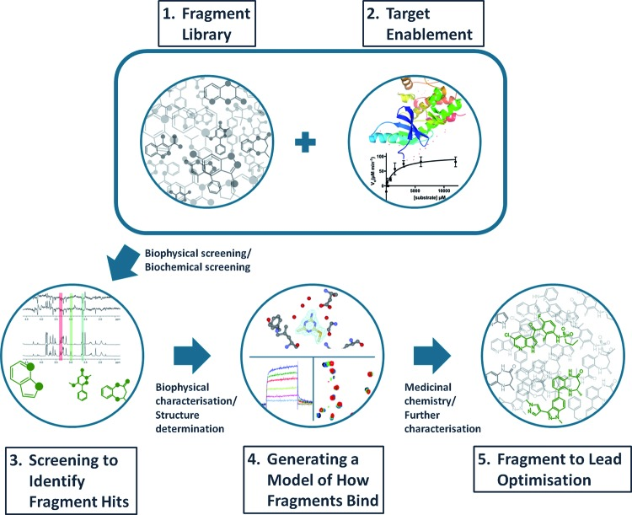
Figure 5: The flow of FBLD system [79].
- Target enablement:
When considering the issues and opportunities for FBLD, it is possible to define two target classes: (1) a conventional target where a crystal structure and a robust binding or functional assay are readily available and precedent for drug-like compounds (such as protein kinase) is established and (2) a difficult and demanding target, such as deterioration of protein-protein interaction or inhibition of multi-protein complex activity, where there is no precedent for lead discovery and where there are many problems to solve in developing a platform for lead discovery, like the establishment of a robust assay or the development of a compound binding model.For these two target classes, the real challenge and time required for target enabling will be distinctly different.
- Fragment screening:
The key techniques used to identify protein-binding fragments are mentioned in section III[b], where the summary of key features of each technique is described. All techniques should offer similar hits when screening a library against a target, taking into account the experimental circumstances and nature of the assay method [83, 84].What is often overlooked is the relative sensitivity of each technique, and whether fragments (and targets) are still in solution and not aggregated under assay conditions (required concentration, pH, buffer, etc.).
- Creating a model for fragment binding:
Discovering fragments that bind to most binding sites on most proteins is fairly uncomplicated [85, 86]. Realizing what to do with them is a difficult task. For most targets with only fragile binding fragments, utilizing trial and error synthesis, it is very hard to generate valid SAR for a fragment.Most of the changes lead to a loss or change of binding affinity that is difficult to differentiate between compounds. All reported promising fragment optimization had been based on some model of how the fragment binds to the target. The most comprehensive model comes from X-ray crystallography, and many hundreds of crystal structures can be recognized in the early stages of a project to enable the medicinal chemist to make informed optimization decisions for well-behaved conventional targets. Where crystallography is not feasible, NMR techniques can provide sufficient input to generate a model, although creating each model can take several weeks.
- Fragment to lead optimization:
Figure 6[79]: shows a flow chart of the three major approaches for fragment to lead optimization.
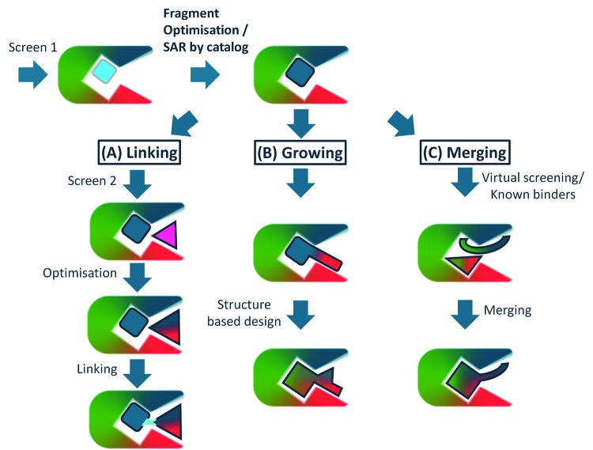

Figure 6[79]: flow chart of the three major approaches for the fragment to lead optimization.
The accompanying discourse incorporates a few instances of each methodology with structures mentioned in Figure 7[79].Techniques for fragment optimization includes: Linking, growing and merging. One of the regular missteps in fragments to hits to leads chemistry is starting the procedure of fragment growth before the center of the fragment itself is investigated and optimized or before the entire arrangement of fragment hits has been described. There are two angles to this. Right off the bat, screening is a numbers game and it is far-fetched that the ideal fragment for a specific binding site will be in the fragment library. It is in this way imperative to investigate firmly related chemo-types to a fragment – by compound buy (SAR by catalogue) or by restricted synthesis, if at all conceivable testing how minor changes influence binding (methyl walk, moving nitrogens around a heterocycle and so on). Besides, exploratory development around fragments is a ground-breaking method for mapping a binding site for specific features that add to the affinity and selectivity of ligands, markedly affecting the accomplishment of optimization.
- Fragment linking:
Venetoclax breakthrough a selective inhibitor of Bcl-2; two-site screening by protein observed NMR followed by structure determination and optimization recognized fragments ' 1 ' and ' 2 ' as Bcl-xL inhibitors. The underlying combination of these to '3' and afterward '4' gave a powerful inhibitor that was along these lines optimized to '5' that as ABT-737 entered clinical preliminaries as a dual Bcl-xL/Bcl-2 inhibitor [87] that built up the confirmation of idea that hindrance of these enemies of apoptotic proteins creates a therapeutic impact. Consequent design of '6' (ABT-263) gave a compound with improved properties that featured that Bcl-xL hindrance prompted thrombocytopenia, further configuration initiated the particular Bcl-2 inhibitor '7' that as venetoclax was affirmed for chronic lymphocytic leukemia (CLL) [88].
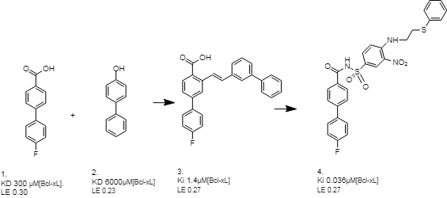

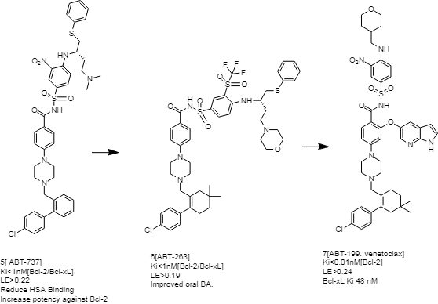
Fig.7. Fragment linking [venetoclax][79].
- Fragment growing: The revelation of Vemurafenib – a specific inhibitor of the B-Raf V600E mutant kinase; fragment '8' was recognized from a biochemical screen against the kinase Pim-1 and early structure-guided plan utilized structures bound to Pim-1 and FGFR to recognize fragment '9' and the compound '10' (PLX4720). This was then improved to '11' (Vemurafenib) that is currently utilized for the treatment of mutant B-Raf driven melanoma [89].
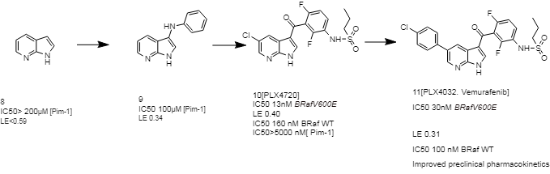
- Fragment merging: Fragment merging ' is a combination of information from multiple chemical hits. It relies on multiple structures of crystals and cautious design based on the structure.
An extension of the merging approach is particularly effective–i.e. combining fragment information with literature-identified information about inhibitors, high-throughput screening (HTS) or natural ligands. A very classic example is the work of a GSK team on the BCATm enzyme, where the fragment was coupled with an HTS hit to give a powerful lead [90].
Examples for Fragment based drug discovery techniques.
There are several fragment discovery examples for several targets from the literature discussed below .The list of targets comprises a wide variety of gene families, but the strategy for kinases and serine proteases seems to be dominant.
ABT-737 and ABT-263
A standout amongst the greatest examples of overcoming adversity in FBDD concerns the Bcl-2 group of proteins. These are appealing anti-cancer targets as it may, on the grounds they form protein– protein interactions, challenging to find small molecule inhibitors. Utilizing SAR by NMR, scientists from Abbot Research facilities distinguished fragments that bind at two nearby sites on Bcl-xL (Fig. 8) [91]. Fragment 32 was identified from a screen of 10,000 fragments, and fragments 33 and 34 were found by screening 3,500 fragments in the presence of 2 mM of compound 32. Parallel chemistry was utilized to connect these compounds, at last leading to compound 35. Be that as it may, an NMR-based model of this compound bound to Bcl-xL proposed that the linker was not perfect: a phenylalanine buildup on the protein obstructed the right-hand fragment binding deep in its pocket. This prompted a redesign of the linker to replace the carboxylic acid with an acylsulfonamide, which is also negatively charged at physiological pH. This methodology prompted a set of compounds created by parallel synthesis, eventually prompting compound 36 [92]. Albeit compound 36 was potent, it was generally insoluble and bound firmly to serum albumin. Further medicinal chemistry led to ABT-737, which albeit potent was not orally bioavailable [93, 94]. Additional medicinal chemistry at long last yielded ABT-263, which is orally bioavailable and has improved pharmacodynamics [95].
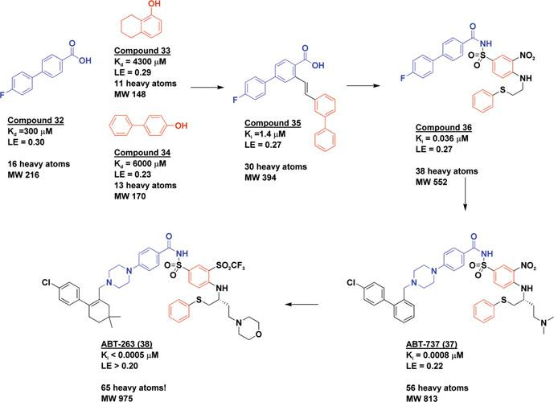
It is worth considering the structure of ABT-263 for a minute (Fig. 8). This molecule, with a molecular weight moving toward 1,000 Da, traveled some distance from its fragment origins. However, preceding the publication of its structure, it is sure that in no way like would it have been found in a high-throughput screening collection. This represents the capability of fragment-based ways to deal with search out and investigate new areas of chemical space.

Figure 8[5] Fragment linking to discover ABT-737 and ABT-263

Drugs that have reached clinical trials based on the FBDD approach have been listed in Table 1[5].
Table 1[5]Drugs based on FBDD efforts that have reached clinical trials.
Drug and latest reported development | Company | Target
Phase 3
PLX-4032 | Plexxikon | B-Raf V600E
Phase 2
ABT 263 | Abbott | Bcl-2/Bcl-xL
ABT 869 | Abbott | VEGF and PDGFR
AT9283 | Astex | Aurora
AT7519 | Astex | CDKs 1,2,4,5
LY-517717 | Lilly/Protherics | FXa
Indeglitazar | Plexxikon | PPAR agonist
VER-52296/NVP-AUY-922 | Vernalis/Novartis | Hsp90
Phase 1
ABT-518 | Abbott | MMP-2 and MMP-9
ABT-737 | Abbott | Bcl-2/Bcl-xL
AT13387 | Astex | Hsp90
DG-051 | deCODE/Emerald | LTA4H
IC-776 | Lilly/ICOS | LFA-1
LP-261 | Locus | Tubulin
PLX-5568 | Plexxikon | Kinase
SGX-523 | SGX | Met
SNS-314 | Sunesis | Aurora

Summary and Conclusion
Fragment-based design has been appeared to be a valuable way to deal with discovering hits over a wide range of target classes. Even though there is an extensive number of reported successes for fragment based drug discovery over the most recent ten years, these are still boundlessly dwarfed by the examples of customary medicinal chemistry methodologies of hit expansion dependent on either precedented lead compounds or HTS. This is probably not going to change significantly throughout the following couple of years, since the speed and straightforwardness with which HTS as of now produces countless hits for targets over numerous gene families, especially for gene families like kinases, GPCRs and PDEs is probably going to avoid reach in terms of throughput for most fragment-based lead discovery approaches [FBLD].
The special case may be in silico procedures like structure-based virtual screening [SBVS], which can deliver hits at a small amount of the speed and cost of conventional screening campaigns. In silico framed molecules can furnish the medicinal chemist with sound help to manage his thoughts regarding significant new chemical entities, and accordingly help the advancement of novel and patent able leads. In numerous ways, a fragment is indistinguishable to whatever other small molecule that binds to a protein – the principle advantage is that the possibility of a fragment binding is a lot more noteworthy than a larger molecule. The primary difficulties have been in building up the strategies and experience in both identifying binding of such weak compounds and the techniques for optimizing the fragments to lead compounds. The preferred fundamental standpoint for the medicinal chemist expert is that in light of the fact that the chemistry is beginning small and there are generally numerous fragments to consider, there are more chances to settle on better quality choices in producing a lead compound with ideal properties. This has given novel, selective lead compounds for conventional targets past those distinguished through progressively traditional, HTS approaches. Additional striking is the open doors offered for challenging targets. Here, the biophysical techniques, specifically NMR, can distinguish and validate binding of fragments to the target regularly giving starting points to lead revelation when different methods, for example, HTS, have fizzled.
For most targets, including those that fail in HTS, fragments can be discovered. Fragments uncover the chemical space for what can bind to a target, even for well-characterized targets such as protein kinases, offering new chemical entities.
Fragments binding with mill molar affinity can be transformed into powerful lead compounds. There are now numerous compounds discovered from fragment methods in clinical trials and two products on the patient treatment market. As an alternative method in chemical biology, there are springing up ideas of using fragments to test biological systems. For the scholarly scientist, the strategies are alluring since binders can be distinguished utilizing a small library, not requiring the gigantic cost in compounds and computerization that is necessaryu for HTS; the vast majority of the biophysical procedures required for fragment screening are additionally accessible in many establishments. As focused before, it is moderately simple to distinguish fragments that bind to most binding sites on most targets; what is troublesome is comprehending how to manage them. Late research has appeared that imaginative utilization of fragment based strategies can convey new methodologies and results in chemical biology, for example chemical tools to test, comprehend and regulate biological systems and function.
REFERENCES
- G.M. Keseru andG.M. Makara,Nat. Rev. Drug Discov.,8, 203(2009).
- P.J. Hajduk andJ.A. Greer,Nat. Rev. Drug Discov.,6,211(2007).
- M. Whittaker,Drug Discov Today, 14, 623(2009).
- J.A. Wells andC. L. McClendon,Nature,450, 1001 (2007).
- D.A. Erlanson, Top. Curr. Chem.,317, 1 (2012).
- W.P. Jencks,Proc. Nat. Acad. Sci.,78, 4046 (1981).
- S.B. Shuker, P.J. Hajduk andR. P. Meadows,Science,274, 1531 (1996).
- S. Chung, J.B. Parker andM. Bianchet,Nat. Chem. Biol., 5, 407(2009).
- J. . Huth, C. Park andA.M. Petros,Chem. Biol. Drug Des., 70, 1 (2007).
- C.A. Lipinski, F.Lombardo, B.W. Dominy andP.J. Feeney, Adv. Drug Deliv. Rev.46, 3 (2001).
- M.P.J. Gleeson, Med. Chem.55, 817 (2008).
- P.D. Leeson andB. Springthorpe, Nat. Rev. Drug Discov., 6, 881 (2007).
- S.J. Teague, A.M. Davis, P.D. Leeson andT. Oprea, Angew. Chem. Int. Ed.,38, 3743 (1999).
- M. Vieth, J. Med. Chem., 47, 224(2004).
- M.C. Wenlock, R.P. Austin, P. Barton, A.M. Davis andP.D. Leeson, J. Med. Chem.,46, 1250 (2003).
- J.D. Hughes, Bioorg.Med. Chem. Lett.,18, 4872 (2008).
- W.P. Jencks, Proc. Natl. Acad. Sci.,78, 4046 (1981).
- M.I. Page and W.P. Jencks, Proc. Natl Acad. Sci.,68,1678 (1971).
- C.W. Murray andM.L.J. Verdonk, Comput.Aided Mol. Des.,16,741 (2002).
- A.V. Finkelstein andJ. Janin, Protein Eng.,3,1 (1989).
- R.A. Carr, M. Congreve, C.W. Murray andD.C. Rees, Drug Discov. Today,10, 987 (2005).
- A.L. Hopkins, C.R. Groom and A. Alex, Drug Discov. Today,9, 430 (2004).
- I.D. Kuntz, K. Chen, K.A. Sharp andP.A. Kollman, Proc. Natl Acad. Sci.,96, 9997 (1999).
- M. Congreve, R. Carr, C. Murray andH.A. Jhoti, Drug Discov. Today,8, 876 (2003).
- C. Abad-Zapatero andJ.T. Metz, Drug Discov. Today,10, 464 (2005).
- P.J. Hajduk, J. Med. Chem.,49, 6972 (2006).
- M.M. Hann, A.R. Leach andG. Harper, J. Chem. Inf. Comput. Sci.,41, 856 (2001).
- A.R. Leach, M.M. Hann, J.N. Burrows andE.J. Griffen, Mol. Biosyst.,2, 430 (2006).
- T. Fink, H. Bruggesser andJ.L. Reymond, Angew. Chem. Int. Ed.,44, 1504 (2005).
- T. Fink andJ.L. Reymond, J. Chem.Inf. Model.,47, 342 (2007).
- R.S. Bohacek, C. McmartinandW.C. Guida, Med. Res. Rev.,16, 3 (1996).
- P. Ertl, J. Chem. Inf. Comput. Sci.,43, 374 (2003).
- G.M. Rishton,Drug Discov. Today,8, 86 (2003).
- J.B. Baell andG. A. Holloway,J. Med. Chem.,53, 2719 (2010).
- J.B. Baell,Future Med. Chem.,2, 1529 (2010).
- K.R. Guertin, L. Setti, et al.,Bioorg. Med. Chem. Lett.,13, 2895 (2003).
- A. Tjernberg, D. Hallen, J. Schultz et al.,Bioorg. Med. Chem. Lett., 14, 891 (2004).
- F. Yi andL. A., ACS Chem. Bio.,3, 645 (2008)
- L.A. Lor, J. Schneck, D.E. McNulty et al.,J. Biomol. Screen,12, 881 (2007).
- K.M. Soares, N. Blackmon, T.Y, Shun et al.,Assay Drug Dev. Technol.,8, 152 (2010).
- P.A. Johnston, K.M. Soares, S.N. Shinde et al.,Assay Drug Dev. Technol.,6, 505 (2008).
- S.L. McGovern, E. Caselli, N. Grigorieff et al.,J. Med. Chem.,45, 1712 (2002).
- J. Seidler, S.L. McGovern, T.N. Doman et al.,J. Med. Chem.,46, 4477 (2003).
- K. Babaoglu, A. Simeonov, J.J. Irwin et al.,J. Med. Chem.,51, 2502 (2008).
- R.S. Ferreira, C. Bryant, K.K. Ang et al., J. Med. Chem.,52, 5005 (2009)
- B.Y. Feng andB.K. Shoichet, Nat. Protoc.,1, 550 (2009).
- B.K. Shoichet,Drug Discov. Today,11, 607 (2006).
- S.B. Shuker, P.J. Hajduk, R.P. Meadows et al.,Science,274, 1531 (1996).
- M. Pellecchia, I. Bertini, D. Cowburn et al.,Nat. Rev. Drug Discov.,7, 738 (2008).
- M. Mayer andB. Meyer,Angew Chem. Int. Ed. Engl.,38, 1784 (1999).
- B. Becattini, C. Culmsee, M. Leone et al.,Proc. Natl. Acad. Sci.,103, 12602 (2006).
- B. Becattini andM. Pellecchia,Chemistry,12, 2658 (2006).
- P. Sledz, H.L. Silvestre, A.W. Hung et al.,J. Am. Chem. Soc.,132, 4544 (2010).
- M. Pellecchia, B. Becattini, K.J. Crowell et al.,Expert Opin. Ther. Targets,8, 597 (2004).
- E.R. Zartler andM.J. Shapiro,Curr. Pharm. Des.,12, 3963 (2006).
- D.S. Sem,W. Jahnke, D.A. Erlanson (eds) “Fragment-based approaches in drug discovery” Wiley-VCH, Weinheim, Germany, 2006.
- P.J. Hajduk, J.R. Huth, C. Sun,W. Jahnke, D.A. Erlanson (eds) “Fragment-based approaches in drug discovery” Wiley-VCH, Weinheim 2006.
- E.R. Zartler, H. Mo, Curr. Top. Med. Chem.,7, 1592 (2007).
- R.E. Hubbard, B. Davis, I. Chen et al.,Curr. Top. Med. Chem.,7, 1568 (2007).
- C. Dalvit,Drug Discov. Today,14, 1051 (2009).
- H. Jhoti, A. Cleasby, M. Verdonk et al.,Curr. Opin. Chem. Biol.,11, 485 (2007).
- M. Kobayashi, K. Retra, F. Figaroa et al.,J. Biomol. Screen,15, 978 (2010).
- R. Gozalbes, R.J. Carbajo, A. Pineda-Lucena,Curr. Med. Chem.,17, 1769 (2010).
- D.F. Wyss, Y.S. Wang, H.L. Eaton, C. Strickland, J.H. Voigt, Z. Zhu, A.W. Stamford,Top Curr. Chem.,2011; doi:10.1007/128_2011_183
- T.G. Davies andI.J. Tickle,Top. Curr. Chem.,317, 33 (2012).
- J. Blaney, V. Nienaber, S.K. Burley,W. Jahnke, D.A. Erlanson (eds) “Fragment-based approaches in drug discovery” Wiley-VCH, Weinheim, 2006.
- C.W. Murray andT.L. Blundell,Curr. Opin. Struct. Biol.,20, 497 (2010).
- S. Perspicace, D. Banner, J. Benz et al.,J. Bio. Mol. Screen,14, 337 (2009).
- F. Proll, P. Fechner andG. Proll, Anal. Bioanal. Chem.,393, 1557 (2009).
- I. Navratilova andA.L. Hopkins,ACS Med. Chem. Lett.,1, 44 (2010).
- T. Neumann, H.D. Junker, K. Schmidt et al.,Curr. Top Med. Chem.,7, 1630 (2007).
- M. Hennig, A. Ruf andW. Huber, Top Curr. Chem.,2011 doi:10.1007/128_2011_225
- F. Proll, P. Fechner andG. Proll,Anal. Bioanal. Chem.,393, 1557 (2009).
- J. Concepcion, K. Witte, C. Wartchow et al.,Comb. Chem. High Throughput Screen,12, 791 (2009).
- J.E. Ladbury, G. Klebe, E. Freire,Nat. Rev. Drug Discov.,9, 23 (2010).
- A.D. Scott,C. Phillips, A. Alex et al.,Chem. Med. Chem.,4, 1985 (2009).
- D.A. Erlanson, J.A. Wells, A.C. Braisted,Annu. Rev. Biophys. Biomol. Struct.,33, 199 (2004).
- V. Hannah, C. Atmanene, D. Zeyer et al.,Future Med. Chem.,2, 35 (2010).
- B. Lamoree andR.E. Hubbard,Essays Biochem.,61, 453 (2017). doi: 10.1042/EBC20170028.
- Baurin N., Aboul-Ela F., Barril X., Davis B., Drysdale M., Dymock B. et al. J. Chem. Inf. Comput. Sci.,44, 2157 (2004).
- G.M. Keseru,D.A. Erlanson, G.G. Ferenczy, M.M. Hann, C.W. Murray and S.D. Pickett,J. Med. Chem.,59, 8189 (2016).
- W.F. Lau, J.M. Withka, D. Hepworth, T.V. Magee, Y.J. Du, G.A. Bakken et al.,J. Comput.Aided Mol. Des.,25, 621 (2011).
- R.E. Hubbard ad J.B. Murray Enzymol.,493, 509 (2011).
- E. Meiby, H. Simmonite, L. le Strat, B. Davis, N. Matassova, J.D. Moore et al.,Anal. Chem., 85, 6756 (2013).
- I.J. Chen and R.E. Hubbard,J. Comput.Aided Mol. Des.,23, 603 (2009).
- P.J. Hajduk,J.R. Huth and S.W. Fesik, J. Med. Chem.,48, 2518 (2005).
- T. Oltersdorf, S.W. Elmore, A.R. Shoemaker, R.C. Armstrong, D.J. Augeri, B.A. Belli et al.,Nature,435, 677 (2005).
- A.J. Souers, J.D. Leverson, E.R. Boghaert, S.L. Ackler, N.D. Catron, J. Chen et al.,Nat. Med.,19, 202 (2013).
- G. Bollag, J. Tsai, J. Zhang, C. Zhang, P. Ibrahim, K. Nolop et al.,Nat. Rev. Drug Discov., 11, 873 (2010).
- S.M. Bertrand, N. Ancellin, B. Beaufils, R.P. Bingham, J.A. Borthwick, A.B. Boullay et al.,J. Med. Chem., 58, 7140 (2015).
- T. Oltersdorf, S.W. Elmore, A.R. Shoemaker et al.,Nature,435, 677 (2005).
- A.M. Petros, J. Dinges, D.J. Augeri et al.,J. Med. Chem.,49, 656 (2006).
- M.D. Wendt, W. Shen, A. Kunzer et al.,J. Med. Chem.,49,1165 (2006).
- M. Bruncko, T.K. Oost, B.A. Belli et al.,J. Med. Chem.,50, 641 (2007).
- C.M. Park, M. Bruncko, J. Adickes et al.,J. Med. Chem.,51, 6902 (2008).
- R.E. Hubbard, The Royal Society of Chemistry,2015; 10.1039/9781782621836-00122
- C.N. Johnson, D.A. Erlanson, C.W. Murray and D.C. Rees,J. Med. Chem.,60, 89 (2017).
- V. Vivat, C. Atmanene, Z. Denis, A. Van Dorsselaer and S. Sanglier-Cianférani J. Biomol. Screen,21, 414 (2010).
- A.D. Gossert and W. Jahnke,Prog. Nucl. Magn. Reson. Spectrosc.,97, 82 (2016).
- T.L. Blundell, H. Jhoti andC. Abell, Nature Rev. Drug Discov.,1, 45 (2002).
- S. J. Teague, A.M. Davis, P.D. Leeson andT. Oprea, Angew. Chem. Int. Ed. Engl.,38, 3743(1999).

