“A review on Endophytes and its importance for the improvement in plant growth”
¹Dr Pooja R*
¹Assistant Professor, Department of Biotechnology, Surana College (Autonomous), South end road, Bangalore-560004
*Corresponding Author: Dr Pooja R
Email Id: poojaravi2015@gmail.com
Abstract:
Endophytes are microscopic organisms that asymptomatically reside in plants, primarily bacteria and fungi. Endophytic microorganisms are typically useful because they can influence plant development, raise plant stress tolerance, decrease pathogen virulence, boost plant disease resistance, and prevent the emergence of competing plant species. It has been demonstrated that endophytic microbes: (i) draw nutrients from the soil and transfer them to plants through the rhizophagy cycle and other nutrient-transfer symbioses; (ii) boost plant growth and development; (iii) lessen oxidative stress in hosts; (iv) prevent the growth from disease; (v) discourage herbivore nutrition and hydration; and (vi) suppress the growth of rival plant species. While endophytic bacteria are an important source for drug discovery, plant sources for novel chemical entities for therapeutic purposes are also the subject of intense research. Understanding the role and application of endophytes as a potential source of drugs against various diseases and other potential medical purposes is the goal of this chapter.
Introduction:
For millennia, plants have been used as a source of therapeutic bioactive substances to treat a wide range of diseases. Ironically, microbes connected to plants have emerged in recent years as the source of materials and goods with the highest potential for therapeutic use. Biodiversity, or the variety of living things, has always excited people's curiosity. It has become clear in recent years that human activities are contributing to the loss of biological diversity at a faster rate than ever before; in fact, the current rate of extinction seems to be among the greatest in the fossil record. No other organisms produce such significant effects over such vast areas as humans do and have done at least locally for thousands of years, despite the fact that nonhuman organisms can, to a little extent, cause the extinction of other species.
Emergence of Endophytic fungi
When first coined, the term "endophyte" was used to refer to any organism found inside the tissues of living autotrophs (Arnold and Lewis, 2005). However, this phrase has been redefined numerous times. Endophytes are defined as "organisms inhabiting plant organs that at some point in their life can infiltrate internal plant tissues without appearing to harm their host" by Petrini in 1991, and this description has since been widely accepted by the scientific community. This description applies to latent organisms that survive asymptomatically inside their hosts as well as endophytic species that have a long epiphytic phase (Petrini, 1991). Endophytes are a variety of microorganisms that live in the vascular tissues and reproductive organs of plants. They include bacteria, fungus, and cyanobacteria. Endophytes are primarily plant mutualists because they depend on their hosts for nutrition and protection. In return, the host plant benefits from having endophytes living inside it by having increased resistance to herbivores, pathogens, increased competitive abilities, and resistance to various abiotic stresses. Every type of plant has endophytes, which are bacteria and fungus that live inside the tissues of the plant without doing any harm. These endophytic microbes are abundant sources of bioactive natural chemicals, and a wide range of agents have been extracted from them with promise uses in the production of natural medicines and other industrial goods.
The interaction between the endophytes and the plant ranges from symbiotic to harmful in nature. Only one grass species had demonstrated a full complement of endophytic research in the majority of the plants.
Endophytic fungi were previously only examined in plants from temperate locations, but more recently, studies on tropical plants have also been conducted. Fungal endophytes and epibionts can be found on all plants. In nature, these connections between fungi and plants are typically obscure. Endophytic fungi inhibit tissues of stems, bark, branches, roots, petioles, flowers, seeds, and fruits which includes xylem of all plant organs. Drugs are derived from medicinal plants, whose value is greatly influenced by aspects including the genetic makeup of the relevant plants, as well as their biological habitats and soil nutrient intake (Dai et al., 2003; Sherameti et al., 2005). By influencing the quantity and quality of crude medicines found in the fungal extract of medicinal plants, endophytes now play a significant role in modern medicine. So it follows that the interactions between medicinal plants and endophytic fungi are crucial for both the development and the generation of crude medications (Faeth and Fagan, 2002). Although endophytic fungi are an important part of plant micro-ecosystems and must have a big impact on the growth and development of host plants, knowledge of the connections between endophytic fungi and their hosts is still lacking. Some techniques were utilised to create medical plants, such as adding a specific class of endophytic fungi to the plants, which increases the quantity and quality of the drugs (Firáková et al., 2007). Through the bioengineering of the chosen medicinal plants and endophytic fungi, some of the techniques were used as an alternative for the synthesis of desired pharmaceuticals under specific circumstances (Kumaran et al., 2008, 2009). Such a method of manufacturing could displace the conventional method of making pharmaceuticals, which primarily relies on natural medicinal plants.
In the temperate and tropical rainforests, where endophytic fungi are found naturally, there are about 30,000 different types of terrestrial host plants. According to Bacon and White (2000), these endophytic fungi, which are members of the meiosporic and mitosporic ascomycetes, "asymptomatically reside in the internal tissues of plants under the epidermal cell layer, where they invade healthy and living tissue through quiescent infections." There are several endophytic fungus species on every host plant type. Endophytes typically exist in the healthy tissues of underground live plants, such as their leaves, stems, or roots. There are more than a million different types of endophytic fungi in nature (Faeth and Fagan, 2002). Fungal endophytes are grouped into three primary ecological groupings, according to the scientist Schultz (2006): mycorrizal, balansicaeous or pasture endophytic fungi, and non pasture endophytic fungi (Faeth and Fagan, 2002). This promotes the adaptability of both endophytic fungi and their host plants, such as their tolerances to abiotic and biotic stimuli. Endophytic fungus create a large number of bioactive chemicals that are particularly specific to their host plants. As a result, these substances have the potential to stimulate the creation of novel, biologically active secondary metabolites that humans can use as significant medical resources (Zhang et al., 2006; Firáková et al., 2007; Rodriguez et al., 2009). In addition, through long-term co-evolution, several secondary metabolites, such as saponin and essential oils from medicinal plants, are created as a defence strategy against the pathogens, which most likely include endophytic fungi. As a result, endophytic fungi found it extremely difficult to colonise secondary metabolites. Endophytic fungi should release the appropriate detoxifying enzymes, such as lactase, cellulases, proteases, and xylanases, to overcome this and to degrade these secondary metabolites before they get across the host plants' defensive mechanisms. Once embedded in a host plant's tissues, endophytic fungi adopted a dormant (latent) state that lasted either as long as the host plant did (neutralism) or for a considerable amount of time (mutualism or antagonism) until the environment was suitable for endophytic fungi or both.
(A)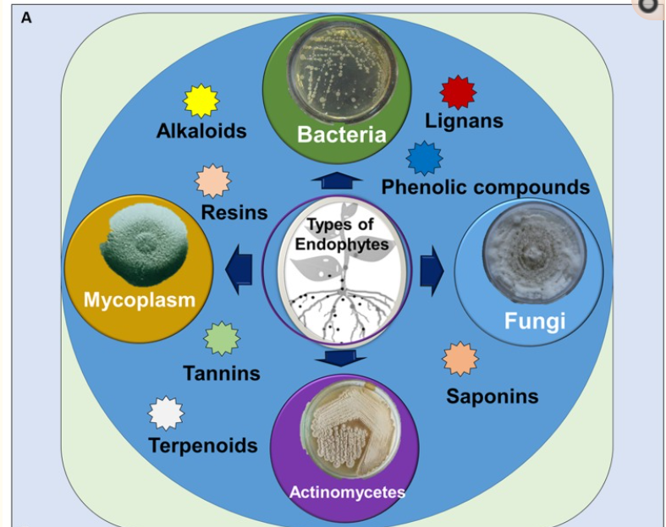 (B) 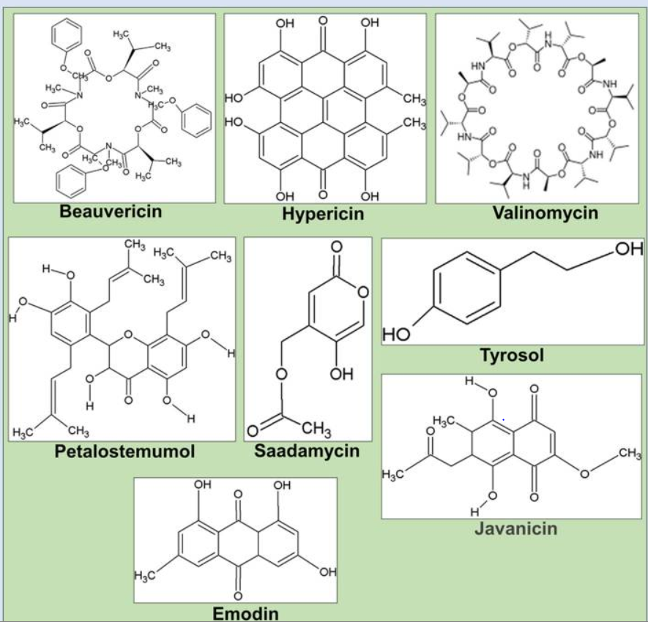
Fig. 1.1: Structure of various secondary metabolites
Endophytes have long co-evolved with their host plants, evolving genetically to adapt to their unique microenvironments, even incorporating some plant DNA into their own genomes. In addition to fungi, bacteria from other genera have also been demonstrated to exist inside plants without manifesting indications of disease (Hallmann et al., 1997). Other advantageous effects of endophytes on plants include aiding in nutrient uptake, nitrogen fixation, phosphate solubilization, or iron chelation, as well as increased drought resistance, thermal protection, survival under osmotic stress, and suppression of phytopathogens through competition in invasion sites and antibiotic compound secretion (Ryan et al., 2008).
Even though the research on endophytic bacteria and their function in host trees is still in its early stages, the results thus far are highly positive and should help this field of study gain greater recognition. A wide variety of endophytic bacteria that interact with their hosts in a nonpathogenic way are beneficial to plants as well (Nunes and Melo, 2006). The extraction of metabolites from endophytes by plants or fungi is influenced by a number of variables, including the climate, the time of year when samples are collected, and the location of the endophytes (Shukla et al., 2014). Plant and other natural resource extraction has improved over the past few years in terms of efficiency, convenience, and viability (Hussain et al., 2012). The evolution of the host of microorganisms, which may have incorporated genetic information from higher plants, has been directly linked to the production of bioactive compounds by endophytes. This has allowed them to better adapt to the host plant and perform some functions, such as protection from different types of pathogens, grazing animals, and insects (Strobel, 2003).
When the plant or host tissue reaches senescence, endophytes, which grow within stems, leaves, and/or roots, emerge to sporulate (Sherwood and Carroll, 1974; Carroll, 1988; Stone et al., 2004). The endophytes that infect some grasses are clavicipitaceous endophytes (Cendophytes), which can be recovered from asymptomatic tissues of nonvascular plants, ferns and allies, conifers, and angiosperms. Nonclavicipitaceous endophytes (NC endophytes), which can be recovered from symptomatic tissues of nonvascular plants, ferns and allies, conifers, and angiosperms.
Table 1. Endophytic fungus classification
Groups | Clavicipitaceous | Non Clavicipitaceous
Criteria | Class I | Class 2 | Class 3 | Class 4
Host range | Narrow | Broad | Broad | Broad
Host plants | Grasses such as perennial ryegrass, tall and meadow fescue | Vascular and nonvascular plants such as Bryophytes, Ferns, Gymnosperms and Angiosperms
Distribution | Temperate grasslands, Alpine grasslands | Deciduous and evergreen perennials | In tropical forest and Antarctic regions | Antarctic, arctic, alpine, sub-alpine, temperate and tropical ecosystems.
Tissue(s) colonized | Shoot and rhizome | Shoot, root and rhizome | Shoot | Root
Transmission | Vertical and horizontal | Vertical and horizontal | Horizontal | Horizontal
In planta biodiversity | Low | Low | High | Unknown
In planta colonization | Extensive | Extensive | Limited/ Localized | Extensive in roots
Fitness benefits* | NHA | NHA and HA | NHA | NHA
* Nonhabitat‐adapted (NHA) benefits such as drought tolerance and growth enhancement are common among endophytes regardless of the habitat of origin.
* Advantages from habitat-specific selective pressures including pH, temperature, and salinity are known as habitat-adapted (HA) benefits..
Endophytes of Level 1 are found in both warm- and cool-season grasses and are phylogenetically related. They inevitably settle on shoots, where they create an intercellular infection throughout the body. Vertical transmission is used to spread them from host to host, and it involves maternal plants passing on fungi to their young by seeds. Type I, Type II, and Type III are other classifications. Different interactions with their plant hosts are seen among these 3 different forms of clavicipitaceous endophytes. These interactions can be asymptomatic, symbiotic, pathogenic, or symbiotic. Endophytes of type III clavicipitaceous that develop inside their plant host without displaying any disease symptoms or causing any harm to the host. Class 1 endophytes often provide their plant host with advantages like improved plant biomass, increased drought tolerance, and for the chemial production which are toxic in nature.
A polyphyletic group of organisms is represented by non-clavicipitaceous endophytes. The majority of non-clavicipitaceous endophytes are ascomycota fungi. These fungus have a variety of complex and still poorly understood ecological roles. Nearly all terrestrial plants and ecosystems have been discovered to exhibit these endophyte plant interactions (Rodriguez et al., 2009). The ability to flip between endophytic behaviour and free-living lifestyles is shared by many non-clavicipitaceous endophytes. There are three classes of non-clavicipitaceous endophytes: classes 2, 3, and 4. Class 2 endophytes can develop in both above- and below-ground plant tissues. As a result of habitat-specific stressors including pH, temperature, and salinity, this class of non-clavicipitaceous endophytes has undergone the most thorough investigation and has been found to improve the fitness benefits of their plant host (Rodriguez et al., 2009). Class 3 endophytes can only originate locally in plant tissue and can only thrive in underground plant tissues. Although they can colonise much more of the plant tissue, Class 4 endophytes are only found in underground plant tissues. These non-clavicipitaceous endophyte classes have not yet undergone as much research (Rodriguez et al., 2009).
Endophytes can be studied via three methods:
- Histological method revealing the internal location of the endophytes, whether infection is intercellular or intracellular.
- Direct amplification of microbial genomic DNA from colonised plant tissue via a genetic technique.
- Microbiological technique using surface-sterilized tissue and plating onto the proper growth medium (Schulz and Boyle, 2005).
Plant collection is one of the most important steps during surveying endophytes. The exact position of the vegetation should be recorded using; for example, a General Positioning System (GPS) to allow for repeated resampling. Healthy plant tissues without lesions or spots should be prioritized. In addition, conducting samplings on different parts of the plants, different ages, growing in different location and at different season allows gathering useful information on the distribution of the endophytes, community analysis, ecological diversity, and influence of abiotic factors on endophyte infections. As far as possible, fresh plant material should be transported in good condition to the laboratory and surface sterilization should be done within 24 hours after moving from the collecting areas. During the transport, plant tissues should be maintained in proper aeration in order to prevent desiccation, tissue senescence and contamination by epiphytic fungi and bacteria. Processing plant materials at the collection site remains the most adequate to avoid hyper-contamination with epiphytes.
In order to recover the broadest range of internal endophytic communities, the use of selective media and media which favor the growth of slow-growing endophytes is needed to avoid that plate to be overgrown by rapid-growing ones. For example, if the goal is to isolate endophytic fungi, antibacterial antibiotics such as chloramphenicol, streptomycin sulphate, oxytetracycline are incorporated into the agar media either singly or combined along with low concentration of cyclosporin A, dichloran or rose bengal that restrict rapid radial growth of fungi. In contrast, for selective isolation of endophytic bacteria, fungitoxic agents such as cycloheximide and/or nystatin are added to the growth media.
References:
- Arnold, A. E. and Lewis, L. C. 2005. Ecology and evolution of fungal endophytes, and their roles against insects. Insect- Fungal Association: Ecology and Evolution. Oxford University Press, New York, 74-96.
- Petrini, O. 1991. Fungal endophytes of tree leave In: Andrews, J. H, S. S. Hirano, editors. Microbial ecology of leaves. New York: Springer. p. 179–197.
- Dai, C. C., B. Y. Yu, Z. L. Xu, and S. Yuan. 2003. Effect of environmental factors on growth and fatty acid composition of five endophytic fungi from Sapium sebiferum. J. Appl. Ecol. 14, 1525–1528. h.
- Sherameti, I., B. Shahollari, Y. Venus, L. Altschmied, A. Varma, and R. Oelmüller. 2005. The endophytic fungus Piriformospora indica stimulates the expression of nitrate reductase and the starch-degrading enzyme glucan-water dikinase in tobacco and Arabidopsis roots through a homeodomain transcription factor that binds to a conserved motif in their promoters. J. Biol. Chem. 280, 26241–26247. doi: 10.1074/jbc.M500447200.
- Faeth, S. H., and Fagan, W. F. 2002. Fungal endophytes: common host plant symbionts but uncommon mutualists. Integr Comp Biol, 42(2), 360-368. doi: 10.1093/icb/42.2.360.
- Firáková, S., M. Šturdíková, and M. Múčková. 2007. Bioactive secondary metabolites produced by microorganisms associated with plants. Biologia 62:251–257. doi: 10.2478/s11756-007-0044-1.
- Kumaran, R. S., J. Muthumary, and B. K. Hur. 2008. Taxol from Phyllosticta citricarpa, a Leaf Spot Fungus of the Angiosperm citrus medica. J. Biosci. Bioeng. 106, 103–106. doi: 10.1263/jbb.106.103.
- Kumaran R. S., J. Muthumary, E. K. Kim, and B. K. Hur. 2009. Production of taxol from Phyllosticta dioscoreae, a leaf spot fungus isolated from Hibiscus rosa-sinensis. Biotechnol. Bioprocess. Eng. 14, 76–83. 10.1007/s12257-008-0041-4.
- Bacon, C. W., and J. F.J. White. 2000. Physiological adaptations in the evolution of endophytism in the Clavicipitaceae. Microbial endophytes. New York, NY, USA: Marcel Dekker Inc., 237–263.
- Schulz, B., and C. Boyle. 2006. What are endophytes? Microbial Root Endophytes (Schulz, B. J. E., C. J. C. Boyle and T. N. Sieber, eds), pp. 1–13. Springer-Verlag, Berlin.
- Zhang, H. W., Y. C. Song, and R. X. Tan, 2006. Biology and chemistry of endophytes. Nat. Prod. Rep. 23, 753–771. doi: 10.1039/b609472b.
- Rodriguez, R. J., J. F. White, A. E. Arnold, and R. S. Redman. 2009-04-01. "Fungal endophytes: diversity and functional roles". The New Phytologist. 182 (2): 314–30. doi:10.1111/j.1469-8137.2009.02773. x. PMID 19236579.
- Sieber, T. N. (2007). Endophytic fungi in forest trees: are they mutualists?. Fungal biology reviews, 21(2-3), 75-89.
- Hallmann, J., A. Quadt-Hallmann, W. F. Mahaffee, and J. W. Kloepper. 1997. Bacterial endophytes in agricultural crops. Can. J. Microbiol. 43 895–914. 10.1139/m97-131.
- Ryan, R. P., K. Germaine, A. Franks, D.J. Ryan, D.N. Dowling. 2008. Bacterial endophytes: recent developments and applications. FEMS Microbiol. Lett., 278, pp. 1-9. Nunes, F. V., and L. S. de Melo. 2006. Isolation and characterization of endophytic bacteria of coffee plants and their potential in caffeine degradation. Environmental Toxicology 1, 293–297. https://doi.org/10.2495/ETOX060291.
- Shukla, S. T., P. V. Habbu, V. H. Kulkarni, K. S. Jagadish, A. R. Pandey, and V. N. Sutariya. 2014. Endophytic microbes: a novel source for biologically/pharmacologically active secondary metabolites. Asian J. Pharmacol. Toxicol. 2 1–16.
- Hussain, M. S., S. Fareed, S. Ansari, M. A. Rahman, I. Z. Ahmad, and M. Saeed. 2012. Current approaches toward production of secondary plant metabolites. J. Pharm. Bioallied Sci. 4 10–20. 10.4103/0975-7406.92725.
- Strobel, G. A. 2003. Endophytes as sources of bioactive products. Microbes Infect.5, 535–544. doi: 10.1016/S1286-4579(03)00073-X.
- Sherwood, M., and G. Carroll. 1974. Fungal succession on needles and young twigs of old-growth Douglas fir. Mycologia 66: 499–506.
- Carroll, G. 1988. Fungal endophytes in stems and leaves – from latent pathogen to mutualistic symbiont. Ecology 69: 2–9.
- Stone, J. K., J. D. Polishook, and J. R. J. White. 2004. Endophytic fungi. In: Mueller, G., G. F. Bills, and M. S. Foster, eds. Biodiversity of fungi: inventory and monitoring methods. Burlington, MA, USA: Elsevier, 241–270.

