ISOLATION AND CHARACTERIZATION OF MICROBES FROM DIABETES MELLITUS CELLULITIS WOUND SAMPLE AND ESTIITS ANTIMICROBIAL PROPERTIES

*KRISHNAVENI.R'., AYISHA SHIFANA.A'., THAMEENA BEGAM.M'.,

ASEELA MAIMOONA.H'., KEERTHIKA.S'.

Assistant professor and Head, PG &Research Department of Microbiology,

IdhayaCollege for Women ,Kumbakonam.

Ayisha Shifana.A, Thameena Begam.M, Aseela Maimoona.H, Keerthika.S, Ug Students, PG &Research Department of Microbiology,

IdhayaCollege for Women, Kumbakonam.

*Corresponding author. krishnavenimicro@gmail.com

ABSTRACT:

Bacterial Cellulitis is a spreading skin infection and causes skin lesions, necrotizing fasciitis, septic Arthritis and Osteomyelitis. It Damage the skin causes an abscess, Folliculitis. In the present study carriedout isolation and characterization of microbes from Cellulitis wounds samples from Diabetes Mellitus patients and testing its antimicrobial activity against the herbal plants, medicinal
plants Biden spilosa, Aloe barbadensis ,Rauvolfia serpentina. Streptococcus sp., shows maximum zone of Inhibition (13mm) and minimum in Aloe barbadensis (1mm). In the present study it concludes Rauvolfia serpentinaand Biden spilosa, maximum zone of inhibition against Cellulitis wound infection in Klebsiella shows maximum zone of inhibition. And Rauvolfia serpentine (22mm) and Bidens pilosa (19mm) were observed.

INTRODUCTION
Diabetes Mellitus is Prolonged disease. If the Pancreas Cannot Produce Sufficient Insulin. This Condition is known as Diabetes Mellitus. The Person who affected by Diabetes Mellitus faced many critical problems by microvascular dysfunction.
Bacterial Cellulitis and erysipelas which means burst, Spreading skin infection and other infection belongs with occurring suppurative foci like Skin lesions, necrotizing fasciitis Septic arthritis and Osteomyelitis. Normally innermost occurred skin infection is called Cellulitis and outermost layer infection is known as Erysipelas. Therefore the difference between these two diseases is not vivid properly and other two conditions distributed the medical properties. Group B and rarely ,Staphylococcus sp., can also cause these disease(BonnetblancJM,BedaneC.2003,Chartier C,Groshans E 1990;Eriksson B et al 1996) .Result of patient blood culture normally positive for Beta-hemolytic Streptococcus sp., in <5% of cases (Bonnet blanc JM et al.,2003).( Chartier et al.,1990.Eriksson B et al.
Streptococcus sp., are classified under their Hemolytic properties and origin blood typing The explanation of wound healing is group of completive process . (Ballers S., et al.,2012).The antibiotics, antiseptics and chemical properties are the several agent that cure the infection. Streptococcus sp., is a Beta-hemolytic Streptococci and it is originated group A highly medical vital Species. Siddha Medicine have the capacity to recur from infections are ulcers, wound healing, skin lesions, Scabies, leprosy and venereal disease (kirthikar KR and Basu BD 2001.
The anaerobic bacterium causes wound on foot of Diabetes Mellitus persons. (Aherrao N et al., 2012). Isolation and characterization of microbes on wound infection and testing its antimicrobial activity against medicinal plants.( Krishnaveni et. al.(2020)into different sp., by their ability to Heamolyse blood by serology and or by biochemical tests.
All Staphylococcus aureus., produce the enzyme catalase which is used in the laboratory for rapid identification Kumar et. al.,(2006).Inflence of Aloe vera on wound healing properties was explained by (Chithra,P., et. al.,(1998).
Habitat and Herbal powders
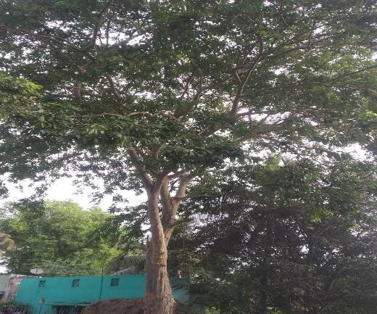
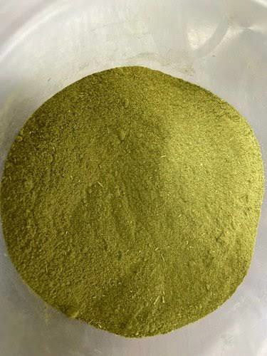

Bidens pilosa Bidenspilosa
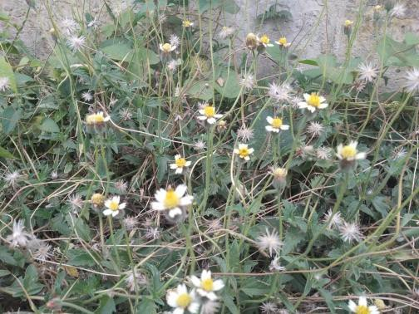
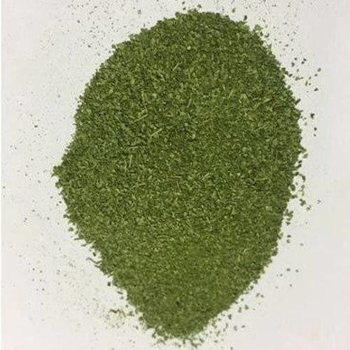

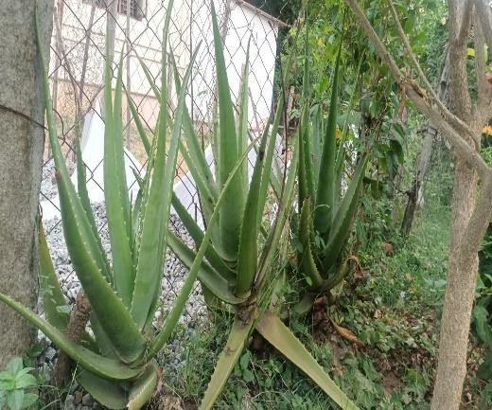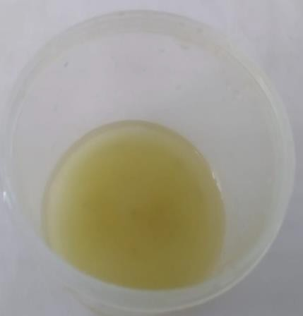

Aloe barbadensis Aloebarbadensis extract

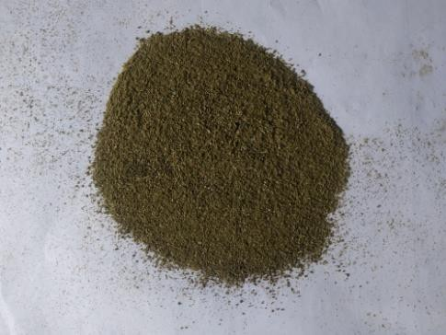
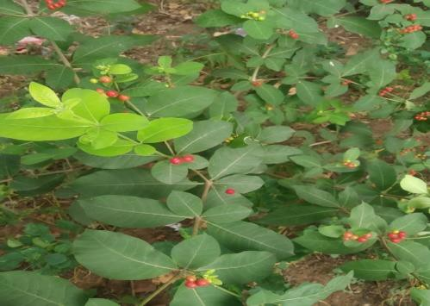

Rauvolfia serpentine Rauvolfia serpentina leaf powder

Cellulitis Wound on Isolated Microbes from Cellulitis Diabetic Patients Diabetic Wound Sample

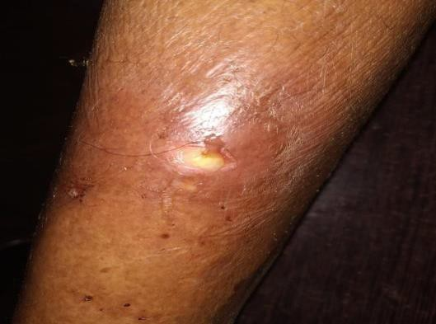
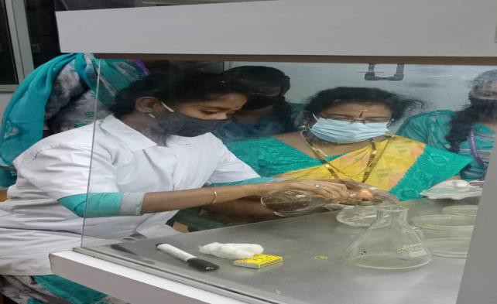

RESULTS

Table 1:Isolation of Microbes from Diabetic Wound

s. no | Isolated microbes | Colony forming units  CFU/ ml
 |  | Colonies | Units
1.  2.  3.  4. | E-coli  Staphylococcus aureus  Streptococcus sp.,  Klebsiella | 180  200  280  160 | 1.8X10³  2.0X10³  2.8X10³  1.6X10³

Table – 1 a): Biological Characteristics of E.Colion Cellulitic Diabetic Wound

S.No | Biological Test/ Staining | Positive/Negative
1 | Gram staining | (Rod shape) negative
2 | Culture characteristics on agar | White, moist glistening
 | slant | appearance
3 | Gelatin liquification | Negative
4 | Starch hydrolysis | Negative
5 | Liquid hydrolysis | Negative
6 | Lactose | AG
7 | Dextrose | AG
8 | Sucrose | A+
9 | H2s production | Negative
10 | No3 reduction | Positive
11 | Indole production | Positive
12 | MR reaction | Positive
13 | VP reaction | Negative
14 | Citrate utilization | Negative
15 | Urease activity | Negative
16 | Catalase activity | Positive

Acid +, gas +, reduction +
Fig – 1a): Biochemical Characters of Escherichia coli

E.coli on EMB AgarE .coli on Blood Agar

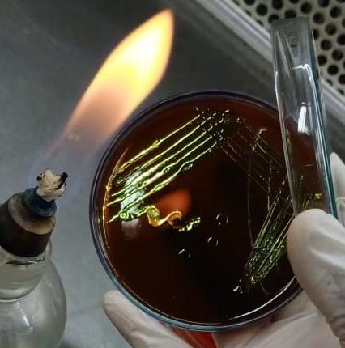
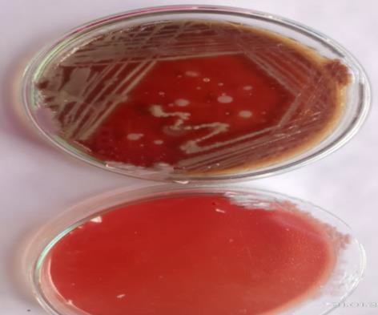

S.No | Biochemical Characters |  | Positive/ Negative
1 | Gram staining |  | Rod (Negative)
2 | Culture characteristics | on | Slimy, white somewhat
 | agar slant |  | translucent raised growth.
3 | Gelatin liquification |  | Negative
4 | Starch liquification |  | Negative
5 | Liquid liquification |  | Negative
6 | Lactose |  | AG
7 | Dextrose |  | AG
8 | Sucrose |  | AG
9 | H2s production |  | Negative
10 | No3 reduction |  | Positive
11 | Indole production |  | Negative
12 | MR reaction |  | Negative
13 | VP reaction |  | + acid gas, curd +
14 | Citrate use |  | Positive
15 | Urease activity |  | Positive
Table - 2: Biological Characteristics of Klebsiella sp., on Cellulitic Diabetic

Fig – 2: Biochemical characters of Klebsiella sp.

a) Klebsiellasp., on HectoneEntric agar b) Citrate Test – Positive

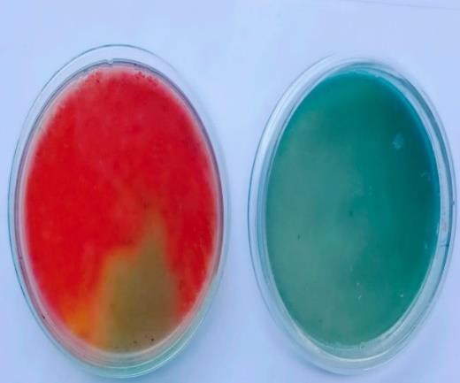
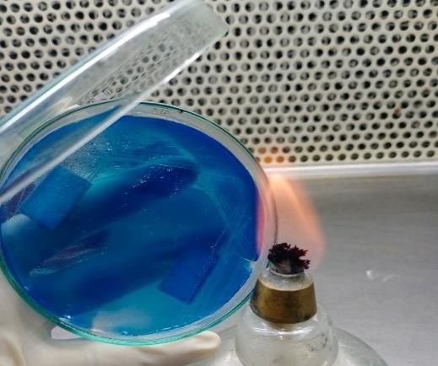

- Klebsiellasp., on Macconkey Agar

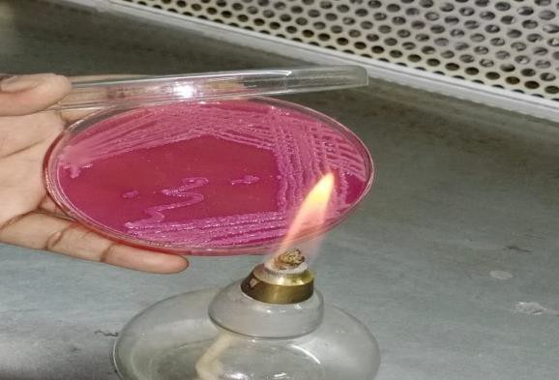
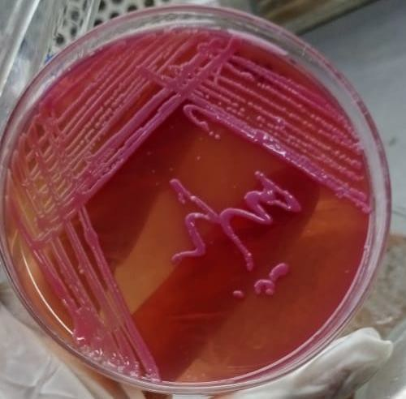

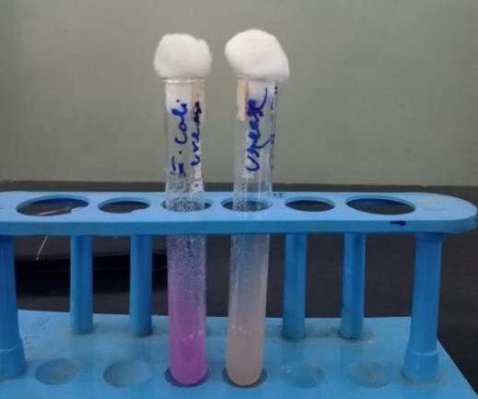
Urease Test - Positive Nitrate Reduction Tes

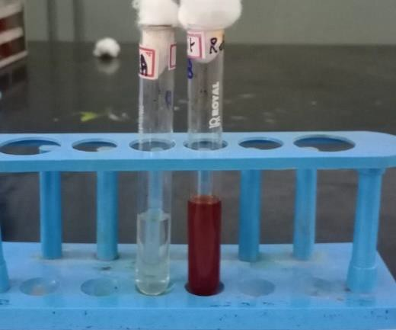
Table - 3: Biological Characteristics of Staphylococcus Sp., on Cellulitic Diabetic Wound

s.no | Biochemical test/staining | Positive/ Negative
1 | Gram staining | Positive coccus
2 | Culture characteristic on agar | Abundant, opaque golden
 | slant | growth
3 | Gelatin liquification | Positive
4 | Starch liquification | Negative
5 | Liquid liquification | Positive
6 | Lactose | Absence
7 | Dextrose | Absence
8 | Sucrose | Absence
9 | H2s production | Negative
10 | No3 reduction | Positive
11 | Indole production | Negative
12 | MR reaction | Positive
13 | VP reaction | +
14 | Citrate use | Negative
15 | Urease activity | Negative
16 | Catalase activity | Positive
17 | Oxidase activity | Negative

Acid reduction +
Fig – 3: Biochemical Characters of Staphylococcus aureus

S.aureuson Blood Agar Medium

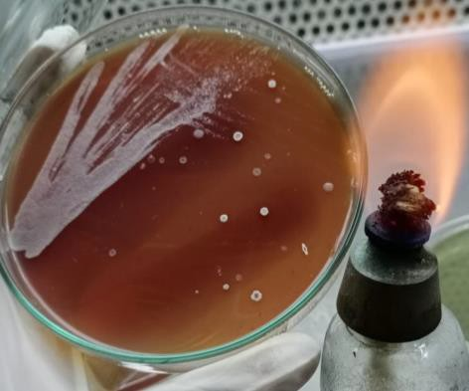

Nitrate Test - Positive MR Test - Positive

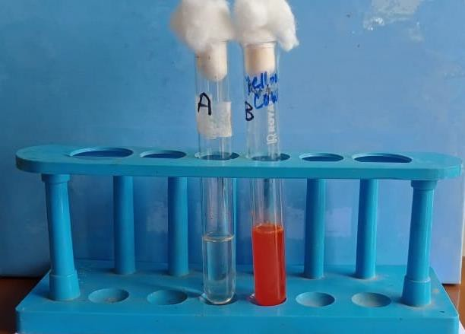
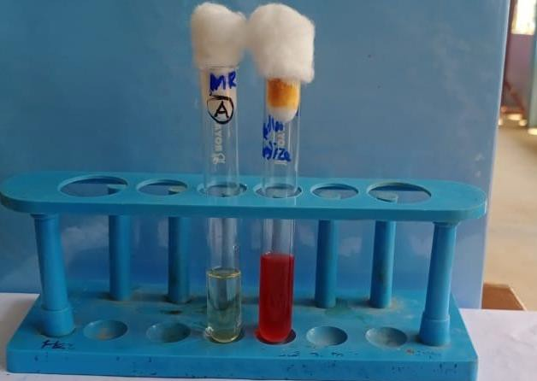

Table - 4: Biological Characters of Streptococcus Sp., on Cellulitic Diabetic Wound

S.NO | BIOLOGICAL TESTING  / STAINING | POSITIVE / NEGATIVE
1 | CAMP (Christie – Alkins | Negative
 | munch Peterson)
2 | Capsule formation | Capsulated
3 | Catalase | Negative
4 | Gram staining | Positive
5 | Hemolysis | Beta hemolysis
6 | Motility | Non -Motile
7 | OF(Oxidative fermentative) | Facultative anaerobes
8 | Shape | Cocci
9 | Spore | Non- sporing
10 | Urease | Negative
11 | VP (VogesProskauer) | Negative
12 | Fructose | Positive
13 | Galactose | Positive
14 | Glucose | Positive
15 | Lactose | Positive
16 | Gelatin liquification | Negative
17 | Starch hydrolysis | Negative

Fig – 4: Bio chemical characters of Streptococcus sp.,

Streptococcus sp., on Blood Agar Medium
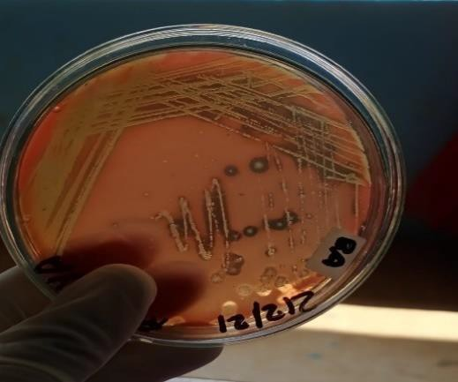

- Table - 5: Antibiotic Sensitivity:

S.NO | ANTIBIOTICS | E .coli | Klebsiella sp., | Streptococcus sp., | Staphylococcus aureus.,
1 | Ciproflaxin | 36mm | 27mm | 12mm | 35mm
2 | Tetracycline | 20mm | 20mm | 19mm | 12mm
3 | Erythromycin | 18mm | 21mm | 11mm | 25mm
4 | Penicillin | No  zone | No zone | 10mm | No zone
5 | Ampicillin | No  zone | No zone | 8mm | 9mm
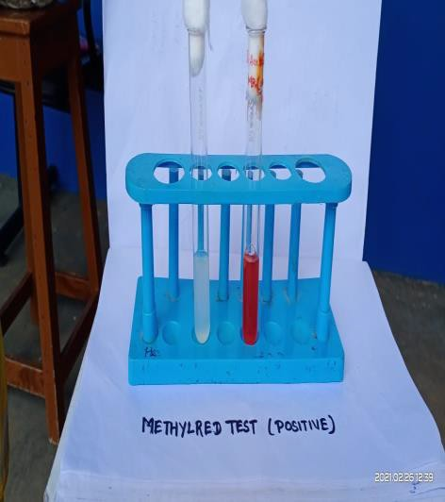
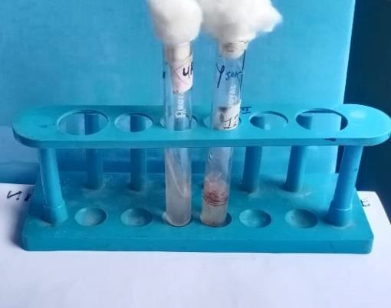
- Methyl Red Test - Positive c) Urease Test - Negative

Fig – 5: Antimicrobial Activity of Isolated Microbes

b) Disk Diffusion Method on) Disk Diffusion Method on
Streptoccocussp.,

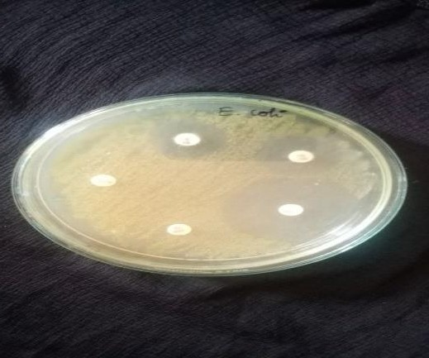
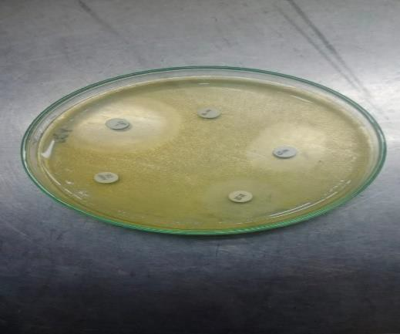

Klebsiellasp., Staphylococcus aureus.,

Table - 6: Antimicrobial Activity of Isolated Microbes

Tested Herbal Extract | E.coli., | Klepsiella sp., | Streptococcus sp., | Staphylococcus aureus.,
Terminalia arjuna | 6mm | 14mm | 12mm | 13mm
Rauvolfiaserpentina | 19mm | 22mm | 10mm | 12mm
Aleobarbadebnsis | 4mm | 2mm | 1mm | 3mm
Bidenspilosa | 14mm | 19mm | 13mm | 15mm

Fig -6: Anti microbial Activity of E.coli Against Herbal Plants
d) Rovolfia serpentine., aginstE.coli b) Bisenspilosaagainst E.coli

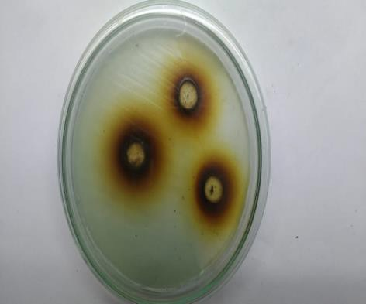
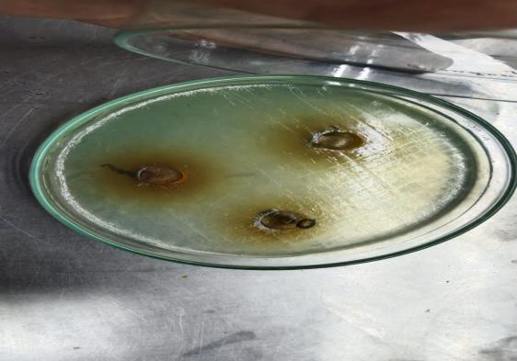

Fig -8: Anti microbial Activity of Streptococcus sp.,

Against Herbal Plants

c) Aloe barbadencisagainst d) Rovolfia serpentine
Streptococcus sp., Streptococcus sp.

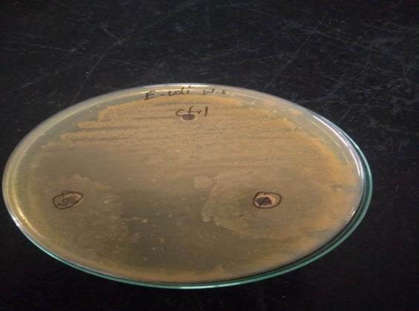
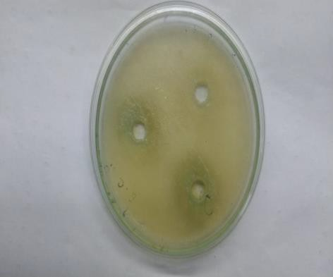

Fig -7: Anti microbial Activity of Staphylococcus aureus., Against Herbal Plants

a)Terminalia arjunaagainst
streptococcus sp., c) Aloe barbadencisagainst

Fig -7: Anti microbial Activity of Staphylococcus aureus., Against Herbal Plants

d) Rovolfiaserpentinaagainst

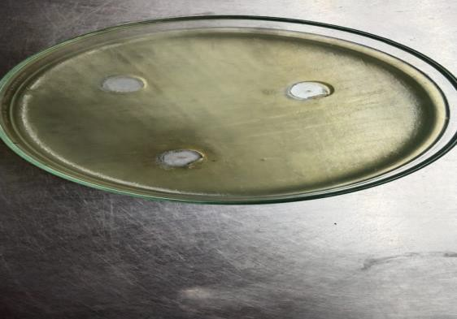

SUMMARY AND CONCLUSION
Total Number of Colonies was tabulated CFU/ml of isolated microbes. In the findings Staphylococcus aureus (2.8X10³) maximum no of colonies (280) and minimum Number of colonies (1.6x10³) observed in klebsiella sp., 160 colonies. Followed by E.coli (1.8x10³) colonies and streptococcus (2.0x10³) colonies noted.the biochemical characteristics of E.coli. It is gram negative rods in staining in cultural character. It is white moist glistening appearance. It shows positive on MR reaction, Catalyse active, Indole production and No3 reduction test. It is Negative on Gelatin Liquification, Starch Hydrolysis and Liquid Hydrolysis. It produces Acid and Gas in Lactose and Dextrose Test. It shows the Negative result in H2s production.(Fig-1a)the Biochemical Characters of Klebsiella sp.,., its Gram-Negative Rod in Staining in culture character. It is Slimy, white somewhat translucent raised growth. It shows Positive reaction on Urease Activity, Citrate Use, Catalase Activity test. It is Negative on Gelatin Liquification, Starch Hydrolysis, Liquid Hydrolysis, H2s Production, No3 Reduction, Indole Production, MR Reaction and Oxidase activity. (Fig-2).the biochemical characters of Staphylococcus aureous, its Gram-Positive coccus in Staining in cultural character. It is abundant, opaque golden growth. It shows Positive reaction on Gelatin Liquification, Liquid Hydrolysis, No3 reduction and Catalase Test. It is Negative on Starch Hydrolysis, H2s production, Indole Production, Citrate Utilization Test, Urease Activity and Oxidase Activity. It makes absents in Lactose, Dextrose and Sucrose .Streptococcus it is a Gram Negative, Non motile, Non spore forming cocci. It is catalase Positive and shows β hemolysis in Blood Agar Medium. Its Positive to Fructose, Galactose, Glucose, Lactose, test. It is Negative on Starch hydrolysis, Gelatin liquification, Urease and Catalase test. (Fig4-)

CONCLUSION
From the cellulitis wound infection microbes Staphylococcus sp Streptococcus sp,Klesiella sp and E.coli was isolated. Streptococcus sp., shows Higher effective zone of inhibition (13mm) and lower in Aloe barbadensis(1mm).In the present study it concludes Rauvolfia serpentine and Bidens pilosa, higher effective to treat cellulitis wound infection.

Streptococcus sp., shows maximum zone of inhibition (13mm) and minimum in Aloe barbadensis(1mm).In the present study it concludes Rauvolfia serpentine and Bidens pilosa, maximum zone of inhibition against cellulitis wound infection in Klebsiella shows maximum zone of inhibition. And Rauvolfia serpentina(22mm) and Bidens pilosa shows (19mm) were observed. So, Rauvolfia serpentine and Bidens pilosa

REFERENCES

- Aherrao.N ,ShahiS.K, Dwivedi A KumarAGuptaS,SinghS.K.Delection of Anaerobic Infection in Diabetic Foot Ulcer Using Pcr Technique and The Status of Metronidazole Therapy onTreatment Outcome, Wound2012;24:283-8.
- American Diabetes Association ,Diagnosis and classification of Diabetes Mellitus, Diabetes Care2013;36(suppl1):S67.

- Chithra, P., Sajithlai, G.B. and Chandrakasan, G.(1998) Influence of Aloe veraon the on the healing of dermal wounds in diabetic rats. J.Ethnopharmacol.,59(3): 195-201.
- Cianfarani,F.,Toietta,G.,Di- Rocco,G.,Cesareo,E.,Zambruno,G.andOdorisio,T.(2013) Diabetes impairs adipose tissue-derived stem cell function and efficiency in promoting wound healing.WoundRepair Regen.,21(4):545-553.

- Kirthikar K.R., Basu BD (2001) Indian Medicinal PlantsmInt Plants Oriental EnterprisesDehraDum.

- Komolade AO and Adegoke AA (2008). Incidence of bacterial septicaemia in I le-I fe,NigeriaMalasianJ Microbial.,4(2):51-61.

- Krishnaveni R. EuginAmala V, Uma Maheshwari B, Josepin J, Vasukipriya C, Abinamery A. Isolation and characterization and effects of antibiotics and disinfectant on various wound sample (2020).

- Kumar, M.S., Sripriya, R., Raghavan, H.V., And Sehgal, P. K., (2006) Wound healing potentialofcassiafistulaoninfected albinoratmodel,J.Surg.Res.,131(2): 283-289
- LipskyB.A,PecoraroR.E.WheatL.J.TheDiabeticFoot.SoftTissueandBoneInfe ction.InfectDisClinNorthAm1990;4:409-32.

- Maiti P.K. Haldar J. Mukherjee P. Dey R, Anaerobic Culture on Growth Efficient Bi-Layered Culture Plate in A Modified Candle Jar Using A Rapid and Slow Combustion System.IndianJMedMicrbial2013;31:173-6.

- Menichetti F(2005).Current and emerging serious gram-positive infections.

ClinMicrobial.infect,11(3):22-28.

- Pastar, I.,stojadivonic, O.,Yin,N.C.,Ramirez, H., Nusbaum, A.G.,Sawaya, A., Patel,S.B.,Khalid,L., Isseroff, R.R., and Tomic-Canic, M.(2014) Epithelialization in wound healing:A Comprehensivereview.Adv.Woundcare,3(7):1-10.

- Servant PR. Diet recommendations in diabetes and obesity. Nutra Hosp.

2018;35 (SpecNo4):109-15 Evolving antimicrobial chemotherapy for staphylococcus aureus infection,ourbacks tothewall.CritCareMed.,29(4:Suppl):92-96.

- William lrving, Tim Boswell, DlaverAlalAldeen (2105).,Medical Microbiology book.

- Yuvan, H. M A Q.Ye L. Piae G (2016) The Traditional Medicine and Modern Medicine from Natural Products Mol:21(5):559.

