Oral Biopsy: An Irreplaceable Diagnostic Tool

Anjali Ravi¹
Student
Clinical dentistry and comprehensive care
Rutgers school of dental medicine
Newark, New jersey- 07103

Prasanna Kumar Rao²
Professor
Oral Medicine & Radiology
A.J Institute of Dental Sciences
Kuntikana, Mangaluru 575004, India.

Priyanka Shetty³
Assistant Professor
Oral Pathology and Microbiology
A.J Institute of Dental Sciences
Kuntikana, Mangalore 575004, India

Priyal Rohan³
Assistant Professor
Oral Pathology and Microbiology
A.J Institute of Dental Sciences
Kuntikana, Mangalore 575004, India

ABSTRACT
Oral mucosal lesions are commonly encountered in a clinical practice. Among these lesions, diagnosis of few oral lesions can be made based on the history and clinical examination, but there are others where histopathological studies are needed to confirm the presumed clinical diagnosis, wherein oral biopsy procedure plays an inevitable role. An oral pathologist’s histopathological interpretation of a lesion is mainly dependent on a good biopsy performed .The oral environment being moist and confined possess challenges for collecting a sample that is suitable for diagnosis, and these challenges are added upon by the myriad of biopsy techniques or handling which has led to diagnostic failure and misery. This article aims to shed some light upon Oral biopsy as an efficient diagnostic tool, various techniques involved and some potential difficulties encountered. Keywords—component; formatting; style; styling; insert (key words)

INTRODUCTION

The word biopsy is derived from the Greek term Bios (life) and Opsis (vision), vision of life.[1] The term was introduced into medical terminology in 1879 by Ernest Besnier. [2, 3] Biopsy is defined as the removal of a sample of tissue from the living body for examination under microscope for the purpose of diagnosis. [4] There are four main objectives of performing a biopsy; first is to establish a definite diagnosis as early as possible so that correct treatment can be formulated without delay. The second objective is to establish a prognosis. Thirdly to determine if the lesion was completely removed and fourth is to act as a document of medical –legal value. [1, 4]Oral biopsy is useful in detecting tumors and in determining the nature of various oral lesions. [5, 6] Early diagnosis plays an inevitable role in treatment planning and establishing prognosis of the disease. Thus, failure to diagnose oral disease can turn into a nightmare for both the patient and dentist. [4] The key to proper biopsy technique starts with detailed history recording followed by clinical examination. [7, 8, 9]

INDICATION AND CONTRAINDICATIONS OF BIOPSY

It is an accepted fact that microscopic analysis is the gold standard for diagnosis of most lesions. [2] Biopsy is used for all bodily tissues, including oral cavity where a wide spectrum of disease process may occur. [10] According to the American Academy of Oral and Maxillofacial pathology any tissue removed from the oral and maxillofacial region should be submitted to an oral and maxillofacial pathologist.[2]
- Any lesion suspected as neoplasm, such as an enlarging mass, chronic ulceration, tissue friability and induration on palpation or persistent mucosal changes. [11, 12, 13]
- New, enlarging homogenously pigmented lesions with irregular border.[ 10]
- Lesions of unknown etiology associated with pain, paresthesia and anesthesia.[1]
- Any inflammatory lesion s that does not respond to treatment even after 2 weeks. [1]
- Any immune mediated disease which presents with widespread mucosal erythema and ulceration.[10]
- In bony lesions that cannot be diagnosed radiographically, accompanied by pain and alteration in sensation.[6]
However, absolute contraindications are not present, there are few conditions where decision to proceed with biopsy is critical [2]:
- A vascular lesion: Significant hemorrhage may occur post biopsy. Thus extra care should be taken in the biopsy of any lesion with red, purple or blue coloration.[10]
- Location of lesion: Esthetic regions such as vermilion border of the lip are not a strict contraindication but it calls for referral to a specialist. Certain oral sites such as the floor of the mouth can be difficult to access, challenging to provide hemostasis and can cause damage to anatomic structures.[10]
- Risk of osteoradionecrosis in a patient undergoing radiotherapy or bisphosphonate therapy if the bone is exposed.[14]
- A case of multiple neurofibromatosis due to risk of neurosacromatous transformation.[6]
- Poor general condition of the patient: In medically compromised patients, including those with severe or poorly controlled systemic disease such as coronary artery disease, renal or hepatic impairment , various endocrinopathies and immune compromised states require modification in the standard biopsy procedures. Always consult the medical practioner before performing a biopsy in such cases.[1,10]
- Tori, exostosis, carious teeth lacking attached soft tissue, extirpated dental pulp and clinically normal tissues.[2]

GENERAL GUIDELINES FOR ORAL BIOPSY
Biopsy is the simplest and most speedy method of obtaining diseased tissue for diagnosis of lesions of uncertain significance or etiology. Careful handling of the tissue and appropriate fixation of the same is important. [2]Certain guidelines need to be followed to ensure a successful biopsy procedure. [Table 1]

TABLE 1: GENERAL GUIDELINES FOR ORAL BIOPSY
- Consent
- Importance of history taking and clinical examination
- The administration of local anesthesia
- Selection of tissue sample
- Size and depth of the tissue
- Preparation of surgical field
- The biopsy techniques
- Handling of specimen
- Hemostasis
- submission of biopsy specimen.

Consent
Verbal and written informed consent before any biopsy is mandatory. The surgical details and the possible complications should be discussed with the patient. The patient should be informed that reactive lesion may recur and re-excision may be required.[10]

Importance of history taking and clinival examination
The part of history taking and clinical examination cannot be neglected in a biopsy. These are the first step towards diagnostic biopsy. Obtaining information regarding previous surgical experience and hospitalization, the current medication and habits like smoking and alcohol consumption is pivotal in arriving at a correct diagnosis. The past surgical history will indicate if the lesion is of recurrent nature. Drug history should be obtained as medications have profound effect on the oral mucosa. A detailed clinical examination involves thorough evaluation of the oral cavity by inspection and palpation. The color, consistency, size and site of the lesion should be noted. Systemic history should also be recorded. These clinical details should be documented and sent to the pathologist along with the specimen as it will help the oral pathologist in correlating the clinical features and details with histopathological features. [5, 7]

Administration of local Anaesthesia
Local anesthetic solution should not be injected into the lesional tissue to be removed, as it can cause artificial distortion of the specimen. Regional block local anesthesia rather than infiltration with local anesthesia is preferred. A needle insertion at the biopsy site should be avoided as it can produce bleeding which can mask the normal cell architecture.[5,15]

Selection of tissue sample
An unrepresentative sample is of no use and will eventually lead to repetition of the biopsy procedure. Thus meticulous selection of the tissue sample is the most important and first step towards the biopsy procedure. Representative sites including full epithelial thickness with supporting connective tissue is recommended in carcinomas and invasive carcinoma cases. [10] The center area of large tumors should be avoided as a sample in biopsy as they are often necrotic and not of diagnostic value. [5, 16]In case of mucocutaneous lesions such as lichen planus, non- erosive lesional area should be chosen because erosive areas will exhibit inflammatory changes and it will not confirm the diagnosis. [17] For vesiculobullous lesions, adjacent to the bulla where the epithelium is intact is the preferable site of biopsy.[4,18]In diagnosing Sjogren’s syndrome labial salivary gland biopsy is performed on the lower lip after administration of local anesthesia. [6, 7, 19] Mucoceles results from blockage and rupture of minor salivary gland ducts. So excisional biopsy along with the feeder minor salivary gland is preferred.[7] Biopsy is avoided in major salivary gland. Biopsy of parotid gland can lead to scarring and because of increased vascularity; it is difficult to preserve the branches of facial nerve. For diagnosis of Oral candidiasis smears, swabs and oral rinses are the common specimens. Biopsy specimens are usually preferredin case of chronic hyperplastic candidiasis [Table 2]. [20, 21]Fine needle aspiration biopsy is done if abnormal lumps are found. [6]

TABLE 2: SELECTION OF TISSUE SAMPLE
Red or white epithelial lesion | full epithelial thickness with some supporting connective tissue
Lichen planus | non- erosive lesional area
Vesiculobullous lesion | adjacent the bulla where the epithelium is intact
Sjogren’s syndrome | labial salivary gland biopsy on the lower lip
Mucoceles | Excisional biopsy along with the feeder minor salivary gland
Oral candidiasis | smears, swabs and oral rinses are the common specimens

SizeAnd Depth Of The Tissue
There are no specific criteria for size, but small sized samples pose a difficulty in processing and interpretation. An insufficient sample does not aid in diagnosis. Besides, shrinkage that occurs during fixation causes the tissue to become even more smaller. The tissue sample for biopsy should be of sufficient depth, but the depth varies from one lesion to another depending on the thickness and location of the mass. [5,22,23]

Preparation Of Surgical Field

The surgical area is disinfected with a quaternary ammonium compound. Iodine containing surface antiseptics should not be used, as they may stain the tissues. A 0.12- 0.20 % chlorhexidine solution is preferred. [24]

The Biopsy Techniques

Final diagnosis, to a great extent dependsupon the amount and type of tissue specimen obtained from the lesional site.Depending upon location, size and various other parameters, biopsy techniques are of various types.[Table 3& 4]

TABLE 3: TYPES OF BIOPSIES
1.Depending on the characteristics of the target lesion | - Direct (located superficially,  with easy access)  - Indirect (when the lesion lies  in depth and is covered by  normally appearing mucosa or tissue)
2.Depending on the techniques used | - Incisional biopsy  - Excisional biopsy
3.Depending on the material employed | - A conventional scalpel  - A punch  - Electro scalpels  - CO2 Laser
4.Depending on the processing of the sample | - Paraffin embedded  - Analyzed frozen  - Embedding in methacrylate
5. Depending on the location of the target lesion. | - The salivary gland  - Bone  - Lymph nodes  - Other head and neck tissues
6.Depending on the time | - Pre-operative  - Intra-operative  - Post-operative
7.Depending on the purpose of the biopsy | - Diagnostic  - Experimental

TABLE 4: BIOPSY TECHNIQUES.

.
Excisional | Complete removal of the tissue with surrounding normal tissue so that it can be examined. Indicated in small lesions.
Incisional | Removal of a portion of the lesion for diagnostic purpose. Indicated in a large lesion.
Punch | Removal of a cylinder of the lesional tissue using a disposable instrument designed for this purpose
Brush | Utilizes a complete transepithelial biopsy specimen with cellular representation from each of the three layers of the lesion.
Exfoliative cytology | Obtaining a sample of cells using a cytobrush for microscopic examination.
Fine needle aspiration. | Involves passing a thin gauge needle (22 - 26 G) through the skin and into the mass, collecting the sample and preparing thin smears of the material on glass slides

Different biopsy techniques:

Incisional biopsy

Incisional biopsy is a biopsy that samples only a particular portion of a lesion. It is of use when the lesion is large to be excised. [6]. Its accuracy is still at stake, since it does not allow study of the entire lesion [4].If the lesion is extensive, different samples should be obtained, placing each of them in a separate and adequately identified container.[6] The sample should be obtained from the most significant affected area of the lesion.[4,6,25] Technique: An elliptical incision using a 15 scalpel blade, with a length to width ratio of 3:1 is made. The elliptical incision allows primary intention closure. The inferior incision is made first, so that hemorrhage does don’t obscure the surgical field. The anterior tip of the ellipse is gently lifted with tissue forceps, and the base is severed. If the lesion is ulcerated, the clinician should include a portion of the adjacent intact epithelium in the specimen. [10] [FIGURE 1]

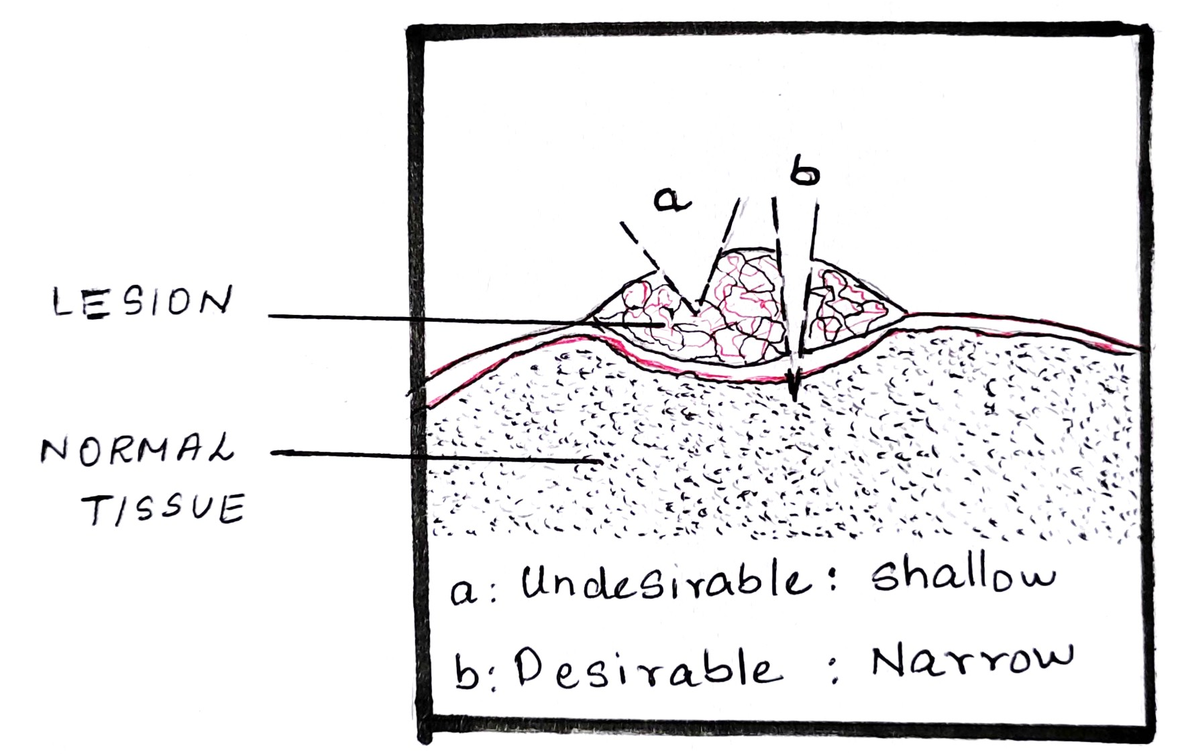
FIGURE 1

Advantages:
- Small fragment of tissue is obtained. [11,25]
- Method of choice when the differential diagnosis includes malignancy. [10]

Disadvantages:
- May increase the risk of metastasis of malignant lesions.[26]
- Avoided in vascular cases as it may cause profuse bleeding. [14]

Excisional biopsy.

Excisional biopsy involves complete removal of the lesion for functional, aesthetic as well as to confirm the clinical diagnosis. This technique is appropriate only if the lesion is almost certainly benign. The size, accessibility and regional anatomy of the lesion must be considered. [7, 10] Technique:An ellipse is traced around the lesion, with the blade angled toward the center of the lesion. This produces a wedge-shaped specimen that is deepest under the center of the lesion and leaves a wound that is simple to close. [FIGURE 2]

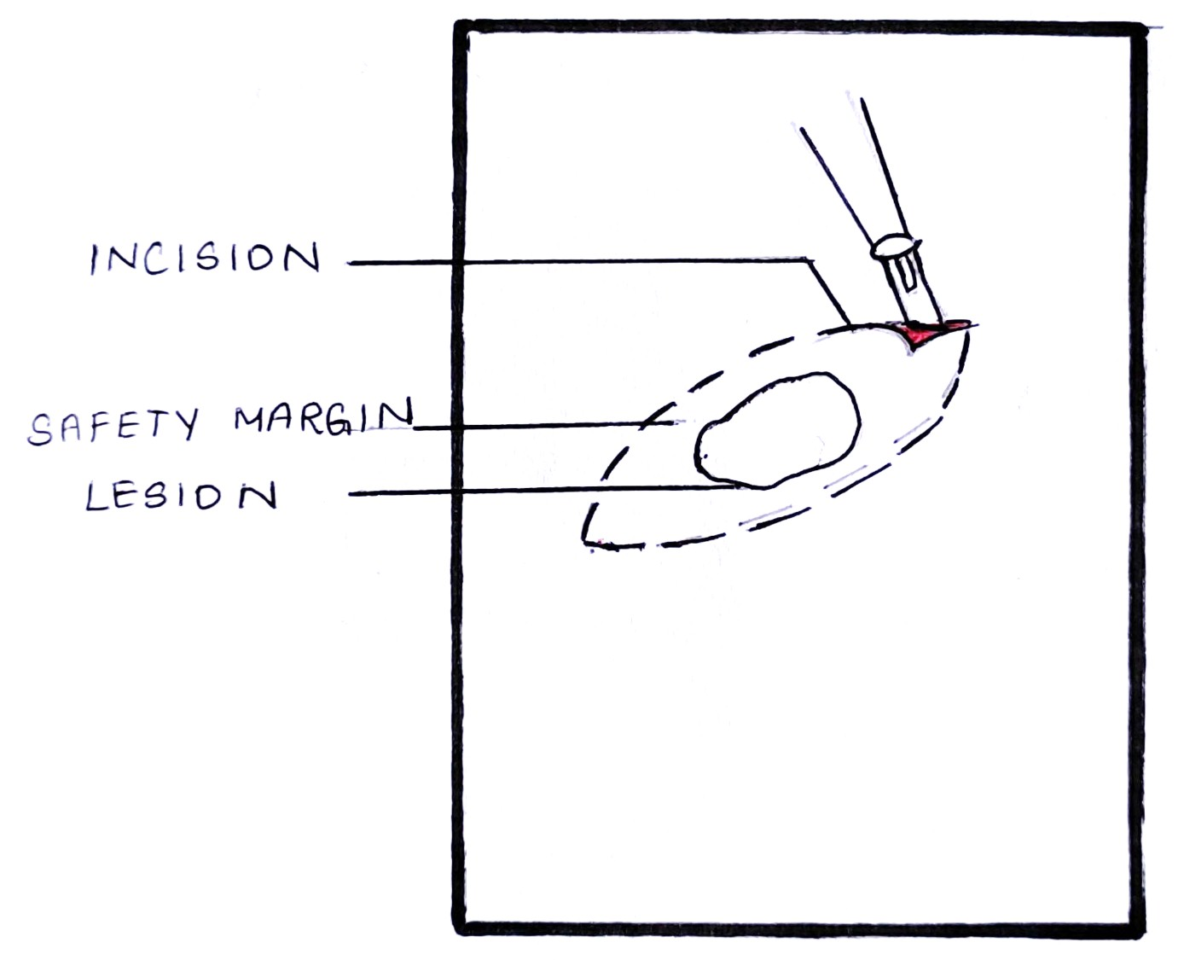

FIGURE 2

Advantages:
- Complete removal of the lesion. [10,27]
- Most appropriate for small peripheral benign lesions. [4,28]

Disadvantages:
- Difficult to perform in large lesions.[10]
- Should be avoided in cases where a high-grade malignancy is suspected.[14]

- Punch biopsy
Punch biopsy is considered the primary technique to obtain diagnostic, full thickness skin specimens. It is usually used as an alternative to incisional or excisional biopsies for small lesion at an accessible site. The lateral tongue and buccal mucosa are appropriate sites for punch biopsy, as it is feasible for device to approach the mucosal surface perpendicularly. [10]
Technique: It is performed using a circular blade or trephine attached to a pencil-like handle. The instrument is placed on the lesion rotated down through the epidermis dermis and into the subcutaneous fat. The punch biopsy yields a cylindrical core of tissue that must be gently handled. The tissue core is then severed at the base with a curved scissors. The circular wound makes approximating the edges more difficult than in case of an elliptical lesion. [29] [FIGURE3]

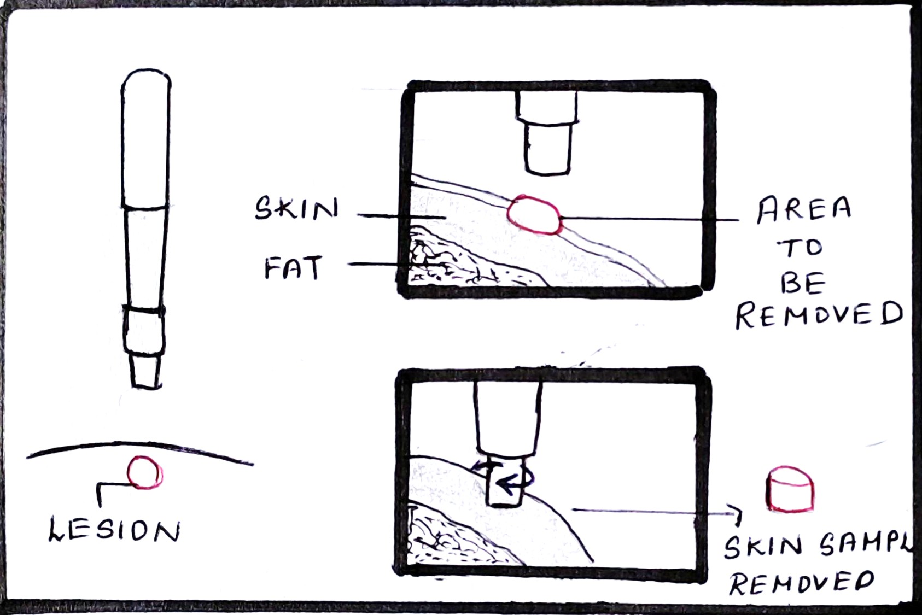
FIGURE 3
Advantages:
- Rapid, simple, safe and inexpensive technique.
- Good esthetic results due to better and fast wound healing.[6]
- Punch biopsy allows collection of multiple samples from different sites simultaneously, generating less patient anxiety than scalpel biopsy.[30]

Disadvantages:
- Punch biopsy is not suitable for vesiculobullous disease, as the twisting motion can detach the epithelium and prevent the proper interpretation of the interface between the epithelium and connective tissue. [10,30]
- They cannot be performed on deep lesions and cannot remove large lesions.[6]
- They cannot be used in intensely vascularized or innervated areas.[31]

- B- forceps

To facilitate better sectioning, Bermejo developed this instrument for helping in measuring the depth of the samples. The forceps are equipped with two cusps, one with a window to allow compression of the target tissue between them. The target zone is positioned exposed within the window, and compressive effect of the cusps allows us to work in an ischemic field within the window. Compression by the forceps causes the sectioned portion, free from its peripheral connective tissue attachments, to propel from window. [32]

- Frozen section biopsy

Mainly used for diagnosis during intra-operative period. [31,33]
Technique: During the frozen section procedure, the surgeon removes a portion of the tissue mass which is immediately given to a pathologist. The pathologist freezes the tissue in a cryostat machine, cuts it with a microtome, and then stains it with various stains so that it can be examined under the microscope. The procedure usually takes few minutes. [34]

Advantages:
- If more tissue is needed to make an accurate diagnosis, the surgeon is able to obtain an additional sample, avoiding a second operation.[34]
- If the tissue is determined to be cancerous and is amenable to surgery, the mass can be removed at that time.[34]
- The surgeon and pathologist are able to collaborate to care for the patient.[34]
Disadvantages:
- In some cases, the final diagnosis may differ from the frozen section diagnosis.[35]

- Brush biopsy

It is a non-invasive method of evaluating oral mucosal lesions. Brush biopsy was just introduced for cervical smears in gynecological lesions and was later modified for oral smears too. [36]
Technique: This method utilizes an improved brush biopsy instrument having two cutting surfaces, the flat end of the brush and the circular border of the brush. Either surface may be used to obtain the specimen. The biopsy method utilizes a complete transepithelial biopsy specimen with cellular representation from each of the three layers of the lesion: the basal, intermediate, and superficial layers. Unlike previous cytology instrument, which collects only exfoliated superficial cells when used properly and rubbed against an area of suspected tissue aggressively, the biopsy brush penetrates to the basement membrane, removing tissue from all three epithelial layers of the oral mucosa. [37] [FIGURE 4]

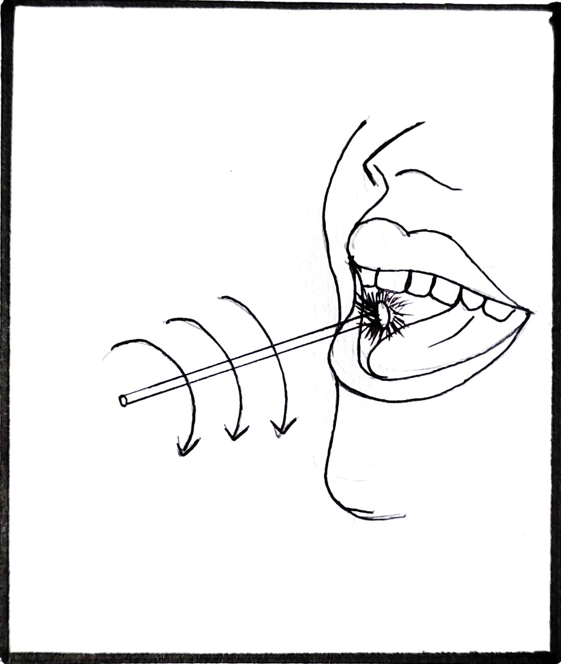
FIGURE 4

Advantages:
- In contrast to exfoliative cytology, the brush biopsy collects cells from the full thickness of the oral epithelium.
- Non-invasive, chair side procedure, easy to perform and painless and less bleeding.

Disadvantages:
- Significant false results may be observed due to sampling error.[31,33]
- Cannot substitute scalpel biopsy[31]

- Fine needle aspiration biopsy [ FNA biopsy]
This technique was first described by Kun in 1847. It cannot replace histologic examination, as the biological specimen obtained does not provide adequate cellular architecture. Fine-needle aspiration has the advantage of providing samples from multiple lesional sites. [38]
Technique: The area of interest is palpated and localized to assess the depth or third dimension of a mass. This assessment is important as passing a needle too deep or too superficially will result in a failed procedure. Local anesthesia is not required for the procedure as it is painless; however it depends on the pain threshold of the patient. In brief, aspiration involves passing a thin gauge needle (22 - 26 G) through the skin and into the mass, collecting the sample, and then removing the needle. After the material is aspirated, the practitioner prepares thin smear on the glass slide, taking care to spread it evenly on the slide. [39]
Advantages:
- Simple, accurate, fast and economic procedure.[40]
- The technique is relatively painless.[38]
- The low risk of complications is an additional advantage that allows FNA biopsy to be performed as an office procedure, in outpatient departments.[38]
- It is also suitable in debilitated patients, is readily repeatable, and useful for multiple lesions.[38]
Disadvantages:
- Sampling is scanty and histological architecture may be lost thereby rendering impossible diagnosis based on histology.[41]

Handling Of Biopsy Specimen

Biopsy specimens are vulnerable to artifacts. Most of the artifacts are due to improper handling of the specimen. [2] First and foremost the specimen should be grasped carefully with forceps. Blunt forceps are preferred over toothed forceps.[2] Orientation of the biopsy specimen is important as they are small in size and have a limited morphological characteristics. It is accompanied by placing one/multiple sutures on the known margin. Always provide a written description of the specimen in relation to the suture. If the specimen is too thin, it is placed on a piece of paper, with the connective tissue side down, for at least 1 min so that the sample stays flat during fixation. When more than one specimen is obtained, the specimens should be distinguished clearly either by placing identifying sutures or submitting in separate specimen containers. [2,4,10,42,]. Fixation is a process which inhibits autolysis of the tissue once they are removed from the patient. The biopsy specimen must be placed in 10% neutral buffered formalin which is least 15-20 times the volume of the specimen to avoid improper fixation. Formalin fixes specimens by forming intermolecular bridges between the proteins and cross-links between protein end groups. [7, 42]

Submission Of Biopsy Specimen

The clinician should make sure that the specimen is placed in a wide mouth container to avoid rough handling. The specimen should always be accompanied with the clinical information which includes patient details, clinical presentation of the lesion, and relevant medical history. The specimen should be sent as soon as possible avoiding any sort of delay. [10]

VARIOUS PITFALLS AND ARTIFACTS ENCOUNTERRD DURING ORALBIOPSY

The proper handling of the biopsy specimen removed from the oral cavity is inevitable. These specimens are often small, and the possibility of producing artifact is thus enhanced. The routine procedures used in processing tissues also result in alteration of normal morphologic and cytologic features. In addition, there are other circumstances that result in artifact such as errors by the surgeon or assistant in handling the tissue at the time of biopsy, problems in the transport of tissue to the laboratory, and faulty tissue processing.[15,43]
- Forceps artifacts: If a toothed frocep is used to hold the specimen it might result in formation of voids/ tear/compression of the surrounding tissues. This results in loss of cytological details with loss of nucleus.[45]
- Injection artifacts: Injecting large amount of anaesthetic solution into the area to be biopsied results in tissue swelling. It can also produce hemorrhage with extravasation which will mask the cellular architecture. There will be separation of connective tissue from epidermis with vacuolation .[6, 46]
- Crush artifacts: Even a slight compression of the biopsy sample can cause distortion of the tissue which is referred to as crush artifacts. It results from improper usage of tissue forceps and also dull scalpel blades which tears the tissue instead of incising them. The artifact rearranges tissue morphology and squeezes the chromatin out of nuclei. This can be avoided either by using a small non –toothed forceps or by placing a suture on one edge of the specimen[47].
- Fulguration Artefacts: Tissue distortion results from excessive heat generated from surgical electrical – cautery instrument or from laser, which render small biopsy specimen non-diagnostic. This is called Fulguration artifact or Heat artifact. The epithelial cells appear detached and the nuclei assume a spindled, palisading configuration. There may also be separation of the epithelium from the basement membrane. [47,48].
- Fixation artifacts: Biopsy is followed by fixation of the sample. Prolonged fixation in formalin may cause secondary shrinkage and hardening and it may result in separation of tissue, giving an appearance of empty spaces. Delayed fixation can result in cell shrinkage and cytoplasmic clustering. The nuclear chromatin cannot be distinguished and the nucleoli are sometimes not visualized. [50]
- Suction Artifacts: It is induced by the vaccum effectof surgical suction tips .It shows highly vascularized tissue with pleomorphic connective tissue vacuoles resembling traumatized adipose tissue.

CONCLUSION
Biopsy has been used since more than 150 years for establishing a diagnosis in various medical conditions. Biopsy is one of the oldest and most reliable methods currently available to obtain a definite diagnosis and remains the gold standard procedure. A biopsy performed with proper planning and a little technical skill can improve the diagnostic value. Thus a dental practitioner must be well aware about the various techniques of biopsy and the expected pitfalls to be encountered and the methods to overcome the same.

REFERENCES

[1] Ali FM, Prasant MC, Patil A, Ahere V, Tahasildar S, Patil K, Deshpande R. Oral biopsy in general dental practice: a review. International Journal of Medicine and Public Health. 2012;2(1).
[2] Kumaraswamy KL, Vidhya M, Rao PK, Mukunda A. Oral biopsy: Oral pathologist's perspective. Journal of cancer research and therapeutics. 2012 Apr 1;8(2):192.
[3] Zerbino DD. Biopsy: its history, current and future outlook. Likars' ka sprava. 1994 Mar 1(3-4):1-9.
[4] Rosebush MS, Mark Anderson K, Rawal SY, Mincer HH, Rawal YB. The oral biopsy: indications, techniques and special considerations. Journal of the tennessee dental association. 2010 Jan 1;90(2):17.
[5] Masthan KM, Sankari SL, Babu NA, Rajguru JP. How to help the oral pathologist in making an accurate diagnosis. Journal of clínical and diagnostic research: JCDR. 2013 Jan;7(1):181.
[6] Mota-Ramírez A, Silvestre FJ, Simó JM. Oral biopsy in dental practice. Medicina Oral, Patología Oral y Cirugía Bucal (Internet). 2007 Nov;12(7):504-10.
[7] Oliver RJ, Sloan P, Pemberton MN. Oral biopsies: methods and applications. British Dental Journal. 2004 Mar;196(6):329-33.
[8] Parkin DM, Bray F, Ferlay J, Pisani P. Global cancer statistics, 2002. CA: a cancer journal for clinicians. 2005 Mar;55(2):74-108.
[9] Sciubba JJ. Oral cancer. American journal of clinical dermatology. 2001 Aug;2(4):239-51.
[10] Sylvie-Louise Avon DM, Klieb H. Oral soft-tissue biopsy: an overview. J Can Dent Assoc. 2012;78:c75.
[11] Mashberg A, Samit A. Early diagnosis of asymptomatic oral and oropharyngeal squamouscancers. CA: a cancer journal for clinicians. 1995 Nov;45(6):328-51.
[12] Driemel O, Kunkel M, Hullmann M, Eggeling FV, Müller‐Richter U, Kosmehl H, Reichert TE. Diagnosis of oral squamous cell carcinoma and its precursor lesions. JDDG: Journal der Deutschen Dermatologischen Gesellschaft. 2007 Dec;5(12):1095-100.
[13] Rawat M, Saxena S, Sireesha SK. A Comparative Study of Diode Laser and Conventional (Scalpel) Technique for Biopsy of Soft Tissue Oral Lesions.
[14] Shklar G. The effect of manipulation and incision on experimental carcinoma of hamster buccal pouch. Cancer research. 1968 Nov 1;28(11):2180-2.
[15]Margarone JE, Natiella JR, Vaughan CD. Artifacts in oral biopsy specimens. Journal of oral and maxillofacial surgery. 1985 Mar 1;43(3):163-72.
[16] Khoo SP. Oral biopsy in dental practice-The pathologist's perspective. Annals of Dentistry University of Malaya. 1995 Dec 29;2(1):29-32.
[17] Canto AM, Müller H, Freitas RR, Santos PS. Oral lichen planus (OLP): clinical and complementary diagnosis. Anais brasileiros de dermatologia. 2010 Oct;85(5):669-75.
[18] Arisawa EA, Almeida JD, Carvalho YR, Cabral LA. Clinicopathological analysis of oral mucous autoimmune disease: A 27-year study.
[19] Stewart CM, Bhattacharyya I, Berg K, Cohen DM, Orlando C, Drew P, Islam NM, Ojha J, Reeves W. Labial salivary gland biopsies in Sjögren's syndrome: still the gold standard?. Oral Surgery, Oral Medicine, Oral Pathology, Oral Radiology, and Endodontology. 2008 Sep 1;106(3):392-402.
[20] Olsen I, Stenderup A. Clinical-mycologic diagnosis of oral yeast infections. Acta Odontologica Scandinavica. 1990 Jan 1;48(1):11-8.
[21] Silverman Jr S, Migliorati CA, Epstein JB, Samaranayake LP. Laboratory diagnosis of oral candidosis. Laboratory diagnosis of oral candidosis.. 1990:213-37.
[22] Ficarra G, McClintock B, Hansen LS. Artefacts created during oral biopsy procedures. Journal of Cranio-Maxillofacial Surgery. 1987 Jan 1;15:34-7.
[23] Meghana SM, Ahmedmujib BR. Surgical artefacts in oral biopsy specimens: Punch biopsy compared to conventional scalpel biopsy. Journal of Oral and Maxillofacial Pathology. 2007 Jan 1;11(1):11.
[24] McAndrew PG. Oral cancer biopsy in general practice. British dental journal. 1998 Nov 14;185(9):428.
[25] Poh CF, Samson Ng, Berean KW,Williams PM, Rosin MP, Zhang L.Biopsy and histopathologic diagnosis of oral premalignant and malignant lesions. J Can Dent Assoc. 2008;74(3):283-8.
[26] Shyamala K, Girish HC, Murgod S. Risk of tumor cell seeding through biopsy and aspiration cytology. Journal of International Society of Preventive & Community Dentistry. 2014 Jan;4(1):5.
[27] Khajuria N, Anjum R. Attitude and Practices of General Dental Practitioners Towards Oral Biopsy. Int J Res Health Allied Sci. 2019;5(1):10-2.
[28] Mehrotra R, Gupta DK. Exciting new advances in oral cancer diagnosis: avenues to early detection. Head & neck oncology. 2011 Dec;3(1):1-9.
[29] Zuber TJ. Punch biopsy of the skin. American family physician. 2002 Mar 15;65(6):1155.
[30] Eisen D. The oral mucosal punch biopsy: a report of 140 cases. Archives of dermatology. 1992 Jun 1;128(6):815-7.
[31] Hershita Singh, Shalini, Nancy charaya, Monika Poonia, Supreet Kaur Sidhu, Sandeep Singh Sihmar, Monika. Biopsy- A vision of life. International Journal of Contemporary Medical Research 2016;3(6):1734-1737.
[32] Bermejo-Fenoll A, Lopez-Jornet P. Instrument for biopsy of oral lesions: an improved chalazion forceps. Dermatologic surgery. 2006 Dec 1;32(12):1493-5.
[33] Hall DL. Oral brush biopsy technique instruction outcomes for senior dental students. Journal of dental education. 2006 Aug;70(8):820-4.
[34] Brender E, Burke A, Glass RM. Frozen section biopsy. Jama. 2005 Dec 28;294(24):3200-.
[35] MacLeod CB, Branton P, Bruzzi C, Dow N, Katz R, Martin E. Addressing: Molecular testing for indeterminate thyroid FNA biopsy.
[36] Sciubba JJ, US Collaborative OralCDx Study Group. Improving detection of precancerous and cancerous oral lesions: computer-assisted analysis of the oral brush biopsy. The Journal of the American Dental Association. 1999 Oct 1;130(10):1445-57.
[37] Ehtisham M, Nissar S. Oral brush biopsy: Pros and Cons. Heal talk. 2015;8(2):29-30.
[38] Iacob A, Zazgyva A, Ormenişan A, Mezei T, Sin A, Tilinca M. Effectiveness of fine-needle aspiration cytology in the diagnosis of lateral cervical nonthyroid tumors. Medicine. 2016 Aug;95(31).
[39] Weydert JA, Cohen MB. Fine needle aspiration: current practice and recent developments. Laboratory Medicine. 2003 Dec 1;34(12):851-4.
[40] Grohs HK. Starting Out: The Interventional Cytopathologist: A New Clinician/Pathologist Hybrid. American journal of clinical pathology. 1988 Sep 1;90(3):351-4.
[41] Martin HE, Ellis EB. Biopsy by needle puncture and aspiration. Annals of surgery. 1930 Aug;92(2):169.
[42] Melrose RJ, Handlers JP, Kerpel S, Summerlin DJ, Tomich CJ. The use of biopsy in dental practice. The position of the American Academy of Oral and Maxillofacial Pathology. General dentistry. 2007 Sep 1;55(5):457-61.
[43] Bancroft JD, Gamble M, editors. Theory and practice of histological techniques. Elsevier health sciences; 2008.
[44] Zegarelli DJ. Common problems in biopsy procedure. Journal of Oral Surgery (American Dental Association: 1965). 1978 Aug 1;36(8):644-7.
[45] Rastogi V, Puri N, Arora S, Kaur G, Yadav L, Sharma R. Artefacts: a diagnostic dilemma–a review. Journal of clinical and diagnostic research: JCDR. 2013 Oct;7(10):2408.
[46] Takahashi K, Iwase S. On artifacts appearing in the histochemical fixation of glycogen. The Journal of Cell Biology. 1955 Sep 25;1(5):391-8.
[47] Chatterjee S. Artefacts in histopathology. Journal of oral and maxillofacial pathology: JOMFP. 2014 Sep;18(Suppl 1):S111.
[48] Krishnanand PS, Kamath VV, Nagaraja A, Badni M. Artefacts in oral mucosal biopsies–A review. Journal of Orofacial Sciences. 2010 Jan 1;2(1):57.

