Study of Water Quality Using GIS & Surfer

C.Vaidevi^{a)} , S. Monisha^{a)}C, Mohammed Ashique^{b)}, Lijish Puthiya Purayil^{b)},
Mohammed Asfar^{b)}

Faculty^{a)}, Student^{b)}, Department of Civil Engineering,
Aarupadai Veedu Institute of Technology, Vinakaya Mission’s research Foundation, Chennai, Tamil Nadu, India.,
- Corresponding Author : vaiducivil@gmail.com

Abstract. Water is the most needed natural resource for living things which is employed for domestic, industrial and also agricultural purposes. The recent flood has affected various regions of Kerala resulting in decrease of water quality and inadequate supply of safe potable water. The project aims to study the water quality of ‘Mayyil - Panchayath’ by incorporating modern water quality assessment tools. GIS based attempt has been employed to evaluate and characterize the quality of water. The study area water samples were analysed for physico-chemical, bacteriological parameters and compared with water quality standards (IS 10500-2012). Further Water Quality Index (WQI) method integrated with GIS is used to visualize the spatial pattern of the water quality.

Keywords. Geographic Information System (GIS), Water Analysis, Water Quality Index (WQI).

Introduction
Groundwater is most important source for domestic, industrial facility and also for irrigation purpose. The previous two decades, there have been increase in demand of water due to increasing population. The recent flood has affected various regions of Kerala. The flood has affected the water quality of drinking water sources. The study area Mayyil Panchayath was also effected resulting in muddy water entering the wells, which were a source of drinking water for the households. In this area, peoples are suffered from water borne diseases due to the use of contaminated water, so it is necessary to check the water quality parameters at regular interval of time. Water quality index is the most effective tools in water quality analysis. The standards are specified as per IS: 10500-2012 for potable Water Quality is specified. WQI is used to determine the drinking water quality in rural, urban and industrial area. Geographical Information System (GIS) has emerged as efficient and strong tool in different fields of science over the last two decades. Thus, it becomes a necessary parameter for assessment and management of groundwater.

OBJECTIVES

The main objective of the study is to:
- Analyse the collected water samples from various regions of Mayyil Panchayath.
- Analyse various physical, chemical and biological parameters of collected water samples.
- Quality Index of the each parameter then compare with Standards for Drinking water [IS 10500-2012].
- Generate ground water quality map based on these parameters using GIS.

WATER QUALITY

Water quality refers to a measure of the condition of water like physical, chemical and biological characteristics. The most common standards used to assess find the water quality related to human health, safety of human contact and drinking water. Various parameters were analyzed and compared the results. The parameters analyzed are as follows as a TABLE 1.
Physical Parameters
- Turbidity

Chemical Parameters
- pH
- Total dissolved solids
- Total Hardness
- Total Alkalinity
- Acidity
- Electrical Conductivity
- Chloride content
- Iron content
- Fluoride
- Determination of BOD
- Determination of DO

Bacteriological Parameters
- Escherichia coli
TABLE 1. IS-10500-2012 STANDARDS OF DRINKING WATER
Sl No | Parameters | Units | Acceptable Limits | Permissible Limits
1 | pH |  | 6.5-8.5 | No relaxation
2 | Turbidity | NTU | 1 | 5
3 | Total dissolved solids | mg/l | 500 | 2000
4 | Electrical Conductivity | µS/cm | 200 | 800
5 | Total Alkalinity | mg/l | 200 | 600
6 | Total Hardness | mg/l | 200 | 600
7 | Chloride content | mg/l | 250 | 1000
8 | Acidity | mg/l | 50 | No relaxation
9 | Iron content | mg/l | 0.3 | No relaxation
10 | Fluoride | mg/l | 1 | 1.5
11 | DO | mg/l | 4-5 | 4-6
12 | BOD | mg/l | 2 | 8
13 | Escherichia coli |  | 0 | 0

METHODOLOGY

General
Water is mainly employed for domestic purposes as source of drinking water. Due to rise in population there is increase in the demand for water as a result and therefore to check the quality of water quality parameters to ensure its safety. Water quality is analysied through Geographic Information System integrated with Water Quality Index has proved to be the most efficient method than any other methods. The methodology is shown in FIGURE. 1.

Selection of Study Area and Locations

Water Sample Collection

Water sample Quality Analysis

Conclusion

FIGURE 1. Methodology

Study Area
The study area is Mayyil Grama Panchayath. This area belongs to Irikur block and Thaliparamba assembly constituency. The basic reason for selecting the area is, the various regions of the study area were affected by the recent flood of 2019. The area extents over 33.08 square kilometers consisting a total of 18 wards. The study area has latitude 12° 02' 24.00'' N and longitude 75° 27' 36.00''E. It has tropical climate so most of the months have significant rainfall were is a short dry season. The 27.1°C(80.9°F) is an average annual temperature and precipitation is about 3629mm(142.9 inch) per year. In 2019, the least amount of rainfall occurs in January. The average in this month is 3 mm / 0.1 inch.

STUDY AREA MAP

The .kml file produce from Google Earth is imported to QGIS and we get a study area map as shown below FIGURE 2.

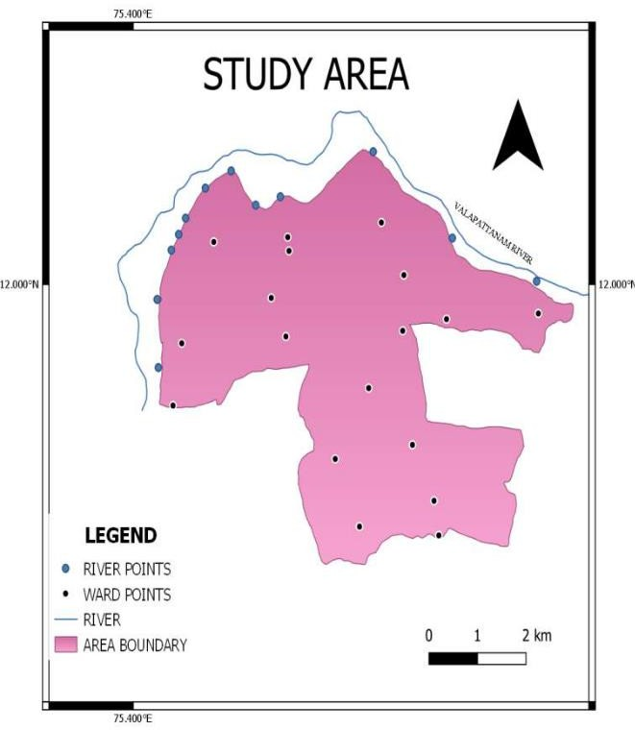
FIGURE 2. Study area map created in QGIS

Water Sampling Locations
Total 30 sampling stations were selected, covering various regions of Mayyil Panchayath. Out of the 30 points, 18 sampling points are located among the 18 wards and the remaining sampling points 12 are located along the river which passes along the outskirts of the study area. The sampling locations were selected so that the sample sources form the most extensively used drinking water source of the area. The latitude and longitude of the sample locations were found out by employing GPS survey using mobile GPS.

Water Sample Collection
Plastic bottles that are sterilised and cleaned are used for collecting water samples. The sample collected should be handled in such a way that there will be no significant change in composition of the collected sample before the tests are done.

EXPERIMENT WORK

Water Quality Parameter Analysis
The experimental procedures for analysing water quality water samples are as follows.

1. pH value
Collected samples are taken in the beaker. The pH value is recorded for all the samples by using the pH meter.

2. Turbidity
Take a cuvettes and wash properly. Then distilled water is poured into the cuvettes and Turbidity of distilled water is measured by the Nephlo-turbidity meter, set the turbidity meter settings as zero if not set as zero adjust the setting. Then take the cuvettes again wash properly and keep the samples in it and measure the turbidity.

3. Total Dissolved Solids
Through whatman filter paper by following procedure the total dissolved solids is calculated.

4. Electrical conductivity
Take potassium chloride and dissolved in distilled water & potassium chloride solution is prepared. Conductivity of potassium chloride is checked using the conductivity meter. If there is some error in the conductivity of KCl, then adjust the settings. Then conductivity of the given sample is measured. The same procedure is repeated for all the samples and the conductivity is recorded.

5. Total Alkalinity
By following the procedure the sample is titrated against sulphuric acid, the colour is obtained which turns to orange yellow. Then the total volume is noted.

6. Total Hardness
Then titrate it against std. EDTA solution till reddish wine colour changes to blue and note the volume of EDTA solution.

7. Chloride content
First take 25 ml of sample in an Erlenmeyer flask. Then add 25ml of distilled water and add 1ml of prepared potassium chromate solution. Titrate with silver nitrate solution and mix well and the end point from light yellow colour to red colour. Repeat the titration until concordant values is obtained.

8. Acidity
First pipette 100 ml of water sample to the flask and add one or two drops of methyl orange indicator. This sample is titrated against 0.02 N standard NaOH solutions. The volume when colour changes from orange red to yellow was noted. Again one or two drops of phenolphthalein indicator is added and titrated till the colour changes to faint pink. Finally the volume at this colour change is also noted.

9. Iron content
From the water sample UV- Visible spectrophotometer with absorbance at 565 nm is measured. From UV- Visible spectrophotometer using calibration curve the dissolved iron content was calculated.

10. Fluoride content
In burette filled with sodium hydroxide solution. Take sample water and add 1 ml of concentrated HCL and phenolphthalein indicator 3 drops added, titrate with sodium hydroxide note down the colour changes and the end point is pink colour note down the volume of sodium hydroxide consumed and do the titrations for concordance and again take conical flask add 10 ml of distilled water with 1 ml of concentrated HCL and add 3 drops of phenolphthalein indicator then note down colour change to pink colour and fluoride is calculated

11. Dissolved Oxygen
A BOD is found using the DO meter. The value is obtained and noted.

12. Biochemical Oxygen Demand
Taking 4 BOD bottles and each of them filled with 300 ml water sample. Be careful to avoid contact with air. Add 2ml of MnSO₄ by means of a pipette. Add 2 ml of azide alkali(KI). Insert stopper and shake well. Red precipitate formed and it shows DO is present. Allow the precipitate to settle. Two bottles go for dissolved oxygen test. Other to bottles are placed in BOD incubator at 20°C for five days. After 5 days bottles are taken out and determine the dissolved oxygen content.
BOD = Initial DO – Final DO

13. E. coli
The E.coli test was carried out by positive presumptive tube test. It is obtained from which MPN for E. coli in the sample may be estimated using the most probable number tables.

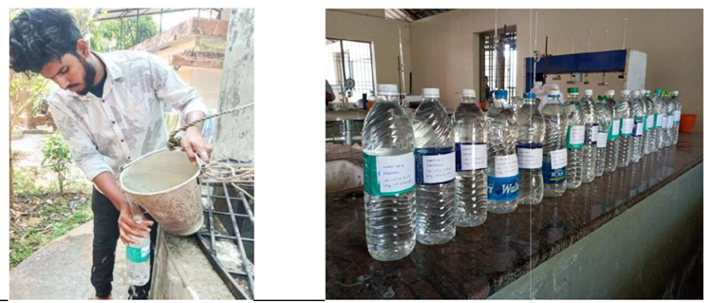
FIGURE 3. Collecting Water Samples FIGURE 4. Collected Water Samples

RESULT AND DISCUSSION

Water Quality Parameters Analysis

The results of laboratory tests are given in the tables below. The groundwater samples and water samples from river are taken separately analysed. Table. 2 & 3 shows the test results of water quality parameters analysed.

TABLE 2. WARD SAMPLES
Sample No. | pH | Turbidity (NTU) | Alkalinity  (mg/L) | Chloride  (mg/L) | Hardness  (mg/L) | Acidity  (mg/L) | IRON (mg/L) | FLUORIDE  (mg/L) | TDS (mg/L) | EC (μS/cm)
1 | 5.51 | 0 | 16 | 239.926 | 12 | 49.34 | 0.29 | 2 | 123 | 97
2 | 5.29 | 0 | 12 | 89.972 | 32 | 50.04 | 0.36 | 2.2 | 101 | 236
3 | 5.86 | 0 | 8 | 29.991 | 56 | 43.26 | 0.31 | 0 | 73.9 | 29
4 | 6.02 | 0 | 8 | 45.986 | 32 | 46.52 | 0.28 | 1.1 | 20.3 | 57
5 | 5.91 | 0 | 8 | 47.985 | 32 | 41.04 | 0.33 | 1.5 | 86.5 | 47
6 | 5.7 | 0 | 8 | 49.985 | 28 | 48.63 | 0.332 | 4.4 | 116 | 74
7 | 4.9 | 0 | 4 | 43.986 | 32 | 47.5 | 0.321 | 2.7 | 79 | 105
8 | 5.59 | 0.01 | 8 | 45.986 | 24 | 47.08 | 0.271 | 0.43 | 31 | 193
9 | 5.5 | 0 | 4 | 51.984 | 16 | 46.53 | 0.289 | 1.4 | 52 | 41
10 | 6.09 | 0 | 8 | 65.979 | 68 | 44.6 | 0.268 | 0 | 49.5 | 180
11 | 5.3 | 0 | 12 | 231.928 | 20 | 42.78 | 0.291 | 3.8 | 130 | 45
12 | 4.9 | 0 | 4 | 77.976 | 24 | 42.96 | 0.301 | 1.1 | 127 | 260
13 | 4.88 | 0 | 12 | 61.981 | 20 | 46.4 | 0.263 | 0.43 | 71.2 | 67
14 | 5.18 | 0.1 | 4 | 37.988 | 20 | 48.01 | 0.261 | 2.9 | 58.9 | 41
15 | 5.8 | 0 | 4 | 39.988 | 36 | 46.1 | 0.32 | 2.4 | 89 | 84
16 | 6.38 | 0 | 12 | 127.960 | 80 | 43.2 | 0.36 | 5.6 | 91.3 | 553
17 | 5.29 | 0 | 4 | 71.978 | 24 | 49.5 | 0.38 | 4.4 | 96 | 131
18 | 5.48 | 0 | 8 | 45.985 | 40 | 51.64 | 0.27 | 1.5 | 78 | 100

TABLE 3 RIVER SAMPLES
Sample  No. | pH | Turbidity (NTU) | Alkalinity  (Mg/L) | Chloride  (Mg/L) | Hardness  (Mg/L) | Acidity  (Mg/L) | IRON (mg/L) | FLUORIDE  (mg/L) | TDS (mg/L) | EC (μS/cm)
1 | 6.68 | 0 | 8 | 1117.653 | 1548 | 76.1 | 0.41 | 2.8 | 75.2 | 142.5
2 | 6.71 | 0 | 8 | 1369.575 | 744 | 53.4 | 0.42 | 3.1 | 71.2 | 146.2
3 | 6.65 | 0 | 8 | 993.692 | 1284 | 84.19 | 0.36 | 1 | 59.5 | 273.6
4 | 6.69 | 0 | 8 | 941.707 | 1568 | 63.12 | 0.21 | 0.03 | 54.5 | 584
5 | 6.59 | 0.1 | 12 | 1813.438 | 784 | 61.02 | 0.38 | 0.1 | 41.9 | 624.5
6 | 6.89 | 0 | 8 | 759.764 | 640 | 58.19 | 0.43 | 1.5 | 48.2 | 45.1
7 | 6.83 | 0 | 12 | 1175.635 | 996 | 76.34 | 0.31 | 4.5 | 12.36 | 22.89
8 | 6.82 | 0 | 12 | 1165.639 | 1560 | 65.5 | 0.39 | 5.1 | 63.33 | 112.6
9 | 6.7 | 0 | 12 | 1799.442 | 1856 | 61.2 | 0.47 | 6.8 | 19.38 | 44.14
10 | 6.69 | 0 | 12 | 1961.392 | 2000 | 53.26 | 0.44 | 3 | 96.4 | 246
11 | 6.85 | 0 | 8 | 1999.38 | 2004 | 51.7 | 0.32 | 1.17 | 94.2 | 273
12 | 6.69 | 0 | 12 | 1919.405 | 2004 | 60.09 | 0.3 | 1.2 | 86.2 | 112.6

WATER QUALITY INDEX (WQI) AND ITS CALCULATION

It is defined as a rating that reflects the composite influence of various water qualities.
The Water Quality Index (WQI) is calculated for both groundwater and river water samples. They are listed in Table 4 and 5.

TABLE 4 WATER QUALITY INDEX OF WARD SAMPLES
SAMPLE NO. | WATER QUALITY INDEX (WQI)
1 | 65.763
2 | 68.690
3 | 29.180
4 | 43.914
5 | 51.944
6 | 95.350
7 | 70.078
8 | 37.9743
9 | 47.656
10 | 33.664
11 | 88.941
12 | 52.269
13 | 33.841
14 | 67.973
15 | 65.769
16 | 133.435
17 | 99.457
18 | 51.6863

TABLE 5 WATER QUALITY INDEX OF RIVER SAMPLES

RIVER SAMPLES
SAMPLE NO. | WATER QUALITY INDEX (WQI)
1 | 209.968
2 | 159.0748
3 | 138.610
4 | 132.416
5 | 145.365
6 | 88.60435
7 | 173.794
8 | 200.753
9 | 253.316
10 | 217.822
11 | 197.260
12 | 185.094

The calculated WQI provides the overall potability of water quality. WQI value are greater than 300 indicates that the water is unfit for drinking purposes. All the WQI values are below 300 but show variations from sample to sample. All the ground water samples are good for drinking with value less than 100 except at ward 16 (Naniyoor Nambram). All the river water saamples are of poor quality except for sample 6. River sample 6 has a value less than 1000 indicating it is of good quality.

GIS & SUFFER APPLICATIONS IN SAMPLES

The water samples are analysed using the software and the contour maps are given below in FIGURE 5- 17.

CONTOUR MAPS OF PARAMETERS

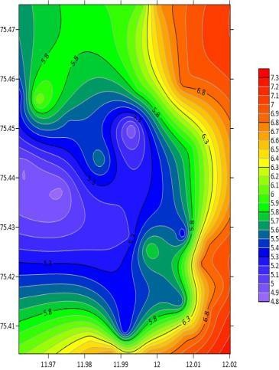
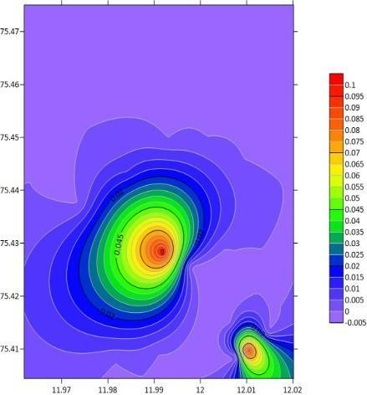
FIGURE 5. pH FIGURE 6. Turbidity

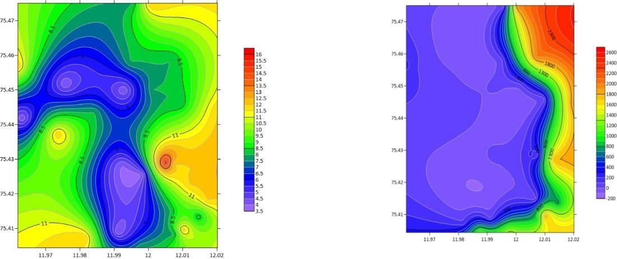
FIGURE 7. Alkalinity FIGURE 8. Chloride

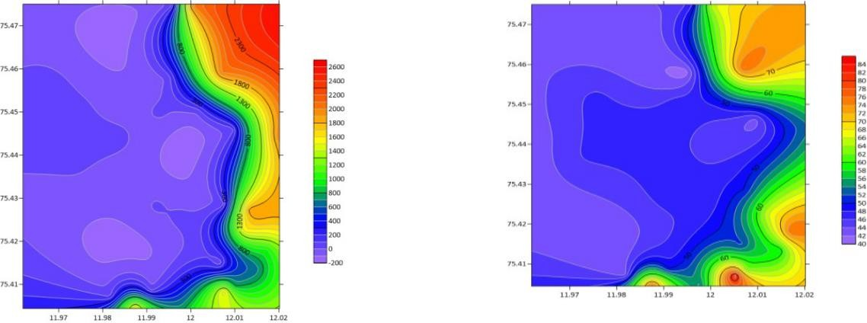
FIGURE 9. Hardness FIGURE 10. Acidity

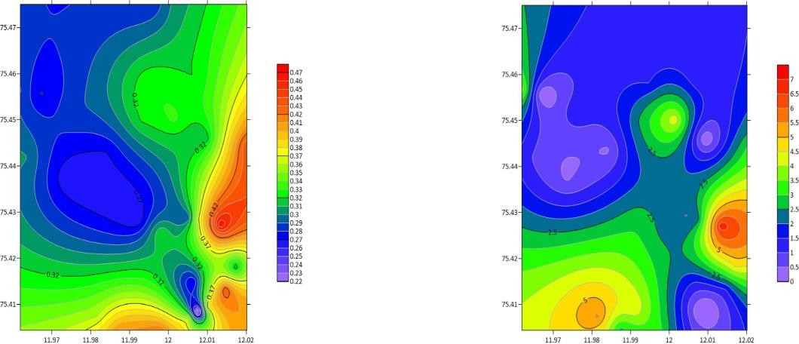
FIGURE 11. Iron FIGURE 12. Fluoride

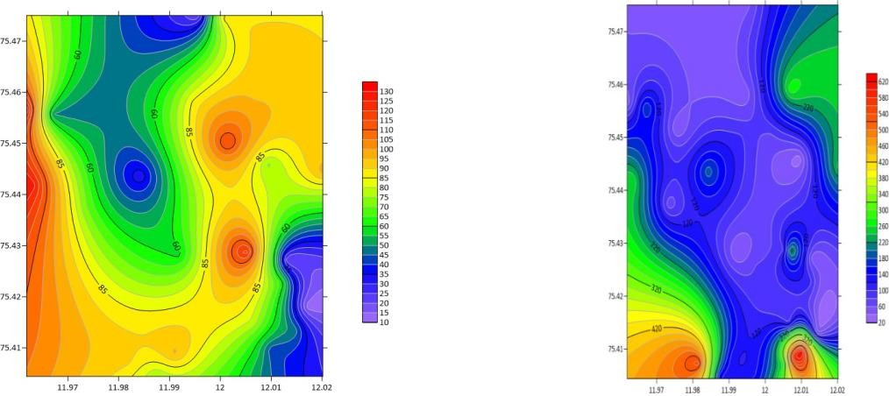
FIGURE 13. TDS FIGURE 14. EC

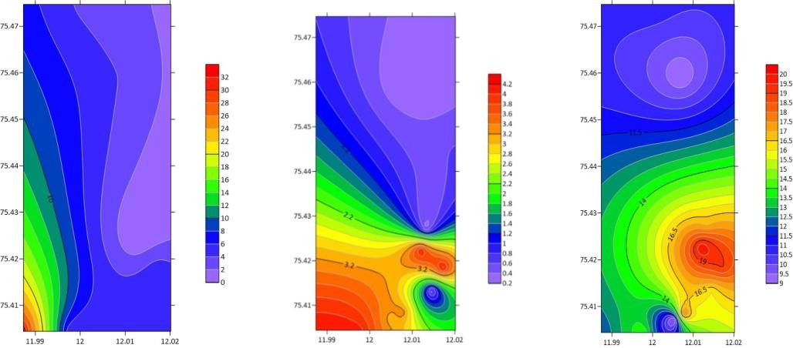
FIGURE 15. DO FIGURE 16. BOD FIGURE 17. E-Coli

The contour maps shown above are produced from Surfer software. These are water quality contour maps and are generated using water quality sample results. Colours are assigned to the maps to easily understand them. Kriging method of interpolation is used and is a very flexible gridding tool. Rainbow colour ranges are used. The violet colour shows minimum value and red colour shows maximum value. The latitude and longitude coordinates are also given in the contour map. The X coordinate is latitude, Y coordinate is longitude and Z coordinate is water quality parameter value. From that we can clearly understand which location has the highest concentration and which has the lowest. Considering the first map of pH (fig 4.2) we can clearly understand the variations in parameter value from point to point. The violet colour regions indicate low concentration of pH and red colour regions indicates higher concentration of pH. Between these violet and red colours five different colours mark the variation from low to high concentration of water quality parameters. Similarly all other contour maps are produced and analysed. It is easy to understand and interpret the value using these above contour maps. The Surfer contour maps can give a full control over all map parameters.

CONCLUSION

Ground water is contaminated due to human and commercial activities which causes serious issues now a day. So analysing the water quality is very important to preserve the natural eco system. The assessment of the ground water quality will be carried out in the different wards of Mayyil Panchayath. The sampling stations were selected from the study area which includes a total of 30 sampling locations (18 from 18 wards and 12 from surface sources). The project works include fixing Latitude and Longitude of sampling stations, collecting water samples, testing samples for physical, chemical and bacteriological parameters, calculating Water Quality Index and finally producing spatial distribution maps using GIS. The test results were compared with drinking water standards IS10500-2012. WQI shows an effective method for determining the suitability of water.

REFERENCES

- P Balakrishnan, Abdul Saleem and N D Mallikarjun, ‘Groundwater Quality mapping using Geographic Information System(GIS): A Case study of Gulbarga City, Karnataka, India’, African Journal of Environmental Science and Technology, Volume 5(12), December 2011.
- Rajkumar V Raikar and Sneha M K, ‘Water Quality Analysis of BhadravatiTaluk using GIS- A case study’, International Journal of Environmental Sciences, Volume 2, Issue 4, May 2012.
- Suresh Konkey, Dr. U B Chitranshi and Dr. Rahul Dev Garg, ‘Ground Water Quality Analysis and Mapping using GIS Techniques’, International Journal of Engineering Science & Technology(IJEST), Volume 6, Issue 8, August 2014.
- SmithaAsok V, Sajitha V and Jobin Thomas, ‘Spatial Evaluation of Pond Water Quality Using GIS: A Study from Athiyannor Block Panchayath, Thiruvananthapuram, Kerala, India’, International Journal of Scientific and research Publications, Volume 5, Issue 10, October 2015.
- Subin K Jose, R V Rajan and R Santhosh Kumar, ‘Water Quality Mapping of Coastal Aquifers in Central Part of Penisular India Using Geographic Information System’, IOSR Journal of Environmental Science, Toxicology and Food Technology (IOSR-JESTFT), Volume 10, Issue 6 Ver, June 2016.
- S Karthikeyan, D Prabhakar and Dr. R A Alagu Raja, ‘Groundwater Quality Monitoring System using GIS’, International Journal of Engineering Research & Technology(IJERT), Volume 5, Issue 17, Special Issue 2017.
- Geeja K George, Arundev R, Parvathy Manoj, Seethal P V and Sanjith P, ‘Water Quality Analysis of Edapally Canal using GIS Mapping’, International Research Journal of Engineering and Technology(IRJET), Volume 4, Issue 4, April 2017.
- Fehmida Fatima S and Bindu A G, ‘Evaluation of Groundwater Quality at Eloor, Ernakulam District, Kerala Using GIS’, International Journal of Engineering and Advanced Technology(IJEAT), Volume 8, Issue 4C, December 2018.
- R. Aravind Raj, Vidhya Lakshmi Sivakumar, Manoj Nallanathel and Ramalakshmi M, “Estimation Of Water Spread Area For Chembarabakkam Lake Using Remote Sensing”, Indian Journal of Environmental Protection, Vol. 41, Issue. 4, pp. 471-475, April 2021.

Gupta, D., Kumar Ranjan, R., Parthasarathy, P., Ansari, A. , “Spatial and seasonal variability in the water chemistry of Kabar Tal wetland (Ramsar site), Bihar, India: multivariate statistical techniques and GIS approach”, Water Science and Technology, Vol.83, Issue: 9, pp. 2100–2117, 2021.
- S Vidhya Lakshmi, Y Vinay Kumar Reddy, “Identification of groundwater potential zones using GIS and remote sensing”, International Journal of Pure and Applied Mathematics, Vol. 119, Issue: 17, pp. 3195-3210.

