Beneficial effect of Lactic Acid Bacteria in Human
A Bala and J Victoria
PG and Research Department of Microbiology,
Sengamala Thayaar Educational Trust Women’s College,
Mannargudi, Tamilnadu, India.

Abstract
Consuming fermented foods has been reported to result in improvements in a range of health parameters. These positive effects can be exerted by a combination of the live microorganisms that the fermented foods contain, as well as the bioactive components released into the foods as by-products of the fermentation process. In many instances, and particularly in dairy fermented foods, the microorganisms involved in the fermentation process belong to the Lactic Acid group of Bacteria (LAB). An alternative approach to making some of the health benefits that have been attributed to fermented foods available is through the production of ‘fermentates’. The term ‘fermentate’ generally relates to a powdered preparation, derived from a fermented product and which can contain the fermenting microorganisms, components of these microorganisms, culture supernatants, fermented substrates, and a range of metabolites and bioactive components with potential health benefits. Here, a brief overview of a selection of in vitro and in vivo studies and patents exclusively reporting the health benefits of LAB ‘fermentates’ are provided. Typically, in such studies, the potential health benefits have been attributed to the bioactive metabolites present in the crude fermentates and/or culture supernatants rather than the direct effects of the LAB strain(s) involved.
Introduction
Lactic Acid Bacteria (LAB) are widespread microorganisms which can be found in any environment rich mainly in carbohydrates, such as plants, fermented foods and the mucosal surfaces of humans, terrestrial and marine animals. In the human and animal bodies, LAB are part of the normal microbiota or microflora, the ecosystem that naturally inhabits the gastrointestinal and genitourinary tracts, which is comprised by a large number of different bacterial species with a diverse amount of strains [1,2].
Moreover, nowadays, LAB play an important role in the industry for the synthesis of chemicals, pharmaceuticals, or other useful products (Figure 1). Also, the biotechnological production of lactic acid has recently reported that offers a solution to the environmental pollution by the petrochemical industry [3].
The term Lactic Acid Bacteria cover a large group of micro-organisms. The first pure culture of a lactic acid bacterium was obtained in 1873 and the similarity between milk souring bacteria and other Lactic Acid-producing Bacteria of other habitats was recognized in the early 1900s. The basis of systematic classification of LAB was elaborated and published in 1919 by Orla-Jensen. Although revised to a considerable extent, the main characteristics of classification have remained unchanged. In the framework of this article, primarily the classification, physiology and industrial use of Lactic Acid Bacteria will be treated. In addition, a short review will be given about health aspects of LAB and some future aspects in research and product development on Lactic Acid Bacteria.
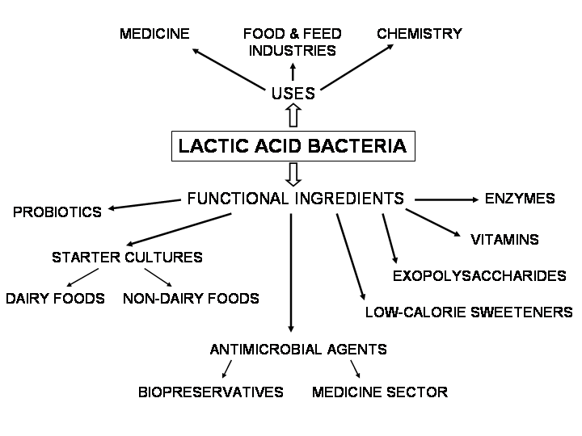

Lactic Acid Bacteria as source of probiotics

Etymologically the term probiotics is derived from the Greek “probios” which means “for life”. In 1974 Parker [4] defined probiotics as “organisms and substances which contribute to intestinal microbial balance”. Fuller in 1989 [5] defined probiotic as “a live microbial feed supplement which beneficially affects the host animal by improving its intestinal microbial balance”. Later the Food and Agriculture Organization / World Health Organization defined probiotic bacteria as “live microorganisms which when administered in adequate amounts confer a health benefit on the host” [6]. Since probiotics can colonize the gastrointestinal tract and exert their beneficial effect long term, without requiring continuous medical intervention, they have been used for a century to treat a variety of mucosal surface infections (gut, vagina), but their use decreased after the appearance of antibiotics. However, today, probiotics are considered as an alternative solution to antibiotics due to the increasing spread of antibiotic resistance and the need for treatment cost reduction [7].
Microorganisms considered as commercial probiotics are mainly of the Lactobacillus genus with over one hundred species recognized, for example: L. acidophilus, L. rhamnosus, L. reuteri, L. casei, L. plantarum, L. bulgaricus, L. delbrueckii, L. helveticus [8]. Lactobacilli are Generally Recognized as Safe (GRAS) organisms [9,10].
Effects on Gastrointestinal Tract
About 10 billion of bacteria belong to 500 species coexist in human gastrointestinal tract. 20 genera are dominant among these including LAB. These are Bacteroids, Lactobacillus, Clostridium, Fusobacterium, Bifidobacterium, Eubacterium, Peptococcus, Poststreptococcal, Escherichia, and Veillonella. Microbial balance is very important for maintaining the intestinal homeostasis. Live Lactic Acid Bacteria intake through dairy products have Myriad beneficial effects on gastrointestinal tract of human beings ranges from correction of lactose mal absorption, alleviation of viral and drug induced diarrhoea, post operative pouchitis, irritable bowel syndrome, inflammatory bowel syndrome, antineoplastic effects on human cell line, maintenance of normal insulin level in blood and also helpful to enhance the absorption of fatty acids through intestine. LAB produce these beneficial effects by restoration of normal intestinal flora, elimination of intestinal pathogens, reinforcement of intestinal barrier capacity to foreign antigens, stimulation of nonspecific immunity such as phagocytosis, stimulation of humoral immunity and production of anti-inflammatory products, [11,12] .
Effects on Lactose Intolerance and Malabsorption
Lactose intolerance is the inability to digest lactose into its constituent’s, i.e., glucose and galactose owing to low level of lactase enzyme in the brush border of duodenums. It commonly occurs in children. Symptoms of lactose intolerance appear from 30 minutes to 2 hours after consumption of food that contain lactose in it. Symptoms include, bloating, cramping, flatulence, and loose stool. There are three clinical forms of lactose intolerances, i.e., primary lactose intolerance occurs after weaning, secondary lactose intolerance due to diarrhoea, inflammatory bowel disease and HIV infection and third type is congenital lactose intolerance which has genetic origin. Lactose malabsorption is the condition in which lactose is digested in to its constituents but because of deficiency of anatomical and cofactors these constituents are not properly absorbed by the intestine. About 50 million of Americans are affected by lactose intolerance every year. Study conducted in United States suggested that 95–100% of American Indians, 80–90% of blacks, Asian, Mediterranean, Jews, and 50% of Northern and Central European descent have primary lactose intolerance. Incidences of secondary lactose intolerance are variable depend upon the under lying etiology [13].
Role of Lactic Acid Bacteria in Treating Ulcer
Myllyluoma et al., in their study reported the beneficial effects of Lactic Acid Bacteria in gastric ulcer. They proposed that these effects were due to the destructive actions of Lactic Acid Bacteria on H. pylori. If LAB are used in combination of an ulcerative therapy, then results are astonishingly fast recovery and improved delicacy of therapy. In LAB use of Lactococcus rhamnosus as an adjuvant therapy during H. pylori eradication has been proved [14]. Lactococcus rhamnosus not only is used as adjunct in anti-ulcerative therapy but also reduced ethanol-induced mucosal lesion. Pre-treatment with Lactococcus rhamnosus also significantly increases the basal mucosal prostaglandin E2 (PGE2) level, also attenuates the suppressive actions of ethanol on mucus secreting layer and transmucosal resistance and reduces cellular apoptosis in the gastric mucosa. Hence, we can say Lactococcus rhamnosus is an antiulcerative in many ways as reported by researchers [15].
Effects of Lactic Acid Bacteria on Human Immune System
Immunity is denied as the resistance of body against foreign invaders or anybody abnormalities. Immunity is basically of two types innate and acquired immunities. Former is nonspecific type of immunity and latter is specific type of immunity. Innate immunity includes mechanical barriers, antiseptic actions of body fluids, inflammatory response while acquired immunity consists of lymphocytes, specific types of proteins and antibodies to defend the body [16]. These pathways are helpful to maintain the body functional. Antibodies are the major component of immune system. These may be monoclonal and polyclonal. LAB especially Staphylococcus aureus if injected in its inactive state can generate IgA. The antibodies produced in this way are polyclonal and can provide immunity against various antigens. To provide a cheap source of immunization cow milk can be used. This can provide immunity against Staphylococcus aureus infections as reported by Plat-Sinninge et al [17].
Antifungal activity of Lactic Acid Bacteria
LAB have been found to show antifungal activity. Fungal diseases are difficult to treat. Different strains of LAB have been screened out to identify their potential anti-fungal activity. Among various strains of LAB, Lactobacillus fermentum has been marked possessing a strong antifungal property, especially against Candida albicans and Candida glabrata. As LAB possesses anti-mycotic property they can be uses as probiotics against various lethal fungal diseases. Fungal infection causes by Candida glabrata and Candida albicans are common. LAB use as probiotics may address these issues in a better way.[18]. Hydrogen per oxide has deleterious effects on fungi. Hydrogen per oxide is also effective against bacterial infections. Some types of LAB produce hydrogen per oxide. These strains possess antibacterial as well as anti-fungal activity. Mijac et al., in their work demonstrated that lactobacilli are the special type of LAB which have this unique property of producing Hydrogen per oxide. These bacteria can be used in a wide range of infections including vulvovaginal candidiasis (VVC) and trichomoniasis (TV) and trichomoniasis (TV).
In fact, vagina is the main site of infection in females. Different types of fungal infections are common to this area. Use of LAB as probiotics may contribute a lot of ease in therapy of these infections [19]. Lactobacillus casei and Lactobacillus acidophilus possess good antifungal properties and are able to protect immunocompromised people from opportunistic infections by Candida albicans. LAB show antifungal activity by possessing anti adhesive actions against Candida albicans.

Role of Lactic Acid Bacteria in preventing colon cancer
Kim et al. (2006) [21] in their study found that LAB such as Lactobacillus rhamnosus ATCC 9595 was useful in preventing colon cancer in human being. hey conducted experiments on two cell lines of cancer, i.e., PANC-I (pancreas) and HI-29 (colon). hey found that Lactic Acid Bacteria successfully decreased the cancer growth. he anticancer activity of Lactobacillus rhamnosus was might be due to the induction of apoptosis by two expolysaccarides of bacteria name rEPS (released exopolysaccharides) and cbEPS (cell bound exopolysaccharides). rEPS were more effective in preventing cancer than cbEPS. Uncontrolled growth of colon cells may be affected by the different strains of LAB. Different strains of LAB exhibit different action which ranges from inhibition of proliferation of cancerous cells. Various types of LAB were investigated by Baricault et al (1995) the most important strains with anticarcinogenic property were Lactobacillus helveticus, Biido-bacterium, Lactobacillus acidophilus, or a mixture of Streptococcus thermophilus and L. bulgaricus. From these Lactobacillus helveticus is the most effective one in inhibiting the uncontrolled growth of colonic cells.
Lactococcus lactis possesses anticolonic cancer activity because of its ability to increase the level of antiproliferative protein and decrease the effects of mutagenic protein more these organisms can be given orally. Orlando et al. (2009) [20] have shown the anticancer effects of another lactic acid bacterium Lactobacillus rhamnosus. Another study conducted by Golden et al. (1996) [22] shown that Lactococcus rhamnosus show antimutagenic effects and their antimutagenic effects can be potentiated by giving them with fat.
Role of Lactic Acid Bacteria in allergy
LAB also play a vital role in minimizing allergic responses but also in circumstances potentiation of its responses. Antibody E (IgE) is involved in immediate type hypersensitivity which is commonly occurring reactions. It has been found that Lactobacillus citreum regulates serum IgE generation controls over-all antibody production. Lactobacillus citreum can be useful in preventing the development and progression of IgE production. Hence it is possible to prevent hypersensitivity reactions by the use of this microbe. Here is no doubt in an anti-allergic role of Lactic Acid Bacteria. Interest in anti-allergy immuno-regulation by LAB has been developed in recent years. Here are evidences that suggest that Enterococcus faecalis could relieve the clinical symptoms of Japanese cedar pollinosis. Shimada et al. (2004) has demonstrated an improved clinical symptom in allergic rhinitis. Enterococcus role was investigated in eosinophil aggregation. As eosinophils play an important role in the development of allergic reaction. Hence this role has a greater importance. Accumulation of eosinophil is inhibited by Enterococcus faecalis. It can be concluded here that Enterococcus may play a role in alleviation of allergic reactions.
Production of Inhibitory Compounds
The LAB can produce a wide range of inhibitory compounds to reduce pathogens invasion. These include AMPs such as bacteriocins, organic acids, ethanol, diacetyl, carbon dioxide, and hydrogen peroxide (Liao and Nyachoti, 2017) [23]. Bacteriocins are ribosomally synthesized AMPs produced by both Gram-negative and Gram-positive bacteria. Bacteriocins produced by LAB referred here as LAB-bacteriocins are most often devoid of cytotoxic traits, and endowed with antagonistic functions as well as additional beneficial attributes. LAB-bacteriocins are emerging as a novel wave of antibiotics with potent in vitro and in vivo activities. In contrast to traditional antibiotics, LAB-bacteriocins target specific species and do not affect other population within the same ecosystem.
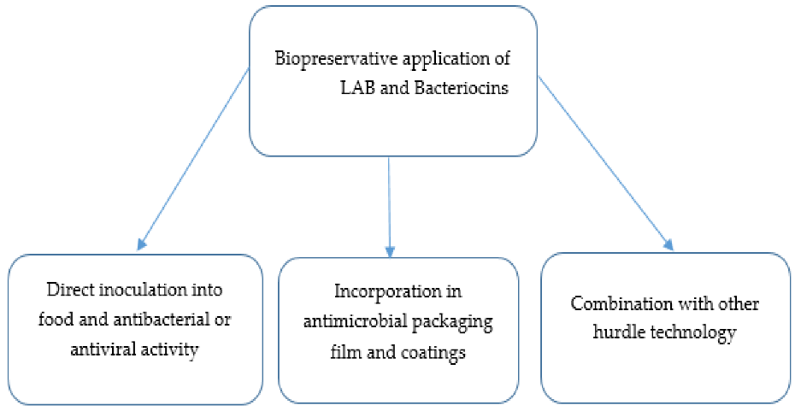
LAB-bacteriocins are known to exert either bacteriostatic or bactericidal activity toward sensitive organisms. Their modes of action have been widely but not thoroughly investigated. Recent insights on modes of action are reviewed elsewhere. Combinations of LAB-bacteriocins and antibiotics are emerging as novel therapeutic options for food-producing animals. Different reports have established the main advantages and synergistic actions of LAB-bacteriocins with other biomolecules. These are the case of enterocin AS-48 and ethambutol against Mycobacterium tuberculosis (Aguilar-Pérez et al., 2018) [24], nisin and citric acid against Staphylococcus aureus and Listeria monocytogenes , nisin and beta-lactams against Salmonella enterica serovar Typhimurium and Garvicin KA-farnesol against a set of Gram-positive and Gram-negative bacteria (Chi and Holo, 2018) [25]. Orally administration of these substances is a challenge because of their enzymatic degradation.
Conclusion
In a worldwide concern, the use of LAB-probiotics stands as an efficient and promising alternative. Different benefits have been observed in animals fed with various LAB-probiotics. As supported by a variety of studies, LAB-probiotics can control the development of bacterial diseases, increase weight gain in healthy and affected animals, stimulate the quality of the (by-) products of this industry or even improve aquaculture water quality. LAB-probiotics can control bacterial infections by excretion of inhibitory compounds, or by other mechanisms including competitive exclusion, decreasing bioavailability of toxins, strengthening intestinal barrier or positively stimulating the immune system. Their actions are exerted in strain and host-specific manners. Finally, there are a variety of synergistic effects when combining LAB with other probiotic species, prebiotics, or enzymes. In terms of future design, recombinant LAB-probiotics may offer additional advantages.
Acknowledgement
I wish to express my profound sense of thanks to our correspondent, Dr. Jeyanandh Dhivaharan., and our chartered correspondent Dr. V. Dhivaharan., Dean, PG and Research Department of Microbiology, S.T.E.T Women’s college,Sundarakkottai, to offering to do the valuable work.
References:
- Aureli CapursoL.CastellazziA.M. ClericiM.GiovanniniM.MorelliL.PoliA.PregliascoF. SalviniF.Zuccotti 2011 Probiotics and Health: An Evidence-based Review. Pharmacol. res. 63 366376.
- BarinovA.BolotinA. LangellaP.MaguinE.Van De Guchte 2011aguin E, Van De Guchte M (2011) Genomics Of The Genus Lactobacillus. In: Sonomoto K, Yokota A, editors. Lactic Acid Bacteria and Bifidobacteria: Current Progress in Advanced Research. Caister Academic Press, Portland, USA.
- Hamdan AM, Sonomoto (2011) Production of Optically Pure Lactic Acid for Bioplastics. In: Sonomoto K, Yokota A, editors. Lactic Acid Bacteria and Bifidobacteria: Current Progress in Advanced Research. Caister Academic Press, Portland, USA.
- Parker RB 1974 Probiotics, The Other Half of The Antibiotic Story. Animal nutr. health. 29 48.
- Fuller 1989 (1989) Probiotics in Man and Animals. J. appl. bact. 66 365378.
- FAO/WHO- Food and Agriculture Organization / World Health Organization 2001 Health and Nutritional Properties of Probiotics in Food Including Powder Milk with Live Lactic Acid Bacteria, Report of A Joint FAO/WHO Expert Consultation on Evaluation of Health and Nutritional Properties of Probiotics in Food Including Powder Milk with Live Lactic Acid Bacteria, Cordoba.Argentina. http://www.who.int/ foodsafety/publications/ fs_management/ en/ probiotics.pdf. Accessed 2011 Dec 15.
- O’May GA, Macfarlane GT 2005 Health Claims Associated with Probiotics. In: Tamime AY, editor. Probiotic Dairy Products. Blackwell Publishing, Oxford, UK.
- KrishnakumarV.GordonI. R. 2001 Probiotics: Challenges and Opportunities. Dairy ind. Int. 66 3640.
- Avall-Jaaskelainen S, Palva A (2005) Lactobacillus Surface Layers and Their Applications. FEMS microbiol. rev. 29: 511-529.
- Choi SS, Kang BY, Chung MJ, Kim SD, Park SH, Kim JS, Kang CY and Ha NJ 2005 Safety Assessment of Potential Lactic Acid Bacteria Bifidobacterium longum SPM1205 Isolated from Healthy Koreans. J. microbiol. 43 493498.
- Hoves H, Norgaard H, Mortensen BP. (1999). Lactic Acid Bacteria and Human Gastrointestinal Tract. Euro J Clin Nutr, 53, 339–350.
- Harish K, Varghese T. (2006). Probiotics in Human-Evidence based Review. Calicut Med J, 4(4), e3.
- Rusynyk RA, Still CD. (2001). Lactose Intolerance, JAOA, 101(4), S10–12.
- Myllyluoma E, Kajander K, Mikkola H, Kyrönpalo S, Rasmussen M, Kankuri E, Sipponen P, Vapaatalo H, Korpela R. (2007). Probiotic intervention decreases serum gastrin-17 in Helicobacter pylori infection. Digest Liver Dis, 39(6), 516–523
- Lam EKY, Tai EKK, Koo MWL, Wong HPS, Wu WKK, Yu L, So WHL, Woo PCY, Cho CH. (2007). Enhancement of gastric mucosal integrity by Lactobacillus rhamnosus GG. Life Sci, 80(23), 2128–2136.
- Arora DR. (2007). Text book of Microbiology (2nd Ed), New Delhi: CBS Publishers, 107–115.
- Plat-Sinnige MJT, Verkaik NJ, Van Wamel WJB, Groot Nd, Acton DS, Belkum AV. (2009). Induction of Staphylococcus aureus-specific IgA and agglutination potency in milk of cows by mucosal immunization. Vaccine, 27(30), 4001–4009.
- Rönnqvist D, Forsgren-Brusk U, Husmark U, Grahn-Håkansson E. (2007). Lactobacillus fermentum Ess-1 with unique growth inhibition of Volvo-vaginal candidiasis pathogens. J Med Microbiol, 56(11), 1500–4.
- Mijac VD, Duki SV, Opavski NZ, Duki MK, Ranin LT. (2006). Hydrogen peroxide producing lactobacilli in women with vaginal infections. Eur J Obstet Gynecol Reprod Biol, 129(1), 69–76.
- Orlando A, Messa C, Linsalata M, Cavallini A, Russo F. (2009). Effects of Lactobacillus rhamnosus GG on proliferation and polyamine metabolism in HGC-27 human gastric and DLD-1 colonic cancer cell lines. Immunopharmacol. Immunotoxicol, 31(1), 108–16
- Kim, Ji-UK, Kim Y,Han K, Sejong OH, Whang KY, Jai, Neung Kim, Kim SH. (2006). The function of cell bound and cell released Exopolysaccharides produced by Lactobacillus rhamnosus ATCC 9595. J Microbiol Biotech, 16(6), 939–945
- Goldin BR, Gualtieri LJ, Moore RP. (1996). The effect of Lactobacillus GG on the initiation and promotion of DMH-induced intestinal tumors in the rat. Nutr Cancer, 25(2), 197–204.
- Liao S. F., Nyachoti C. M. (2017). Using probiotics to improve swine gut health and nutrient utilization. Anim.Nutr. 3 331–343. 10.1016/j.aninu.2017.06.007 [PMC free article] [PubMed] [CrossRef] [Google Scholar]
- Aguilar-Pérez C., Gracia B., Rodrigues L., Vitoria A., Cebrián R., Deboosère N., et al. (2018). Synergy between circular bacteriocin AS-48 and ethambutol against Mycobacterium tuberculosis. Antimicrob. Agents Chemother. 62:e00359-18. 10.1128/AAC.00359-18 [PMC free article] [PubMed] [CrossRef] [Google Scholar]
- Chi H., Holo H. (2018). Synergistic antimicrobial activity between the broad spectrum bacteriocin garvicin KS and nisin, farnesol and polymyxin B against Gram-positive and Gram-negative bacteria. Curr.Microbiol. 75 272–277. 10.1007/s00284-017-1375-y [PMC free article] [PubMed] [CrossRef] [Google Scholar]

