**INSTALLATION & TESTING IN BDSL TEST**

**PROF. RAHEMANALI PARABADIYA**

**ASSIT.PROFESSOR OF CIVIL ENGINEERING**

**GROWMORE INSTITUTE OF ENGINEERING HIMATNAGAR**

**TERMINOLOGY RELATED TO BDSL TEST**

* **Axial compressive load**: - The maximum axial compressive load is a deep foundation cantransfer to the soil and rock around it at a suitable axial movement.
* **Bi-directional jack**: - A specialized hydraulic jack that has a repeatable, linear load-pressurecalibration over its increase range. Urban development due to which the residential growth is efficient and has achieved certain level of uniformity.
* **Bi-directional axial compressive load test:** - An axial compressive load test performed on a deepfoundation element by pressuring an embedded jack assembly, that the foundation section above the jack assembly moves upwards and the foundation section below the jack assembly moves downwards, each section providing reaction from which to load the other.
* **Cast in-situ pile**: - A deep foundation element made of cement grout and constructed inits final location, for example drilled shafts, bored piles, caissons, auger cast piles etc.
* **Deep foundation**: - A comparatively slender structural element is transmitting some load itsupports to soil or rock well below the ground, such as a steel pipe pile or concrete drilled channel.
* **Driven pile**: - A deep foundation element is made of preformed material with a prearranged shapeand size and typically installed by impact hammering, vibrating, pushing.
* **Jack Assembly**: - One or more bi-directional jacks prescribed together with each plates to act inparallel symmetrically around a central axis, which will be embedded within a deep foundation element to apply a bi-directional compressive load allied with the central axis of the deep foundation element.
* **Steel reinforcement:** - the purpose of this Standard, this may consist of any steel accumulationor steel member such as a reinforcement cage, channel frame, box beam, wide-flange beam used to reinforce the concrete column, or in a non-production pile, to fix the jack and instrumentation in place.
* **Tell-tale rod: -** An unstrained metal rod extended through the test pile from a specific point withinthe pile should be used as a reference from which to measure the change in the length of the loaded pile section, or the absolute movement at that specific point.
* **Wire line:** - a steel wire attached with a constant tension force between two supports and used as areference line to read a scale indicating movement of the test pile.
* **Barrette:** - A cast-in-situ constructed pile is non-circular cross-section, i.e. rectangular, square,T-shaped, H-shaped etc.

**INSTALLATION PROCESS OF BI-DIRECTIONAL STATIC LOAD TEST**

Giving to the Geology and soil investigation finding out the ultimate bearing capacity of the soil by friction and end bearing. belong to this data design load and other calculation like pile parameter are calculated. Based on pile parameter the boring process is done.

**BRIEF STEPS OF THE INSTALLATION**

* Finding the location of balance point.
* Choose of right size and type of super cell, and appropriate level to install load cells.
* Preparation of super cell, strain gauge and accessories to be pre-installed into the pile.
* Field work to install instruments on re-bar, and completion of concrete casting.

**FINDING THE LOCATION OF BALANCE POINT**

Preliminary data and pile parameter of site, friction resistance and end bearing through finding out the balance point at which the load is distributed 50-50 %. Selection of the supercell according to the pile parameters.

1. Supercell on bottom of pile when the maximum skin friction around equals to end bearing.
2. It is located at this balance point when the upper portion of skin friction equal to the lower portion friction plus end bearing.
3. In over-drill pile bore and place supercell at the originally designed pile length(depth).it is purpose to measure uplift capacity of the pile.
4. To determine the uplift capacity of pile with enlarged bottom.
5. When skin friction is larger than end bearing, an expansion of pile toe may be built to produce more reaction from below of super-cell.
6. Concrete may just be casted in rock socket, so the cell embedded may be utilized just to measure the skin friction and end bearing of socketed rock sections.
7. It is used, when cut off level is lower than the ground level. example, high rise building with multi-storey basement using extension of tell-tales rods and hydraulic hoses.
8. If there is need to test when skin friction of two and more soil layers.
9. Install multiple supercell at different levels and make sure each section of test pile is always fully motivated after loaded enough reaction.
10. Easily applied in basement for test.
11. Installation of supercell in pre-fabricated pile ahead of piling, test is applicable to drive pile too.
12. One cell installed on pile bottom, other installed at the level where upper reaction approx. equals lower reaction the loading test before and after grouting inside the pile may help tell the difference the grouting process would make on skin friction and end bearing.
13. Two or more supercell may be utilized for different test purposes. The upper portion supercell only function to test the pile side resistance and cell placed on pile bottom function to test end bearing.
14. If there is no enough skin friction provided above jack assembly, dead load may be added on pile head as extra reaction.

**CHOOSE OF RIGHT SIZE AND TYPE OF SUPER CELL, AND APPROPRIATE LEVEL TO INSTALL LOAD CELLS:**

* Based on the balance point and pile parameter the supercell is chosen.
* Formula for the supercell load calculation: -

**For one cell load capacity = ultimate load (factored)/ (2*number of cells provided).**

* Based on above formula and type of super cell, the supercell is factory-made in the workshop and transported to the site.
* According to the diameter of pile super cell is chosen.
* **Type of supercell: -**

1. **Donut-shaped Super Cell:** - Usually applicable to friction pile with max. 1.2m diameter.



Fig.Donut shaped supercell

1. **Multiple/combine Super Cell: -** Usually applicable to large pile diameter (>1.2m) and large load, flexible combination.



Fig. Combined supercell

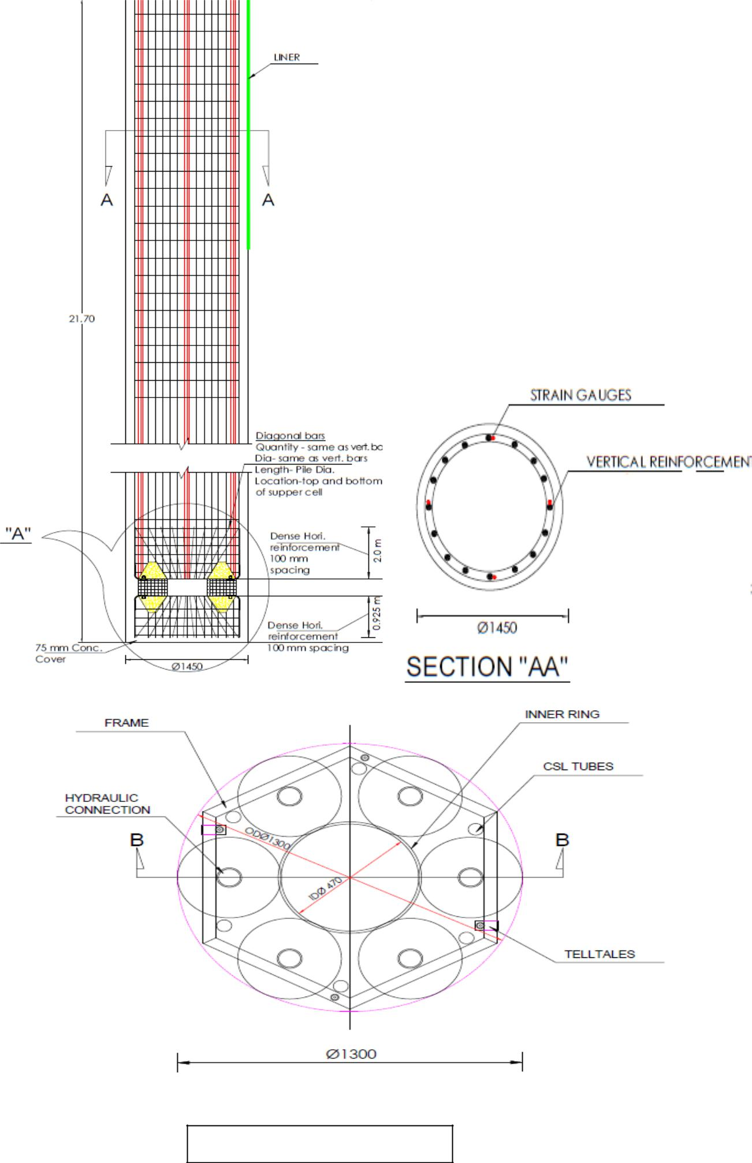

Fig. section of self-configuration drawing

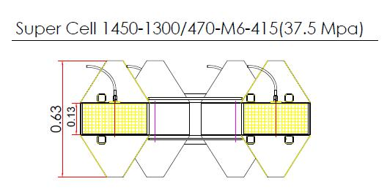

Fig. Detail clarify the Supercell 1450-1300/470-M6-415(37.5 Mpa)

* **DETAIL CLARIFY THE SUPERCELL 1450-1300/470-M6-415(37.5 MPA)**
* This detail clarifies the supercell.
* Where, supercell is name given.
* 1450 =diameter of pile
* 1300 =supercell diameter out-to-out
* 470 = inner diameter of opening space
* M6 = six number of cells is used
* 415 = diameter of each cell
* 37.5 Mpa = vertical test load in MN (mega newton)
* Concreting of the supercell before the 24-hour pile concreting., same grade of concrete used in test pile. concrete pore into the supercell cone shape.

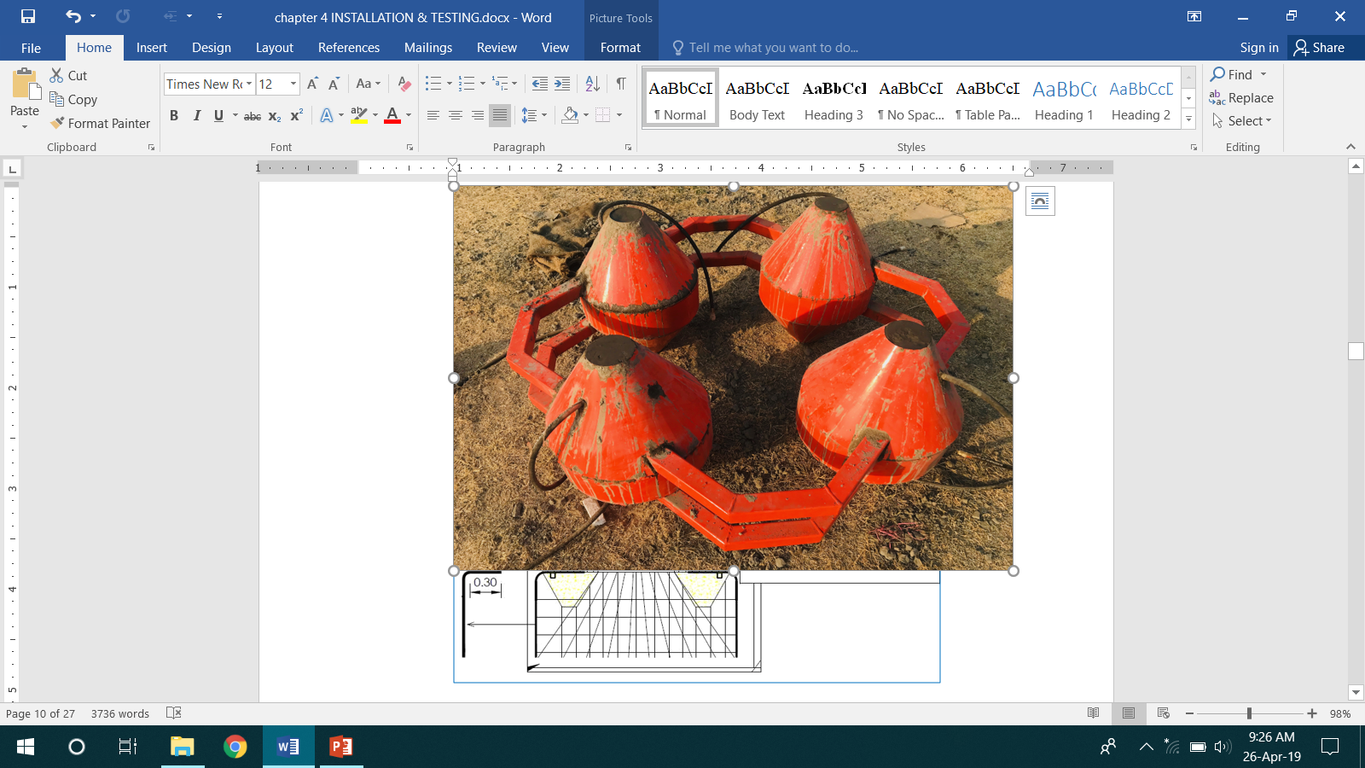

Fig. Precast of flow guides

**PREPARATION OF SUPER CELL, STRAIN GAUGE AND ACCESSORIES TO BE PRE-INSTALLED INTO THE PILE CONNECTION OF SUPERCELL IN TO THE PILE CAGE:**

Supercell connected to pile cage using arc weld. L-type of re-bar made of the diameter of vertical bars is used. L-type of bar used to connect between the supercell and pile cage or connection purpose. Supercell not tilted on pile cage so proper level check by use of plumb bomb and bubble level tube. Tell-tale rod some cover type mechanism is used at bottom of the frame of supercell.

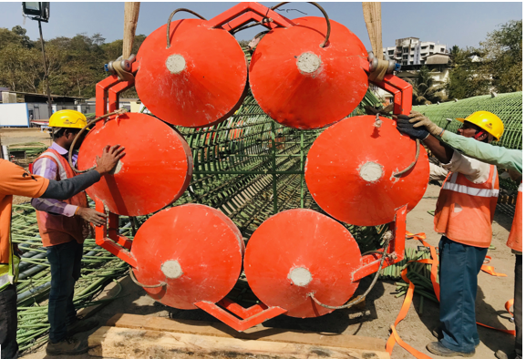

Fig. Connection of super cell to the pile

* **CAGE CONNECTION OF HYDRAULIC HOSES FROM SUPERCELL: -**

Two hydraulic hoses shall be provided for input and return flexible pipe which resist the higher viscous pressure. It is extended from top of test pile to cell location. In combine cell hydraulic connected in parallel with an embedded jack manifold to verify the flow and pressure leakage. Each hose pipes should be clearly marked at each jack and both side of any connection and at the test pile top should be identify easily.

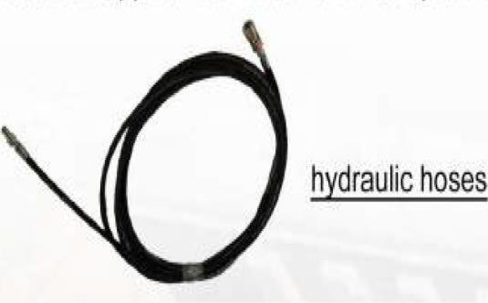

Fig. Hydraulic hoses

* **STRAIN GAUGE CONNECTION INTO PILE CAGE: -**

The vibrating wire strain gauges work on the principle that the natural frequency of a wire changes as its length changes. Thus, by measuring the change in frequency with the vibrating wire readout device, the corresponding stress can be calculated by means of relevant formulas, and hence strain obtained. The axial load at each level where the VWSG is installed can be calculated by the strain of the gauges multiplied by Young’s Modulus Ec and cross section of the pile area, of both the concrete and the main steel reinforcement.

Strain gauge preparation on office. First of all, based on level of given into elevation at which the strain gauge should place. Calculating the length of cable base on Reduce level. How many numbers of cable used is show into plan? Cutting of the cable according to calculated length. Each strain gauge checks the frequency and note as before the concreting this much frequency. After this the strain gauge cable and cutting cable is connecting with soldering using cladding. in this connection slive is used. Slive basically the polymer thin cover provided on connection to don’t enter water of concrete. slive is shrink and stick to cable when using the heat shot gun which hot air flow to slive. Strain gauge preparation was completed and transported near to the pile installation.

* **CONNECTION OF THE STRAIN GAUGE CABLES INTO PILE CAGE:**

Strain gauge cable connected to pile cage using the tie (plastic type of tread, which easily interlock as rope). Strain gauge cable at level of strain gauge loop (circle) is provided so that not elongation during the extension of cable up to top of test pile. At the level of the supercell strain gauge cable was looped and it put into the soil waste pipe (plastic pipe of 5 cm diameter) and properly sealed with using Teflon tape. Strain gauge is providing at particular level opposite of each other.

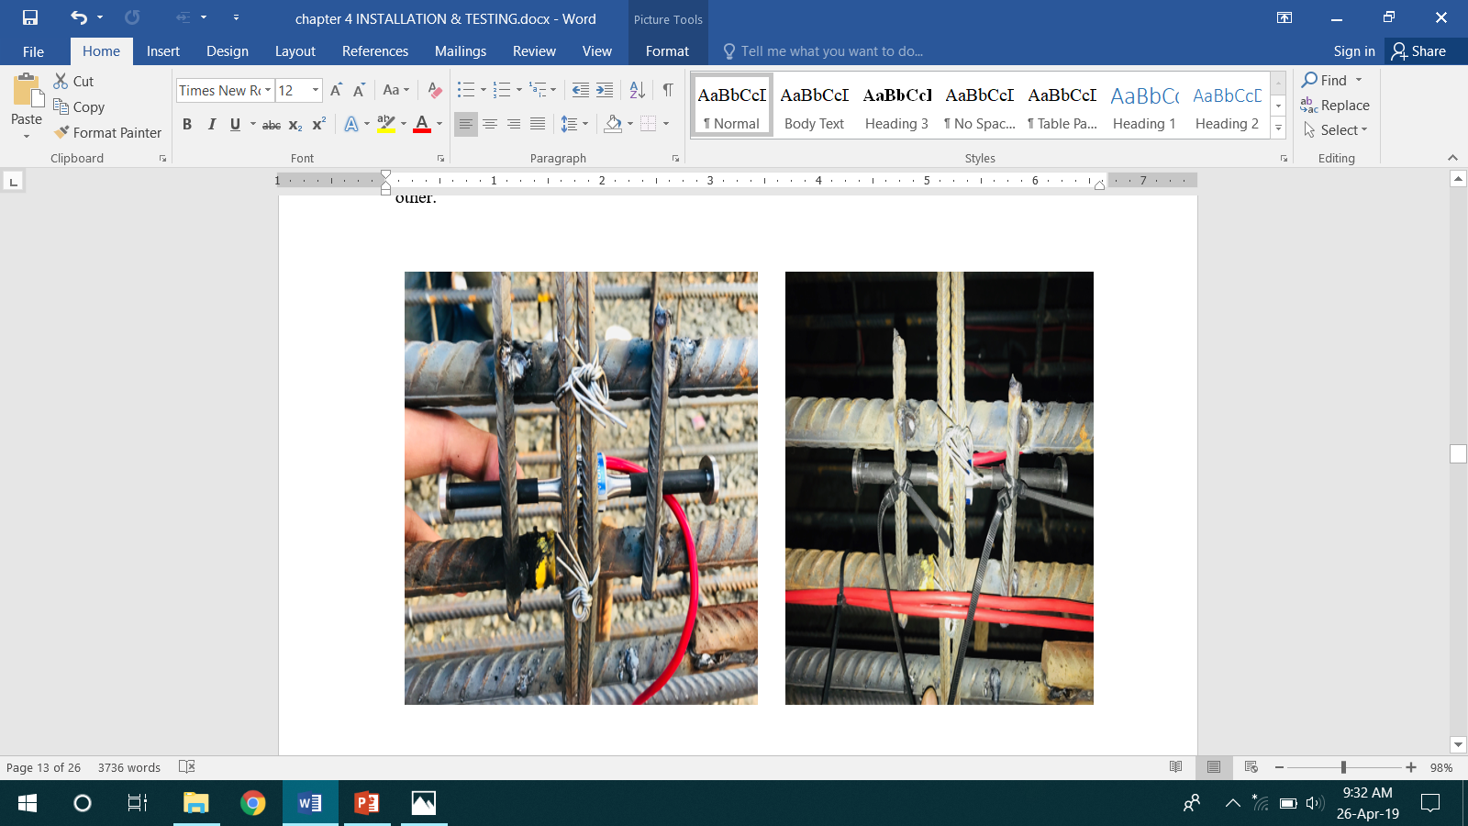

Fig. joint the strain gauge in pile cage

* **TELL TALE ROD CONNECTION TO SUPERCELL: -**

Tell-tale rod is basically metallic rod which used for top pile to measurement of displacement using displacement transducer. Tell-tale rod is cover with steel pipe so easy movement or free movement of tell-tale rod. Tell-tale rod connected at bottom and top of the supercell frame.it is extended up to pile top. Tell-tale is nut -bolt type mechanism so that it is easily connected. If it was not proper connected than weld is used.

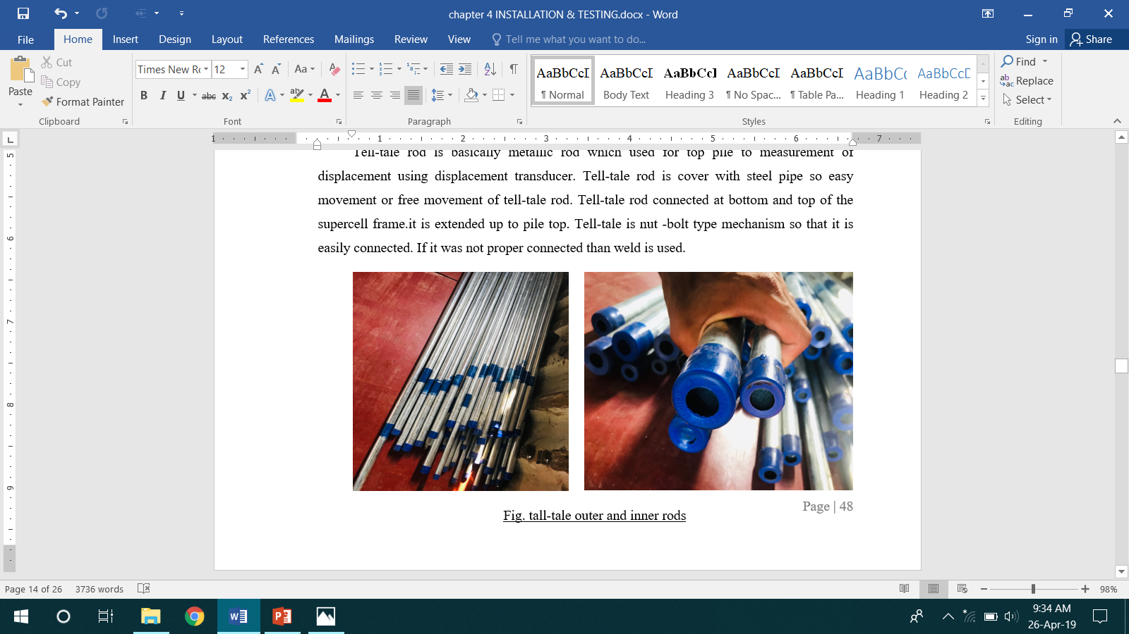

Fig.Tell-tall outer and inner rods

* **CSL (CROSS HOLE SONIC LOGGING PIPE):**

It is used to finding the cavity in concreting of pile. It is connected the pile cage and supercell CSL hole provided so that this hole through at the end of pile cage. it is connected to pile cage using the U –type using of 12 mm diameter of re-bar. it is connected properly fitted to each other. then checked at the interval of CSL pipe using water, when the water is stable, not reduces so that CSL pipe is leakage proof. It is also extended up to the pile top. CSL pipe is also provided Teflon type tape to help leakage proofing. CSL pipe is tested for concrete cavity and then filled concrete.

* **FIELD WORK TO INSTALL INSTRUMENTS ON RE-BAR, AND COMPLETION OF CONCRETE CASTING.**

Guide rails is connected to the supercell for purpose guide the tremie concrete pipe during concreting. After the preparation of the strain gauge the combine supercell or selected cell is connected the hydraulic hose/s for use of pressure applied during the test. Hydraulic hose, cross whole sonic logging (CSL) pipe, tell-tale rod is extended up to the pile top. In large length pile cage is connected in the parts During connection proper care taken for Hydraulic hose, Cross hole sonic logging (CSL) pipe and tell-tale rod. Near by the supercell connection the close helical loop (10 mm diameter bar ring) is provided below and above up to 2 meters with 100mm spacing using weld. Staggered length of pile cage for lapping is 40*diameter of pile*1.3, this formula is used. After the connected the supercell and pile cage is lower down the pile assembly into bore hole. If the hydrostatic force is presented in soil for stabilization process using viscous material (chemical) also used in pile bore hole. The strain gauge frequency measured before and after concreting of pile. If during the installation of pile cage concrete cover is broken if possible than the broken piece of concrete is removed. After the lower down process, the Concreting was done.

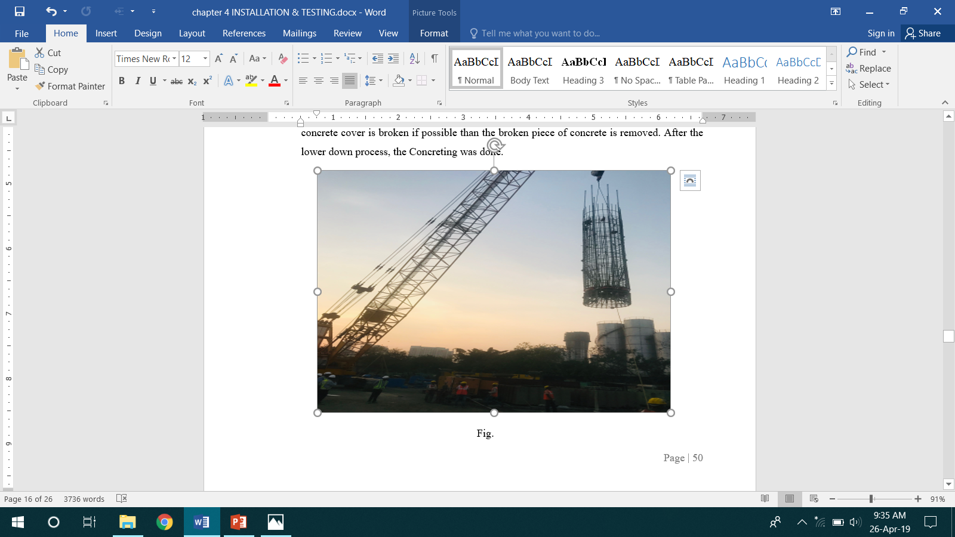

Fig. Lift the cage with cell

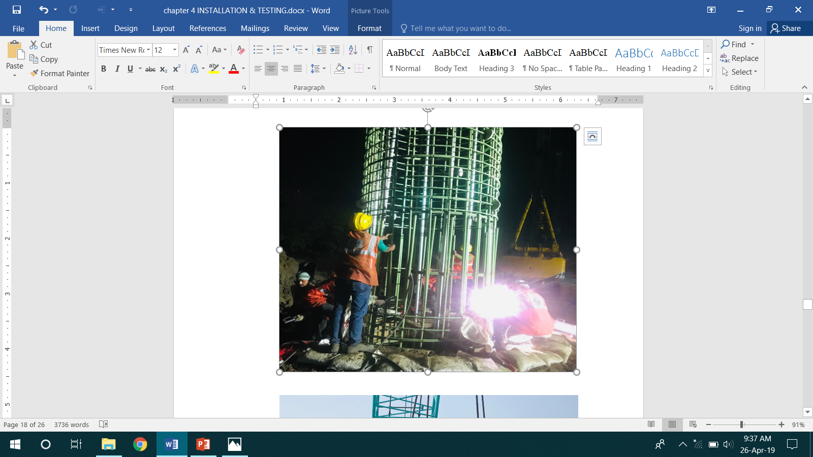

**TESTING**

**TESTING SETUP & DATA ACQUIRSITION**

Upward pile movement shall be informed as positive and downward movement as negative. Pilecompression shall be reported as positive and expansion as negative. Jack assembly expansion shall be reported as positive and closure as negative.

Reference beams and wire lines used shall have supports firmly embedded in the ground at a clear distance from the test pile of at least three times the diameter of test pile. A single reference beam shall be oriented across pile top or two parallel reference beams, one on each side of test pile. Reference beams shall have adequate strength, stiffness and cross bracing to provide stable support for the test instrumentation and to minimise vibrations that may affect the measurement of pile movement. One end of each beam shall be free to move laterally as the beam length changes with temperature variation. Supports for reference beams and wire lines are isolated from moving water and wave action.

A trap shall be providing to prevent directsunlight and rainfall from affecting the measuring and reference systems.

General test arrangement and setup for load, displacement and strain gauge data collections are detailed below.

* Five (5) Linear Variable Wire Displacement Transducer (LVWDT) were used to collect the displacement data.
* Two (2) LVWDT setup in top of 16 mm tell-tale rod positioned inside 32 mm casing connected to bottom of supercell to measure bottom compression.
* Two (2) LVWDT setup in top of 16 mm tell-tale rod positioned inside 32 mm casing connected to top of supercell to measure upper compression and to vent the break in the pile formed by Expansion of the Supercell; and One (1) LVWDT gauge setup in top of pile to measure upward movement of pile.
* Approximately 13-meter-long ISMB250 section was used as reference beam supported on 900 mm diameter casing driven into ground. The reference beam was about 600 mm above the top of the pile.
* A vibrating wire pressure transducer and digital gauge was used to maintain and measure the applied load. Closed agreement between two gauges was observed.
* Pressure gauge and displacement gauge were connected to data logger for automatic reading at present time interval real time.
* All the Strain gauges were read by automatic data logger prior to each increment of the load using DATATAKER 85G.

Electronic indicator movements shall be displayed in real-time during the test. Displacement indicators used for measuring pile movements shall have a minimum travel of 100 mm and minimum advancements of 0.01mm or less. If larger displacements are expected, bigger travel, stem extensions shall be provided. Dial indicators and electronic **On-Site Test Set up Location.**

Displacement indicators shall be in good working condition and shall have a full range calibration within 12 months prior to the test. Laser, digital survey levels can be used for secondary pile top axial movementmeasurements and to confirm reference movements.

Unstrained tell-tale rods, with a typical diameter of 6 mm shall be used to measure the axial pilemovement. Tell-tale rods will be installed in an open sheath or casing or tubing having an inside diameter around two times the tell-tale rod diameter to ensure free rod movement during the test. A glass plate shall be clamped and glued to the tell-tale rod perpendicular to the rod. A single tell-tale can be installed on the axis or tell-tales can be provided in pairs at the same elevation to obtain an average measurement on the pile axis, with the tell-tales in each pair concerned with diametrically opposite to each other and intermediate from and parallel to pile axis. For test piles exceeding 1.80 m diameter a minimum of two pairs of tell-tales shall be installed at each elevation to obtain an average measurement, ideally with one pair orthogonal to other. The tell-tale rods shall have a rounded or pointed tip that bears on a clean steel plate affixed within the pile or shall be threaded into a nut affixed within the pile or firmly fixed with any available method. Tell-tale rods shall be cleaned and lubricated prior to installation in pile. Centralisers will be provided for the rods at the pile top to restrain lateral movement but not axial movement. Alternatively, an axial tension displacement indicator can be attached to the tell-tale and other end can be fixed to a rigid reference to measure the axial movement of tell-tale rod. Distance from pile top reference to the end point of each tell-tale shall be measured to nearest 25 mm or less.

Indicators, scales or reference points involved to the test pile, reference beam or other referencesshall be resolutely affixed to prevent slippage during test. Verification shall be done for wire line supports and reference beams, so as, to prevent movement during the test by using a surveyor’s level for taking readings on a survey rod to permanent bench mark located outside instant test area.

**TEST PROCEDURE**

Use of embedded jack assembly apply load the test pile will result in application of test load which is twice the load measured in jack assembly. The test uses load intervals to better estimate the anticipated movements. Structural capacity of pile or jack assembly will not be exceeded in the test procedure.

Prior to testing, concrete in the pile should generally achieve approximately uniform strengththroughout the pile and at least 85% of maximum design compressive strength.

The static axial capacity of piles typically changes as time intervenes after pile installation, dependingon rock or soil properties, on the pore water pressure and soil structure interface while installing pile. This behaviour can be for both cast-in-situ as well as driven piles.

Prior to performing the test hydraulic fluid shall be dispersed through each jack to verify hoseconnectivity, soak the system and flush some blockages.

Prior to test, any safety locks placed on the jack assembly will be removed for safe handlingduring placement in the pile. Welding must be cracked during initial pressurisation of the jack assembly. The initial pressurisation shall proceed until a crack plane forms across the pile and all welds or locking mechanisms are completely disengaged, at that time the pressure shall be reduced to zero for at least 1 minute before opening the loading on pile.

Jack operating peoples shall check for pressure leakages during each load interval. Constantpumping without expansion of jack assembly or a significant difference between the pressures slow on the input and return pressure lines can indicate hydraulic leak. Leaks shall be identified, isolated and repaired before remaining the test. The effect of leak will be assessed with consistency of test results.

**LOADING PROCEDURE**

Load on jack assembly will be applied in 10 equal increments with each increment not morethan 5% of maximum specified test load, since maximum specified jack assembly load will be 50% of maximum specified test load. Separately load increment shall be added in a constant operation attaining the load following the completion of movement readings for the previous load intervals. If significant movement occurs above or below the jack assembly, the loading time is comprehensive to apply the load increment to the opposing portion of the pile. Load increments shall be added till reaching half of the maximum specified test load, until reaching the maximum expansion or load capacity of jack assembly, or until observing continuing, progressive expansion of jack assembly, but structural capacity of pile shall not be exceeded. Below results shows Load vs displacements top and bottom movements.

**RECORDING TEST READINGS**

Time of practical pressure, jack assembly load, pile measure, jack assembly expansion, pilecompression, pile strain, reference movement for each identified gauge, scale and reference point shall be verified for each increment directly, preferably within 1 minute of each loading. It is desirable to use a data logger system to condition and store the test data in digital form. Thedata logger will be connected to an electronic system that displays the numeric results in real time during the test. The jack’s manufacturers shall verify its accuracy Load shall be useful in each increment and decrement of 5% of maximum specified test load at1, 2, 5, 10 and further each at 10 minutes up to the duration of total load. It should be observed here that maximum specified jack assembly load will be 50% of maximum identified test load in bi-directional testing. Instrument reading shall be recorded within 1 minute before application of next load increment or decrement. If required, data logger can be recycled to automate the test of results. Measurements obtained in the form of bend upwards and downwards shall be plotted. The ordinate above 0.00 mm displacement with respect to the load in abscissa indicate upwardmovement of the jack system recorded, and the ordinate below 0.00 mm with respect to the load in abscissa indicate downward movement of the jack system at respective loads. Further an equivalent top load curve derived and plotted. This equivalent top-load curve shall be read for load – displacement requirements.

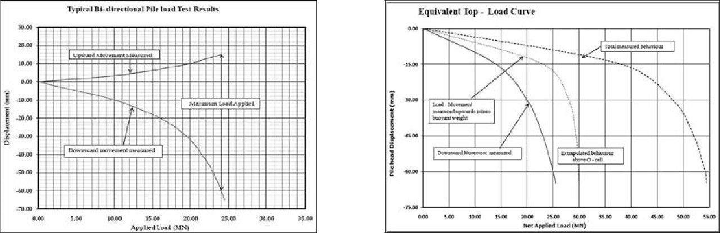

Fig.Equivalent top-load curve

**BI-DIRECTIONAL STATIC LOAD TEST ADVANTAGES**

In comparison with traditional loading test methods such as kentledge or anchor reaction, bi-directional loading test is a relatively new method that requires load cells and other apparatus to conduct the testing process. The following advantages separate bi-directional loading test from conventional static loading tests.

* Unlimited test load

Test load is no longer limited by reaction load anymore. Theoretically, in bi-directional loading test, load cells may produce enough force to crush the concrete, hence, the max test load to be applied would be limited by strength of concrete, instead of load cells.

* Improved safety

The reaction load of bi-directional loading test is built up by load cells embedded inside the test piles. Therefore, there is no need to set up any reaction force on the ground, by preparing exterior anchor structure or concrete blocks as dead load, eliminating the safety risks of collapsing structures, which may result in serious consequences.

* Limited work area required

Testing may be conducted next to existing buildings, under passageways, highway median strips, and even offshore. Testing apparatus is set next to the pile, with a reference beam six times the pile diameter. Testing tents may be set up quickly, and requires much less space compared to conventional static load tests.

* Time-saving

A considerable amount of time can be saved, without the work needed to prepare dead load or anchor piles for reaction.