**MUTUAL FUNDS: ADDRESSING THE NEEDS OF MANY INVESTORS**

**Manish Sharma, Assistant Professor, Apeejay Stya University**

**E-mail (tipsmanish.s@gmail.com)**

**Abstract**

Mutual funds are getting popular in India which is evident from the growth of Mutual funds in the last decade. The AUM of the Indian MF Industry has multiplied more than 5 times from ₹ 7.30 trillion in July 2012 to ₹37.75 trillion in July 2022. It offers many benefits to retail investors which include the benefits of professional fund management, diversification, and convenient administration. Mutual funds have good return potential and charges low cost from investors. Liquidity, transparency, flexibility, and choice of schemes also make it an attractive investment option. Mutual funds also offer tax benefits and are well-regulated. Mutual funds are available in a large variety that can fulfil the requirements of many investors in India. There are Mutual funds that can help your money to grow. Also, funds like debt funds are available that can help you earn stable returns with lesser exposure to risks. This chapter intends to highlight the meaning, functioning, and benefits of mutual funds in India. The growth of the mutual funds' industry in India is also discussed in this chapter. In the end, this chapter explains how mutual funds have actually simplified the complex investment decisions of many retail investors.

**Keyword (s):** Mutual Funds; Investment; Investment decisions; Asset under Management; Investment Avenues.

1. **Introduction**

You may have different financial goals in your life. The majority of these goals would be the education of your children, buying a house or a car, marriage of the children, going on a world trip, or your retirement. For all these goals, planning of finances is important. It is important for you to create financial plans for all these goals so that you have sufficient funds for fulfilling these goals. Financial instruments play an important role in fulfilling your financial dreams. There are many investment avenues where one can invest. Before you invest in any investment product, you should learn about its potential risks, limitations, costs, liquidity, tax benefits as well as other characteristics of the products. Figure 1.1 indicates a few investment parameters that every investor shall consider before investing.



Figure 1.1 Investment parameters

These instruments can be categorized into financial assets and non-financial assets. Financial assets may include market-linked products like equity shares, mutual funds, NPS; and fixed income products like PPF, Bank Deposits, or other small saving schemes. Non-financial assets are traditional products like gold or real estate. A large number of financial products are available in our county. Figure 1.2 indicated the investment avenues available in India.

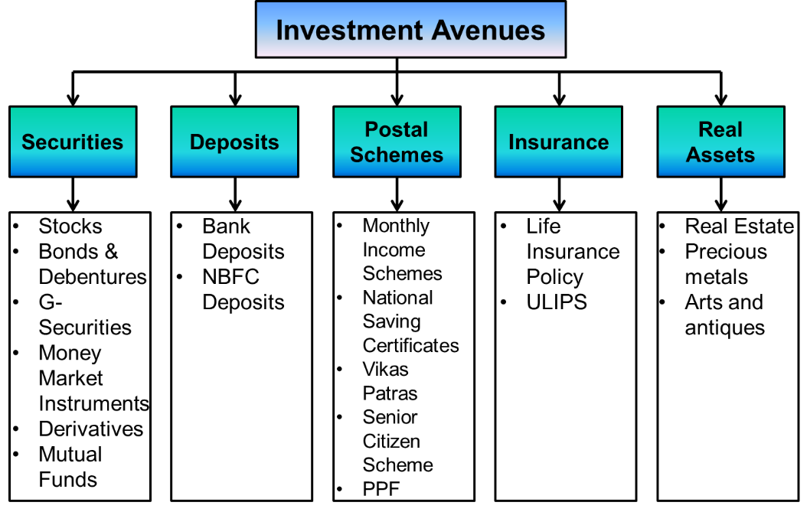

Figure 1.2: Investment Avenues in India

Mutual funds are becoming popular these days that can meet the requirements of many investors. There are various types of mutual funds available in our country with a variety of return potentials having different risks associated with them. Let us now understand what mutual funds are.

1. **Meaning of Mutual Fund:**

“A mutual fund is a collective investment vehicle that collects & pools money from a number of investors and invests the same in equities, bonds, government securities, money market instruments”[1]

In a mutual fund, investors having similar investment objectives pool their money. A fund manager invests this pool of money in different investment avenues to generate returns for the investors. The assets managed by AMC is known as an asset under management (AUM). Anyone with a small surplus of even thousands can start investing in mutual funds. You can start investing in a mutual fund by paying $₹$ 500/- per month through a systematic investment plan (SIP).

1. **Mutual Fund Industry**

Indian Mutual Fund Industry was having an average Assets Under Management of ₹ 37,76,911 crore for July 2022. The AUM of the Indian MF Industry in July 2012 was ₹ 7.30 trillion, which has grown more than 5 times to ₹37.75 trillion in July 2022. In a span of the last 5 years, the AUM of the Indian Mutual Fund Industry has approximately doubled from the AUM of ₹ 19.97 trillion in July 2017 to the AUM of ₹37.75 trillion on July 31, 2022.[2]

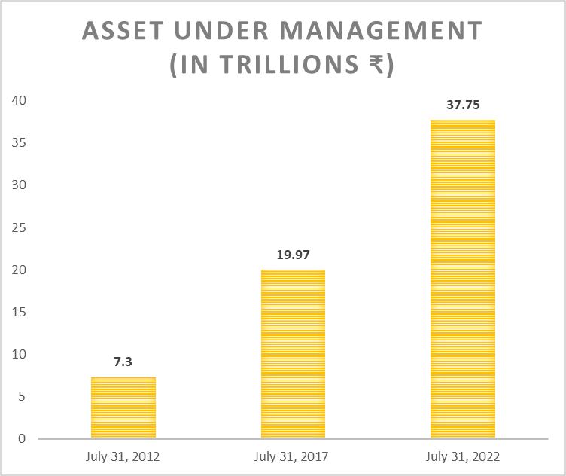

Figure 3.1: Investment Avenues in India

The Indian Mutual fund industry had crossed the AUM of ₹10 Trillion (₹10 Lakh Crore) in May 2014, ₹ 20 trillion (₹20 Lakh Crore) in August 2017, and ₹ 30 trillion (₹30 Lakh Crore) in November 2020.[3]

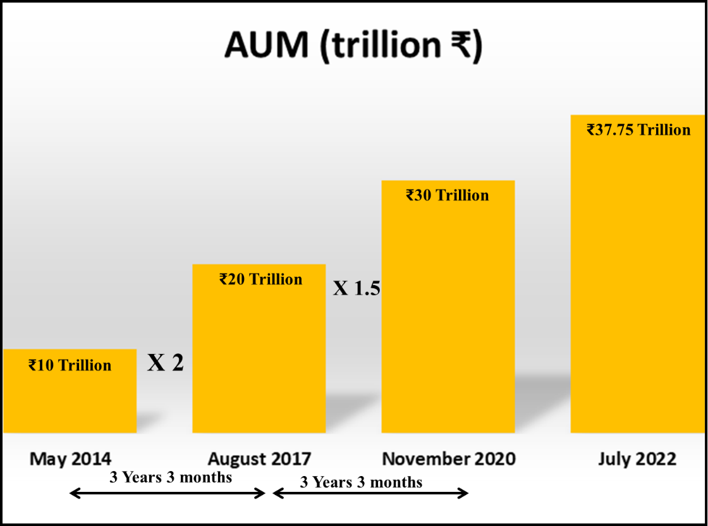

Figure 3.2: Growth of Mutual Funds in India

1. **How Mutual Fund works?**

Investors with similar objectives pool their funds to invest in mutual funds. A pool of funds is created. A mutual fund manager then uses this money to invest in various investment instruments in the market. The investment avenues may include a variety of instruments like equity shares, debentures, bonds, derivatives, money market instruments, and mutual funds of other companies. The instruments in the portfolio will be decided according to the objectives of the fund. Investments in these instruments generate returns which are passed back to the investors. As these instruments are subject to market risk, you may face capital depreciation or losses. How much profits and losses you will get depends on the Net Asset value (NAV) of the mutual funds. Figure 4.1 indicates the process of working of Mutual funds.

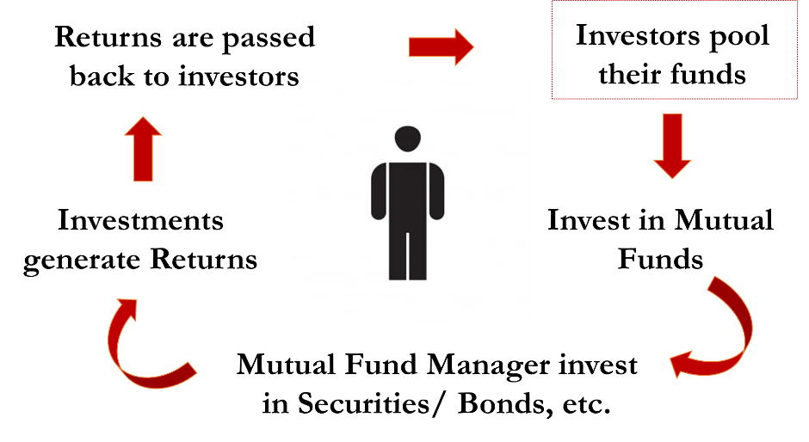

Figure: 4.1 Process of Mutual Fund

1. **Advantages of Mutual Funds**

Mutual Funds offer many advantages to investors. Some of these benefits are indicated in the figure 5.1

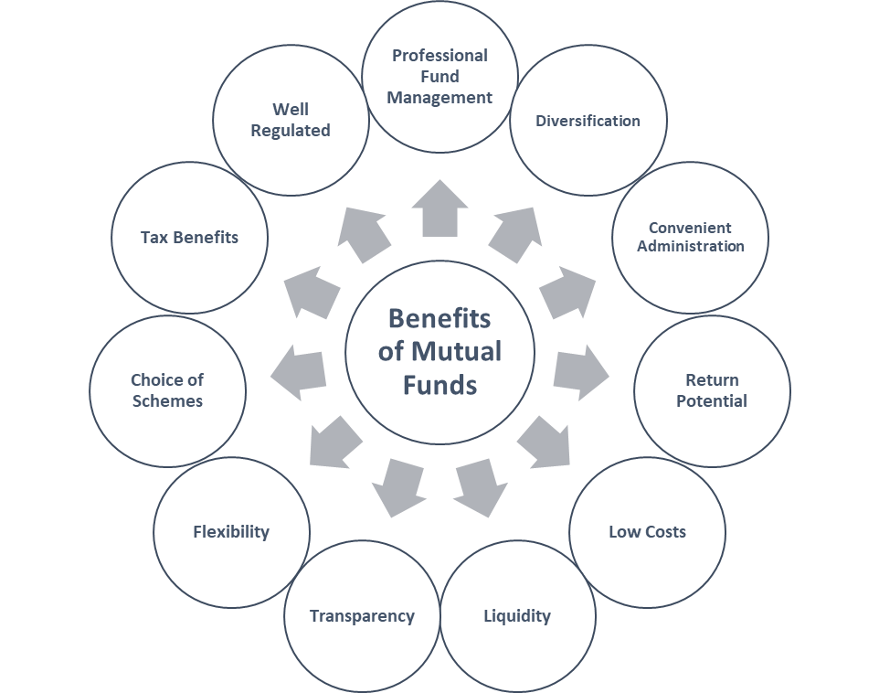

Figure 5.1: Benefits of Mutual Funds

**5.1 Professional Fund Management**

When you invest in a mutual fund, your funds are managed by professional fund managers. Asset Management companies hire experts for managing their mutual funds. You can check the details of the fund managers on the website of company before selecting a mutual fund. You need not decide where the money will be invested. One may not have the expertise or time to manage his investments. Your mutual fund manager will take these decisions on your behalf.

**5.2 Diversification**

Diversification is another benefit that makes mutual funds an attractive investment avenue. Retail investors are generally having a small kitty of funds to invest. But there are investment instruments that require a large amount of money for investment. As an individual investor, you may not be capable of investing in those options but as your fund manager is having a bigger pool of funds, he/she can invest in those investment options. The returns generated by these investments’ options will be passed back to the investors in the same proportions of their investments.

**5.3 Convenient Administration**

It is very easy for an investor to invest in a mutual fund. One can easily buy a mutual fund with a click of a button. Details related to fund managers, the objective of the mutual funds, NAV, past returns and current performance is all available online.

**5.4 Return Potential**

Risk and return are directly proportional. Investors should invest in a variety of Mutual funds as per their risk appetite. You can also see the returns generated by different categories of mutual funds for getting an idea about their performance and return potential. One should always remember that investments in mutual funds are also subject to the risk of the market. You should read all the terms and conditions of the mutual funds before investing.

**5.5 Low Costs**

As per the SEBI (Mutual Funds) Regulations, 1996, Asset management companies are allowed to charge a fee against their operating expenses for managing a mutual fund scheme. This may include expenses related to marketing and sales, advertisement, investment management fees, registrar and custodian fees, fees related to audit, etc. as a percentage of the daily net assets of the respective fund. The cost related to these heads collectively can be referred to as TER or Total Expense Ratio. TER is the annual fee charged by the mutual fund which is deducted from the NAV on the daily basis. Table 5.1 indicate the TER limit with effect from April 1, 2020. The cost of the mutual fund is low when compared with the majority of other financial instruments.



Table 5.1: Total Expense Ratio based on AUM with effect from April 01, 2022

**5.6 Liquidity**

Investors can easily redeem or liquidate the units of open-ended mutual funds to meet their financial needs. This can be done on any business day when stock markets or banks are generally open. The redemption amount is credited to your account within a day to a max 3-4 days. This depends on the type of scheme, as for liquid funds or overnight funds, the amount is paid out the next business day of the redemption request. Close-ended funds cannot be redeemed through a fund house but can be bought and sold on the stock exchanges. The liquidity is provided through the selling of mutual funds on stock exchanges.

**5.7 Transparency**

Transparency in mutual funds also makes it an attractive investment option for investors. Investors have easy access to information like, the details of the fund managers, portfolio of the scheme, cost charged by a particular mutual fund, past performance, NAV, etc.

**5.8 Flexibility**

Mutual funds in India offers you flexibility in terms of dividend that can be reinvested. It also offers you the option of systematic investment plans where one can regularly invest in mutual funds just like recurring deposits. The option of systematic withdrawal plans is also available where you can withdraw at regular intervals.

**5.9 Choice of Schemes**

Mutual funds are available in different varieties that can meet the requirement of many retail investors. Mutual Funds can be categorized on different basis. Figure 5.1 indicates the categorization of Mutual Funds based on the investment objective.

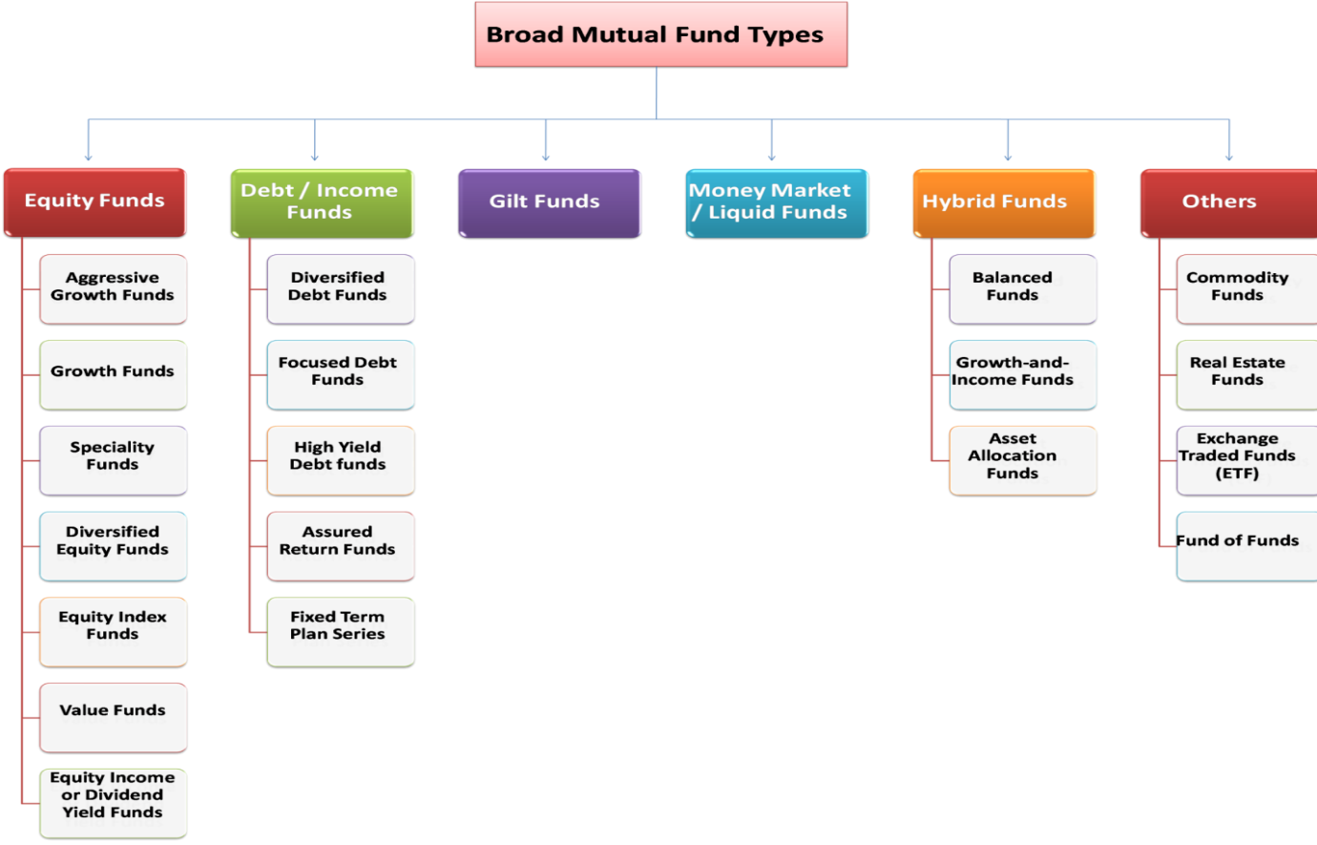

Figure 5.1: Categorisation of Mutual Funds on the basis of investment objective

Equity funds and Debt funds are very popular among investors. Equity funds, popularly known as ‘Equity oriented Mutual funds’ are those where your money is primarily invested in the equity shares of the companies. Debt funds on the other hand are those funds where your money is invested in fixed income securities like debt and money market instruments. Debt market instruments include Non-convertible debentures (NCDs), Corporate Bonds, Government Bonds or G-Secs, etc. Money market instruments include Treasury bills (T-Bills), Certificates of deposits (CDs), Commercial papers (CPs), etc. Equity funds have the potential to generate higher returns but are riskier at the same time as it bears the same risk which is present with the equity shares. Debt funds are suitable for those who are looking for stable returns with less risk appetite.

There are many other categories like Gilt Funds, Money market or Liquid funds, Hybrid funds, etc. that one should explore before investing. Gilt funds invest in government securities whereas Money market or Liquid funds invests your money in very short-term securities. Hybrid Funds as the name suggests have the features of multiple categories of funds.

**5.10 Tax Benefits**

ELSS or Equity linked saving scheme is a type of Mutual fund that can help you save tax. Investments in ELSS qualify for section 80C and you can claim exemption up to ₹ 1.5 Lakh as per the income tax provisions.

**5.11 Well Regulated**

Mutual funds in India are regulated by the Securities Exchange Board of India (SEBI). SEBI is taking various initiatives to protect the interest of the investors. It formulates policies and regulates the mutual fund industry.

**6 Conclusion**

Mutual funds are getting popular in India which is evident from the growth of Mutual funds in the last decade. The AUM of the Indian MF Industry has multiplied more than 5 times from ₹ 7.30 trillion in July 2012 to ₹37.75 trillion in July 2022. It offers many benefits to retail investors including convenience, safety, and professional fund management. There are a variety of mutual funds available in India which fulfil the requirements of many retail investors. One may select these funds based on their requirements, risk appetite, and choice. Mutual funds have simplified the complex investment decisions of many.

**References**

* *Indian Mutual Fund Industry’s Average Assets Under Management (AAUM) stood at ₹ 37.77 Lakh Crore (INR 37.77 Trillion)*. (n.d.). The Association of Mutual Funds in India (AMFI). Retrieved August 26, 2022, from https://www.amfiindia.com/indian-mutual
* *INTRODUCTION TO MUTUAL FUNDS*. (n.d.). The Association of Mutual Funds in India (AMFI). Retrieved August 26, 2022, from https://www.amfiindia.com/investor-corner/knowledge-center/introduction-to-mutual-funds.html

1. AMFI Website-What are Mutual Funds?, Available at <https://www.amfiindia.com/investor-corner/knowledge-center/introduction-to-mutual-funds.html>
2. AMFI Website-Data on Mutual Fund industry in India, Available at <https://www.amfiindia.com/indian-mutual>
3. AMFI Website-Data on Mutual Fund industry in India, Available at <https://www.amfiindia.com/indian-mutual>