GENE THERAPY & ITS FUTURE PROSPECTIVES

Dr. Davina Hijam, Associate Professor, Department of Biochemistry, RIMS
Regional Institute of Medical Sciences
Imphal, Manipur, India
davina_hijam@yahoo.co.in

Dr. Tina Das, Senior Resident, Department of Biochemistry, RIMS
Regional Institute of Medical Sciences
Imphal, Manipur, India
dr.tinadas@gmail.com

Corresponding author: Dr. Tina Das

Abstract
Gene therapy is the process of introduction of nucleic acids usually DNA into cells to treat or prevent a medical condition or disease. It is a technique for correction of defective gene responsible for disease development. Gene can now be considered as a pharmaceutical agent for treating disease. The aim of gene therapy is to introduce a functional and expressible gene copy for the genes which are damaged, thereby increasing the availability of genes that can modify the disease or can suppress the activity of damaged genes. Gene therapy is basically of two types- i) somatic cell gene therapy, ii) Germ line gene therapy. The gene which can correct the disease need to be delivered to the target cell inside the body by means of a vehicle, this vehicle is known as vector. Gene editing is another tool which is being studied in the field of gene therapy. Unlike traditional gene therapy, gene editing can precisely correct point variants, disrupt a specific mutant gene and place an extra, healthy gene at a safe genomic location. Gene therapy is one of the most innovative field in biomedical research which has a unlock new areas in medicine and has given new approach to deal with genetic diseases.
Key words: Gene therapy, vector, gene editing

- Introduction
Gene therapy is the process of introduction of nucleic acids usually DNA into cells to treat or prevent a medical condition or disease. Gene therapy aims to treat genetic or acquired diseases by modifying the properties of a single cell or a group of cells without affecting the genotype and thereby improve the quality of life of the patient. It is a technique for correction of defective gene responsible for disease development. Gene can now be considered as a pharmaceutical agent for treating disease. Gene therapy is to introduce a functional and expressible gene copy for the genes which are damaged, thereby increasing the availability of genes that can modify the disease or can suppress the activity of damaged genes. Gene therapy helps to correct the effect of damaged genes either by gene augmentation or by gene inhibition. In gene augmentation, the new therapeutic gene which is inserted into the host genome synthesizes the missing product which is otherwise not produced by the defective gene. Whereas, in gene inhibition, the newly inserted therapeutic gene inhibits the expression of the defective gene. Several obstacles limit a successful gene therapy and a most important one is transferring the therapeutic gene into the specific target and its appropriate expression so as to correct the disease. There are a number of hurdles to achieve a successful gene therapy. Transferring the correct gene to the target cell, so as to produce an appropriate amount of gene product to cure the disease is one of the difficult task to achieve in a successful gene therapy. Presently gene therapy is confined in research laboratories and its application is still in the infancy stage. Most trials are conducted in United states, Europe and Australia. Till date gene therapy has been able to successfully treat certain diseases. Adenosine deaminase deficiency, which is an immune disorder has been successfully treated with the help of gene therapy. Leber’s congenital amaurosis, which is a degenerative disease causing blindness has been treated by gene therapy. Though gene therapy has not been able to prevent further degeneration of the retina but it has been able to improve the vision to a great extent. Patient’s of hemophilia present with severe bleeding episodes due to deficiency of the clotting factor “Factor IX”. In such patient’s, using adeno-associated virus the gene responsible for the synthesis of Factor IX was delivered, after the treatment the patients could at least synthesize some amount of Factor IX which then at least reduced their bleeding episodes. Gene therapy has also been able to improve the muscular control in Parkinsonism.

- HISTORY

In the 1960s and early 1970s the development of genetically marked cells lines and the clarification of mechanisms of cell transformation by the papovaviruses polyoma and SV40 was in progress and it was during this period that the concept of gene therapy started. A paper titled “Gene Therapy for Human Genetic Disease?” was published in Science by T Friedmann and R Roblin. In 1984 retroviruses were identified as viral vectors for delivery of genes into the human cells for gene therapy. William French Anderson, in September 1990 in United States,at the National Institute of Health (NIH), headed the team who carried out the first gene therapy clinical trial and this got approved for use in human. The goal of this phase I study was to define the safety issues involved. A 4-year old girl, Ashanti De Silva, had the genetic disease known as adenosine deaminase (ADA) deficiency, which is caused due to mutation of the gene for the enzyme adenosine deaminase, resulting in severe combined immunodeficiency (SCID). Via a modified retrovirus, normal ADA genes were transferred to T-lymphocytes that had been removed from the girl’s body and grown in culture. The white cells were then returned to the patient. In January 1991, a 9-year old girl underwent the same procedure. Anderson being very optimistic looked 50 years ahead and predicted that by 2053, there will be a gene-based treatment essentially for every disease. In 1992, the first gene delivery to correct hereditary diseases was done by Dr. Claudio Bordignon, using hematopoietic stem cells as vectors. Since, then many clinical trials have been going on in this field. In 1999, Jesse Gelsinger died in a clinical trial for gene delivery, which was being done using adenovirus as a vector. In 2003, a team of researchers inserted gene into the brain for the first time using liposomes. As of Decemeber 2004. 667 human gene transfer clinical protocols had been submitted for review by the National Institute of Health’s Recombinant DNA Advisory Committee(RAC) and the US Food and Drug Administration. In October 2003, in China, Gendicine became the world’s first gene therapy approved for commercial production. In 2006, gene therapy was successfully use to two patients for X- linked chronic granulomatous disease. An 18 year old male patient in France with β thalassemia major had been successfully treated in 2010. Following this in the year 2011 , GeroHutter has cured a man with HIV.

- Gene Therapy application:
Gene therapy has been applied to treat several diseases. It has been used to introduce gene into patients suffering from cancer where the newly introduced gene can hasten the destruction of cancer cells. It can be utilized to replace a defective gene or introduce a missing gene. Introduction of gene can also help to stimulate healing of damaged tissues and can also promote or delay the growth of new tissues.

- TYPES

Gene therapy aims to insert a normal gene into the genome to replace an abnormal disease causing gene. A carrier molecule known as Vector is utilised to deliver the normal gene to the reciepients target cell. Gene therapy is basically of two types- i) somatic cell gene therapy, ii) Germ line gene therapy
- Somatic cell gene therapy – Somatic cells are the non-reproductive cells of the body such as cells of bone, liver, blood etc. In somatic cell gene therapy, the genes which are fully functional, completely expressed and are capable of correcting the disease are transferred to the target somatic cell eg introduction of gene into bone marrow cells, blood cells, skin cells etc. Since, the modifications done in the somatic cells by introducing new genes in the somatic cells are not inherited by the offspring, so the modifications are not passed on to the successive generations and the patient’s descendants are not affected.
- Germ line gene therapy – The reproductive cells (eggs or sperm cells) which constitutes the germ line cells are being genetically modified in germ line gene therapy. In this, a fully functional and expressible gene is introduced into the genome of the germ cells. Since, the germ cells are inherited by the offsprings, so the modifications made by the introduction of the new gene will be passed on to the progeny. Along with the modification made to correct the disease, other unwanted mutations may also be introduced which may be potentially hazourdous and which will also get passed on to the successive generations. This makes germ line gene therapy very much debatable and less practiced.

- VECTORS

The gene which can correct the disease need to be delivered to the target cell inside the body by means of a vehicle, this vehicle is known as vector. The characteristic of an ideal vector are – they will target the right cells, integrate the gene in the cell, activate it without harmful side effects.
The vectors are majorly of 2 types - a) VIRAL, b) NON- VIRAL

- Viral vector- Viral vectors or carriers has the ability to enter a cell and deliver the genetic material to the nucleus of the cell which contains the DNA of the cell. This genetic material may get incorporated into the host cell genome or may lie free in the nucleus. Retroviruses may be used as a vector to carry the new therapeutic gene in gene therapy. Retroviruses carry their genetic material in the form of an RNA, so when it infects a cell it introduces the RNA along with some enzymes such as integrase & reverse transcriptase into the cell. The virus then makes a copy of its DNA from the RNA with the help of the enzyme reverse transcriptase. The DNA of the virus so formed (which carries the new therapeutic gene) gets incorporated into the host cell DNA with the help of the enzyme integrase and the modified host cell now containing the new gene is able to correct the gene defect. Later when the host cell divides its descendants will contain the new therapeutic gene. But the disadvantage of using retrovirus is that the DNA of the virus may get incorporated into the host cell genome in any arbitrary position which may result in the occurrence of some other diseases such as cancer, leukemia etc. This disadvantage of using retrovirus can be avoided by using adenovirus as a vector. Adenovirus carry their genetic material as double stranded DNA. Once they infect a cell, the DNA of the virus lies free in the nucleus and doesn’t get incorporated in the host cell genome. The therapeutic gene present in the DNA of the adenovirus then transcribes itself to correct the gene defect. When the host cell divides, the viral DNA does not replicate and so the descendants of the host cell will not have the new thearapeutic gene and hence, treatment with adenovirus as a vector in gene therapy requires readministration. Both retroviruses and adsenoviruses iniate strong immune response which make them less effective. Researchers have developed methods to produce viral vectors by deleting viral genes which are more immunogenic and thereby, reduce the immunogenic responses which occur during gene therapy. But this method of viral vector production becomes difficult for retroviruses because of the complexity of their genome and the toxicity related to the production of the viral proteins.
Compared to retroviruses and adenoviruses, adeno associated virus due to their unique features are more preferred to be used as viral vectors. Adeno associated virus is a small virus carrying a single stranded DNA as their genetic material. They can be inserted into the host genome at specific sites and insertion at random sites of host DNA is very negligible, which eliminates the risk of development of mutagenesis in the host. This virus can infect both dividing and non-dividing cells and the immunogenic response associated with it is also very mild. The disadvantage of this virus is that the cloning capacity of the virus is limited. This is a small virus, requiring the replacement of the entire viral genome for incorporation of the therapeutic gene and so large therapeutic genes cannot be used for gene therapy by using adeno associated virus vector. The Herpes Simplex virus, double stranded DNA virus is a human neurotropic virus. It is mostly use for gene transfer in the nervous system.

Table 1: Different viral vectors with their unique features & properties
Virus | Gene  Material | Packaging Capacity | Chromosome integration | Key properties
Retrovirus  Adenovirus  Adeno-associated virus  Herpes Simplex Virus –I | RNA  Ds DNA  ssDNA  ds DNA | 8kb  30kb  5kb  40kb | Yes  No  No  No | Target dividing cells  Efficient short term gene expression  Carry small genetic material  Strong tropism for neurons
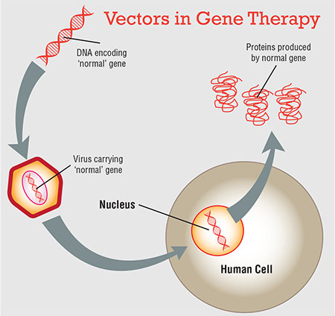
Figure 1: Showing mechanism of action viral vector for gene therapy

- Nonviral vector- Non-viral vectors are an alternative to viral vectors and have some advantages over the other. The non-viral vectors can be produced in large scale, they also induce a very low immune response in the host and the cost of maintaining the virus is not there while using non-viral vector. Pure DNA constructs, human artificial chromosomes, lipoplexes etc. are some of the non-viral vectors. Pure DNA constructs are artificially designed DNA of few base pairs. It contains a therapeutic gene which with the help of vectors such as plasmids, bacteriophages etc. can be incorporated into the DNA of the target cell. But the efficiency of expression of such DNA constructs and its uptake by cells is very low. DNA molecular conjugates used synthetic conjugate like poly- L- lysine bound to specific target cell receptor combined with therapeutic DNA. It avoid lysosomal break down of DNA. Human artificial chromosome (HAC) are synthetically produced chromosome carrying transgene introduced by the researchers to correct the genetic defect. HAC do not integrate with the genome of the host thus preventing insertional mutagenesis (which may otherwise occur due to insertion of the transgene in arbitrary position of the host genome). Lipoplexes are complexes of cationic lipids and DNA. The DNA which is carrying the therapeutic gene for gene therapy is condensed with cationic lipids which are positively. This condensation helps in encapsulation of the DNA within the liposome which is formed after the cationic lipid combines with them and protects them from any damage while guiding them to the target cell. Lipoplexes are easily prepared, initiate less immune response in the host and can be used to deliver large gene.
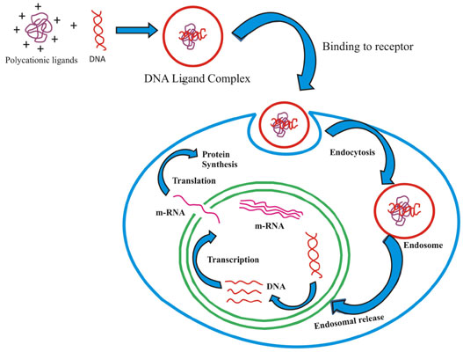
Figure 2: Showing mechanism of action of a non-viral vector (lipoplex) for gene therapy

- GENE DELIVERY

To achieve gene therapy, the modified gene should be introduced into the cells of the individual with the mutated gene. This can be done by either of the 2 different methods – a) ex-vivo gene therapy and b) in-vivo gene therapy
- Ex-vivo gene therapy – In ex-vivo gene therapy, the cells from the diseased individual which can be cultured in the laboratory are removed, genetically modified and reintroduced in the patient’s body. Here, patient’s own cells are being utilised and genetically modified to correct the disease and therefore, this procedure carries less chance of developing immunological reaction in the patient.

Following steps are involved in ex-vivo gene therapy-
-Cells having the genetic defect are removed from the patient
-The cells are grown in culture
-The therapeutic gene which will correct the disease is introduced into the cultured cells
-The cells which have taken up the therapeutic gene are selected and grown
-These cells are then reintroduced into the patient’s body

- In-vivo gene therapy – The patient’s cells having the defective gene is treated inside the patient’s body in in-vivo gene therapy. The therapeutic gene which can correct the disease is introduced into the patient by means of a viral or non-viral vector system. The challenges which are faced in in-vivo method are the inefficient uptake of the therapeutic gene by the target tissue and the incomplete expression of the therapeutic gene inside the cell nucleus. The vector also induces an immune response in the patient, which leads to the synthesis of antibodies against the vector and this makes it difficult for introduction of vector with the therapeutic gene again.
Steps involved in ex-vivo gene therapy are
-packaging of the therapeutic gene in the viral or non-viral vectors
-introduction of the vector by injections (subcutaneous, intravenous, intramuscular, intraperitoneal, intra-arterial) or by means of gene gun.
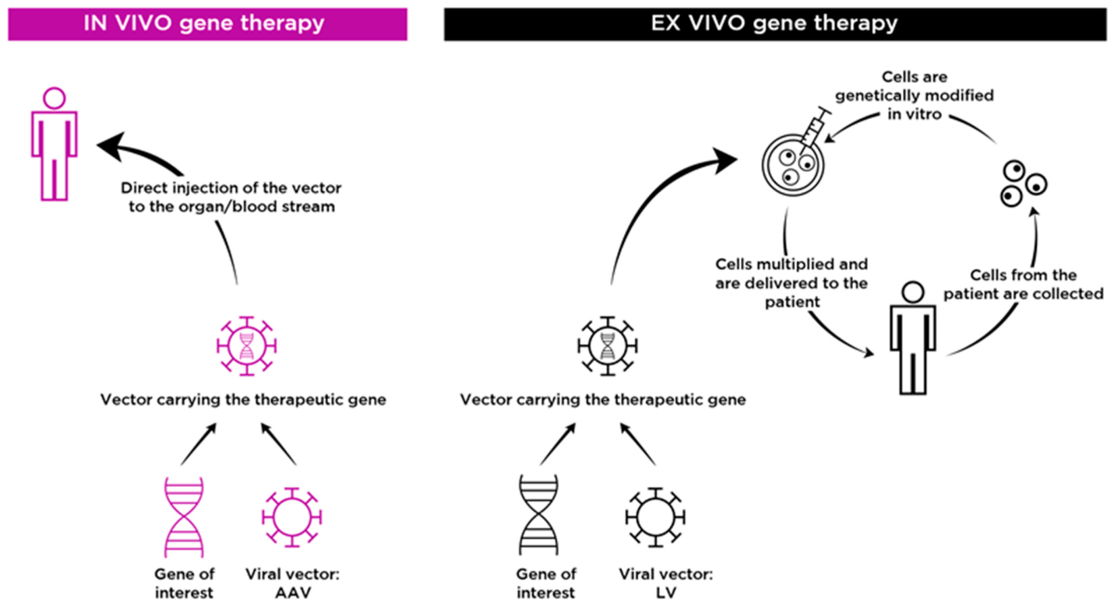

Figure 3: Showing steps involved in ex-vivo and in-vivo gene therapy

- ADVANTAGE

Many inheritable diseases such ADA-SCID, cystic fibrosis, haemophilia etc. can be treated by gene therapy. It gives hope to individuals who are born with some inborn diseases to live.

- DISADVANTAGE

Since, cells keep on dividing and new cells regenerate, so the effect of gene therapy is short and hence, life long benefit cannot be attained. Introduction of a new therapeutic gene carries with it the potential risk of mounting an immune response. Besides the correction of the mutated gene by introduction of a new therapeutic gene, it can also modify the genome in a way which may result in the production of a new character which may not be accepted. The viral vector which carries the therapeutic gene to the target cell(with the mutated or the missing gene) can also infect other healthy cells which may give rise to unpredictable results such as other immune disorders and even cancer. The high cost of the therapy is a drawback which makes it inaccessible for many people

- ETHICAL ISSUE

Gene therapy modifies the genome of a person and along with this it raises many ethical concerns. One cannot determine how good or bad the outcome of gene therapy will be. It may allow a person to change the complexion, height, intelligence and other basic traits and so at a certain point of time gene therapy may make people with a particular trait unacceptable in the society. Individuals who are born after being affected by germline gene therapy do not have the option to choose the treatment.

- POTENTIAL STRENGTHS & FUTURE PROSPECTIVES OF GENE THERAPY

Gene therapy has the potentials to treat a disease with a long term prospect by correcting the defect at its basic level. Many diseases are being treated by giving injections of the defective or missing protein and since the protein stays in the blood stream for a limited period of time so the injections have to be given repeatedly. Whereas, genes are located in the cells and are stable so gene therapy is a better approach for treating such diseases as it provides a long term expression of proteins.
Another innovative method which has been studied is site specific modifications done by editing the human genome and is accompanied by several challenges. Unlike traditional gene therapy, gene editing can precisely correct point variants, disrupt a specific mutant gene and place an extra, healthy gene at a safe genomic location. Gene editing involves the introduction of endogenous double-stranded breaks (DSBs) with the help of nucleases and then repair the DSBs by non-homologous end joining repair mechanism (NHEJ) or by homologous direct repair (HDR) mechanism. NHEJ repair the damaged DNA without a homologous template, which causes deletion or insertion of nucleotides in the damaged loci and so NHEJ repair is more prone to error. Whereas, HDR repairs the damaged DNA by using a homologous template and so causes less errors. Hence, HDR is a more preferred method as compared to NHEJ for therapeutic purpose. Different agents, depending on their structures that have been identified for gene editing are meganucleases, oligonucleotides, peptide nucleic acids, zinc-finger nucleases, transcription activator-like effector nucleases and CRISPR- associated nucleases. CRISPR-Cas system has potential gene editing ability. Based on construction of interference module, CRISPR-Cas system has been classified as Class 1 & Class 2 types. Multi-Cas protein complexes is being used by Class 1 CRISPR-Cas system for interference and Class 2 CRISPR-Cas system uses single effector proteins and a DNA-targeting mechanism programmed through Watson-Crick RNA-DNA pairing.
Gene silencing technique involving RNA interference (RNAi) to knockdown specific genes causing tumor is being used for the treatment of cancer. RNAi a noncoding RNA, is being introduced into the host cell which induces sequence specific degradation of the complementary mRNA. Oncogenes, genes involved in progression of cancer and resistance to drugs are important targets of RNAi for cancer treatment by gene silencing.
Suicide gene therapy is another treatment modality which is being studied for cancer treatment by gene therapy. In the malignant cells, it utilizes viral or bacterial genes to metabolize non-toxic prodrug to toxic compound. One such suicide gene therapy that has been identified is the use of herpes simplex virus(HSV)- thymidine kinase along with ganciclovir. A adenovirus vector containing HSV-thymidine kinase gene is introduced locally into the tumor site and next the drug ganciclovir is administered. HSV-thymidine kinase gene expresses itself leading to the production of thymidine kinase. Thymidine kinase phosphorylates ganciclovir to ganciclovir monophosphate, which subsequently gets converted to ganciclovir triphosphate by the cellular kinases. Ganciclovir is an analogue of deoxyguanosine triphosphate and itself gets incorporated into the DNA, preventing chain elongation by the DNA polymerases and thus causing chain termination followed by tumor cell death. In the last few decades many drugs have been approved and many others are still under trial for being used for treatment of cancer by gene therapy. Gene therapy is one of the most innovative field in biomedical research which has a unlock new areas in medicine and has given new approach to deal with genetic diseases.

REFERENCE

- Mark AK, Dexi L, Peter MH. Gene Therapy. Proc. Natl. Acad. Sci. 1997 Nov; 94:12744-46.
- Giulliana ARG, Raquel DMAP. Gene therapy: advances, challenges and perspectives. Einstein. 2017;15(3):369-75
- T Friedmann. A brief history of gene therapy. Nat Genet 1992 Oct;2(2):93-8.
- Jack M. The future of gene therapy. Biotechnology Heathcare. 2005 June.
- T Friedmann, R Roblin. Gene Therapy for human genetic disease? Science 1972 Mar 3;175(4025):949-55.
- Tafere MB. The Current Status of Gene Therapy for the Treatment of Cancer. Biologics: Targets and Therapy 2021;15:67-77.
- Ashworth J, Havranek JJ, Duarte CM, et al. Computational redesign of endonuclease DNA binding and cleavage specificity. Nature. 2006; 441:656–659.
- Chin JY, Glazer PM. Repair of DNA lesions associated with triplex-forming oligonucleotides. Mol Carcinog. 2009; 48:389–399.
- Kim KH, Nielsen PE, Glazer PM. Site-specific gene modification by PNAs conjugated to psoralen. Biochemistry. 2006; 45:314–323.
- Junxia Zhang, Yongping You. CRISPR-Cas13a system: a novel approach to precision oncology. Cancer Biol Med 2020; 17.

