Latest Innovations &Trends in Medical Science - “Single Institutional Comparative Study on the Impact of the Standard Pressure and Low Pressure Pneumoperitoneum on Post - Operative Pain following Laparoscopic Cholecystectomy - A Stratified Randomized Controlled Trial”
Dr. Rajkiran K. Deshpande
MBBS – KMC Mangalore, DNB – Gen. Surgery (Manipal Hospitals)
MRCS – Glasgow- United Kingdom, FRSPH (London)
Specialist Registrar – Vascular Access & Renal Transplant Surgery
Queen Elizabeth Hospital, University Hospitals Birmingham
NHS Foundation Trust, United Kingdom

Introduction

There are no Stratified RCT studies conducted before on this topic. Therefore, we conducted a stratified randomization in this pilot study to compare the impact of the Standard Pressure and Low- Pressure pneumoperitoneum technique on post-operative pain following conventional laparoscopic cholecystectomy

In recent years we are witnessing a revolution with the innovation and introduction of laparoscopic techniques. Early experience of gynaecologists suggests that they noticed shoulder pain post-surgery, in at least 30% of patients undergoing laparoscopic sterilisation. Subsequently even the “Keyhole Surgery” brought with it a discrepancy due to the challenges involved in training of surgeons to carry out surgery¹⁻³.Today the latest techniques in surgical methods aim at curing the ailments with the help of minimal invasive techniques to ensure patient safety and at the same time ensure operations are conducted successfully.

We have observed that post laparoscopic cholecystectomy there are 3 kinds of pain namely: Visceral Pain, Parietal Pain and Shoulder Pain. Gastrointestinal disorders such as Cholelithiasis was treated or by open cholecystectomy. Today it is a standard procedure as it results in less pain, less hospital stays and fast recovery time. This of course depends on multiple factors such as: Shoulder tip pain, Vomiting and Nausea coupled with fatigue because of stretching of peritonea & diaphragmatic exasperation caused by abdominal pressure inside abdomen and by carbon dioxide³⁻⁵. It is to be noted that stimulation of sympathetic nervous by hypercarbia are the main reasons for shoulder pain.

Cholelithiasis, which is one of the most common Gastrointestinal disorders seen, was traditionally treated by conventional or open cholecystectomy. Currently laparoscopic cholecystectomy is the standard procedure as it is less painful, needs shorter recovery period and short hospital stay⁶⁻⁸.
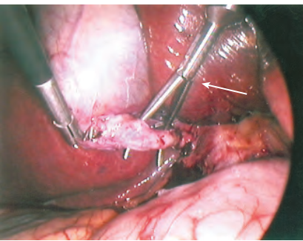
Figure 1: Operative image of a laparoscopic cholecystectomy. Laparoscopic forceps (arrow) are used to dissect “Calot’s triangle” ⁷

Materials and Methods:

Primary Objective:
- Assessment of intensity and frequency of post-operative pain using VAS score (Visual Analog Scale).

Secondary Objective:
- Assessment of the Duration of the Surgery.
- To measure the number of bile spillage in both the Standard and Low-Pressure pneumoperitoneum technique.
- Post-operative Opioid consumption.
- To Assess Time for Patient Mobilization Post Surgery

This study was carried out in a tertiary care hospital with over 750 beds, and lasted for a period 2 years.

Inclusion Criteria:
- Patients between 18 to 70 Years
- Planned surgery was done for gall stone
- Normal CPD anatomy
- USG confirmed gall stone disease with at least one episode of epigastric pain.

Exclusion Criteria:
- Above 70 years
- Pregnant Patients those with extra hepatic pathology
- ASA III / IV
- Conversion to open cholecystectomy.
- Portal hypertension, Coagulopathy and Malignancy
- CBD stones
- Past Abdominal surgery.
- Patients without consent

A total of 143 patients were randomly selected, during the period of Jan 2018- Dec 2019. The patients were divided into 2 groups namely:

- Group – A, low pressure pneumoperitoneum –LPP (7-8 mm Hg) while,
- Group – B, standard pressure pneumoperitoneum -SPP (12-14 mm Hg).

Shoulder pain, Port site pain and / or diffuse abdominal pain was measured at 2, 4, 6, 12, 24, and 48 hours, respectively. Pain score VAS (Visual Analogue Score) according to scale was used to detect the intensity of the pain postoperatively

World Health Organization (WHO) analgesic step ladder was used as a framework for providing symptomatic pain relief to the patients. Statistical analysis was done using standard tools. We compared the two groups with the help of independent t-test and Chi square test to understand statistical significance.

Study Process Flow Diagram:

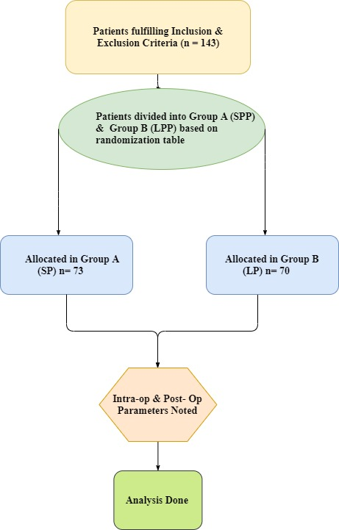

Pre-Operative Parameters:

Pressure of pneumoperitoneum:
- Standard Pressure Pneumoperitoneum (SPP) was done in 51% patients and Low Pressure Pneumoperitoneum (LPP) was done in 49% patients.

Distribution according to Patient Age Group:
- Most of them were between of 28-37 years (39.2%) followed by 38-47 years (18.2%), 18-27 years (16.1%), 48-57 years (15.4%) and >58 years (11.2%). Mean age in SPP is 39.34+12.015, and mean age in LPP is 38.73+12.41. Overall mean age was 39.04+12.171.

- In patients receiving Standard Pressure Pneumoperitoneum, most of them were in 28-37 years (38.4%) and in patients receiving low pressure Pneumoperitoneum, were between 28-37 years (40%). The association was found to be statistically not significant.

Intra-Operative Parameters:
Surgeon visibility:
- Surgeon visibility was good in 98.6% patients and poor in 1.4% patients. In patients receiving Standard Pressure Pneumoperitoneum, surgeon visibility was good in all the patients (100%) and in patients receiving Low Pressure Pneumoperitoneum, surgeon visibility was poor in 2.9% patients only. The association was found to be statistically not significant.

Bile spillage:
- Bile spillage was seen in 7.7% patients. In patients receiving Standard pressure Pneumoperitoneum, bile spillage was seen in 4.1% patients and in patients receiving Low Pressure Pneumoperitoneum, bile spillage was seen in 11.4% patients indicating statistical insignificance.

Post-Operative Parameters:
Post- operative Pain Score:
- We noticed statistical significance at different time intervals as can be seen from the Table -1
Post Operative Patient Mobilization Time
- It was noted that patients belonging to LP group exhibited early post-operative mobilization with a mean of 8.39 + 0.967 Hrs as compared to patients belonging to SP group in whom the mean duration of postoperative mobilization was 9.67 + 1.001 Hrs.

This can be attributed to the fact that early postoperative pain relief is associated with early mobilization and increased patient satisfaction.

Post- Operative Opioid Consumption:
- It was noted that post-operative opioid consumption was significantly less in the LP group. The Analgesia was given to the patients according to WHO Pain Stepladder Approach. Opioids ( Inj Tramadol 50mg ) was given when the VAS Score was more than 5.

- It was noted, that there was a fall in the use of opioid in LP group in the 2nd and 4th hr and no additional use of opioid in the LP group in 6th , 12th and 48th hr.

- When comparing the Post- Op Opioid Consumption between the two groups, there was a statistical significance at 2nd, 4th, 6th, and 12th hour.

Table 1: Group Statistics showing Pressure of Pneumoperitoneum & Pain score

Group Statistics
Pressure of Pneumoperitoneum |  | N | Mean | SD | T test | P value
Pain Score-2nd hr | SP | 73 | 5.42 | 0.644 | 12.32 | 0.001*
 | LP | 70 | 4.11 | 0.627
Pain Score-4th hr | SP | 73 | 4.56 | 0.850 | 7.69 | 0.001*
 | LP | 70 | 3.60 | 0.623
Pain Score-6th hr | SP | 73 | 3.95 | 0.896 | 7.97 | 0.001*
 | LP | 70 | 2.89 | 0.671
Pain Score-12th hr | SP | 73 | 3.10 | 1.120 | 4.10 | 0.001*
 | LP | 70 | 2.43 | 0.791
Pain Score-24th hr | SP | 73 | 2.41 | 0.998 | 4.58 | 0.001*
 | LP | 70 | 1.73 | 0.760
Pain Score-48th hr | SP | 73 | 1.73 | 0.786 | 3.86 | 0.001*
 | LP | 70 | 1.30 | 0.492

- There was statistical significance, when we compared the mean score of pain among two Group and at different time intervals.

Chart Line Diagram- Scatter Plot Pain Score at different intervals between LP and SP Group

Conclusion:

We would like to conclude that Low pressure pneumoperitoneum is feasible, safe and results in less pain and early mobilisation after surgery that resulted in less requirement of post operative opioids. Consequently, it reduced opioids related complications like drowsiness and constipation.

There is a need for more stratified RCT studies and investigation on this topic to understand the potential benefit.

BIBLIOGRAPHY

- Reddy BV, Shetty AS. Pain and Duration Scoring Between Open and Laparoscopic Cholecystectomy. International Journal of Science and Research (IJSR). 2016 July; 5 (7):858-861.

- Rubinstein LM, Lebherz TB, Kleinkopf V. Laparoscopic tubal sterilization: long-term postoperative follow-up. Contraception. 1976;13: 631-8.

- Lepner U, Goroshina J, Samarutel J. Postoperative pain relief after laparoscopic cholecystectomy: a randomised prospective double-blind clinical trial. Scand J Surg. 2003;92: 121-4.

- Edward ND, Barclay K, Catling SJ, Martin DG, Morgan RH. Day care laparoscopy: A survey of post-operative pain and assessment of the value of diclofenac. Anaesthesia. 1991; 46: 1077-80.

- Mouton WG, Bessel JR, OttenKT. Pain after laparoscopy. Surg Endosc 1999;13: 445–448.

- Ahmad A, Faridi S, Siddiqui F. Effect of bupivacaine soaked gauze in post operative pain relief in laparoscopic cholecystectomy: a prospective observational controlled trial in 120 patients. 2015;9: 31.

- Wallace DH, Serpell MG, Basxter JN, O’Dwyer PJ. Randomized trial of different insufflation pressures for laparoscopic cholecystectomy. Br J Surg. 1997; 84: 455-8

- Kanwer DB, Kaman L, Nedounsejiane M, Medhi B, Verma GR, Bala I. Comparative study of low pressure versus standard pressure pneumoperitoneum in laparoscopic cholecystectomy: a randomised controlled trial. Trop Gastroenterol. 2009; 30(3):171–174.

***************

