CROP YIELD PREDICTION USING MACHINE LEARNING ALGORITHM

Ms. ANCY Y. DAS
Assistant Professor
Department of CSE,
BGS Institute of technology
ACU, BG Nagar
ancyydas91@gmail.com
Mrs. VANI N
Assistant Professor
Department of CSE,
BGS Institute of technology
ACU, BG Nagar
vanin@bgsit.ac.in

ABSTRACT

Agriculture has the largest contribution in the GDP of our country. But still the farmer’s don’t get worth price of the crops. It is mostly happening due to improper irrigation or inappropriate crops selection or also sometimes the crop yield is less than that of expected. By analyzing the soil and atmosphere at particular region best crop in order to have more crop yield and the net crop yield can be predicting. This prediction will help the farmers to choose appropriate crops for their farm according to the temperature, soil PH and Rainfall. This prediction can be carried out using machine learning algorithm. The World population is constantly increasing and it is necessary to have sufficient crop production. Monitoring crop growth and yield estimation are very important for the economic development of a nation. The prediction of crop yield has direct impact on national and international economies and play important role in the food management and food security. Deep learning gains importance on crop monitoring, crop type classification and crop yield estimation applications with the recent advances in image classification using Deep Neural Networks. Traditional crop yield prediction approaches based on remote sensing consist of classical Machine Learning methods. India being an agriculture country, its economy predominantly depends on agriculture yield growth and agro industry products. Data Mining is an emerging research field in crop yield analysis.

Keywords—Agriculture, Prediction, Machine learning algorithm

INTRODUCTION

Predicting crop yield is crucial to addressing emerging challenges in food security, particularly in an era of global climate change. Accurate yield predictions not only help farmers make informed economic and management decisions but also support famine prevention efforts. Machine learning is an important decision support tool for crop yield prediction, including supporting decisions on what crops to grow and what to do during the growing season of the crops. Several machine learning algorithms have been applied to support crop yield prediction research.Machine learning model predictions allow businesses to make highly accurate guesses as to the likely outcomes of a question based on historical data, which can be about all kinds of things – customer churn likelihood, possible fraudulent activity, and more. Machine learning allows the user to feed a computer algorithm an immense amount of data and have the computer analyze and make data-driven recommendations and decisions based on only the input data.
Based on the climatic input parameters the present study provided the demonstration of the potential use of data mining techniques in predicting the crop yield based. The developed web page is user friendly and the accuracy of predictions are above 75 are is used.
percent in all the crops and districts selected in the study indicating higher accuracy of prediction. By providing climatic data of that place the user-friendly web page developed for predicting crop yield can be used by any user their choice of crop.

We have to collect all required data by giving GPS locations of a land and by taking access from Rain forecasting system of by the government, we can predict crops by just giving GPS location. Also, we can develop the model to avoid over and under crisis of the food. In coming years, can try applying data independent system. That is whatever be the format our system should work with same accuracy. Integrating soil details to the system is an advantage, as for the selection of crops knowledge on soil is also a parameter. Proper irrigation is also a needed feature crop cultivation. In reference to rainfall can depict whether extra water availability is needed or not. This research work can be enhanced to higher level by availing it to whole India.

LITERATURE SURVEY

D. Jayanarayana Reddy, M. Rudra Kumar, “Crop Yield Predication Using Machine Learning”, 2021.

Agriculture is the pillar of the Indian economy and more than 50% of India's population are dependent on agriculture for their survival. Variations in weather, climate, and other such environmental conditions have become a major risk for the healthy existence of agriculture. Machine learning (ML) plays a significant role as it has decision support tool for Crop Yield Prediction (CYP) including supporting decisions on what crops to grow and what to do during the growing season of the crops. The present research deals with a systematic review that extracts and synthesize the features used for CYP and furthermore, there are a variety of methods that were developed to analyze crop yield prediction using artificial intelligence techniques.

Nathaniel D. Mueller, Vangimalla R. Reddy ,“Random Forests for Global and Regional Crop Yield Predictions”, 2020.

Accurate predictions of crop yield are critical for developing effective agricultural and food policies at the regional and global scales. We evaluated a machine- learning method, Random Forests (RF), for its ability to predict crop yield responses to climate and biophysical variables at global and regional scales in wheat, maize, and potato in comparison with multiple linear regressions (MLR) serving as a benchmark.

Hrishikesh Mashire, Prasad Tilekar, “A machine learning approach for forecasting crop yield based on Climatic Parameters”, 2019.

In today’s world the most important thing for living in the Indian economy is Agriculture. Above 70% of the world's population is likely to be dependent on agriculture. Many crops are cultivated in India, with wheat being one of the most important food grains cultivated and exported by this country. It can thus be seen that wheat is a big part of the Indian agricultural system and the economy of India. Therefore, it is very important to maintain the steady production of the above-stated crop. To handle the segmentation of the system we use the crop predictive model. Planning for agriculture plays a major role in agro- based countries' economic development and food security.

OBJECTIVES

This project aims at predicting the crop yield at a particular weather condition and thereby recommending suitable crops for that field. It involves the following steps.
- Collect the weather data, crop yield data, soil type data and the rainfall data and merge these datasets in a structured form and clean the data. Data Cleaning is done to remove inaccurate, incomplete and unreasonable data that increases the quality of the data and hence the overall productivity.
- Perform Exploratory Data Analysis (EDA) that helps in analyzing the complete dataset and summarizing the main characteristics. It is used to discover patterns, spot anomalies and to get graphical representations of various attributes. Most importantly, it tells us the importance of each attribute, the dependence of each attribute on the class attribute and other crucial information.
- Divide the analysed crop data into training and testing sets and train the model using the training data to predict the crop yield for given inputs.
- Compare various Algorithms by passing the analysed dataset through them and calculating the error rate and accuracy for each. Choose the algorithm with the highest accuracy and lowest error rate.
- Implement a system in the form of a mobile application and integrate the algorithm at the back end.
- Test the implemented system to check for accuracy and failures.
- The reason for this decline in the agriculture sector is due to the fact that farmers are not empowered and due to lack of application of in the farming sector.
- Farmers have inappropriate knowledge about different types of crops and the climatic change.
- We tend to overcome this obstacle by applying machine learning techniques to predict the crop yield and name by considering various factors such as temperature, rainfall, Season and area.

IMPLEMENTATION

The implementation of the project was divided into two .i.e. crop yield prediction and rainfall prediction (for fertilizers module).

Crop Yield Prediction
This module returns the predicted production of crops based on the user's input. If the user wants to know the production of a particular crop, the system takes the crop as the input as well. Else, it returns a list of crops along with their production as output.
- Fertilizers Module
This module is used to suggest the farmer on usage of fertilizer based on the rainfall in next few days. To predict the rainfall for the next 15 days we are using an API service provided by Open Weather. If it is likely to rain we suggest the farmer not to use the fertilizer.

Develop and refine the model

This is where you begin to experiment and use your outside knowledge and intuition to make adjustments to your model. To train the data, and then validate it later, you will need to split data into training, validation, and test datasets.

Many data scientists often start with the most basic algorithms when developing a model and move up from there:

- Linear regression for basic regression.
- Logistic regression for basic classification.

The following libraries of python are used they are:

Pandas

Numpy

Seaborn

Matplotlib

Components
The Jupyter Notebook combines three components:
- The notebook web application
- Kernels
- Notebook documents

RESULTS

The project uses the data as shown in below fig 7.1, this are the data set used for crop yield predication which contains all the data which is necessary for crop yield predication.
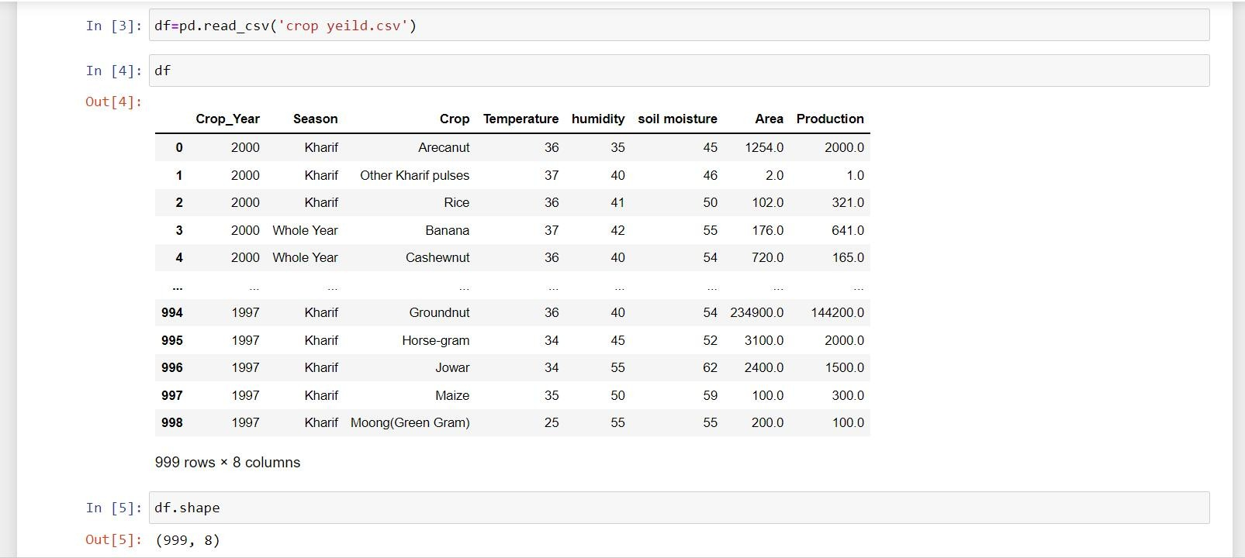
Fig 1: Data set

Description:This fig 7.2 Shows the complete information about the X test which is present in the given data set.
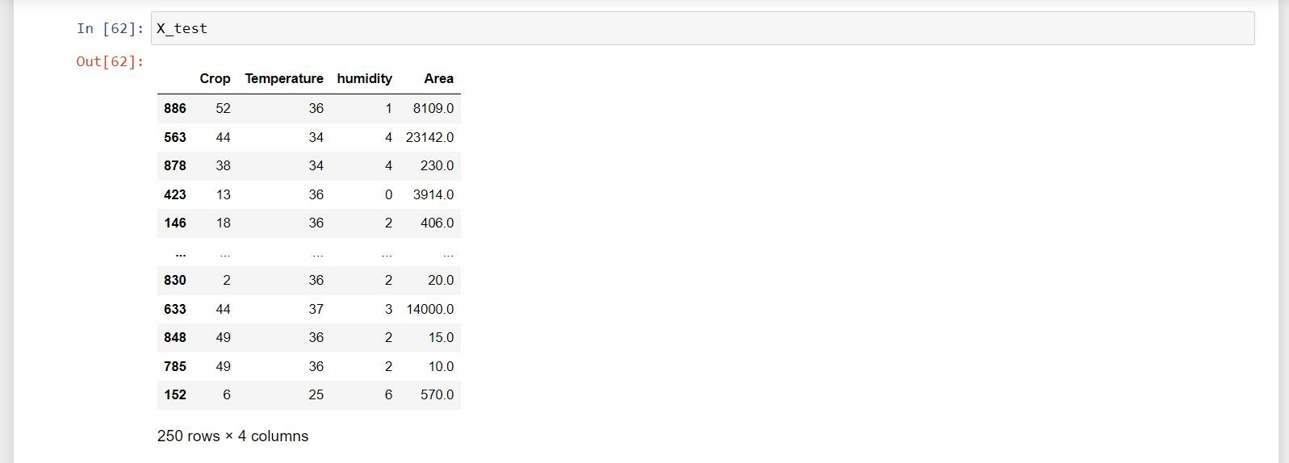

Fig 2: Shows X_TestDescription

This fig 7.3 shows the bar graph which plots the graph p v/s l rate and bar graph contains object of three attributes.
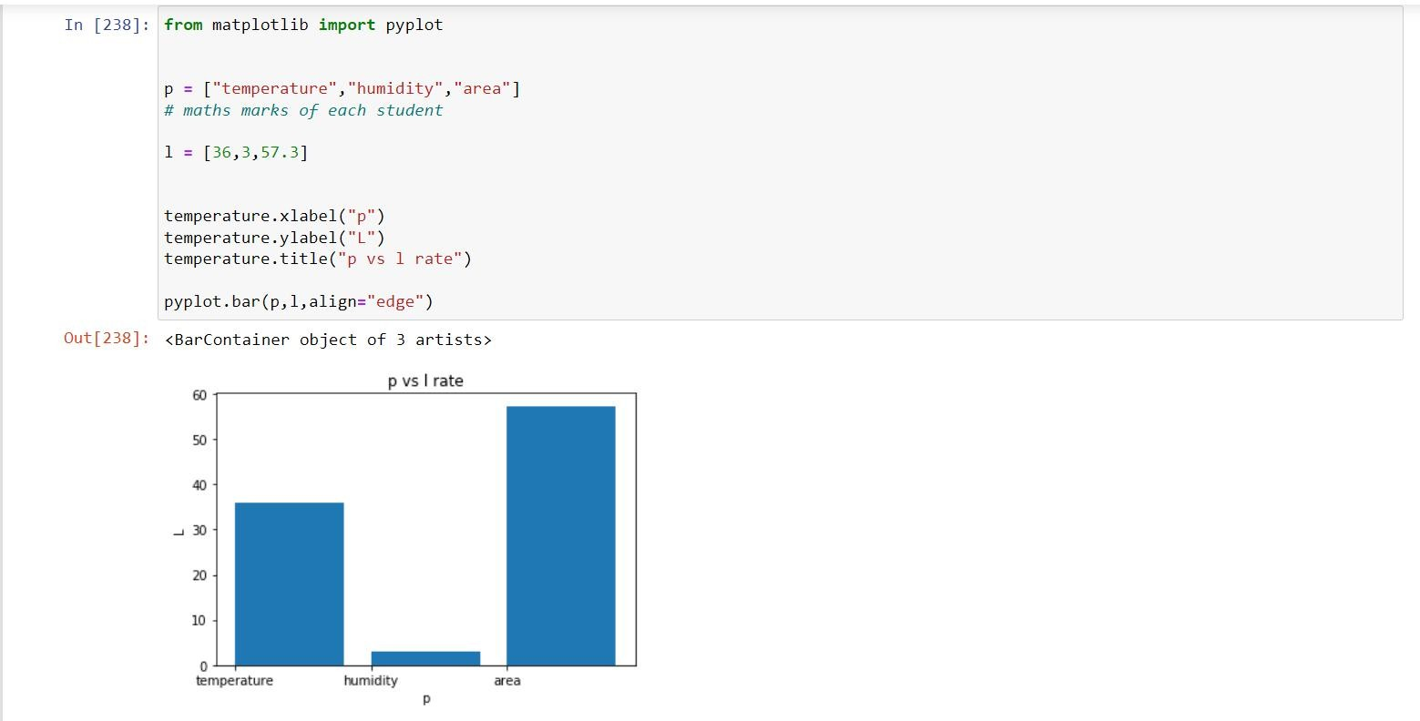

Fig 3: Shows Bar graph

Description:This fig 7.4 Shows the score of linear regression for the given data set and linear regression is a continues process and it minimize the errors in the regression process.
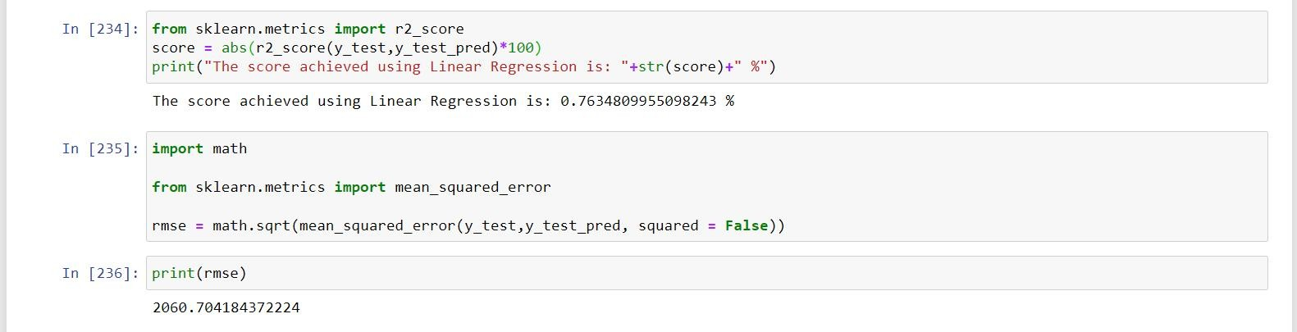
Fig 4: Score of Linear Regression
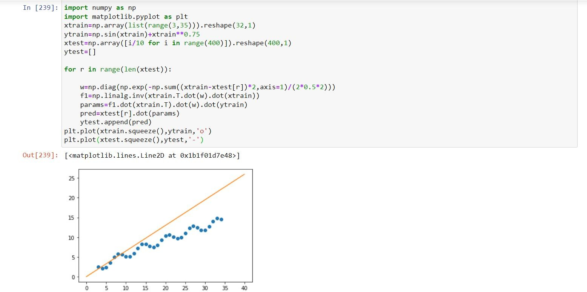
Description:This fig 7.5 Shows the histogram graph for the given data set and this graph represents the data that buckets a range of outcomes into columns along the X-axis.

Fig 5: Histogram

CONCLUSION

It focuses on the prediction of crop and calculation of its yield with the help of machine learning techniques. Several machine learning methodologies used for the calculation of accuracy. But Random Forest classifier was used for the crop prediction for chosen district. Implemented a system to crop prediction from the collection of past data. The proposed technique helps farmers in decision making of which crop to cultivate in the field. This work is employed to search out the gain knowledge about the crop that can be deployed to make an efficient and useful harvesting. The accurate prediction of different specified crops across different districts will help farmers. This improves our Indian economy by maximizing the yield rate of crop production.

REFERENCES
- Aruvansh Nigam, Saksham Garg, Archit Agrawal “Crop Yield Prediction using ML Algorithms “,2019.
- Priya, P., Muthaiah, U., Balamurugan, M.”Predicting Yield of the Crop Using Machine Learning Algorithm”,2015.
- Leo Brieman, “Random Forests”, 2001.
- Mishra, S., Mishra, D., Santra, G. H.,“Applications of machine learning techniques in agricultural crop production”,2016.
- Dr.Y Jeevan Kumar,”Supervised Learning Approach for Crop Production”,2020.
- Ramesh Medar,Vijay S, Shweta, “Crop Yield Prediction using Machine Learning Techniques”, 2019.

