GROUNDWATER EXPLORATION USING GEOPHYSICAL RESISTIVITY METHOD IN SIRUVADI VILLAGE, VILLUPURAM DISTRICT, TAMIL NADU, INDIA

Gopal V¹*., Chandravijay M¹., Ranjith Kumar R¹., Anshu R², Krishnamurthy R.R¹.

Department of Applied Geology, University of Madras, Guindy Campus, Chennai-600 025.
Department of Geology, University of Madras, Guindy Campus, Chennai-600 025

*Corresponding Author

Dr. Gopal V
veegopaal@gmail.com

INTRODUCTION
GEOPHYSICS
Geophysics is a subject of natural science concerned with the physical properties of the Earth and its environment, and the use of quantitative methods for their analysis. The term geophysics sometimes refers only to the geological applications. Earth's shape, its gravitational and magnetic fields structure and composition, its dynamics and their surface expression in plate tectonics, the its internal generation of magmas, volcanism and rock formation. However, modern geophysics organizations use a broader definition that includes the hydrological cycle including snow and ice, fluid dynamics of the oceans and the atmosphere electricity and the ionosphere and magnetosphere and solar-terrestrial relations and analogous problems magnetism in associated with the Moon and other planets. Over the past several decades, geophysical surveying has become increasingly effective and useful for understanding the subsurface groundwater conditions (Murthy et al., 1968; Raman et al., 2000).
GEOPHYSICAL METHODS
Geophysical methods in exploration are based on certain physical properties of earth materials. The properties are measured and their variation values in lateral or vertical trend are recorded. Gathered data are interpreted to determine the subsurface information. The most important rock properties are studied using the following methods.
a). Gravity prospecting b). Magnetic prospecting c). Seismic prospecting d). Electrical prospecting e). Radiometric prospecting.

GEOPHYSICAL EXPLORATION OF GROUNDWATER
Geophysical exploration is the scientific method, wherein the physical properties of the earth, the investigation of mineral deposits and other geologic structure are measured. With the discovery of oil by geophysical methods in 1926, economic importance for locating petroleum and mineral deposits accelerated the improvement of many geophysical methods and equipment’s for research and development purpose. Using geophysical methods, anomalies of the physical properties within the Earth's crust are detected. Properties such as density, magnetism, elasticity, and electrical resistivity of the rocks are most commonly measured by geophysical methods. while in the application of geophysical methods in groundwater exploration, it is often misunderstood by many that they are used directly to detect groundwater .Rather Scientific methods of groundwater exploration includes other tools as well.
ELECTRICAL PROSPECTING AND EXPLORATION METHOD
Electrical resistivity techniques are based on the response of the earth to flow of electric current. The resistivity of a rock unit depends on its mineral composition and is influenced by the interstitial water content present in it. In actual field measurements, a variety of electrode arrangements are employed. Electrical resistivity methods involves the measurement of surface potential caused by the passage of an electric current, which are allowed to flow on the ground from an artificial source. Further interpretation is based on the validity of Ohm's law for linear conductors R-Av/1, where R is the resistance in Ohms, offered to the flow of current I and Av is the potential difference, in volts, across two end faces of the conducting material. The resistance of the medium is directly proportional to its length L and inversely proportional to its cross-sectional area so that R α L/A .The electrical resistivity or the specific resistance, P of the conducting medium, then is Ρ= (A/L) R = (∆v / I) A/L .Thus, the resistivity can be defined as the resistance offered by a material of unit dimensions and in the mks system and its unit is ohm-meter (Ω m). The efforts of Conrad Schlumberger (1912 - 1914) are mainly responsible for the development of electrical resistivity method as an effective tool in geophysical exploration of groundwater. In field measurement, current is introduced to the ground via two electrodes and the potential difference between another pair of electrodes is measured. The strength of the current applied and their potential difference is measured which is then used to calculate the resistivity of the ground. Taking into account that geometry of the electrode spread can also make a difference while interpreting.

ELECTRODE CONFIGURATION
In actual field measurements, a various conventional electrode arrangements or configurations are employed, the difference being in the inner electrode distance and or geometry. The most commonly employed configurations are the Wenner, Schlumberger and dipole- dipole arrangements. In the Wenner electrode array, the four electrodes, equidistant with respect to each other, are kept along a straight line, the outer two being the current electrodes. The inner electrode distance is commonly denoted by the letter 'a'.
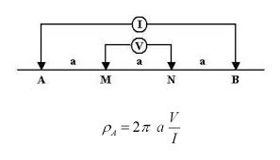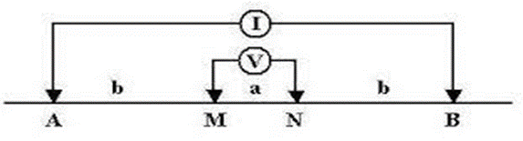
Fig 1 Wenner electrode configuration Fig 2 Schlumberger electrode configuration

The Schlumberger electrode configuration is also a symmetrical array like wenner, but in this case the potential electrodes are kept close to each other and away from the current electrodes, with the distance between the potential electrodes (MN) being generally kept less than 0.2 AB
HORIZONTAL PROFILING
Horizontal profiling is done to examine lateral variations in the subsurface in the area of interests. Apparent resistivity measurements are made along the chosen azimuth covering the entire area using a pre - determined electrode separation, the value of the separation dependent of the depth of interests. In practice, the whole electrode array is moved from one point of measurement to the next as a single unit. The distance between two locations were measured .Data variation might occur and it depends on the nature of the rock, type of terrain and time etc.,
VERTICAL ELECTRICAL SOUNDING
Profiling gives an indication of any changes in the lateral direction, to obtain information of the subsurface in the vertical direction, a technique known as vertical electrical sounding (VES) is employed. This involves in making a series of measurements at a given point with several electrode separation. The electrode separations are expanded, around the point of measurement, from an initial small value to several hundred meters, depending on the depth of interests. This is because, in in general, larger the electrode separation, greater will be the depth of investigation is quite a complex one, and among other things is controlled by the relative thickness of individual layer, and the resistivity contrast present between them .The VES data is plotted as an apparent resistivity versus electrode separation curve, normally on a log - log scale. The general practice is to plot a as a function of a' in case of Wenner and AB/2 in the case of Schlumberger.
STUDY AREA
The study area is from Siruvadi, Villupuram district, Tamil Nadu. This area lies between 12◦12’41.70″ and 12◦12’41.62″ North latitude and 79◦50’19.45″ and 79◦50’23.12″ east longitude. The Elevation of the area is 44 m (144 ft.) (MSL).The study area comprises mostly Pink augen gneiss and pink migmatite with younger instructions of Tindivanam and Gingee Granites (2250 Ma) and basic dykes (Proterozoic). The Migmatite Complex forms the major country rock of the area covering more than sixty percent and extending towards east upto Vikravandi, South of Gingee.
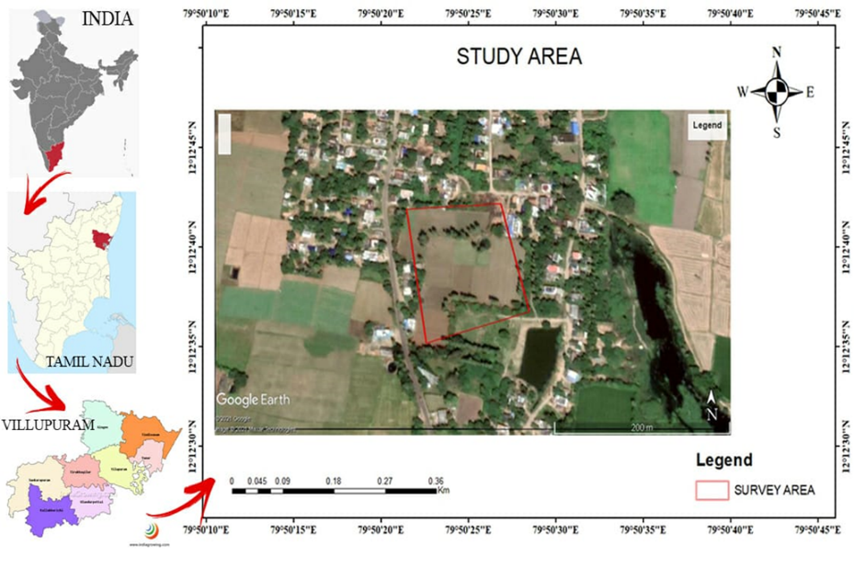
GEOLOGY
Alkali complex of Proterozoic age, including the Charnockite Group, Migmatite Complex, Sathyamangalam Group, and Bhavani Group. The area contains the Charnockite Group of rocks, including charnockite, pyroxene granulite, and garnetiferous gabbro, west of Kallakurichi (in the district's southwest). The Migmatite complex is made up of Hornblende-biotite gneiss and is located west of Tirukoilur (the district's major area) and east of the charnockite terrain, or the kallakurichi area. Pink migmatite and augen gneiss with newer Tindivanam and Gingee granite intrusions (2250 Ma) and dykes (Proterozoic). More than 60% of the region is made up by the Migmatite Complex, which also extends eastward up to Vikravandi, south of Gingee. Small, isolated outcrops of epidote-hornblende gneiss (Proterozoic age) are found. . The basic intrusive that travels equally through the migmatite and charnockite regions is composed of dolerite dykes. The marine fossiliferous Upper, Cretaceous, and Paleogene Formations, which are located in two distinct sub-basins and are divided by a thick layer of alluvial sediments deposited by the Gadilam and Pennaiyar Rivers, overlie the Archaean. The Palaeocene rocks that lie on top of the Upper Cretaceous Formations are separated into the Putturai Group's Karasur Formation and Manaveli Formation, which both contain siltstone and fine-grained argillaceous sandstone. The Karasur Formation is composed of fossiliferous limestone with calcareous shale. The Cuddalore Formation is part of the Tertiary strata and is made up of cobbly and pebbly sandstone, mottled sandstone, ferruginous sandstone with bands and lenses of clay, as well as lignite seams. Around Thiruvakkarai, this deposit has a significant amount of fossil wood that has been designated and preserved as a national fossil wood park. These are dominated by Quaternary fluvial, marine, and aeolian formations near the shore as well as river courses. Due to the numerous deformations the terrain has undergone, it exhibits a highly complicated structural makeup. There are many notable shear zones that have been identified, including the N-S shear shone east of Gingee town and the NNE-SSW to ENE-WSW shear zone, the most notable of which is the one running NNE-SSW near the eastern foot of the Kalrayan hills SW of Kallakurichi. The dense valley fill close to Villupuram creates the primary ground water discharge zone. Only a small portion of the Kallakurichi and Sankarapuram regions have lineaments, and certain pockets have productive fractures. Hard rocks along the crystalline sedimentary contact fault have sympathetic fractures, however they are typically dry fractures. . Red soil and forest soil make up the majority of the district's soil types. On the eastern side along the coast, alluvial soils are present. Black soils are only found in a few low-lying areas in the Vanur taluk.
RAINFALLS AND CLIMATE
The district receives rainfall from southwest monsoon (June – September), northeast monsoon (October – December) and non-monsoon periods (January – May). The rainfall is generally heavy during low-pressure depressions and cyclones during the northeast monsoon period. The normal annual rainfall is 1119.8 mm (1901-1980) and the higher is towards coast. The area falls under tropical climate with temperature in the summer months of March to May.
HYDROGEOLOGY
The western and eastern sides of the Villupuram district are both covered by sedimentary tracts and crystalline metamorphic complexes, respectively (Plate-II). Near the southern portion of the district, the silt thickness approaches 600 meters. While groundwater exists in phreatic, semi-confined circumstances in unconsolidated sedimentary rocks such as Vanur sandstone, Kadapperikuppam formation, and Turuvai limestone, it occurs in consolidated formations such as worn and fractured granites, gneisses, and charnockites. The majority of the Kallakurichi, Sankarapuram, and Tirukoilur taluks of the district are covered in rocky outcrops. The level of weathering and fracturing is quite unpredictable, and it determines how deep the abstraction structures go. Wells range in depth from 6.64 to 17 m bgl, and water levels are monitored. pre-monsoon (May 2006) ranged from 0.74 to 9.7 m bgl on shallow aquifer wells, while post-monsoon ranges from 0.7 to 4.45 m bgl (January 2007).
EQUIPMENTS AND ACCESSORIES
Basically there are two types of equipment for carrying out electrical resistivity investigation using direct current or low frequency alternating current. The direct current has the disadvantage of being affected by naturally existing current (e.g. S.P.). Measurement with AC equipment are influenced by "skin effect". Used of non-polarizing electrodes solves the problem created by natural potential and cell-effect associated with direct current .A simple non-polarizing electrode can be designed by taking a porous earthen pot, filling it with copper sulphate solution, in which a copper electrode is kept immersed.
FIELD PROCEDURE
Resistivity sounding also known as vertical electrical sounding (VES) has been used in this study. This method is most commonly used for groundwater investigations and will be discussed in detai. A series of measurement of resistivity were made by increasing the electrode spacing in successive steps about a final point, depending on the depth of interest. This is because, in general, larger the electrode separation greater will be the depth of investigation. The variation of apparent resistivity with current electrode separation thus obtained would give the variation in the electrical characters of the formation with depth .In the study area 12 vertical electrical sounding were carried out in the field using schlumberger electrode arrangement with maximum current electrode separation of AB/2 - 100m. The locations of these VES are shown in fig.The 'p.' values obtained for various AB/2 separation after this exercise are given in table. The field VES curves are discontinuous in nature, the discontinuity is caused by the shifting of potential electrodes during the sounding. Data on another 10 sounding were collected for the area from other workers (Ballukraya PN. 1994).
INTERPRETATION OF THE FIELD DATA
Interpretation of the electrical resistivity data in terms of subsurface geology and hydrogeology forms the most important part for groundwater explanation. The resistivity pattern and the anomalies if any form the key part of the exercise (Ruwaih and Ali, 1986).Interpretation of VES data is both qualitative and quantitative. The type of VES curve obtained indicates the qualitative nature of subsurface that may be expected in an area. And the main aim of interpretation of resistivity data is to determine the thickness and resistivity of different horizons. This method is a faster way of solving and VES curves, makes use of two-layer theoretical curves. Two auxiliary charts are needed. H type for A and H type VES curves and Q-type for Q and K-type VES curves. Using this method three or more layers solved, since the method involves solving the curve in sections of two layers at a time .The procedure of the interpretation can be given as-the first part of the curve (two layers) is matched with cither ascending or descending two layer theoretical curves and the origin of the type curved is marked on the field curve sheet. The co-ordinates of the origin of the master curves as read as on the field curve will give the value of p, and h, (resistivity and thickness of the first layer). The theoretical curve also gives the ratio p/pi, from which pa can be calculated. This origin is superimposed on the origin of the appropriate APC, with the axes of the two parallels to each other. The trace of the curve for the same resistivity ratio of the APC is now marked on the field curve sheet. Then, the next part of the field curve is matched with the appropriate two-layer curve, ensuring in the process that the origin of the two-layer curve lies on the previous APC curved. Once a match is found the origin of the type curve is marked as second origin and the resistivity ratio is noted. If there is one more layer the process is continued, till the entire field curve is completed. Next, the first origin is superimposed on the appropriate APC and the value of the line passing through the second origin is noted, which gives the high ratio, Thus the second layer thickness (h;) is obtained. The resistivity of the third layer is calculated by reading the value of the second resistivity ratio noted. In this way any number of layers present can be solved by repeating the same procedure.
The data obtained from the study area are thus interpreted and the layer parameters are found out. Out of the 12 soundings, 7curves are of A-type (pi>pp); 4 curves are of H-type (PPP2<) and one of K-type. And one sounding is of two layer, 6 of three layer and 5 of four layer. The results of interpretation thus obtained were further verified and corrected with computer simulation using RESIST-87 software package (Vander velphen, 1988).The results of VES interpretation are given in table -Ilb.
RESULT AND DISCUSSION
ANALYSIS WITH "IPI2 WIN"
The interpreted resistivity and thickness of different layers are shown in Fig.2 to Fig 7.Solid line represents the interpreted data and solid line with circles represents the observed data. The curve types obtained in the study area where 6 VES sounding was carried out include 1 H type curves (p1 > p2 <p3), 5 A type (p1 <p2 < p3), respectively (Table.2). IPI 2WIN output shows good match with concept of three-layers and few cases it matches perfectly. Based on the interpretations a typical geo-electric cross section is arrived at for the study area is as follows:

Layer 1 | Dry Sand
Layer 2 | Medium Sand
Layer 3 | Massive Charnockite

Fig. 2 VES Curve at Location 1 Fig 3 VES Curve at Location 2

Fig 4 VES Curve at Location 3 Fig 5 VES Curve at Location 4
Fig.6 VES Curve at Location 5 Fig.7 VES Curve at Location 6
CONCLUSION
Ground water exploration has been carried out in part of the Siruvadi Village, Marakkanam Taluk, Villupuram District in Tamilnadu using VES Schlumberger electrode configuration .Vertical electrical sounding technique of the electrical resistivity method has proven to be successful and highly effective in the identification and delineation of subsurface structures that are favourable for groundwater accumulation in a crystalline basement complex area. The interpretation of the VES data indicates the presence of two, three, four layers in the study area. In this study, an attempt has been made to assess the resistivity values for various layers. The most part of the study area is dominated by the A and H type curve which reveals the number of subsurface layers, their thickness and their water bearing capacity within the study .VES based on Schlumberger method, Identified six water bearing zone 50m,70m,40m,60m,80m and 73m depth .The investigated VES (VES POINT 5,Depth at 80m) point suggested as high yielding well bore point among the study area .In conclusion it can be said that the electrical resistivity studies have helped in understanding the subsurface hydrology and the occurrence of saline and brackish water in the centre part of the study area and the surfer diagram reveals that 3D subsurface of the study area.

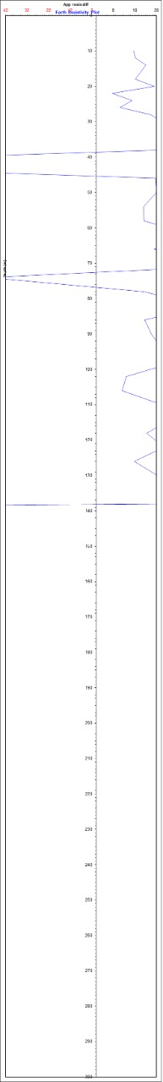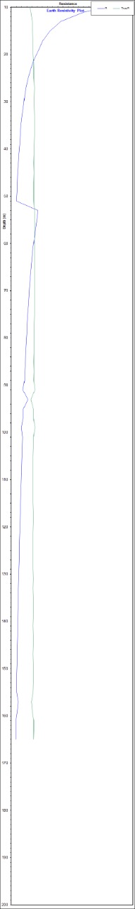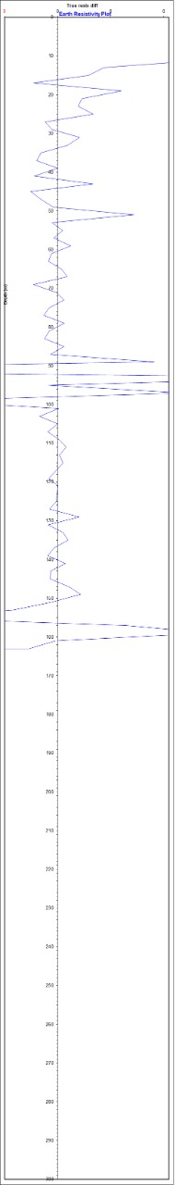
(a) (b) (c)
Fig.8 a, b, c APPARENT RES PLOT VS DEPTH

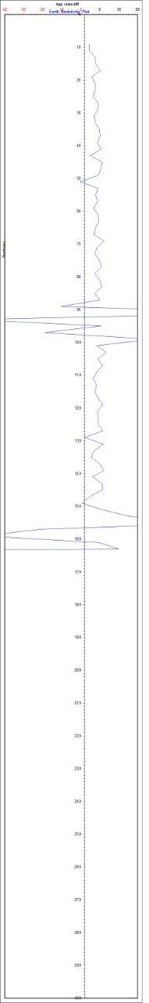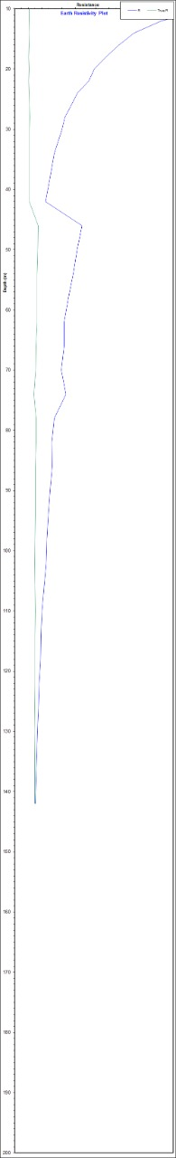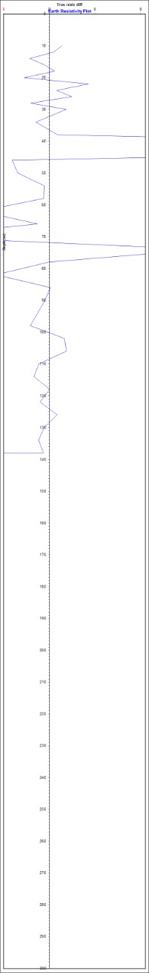
(d) (e) (f)
Fig.8 d, e, and f APPARENT RES PLOT VS DEPTH

REFERENCES
Adeotil, L., Alile. O. M., Uchegbulam, O, and Adegbola, R. B. Geoelectrical Investigation of the Groundwater Potential in Mowe, Ogun State, Nigeria, British Journal of Applied Science & Technology 2(1): pp. 58-71.
Adepelumi, A. A., Akinmade, O. B., Fayemi, O (2013). Evaluation of Ground Water Potential of Baikin Ondo State Nigeria Using Resistivity and Magnetic Techniques: A Case Study. Universal Journal of Geoscience, Vol 1(2), pp. 37-45.
Emmanuel C. Okolie (2010). Geophysical investigation of effects of topographic complexities on groundwater potential in Ibusa, Delta State Nigeria, Archives of Physics Research, 1 (3): pp. 62-71. Jeyavel, T., Raja Kumar., Balasubramanian, A., Kumar, R.S., Dushiyanthan, C., Karthikeyan,
Thiruneelakandan, B., Davidraju, D., and Manoharan, K (2011). Delineation and evaluation of groundwater potential zones using electrical resistivity survey and aquifer performance test in Uppodai of Chittar - Uppodai water shed, Tambaraparani River Basin, Tirunelveli-Thoothukudi Districts, Tamilnadu, J. Ind. Geophys. Union Vol.15, No.2, pp.85-94.
Joseph Olakunle Coker, (2012). Vertical electrical sounding (VES) methods to delineate potential groundwater aquifers in Akobo area, Ibadan, South-western, Nigeria. Journal of Geology and Mining Research Vol. 4(2), pp. 35-42.
Kavidha, R., and Elangovan, K (2013). Delineation of Groundwater Prospective Zones by Electrical Resistivity Method in Erode District, Tamilnadu, India, Journal of Environment. Vol. 02, Issue 01, pp. 14-18.
Lateef, T.A. (2012). Geophysical Investigation For Groundwater Using Electrical Resistivity Method - A Case Study Of Annunciation Grammar School, Ikere Lga. Ekiti State, South Western Nigeria. IOSR Journal of Applied Physics (IOSRJAP) ISSN - 2278-4861 Volume 2, PP 01-06.
Murthy, B. V. S., Varaprasada Rao, S. M and Bhimasankara, M. V. L. S (1982). Structure and geology of the Munneru valley as inferred from gravity and magnetic surveys, J. Indian Acad.
Narasimha Prasad, N.B (2011). Geophysical investigation for groundwater exploration in Lakshadweep Islands - A case study, J. Ind. Geophys. Union Vol.15, No.4, pp.221-227.
Oseji. Julius Otutu and Ajnabi, O (2009). Hydrogeophysical investigation of groundwater potential in Emu kingdom, Ndokwa land of Delta State, Nigeria. International Journal o f Physical Sciences Vol. 4 (5), pp. 275-284

Owen, R., Gvavav O.,and Gwaze, P(2005). Multi-electrode Resistivity Survey for Groundwater Exploration in the Harare Greenstone Belt, Zimbabwe. Hyrdogeology Joumal. Vol 14, pp.244-252.
Raman, K. Kumar, K V., Tata S. N and Chary, M N (2000). Report on geophysical investigations for groundwater in the upland areas of Krishna district, A.P, Central Groundwater Board.
Sabet Mohamed, a.,( 1975) Vertical Electrical Resistivity Soundings to Locate Ground water Resources: A Feasibility Study A publication of Virginia Water Resources Research Center Virginia Polytechnic Institute and State University Blacksburg, Virginia 24061
Selvam, S. and Sivasubramanian, P. (2012) Groundwater potential zone identification using Geoelectrical survey:A case study from Medak district, Andhra Pradesh, India. International journal of geomatics and geosciences Volume 3. pp. 55-62.
Senthil kumar, M. Gnanasundar, D., Elango, L (2001). Geophysical studies to determine hydraulic characteristics of an alluvial aquifer. Journal of environmental hydrology, Vol.9. Sreedevi. P.D., Srinivasulu, S., Kesava Rju, K (2001). Delineation of Ground Water Potential Zones and Electrical Resistivity Studies for Groundwater Exploration Springer, Vol.40, pp. 1252-1264.
Srinivas, Y., Muthuraj, D., and Chandrasekar, N (2008). Resistivity studies to delineate structural features near Abhishekapatti, Tirunelveli, Tamil Nadu, India, J. Ind. Geophys. Vol.12, No.4, pp. 157-163
Srivastava, V.K., Devendrantah Giri and Pawan Bharadwaj (2012) Study and Mapping Of Groundwater Prospect Using Remote Sensing, GIS nad Geoelectric Resistivity Techniques- A Case Study Of Dhanbad District, Jharkhand, India. J. Ind. Geophysics. Union Vol.16, No.2, pp. 55-63
Srinivasamoorthy, K., Chidambaram, S., Vasanthavigar, M., Anandhan, P., Sarma, V. S (2013) Geophysical investigations for groundwater in a hard rock terrain, Salem district, Tamil Nadu, India, Springer, pp. 63-86.
Venkateswaran, S., Vijay Prabhu, M, and Karuppannan, S (2014). Delineation of Groundwater Potential Zones Using Geophysical and GIS Techniques in the Sarabanga Sub Basin, Cauvery River, Tamil Nadu, India, International journal of current research and academic review, ISSN: 2347-3215, Vol 2, pp. 58-75
Victor, Much., Chukwudi, C., and Austin, C (2014). Ground Water Exploration of Lokpaukwu, Abia State South eastern Nigeria, using electrical resistivity method, IRJGM, Vol.4(3), pp. 76- 83.
Yadav, G.S and Shashi Kant Singh (2007). Integrated resistivity surveys for delineation of fractures for ground water exploration in hard rock areas. Journal of Applied Geophysics 62(301-312).

