BIOLOGICAL SYNTHESIS OF NANOPARTICLES

Prachi Jha
School of Sciences
MATS University
Raipur, C.G.
E mail id – Prachi.jha0@gmail.com

Ashish Saraf
School of Sciences
MATS University
Raipur, C.G.
E mail id- ashish.saraf22@gmail.com

ABSTRACT
Nanotechnology has emerged as a very promising branch of science. Nanoparticles with wide application in various industries have received global attention. Recently, synthesis of nanoparticles using green methods has gained importance as it has been considered cost effective, environment safe as well as efficient. This method uses microorganism and plants working as nano-factories to mediate synthesis of nanoparticles with different size, shape and characteristics. This chapter includes green methods of nanoparticle synthesis, advantages of biological methods and characterization techniques of nanoparticles.

Key Words- Nanoparticles, green method, cost effective, plant, microbe

- INTRODUCTION

Nanotechnology deals with the application of different properties of any matter at nanoscale. It is considered as one of the most promising approach to many areas such as biomedicine, electronics, agriculture, antimicrobials and cosmetics, etc. [1][2][3]. The physical, chemical and optical attributes of Nanoparticles (NP) are different from their respective larger matters. These Properties of NPs change with the change in size, surface properties and morphology of the particle. The novel idea of nanotechnology was given for the very first time in 1959 by Richard Feynman, but the term “Nanotechnology” was coined in 1974 by Norio Taniguchi. Since then Nanotechnology has set many milestones. Currently, the more commercially viable and environment friendly approach to synthesize the NPs are being worked upon by the scientist all over the world which may eliminate the adverse effects of already existing physical and chemical processes.

- METHODS OF NANOPARTICLE SYNTHESIS

Methods of Synthesis

Physical
Biological
Chemical

Chemical precipitation, micro emulsion, spray method etc.
Use of plants, algae, bacteria, fungi.
Laser ablation, ultrasonication, high energy ball milling etc.

Figure 1. Nanoparticle synthesis methods
Generally there are 3 ways to produce NPs i.e. chemical, physical, and green method or the biological method. (Fig-1). The first two methods of the NP synthesis are traditional methods with many attractive advantages such as high yield in less time, precise control over structure of NPs, and extensive scalability. However, potential harm associated with these methods overshadows the advantages of these approaches. The excessive use of chemicals as capping agent and precursor leading to the production of toxic by-products, disposal of these by products, high pressure and high temperature working conditions are some disadvantages that raises grave concern. Therefore, there is an urgent need for environment friendly, non-toxic, and cost effective approach for NP synthesis. These disadvantages can be overcome by applying biological method or green technology which uses the biological entities as nano-factories (Fig. 2). In this approach, natural sources like plants, fungi, yeast, actinomycetes, and bacteria etc. are used to synthesize intracellular and extra cellular NPs having natural reducing and stabilizing properties [4].

Cost effective

Eco friendly

Advantage of Biological synthesis

Single step process
No hazardous by-products

Presence of natural reducing and capping agents

Fig 2 Advantages of the biological method of Nanoparticle synthesis

- BIOSYNTHESIS OF NANOPARTICLES

In the current scenario the green method of NPs synthesis using plants, bacteria, fungi etc. has gained attention as they are compatible to be used in biomedical and pharmaceutical sectors [5]. Basically, in biosynthesis, the metal salt is reduced to ions by bioactive compounds. Various factors like temperature, concentrations of precursor metal, and p^{H} affects the process of synthesis. Thus, it becomes important to understand the interaction mechanism of biological systems and precursor metal to get the control the entire process.

- Synthesis of Nanoparticles by Microorganisms

The NPs are formed when metal salts are reduced to ions [6]. Prokaryotes are commonly used for the synthesis of metallic NPs [7]. Bacteria mediated synthesis have gained attention as bacterial cultures are easy to grow and their genetic code can be easily manipulated. The first ever bacteria mediated NP synthesis was reported in 1984 when a strain of Pseudomonas stutzeri AG259, isolated from silver mine was found to be capable of synthesizing silver NPs [8].
There are reports of fungal mediated synthesis as well [9]. Higher tolerance to toxicity, easy culture methods and simple biomass handling characteristics has made fungus a very significant medium of NP synthesis. They also produce and release enormous amount of enzymes.
Algae have the ability to merge heavy metals from the surroundings. They reduce these metals to NPs. Fucus vesiculosus, is one such algae which was reported to absorb Au [III] ion [10].

- Plant mediated synthesis of Nanoparticles

Plants contain many bioactive elements which are responsible for the formation of NPs. Plant extracts based synthesis has advantages as it’s single step process, cost-effective and nonpathogenic (Fig. 3) [11][12][13][14]. It also eliminates the tedious process of maintenance of cell cultures and release of hazardous by-products.

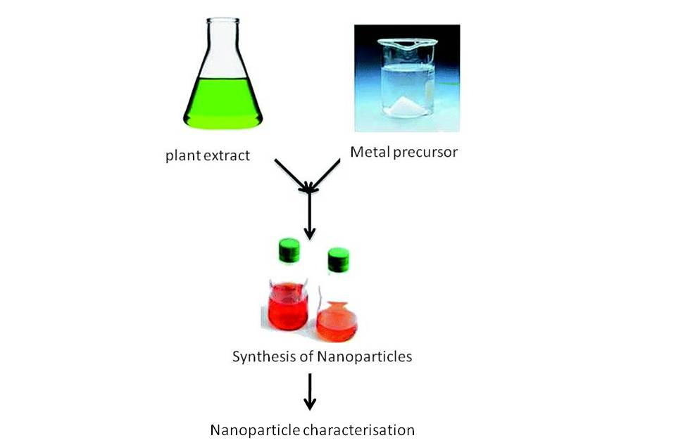

Fig 3 Synthesis of the Nanoparticles from Plants

- CHARACTERIZATION OF NANOPARTICLES

- Scanning Electron Microscope (SEM)
SEM determines the surface properties of any sample. In SEM, electrons beam strikes a sample surface. The electron scattered from the surface of the sample is detected to get the information about sample’s surface characteristics [15].

- Transmission Electron Microscope (TEM)
TEM studies the dimensions and structure of NPs. When electrons are passed through a sample, some of the electron beam interacts with the sample, remaining is diffracted. The electrons transmitted from the sample generate an image which reveals the information about the internal composition of the sample.

- Dynamic Light Scattering (DLS)
DLS determines the size of the particles within sub micron range [15]. DLS typically measure the Brownian motion of the sample particles. When the sample particles are hit by the laser, the small sized particles will have fast Brownian motion whereas the large sized particles will move slowly owing to their size. The change in the intensity of light is measured with suitable optical setup which corresponds to the size of the sample particle.

- UV-Vis Spectroscopy
NPs are made of metals which have the property to absorb light at a specific wavelength. When the Ultraviolet light is passed through a sample containing NPs, some of the light is absorbed creating absorption spectra. This spectrum is used to identify the metallic NPs. The spectrum is dependent on the size, shape, and the aggregation state of the NPs.

- Fourier Transform Infrared Spectroscopy (FTIR)
FTIR is a significant tool to identify functional groups present on the NPs using infrared spectroscope. In FTIR, when a sample is exposed to IR, some amount of the radiation is absorbed whereas some is transmitted. The resulting spectrum is used to identify the molecule as no two molecules can have the same IR spectrum. Identification of the groups is important as these groups can be responsible for synthesis and stability of NPs [16].

- CONCLUSION

Various studies are reported for the green synthesis of the NPs. The physical and chemical methods bring about many drawbacks including hazardous by-products, use of toxic chemicals, high energy consumption etc. Therefore it can be assumed that in future a clean, safe and green method of the NP synthesis will be largely accepted. Greater understanding of mechanism involved with biological nano-factories will help to regulate the process more efficiently.

- BIBLIOGRAPHY

- Shah , M.A., Pirzada, B.M., Price, G., Shibiru, A.L., Qurash, A. Applications of nanotechnology in smart textile industry: A critical review, Journal of Advanced Research,Volume 38, pp 55-75, 2022.

- Salvioni,L., Morelli, L., Ochoa, E., Labra, M., Fiandra, L., Palugan, L., Prosperi, D., Colombo,M. The emerging role of nanotechnology in skincare. Advances in Colloid and Interface Science, Volume 293, July, 2021.

- Jha, P., Saraf, A., Sohal, J. K. Antimicrobial Activity of Biologically Synthesized Gold Nanoparticles from Wild Mushroom Cantharellus Species. Journal of scientific Research, Vol 6(3), pp. 78-83, 2021.

Bahrulolum, H., Nooraei, S., Javanshir, N., Tarrahimofrad, H., Sadat, V., Mirbagheri, Easton, A.J., & Ahmadian, G. Green synthesis of metal Np using microorganisms and their application in the agrifood sector, journal of Nanobiotechnology, volume 19, Article number: 86 , 2021.
- Geethalakshmi R, Sarada DVL. Synthesis of plant-mediated silver nanoparticles using Trianthema decandra extract and evaluation of their antimicrobial activities. International Journal of Engineering Science and Technology, 2(5),970-975,2010.
- Sadowski Z, MaliszewskaIh, Grochowalska B, Polowczyk I, Koźlecki T. Synthesis of silver nanoparticles using microorganisms. Materials Science-Poland, 26(2), 419-424, 2008.

- Gobinath, R., Bandeppa, Manasa, V., Rajendiran, S., Kumar, K., Paul, R., & Basavaraj, K. Nanoparticle-Mediated Adsorption of Pollutants: A Way Forward to Mitigation of Environmental Pollution. Microbial Rejuvenation of Polluted Environment,vol 2, pp 317–348.,2021.

- Venkataraman D, Kalimuthu K, Sureshbabu RKP, Sangiliyandi G, Rai M, Duran N. Metal nanoparticles in Microbiology. Springer, Vol.-XI, , , 17-35, 2011.

- Wang, D., Xue, B., Wang, L., Zhang, Y., Liu, L., Zhou, Y. Fungus-mediated green synthesis of nano-silver using Aspergillus sydowii and its antifungal/antiproliferative activities. Sci Rep 11, 10356, 2021.

- Mata YN, Blazquez ML, Ballester A, Gonzalez F, Munoz JA. Biosorption of cadmium, lead and copper with calcium alginate xerogels and immobilized Fucus vesiculosus. Journal of Hazardous Materials,163(2–3):555–562,2009

- Roy, A., Bharadvaja, N. Qualitative analysis of phytocompounds and synthesis of silver nanoparticles from Centella asiatica, Innovat. Tech. Agric. 1 (2) ,88–95,2017a.

- Roy, A., Bharadvaja, N. Silver nanoparticles synthesis from a pharmaceutically important medicinal plant Plumbago zeylanica. MOJ Bioequiv Availab 3 (5),00046,2017b.

- Nagore, P., Ghotekar, S., Mane, K., Ghoti, A., Bilal, M., Roy, A. Structural properties and antimicrobial activities of polyalthia longifolia leaf extractmediated CuO nanoparticles. BioNanoScience 11 (2), 579–589, 2021.

- Mittal, S., Roy, A. Fungus and plant-mediated synthesis of metallic nanoparticles and their application in degradation of dyes. In: Photocatalytic Degradation of Dyes. Elsevier,pp. 287–308, 2021.

Begum, S.J.P.; Pratibha, S.; Rawat, J.M.; Venugopal, D.; Sahu, P.; Gowda, A.; Qureshi, K.A.; Jaremko, M. Recent Advances in Green Synthesis, Characterization, and Applications of Bioactive Metallic Nanoparticles. Pharmaceuticals,15, 455, 2022.

Eid, M. Characterization of Nanoparticles by FTIR and FTIR-Microscopy. Handbook of Consumer Nanoproducts,June 2022. DOI:10.1007/978-981-15-6453-6_89-1

