RECOMBINANT DNA TECHNOLOGY

Davina Hijam
Niketa Ashem
Post Graduation Trainee: Dept. of the Biochemistry
Regional Institute Of Medical Science
Imphal, India
officialniketa@gmail.com

Associate Professor: Dept. of the Biochemistry
Regional Institute Of Medical Science
Imphal, India
davina_hijam@yahoo.co.in

ABSTRACT
Recombinant DNA technology is the procedure that combined together DNA segments to get the desired chimeric molecules. Cloning also uses genetic engineering as a primary component. This technique allows for the identification of the specific gene which might be accountable for disease, and for the investigation of how illness may result from faulty gene. In the recent era, it has shown various applications in improving human life. This new technology allows researchers to inquire and manipulate genomic sequences at the molecular level. By the application of this technology, various crucial proteins, diagnostic kits and vaccines are produced in abundance for improving various health status. In the field of agriculture, genetically modified crops are more resistant to various harmful agents, yield enhanced products and have better survival. The Gene therapy technique has the potential of curing various diseases, for instance, single gene deficiency diseases like sickle cell disease. However, this technology needs effective clinical trial before it is made available to the general public. Therefore, more in-depth research is needed in this area to address various problems and the concerns of the general public.

Keywords: recombinant DNA technology; chimeric; gene therapy

INTRODUCTION

Three key causes, including environmental challenges, health problems, and food shortages, have a considerable influence on the standard of human existence. The environment has become more polluted as a result of rapid industrialization and inadequate regulatory oversight. Industrial waste disposal in water has impacted aquatic marine life and, indirectly, humans. Infectious and non-infectious diseases like cancer, diabetes, heart disease, AIDS/HIV, tuberculosis, etc. claim the lives of almost 36 million people annually. Hunger and malnutrition will worsen as a result of a worldwide crisis brought on by food scarcity and record-high food costs that will push millions more into extreme poverty. Thus, with current technologies, these problems must be resolved.
In the modern era, Recombinant DNA technology has an impact on the progression of human existence. It can bring many changes in various aspects of life viz, health improvement, improving food availability and increase tolerance to the unfavourable environmental conditions. Genetic engineering has taken the place of traditional methods and has a better chance of resolving agricultural, health, and environmental issues. It utilizes modern tools and approaches, which are less time consuming and produces greater yield.
Recombinant DNA technology plays a vital role in improving health conditions by developing new vaccines, pharmaceuticals, and improving diagnostic, monitoring and therapeutic tools. It also helps in improving agricultural products and tackling environmental issues. It has transformed biological research and caused several changes in human existence. It constitutes a significant advance in molecular biology. With the use of DNA manipulation tools, new combinations of genes are created in the laboratory, enabling for desired gene modifications and gene transfer between one species to another. The new gene is now capable of producing the desired protein in whatever amount required.

.

RECOMBINANT DNA TECHNOLOGY

Recombinant DNA technology is a process which consists of altering genetic material outside an organism to obtain enhanced preferred characteristics in living organisms or as their products. In 1973 for the first time, Stanford University and University of California San Francisco researchers, Paul Berg, Herbert Boyer, Annie Chang and Stanley Cohen created Recombinant DNA (rDNA). They successfully recombined two plasmids and cloned the new plasmid in E. coli. In 1975 at The Asilomar Conference Centre, California various regulations and cautious used of rDNA technology was debated. However, due to unexpected challenges and barriers to obtaining adequate results, recombinant approaches to obtain agricultural and pharmaceutical breakthroughs took longer than anticipated.

Basic steps
Recombinant DNA technology's core competencies are DNA separation and manipulation, including the end-to-end combining of sequences from widely diverse origins to create chimeric molecules. This is possible because of the annealing characteristics of nucleic acid and the presence of enzymes acting on nucleic acid. Enzymes called restriction endonucleases, one of the most important tools in recombinant research, cut DNA at precise locations inside the molecules around the two base pair away from the symmetrical axis on both strands of DNA eg: EcoRI, HindIII, TaqI. Either the blunt or sticky ends are produced when the enzyme cleaves the double-stranded DNA. Among these, sticky ends are especially helpful in making chimeric DNA, however it faces certain disadvantages as it may automatically reconnect themselves with no net gain of DNA. Not only this, sticky end-sites may not be present in an advantageous location. Hence, terminal transferase enzyme or synthetic sticky ends are directly ligated to the blunt end to solve this problem. One such enzyme which directly ligates the blunt end is bacteriophage T4 enzyme DNA ligase.

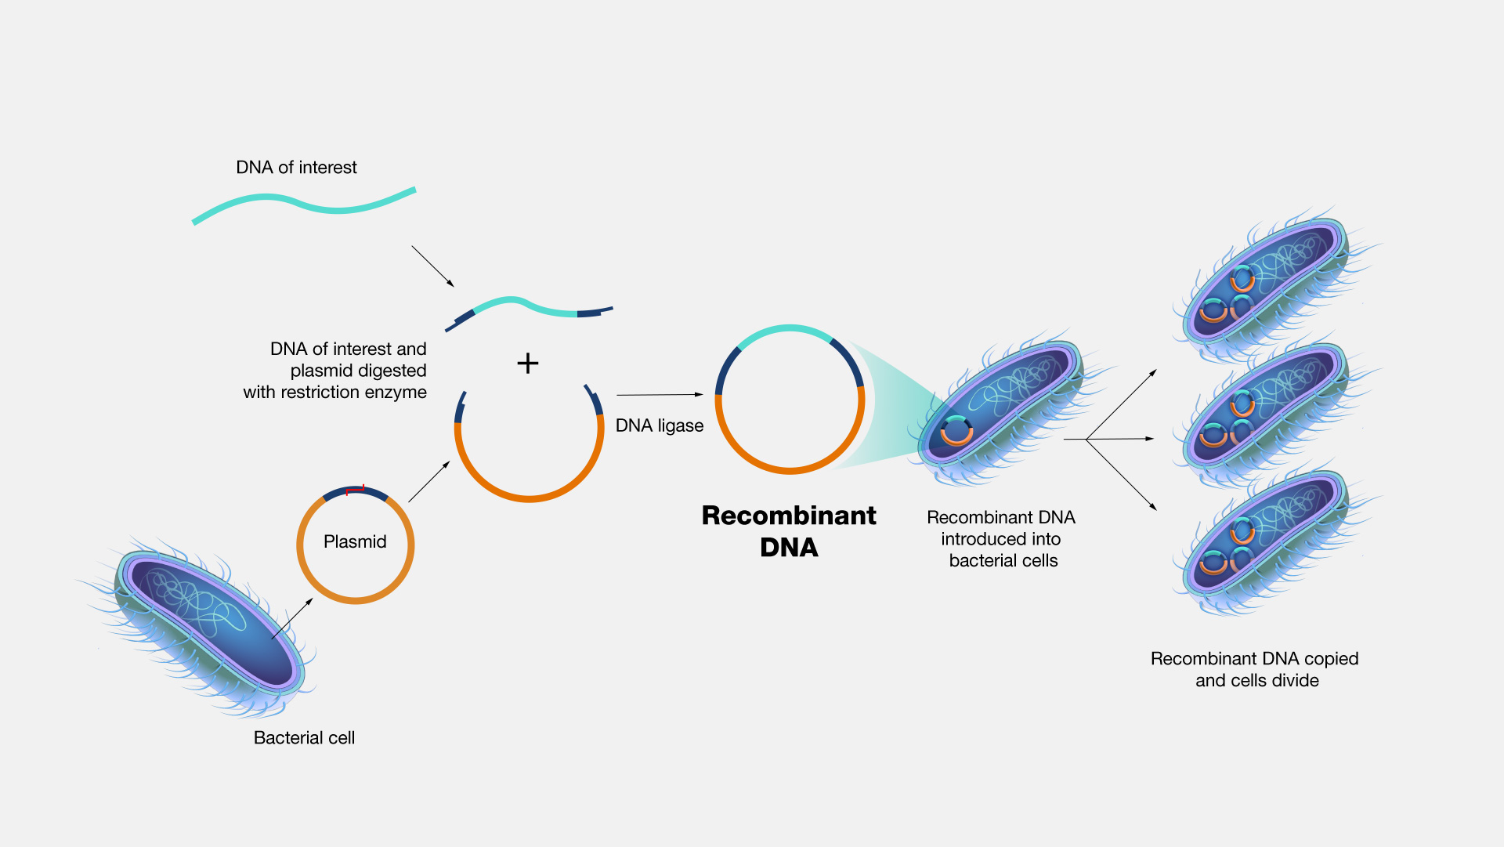
Figure 1: https://www.genome.gov/genetics-glossary/Recombinant-DNA-Technology

The chimeric or hybrid DNA molecules are then cloned in cloning vectors, which are often bacterial plasmids, phages, or cosmids. From there, they continue to multiply inside the host cell with the help of their own regulatory mechanisms. This process of insertion of plasmid vector into the host cell usually E.coli is known as transfection. Plasmids are small, circular, duplex DNA molecules and provides antibiotic resistance to the host cell. Phages are the bacterial viruses with linear DNA molecules that may accommodate foreign DNA pieces of 10-20kb in length at multiple restriction enzyme sites. After the phage completes its lytic cycle, the hybrid DNA is harvested. Cosmid vector combines the best characteristics of plasmids and phages which contains a DNA sequence called COS-sites required for packaging lambda DNA into phage particles. Cosmid can accept large cDNA fragments upto 35-50kb.
From the transfected bacterial colonies, using the antibiotic sensitive method, the bacterial colonies carrying the desired gene is selected. Then the selected colonies are cultured in the suitable medium where they grow and multiply. Usual methods of protein separation isolate the desired protein from such protein producing bacterial colonies. Enzyme based cloning involves the use of the polymerase chain reaction for in vitro amplification of DNA.
It is possible to build a library of various recombinant clones, such as a genomic or cDNA library. A genomic library is a sizable assembly of bacterial cells, each carrying a casual fragment of human genomic DNA. Partial digestion of an organism's total DNA with restriction enzymes and then ligating the resulting larger fragments to a vector which preserve the majority of the organism's genes made up the genomic library. The preparation of a cDNA, on the other hand, involves seperating all the messenger RNA (mRNA) present in a tissue and then converting them into ds-DNA using reverse transcriptase and DNA polymerase. A cDNA is a made up of all the expressed DNA of a particular cell type or tissue. In order to manufacture proteins using recombinant technology and to identify specific cDNA molecules from libraries, expression vectors are frequently utilised. Probes are fragments of DNA or RNA labelled with a $P^{32}$- containing nucleotide or fluorescently labelled nucleotide which searches libraries or complicated samples for particular genes or cDNA molecules.
The nucleotide sequence of rDNA can be observed by the used of techniques such as the manual enzymatic Sanger method and automated DNA sequencing procedures. The automated chemical synthesis of oligonucleotide, generating approximately 100 nucleotides, is now a routine laboratory procedures. Such oligonucleotides are used for procedures including DNA sequencing, library screening, protein-DNA binding assays, polymerase chain reaction, complete synthetic gene synthesis and various other applications.
CRISPR-Cas9 (Clustered Regularly Interspersed Short Palindromic Repeats-CRISPR Associated Gene 9) is a newly found novel DNA editing the regulatory system which reflects an acquired immunity against bacteriophages infection. CRISPR system is found in many bacteria which uses RNA-based targeting to bring Cas9 nuclease to foreign DNA. Then, within the bacteria, this CRISPR-RNA –Cas9 complex will degrade and inactivates the targeted DNA.

APPLICATIONS OF RECOMBINANT DNA TECHNOLOGY

Health and Diseases
Molecular genetics technology has revolutionized the diagnosis and treatment of various diseases. The significance of recombinant DNA technology's contributions to improving human health is discussed in the following paragraphs:
The first successful gene therapy was done in a primary immunodeficiency disease known as adenosine deaminase-deficiency (ADA-SCID) in 1990. Enhanced gene transfer methodology and a myeloablative conditioning regimen have targeted the used of haematopoetic stem cells. This success has opened the future doorway for the treatment of various diseases. Deficiency of HexoaminidaseA (HexA) enzyme caused a severe neurological disease known as the Tay–Sachs disease. After over 14 years of development, two babies aged 2 ½ years and 7 months old have received the 1st ever gene therapy for the Tay Sachs disease. In this case DNA instructions enter and stay at the brain cell nucleus, allowing a long term production of HexA.
Gene silencing drugs work by targeting mRNA. A new cholesterol jab, a gene silencing drug uses small interfering RNA (siRNA) which targets the mRNA that carries instructions for the excessive production of PCSK9 protein in people with high levels of LDL cholesterol thereby significantly reducing this protein. Researchers are also currently investigating on the gene silencing application in various numerous health conditions like Alzheimer’s disease and cancer. CRISPR- therapy has also targeted many single gene disorder like sickle cell anemia, cystic fibrosis and Huntington disease as it is much easy to fix or replace just one defective gene. Through a tiny gateway protein called CCR5, the HIV virus penetrates human white blood cells. As a potential HIV treatment, researchers are investigating how to use gene therapy to specifically target the CCR5 entryway.
Gene therapy has also targeted many tumors of lungs, urogenital, skin, gastrointestinal and hematological malignancies. A tumor suppressor gene known as p53 acts as the main player in the effort of treating cancers. Genetically engineered T-cells are transferred to metastatic cancer which leads to regression. Cancer specific antigen identification genes are recombined with genes which impart resistance to immunosuppression to extend the longevity of T-cells in cancer patients. This modification will promote the movement of T-cells to tumors.
Some of the important vaccination approaches that have been employed are: vaccination with engineered tumor cells that express immune-stimulatory molecules, vaccination with recombinant viral vectors which encode tumor antigens and vaccination with engineered host cells that express tumor antigens. One such example is hepatitis B vaccine which is an inactivated surface antigen vaccine containing 10-40 micrograms of HB3Ag protein per ml with an apparently similar rate of seroconversion. Recombinant COVID-19 vaccines are also being developed and tested for their efficacy. The CORBEVAX vaccine is a protein subunit vaccination that directly provides the body with the spike protein. The vaccine is safe, well tolerated, and more than 90% effective at preventing symptomatic infections from the original strain of COVID-19 and more than 80% effective against the delta variation, according to two large clinical studies involving over 3000 individuals in India.
Therapeutic human proteins have been produced in abundance with the advancement of recombinant DNA technology. Production of injectable human insulin for diabetic patients is itself a very great success in pharmaceutical industry. Recombinant growth hormones are being used to bolster up the normal growth and development for patients with the dysfunctional pituitary gland. Ovulation and pregnancy are enhanced through the recombinant follicle stimulating hormone (r-FSH) and Luteinizing hormone (LH) recombination. Additionally, it can also produce blood-clotting and fibrinolytic proteins such as clotting factors VIII and IX and tissue-type plasminogen activator as well as humoral immune response mediators.

Environment
Researchers are trying to solve numerous environmental problems through genetic engineering, The University of Tennessee and Oak Ridge National Laboratory first used the genetically engineered microbes Pseudomonas fluorescens strain known as HK44 for bioremediation, a branch of biotechnology which utilized living organisms like microbes and bacteria to decontaminate affected areas. This strain is employed as an online instrument for in situ analysis of bioremediation processes because of its advantage of increased naphthalene breakdown and a bioluminescent response. Use of improved Pi absorption transgenic plants like AtPHR1 can lead to efficient phytoremediation in contaminated aquatic settings. However, some chemicals are resistant to degradation, for example, trinitrotoluene undergoes partial degradation to form toxic superoxide. The gene for monodehydroascorbate reductase is knocked out through genetic engineering in order to increase the plant's resistance to TNT. Oil spill cleanup employs genetically modified marine microbes that can break down petroleum. The future possibilities of these methods are boundless and extremely hopeful.

Figure 2: Phytoremediation. Credit: Trood/ Getty images
Genetically modified cyanobacteria in terms of growth and nutrients to enhance hydrogen production is used as biofuels, providing an environmental friendly energy source. They are also genetically altered to convert carbon dioxide into reduced fuel compounds making the carbon energy sources environmentally safe.
Recombinant DNA technology has demonstrated its efficacy in eliminating soil pollutants such as arsenic, which is regarded as a major one. Genetically engineered Arabidopsis expressed PvACR3, a crucial Arsenite [As(III)] antiporter, that exhibited increased arsenic tolerance. In contrast to wild-type seeds, which ordinarily perish in the presence of higher-than-normal concentrations of arsenate [As(V)], PvACR3-modified Arabidopsis seeds may sprout and thrive in these conditions. The arsenic reductase found in Arabidopsis thaliana reduces the element arsenic (As). Phytochelatins limit the migration of arsenic in phloem companion cells and root cells.

C. Agriculture
In the last 25 years, there is 100 fold increase in the production of Genetically Modified (GM) crops. A plant is considered genetically modified in accordance with the United Nations's Cartagena Protocol on Biosafety of "Living Transformed Organisms" (LMO) if it satisfies two criteria: 1) it contains a novel combination of genetic material; and 2) it was modified using modern biotechnologies. Here modern biotechnology implies in the application of either using 1) in vitro nucleic acid techniques, which includes recombinant DNA and direct injection of nucleic acid into cells or organelles or 2) fusion of cells beyond the taxonomic family. 46% of the total biotech crops are cultivated in the industrialized countries including The United States, Canada, Australia, Spain and Portugual. The remaining 54% are grown by developing countries including Brazil, Argentina, and India are amongst the top five countries with the largest areas of biotech crop cultivation.
Genetically engineered crops with Bacillus thuringiensis (Bt) toxins of bacteria are used to replace chemical pesticides to control insect disease. Such crops produced Bt toxins of their own so they can defend themselves against specific types of insects. In China, a lot of Bt cotton and virus-resistant papaya are farmed. Some transgenic plants include genes that allow them to destroy herbicide's active components, rendering it harmless.
Bio-fortification of plant through modern bio-technological method is a promising way to provide micronutrients to the deficient population on a global scale. Novel genes, gene over-expression, gene down-regulation, gene disruption, or disruption of the production route of an inhibitor have all been used to create the transgenic crops. One such example is the Golden rice which is enriched with beta carotene which is a precursor of vitamin A.

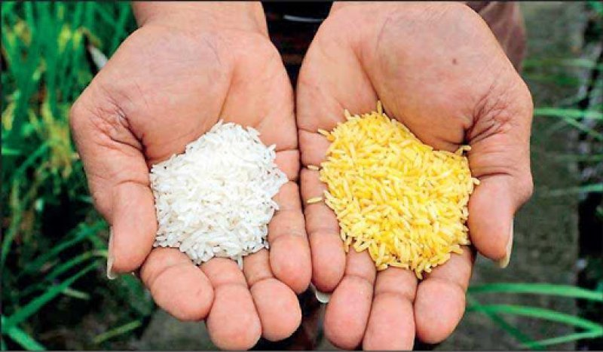
Figure 3: Golden Rice. Credit: Getty Images

IV. FUTURE PROSPECTS AND CHALLENGES
By creating novel medications and vaccines, Recombinant DNA Technology is crucial for enhancing health conditions. Furthermore, the development of diagnostic tools, monitoring technologies, and numerous therapy modalities improves treatment options. The widespread application of rDNA technique in genetically modified crop development, gene therapy, veterinary product development and bio-pesticides and biofuel production will expand in the future.
Since most non-viral vectors lack precision targeting capability while using viral vectors carries the danger of carcinonegenesis, gene therapy is presently in the preliminary phase and only effective in managing a small number of disorders. Nevertheless, despite all of these challenges, there is still a great deal of optimism that gene therapy will play a significant role in clinical practice and have implications in many areas of medicine.
In clinical trials, human gene therapy is mostly used to treat cancer. High transfection effectiveness in relation to creating gene delivery systems has been the main focus of research. It is still being researched whether transfection could be used for cancer gene treatment with minimum side effects, including cancers of brain, breast, lung, and prostate. Gene therapy is also takin into account for kidney transplantation, Gaucher disease, haemophilia, Alport syndrome, renal fibrosis, and certain other illnesses.
However, this technology needs effective clinical trial before it is made available to the general public. For example, gene, silencing technology should undergo further clinical trials before they can be rolled out for use on a wider scale. Making sure that the prices of these medications remain low so that more people may afford them will be another significant hurdle. However, these advances as a whole are highly encouraging.
In regards to GM crops, every country has a unique set of laws and regulatory structures to control the cultivation of GM crops. For example, one of the most well-known GM crops that is still awaiting release permission is biofortified Golden Rice. Currently, Golden Rice is allowed for human consumption in Australia, Canada, New Zealand, the United States, and the Philippines but not for production. The biosafety law should be adhered to in order to protect the wellbeing of people, animals, and the environment.

V. CONCLUSION
The development of recombinant DNA technology has significantly improved the quality of human existence. Recombinant DNA technology's contribution to a clean environment (phytoremediation and microbial remediation) and improved plant resistance to many harmful variables (drought, pests, and salt) are well-known. Regarding medical concerns, recombinant technology is assisting in the treatment of various diseases that cannot be treated under normally, although immune reactions provide a challenge. The methodologies for genetic engineering face a number of challenges that have to be resolved by more focused gene improvement in accordance with the organism's genome. Therefore, more in-depth research is needed in this area to address various problems and the concerns of the general public.

REFERENCES

.

- Harper’s Illustrated Biochemistry 31st ed,. Molecular genetics, recombinant DNA and Genomic technology. McGraw Hill Education. 2018. p. 1051-119
- Khan S, Ullah MW, Siddique R, Nabi G, Manan S, Yousaf M, Hou H. Role of recombinant DNA technology to improve life. International journal of genomics. 2016 Oct;2016.J.
- Turnbull C, Lillemo M, Hvoslef-Eide TA. Global regulation of genetically modified crops amid the gene edited crop boom–a review. Frontiers in Plant Science. 2021 Feb 24;12:630396.
- Flotte TR, Cataltepe O, Puri A, Batista AR, Moser R, McKenna-Yasek D, Douthwright C, Gernoux G, Blackwood M, Mueller C, Tai PW. AAV gene therapy for Tay-Sachs disease. Nature medicine. 2022 Feb;28(2):251-9.

