Schizophrenia: An overview

Inderpreet Kaur*, Himani¹
*K.C. College of Pharmacy, Nawanshahr-144514, Punjab, India
¹Assistant Professor of Pharmacology, K.C. College of Pharmacy, Nawanshahr-144514, Punjab, India

ABSTRACT:
Schizophrenia is yet one of the most strange psychiatric disorders that are described by delusions, hallucinations and impaired social behavior. Symptoms of schizophrenia appear in adolescence and early adulthood while their description is managed by standard criteria. The occurrences of the psychiatric disorder fluctuate over society and migrant groups. Genetic exposure overlaps with environmental factors causing particular symptoms and course. This article focuses on introduction, history, epidemiology, etiology, symptoms, causes, mechanisms, pathophysiology, treatment, medication, side effects and preventions of schizophrenia.

Key words:
Psychiatric disorder,
Genetic and Environmental factors,
Incidence rates,
Dopamine hypothesis,
Anti-psychotic agents,
Prevention of Schizophrenia.

Corresponding author:
Email address: indersaini8146@gmail.com (*), himani.sharma270197@gmail.com (¹)

INDEX
- Abstract..................................................................... 2
- Introduction ............................................................. 2
- History ...................................................................... 3
- Epidemiology............................................................ 4
- Etiology..................................................................... 5
- Symptoms................................................................. 7
- Positive symptoms ...................................................... 7
- Negative symptoms .................................................... 8
- Cognitive symptoms ................................................... 8
- Cause ........................................................................ 9
- Mechanism ..............................................................10
- Neurodevelopment hypothesis .................................. 10
- Dopamine hypothesis ................................................ 11
- Glutamate hypothesis ................................................ 12
- Pathophysiology ...................................................... 12
- Treatments............................................................... 13
- First generation agents................................................ 14
- Second generation agents ........................................... 15
- Medication and side effects..................................... 16
- Preventions............................................................... 17
- Conclusion ............................................................... 19
- Reference.................................................................. 19

SCHIZOPHRENIA: AN OVERVIEW

ABSTRACT:
Schizophrenia is yet one of the most strange psychiatric disorders that are described by delusions, hallucinations, and impaired social behavior. Symptoms of schizophrenia appear in adolescence and early adulthood while their description is managed by standard criteria. The occurrence of the psychiatric disorder fluctuates over society and migrant groups. Genetic exposure overlaps with environmental factors causing particular symptoms and course. This article focuses on introduction, history, epidemiology, etiology, symptoms, causes, mechanisms, pathophysiology, treatment, medication side effects, and prevention of schizophrenia.
INTRODUCTION:
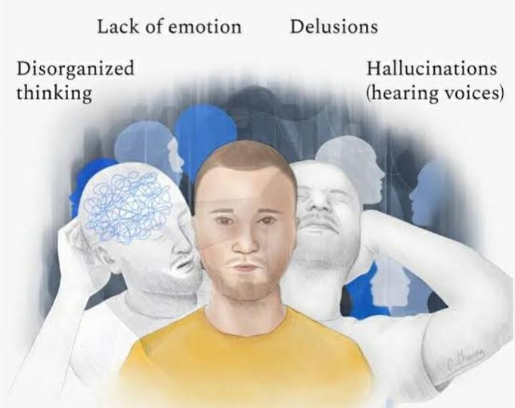
Schizophrenia is a serious psychiatric disorder, a dissimilar behavioral and cognitive syndrome that is related to the disordering of brain development caused by genetic or environmental factors [1]. According to American psychiatric Association schizophrenia is a psychological disorder that is described by hallucinations, delusions and interruption in speech, thoughts, behavior, understanding, feelings and consciousness [2]. It is derived from the Greek word “Schizophren” in which ‘schizo' means ‘splitting' and ‘phren' means ‘mind’ .
Figure 1: Schizophrenia a psychiatric disorder.
This term was first invented by Eugen Bleuler in 1908. Although a low frequency, schizophrenia’s global burden of disease is vast. Over half of the patients have significant co-morbidities, both psychiatric and medical, making it one of the leading causes of disability worldwide [3]. The diagnosis interconnected with a 20% reduction in life expectancy, with up to 40% of deaths allot to suicide [4]. Schizophrenia affects men and women with equal frequency. It is not as common as other brain diseases; it can be very disabling as approximately 7-8 individuals out of 1000 will have this disorder [5].
HISTORY:
The earliest medical description of schizophrenia symptoms belongs to Haslam and Pinel published in 1809. However, the definition “schizophrenia” appeared much later. During the 19th century, psychiatrists described more cases with the same symptoms though the definitions were different. In 1899, Emil Kraepelin improved the classification of mental disorders separating mood disorder and dementia praecox that was characterized by schizophrenia-like symptoms.
In 1908, psychiatrist Eugen Bleuler introduced the definition “schizophrenia” which is translated from Greek as “splitting of the mind.” He described four main symptoms related to the disease: Flattened affect, autism, impaired association of ideas, and ambivalence. Later, the psychiatrist Kurt Schneider described more detailed symptoms that distinguished schizophrenia from other disorders. They are called first-rank or Schneider’s first rank symptoms including, for example, delusions, voice auditory hallucinations commenting actions or conversations, and inserted thoughts [6].
In 1950, first antipsychotic named chlorpromazine introduced to treat schizophrenia [7]. This was the revolutionary discovery that started the development and investigation of new antipsychotic agents that helped to understand the molecular bases of schizophrenia and the development of dopamine hypothesis in 1960s.
Psychoeducation and family therapy, as well as atypical psychotics including clozapine, were used for treatment beginning from 1970s. Cognitive-behavior therapy and cognitive remediation were introduced to treat schizophrenia starting from 2000s. Now, molecular mechanisms based on the gene-environment interaction and personalized approaches to treatment are the major directions of modern neurobiology, psychiatry, and medicine in the field of schizophrenia [7].
EPIDERMIOLOGY:
Schizophrenia take place all over the world .The frequency of schizophrenia set about 1 percent internationally [8, 9]. It is regularly measured that schizophrenia affects <1% of the human population at certain point of their life.
However, the frequencies can changes between 0.3 and 0.66% depending on multiple factors. The studies have indicated that its frequency and occurrence changes in different countries and cultures of the world and even at local areas show in figure 2. The occurrence of schizophrenia alters from 7.7 to 43/100,000 person-years [10].
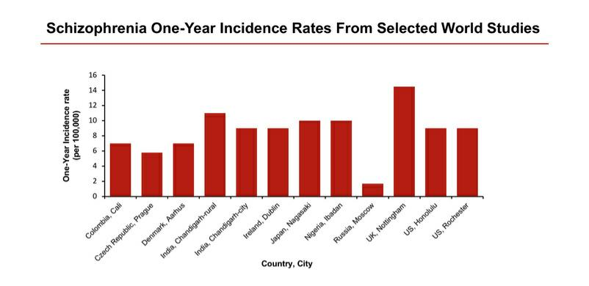
Figure 2: one-year incidence rates of selected Countries, city on schizophrenia.

Moreover, in men, the symptoms arise between 18 to 25 years of age, while in women, symptoms occurrence has two ranges -first arise in the age between 25-30 years and second arise after the age of 40 years (Figure3)[11]. The season of birth is one of the epidemiological properties of high risk of schizophrenia [12]. The viable explanations are dietary deficiency or high risk of infectious disease that affects fetal organism during 2nd trimester of pregnancy. It was illustrated that fetal exposure to genital and reproductive infections, influenza virus, herpes simplex virus, and toxoplasmosis increase the risk of schizophrenia development [10]. Adult patients with toxoplasmosis may develop alike symptoms to psychotic disorders. It was also appearing that toxoplasma increases dopamine synthesis and release [12].
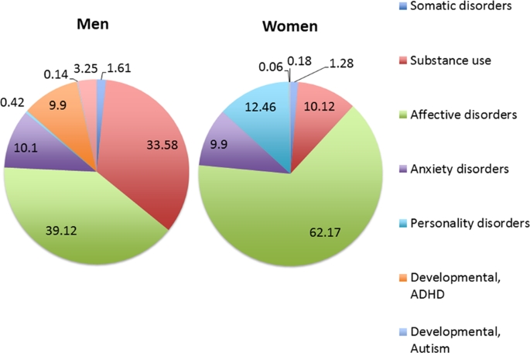
Figure 3: Shows that the occurrence of schizophrenia in men and women due to multiple factors or disorders.

Other studies verify that pregnancy and birth reissues also are connected with schizophrenia. These complications can be categorized into three types also involves:
- complications of pregnancy (bleeding, diabetes and rhesus compatibility),
- abnormal fetal growth and development (low birth weight and decrease in head circumference),
- Compilations of delivery (uterine atony and emergency Caesarean section) [13].

Several studies appear that there is a relation between parental loss or separation, physical abuse in early childhood, and schizophrenia development [10]. In adolescence, stress linked to the emotional life incidents and community separation may increase schizophrenia risk. The deformities of hippocampus are caused by the increase of dopamine system after exposure to stress or drugs. These deformities can be the reason for psychotic disorders [12].
ETIOLOGY:
Several studies postulate that the development of schizophrenia results from abnormalities in multiple neurotransmitters, such as dopaminergic, serotonergic and alpha-adrenergic hyperactivity or glutaminergic and GABA hypoactive [14]. Scientists also believe that brain structure of the people with schizophrenia is slightly different than healthy peoples. For example, fluid-filled cavities at the center of the brain called ventricles are larger in some people with schizophrenia. Other most common cause of schizophrenia evidenced that most people identified with schizophrenia have increased in dopamine level but it's still not known that how everyone diagnosed with schizophrenia have too much dopamine [15, 16].
The despite more than a century of investigation, the specific cause of schizophrenia continues to avoid examiners. It is generally accepted, although, that the various phenotypes of the illness occurs from many factors, including genetic weakness and environmental impacts (figure4). One description for the occurrence of schizophrenia is that the disorder starts in utero [17].
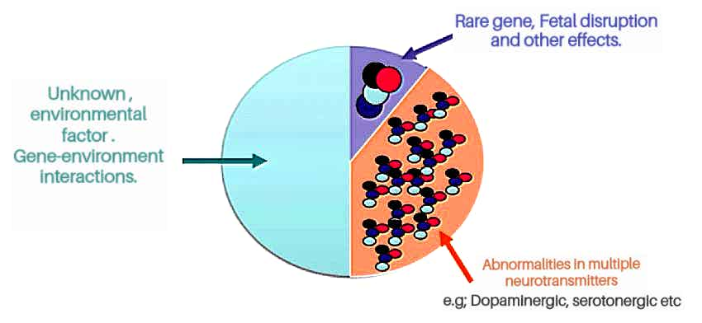
Figure 4: Etiology of schizophrenia.
There are many obstetric complications occur such as:
- Bleeding during pregnancy,
- Low birth weight,
- Gestational diabetes,
- Emergency cesarean section, etc have been related with schizophrenia disease later in life [18].
Fetal disruption occurs during the second trimester—critical stages in fetal neurodevelopment—have been of specific interest to researchers. The excess of stress levels and infections during this period have been results to increasing the risk of developing schizophrenia.
Scientific authentication assists the idea that genetic factors play an important role in the causes of schizophrenia [18]. The research has shown that the risk of illness is approximately 6 to 17% for a first-degree relative and 2 to 6 % for second-degree relative. In the case of monozygotic twins, the risk of one twin having schizophrenia is 50%, if the other has the disorder, whereas the risk is 17% in dizygotic twins also show in table 1. If both parents have schizophrenia, the risk that they will produce a child with schizophrenia is approximately 42% [20].
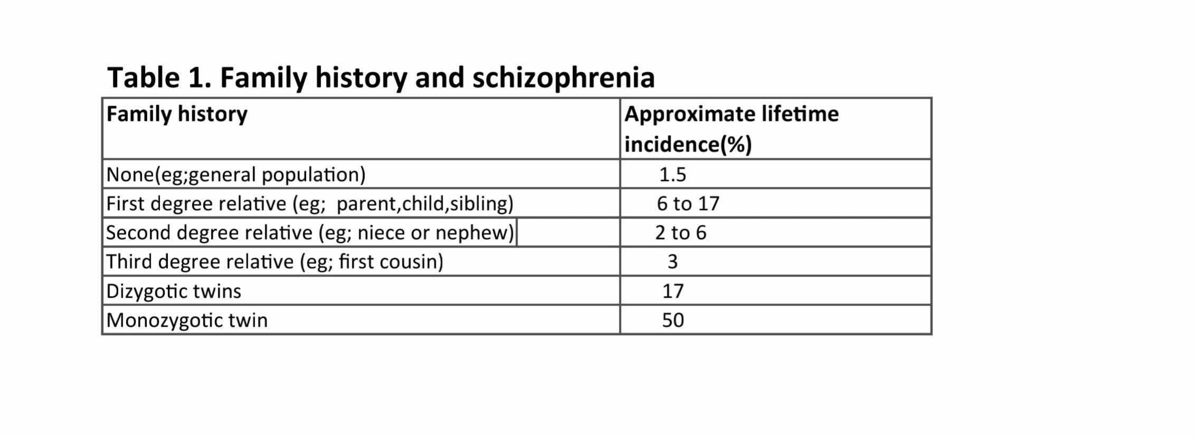
Mainly, the etiology of schizophrenia is based on the genetic vulnerability and environmental factors, which relates with each other affecting development, maturation, and plasticity of the brain.
SYMPTOMS:
The symptoms of schizophrenia begin between late adolescence and the middle 30s. All the symptoms of schizophrenia are divided into three separate categories [5]:
- Positive symptoms
- Negative symptoms
- Cognitive symptoms
- Positive symptoms: The Symptoms which does not recognized normally in individuals but are present in patients with schizophrenia. The symptoms are characterized into five groups :
- Delusions (persecutory delusions, delusions of guilty and religious delusions)
- Hallucinations (voices commenting, voices conversing and visual hallucinations)
- Thought disorder (incoherence, illogicality and pressure of speech)
- Bizarre behaviour (clothing and appearance, aggressive and agitated behaviour and repetitive behaviour)
- Inappropriate affect [6]
- Negative symptoms: These symptoms can occur in patients with other neurodegenerative disorders: Parkinson’s disease, Alzheimer’s disease, or severe depression. These symptoms include :
  - Blunted effect (reduction of spontaneous movements, scarcity of facial expressions, poor eye contact, and lack of voice modulation)
  - A logia (poverty of speech)
  - Anhedonia (inability to experience pleasure, scarcity of recreational and leisure activities and inability to experience closeness)
  - A volition (poor hygiene and reduced motivation)
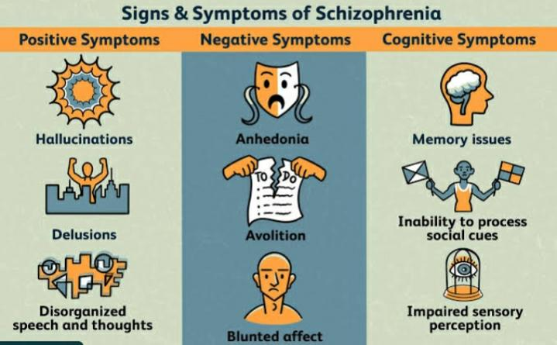
  - A sociality (absence of friends, poor relationship with other people and reduced social interaction) [5].

Figure 5: Signs and symptoms of schizophrenia.

- Cognitive symptoms : It includes:
  - different types of memory (working memory, long term memory, verbal declarative and episodic memory)
  - Attention
  - Learning [9]
CAUSES:
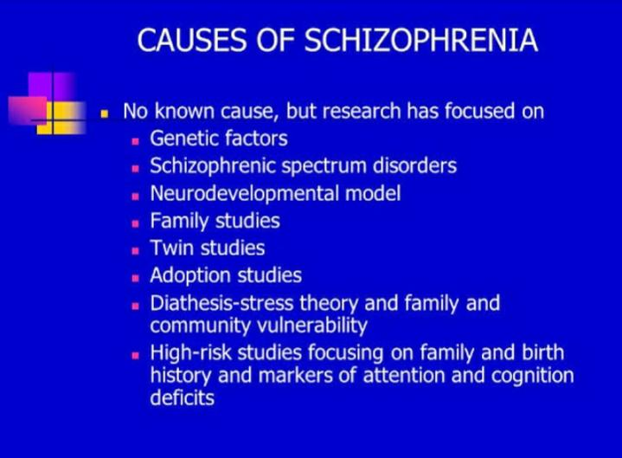
Figure 6: Cause of schizophrenia.

- Genetic factors include changes of the genetic material at different levels starting with gene sequence and finishing with genomic abnormalities. Several studies analyzing variations of coding regions (exome sequencing) have demonstrated that patients with schizophrenia possess de novo mutations in the number of putative genes including dihydropyrimidine dehydrogenase laminin, α2, transformation/ transcription domain-associated protein, and vacuolar protein sorting [24].
- Another investigation has shown that 50 genes related to calcium channels and postsynaptic activity-regulated cytoskeleton-associated scaffold protein complex contained one or two mutations in schizophrenia patient [25].
- Prenatal and perinatal complications have a strong effect and increase the risk of schizophrenia from 1 in 100 to 2-4 in 100 individuals [26]. It was hypothesized that infection-associated immunological disorders during early fetal development increase the risk of neurodevelopmental impairments.
- Furthermore, the abnormal immune response in maternal organism correlates with the development of schizophrenia in children. For example, increased levels of interleukin-8during pregnancy increase the risk of schizophrenia [27].
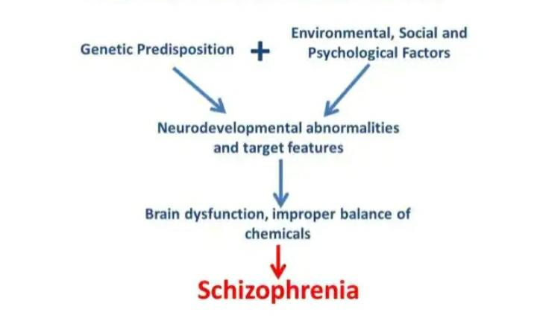
- The use of drugs or other psychotropic substances correlates with the development of schizophrenia. Cannabis is one of the most potential reasons that are consistent with psychosis and schizophrenia [28].
Figure 7: Shows the factors responsible for schizophrenia.
- However, the association between these factors and psychosis is relatively Low. Studies have shown the direct correlation between urban life and psychosis risk [29].
- It was confirmed that rate of schizophrenia is higher in the urban environment. It was suggested that ecological or social factors could have an effect on the development of psychosis symptoms.
- Furthermore, it was hypothesized that these influences can be combined with genetic factors causing changes in the brain development [29, 30].
MECHANISM:
There are different mechanisms related to schizophrenia given below;
- Neurodevelopment hypothesis: The neurodevelopment hypothesis of schizophrenia postulates that effects during an embryonic or fetal stage in brain development lead to defective neural activity and altered neuronal functioning later in life (figure8). The alterations observed in post mortem of a schizophrenic patient that neuro developmental disturbances mainly related to the hippocampal formation and in the superior temporal lobe. The neurodevelopmental abnormalities developing in utero as early as late first or early second trimester and which leads to in young adulthood appear the positive and negative symptoms or both [9, 31].
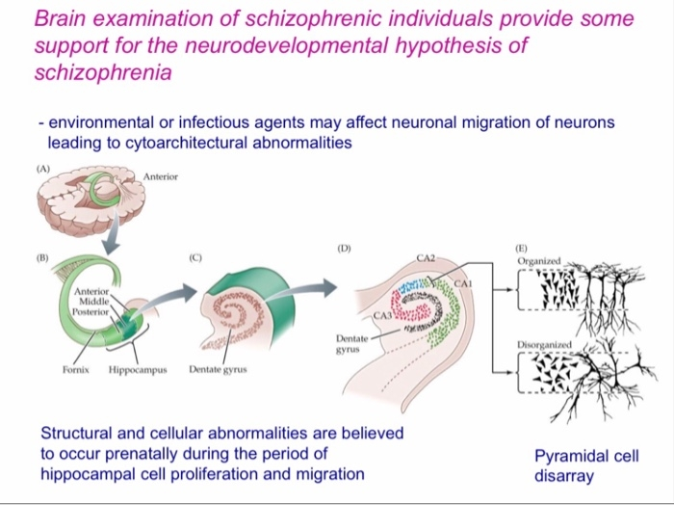
Figure 8: Shows the Neurodevelopment hypothesis of schizophrenia.

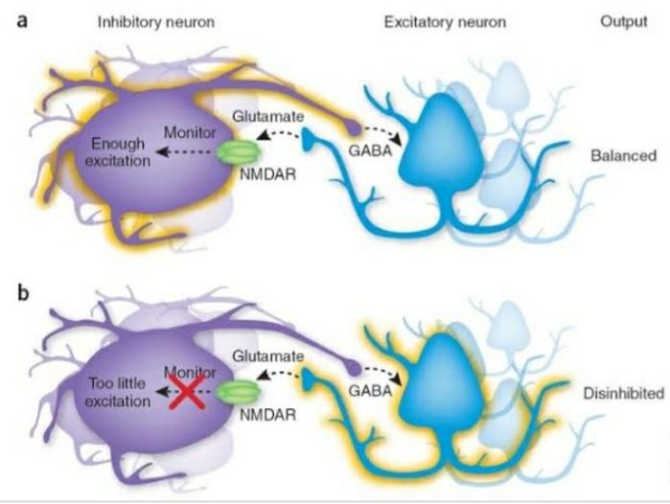
- Dopamine hypothesis : The most widely contemplated neuro chemical hypothesis of schizophrenia is the dopamine hypothesis, which theorizes that symptoms of schizophrenia may results from excess dopaminergic neurotransmission particularly in mesolimbic and striatal brain regions which lead to positive symptoms and finally changes into schizophrenia that show in figure 9. There are many clinical shreds of evidence about schizophrenia that provides support for the dopamine hypothesis. In this hypothesis, the different evidence has appeared. The first evidence that in schizophrenia patient’s dopamine came from amphetamine users.
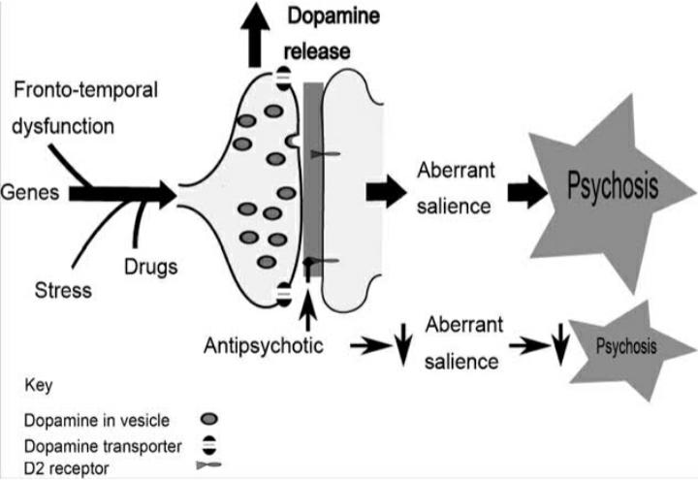
Figure 9: Dopamine hypothesis Figure 10: Glutamate hypothesis

Amphetamine showed that too produces more dopamine and produces psychotic symptoms related to schizophrenia [32, 33].

- Glutamate hypothesis: In this Hypothesis, it is noted that dopaminergic dysfunctioning may be associated with glutamatergic dysfunctioning. In this concept glutamate, dysfunctioning will lead to opening effect in the thalamocortical loop which causes to appear psychotic symptoms and well-known dopamine concentration changes. Glutamatergic receptors consist of two groups which can perform different functions and finally leads to schizophrenic symptoms appear (Figure 10). In these receptors, major receptors are NMDA (N-methyl, D-Aspartate) receptor which causes schizophrenia among most patients by changing dopamine level from the normal range [34, 35].
PATHOPHISIOLOGY:
- Pathophysiological changes can be easily observed using modern neuroimaging techniques. These studies have shown a decrease in gray matter, enlargement of ventricles, and focal alteration of white matter tracts [36]. Schizophrenia brain is characterized by reduced volume of temporal cortex that is associated with schizophrenia psychopathology. The thalamus plays an important role in the integration between the cortex, the cerebellum, and incoming sensory information [37].
- These suggestions are supported by fMRI studies that demonstrate, for example, the association between working memory deficits, impairments, and low activation of prefrontal cortex, superior temporal area, and striatum [38]. PET scanning demonstrates decreased levels of blood flow in the left par-hippocampal region, reduced glucose metabolism in the thalamus, and frontal cortex. These techniques also show an association between delusions and hallucinations and decreased blood flow in the cingulate, left frontal and temporal areas.
- In contrast, patients with active auditory hallucinations are characterized by increased blood flow in thalamus, hippocampus and striatum, orbitofrontal and cingulate areas [39].
- Previous pharmacological studies and observations suggested the “dopamine hypothesis” for schizophrenia development that shown in figure 11. The action of antipsychotics helped to identify that D2-dopamine receptors blockade has a positive effect on the symptoms.
- Furthermore, such drugs as amphetamine that stimulates the action of dopamine cause psychotic symptoms in normal individuals. Further, studies have confirmed that dopamine modulates cognitive function in the prefrontal cortex that is in line with the schizophrenia disorder [40].
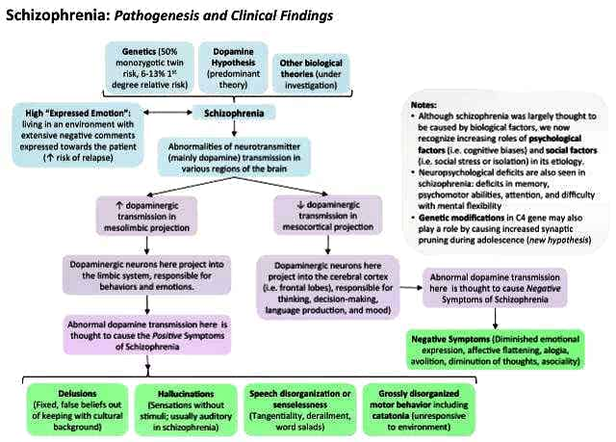
- Functional MRI has shown abnormalities in the brain structures and hyperactivity or hypoactivity of their functions. It was shown that in patients with schizophrenia possess a reduced brain response to new stimuli while the response to repeated stimuli cannot be suppressed and is highly activated [41].

Figure 11: Pathophisiology of schizophrenia.

TREATMENT :
Patients with diagnosed with schizophrenia should be directed immediately for specialized treatment. Not all patients should be hospitalized though it is important to oversee the patient due to a possible danger to themselves [11]. The effective treatment of schizophrenia includes complex and systematic approach consisting of pharmacologic, psychological and social treatment, and support.
The main goal of the treatment is to reach the periods without symptoms during the period of 6 months. Pharmacologic treatment includes the use of medical drugs that reduce the expression of major symptoms of schizophrenia.
The first-line treatment agents are ANTIPSYCOTIC AGENTS. There are over 60 antipsychotic drugs that have been developed to use in schizophrenia treatment for reducing the positive symptoms expression All the antipsychotics are characterized by the ability to block the dopamine D-2 receptors [7].
These drugs are classified into two groups:
- First- generation agents.
- Second-generation agents.
- The First-generation agents are effective in reducing the psychotic symptoms though they can lead to motor side effects. The World Health Organization considers three of the first-generation agents as essential medications. These agents include :
- Chlorpromazine and derivatives :
- fluphenazine
- haloperidol
- Fluphenazine etc.
Chlorpromazine: It was discovered in 1950 and used for the treatment of schizophrenia. It reduces the intensity of schizophrenia. This class includes other agents or derivatives of chlorpromazine which was discovered by changing structure and activities which are: Loxapine, Fluphenazine, Perphenazine, and haloperidol [34].
These all drugs have major side effects, extrapyramidal symptoms. Therefore, these all drugs no use longer. These drugs are also called as Typical or conventional drugs [42].
Mechanism of drug: There are numerous drugs used for to treat schizophrenia and they have different mechanisms of action to produce an effect in the body.
Mechanism of action of First generation antipsychotic agents:
- All typical antipsychotics have potent dopamine D2 receptor blocking action.
- Blockade of D2 receptors to the temporal and prefrontal areas constituting the ‘limbic system’ is responsible for the antipsychotic action.
- Drugs which increase DA activity (levodopa, bromocriptine) induce or exacerbate schizophrenia.
- Accordingly, blockade of DA overactivity in limbic area produces the antipsychotic therapeutic effect as well as the extrapyramidal side effects (parkinsonian adverse effects).
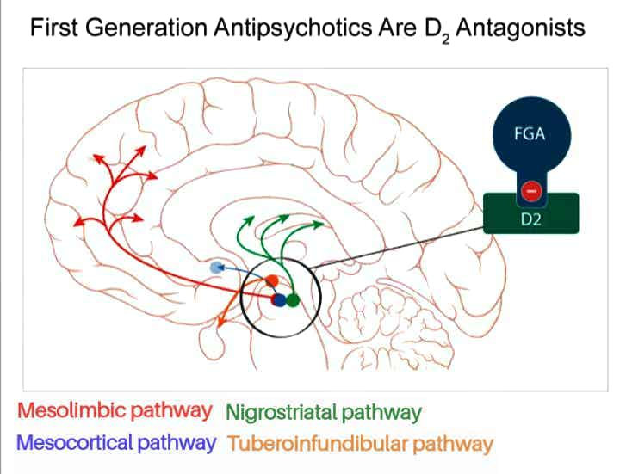
- These agents also depress the release of hypothalamic and hypophyseal hormones, also blocking mesolimbic dopamine receptor which is responsible for positive symptoms of schizophrenia. (Overactive of different pathway like a mesolimbic pathway, mesocortical pathway ,etc Show in figure12) [43, 44].
Figure 12: Mechanism of action of First generation antipsychotic agents.

- The Second-generation agents mostly do not cause the development of motor side effects [36]. These are used as a first line treatment for schizophrenia. These agents are more effective then FGAs. These agents having higher risks with low efficiency. These are called atypical antipsychotic drugs but now also known as Second generation antipsychotic [45].

These agents include:
- Clozapine
- risperidone
- quetiapine etc
Clozapine: It is a strong serotonin antagonist, with strong binding to 5-HT, 2A/2C receptor subtypes. It is also show affinity with dopaminergic (D2) receptor but with weak extent.
Mechanism of action:
Clozapine show two types of mechanism of action in combination form with other drugs like
- Risperidone,
- Quetiapine, etc.
Clozapine show antagonist effect

Block D2 receptor in mesolimbic pathway
and 5-HT /2A receptor in frontal cortex.

Reduction in activation of both mesolimbic
pathway and frontal cortex.

Relieves in both positive and negative symptoms [46, 47]

Figure 13: Mechanism of action of Second generation antipsychotic agents.

ADDITIONAL THERAPEUTIC DRUGS INCLUDE:
- Anticonvulsants,
- Antidepressants,
- Benzodiazepines,
- Lithium, etc.
For example, Anticonvulsants valproic acid, carbamazepine, and lamotrigine are effective in reducing the aggression and impulsivity. Depression and anxiety are controlled by adjunctive Antidepressants, while insomnia and agitations are treated using Benzodiazepines [7].

MEDICATION AND SIDE EFFECTS:
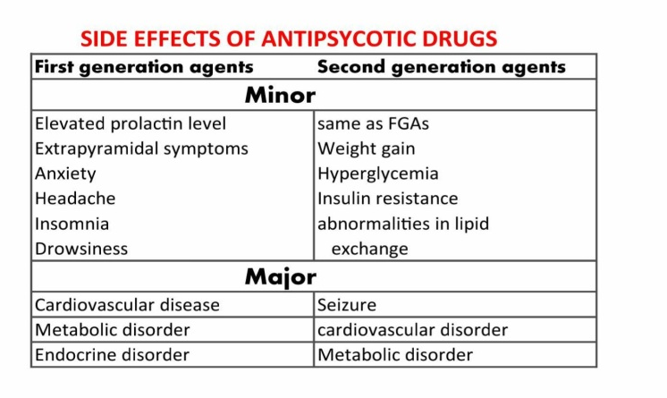
Antipsychotic medication is major psychiatric strategy of schizophrenia treatment through these substances possess limitations in the effectiveness of treatment in individual patients and is associated with adverse side effects. Antipsychotics are considered to take approximately 7–14 days to reach their major effect [48]. In the early 1950s, the term “neuroleptic” was introduced to denote the effects of chlorpromazine (Thorazine; brand no longer available in the United States).
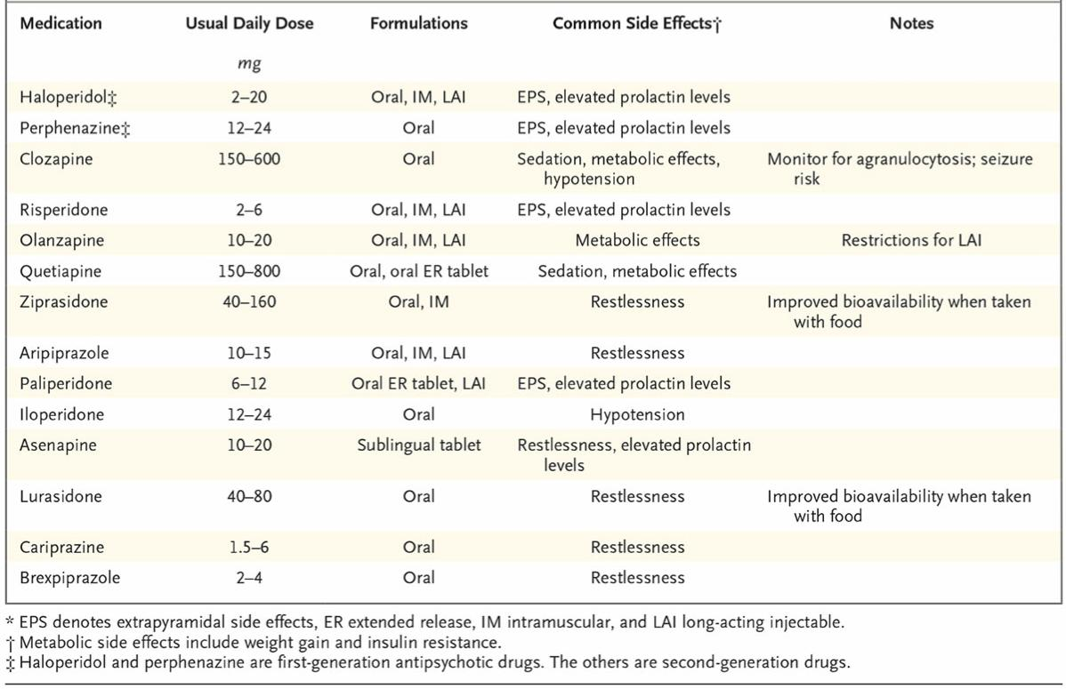
It was intended to distinguish their effects from those of sedatives and other central nervous system depressants [49]. Although “neuroleptic” is still used synonymously with “antipsychotic,” the term now usually refers to first-generation antipsychotics that confer an increased risk of extrapyramidal side effects shown in table 2, such as

Table 2: Shows the medication for schizophrenia with Daily Dose, formulation and side effects.

- dystonic reactions (e.g., fixed upper gaze, neck twisting, facial muscle spasms),
- parkinsonian symptoms (e.g., rigidity, bradykinesia, shuffling gait, tremor),
- Akathisia (e.g., inability to sit still, restlessness, tapping of feet) [50].
PREVENTION:
Prevention of schizophrenia is difficult due to heterogeneity of symptoms and causes of the disorder. Psychotic disorders occur in young people disrupting educational and social contacts that is why it is important to prevent the development of schizophrenia. Several studies have demonstrated that early interventions may help to improve the symptoms that shown in figure14 [36]. Identification of risk factors is crucial for the disease prevention though causes of schizophrenia are considered currently as a complex of genetic-environmental interactions. There are some preventions such as:
- Translate scientific evidence for cost-effective preventive intervention into public health initiatives, clinical practice, and service delivery systems.
- Increase social, professional, and political awareness of advancements and the importance of mental health prevention and promotion.
- Move clinical practice toward at-risk-oriented detection and intervention.
- Provide interventions designed for each developmental stage aimed at minimizing the impact of risk factors.
- Promote interventions with a multidisciplinary and multilevel (psychological, social, familial, and legal) approach.
- Promote healthy lifestyles including nutrition and exercise.
- Encourage school-based interventions (targeting children, parents, and education professionals).
- Take low dose of anti-psychotic medication.
- Take care during parental period or in pregnancy.
- Avoid using of alcohol, cigarette, or other drugs during the pregnancy.
- Training and education in urban areas.
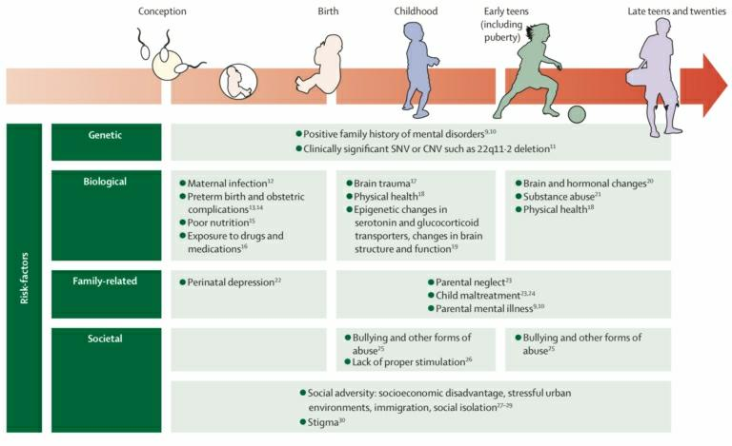
Figure 14: shows the risk factors of schizophrenia for the early prevention.

CONCLUSION:
We concluded from this study that Schizophrenia is a complex, chronic mental health disorder characterized by an array of symptoms, including delusions, hallucinations, disorganized speech or behavior. Schizophrenia is a complex disorder that requires prompt treatment. Although patients can increase adaptive functioning through available pharmacological and non-pharmacological treatment options, it is hoped that future research will address gaps in treatment and potentially a cure for schizophrenia.
REFERENCE:
  - Owen MJ, Sawa A, Mortensen PB. Schizophrenia. Lancet (London, England) 2016; 388:86-97.
  - Tandon R, Gaebel W, Barch DM, Bustillo J, Gur RE, Hackers S, Malaspina D, et al. Definition and description of schizophrenia in the DSM-5. Schizophrenia 2013; 150:3-10.
  - Chong HY,Teoh SL,Wu DB,Kotirum S,Chiou CF,Chaiyakunapruk N, Global economic burden of schizophrenia: a systematic review. Neuropsychiatric disease and treatment. 2016 [PubMed PMID: 26937191]
  - De Luca V,Tharmalingam S,Müller DJ,Wong G,de Bartolomeis A,Kennedy JL, Gene-gene interaction between MAOA and COMT in suicidal behaviour: analysis in schizophrenia. Brain research. 2006 Jun 30 [PubMed PMID: 16725119]
  - McGrath J, Saha S, Welham J, et al. A systematic review of the incidence of schizophrenia: the distribution of rates and the influence of sex, urbanicity, migrant status, and methodology. BMC. Med. 200; 2: 13.
  - Berrios G, Luque R, Villagrán JM. Schizophrenia: A conceptual history. Int J Psychol Ther 2003; 3:111-40.7.
  - Tandon R, Nasrallah HA, Keshavan MS. Schizophrenia, “Just the Facts” 5. Treatment and prevention past, present, and future. Schizophrenia Res 2010; 122:1-23.
  - McGrath J, Saha S, Welham J, et al. A systematic review of the incidence of schizophrenia: the distribution of rates and the influence of sex, urbanicity, migrant status, and methodology. BMC. Med. 2004; 2: 13.
  - Fatemi SH, Folsom TD. The Neurodevelopmental Hypothesis of Schizophrenia, Revisited. Schizophr. Bull. 2009; 35(3), 528-548.
  - Stilo SA, Murray RM. The epidemiology of schizophrenia: Replacing dogma with knowledge. Dialogues Clin Neurosci 2010; 12:305-15.
  - Holder SD, Wayhs A. Schizophrenia Am Fam Physician 2014; 90:775-82.
  - Mura G. Schizophrenia: From Epidemiology to Rehabilitation. Clin Pract Epidemiol Ment Heal 2012;8:52-66.
  - Cannon M, Jones PB, Murray RM. Obstetric complications and schizophrenia: Historical and meta-analytic review. Am J Psychiatry 2002;159:1080-92.
  - Messias EL, Chen CY, Eaton WW, and Epidemiology of schizophrenia: review of findings and myths. The Psychiatric clinics of North America. 2007 Sep [PubMed PMID: 17720026]
  - Abel KM, Drake R, Goldstein JM. Sex differences in schizophrenia. Int. Rev. Psychiatry 2010; 22: 417 .
  - Messias E, Chen CY, Eaton WW. Epidemiology of Schizophrenia: Review of Findings and Myths. The Psychiatr. Clin. North. Am.2007; 30(3), 323-338.
  - Jentsch JD, Roth RH. The neuropsychopharmacology of phencyclidine: from NMDA receptor hypofunction to the dopamine hypothesis of schizophrenia. Neuropsychopharmacology 1999;20(3):201–225.
  - Crismon L, Argo TR, Buckley PF. Schizophrenia. In: DiPiro JT, Talbert RL, Yee GC, et al, eds. Pharmacotherapy: A Pathophysiologic Approach. 9th ed. New York, New York: McGraw-Hill; 2014;1019–1046.
  - Beck AT, Rector NA, Stolar N, Grant P. Biological Contributions. In: Schizophrenia: Cognitive Theory, Research, and Therapy. New York, New York: Guilford Press; 2009;30–61.
  - McDonald C, Murphy KC. The new genetics of schizophrenia. Psychiatr Clin North Am 2003;26(1):41–63.
  - Makinen J, Miettunen J, Isohanni M, Koponen H. Negative symptoms in schizophrenia: A review. Nord J Psychiatry 2008;62:334-41.
  - Andreasen NC, Olsen S. Negative v positive schizophrenia. Definition and validation. Arch Gen Psychiatry 1982;39:789-94.
  - Kurtz MM, Moberg PJ, Gur RC, Gur RE. Approaches to cognitive remediation of neuropsychological deficits in schizophrenia: A review and meta-analysis. Neuropsychol Rev 2001;11:197-210.
  - Modai S, Shomron N. Molecular risk factors for schizophrenia.Trends Mol Med 2016;22:242-53.
  - Purcell SM, Moran JL, Fromer M, Ruderfer D, Solovieff N, Roussos P, et al. A polygenic burden of rare disruptive mutations in schizophrenia. Nature 2014;506:185-90.
  - Gilmore JH. Understanding what causes schizophrenia: A developmental perspective. Am J Psychiatry 2010;167:8-10.
  - Clarke M, Tanskanen A, Huttunen M, Cannon M. Evidence for an interaction between familial liability and prenatal exposure to infection in the causation of schizophrenia. Am J Psychiatry 2009;166:1025-30.
  - Henquet C, Murray R, Linszen D, Os JV. The environment and schizophrenia: The role of cannabis use.Schizophr. Bulletin 2005;31:608-12.
  - Van Os J. Does the urban environment cause psychosis? Br J Psychiatry 2004;184:287-8.
  - Krabbendam L,Van Os J. Schizophrenia and urbanicity: A major environmental influence -Conditional on genetic risk. In: Schizophrenia Bulletin 2005;31(4) p.795-9.
  - Coyle JT. NMDA Receptor and Schizophrenia: A Brief History. Schizophr. Bull. 2012;38(5), 920-926 .
  - Gründer G, Cumming P. The Dopamine Hypothesis of Schizophrenia. The Neurobiology of Schizophrenia 2016;109-124 .
  - Jentsch JD, Roth RH. The neuropsychopharmacology of phencyclidine: from NMDA receptor hypofunction to the dopamine hypothesis of schizophrenia. Neuropsychopharmacology 2019;20(3), 201-225 .
  - Clinton SM, Meador-Woodruff JH. Abnormalities of the NMDA Receptor and Associated Intracellular Molecules in the Thalamus in Schizophrenia and Bipolar Disorder. Neuropsychopharmacology. 2004;29(7), 1353-1362 .
  - Lewis S. Treatment of Schizophrenia: Discussion. J. Schizophr. Res. 2009; 441-445.
  - Van Os J, Kapoor S. Schizophrenia. Lancet 2009;374:635-45.
  - Siever LJ, Davis KL. The pathophysiology of schizophrenia disorders: Perspectives from the Spectrum. Am J Psychiatry 2004;161:398-413.
  - Lakhan SE, Vieira KF. Schizophrenia pathophysiology: Are we any closer to a complete model? Ann Gen Psychiatry 2009;8:12.
  - Shenton ME, Dickey CC, Frumin M, McCarley RW. A review of MRI findings in schizophrenia. Schizophr Res 2001;49:1-52.
  - Ross CA, Ross CA, Margolis RL, Reading SA, Pletnikov M, Coyle JT. Neurobiology of schizophrenia. Neuron 2006;52:139-53.
  - Coyle JT. Glutamate and schizophrenia: Beyond the dopamine hypothesis. Cell Mol Neurobiol 2006;26:365-84.
  - Freedman R. The Choice of Antipsychotic Drugs for Schizophrenia. N. Engl. J. Med. 2005;353(12), 1286-1288 .
  - Harrigan P. New anti-psychotics in sight for schizophrenics. The Lancet 1996;347(9018), 1822 .
  - Meltzer HY. The Mechanism of Action of Novel Antipsychotic Drugs. Schizophr. Bulletin 1991; 17(2), 263-287 .
  - Davis JM. The Choice of Drugs for Schizophrenia. N. Engl. J. Med. 2006;354(5), 518-520.
  - Bishara D, Taylor D. Upcoming Agents for the Treatment of Schizophrenia. Drugs 2006;8(16), 2269-2292 .
  - Girgis RR, Javitch JA, Lieberman JA. Antipsychotic drug mechanisms: links between therapeutic effects, metabolic side effects and the insulin signalling pathway. Mol. Psychiatry2006;13(10), 918-929.
  - Essali A, Al-Haj Haasan N, Li C, Rathbone J. Clozapine versus typical neuroleptic medication for schizophrenia. Cochrane Database Syst Rev 2009;1:CD000059.
  - Goodman LS,Gilman A, Hardman JG, Limbird LE. Goodman and Gilman’s the Pharmacological Basis of Therapeutics.10th ed. New York, McGraw-Hill,2001;500-6.
  - Lieberman JA, Stroup TS, McEvoy JP, Swartz MS, Rosenheck RA, Perkins DO, et al., for the Clinical Antipsychotic Trials of Intervention Effectiveness (CATIE) Investigators. Effectiveness of antipsychotic drugs in patients with chronic schizophrenia. N Engl J Med 2005;353:1209-23.

