Biotechnological Approaches for Improving Crop Adaptations to the Changing Climate
Devina Seram^{1*} and James Watt Haobijam²
¹Department of Entomology, School of Agriculture, Lovely Professional University, Phagwara, Punjab, India
²Department of Agricultural Economics and Extension, School of Agriculture, Lovely Professional University, Phagwara, Punjab, India
*Correspondence Email: devnah@gmail.com
Abstract
The role of biotechnology in the adaptation of crops to climate change goes beyond the simple introduction of foreign genes into a crop that normally would not reproduce (i.e. genetically modified crops). Instead of relying on the outward look or stress response of the plant (its phenotype) as a measure for the existence of that gene, biotechnological methods allow for direct detection and transfer of genes of interest from other plant lines or organisms into the crop of interest. Abiotic stress tolerance genes can be found in germplasm collections, wild relatives, or in other species that thrive in conditions of water scarcity, water plenty, high salt, or high temperature. These resources can be transferred to various crops in order to facilitate the development of superior hybrid lines. Biotechnological applications have the potential to increase crop yields in the face of biotic and abiotic stresses. However, in developing nations, public opinions and acceptability, as well as cultural and institutional processes, will affect the rate of adoption of transgenic crops to counteract abiotic stresses, which are expected to increase in frequency and intensity in the near future. Therefore, the complexity of crop responses to various abiotic stresses due to climate change and the strategic steps in mitigating these challenges through biotechnological approaches are discussed in this chapter.
Keywords: climate change, modern technology, crop stress, biotechnology
Introduction
The impact of agricultural production on anthropogenic greenhouse gases emissions is increasingly being considered by different spheres of people including scientists, educationist, environmentalists, policymakers, etc. This occurs as countries strive to achieve and negotiate mandatory climate change targets. Taking into consideration the significance that agriculture plays in the provision of food, feed, fuel, and fibre, it is imperative to identify methods of reducing agricultural emissions that are both cost-effective and efficient. This needs to be done in a way that does not compromise other goals, such as food security and the reduction of poverty, all of which should be evaluated in light of the expanding population across the world and the shrinking supply of land that is suitable for agricultural production. On the other hand, agriculture will be significantly impacted by climate change, necessitating the development of an efficient adaptation strategy in addition to policies that reduce greenhouse gas emissions. The adverse effects of global warming and climate change (Fig,1), which include heat waves, storms, floods, changes in the pattern of rainfall, water availability in water-stressed areas, and soil degradation, have the potential to have major repercussions for life's necessities, such as food, water, land, and the environment. Agriculture is a significant contributor to global greenhouse gas emissions, accounting for 13% of all anthropogenic emissions worldwide (Ashraf et al., 2008). This is especially true for the gases like methane and nitrous oxide, which are mainly produced from agricultural fields. If measures to reduce emissions are not taken, it is likely that emissions will increase, which will be caused in part by factors such as rising population and shifting patterns of food consumption.
Advanced techniques such as molecular breeding, genetic engineering, and genome editing are examples of some of the tools used in agricultural biotechnology. They may offer a variety of solutions that are driven by scientific research to simultaneously ease the rapid speed of climate change and global food poverty, while building on decades of successfully utilising these goods in a risk-free manner. Farmers have the option of adopting an integrated set of tools, such as biotech crops, that are more resistant to the effects of climate change and can better endure a variety of stresses, such as heat, drought, and flooding. There are a lot of technological developments in the agricultural field, such as biofuels, biopolymers, nutrient-rich food products, and disease or insect-tolerant crops that can respond to the effects of a changing climate while also addressing food insecurity (Clements et., 2011). In addition, scientists are developing a wide variety of features with the intention of lowering emissions of greenhouse gases, reduced wastes, conserving water and land resources, increasing carbon sequestration, and raising crop yields simultaneously (Fig.2). In the end, simply having good biotechnological products that function properly is not enough. Our attempts to mitigate the effects of climate change on crop adaptations rely heavily on the regulatory agencies inside each country that make it possible for these products to be sold in the market. Acceptance from the general public and a regulatory environment that enables these items to be brought to market are also key components. The agricultural industry as a whole is making a significant number of efforts to disseminate information about the safety, benefits, and advantages of incorporating products of agricultural biotechnology into the vast array of tools that are being developed to combat climate change.
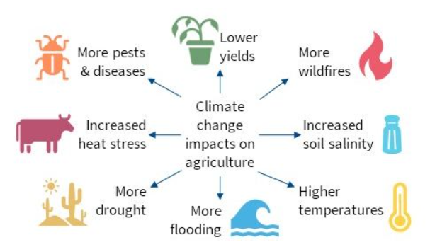
Fig.1. Adverse effects of climate change on agriculture and environment (Source: Kilaru and Peterson, 2022)
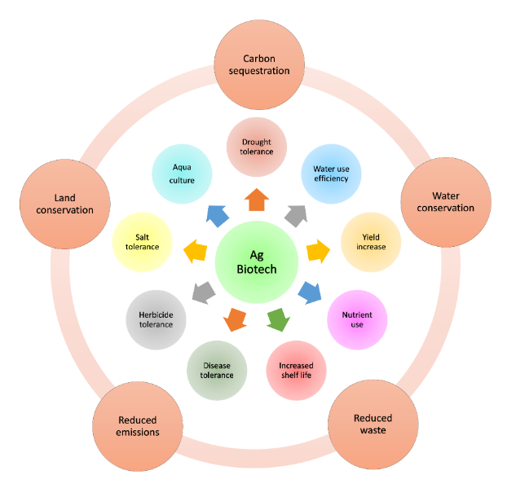
Fig.2. A schematic representation of agricultural biotechnology products (inner circle) with positive impacts on climate (outer circle) (Source: Kilaru and Peterson, 2022)
- Innovative Approaches to address climate change
A policy framework that encourages, adequately protects, and adequately rewards investment in research, innovation, and technology is essential for successfully addressing the challenges posed by climate change in this complex and dynamic scenario, where growing population levels and the correspondingly growing demand for food and nutrition must be considered as a crucial aspect. This is necessary in order to successfully address the challenges posed due to climate change. In order to address the problems and identify ways to strategically confront them, it is necessary to develop new technologies and inventions. The recently created technologies need to take into account the following factors, including but not limited to:
- Crop varieties for crop protection against abiotic and biotic stresses
- Plant Nutrients or Fertilisers
- Carbon Sequestration
- Conservation of soil
- Adjustments in Farm Practices
- Adoption of good Production Techniques and New Technologies
- Innovative Water Management
- Intensification in agriculture
The modification of genetic makeup of crops in order to produce high-yielding results has proven to be a difficult endeavour. Despite this, scientists have been able to effectively generate high-yielding varieties of crops, including corn, rice, wheat, and others. For example, a genetically altered maize variety is more effective at turning sunlight into energy due to increased leaf size up to 8 to 9 per cent, when compared to an existing variety. This results in a 10 per cent increase in yield, regardless of the growth conditions. Adopting these high-yielding varieties can help decrease food insecurity, save arable land, and have a good influence on climate change, all while having a favourable impact on the economy. Similarly, a genome-edited strain of rice generated grains that were approximately thirty per cent larger. This is important because a second study found that an increase of 10% in rice biomass can cut methane emissions by more than 10%, which proves that the current finding has substantial implications. According to various findings, agriculture is responsible for around 32 per cent of the total methane emissions created by humans. As a result, a crucial step in mitigating the effects of global warming is the implementation of environmentally friendly food production practices including biotechnological applications.
  - Developing New Crop Varieties for the Changing Climate
It will be vital to make investments in new crop varieties in order to boost their tolerance to heat and water stress. For instance, the plant biotechnology industry has the potential to play a significant role in mitigating the unfavourable effects and consequences of climate change. This is particularly true in terms of the reduction of greenhouse gases, the adaptation of crops, as well as the protection of yields and the enhancement of their production. The development of new techniques in the areas of nitrogen use efficiency (NUE) and water use efficiency (WUE) may also prove to be valuable new instruments for climate change adaptation and mitigation (Karaba et al., 2007). Already on the market are genetically modified rice and canola plants that are able to make better use of nitrogen. In light of this history, the primary emphasis of this paper is placed on the application of biotechnology to improve new crop varieties in response to climate change. The development of novel crop varieties is predominately based on, and is capable of being accomplished with the help of, two primary types of biotechnological tools: (a) molecular breeding approaches; and (b) biotechnological strategies such as genetic engineering (transgenic approach).
- Molecular Breeding Approaches
Quantitative traits are controlled by a large number of genes and are also referred to as polygenic, multifactorial, or complex traits. Quantitative traits include a wide variety of agriculturally important characteristics, such as yield, quality, and resistance to biotic stresses in the form of disease and insect resistances. The portions of the genome known as quantitative trait loci (QTL) are those that include genes that are linked to a certain quantitative trait. It is not possible to identify QTLs using only traditional methods of phenotypic evaluation alone. The discovery of DNA (or molecular) markers in the 1980s marked the beginning of a significant advance in the characterization of quantitative characteristics. This advancement made it possible to select for QTLs, which led to a major breakthrough in the field. The use of various DNA markers (such as RAPD, RFLP, SSR, SNP, etc.) in plant breeding is referred to as marker-assisted selection (MAS), and it is a component of the emerging field of molecular breeding. The application of DNA markers is a tool that can assist in the plant breeding programme, where the efficiency and precision could be greatly enhanced. Molecular breeding allows for the rapid identification of desirable genes or alleles, even in seeds or very immature plants that have not yet been subjected to the stress in issue, which considerably accelerates the efficient accumulation of these superior genes or alleles. Marker-assisted backcrossing (MAB) and marker-assisted recurrent selection (MARS) are more advanced techniques that allow for the incorporation of precisely identified pieces of DNA (individual alleles, genes, or QTLs) into the target plant line while minimising the transfer of other, less desirable genes. High throughput 'next-generation sequencing' has accelerated this process, and whole genome sequences are now available for soybean, maize, rice, sorghum, and, most recently, potato. This opens the door to sequencing the huge and complex genomes of crops like wheat and barley. Any desirable genetic loci found in one genome can be rapidly investigated in others.
- Transgenic Approaches
It is possible to produce genetically modified organisms (GMO) through a number of different processes. A transgene is the name given to the foreign gene that has been introduced into the cell of an organism, whether it be a bacterium, plant, or mammal. It does so by inserting itself into the genome of the recipients, who are referred to as transgenics. The transgenes are either versions of known genes that have undergone mutations or genes that carry known features. Marker genes are utilised across the majority of research projects due to the identification of transgenic organisms. Gene transfer through the use of modified viruses and plasmids and the electroporation method, in which greater permeability of the cell membrane is achieved, are the two primary methods that are used in the integration of transgenes into the cell. In general, these are the only two methods that are used.
- Crop resistance against insect pests
Chemical pesticides are generally applied in massive quantities by farmers each year. Due to the potential for adverse health effects, customers do not want to purchase and consume food that has been treated with pesticides. Additionally, runoff from agricultural wastes caused by an excessive application of fertilisers and pesticides can poison water supplies and cause damage to the environment. Producing genetically modified foods like Bt corn can help reduce the need for the use of harmful chemical pesticides and cut down the overall cost of getting a crop to market (Moellenbeck et al., 2001). For example,
- The cry1Ac gene engineered into Bt cotton, Bollgard I against cotton bollworms complex
- The cry1Ac and cry2Ab engineered into Bt cotton, Bollgard II
- The cry1Ac gene engineered into canola oil seeds for insect tolerance
- Crop tolerance against herbicide application
Reduced use of herbicides is one way in which genetically modified crop plants can help protect the environment. For instance, Monsanto developed a Roundup-resistant variety of genetically modified soybeans. Long-term exposure of a freshwater fish (Leporinus obtusidens) to environmentally appropriate doses of a Roundup formulation disrupts the fish's metabolism, according to a study published by Salbego et al. (2010). Production of this soybean variety only requires a single application of the herbicide, saving money and lowering the risk of agricultural wastes run-off, which ultimately benefits the farmers (Ohkawa et al., 1999).
- Responses of plants to different Abiotic Stresses
Complex plant responses to abiotic conditions such drought, salinity, cold, heat, and chemical pollution induce cellular damage and secondary stresses like osmotic and oxidative stress. Initial stress signals (e.g. osmotic and ionic effects or changes in temperature or membrane fluidity) activate stress-responsive mechanisms to re-establish homeostasis and protect and repair damaged proteins and membranes. Inadequate responses at one or more levels in signalling and gene activation may cause irreversible alterations in cellular homeostasis and the breakdown of functional and structural proteins and membranes, resulting to cell death (Fig.3).
  - Effects of water stress on plant metabolism
- Limits photosynthesis process
- Water stress affects translocation of nutrients
- Affects hormonal balance
- Reduction in enzyme activities
- Affects the development, reproduction and assimilate partitioning
- Cellular osmotic adjustment contributes to plant water balance
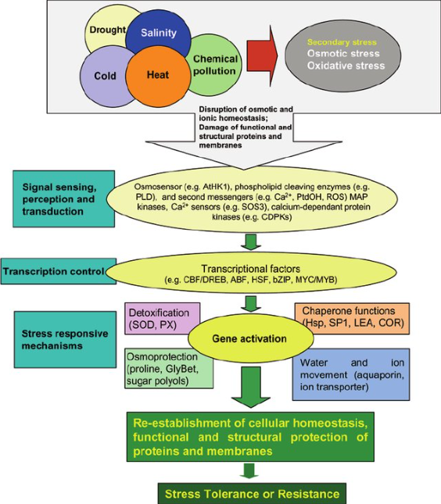
Fig.3. Responses of plants to various abiotic stresses
Abbreviations: ABF, ABRE binding factor; AtHK1, Arabidopsis thaliana histamine kinase-1; bZIP, basic leucine zipper transcription factor; CBF/DREB, C-repeat-binding factor/ dehydration-responsive binding protein; CDPK, calcium-dependent protein kinase; COR, cold-responsive protein; Hsp, heat shock protein; LEA, late embryogenesis abundant; MAP, mitogen-activated protein; PLD, phospholipase D; PtdOH, phosphatidic acid; PX, peroxidase; ROS, reactive oxygen species; SOD, superoxide dismutase; SP1, stable protein. (Source: Wang et al., 2003)
  - Drought tolerant crops through Marker-Assisted Breeding (MAB)
Crop tolerance to drought stress is mainly controlled by a large number of small genes known as polygenes and these polygenes have cumulative effects in the way they are expressed (Cho et al., 2008). Because of this, the regions of chromosomes that contain genes of this kind are known as quantitative trait loci (QTL). Direct selection under stressful conditions, whether simulated or natural, can be used to take advantage of the natural genetic variation of a crop. Another option is to map QTL (polygenes) and then use marker-assisted selection (MAS) to take advantage of the natural genetic variation (Ashraf et al., 2008). For example, using F₃ cotton populations derived from a cross between Gossypium barbadense (cv. F-177) and Gossypium hirsutum, researchers were able to identify a subset of 33 quantitative trait loci (QTLs) under water scarcity conditions. This subset included 11 QTLs for plant productivity, 5 QTLs for some key physiological traits, and 17 QTLs for fibre quality. Recently, using marker-assisted selection, near-isogenic lines (NILs) were produced by exchanging QTL for yield and some drought-related traits between G. barbadense cv. F-177 and G. hirsutum cv. Sivon (Levi et al., 2009).
In wheat, the position of genes exhibiting a significant effect on abscissic acid (ABA) accumulation due to drought stress was identified using a series of single chromosome substitution lines and populations obtained from a cross between a high-ABA-producing cultivar (cv. Ciano 67) and a low-ABA-producing cultivar (cv. Chinese Spring) (Quarrie et al., 1994). In light of a number of previous reports, it is evident that molecular mapping and QTLs associated with drought tolerance that have been identified in various crops can be effectively utilised in appropriate breeding programmes meant for improving drought tolerance in crops. During the process of routine QTL mapping, complex phenotypes are replicated based on the available molecular information that is crucial to the comprehension of the genetic basis of stress tolerance.
Table.1. Molecular breeding approaches in different crops for drought tolerance
Crops | Identified  QTLs | Donor Cultivar  for QTL | Recipient  Cultivar for QTL | Improved Traits in crops
Rice | QTL 9 on Chr. 9 | Azucena | Kalinga | Increased root thickness and length
Pearl millet | QTL on linkage group 2 (LG 2) | PRLT 2/89-33 | H-77/833-2 | High grain yield in introgressed lines
Maize | 5 QTLs on Chr.  1, 2, 3, 8, and 10 | Ac7643 | CML 247 | MAS derived varieties gave 50% better yield under severe drought stress conditions
Barley | 81 QTLs used, of  which 6 QTLs for grain yield | Hordeum  spontaneum | Hordeum  vulgare | Improved grain yield, and reduced negative impact of drought on grain filling
Sorghum | 4 QTLs - Stg1, Stg2, Stg3, or Stg4 | BT×642 | BT×642 RT×7000 | Delayed leaf senescence and better grain yield at maturity under drought stress conditions
LG – Linkage Group, QTL – Quantitative Trait Loci, Chr. – Chromosome, MAS – Marker Assisted Selection
  - Engineering crops for enhanced drought tolerance through transgenic approach
The transgenic technique is being actively employed all over the world in order to improve features such as resistance to biotic and abiotic stresses in a variety of crops (Ashraf et al., 2008). It has been demonstrated beyond a reasonable doubt that suitable organic solutes play a crucial part in the drought tolerance of plants. However, one of the most prominent responses of plants that have been subjected to osmotic stress is an increase in the production of compatible organic osmolyte (Ashraf et al., 2008). The genes that code for the synthesis of such organic solutes can be engineered so that transgenic plants produce an increased amount of these solutes. For instance, in response to dehydration stress, an abundance of the organic osmolyte glycine betaine (GB), which is a quaternary ammonium molecule, is produced. GB is one of the numerous organic osmolytes known to play a significant role in stress tolerance. When compared to wild-type maize plants at their early stages of development, the introgressed maize plants showed a higher level of drought tolerance and contained higher quantities of glycine betaine than the wild-type maize plants (Castiglioni et al., 2008). Another example of drought tolerance is seen in wheat. In Brazil and Argentina, wheat breeding lines that can withstand drought and provide a better yield of 20% despite being grown in arid regions has been certified for cultivation (Lightfoot et al., 207). These transgenic wheat lines also boost carbon sequestration by 7% and have a modified form of the sunflower transcription factor HaHB4 that increases yield and improves water efficiency under a wide range of growing conditions (Rivero et al., 2007). Cultivation of this wheat type can make better use of agricultural resources, including water, leading to a less net carbon footprint and less need to grow in arable area. The classic illustration of drought tolerance may be seen in the engineering of DREB1A transgenic rice plants (Lightfoot et al., 2007), which exhibits increased resistance to the effects of water stress and high salinity by expression of more than 40 genes (Fig.4). Examples of crops with improved drought tolerance are given in Table.2.

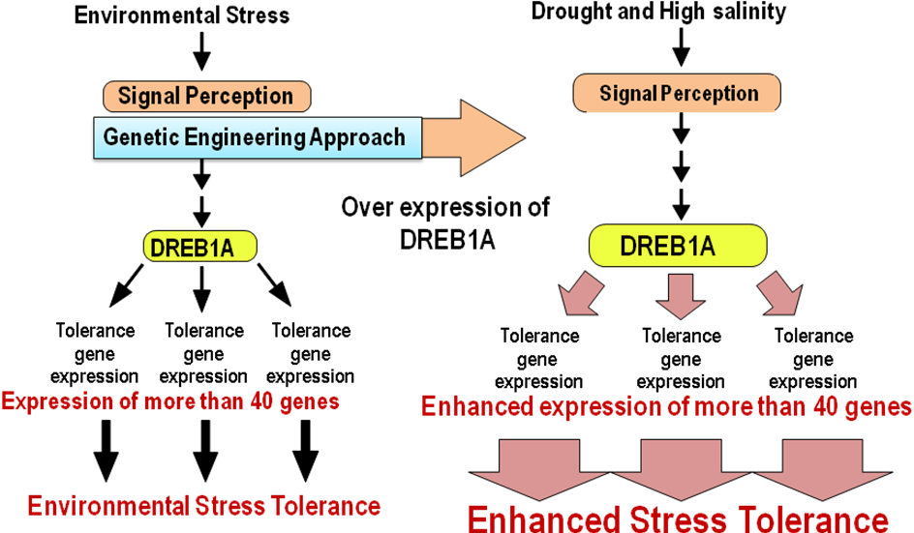

Fig.4. DREB1A gene regulates a lot of target genes to enhance tolerance drought
(Source: Lightfoot et al., 2007)
Table.2. Examples of improved drought tolerance in different crops through transgenic approach
Gene(s) | Host plants | Source organisms | Improved Trait(s)
Choline monooxygenase  (BvCMO) | Nicotiana tabacum - Tobacco | Beta vulgaris - Beet root | Leave, roots and seeds with higher glycinebetaine accumulation; improved tolerance to drought stress and toxic choline level
Choline dehydrogenase  (betA) | Zea mays - Maize  inbred line, DH4866 | Escherichia coli  - Bacterium | Higher glycinebetaine accumulation;  drought stress tolerance during germination
Salt tolerance gene  (TaSTRG) | Oryza sativa - Rice | Triticum aestivum - wheat | Improved chlorophyll content, fresh weight, higher proline content, soluble sugar and plant survival rate
Late embryogenesis abundant gene (HVA1) | Oryza sativa - Rice | Hordeum vulgare - Barley | Higher relative water content in leaves, greater cell membrane protection; and drought tolerance

  - Engineering crops for enhanced salinity tolerance through transgenic approach
    - Salinity effects on crop plants
- Water deficit effect or osmotic effect of salinity – Reduction in the capacity of plants to absorb water, which leads to decreased plant growth.
- Ion excess effect and salt specific effect - Salts absorbed through the leaves during transpiration can cause cell damage and stunt development.
    - The SOS (Salt Overly Sensitive) signalling pathway related to salinity
It is possible to construct a model in which a short-lived elevation in cytosolic Ca²⁺ follows either directly or indirectly from an increase in the concentration of Na Cl in the environment. After that, cytosolic Ca²⁺ connects with and activates calmodulin, which then binds with the Ca2+ binding protein SOS3, leading in the activation of the SOS2 serine/threonine protein kinase (Fig.5). All of these steps take place in the cytosol of the cell. Through the plasma membrane-localized Na⁺/H⁺ antiporter, SOS₁, and maybe other ion transporters or downstream effectors as well, the SOS2-SOS3 complex can either pre- or post-transcriptionally up-regulate Na⁺ export. After that, the ion transporters take on a direct role in the process of restoring ion homeostasis. On the basis of this process, the genes involved in salinity tolerance in plants were designed to be present. The well-known example of engineering antiporters of NHX or HKT1 or SOS1 into plants showed increased tolerance to extreme conditions. Examples of crops with enhanced salinity stress tolerance are given in Table. 3.
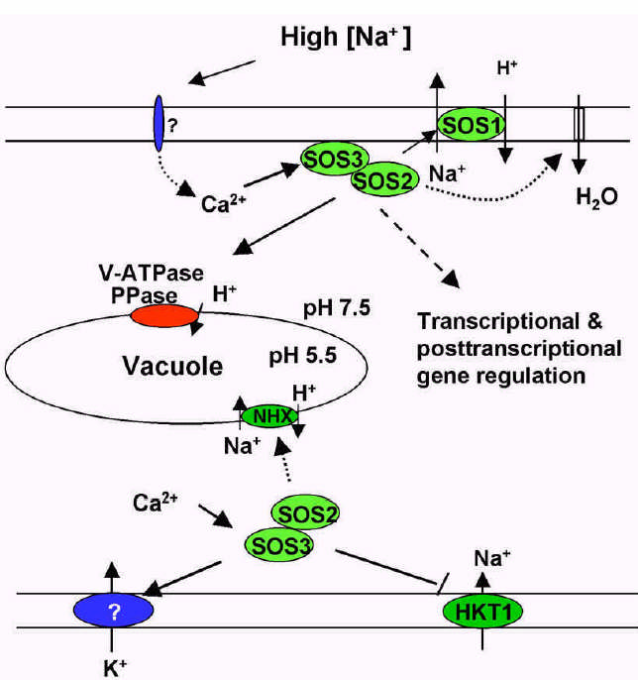
Fig.5. The Salt Overly Sensitive (SOS) signalling pathway for salinity tolerance
(Source:
Table.3. Examples of enhanced tolerance to salinity stress in different crops through transgenic approach
Crop Species | Gene(s) transferred | Improved Traits
Arabidopsis thaliana | Apoplastic invertase, Apo-Inv | Salinity tolerance, increased germination and growth
Rapeseed (Brassica napus) | Arginine decarboxylase, ADC | Salinity tolerance, increased germination and yield
Citrus  (Carrizo citrange) | Betaine aldehyde dehydrogenase, BADH | Salinity tolerance, increased growth and yield
Melon  (Cucumis melo) | Ca2+-dependent protein kinase, CDPK | Salinity tolerance, increased growth and yield
Tomato  (Lycopersicon esculentum) | Ca/H antiporter, CAX1 | Salinity tolerance, increased growth and yield
Tobacco  (Nicotiana tabaccum) | Serine/threonine kinase,  AT-DBF2 | Salinity tolerance, increased growth
Rice (Oryza sativa) | Calcium-binding protein, EhCaBP | Salinity tolerance, increased germination
Potato  (Solanum tuberosum) | Heat shock protein, DnaK/HSP70 | Salinity tolerance, increased growth and yield

  - Crops for submergence or flooding or anoxia tolerance through MAS approach
The majority of rice types exhibit a moderate capacity to lengthen their leaves and the portion of their stems that become entangled in water when they are submerged, whether partially or totally. When the floodwater recedes, this type of growth elongation results in a plant that is slender, weak and easily entangled. If the flood is very severe, the growth elongation that occurs underwater may deplete the plant’s energy supplies, resulting in death in a matter of days. There were no negative effects on the development, yield, or grain quality as a result of the marker-assisted introgression of the Sub1 region, which was successful in improving submergence tolerance over a wide range of crop varieties (Sarkar et al., 2009). The newly introgressed lines are able to survive being submerged as long as the flood takes place after the seedling stage but prior to flowering and the flood entirely recedes within ten to twenty days, depending on the parameters of the floodwater (Das et al., 2009). It is anticipated that the yield advantage offered by Sub1 gene introgression lines will significantly stabilise production in rain-fed lowland areas that are prone to flash flooding. Examples of crops with submergence tolerance developed through MAS are given in Table.4.
Table.4. Examples of submergence tolerance varieties developed through MAS approaches
Crop  variety or line | QTLs | Improved Trait(s)
Swarna | Sub1 | Submergence tolerance
FR-13 A | Sub1 | Submergence tolerance
IR49830-7 | Sub1 | Submergence tolerance

  - Crops for high temperature (HT) tolerance
Plants can only tolerate a narrow temperature range before they begin to suffer. Plants are subjected to low temperature stress when the temperature falls below 150 degrees Celsius, and they are subjected to high temperature stress when the temperature rises above 450 degrees Celsius. Fig.6 provides an explanation of the molecular mechanisms that underlie plant responses to high temperatures. An increase in temperature of 15 to 20 degrees Celsius over the normal temperature induces deeper modifications of growth without necessarily being harmful. These changes include denaturation of proteins, inactivation of enzymes, and a reduction in the photosynthetic activity of chloroplasts.
    - Role of Heat Shock Proteins (HSPs) in imparting high temperature tolerance in crops
Plants have the ability to interact with their surroundings in a wide variety of different ways and to survive in environments that are subjected to extreme levels of abiotic and biotic stresses. The response to heat stress, also known as HS, is highly conserved among various plant species; however, because plants live a sessile lifestyle, this response is of the utmost significance to their growth, development and survival. The HS-response is characterised by (i) a temporary alteration of gene expression and (ii) the acquisition of a higher level of stress tolerance. Both of these characteristics are transient or short-lived (through acclimatization). HSPs are linked to a number of other abiotic stresses including cold, freezing, drought, dehydration, heavy metal contamination, and oxidative stresses, and the induction of HSP-expression is not restricted to the stress of high temperature. HSPs are a type of molecular chaperone that are responsible for either preventing the complete denaturation of enzymes (small HSP: sHSP) or supporting the proper folding of enzymes under or after conditions that result in protein denaturation (Varshney et al., 2011).
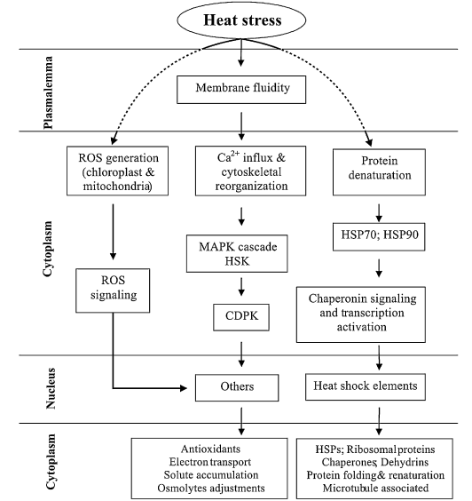

Fig.6. Molecular mechanisms of plant responses to high temperature
(Source:
The manipulation of heat stock protein responses has the potential to improve common stress tolerance, which may lead to a more efficient exploitation of the inherent genetic potential of agriculturally important plants. This improvement could lead to a more sustainable use of the inherent genetic potential of important agricultural crops. Another approach is the expression of gene involved in sugar alcohol like aspartate decarboxylase and glycine betaine (GB) that will be used for resistance against heat tolerance. For example, increased thermal tolerance was observed in genetically modified Arabidopsis plants that were bred to overproduce glycine betaine. These results imply that nitrogenous osmoprotectants may play a role in the cellular defence against heat stress. Another method involves genetically modifying tobacco plants so that they express bacterial aspartate decarboxylase (Cho et al., 2006). This enzyme is responsible for catalysing the decarboxylation of aspartate to beta alanine. Table.5 shows the example of introgressed crops with heat tolerance genes.
Table.5. Example of crops having heat tolerance incorporated with heat tolerant genes
Genes | Crop  Sources | Crops  targeted | Tolerance | References
HSP 101 | Arabidopsis | Rice | Heat tolerance | Katiyar et al.(2003)
HSP17.7 | Carrot | Carrot | Heat tolerance | Malik et al. (1999)
GmHSFA1 | Soybean | Soybean | Heat tolerance | Zhu et al. (2006)
mHSP22 | Maize | Arabidopsis | Heat tolerance | Rhoads et al.(2005)

  - Crops for low temperature (LT) stress tolerance
    - Chilling injury effects on plant cell membrane
The plant cell compartments, also known as the cellular membranes, are the sites of the primary events that take place during chilling stress. It is generally agreed that the first sign of cell injury is an increase in the permeability of the plasmalemma as well as the leakage of organic and inorganic substances. During the process of plasmolysis, both hardened and non-hardened cells have their plasmalemma pressed against the tonoplasts, and this causes the plasmalemma to be deleted into the vacuole as sac-like intrusions. Crystalline deposits can form in root cells as well as the epidermal, mesophyll, and vascular cells found in leaf tissue, which can ultimately lead to the disruption of tonoplasts. Because damage to tonoplasts cannot be repaired, it is impossible for plants to recover after being brought back to normal temperatures. During the process of hardening, which can take place at temperatures below or above zero, lipid bodies accumulate in the cytoplasm and are closely associated with the plasmalemma. During the chilling injury process, membranes go through a phase change that takes them from a liquid crystalline phase to a solid gel state. As a consequence of the phase transition, there is an inhibition of H⁺ ATPase activity, as well as inhibition of metabolic enzymes, which leads to a decrease in carbohydrate translocation (Varshney et al., 2011).. Additionally, energy transduction and solute transportation are both inhibited.
    - Crops for freeze tolerance
Plants that are able to withstand the cold will become more brittle during winter season, where these plants will go through modifications that are necessary for them to survive the formation of ice within their tissues. These alterations have to take place before the temperature drops to an unsafe level in order to satisfy the metabolic requirements of the tissue remodelling process. The most common changes that take place are an increase in cytoplasmic solutes, which serves both to act as a cryoprotectant and to buffer any freeze concentration of other solutes that, in high concentrations, could be toxic. Additionally, membrane changes take place, which increases the fluidity of membranes at low temperatures and increase the stability of membranes to low water contents. Sugars have a cryoprotective effect, which means they can shield plants from the adverse effects of cold. The most common type of sugar is sucrose, which is also intimately linked to tolerance in a number of plant species. In addition to glucose, several types of sugar molecules, including fructose, raffinose, sorbitol, and mannitol, perform similar functions. Typically, one may find them concentrated in the cell walls of plant tissues, where they serve the function of preventing the production of extracellular ice when the temperature is low.
    - Role of Antifreeze Proteins (AFPs) in imparting low temperature tolerance in crops
In some plants, proteins known as antifreeze proteins (AFPs) are generally present, that bring down the freezing point of water, thereby preventing the formation of ice. They have no effect whatsoever on the point at which the solution melts. AFPs are able to bind to the surface of ice nuclei, which inhibits the development of crystals. AFPs have an effect on the structure of the ice crystals, which results in an inhibitory effect on recrystallization (inhibit coalescing of small ice crystals into large ice crystals). AFPs accumulate in apoplastic fluid during cold acclimatisation. Six AFPs with sizes ranging from approximately 16 to 35 kDa (kilo Dalton) accumulate in the apoplastic fluids of winter rye. AFPs are endo-chitinase-like proteins that have antifreeze action in addition to their chitinase activity (Varshney et al., 2011). The objective of engineering these antifreeze proteins into the crops is to increase freezing tolerance and reduce the amount of physical damage caused by ice, especially plant cell membranes and tissues (Fig.7).
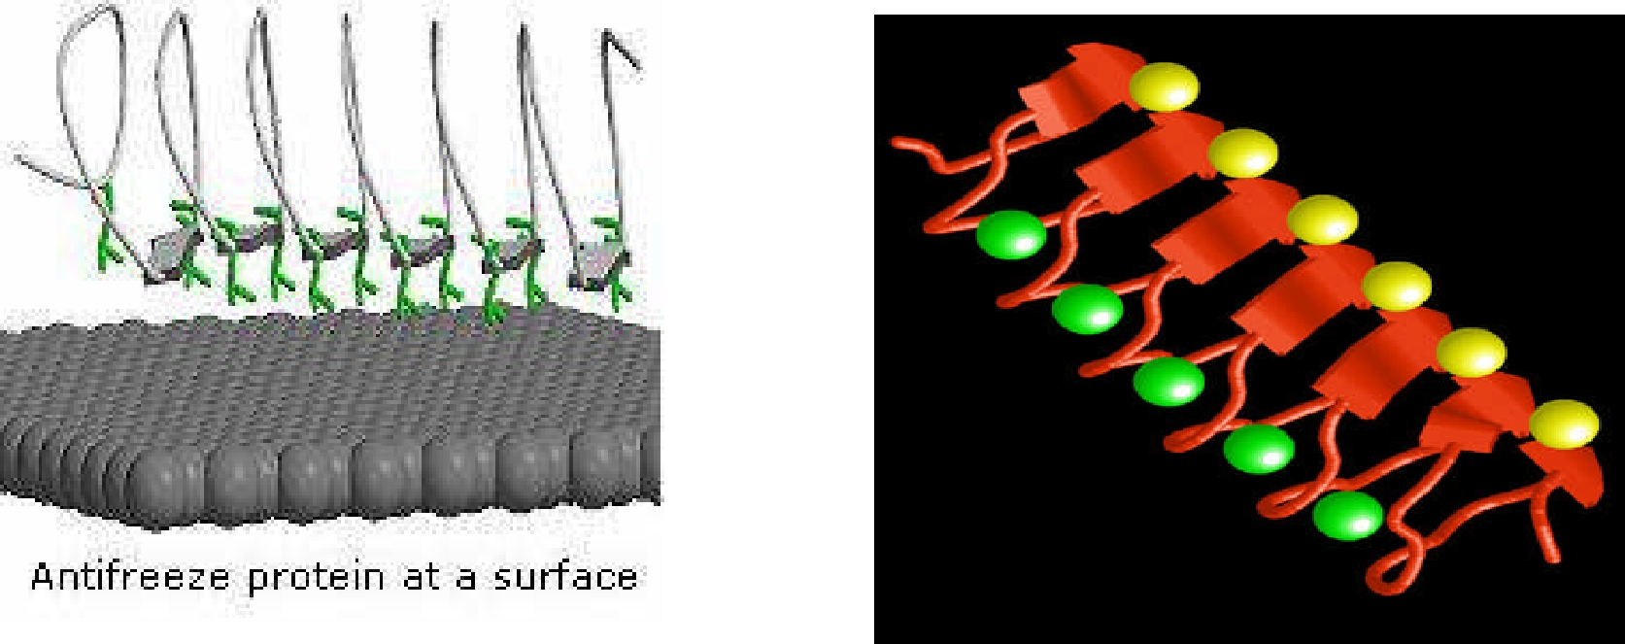

Fig.7. Structure of antifreeze proteins
- Crops with increased Nitrogen Use Efficiency (NUE)
The use of nitrogenous (N) fertilisers has increased sevenfold over the past four decades, which is directly correlated to the doubling of agricultural food productions around the world over the same time period. As a direct result of this, the recent intensification as well as the future intensification of the use of nitrogen fertilisers in agriculture has already had and will continue to have major detrimental impacts on the diversity and functioning of the non-agricultural ecosystems that are located nearby. Using plants grown under agronomic conditions at low and high nitrogen fertilisation regimes, it is now possible to develop whole plant physiological studies combined with gene, protein, and metabolite profiling to build up a comprehensive picture depicting the various steps of nitrogen uptake, assimilation, and recycling to the point where it is deposited in the seed (Lian et al., 2005). The most common examples of this type of impact are the eutrophication of chemicals in fresh water. In very recent times, additional research into the functions of two cytosolic GS isoenzymes (GS1) in maize that are the products of the Gln1-3 and Gln1-4 genes has been conducted through the examination of the molecular and physiological characteristics of mutator insertion mutants. In plants cultivated under conditions that were not optimal for N feeding, an investigation was conducted to determine how the knockout mutations affected kernel yield and its constituents (Martin et al., 2006).
- Crops with increased Phosphorus Use Efficiency (PUE)
The OsPTF1 gene, which stands for "Oryza sativa phosphate transcription factor," was isolated from an indica landrace rice variety called Kasalath. This particular variety is resistant to P-deficiency. Oryza sativa (cv. Nipponbare), a variety of rice susceptible to P-deficiency, was transformed with the help of Agrobacterium transformation allowing the introduction of the transcription factor. In both solution and soil culture experiments, the transgenic rice that overexpresses OsPTF1 gene and which is under the control of CaMV 35S showed improved tolerance to P-deficiency. When rice plants are grown in conditions where there is a lack of phosphorus (P), genetically modified rice produces roots that are longer and have a higher root biomass.
- Crops with improved Water Use Efficiency (WUE)
The limited fresh water resources that are encountered in the society of the 21st century and the scarcity of water that is available for crops are the primary issues that are addressed by the international agricultural economy. Recent research has shown that the Arabidopsis gene HIC, which stands for "high carbon dioxide," is the first gene to be shown to belong to a signalling system that regulates the growth of stomata in response to their surroundings (Karaba et al., 2007). Therefore, the modification of the HIS gene will help to improve the efficiency with which water is used. The OGTR has given its approval for conducting field tests of genetically modified (GM) cotton that is more water efficient. Each of the genetically modified cotton lines, which were developed by Monsanto Australia, contained one of fifty distinct genes that were taken from diverse plants, bacteria, yeast, or fungi. It is anticipated that the newly inserted genes will result in improved water utilisation efficiency. The trials will be conducted in local government areas in the states of New South Wales, Queensland, and Western Australia. The purpose of the trials is to evaluate the agronomic characteristics of the genetically modified cotton lines, including their water use efficiency, yield, and fibre quality under both optimal and water stress conditions. Those lines that show promise will be chosen for possible trials in the future and, eventually, for development in commercial settings.
- Advantages and disadvantages
There is enormous promise for preserving food and fibre production in a deteriorating environment and for expanding the farmable area into currently marginal regions if biotechnology solutions can be supplied to farmers that minimise the detrimental impacts of climate change. It does not negate the need of environmental clean up, but it does put some perspective on the situation. The rapidity with which many characteristics may be found, collected, and introduced into plants and then assessed for stability and efficacy has been the greatest advantage of molecular breeding to yet. The past fifteen to twenty years have seen a meteoric rise in this. Through the application of genetic engineering techniques, we may now utilise capabilities not ordinarily present in our agricultural plants. We can now target gene insertions and check for their effects in ways that weren't feasible before, giving us more assurance that our new plant lines are safe and those we have not accidentally damaged any other important plant genes. Over the next several years, we may anticipate widespread advantages from a wide variety of molecular breeding (including genetic engineering) products.
Droughts and floods can happen at any time. Understanding the molecular underpinnings of reactions to stress is essential to the task of ensuring the produced plants function effectively over a wide variety of environmental circumstances. Molecular breeding, like many other aspects of contemporary technology, is becoming increasingly difficult and expensive for individuals with little resources. Companies are recovering the high costs associated with efficient molecular breeding by charging higher rates for their seeds and only offering their products as hybrids, so restricting the replanting of any of the seeds that are generated. The trade-off is that while this method guarantees pure seed, it also gives the farmer very little freedom. The history of worries about the extinction of crop species is complicated. Over 750 registered Bt cotton varieties exist in India now, almost the same number that existed when the genetically engineered Bt trait was first introduced ten years ago in 2002. However, there is little question that these variations have a smaller genetic foundation than publicly - recognised. About 40% of the cotton land was once occupied by Gossypium arboreum; among the 60% of G. hirsutum land, there were a wide range of G. hirsutum varieties, but only 50% were hybrids. Today, over 95% of the country cultivates a small set of G. hirsutum hybrids. This concentration of high-quality breeding stock is likely to persist, as it takes considerable markets to justify the time and effort required to develop and release new plant varieties.
- Conclusion
Both biotechnology and gene technology are methods that can contribute to finding solutions to the increasing challenges of climate change. In the not-too-distant future, it will most certainly be possible to generate new crop varieties and types through the application of biotechnological approaches such as genetic engineering and biomarkers. Drought and temperature variations are the two forms of stress resistance that are particularly pertinent to climate change. Numerous studies have shown that the key agricultural and horticultural crop species can be genetically modified to boost their tolerance to water deficit conditions when these modifications are carried out. In a similar view, there is the potential for improved resistance to salinity and water-logging, as well as other options, such as a shift in flowering periods or improved reactions to elevated CO₂ levels. Ultimately, public views and public acceptance, as well as cultural and institutional processes in developing nations, will determine the rate of adoption of transgenic crops to ameliorate abiotic stresses, which are predicted to certainly rise in frequency and intensity in the coming years.
References
Ashraf, M.H. Athar, Harris, R. and Kwon, P.J.C. 2008. Some prospective strategies for improving crop salt tolerance. Advances in Agronomy. 97: 45-110.
Castiglioni, P., et al. 2008. Bacterial RNA chaperones confer abiotic stress resistance in plants and improved grain yield in maize under water limiting conditions. Plant Physiology. 147: 446-45.
Cho, E.K., Hong, M. and Cho, B. 2006. Over-expression of tobacco NtHSP70-1 contributes to drought-stress tolerance in plants. Plant Cell Reports. 25: 349-58.
Clements, R., Haggar, J., Quezada, A. and Torres, J. 2011. Technologies for Climate Change Adaptation - Agriculture Sector. X. Zhu (Ed.). UNEP Risø Centre, Roskilde.
Das, K.K., Panda, D., Sarkar, R.K. and Reddy, J.N. 2009. Submergence tolerance in relation to variable floodwater conditions in rice. Environ. Exp. Bot. 66: 425-34.
Karaba, A, Dixit, S., Greco, R., Trijatmiko, K.R., Marsch-Martinez, N., Krishnan, A., Nataraja, K.N., Udayakumar, M. and Pereira, A. 2007. Improvement of water use efficiency in rice by expression of HARDY and Arabidopsis drought and salt tolerance gene. Proceedings of the National Academy of Sciences (USA). 104: 15270-15275.
Kilaru, A. and Peterson, C. 2022. Feed the Future Project, USDA Foreign Agricultural Service. Agrilinks Team. https://www.agrilinks.org/post/agricultural-biotechnology-vital-tool-address-food-security-and-climate-change
Levi, A., Ovnat, L., Paterson, A.H. and Saranga, Y. 2009. Photosynthesis of cotton near-isogenic line introgressed with QTLs for productivity and drought related traits. Plant Science. 177: 88-96.
Lian, X., Xing, M., Xu, Y., Li, H.Y.C. and Zhang, X. 2005. QTLs for low nitrogen tolerance at seedling stage identified using a recombinant inbred line population derived from an elite rice hybrid. Theoretical Applied Genetics. 112: 85-96.
Lightfoot, D.A,, Mungur, R., Ameziane, R., Nolte, S., Long, L., Bernhard, K., Colter, A., Jones, K., Iqbal, M.J., Varsa, E. and Young, B. 2007. Improved drought tolerance of transgenic maize Zea mays plants that express the glutamate dehydrogenase gene (gdh4) of Escherichia coli. Euphytica. 156: 103-116.
Martin, A., Lee, J. and Kichey, T. 2006. Two cytosolic glutamine synthetase isoforms of maize (Zea mays L.) are specifically involved in the control of grain production. The Plant Cell. 18: 3252–3274.
Moellenbeck, J., Peters, M. and Bing, M.J. 2001. Insecticidal proteins from Bacillus thuringiensis protect corn from corn rootworms. Nature Biotechnology. 19(7): 668-672.
Nelson, D.E. et al 2007. Plant nuclear factor Y (NF-Y) B subunits confer drought tolerance and lead to improved corn yields on water limited acres. Proceedings of the National Academy of Sciences (USA). 104:16400-16455.
Ohkawa, H., Tsujii, M. and Ohkawa, H. 1999. The use of cytochrome P450 genes to introduce herbicide tolerance in crops: A review. Pesticides Science. 55(9): 867-74.
Ortiz, R., Iwanaga, M., Reynolds, M.P., Wu, H. and Crouch, J. 2007. Overview on crop genetic engineering for drought prone environments. Journal of Semi-Arid Tropical Agricultural Research.
Quarrie, S.A., Gulli, M., Calestani, C., Steed, A. and Marmiroli, N. 1994. Location of a gene regulating drought-induced abscisic acid production on the long arm of chromosome 5A wheat. Theoretical Applied Genetics. 89:794-800.
Rivero, R.M., Kojima, M., Gepstein, A., Sakakibara, H., Mittler, R., Gepstein, S. and Blumwald, E. 2007. Deayed leaf senescence induces extreme drought tolerance in a flowering plant. Proceedings of the National Academy of Sciences (USA). 104: 19631-19636
Salbego, J., Pretto, M. and Gioda, A. 2010. Herbicide formulation with glyphosate affects growth, acetylcholinesterase activity, and metabolic and hematological parameters in piava (Leporinus obtusidens). Arch. Environ. Contamin. Toxicol. 58(3): 740-745.
Sarkar, R.K., Panda, D. Reddy, J.N. and Patnaik, S.S.C. 2009. Performance of submergence tolerant rice genotypes carrying the Sub1 QTL under stressed and non-stressed natural field conditions. Indian Journal of Agricultural Sciences. 79: 876-883.
Varshney, R.K., Bansal, K.C., Aggarwal, P.K., Datta, S. and Craufurd, P.Q. 2011. Agricultural biotechnology for crop improvement in a variable climate: hope or hype? Trends in Plant Science. 16(7): 363-371.

