Preparation and various characterization techniques of liquid crystal-nanocomposite materials
Mukesh Mishra^{1,2}
¹Center of Material Sciences, Institute of Interdisciplinary Studies, University of Allahabad, Allahabad, India; ²Faculty of Physical Sciences, Shri Ramswaroop Memorial University, Lucknow-Deva Road, Barabanki, 225003, Uttar Pradesh,
India

1.1 Introduction

In this chapter, various techniques used for the thermodynamical, optical, dielectric electro-optical and small angle X- ray scattering (SAXS) characterization of the pure LC and their nanocomposite are describe in brief. Differential scanning calorimeter (DSC), has been used for the thermodynamical studies. For optical studies, polarized optical microscopy (POM) and UV–Visible spectroscopy (UV-Vis) have been used. For determining the changes produced due to dispersion of NPs in the display parameters (threshold voltage, switching voltage, steepness of the transmission voltage curve. etc.) electro-optical studies of pure LC and its nanocomposites are performed. The transmission intensity of white light has been measured by a photo detector mounted on POM and the corresponding photo-voltage has been measured with a six and half digit multimeter. Dielectric (capacitance and resistance) data were acquired by using a Newton’s Phase Sensitive Multimeter (model PSM 1735) coupled with Impedance Analysis Interface (IAI model-1257) in the frequency range of 1Hz-35 MHz and also with the help of Alpha-A high performance frequency analyzer from Nova Control technologies coupled with two-wire Impedance Interface ZG2 in the frequency range of 10 Hz to 40 MHz.
1.2 Liquid Crystal-Nanoparticles (LC-NPs) Dispersion
The LC-NPs composites are prepared by adding a weight percentage of NPs in the liquid crystalline material. LCs and NPs have been dissolved in chloroform (CHCl₃) and nano-composites are ultrasonicated in isotropic phase to obtain uniform dispersion. Slow evaporation of the solvent (CHCl₃), resulted in the formation of desired dispersion [1-9].
1.2.1 Ultrasonics?
Ultrasounds are sound waves with frequencies higher than the upper audible limit of human hearing. Ultrasound is not different from 'normal' (audible) sound in its physical properties, only in that humans cannot hear it. This limit varies from person to person and is approximately 20 kHz (20,000 hertz) in healthy, young adults. Ultrasound devices operate with frequencies from 20 kHz up to several gigahertz.
Sonication is commonly used in nanotechnology for evenly dispersing NPs in LCs. Sonication is a highly system-specific dispersion procedure, involving a variety of concomitant complex physicochemical interactions that can result in either cluster breakdown or further agglomeration, as well as other effects including chemical reactions.
1.2.2 Ultrasonic system
The Ultrasonic system (model-UVD-2-120) generator transforms AC line power to a 20 kHz signal that drives a piezoelectric converter/transducer. This electrical signal is converted by the transducer to a mechanical vibration due to the characteristics of the internal piezoelectric crystals [10].
Special Features [10]
Ultrasonic system generator:
- Solid state generator
- Automatic tuning with liquid level and temperature and work load.
- Compact design modulator constructions.
Ultrasonic system tanks
- Stainless steel tank of 304 or 316 grade, guage Swg 18 or 16 round corners.
- Ultrasonic tank size is 150×150×150 (mm) and tank capacity is 3.3 L.
Frequency:
- 22±3 kHz or 37±3 kHz
Ultrasonic system transducers
- Sandwich PZT transducers for maximum conversion efficiency. Transducer bonded to bottom or to side wall of tank for equal energy distribution without hot spots.
1.2.3 Dispersion effectiveness
The photographs of Ultrasonic system are shown in Figure 3.1. In terms of colloidal dispersion, the term ‘stability’ often means that there are no signs of phase separation over a period of time or without a tendency to sediment over period of storage. In many practical situations for particles in dispersion, colloid stability implies that the particles have no tendency to aggregate. Therefore, the effect of sonication time and temperature on the stability of colloids was performed. In terms of the observation by naked eyes and microscope, the sample prepared after 30 min. sonication was found to be the best as compared to the one with shorter sonication time in this study [11-12].

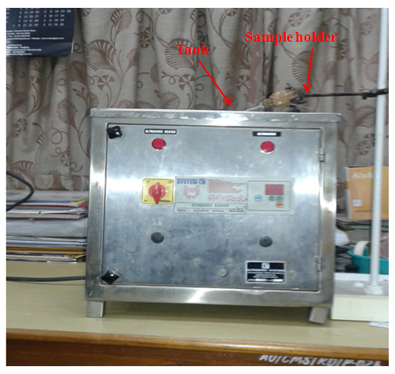
Figure 3.1: Ultarsonic system model-UVD-2-120.

1.3 Thermodynamic Studies
Thermodynamical parameters (transition temperatures, enthalpies, entropies and transition width) of the pure LC and their nanocomposites have been carried out with the help of DSC, Shimadzu’s analytical balance (Model AUW120D for weighing of the samples).
1.3.1 Differential Scanning Calorimeters (DSC)
The following DSCs have been used for the measurement of thermodynamical parameters:
- NETZCSH’s (model DSC-200-F3-Maia) equipped with Intracooler-40 [13]
- Tzero pressure DSC (model DSC Q 20) [14]
1.3.1.1 NETZCSH DSC (model DSC-200-F3-Maia)
The NETZCSH (model DSC-200-F3-Maia) combines the advantages of modern technology, high sensitivity and a robust, easy-to-operate work horse. The main features of the DSC-200-F3-Maia are the newly developed monolithic DSC sensor and a new silver furnace with long life heating element. The heat flux sensor of the DSC-200-F3-Maia combines high stability, improved resolution and fast response time. Laser-guided welding processes for the sensor disk and thermocouple wires yield high sensitivity and robustness [13]. NETZCSH analysis software has been used to acquire and analyze the data by a programmable computer. The technical data of this DSC are given in the Table 2.1.

Table 1.1: Technical Data’s of DSC-200-F3-Maia [13].
Heating System
Temperature Range | -170.0°C to +600.0°C
Heating Rates | Minimum 0.001 K/min  Maximum 100.0 K/min
Linear Cooling Rates | 20.0 K/min down to -100.0°C
Cooling System
Intracooler40 | Minimum -40.0°C from 600.0°C  Minimum cooling time from room temperature to -40.0°C is ~ 30 minutes.
Measuring System
Measuring Range | -40.0°C: ± 600mW  160.0°C: ± 650mW  400.0°C: ± 850mW
Digital Resolution | 0.2μW/digit
Signal Noise | 0.7μW RMS at 130.0°C
Signal Time Constant | >2.5s (Indium melting Peak)
Reproducibility Onset-temperature | ±0.1 K (Indium melting Peak)
Reproducibility of Peak Areas | ± 1% (Indium melting Peak)

Intracooler 40
The temperature range of DSC-200-F3-Maia equipped with Intracooler 40 is -40 to 600 °C at ambient temperature 20 °C. Minimum temperature which may be slightly below -40 °C depends mainly on the ambient temperature. It is strongly recommended to switch on the Intracooler 40 during all measurements. For furnace temperatures higher than 200 °C, it is mandatory that Intracooler 40 is running. Intracooler 40 can be switched on only if the furnace temperature is lower than 80 °C. The protective gas on the DSC measuring unit must be switched on when the Intracooler 40 is running [13]. The photograph of DSC-200- F3-Maia equipped with Intracooler-40 is shown in Figure 3.2.
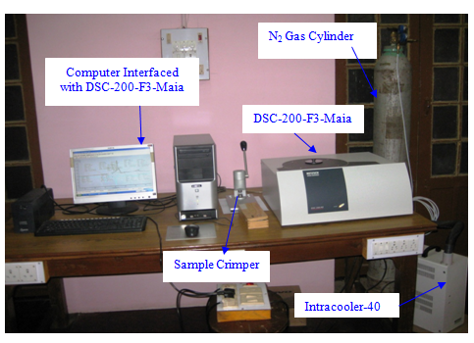
Figure 3.2: Thermodynamical Study Setup: NETZSCH’s DSC model DSC-200-F3-Maia with Intracooler.

1.3.1.2 Tzero pressure DSC (model DSC Q 20)
The Tzero Pressure DSC cell (PDSC) is a DSC cell (shown in Figure 3.3) enclosed in a steel cylinder that can be pressurized to 7 MPa. In addition to performing most of the same basic measurements as a standard cell, the PDSC cell can operate at elevated pressure or under vacuum. This ability to vary pressure, as well as temperature, provides the followings
- Resolution of overlapping peaks
- Determination of heats of vaporization and vapor pressure
- Reaction rates in controlled atmospheres
- Studies of pressure-sensitive reactions
The PDSC cell has two gas flow control valves, a three-way valve, a pressure gauge, a pressure release valve, and gas pressure fittings on the side. An 8.3 mPa gauge pressure relief valve and a pressure transducer are contained in the base of the cell. The PDSC cell sensor consists of a constantant body with separate raised platforms to hold the sample and reference. The platforms are connected to the heating block (base) by thin walled tubes that create thermal resistances between the platforms and the base. Area detectors (thermocouples) on the underside of each platform measure the temperature between these two positions. A third thermocouple measure the temperature at the base. The selected sample and an inert reference are placed in pans that sit on the raised platforms of the sensor. Heat is transferred through the constantan sensor platforms to both the sample and reference pans. A Vented silver lid encloses the heating block and sensor. TA universal analysis software has been used to acquire and analyze the data by a programmable computer [14]. The specifications of PDSC cell are shown in Table 3.2.

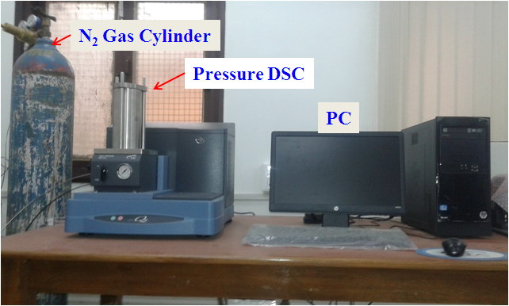

Figure 3.3: Thermodynamical Study Setup: Tzero pressure DSC (model DSC Q 20).

Table 3.2: Specifications of PDSC cell [14].
Item/Area | Specifications
Dimensions of cell only | Height 38.7 cm, width 22.4 cm, depth 23.6 cm
Weight of cell only | 12.2 kg
Temperature range | -130 to 550°C max with nitrogen  -130 to 550°C max with helium or hydrogen
Atmosphere | -100 kPa gauge to 7 mPa gauge, (1 Pa to 7 mPa absolute),  Constant pressure or constant volume
Dynamic gas purge | To 200 mL/min (cell flow rate)
Purge gas | Built-in nitrogen, air, oxygen, carbon-mono oxide, carbon dioxide, hydrogen, helium, argon

1.3.2 Shimadzu’s Analytical Balance (model AUW120D)
For the thermodynamical study of the material by DSC merely 2-3 mg of the sample is sufficient which is weighed by Shimadzu’s analytical balance of Model AUW120D. Shimadzu’s Analytical Balance is the world’s first five decimal balance with advantage of unblock one-piece force cell technology [15]. In this series, the balance of model AUW120D is a high performance analytical balance, which provides rapid and accurate mass measurement. This balance provides window direct functions for transfer of measurement results to personal computer without installing software. It offers consistently accurate measurement without calibration work, with temperature detection and time setting and the built in motor driven calibration weight that performs fully automatic span calibration [15]. The photograph of Shimadzu Analytical Balance of model AUW120D is shown in Figure 3.4 and function of the main keys is shown in Table 3.3.

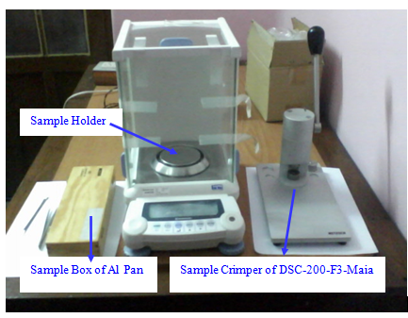
Figure 3.4: Shimadzu Analytical Balance of model AUW120D.

Table 3.3: The functions of the main keys on the front of the Shimadzu Analytical Balance (AUW120D) [15].
Key | During Measurement
 | Pressed once and released Pressed and held for about 3 seconds
[POWER] | Switches between the operations Switches the key notification buzzer  and standby modes. on/off
[CAL] | Enter calibration or menu item Enter calibration or menu item  selection. selection
[O/T] | Tares the balance. (Displays zero)
[UNIT] | Switches the unit of measurement.
[PRINT] | Output the displayed values to an Outputs the date and time to external  electronic printer, computer, or devices.  other external devices.
[1d/10d] | Switches the weighing range.

The Shimadzu’s Analytical Balance (Model AUW120D dual range type) specifications are shown below in Table 3.4.

Table 3.4: Shimadzu’s Analytical Balance (Model AUW120D dual range type)
Specifications [15]
Item/Area | Specifications
Capacity | 120g/42g
Minimum display | 0.1 mg/0.01 mg
Repeatability (standard deviation) | <0.1 mg (120 g range), <0.02 mg (42 g range)
Linearity | ±0.2 mg (120 g range), ±0.03 mg (42 g range
Response time (typical) | 3 s (120 g range), 10 s (42 g range)
Calibration weight | Built-in
Operation temperature range | 5 to 40°C
Pan size | 80 mm dia Approx.
Main body dimensions | 220 mm W* 330 mm D* 310 mm H
Main body weight | 7 Kg
Rated electric power supply | DC 12 V, 1A
Ac adapter (primary) | AC100-240 V, 400Ma, 50/60 Hz

1.3.3 Calculation of transition temperatures, enthalpies, entropies and transition width
DSC is allowed to run at different scanning rates. After completion of one particular run, data is saved in PC and DSC is allowed for another cycle. Well-defined endothermic peaks were found on heating scans, and exothermic peaks were found on cooling scans at different transitions. Samples have been given 5 thermal cycles before collecting fair data in order to stabilize the systems. DSC was operated at various scanning rates between 2.5 °C /min and 15.0 °C /min in the heating and cooling cycles. It has been observed that transition temperatures vary linearly with the scanning rate with opposite slopes in the heating and cooling cycles. Extrapolated peak transition temperatures (T_{p} in °C) at the scan rate of 0 °C/min have been obtained through least square fit. Analysis of the data has been carried out with the help of software and enthalpies, entropies and transition width are determined directly from temperature heat flow diagram. Width of transition process have been calculated by T= T_{s} ~ T_{E}, where T_{s} and T_{E} are respectively the starting and ending parameters of a particular transition peak [16].
1.3.4 Uncertainty in Measurement
The maximum uncertainty in the measurement of transition enthalpy is ± 0.3% and in the transition temperature is ± 0.1°C for pure inorganic material and is ± 5% for organic compounds with operational temperature ranging from room temperature to 600.0°C. For liquid crystals, uncertainties in the measurement of transition enthalpy and entropy for crystal to mesophase are ± 1% while it becomes ± 4% for mesophase to mesophase transition. The Uncertainty in the measurement of half width of the transition process ΔT (= $\frac{1}{2}$ (T_{s} ~ T_{E})) is ~ ± 0.2°C, where T_{s} is start of the transition peak and T_{E} is the end of the transition peak.
1.4 Optical texture study
Optical study of the LC and their nanocomposites has been carried out by using POM. The heating and cooling of the sample has been controlled by a Hot Stage. Therefore, here the hot stage and the technique of recording and capturing of textures from the POM have been discussed.
1.4.1 Temperature Controller
1.4.1.1 Hot Stage of Instec (model HS1)
Temperature of the LC compounds for optical, electro-optical and electrical studies has been controlled with the help of a hot stage of Instec (USA) of model HS1. The HS1-i is a package of hardware and software, which provides precise temperature control of the hot stage. In addition to HS1, the package includes the mK1 temperature controlling printed circuit board (PCB), the PS2 power supply and mK1 temperature controlling program. The circuit consists principally of two parts: an input circuit consist of a Wheatstone bridge, a 17 bit analog to digital converter which provides precision in temperature measurement via a resistive sensor; an output circuit which provides the variation of the average power delivered to the thermostat resistive heater by controlling to 16 bit precision, the closed duration of each cycle of a 15 Hz cyclic on-off-switch connected in series with heater. Thermal contact between heater and the sensor allows the PC to close a temperature servo loop. Both heating and cooling cycles can be programmed between two temperatures with desired scanning rates with the help of mK1 software. Temperature range of the hot stage is 0 to 250 °C with the temperature accuracy of ± 0.003 °C. The material temperature is measured with the help of a copper constantan thermocouple whose one junction kept in ice-water mixture and other near the material [17]. The thermo emf has been measured with the help of a 6 and ½ digit Multimeter of Agilent of model 34410A. The photograph of Hot Stage of Instec Model HS1 is shown in Figure 3.5.
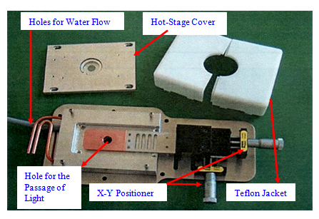
Figure 3.5: The material holder of Instec’s (USA) temperature controller of model HS1.

1.4.1.2 mK1000 Temperature Controller
mK1000 series temperature controller is a high precision temperature controller which has been evolved from Instec’s mK1000 temperature control board. It features dual temperature sensor connections; thus can communicate with two Platinum RTD sensors, two Thermistor sensors, or one platinum RTD and one Thermistor sensors, of which one sensor is deployed as the basis for precision temperature control and the other as an additional means of temperature monitoring. Temperature range of the mK1000 temperature controller with HCS302 hot and cold stage is -190-400 °C [18]. The mK1000 series temperature controller provides temperature control resolution and precision up to 0.001 °C.
1.4.1.3 Hot and Cold Stage of Instec (model HCS302)
The photograph of Hot Stage of Instec Model HCS302 equipped with temperature controller is shown in Figure 3.6. Instec’s HCS302 offers a temperature controlled environment which is an ideal choice for optical thermal microscopy and also for other general applications requiring optical access to the material. All of the dual windows on the HCS302 stage are removable and exchangeable allowing the HCS302 to be used for small angle X-ray diffraction, FTIR, and other experiments requiring beam access to the temperature controlled material. The stage can also be mounted vertically for applications requiring horizontal beam access to the sample chamber. The interior of the HCS302 is large enough to accommodate a variety of samples, including electro-optical devices and cell culture preparations [18].

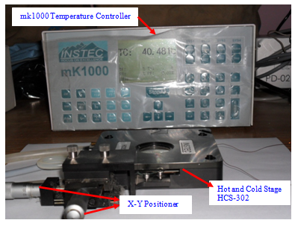
Figure 3.6: The Instec’s (USA) temperature controller of model mK1000 and hot and cold state of model HCS302.

Technical Specifications of Hot and Cold Stage of Instec Model HCS302 are shown in Table 3.5.

Table 3.5: Technical Specifications of Hot and Cold Stage of Instec Model HCS302 [18].
Item/Area | Specifications
Temperature Range | 190°C to 400°C† Below ambient operation requires optional cooling accessory
Temperature Resolution | 0.01°C
Temperature Stability | ±0.05°C at 100°C (better stability optional)
Minimum Heating and Cooling Rate | ±0.1°C per hour
Maximum Heating Rate | +100°C per minute at 100°C
Maximum Cooling Rate | 60°C per minute at 100°C
Sample Area | 38 mm x 50 mm
Chamber Height | 2 mm with inner cover in place (up to 8 mm when using spacers)
Weight | 670 g

1.4.2 Polarizing Optical Microscope (POM)
Optical textures of different phases of LCs and their nanocomposites have been studied on a binocular polarizing microscope of CENSICO and the microphotographs/textures have been captured on the computer with the help of PCTV Vision software. A built-in white light source has been provided in the base of the microscope where its intensity can be changed by changing the voltage across the bulb. Glaring light often impairs the observation and is also harmful to the eyes; hence it is diminished by using filters. Temperature of the material kept between two cover slips of glass under the microscope has been controlled with the help of a hot stage of Instec (USA). The photograph of Polarizing Optical Microscope is shown in Figure 3.7. Radiation loss through the surface of the hot stage is minimized by keeping it in a Teflon jacket and then covered it with thick layers of cotton. Aligned small circular holes in upper and lower plates of the hot stage have been provided for the light to pass through material. The whole jacket is kept on the rotating base of the polarizing microscope between the crossed polarizer and analyzer. The total magnification of the microscope is kept at 100-150 (10 of objective and 10-15 of eye lens) in most of the cases. It has been observed that when objective of the microscope is brought near the material, it absorbs heat from the material creating a temperature gradient between the two glass plates in which the material is kept. To minimize this problem, the material cell is covered with another thick transparent glass plate.

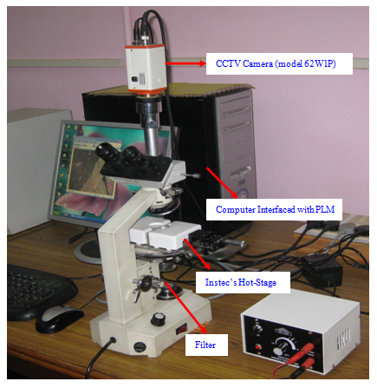
Figure 3.7: Optical Study Setup: CENSICO’s polarized light microscope coupled with CCD Camera interfaced with PC.

1.5 Ultraviolet Visible (UV-Vis) Spectroscopic Studies

Spectroscopy is based, principally, on the study of the interaction between radiation and matter. This interaction causes in the atom an electronic transition from a lower energetic level, m, to a higher level, l, occurring energy absorption from the atom equal to the energy difference between both levels, E_{l} - E_{m}

___________________________ El

ΔE where $∆E =hν = \frac{hc}{λ}$
_____________________________E_{m}
$h$ = Planks constant, $ν$ = Frequency, $λ=$Wavelength

A plot of these latter processes as a function of radiation wavelength is known as spectrum that offers information about the difference of energy involved in each electronic transition. Different types of spectroscopy can be found depending on the wavelength of the incident radiation. UV-Visible spectroscopy (radiations with wavelengths between 10 and 1000 nm) offers information about the transition of the most external electrons of the atoms. Since atoms or molecules absorb UV-visible radiation at different wavelength, spectroscopy/spectrometry is often used in physical and analytical chemistry for the identification of substances through the spectrum emitted from or absorbed by them. This technique is also used to assess the concentration or amount of a given species using the Lambert-Beer- law.

Lambert-Beer- law
This law relates the absorption of a radiation to the properties of the material through which is passing through. States that there is a logarithmic dependence between the transmission (or transmissivity), $T$, of light through a substance and the product of the absorption coefficient of the substance, $α$ and the distance the beam travels through the material (i.e. the path length), $l$. The absorption coefficient can, in turn, be written as a product of either a molar absorptivity of the absorber, $ε$and the concentration $c$ of absorbing species in the material. For liquids, these relations are usually written as,
$\log{T=log\frac{I}{I_{0}}}$ = $εcl$ (3.1)
where $I$ and $I_{0}$ are the intensity of the incident and the transmitted beams, respectively. The transmission also can be expressed in terms of absorbance ($A$)
$A= -logT$ (3.2)
And so, Lambert-Beer equation can be written finally as
$A= εcl$ (3.3)
Either transmittance or absorbance can be measured experimentally with the spectrometer. Thus, if the path length and the molar absorptivity are known and the absorbance is measured, the concentration of the substance (or the number density of absorbers) can be deduced [].
Sample preparation
Generally when a sample is analyzed, it is measured as a solution. Accordingly, the type and the concentration of the solvent must be adequate. A solvent that dissolves the sample well and that is free from mutual action, has small absorbance in measurement wavelength range has small volatility is desired. A cell with a lid is necessary for volatile solvent. As a solvent, water is excellent for measuring absorbance in visible/ultraviolet range, as it has no absorbance itself. On the other hand, many of the normally used organic solvents are transparent to the human eye, so it can be mistakenly believed that absorbance does not exist in ultra-violet range either. In the present study sample were dissolved in CHCl3 and also used as a reference in a standard quartz cells with 10 mm path length. The samples were separately placed in the spectrometer, with another quartz cell as reference for absorption measurements.

1.5.1 UV-Vis Spectrophotometer (mode UV-1800 Shimadzu)
A schematic of the optical system for the UV-1800 is shown in Figure 3.10. The Ultraviolet-visible spectra of LCs and its nanocomposites are acquired on a Shimadzu (model UV 1800) spectrophotometer. Shimadzu spectrophotometer Designed in accordance with the governing Japanese and European Pharmacopoeia, the new UV-1800 UV-VIS spectrophotometer achieves a resolution of 1 nm, the highest in its class, in a compact design. UV-1800 can be used either as a stand-alone instrument or as a PC-controlled instrument. Basically UV-1800 is a double beam- double detector configuration spectrophotometer. In this configuration, the sample beam and the reference beam enter different detectors respectively. Thus, it is necessary to use two detectors with similar characteristics. The advantages of this configuration is that it is not necessary to always pass two beams to the same detector as in the case of the single detector configuration, and so a larger space is possible in the sample compartment, convenient for measuring unclear samples by keeping them in close contact with the light receiving surface [20].

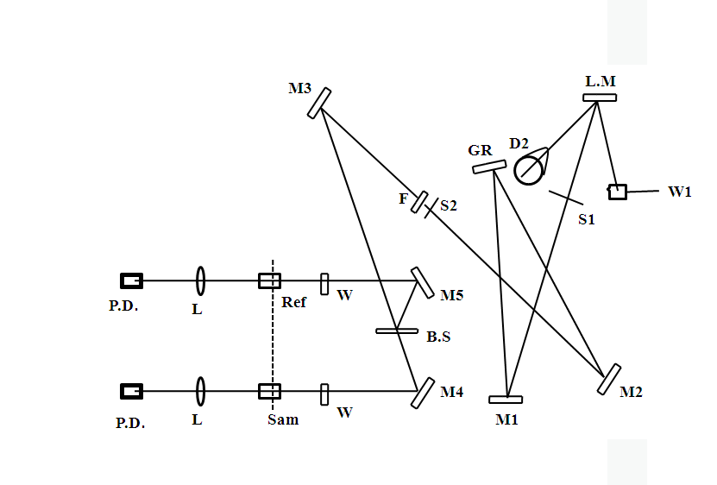
Figure 3.10: Schematic of optical system for the UV-1800 spectrophotometer [20].

D2: Deuterium lamp L.M. Light-source switching mirror
W1: Halogen lamp M1~M5: Mirrors
F: Filter B. S: Beam splitter
GR: Grating L: Lens
S1: Entrance slit Sam: Sample
S2: Exit slit Ref: Reference
W: Window plate P.D: Photodiodes
The light coming from the light source (deuterium lamp D2or halogen lamp W1) is reflected by mirror L.M. and then enters the monochromator. Light source switching is entirely automatic, with the instrument selecting the next light source by rotating the mirror L.M. according to the wavelength. The light coming out of the monochromator passes through a stray light cutting filter F and strikes the mirror M3 and is then split by the beam spliter B.S. into the sample side beam and the reference side beam, which pass through their respective cells and strike the detectors (photodiodes). The photographs and specifications of UV-1800 Shimadzu spectrophotometer is shown in Figure 3.11 and Table 3.6 respectively.
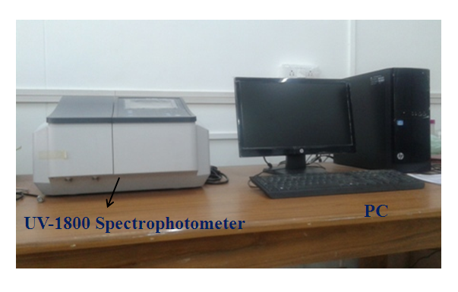
Figure 3.11: The photographs and specifications of UV-1800 Shimadzu spectrophotometer

Table 3.6: Specifications of UV-1800 Shimadzu spectrophotometer [20].
Items | Specifications
Measurement wavelength range | 190~1100nm
Spectral band width (Resolution) | 1±0.2 nm
Wavelength accuracy | ±0.1 nm (656.1 nm D2), ±0.3 nm (All region)
Wavelength repeatability | ±0.1 nm
Wavelength scanning speeds | When shifting wavelength: approx. 6000 nm/min  When scanning wavelength: approx. 3000 nm/min~2 nm/min
Stray light | 0.02 % or less (220nm. Nal)  0.02 % or less (340nm. NaNO₂)  1 % or less (198nm. KCl)
Photometric system | Double beam optics
Photometric range | Absorbance: -4~4 Abs, Transmittance: 0~400%
Photometric accuracy | ± 0.0002 Abs. (at 0.5 Abs), ± 0.004 Abs (at 1 Abs), ± 0.006 Abs (at 2 Abs)
Photometric repeatability | 0.001 Abs or less (at 0.5 Abs), 0.001 Abs or les (at 1 Abs), 0.003 Abs or less (at 2 Abs)
Noise level | Within 0.00005 Abs (700nm)
Baseline flatness | ±0.0006 Abs (190 nm-1100 nm) 1 hour after the light source is ON.
Baseline stability | Within 0.0003 Abs/h (700nm) 1 hour after the light source is ON.
Light source | 20W halogen lamp, Deuterium lamp

Monochromator | Czerny-Turner spectrometer  Uses blazed holographic grating
Detector | Silicon photodiode
Dimensions | 450 *490* 270 (mm)
Weight | 15 kg
Operating temperature | 15°C~35° C

1.5.2 Measurements of Band gap
In this thesis work, determine the energy band gap of LC and their nanocomposite materials that only requires the measurement of the absorbance spectrum and without the need of additional information. The band gap energy can be determined using the Tauc relation [21-22]. It is convenient way of studying the optical absorption spectrum of a material. According to the Tauc relation, the absorption coefficient for material is given by
$αhν={A(hν-E_{g})}^{n}$ (3.4)

where $hν$ is incident photon energy, α is the absorption coefficient, $(α= \frac{2.303×A}{d}$ , where d and A are the thickness of the cell and absorbance respectively) and $E_{g}$ is the band gap corresponding to the particular transition in the material. Exponent $n$ is an index which assumes the values 1/2, 2, 3/2 and 3 corresponding to the direct allowed, indirect allowed, forbidden direct and forbidden indirect transitions, respectively depending on the nature of the electronic transition responsible for the absorptions [21]. ${ E}_{g}$ were then calculated from the Tauc plots by fitting a line through the linear portion of the band edge region [23]. Here the best fitting is characterized by the value of chi-square (χ²) and correlation coefficient (R²). For best fitted curve the value of χ² should tend to 0 and the value of R² should tend to 1. By the process of fitting the best fit values of various parameters of Equations (3.4) are obtained. The Tauc plot is plotted with $hν$ along the X-axis and (αhν) ² along the Y-axis. Therefore the values of ${ E}_{g}$ have been calculated by plotting (${αhν)}^{2}$ versus $hν$ and extrapolating the linear portion of the plot to (${αhν)}^{2}$=0 (see eq 4). The Tauc plot of a sample defines the optical band gap as represented as the region A in Figure 3.12.

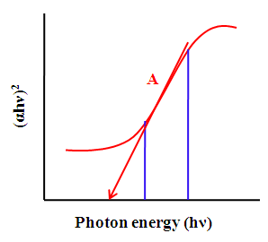
Figure 3.12: Showing the variation of absorbance with photon energy.

1.6 Small Angle X-Ray Scattering (SAXS)
Small-angle X-ray scattering (SAXS) is a small-angle scattering (SAS) technique where the elastic scattering of X-rays by a sample which has inhomogeneities in the nanometer range, is recorded at very low angles (typically 0.1 - 10°). This angular range contains information about the shape and size of macromolecules, characteristic distances of partially ordered materials, pore sizes, and other data. SAXS is capable of delivering structural information of macromolecules between 5 and 25 nm, of repeat distances in partially ordered systems of up to 150 nm. Small-angle X-ray scattering (SAXS) is a valuable tool for molecular structural analysis due to it’s ability to provide information about non-crystalline samples, macromolecular systems, and heterogeneous solutions.
General X-ray Scattering
The principles of small-angle X-ray scattering are based upon the idea that elastic collisions occur between the incoming wave and a particle, causing the reflected waves to scatter in all directions. As the reflected waves interfere with one another, there will be constructive interference along certain angles, causing peaks to present themselves. Using geometry and the Pythagorean Theorem, one can obtain Bragg’s law for simple scattering.

$nλ=2d\sin{θ}$ (3.5)

where $n$ is any integer, $λ$ is wavelength, $d$ is the vector representing the displacement between reflection sites, and $θ$ is the angle between the reflected ray and the plane formed by the material’s surface [24].
At Small Angles

When only the effects of small-angle scattering are taken into account, it becomes possible to study non-repeating structures. The smaller angle causes the scattering vector’s modulus to become dependent on the reflected angle in the form $2πθ/λ.$ Since amplitude is defined as $2π/q$the amplitude is equal to $λ/θ$ [24]. Since X-rays interact with the electrons surrounding atoms, it’s clear that inhomogeneities in the electron density will affect the scattering pattern. At a larger angular range, these effects are diminished due to the large number of contributing particles. When only small angles (<10 degrees) are considered, these effects can be observed and will provide information about the size and shape of macromolecules in the sample.

1.6.1 X-Ray diffractometer (Rigaku, UltraX 18)
` The photographs of Rigaku, UltraX 18 spectrophotometer is shown in Figure 3.13.The ultraX 18 is a powerful, high-frequency 18 kW X-ray generator designed for flexibility, high stability and low maintenance operation. It can be configured to produce either two point focus beams or two line focus beams, by changing the anode mounting orientation. A standard table, of a breadboard design, will mount the anode housing in any position.The hexagonal columnar structure of the DLCs is also confirmed by SAXS techniques. X-rays were produced from a rotating anode X ray generator (Rigaku, UltraX 18) operating at 50 kV and 80 mA. The $CuKα$ radiation having a wavelength of 1.54 Å was selected using a flat graphite momochromator. The sample was taken in a glass capillary having an outer diameter of 0.5 mm to 1 mm and a wall thickness of ~0.01 mm. Then it was placed in a locally built temperature controlled heater with a stability of ±0.1 °C. The data were collected using an image plate having a diameter of 80 mm. WE have carried out our experiments at various temperatures. The features of diffractometer is given below [25]
Features
- Powerful line and point focus rotating anode generator
- The X-ray tube, high-voltage connection unit, and main vacuum system are compactly assembled on the top of the worktable
- The X-ray tube position is easily adjustable for different optical configurations
- The small-sized tube housing makes it possible to bring the optical system closer to the X-ray source
- The X-ray tube in one compact body permits rapid start-up of the entire system
- Choice of anode materials: Cu, Cr, Fe, Co, Ni, Mo, Ag, W, Au
- An ideal high flux generator option for small molecule systems and many XRD applications.

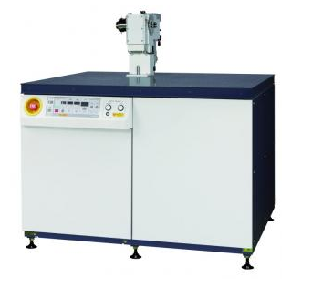
Figure 3.13: photographs of Rigaku, UltraX 18 spectrophotometer.

1.7 Dielectric Studies
The frequency and temperature dependent dielectric study of the pure and nanocomposites has been divided into the following three steps:
- Preparation of the dielectric cell
- Data acquisition with the help of impedance analyzers
- Measurement of the dielectric parameters and Data analysis
    - Preparation of the Dielectric Cell
1.7.1.1 Dielectric Cell and Sample Holder
The cell is made in the form of parallel plate capacitor for dielectric studies. Electrodes are taken in the rectangular shape from optically flat glass plates whose one surface is coated with indium tin oxide (ITO) or gold having sheet resistances approx 25 Ω/⁪ and 1-2 Ω/⁪ respectively. Two Teflon spacers of varying thickness (2-10 μm) are used along the length sides of the electrodes to provide the gap between the electrodes. About 15 to 20 cm long thin copper wires are soldered with the electrodes along the breadth side. For fixing the electrodes with each other no adhesive has been used because adhesives show their own dielectric response. Instead electrodes are kept on a cylindrical base of brass height ~0.5 cm and then clamped with it using screws. For the temperature measurement of the material, one end of the thermocouple is kept between the glass plates and brass clamp. For calibration and dielectric measurement, cell clamped on cylindrical base of brass is placed inside the hot stage of Instec model HCS 302. After placing the cell inside the hot stage mounted on the base, the whole jacket is covered with rectangular Teflon sheet and cotton in order to avoid heat loss due to radiation. A image of dielectric cell clamped with sample holder is shown in Figure 3.14.
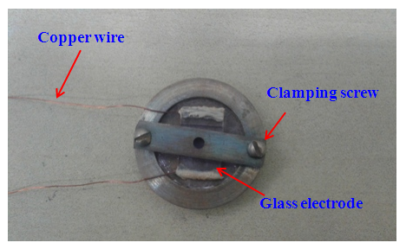
Figure 3.14. Dielectric cell for the measurement of dielectric parameters of the materials

1.7.1.2 Stabilization of the Dielectric Cell
After placing the empty cell inside the hot stage, capacitance (C) and conductance (G) have been stabilized against temperature by heating and cooling it several times from room temperature to a temperature 10 °C above the clearing temperature of the material to be studied. Normally after 4-5 thermal cycling, C and G values are repeatable within the uncertainity limit of the instrument. C and G values of empty cells have been observed to change with temperature and hence to make corrections of this effect, C and G of the empty cell have been acquired at temperature intervals of 5 °C in the whole temperature range of the material studied and the subtracted from measured data taken with material.
1.7.1.3 Alignment Control Techniques
Alignment Control Techniques for the Discotic Columnar Phase
The control of the molecular alignment on/between the surfaces is also an important issue during the discotic material processing. Discotic columnar phases can exhibit two different alignments: the homeotropic alignment, where the molecules adopt face-on orientation on the substrate (Figure 3.15 (a)), and the planar alignment, where the molecules adopt edge-on orientation on the substrate surface [26-29] (Figure 3.15 (b)). For FET, an edge-on organization (Figure…) of the discotics in uniaxially oriented columns is required. In contrast, the large monodomain face-on arrangement (Figure 3.15 (b)) of the disks leads to a homeotropic alignment, which allows faster charge transport between the top and bottom electrodes, and favors the photovoltaic performance of DLCs. So details studies on the control of the supramolecular order and alignment on/between the surfaces leading to device applications are considered.
Homeotropic Alignment of Discotic Columnar Phase
The face-on homeotropic alignment of DLCs has been achieved either in between two substrates or on a single substrate, and the alignment can be obtained from isotropic melt or from solution by different solution processing techniques. In this thesis work the the sandwiched type (capacitors) cells were made using two optically flat glass substrates coated with indium tin oxide (ITO) layers. The cell thickness was fixed by placing two mylar spacers (thickness 10 µm) between the glass plates [30-31]. It is noteworthy that a slower cooling rate is more favored because the high viscosity of the columnar mesophase often quickly promotes multidomain and prevents the perfect homeotropic alignment over a large areas. This is a thermodynamically preferable alignment and spontaneously occurs for different DLCs during cooling of the isotropic melt. Spontaneous homeotropic alignment of DLCs on between two electrodes is termed as self processing. It is noteworthy that the self assembled columns of DLCs self-organize in different 2D lattices, which possess two very important and attractive properties that are self processing between substrates and self-healing of structural defects in the columnar phase [26-27]. Homeotropic aligned samples typically do not show birefringence in the POM between cross-polarizers since the optical axis in this case coincidences with the columnar axes. In order to distinguish between the homeotropically aligned columnar and the isotropic phase, additional experiments are necessary. X-Ray scattering is one method which confirms precisely the alignment.
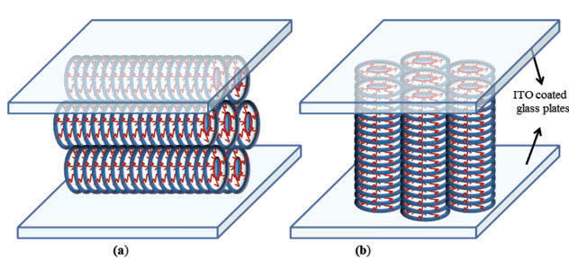
Figure 3.15: Schematic representation of (a) homeotropic and (b) planar alignment configurations of discotic columnar phase.

Homeotropic Alignment of Nematic Material
For homeotropic alignment (long axis of the molecules perpendicular to glass electrodes) of the molecules, the ITO coated glass plates are cleaned thoroughly with ethyl/isopropyl alcohols. A dilute solution of lecithin dissolved in ethyl alcohols is coated on the conducting surfaces of the glass electrodes and electrodes are dried well before clamping for the capacitor action [32]. After getting perfect homeotropic alignment completely dark field of view has been observed in all the phases under the cross polarizers condition and is not disturbed unless material is taken back to isotopic liquid phase. Dielectric permittivity data of the isotropic liquid phase of the material before and after shearing the electrodes were used to normalize the active capacitance of the cell modified due to shearing.

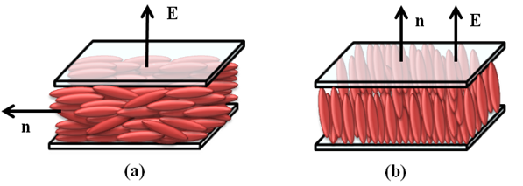
Figure 3.16: Nematic liquid crystal cells (a) Planar (or Homogeneous) alignment (b) Homeotropic alignment.

Planar Alignment of Nematic Material
To get planar (long axis of the molecules parallel to glass electrodes) alignment of the molecules, the conducting surfaces of the ITO coated glass electrodes are thoroughly cleaned and dried. Then the electrodes are dipped in silane solution (0.2 % solution of phenyl-trichlorosilane in toluene) for about 10 minutes and thereafter rinsed thoroughly in isopropyl alcohol. A film coating of polyamide nylon is now deposited on the glass electrodes. To deposit a few hundered angstrom thick layer of nylon polymer, a 0.5 % (wt to volume) solution of nylon prepared in 60 % m-cresol and 40 % methanol (volume to volume) is used. Excess solvent is removed by heating the plates in an oven at ~130 °C for one hour. Both the glass plates are rubbed unidirectionally by cotton in order to obtain planar oriented molecules of the material sandwiched between two plates. To realize planar alignment of molecules, indium tin oxide coated glass cells pre-treated with a unidirectionally rubbed polyimide layer (made by Instec, USA) with spacer’s thickness of 5µm also were used. Material is then filled in the cell by capillary action at about 10 °C above transition to the isotropic liquid phase [32]. Then it is cooled very slowly to get good planar alignment. The homeotropic and planar alignment of molecules in nematic phase is shown in Figure 3.16.
1.7.2 Data Acquisition with the Help of Impedance Analyzers
The dielectric studies of the present thesis work have been carried out on two analyzers viz.
- Alpha-A high performance frequency analyzer (Novocontrol Technologies) coupled with 2-wire impedance interface ZG2

- N4L’s Phase Sensitive Multimeter model PSM-1735 coupled with impedance analysis interface model IAI-1257
1.7.2.1 Alpha-A High Performance Frequency Analyzer (Novocontrol Technologies) Coupled with 2-Wire Impedance Interface ZG2
The Alpha analyzer measures the complex dielectric, conductivity and impedance function of materials in dependence of frequency with high precision. It is especially optimized for dielectric materials with high impedance and low loss factors over a broad frequency range, but can accurately measure high conductive material with low impedance too. The Alpha analyzer is realized as a modular measurement system with one base unit called the Alpha analyzer mainframe and other test interface which can be connected to the mainframe.
Alpha Analyzer Mainframe
The Alpha analyzer mainframe provides the basic functionality in order to operate ZG2 interface. The mainframe contains a frequency response analyzer with a sine wave and dc-bias generator and two ac voltage input channels. Each input channel measures the ac voltage amplitude of an applied sine wave. In addition, the phase shift between the sine waves applied to the both inputs is detected. More detailed each channel measures the amplitude and phase angle of the harmonic wave component of a signal applied to the input. The harmonic base wave component measured at the frequency of the ac sine wave generator. Most other signal components are suppressed. In addition, higher harmonics may be measured. Experimental data evaluation is performed by WinDETA and WinFIT software packages which have established a worldwide standard in dielectric, conductivity and impedance material analysis [33].
WinDETA impedance analysis software
Decades ago, analysis of dielectric and impedance measurements was a time consuming job. Today, WinDETA performs fully automatic test sequences, capturing impedance information into data files. WinDETA has become the laboratory standard control and evaluation software for dielectric and impedance spectroscopy. Its uniform user interface supports the most important impedance analyzers. The Microsoft Windows environment permits a maximum throughput analysis of data, flexibility and high quality graphical data presentation. WinDETA transforms your PC into a powerful system with mouse based user interface, allowing even unexperienced users to setup and start fully automatic measurements in minutes.
Features
- Laboratory standard control and evaluation multitasking software for dielectric/impedance spectroscopy and electrochemical impedance spectroscopy (EIS).
- Uniform user interface for several impedance analyzers and temperature controllers nearly independent of hardware.
- Flexible experiment set-up: control of frequency, temperature, dc-bias and time in any multi dimensional arrangement
- From the measured impedance, more than 30 different electric quantities are evaluated, including permittivity, conductivity, inductance, and many more
- Graphical online display of measured data, temperature curve and system status
- Integrated plot software to display multiple data sets in a single graph, 3D diagrams, Bode and Cole-Cole plots
- Automatic calibration of hardware devices and sample cells
- Exports/imports data in several flexible user-defined ASCII formats
- Optional curve fitting software WinFIT for equivalent circuit modelling, data transformations like WLF, Havriliak-Negami, and time domain conversion
WinFIT impedance analysis software
WinFIT focuses on the analysis of impedance and dielectric spectra. Advanced curve fitting techniques ensure both accurate and fast determination of key materials parameters. Equivalent Circuit Analysis of impedance spectra is extended by arbitrary complex functions. The evaluation of dielectric spectra in polymer research is particularly supported by the Havriliak Negami and Williams Landel Ferry (WLF) functions. WinFIT allows the scaling of spectra, their representation in master plots and their conversion into the time domain.
Features
Frequency domain
- Non-linear curve fitting in the frequency domain special fit functions like Havriliak Negami, Cole Cole, Cole Davidson, Debye etc.
- Automatic evaluation of a series of spectra taken, e.g., at various temperatures
- Separation of relaxation and conductivity contributions
- Automatic creation of master plot representations
Temperature domain
- Non-linear curve fitting in the temperature domain, including Vogel - Fulcher and Williams Landel Ferry (WLF) fit functions
- Relaxation time and maximum relaxation frequency fitting.
- Easy creation of Arrhenius activation plots
- Determination of activation energies and glass temperatures
Time domain
- Conversion of dielectric spectra to the time domain by numerical Fourier Transform
- Complete dielectric time domain representation including relaxation time distribution, relaxation function, step response function, peak answer function, time dependent dielectric constant and conductivity
2-wire impedance interface ZG2
The 2- wire test interface ZG2 is an economical version of the 4-wire test interface ZG4. ZG2 is optimized for, dielectric, conductivity and impedance measurements of components or materials. It contains the Vout and I in BNC terminals for sample connection. The usages and connections schemes of these sockets depend on the interface front mode which is 2-wire impedance or gain phase. Vout applies the generator signal in order to drive the sample. This applies both in impedance and gain phase mode. The output voltage is between 0 to 3 Vrms ac superimposed by optional +-40V dc (bias). The output impedance is 50 Ω. The maximum dc bias current is limited to about 70 mA. V out is internally connected to the V1 rear terminal. The ac voltage magnitude, frequency and the optional dc voltage can be adjusted. The Vout output is protected against shorts to system ground. I in is the input of the current to voltage converter. It should be used in impedance mode in order to sense the response current of a test sample driven by the V out socket. This input is operated at virtual ground, meaning that the voltage at I in is always nearly compensated to 0 V by the feedback loop of the internal current amplifier, if the input currents are within the selected range. Therefore the input impedance up to 10¹⁴ Ω, in spite of the virtual ground, the input impedance may be become quite high.
Current limits: protected to +- 200 mA. DC Voltages up to +- 50 V may be applied as long the current limits are not exceeded [33].
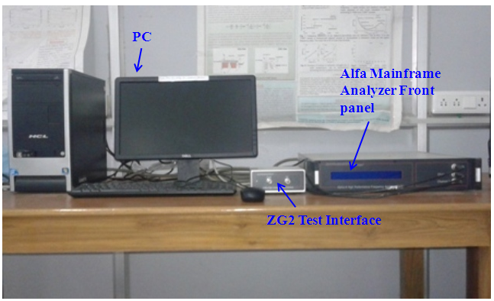
Figure 3.17: Dielectric Study Setup: Photograph of the Novocontrol impedance analyzer coupled with impedance analysis interface model IAI-1257.

Technical data of Alfa mainframe and ZG2 interface is given below [33]
Technical data
Alpha mainframe
Line voltage: 220-240 V ac, 50-60Hz or 110 V, 50-60 Hz
Power consumption: <100 W
Environment:
- Operating temperature: 0° to 40 °C
- Storage temperature: -10 to 60 °C
- Specification limits: 15° to 25 °C
Mainframe frequency response analyzer unit:
Two voltage input channel digital frequency response analyzer with sine wave and dc-bias generator.
Voltage input channels 1and 2
Frequency range: 3μHz to 40 MHz ac or dc coupled
Voltage ranges (V_{rms}):
3.2 V, 1.7V, 1V, 560 mV, 320 Mv, 170 mV, 100 mV, 56 mV, 32 mV
Input impedance:
Resistance: 1 MΩ, capacity <100 pF
ZG2 test interface current to voltage converter
Frequency range: 3 μHz for 20 MHz
Current ranges (rms): 40 mA, 15 Ma, 1.5 mA, 150 μA, 15 μA, 1.5 μA, 150 nA, 15 nA, 1.5 nA, 150 pA, 15 pA, 1.5 pA
Current resolution
- +- 5 fA +- 10⁻⁵ of current range
- +-30 fA/Hz frequency of measurements
Capacity range: 10⁻¹⁵ to 1 F
Resistance range: 0.01-2.10¹⁴ Ω
ZG2 interface differential voltage inputs V+, V-
Common mode rejection
- >80 db below 100 k Hz
- >60 db below 1MHz
Input bias current: < 2×10⁻¹² A
Input impedance : >10⁻¹² Ω in parallel < 10 pF
3.7.2.2 N4L’s Phase Sensitive Multimeter (model PSM-1735) Coupled with Impedance Analysis Interface model IAI-1257
Phase Sensitive Multimeter (Model PSM 1735-NumetiQ)
NumetriQ is a self-contained test instrument, with two inputs and one output, which incorporates a suite of test functions. It has a wide bandwidth of generator output that can be used as signal generator for sine or square wave forms. A dc offset upto 10 V may be added to the signal generator output [34]. It has two processors:
- A DSP (digital signal processor) for data analysis
- A CPU (central processing unit) for control and display
This general purpose structure provides a versatile hardware platform that can be configured by firmware to provide a variety of test functions, including:
- Signal generator
- Two channel true RMS voltmeter
- Phase angle voltmeter (vector voltmeter)
- Frequency response analyzer (gain/phase analyzer)
- Harmonic analyzer
With additional external interfaces, such as current shunts other functions are possible:
- True RMS current meter
- LCR meter
- Power meter
In LCR meter mode, channel 1 measures the voltage across the component under test, and channel 2 measures the current through it. To measure the current, channel 2 must be connected across an appropriate external shunt. It measures the real and imaginary components at the fundamental frequency using Discrete Fourier Transform (DFT) analysis. From the fundamental components of voltage, (a+ib), and those of the current, (c+id), it computes the complex impedance given by:
Z = V/ I = (a+ib) / (c+id) (3.6)
The components of the complex impedance are filtered independently to minimize the effects of noise, which would have random phase and would therefore be filtered out. The magnitude of the voltage and current are also computed. From the complex impedance resistance (R), inductance (L), capacitance (C), Impedance (Z), Phase (φ), loss factor (tanδ) and quality factor (Q) can be derived. Values of different parameters are displayed for both series and parallel configurations. The photograph of the N4L’s impedance analyzer of model PSM-1735 coupled with impedance analysis interface model IAI-1257 is shown in Figure 3.18 and specifications of the N4L’s impedance analyzer is listed in Table 3.7.

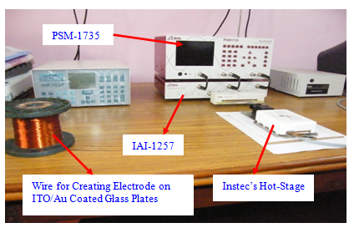
Figure 3.18: Dielectric Study Setup: Photograph of the N4L’s impedance analyzer of model PSM-1735 coupled with impedance analysis interface model IAI-1257.

Table 3.7: The specifications of the N4L’s impedance analyzer [34].
LCR meter
Frequency | 10 μHz to 35 MHz (own generator)  20 mHz to 35 MHz (external source)
Measurement type | Discrete Fourier Transform (DFT) analysis
Measurements | L, C, R (ac), Q, tanδ, impedance, phase  in series or parallel circuit
Conditions | Auto or manual
Display | Numeric values  Table of sweep results  graph of measurements
Ranges  (with external shunt) | C 100 pF to 100 μF  L 1 μH to 100 H  R 1 Ω to 1 MΩ
Ranges  (with active head) | C 10 pf to 1000 μF  L 100 nH to 1 kH  R 10 mΩ, 100 MΩ
Basic accuracy | 0.25 %+.002 %/kHz
Sweep step rate | 1/20 s, 1/3 s or 2.5 s(approx)

Impedance analysis interface (IAI-1257)
The Impedance Analysis Interface from Newtons4th Ltd (IAI) is a precision interface for use with the phase sensitive multimeter range of test instruments, PSM1735 NumetriQ, for impedance analysis applications. Any cables used to interface the device under test (DUT) to the IAI-1257, introduce measurement errors because of the stray impedances. At low frequencies the stray effects can usually be ignored except when measuring at extremes of the impedance range. At higher frequencies, it is almost always necessary to compensate for the stray effects unless using the HF component fixture clipped to the front of the IAI. For maximum accuracy, the IAI- 1257 should be recalibrated annually with the instrument that it is used with. The calibration values are stored in the instrument so the IAI and PSM instrument should be kept together as a pair [35]. The Specifications of IAI-1257 is given in Table 3.8.
Table 3.8: The Specifications of IAI-1257 [35].
Items | Specifications
Connectors | Grounded BNC
Power requirements | Universal input  90-264 Vrms, 47-63 Hz 15 VA max.
Size | 60H×350W×250D mm approx.
Weight | 2 kg
Temperature | 5 to 35 °C

3.7.3 Measurement of the Dielectric Parameters and Data Analysis
For the cell without etching of the sides (i.e. homeotropic cell made in our lab) have two components of capacitance [36]. The capacitance of the empty cell (i.e. air between plates) is:
C (a) = C_{A} + C_{D} (3.7)
where C_{A} and C_{D} are active and dead capacitances of the cell. Active capacitance (C_{A}) is determined by filling standard non-polar liquid (cyclohexane in this case) in the cell. The capacitance of the cell filled with cyclohexane:
C (ch) = ε′ (ch) C_{A} + C_{D}
where ε'(ch) is the relative permittivity of cyclohexane.
Finally, the above two equations yield:
C_{A}= [C (ch)-C (a)]/ [ε' (ch)-1] (3.8)
Complete removal of the cyclohexane (after the calibration) from the cell has been ensured by comparing the capacity of the cell before and after filling the cyclohexane. The dielectric permittivity (ε′) and loss (ε′′) of the material have been calculated with the help of the following equations: For our lab made cells for homeotropic alignment:
= [{C (m)-C (a)}/C_{A}] +1 (3.9)
For cell with etching of sides (Instec cells), there is no contribution of dead capacitance and hence:
= C (m) / C_{A} (3.10)

and
= σ/ε₀ ω = 1/2 π f RC_{A} (3.11)
where C (m) is the capacitance of the cell filled with material; σ is the conductivity, f is the frequency; and R is the resistance of the material filled between parallel glass plates. While obtaining Equation (2.4), the conductivity (σ) has been determined in the following manner: R is proportional to the separation (d) between the electrodes, resistivity (ρ) of the material and inversely proportional to the cross-sectional area of the sample (A) as given below,
R = (ρd)/A (3.12)
Conductance (G) = 1/R = Aσ/d (with conductivity σ = 1/ρ).
Using C_{A} = ε₀ A/d in the above equation,
σ = Gε₀/ C_{A} = ε₀/RC_{A} (3.13)
To analyze the measured dielectric data, complex dielectric permittivity (ε∗) has been fitted with the generalized Cole-Cole equation, [37]
$$ε^{*}=ε^{'}-jε^{''}=ε^{'}\left(∞\right)+\sum{\frac{δε}{1+{(jωτ)}^{(1-α)}}}+\frac{A}{ω^{n}}-j\frac{σ_{ion}}{ε_{0}ω^{k}}-jBω^{m} (3.14)$$
Real (ε') and imaginary (ε'') parts of ε∗ given by equation (1) can be written as:
$${ ε}^{'}=ε^{'}\left(∞\right)+\sum{\frac{δε[1+{ωτ}^{(1-α)}\sin{({απ}/{2)]}}}{1+{(ωτ)}^{2(1-α)}+2{(ωτ)}^{(1-α)}\sin{({απ}/{2)}}}+\frac{A}{ω^{n}}} (3.15)$$

$$ε^{''}=\sum{\frac{δε{(ωτ)}^{(1-α)}\cos{{(απ}/{2)}}}{1+{(ω_)}^{2(1-α)}+2{(ωτ)}^{(1-α)}\sin{{(απ}/{2)}}}}+\frac{σ_{ion}}{ε_{0}ω^{k}}+Bω^{m} (3.16)$$

Where$δε=\left(ε^{'}\left(0\right)-ε^{'}(∞)\right)$, τ and α are the dielectric strength, relaxation time (inverse of relaxation frequency) and symmetric distribution parameter (0<α<1) respectively. ε'(0) and ε'(∞) are the low and high frequency limiting values of the dielectric permittivity. The third and fourth terms in Equation (3.14) are added due to the presence of electrode polarization capacitance and ionic conductance at low frequencies, where A and n are the fitting parameters [38]. The fifth imaginary term Bω^{m} is added in Equation (3.14) in order to partially account for high frequency effect, where B and m are constants as far as correction terms are small [39] The measured dielectric permittivity and dielectric loss data are separately fitted with Equation 3.15 and 3.16 by using a program developed with Origin 6.1 software. The aim of nonlinear fitting is estimate the parameters values that best describe the data and minimize the deviations. Here the best fitting is characterized by the value of chi-square (χ²) and correlation coefficient (R²). For best fitted curve the value of χ² should tend to 0 and the value of R² should tend to 1. By the process of fitting the best fit values of various parameters of equations (2) & (3) are obtained. Low and high frequency correction terms are calculated with the obtained fitting parameters. These terms are then subtracted from the experimental data to get the correct dielectric spectrum of ε' and ε'', free from low and high frequency parasitic effects.
1.8 Electro-Optical Studies
Calculation of Threshold Voltage ($V_{th})$, Switching Voltage ($∆V$) and Steepness of the Transmission Voltage characteristics (TVC) of NLCs
The switching studies of the LC materials possessing N phase is carried out by applying DC or AC voltage by means of a function generator cum power supply across our dielectric cell and measuring the transmission intensity by a photo detector (Instec, USA, PD-02) mounted on POM and the corresponding photo voltage has been measured with a six and half digit multimeter of Agilent.
The variation of the photo voltage is plotted against the applied DC or AC voltage, which gives important information regarding threshold voltage ( $V_{th})$, switching voltage ($∆V$) and the steepness (slope) of the transmission voltage curve (TVC). Bright and dark states are observed under the POM at the lower and higher applied voltage respectively due to the reorientation of N molecules along the direction of external applied voltage. The reorientation of nematic directors with the application of electric field from bright state to dark state is also known as Fredrick transition. The voltage required to achieve this transition is called threshold voltage ($V_{th}).$ At low voltage less than $V_{th}$ molecule lie in the planar alignment and consequently a bright state is observed. When the applied voltage is increased above $V_{th}$ the molecules gradually turn to the homeotropic orientation and a dark state is observed. The switching voltage ($∆V)$ is taken as$V_{90}-V_{10}$, where $V_{90}$and $V_{10}$ are the voltages corresponding to the transmission intensity of 90% and 10% of the maximum value. The lower value of $∆V$ (~0.5-1.0) is beneficial for the applications. Steepness is nothing but the slope (($I_{90}-I_{10}$)/${(V}_{90}-V_{10}$)) of the TVC. The threshold voltage ( $V_{th})$is given by
$${ V}_{th}=π{\left(\frac{K_{eff}}{ε_{0}∆ε^{'}}\right)}^{1/2} (3.17)$$

here $K_{eff }$= $[K_{11}$+ ($1/4$)($K_{33}-K_{22}$)] (3.18)
where $K_{11},$ $K_{22}$and $K_{33}$ are the splay, twist and bend elastic constant of the material respectively. $K_{eff }$or $K_{11}$has been estimated by using the observed experimental values of $V_{th}$ and ∆$ε^{'}$ [40]. The brief description of Photo detector (Instec, USA, PD-02) is given below
Photo detector (Instec, PD-02)
The PD02 is a low noise high speed photo detector, which comes C-mount ready for attachment to a microscope and also includes a standard ¼-20 tapped hole for easy mounting to an optical table. Features and technical specifications of PD-02 is given below [41]
Feature
- 1 μs Response Time
- Easy to Use
- Differential Output
- 4 Post-Gains to Choose From
- Microscope C-mount Ready
- ¼-20 Tapped Hole for Horizontal Mounting
Technical specifications
Response Speed: 1 μs with post gain x1
Post Gain: x1, Rf = 10 KΩ; x10, Rf = 100 KΩ; x100, Rf = 1 MΩ; x1000, Rf = 10 MΩ
Input Voltage: 100V ~ 240 VAC
Output Voltage: 10V
Mounting: C-mount for microscope or ¼-20 for horizontal mounting.

References:

- Y. Y. Huang, E. M. Terentjev. Polymers. 4, 275, 2012.
- J.F. Blach, S. Saitzek, C. Legrand, L. Dupont, J.-F. Henninot, M. Warenghem. J. Appl. Phys. 107, 074102, 2010.
- X. Feng, L. S. Varga, S. Umadevi, T. Mori, Y. Shimizu, T. Hegmann. Adv. Funct. 25, 1180, 2015.
- H. Qi and T. Hegmann, J. Mater. Chem. 18, 3288, 2008.
- S. K. Prasad, K. L. Sandhya, G. G. Nair, U. S. Hiremath, C. V. Yelamaggad, S. Sampath, Liq. Cryst. 33, 1121, 2006.
- A. Kumar, G. Singh, T. Joshi, G. K. Rao, A. K. Singh, A. M. Biradar. Appl. Phys. Lett. 100, 054102, 2012.
- Supreet, R. Pratibha, S. Kumar, K. K. Raina. Liq. Cryst. 41, 933, 2014.
- S. Schymura, M. Kushnast, S. Jagiella, U. D. Weglkowska, S. Roth, F. Giesselmann, C. Tschierske, G. Scalia, J. Lagerwall. Adv. Funct. Mater. 20, 3350, 2010.
- M. Kumar, S. Kumar. RSC Adv. 5, 1262, 2015.
- Ultrasonic systems, Model UVD-2-120, User’s manual.
- I. Dierking, G. Scalia, P. Morales. J. Appl. Phys. 97, 044309, 2005.
- J. P. F. Lagerwall, G. Scalia. J Mater Chem. 18, 2890, 2008.
- Differential Scanning Calorimeter model DSC-200-F3-Maia User’s manual.
- Tzero pressure DSC model DSC Q 20 User’s manual.
- Shimadzu Analytical Balance AUW120D, Instruction Manual, Shimadzu Corporation, Kyoto, Japan.
- R. Dhar, R. S. Pandey, V. K. Agrawal. Ind. J. Pure Appl. Phys. 40, 901, 2002.
- Microscope hot stage and Temperature Controller model HS1, User’s Manual, INSTEC, Boulder, USA 1992.
- Microscope hot and cold stage model HCS302 and Temperature Controller model mk1000, User’s Manual, INSTEC, Boulder, USA.
- Beer lamberts law
- UV-1800 Shimadzu Spectrophotometer, Instructions manual, Shimadzu Corporation, Kyoto, Japan.
- J. Tauc. A. Menth. Non. Cryst. Solids. 8, 569, 1972.
- J. Tauc, R. Grigorovici, A. Vancu. Phys. Status Solidi. 15, 627, 1966.
- S. C. Singh, R. K. Swarnkar, R. Gopal. J. Nanosci. Nanotech. 9, 5367, 2009.
- E. Lifshin. X-ray Characterization of Materials. Wiley-VCH, 1999.
- XRD
- G. Schweicher, G. Gbabode, F. Quist, O. Debever, N. Dumont, S. Sergeyev, Y. H. Geerts. Chem. Mater. 21, 5867, 2009.
- S. H. Eichhorn, A. Adavelli, H. S. Li, N. Fox. Mol. Cryst. Liq. Cryst. 397, 47, 2003.
- J. K. Vij, T. S. Perova, A. Kocot. Mol. Cryst. Liq. Cryst. 397, 531, 2003.
- J. K. Vij, T. S. Perova. Adv. Mater. 7, 919, 1995.
- Y. Miyake, A. Fujii, M. Ozaki, Y. Shimizu. Synth. Met. 159, 875, 2009.
- H. Iino, J. Hanna, R. J. Bushby, B. Movaghar, B. J. Whitaker. J. Appl. Phys. 100, 043716, 2006.
- R. Dhar. Liquid Crystals: Electrical, Optical and Thermodynamical Properties, D. Phil. Thesis submitted to University of Allahabad, Allahabad, India 1996.
- Alfa and Beta Analyzers, User’s manual, Novocontrol Technologies, Germany, 2012.
- Phase Sensitive Multimeter model PSM-1735 operating manual, Newton’s 4th Ltd., UK.
- Impedance Analysis Interface model IAI-1257 operating manual, Newton’s 4th Ltd., UK.
- A. S. Pandey. Liquid Crystals: Electrical, Optical and Thermodynamical Properties, D. Phil. Thesis submitted to University of Allahabad, Allahabad, India, 2012.
- K. S. Cole, R. H. Cole. J. Chem. Phys. 9, 341, 1941.
- S. L. Srivastava, R. Dhar. Ind. J. Pure Appl. Phys. 29, 745, 1991.
- R. Dhar. Ind. J. Pure Appl. Phys. 42, 56, 2004.
- R. Verma, R. Dhar, R. Dabrowski, M. Tykarska, V. K. Wadhawan, M. C. Rath, S. K. Sarkar. J. Phys. D: Appl. Phys. 42, 085503, 2009.
- Photo Detector mode PD-02. Instec, User’s manual.

