Future trends in Renewable energy & Green Technology for Sustainable development
Dr Rubina Sahin
Department of Basic Science & Humanities
NMDC DAV Polytechnic, Dantewada, Chhattisgarh, India
Email Id- rsm141209@gmail.com

Abstract
Now a day demand of energy is growing out of limit. To full-fill the requirement also as future demand technology must be implemented who met and improved efficiently and eco friendly and safe for all. In present scenario renewable energy found to be best option for that. In strategy plan for energy demand, many developed as well as developing countries, developed sustainable technology in relation to the parameters such as economic, social, and industrial support by their energies policy. Green Technology is the usage in science on the environment to save the resources and the ecosystem and to reduce the negative impact of anthropogenic activities. The core to this technology is considered as the best methodology for sustainable development. For this, steps should be taken on the government, social and economy level. The main objective, of this chapter, is to discuss and provide information of the implementation of Green Technology in the environment, humans and organizations in various countries. Survey results on past work of literatures succeeded in identifying the benefits of Green Technology especially in conserving the environment. This chapter gives significant contributions to improve knowledge and understanding of Green Technology and its benefits as well as different option of renewable source of energy. Future research provides an opportunity to investigate the implementation of Green Technology in certain sectors where till date not implemented.
- Introduction
The literature data highlight the demand of energy increases rapidly. As per records, 28% of the world’s population consumed 77% of the total world energy product ion (World Population Prospects, 2019). It is expected that in 2050, population of world’s increase 1.26 times to reach 9.7 billions. In 2016, it has found that about 75% of the total energy demand and 67% of the electricity supply fulfill by fossil fuels. Coal is the best option as fossil fuels as per it demand its consumption increase nearly 25-27% over 20 years (World Energy Resources, 2016). If in such rate fossil fuels will consume that over a time reservoir of these natural resources come to end.
For the last 60 years, our ecosystem has undergone rapid climate change. So many natural activities like sea-level rise up, severe drought, acidification of seawater, depletion of natural resources, rising of earth temperature globally and many more, indicate that our planet is agonizing destructive effects mostly by anthropogenic activities. Besides that biological disturbance has also been reported globally like rapid spread of communicable disease, the origin of different macro-parasites, pandemic effect directly affect the entire biosphere (Albert, 2020). Such type of changes may be irreversible if, responsible humankind does not take rapid action to save our earth. The rapid industrialization from the last 60 years depleted and ruined the natural resources. The huge accumulation of non-biodegradable material such as plastics, electronic waste also called e-waste, production of various toxic chemicals directly pollute the soil and water system (Bergek and Berggen, 2014). The hydrosphere especially the sea & ocean suffered from plastic and oil pollution. These pollutants destroy the aquatic habitat of the sea. Plastic wastes kill fishes and other ocean creatures. Oil pollution destroys the aquatic plants and animals which used dissolved oxygen from seawater. The most destructive result of these toxic wastes is that it enters into food chain via polluted water & soil to contaminated food and results from biological disturbance significantly show an adverse effect on the health of the entire biosphere(WEC, 2019).
Thus, as alternative option is required to overcome from future scarcity. The renewable energy will be most reliable and eco-friendly resources. Not only that it also creates better job option and industry establishment based on renewable energy resources. In present circumstances, Green technologies are playing a vital role in changing the itinerary of the nation’s economical growth towards environmental sustainability and providing the best model that will facilitate present and future generations to live in a clean and healthy environment, in accord with nature. The use of renewable energy resources, proper waste management and effective recycling method are main confronts and areas for research and innovation in green technologies.
The main purpose of this chapter, to bring awareness about friendly environmental technologies, which will provide efficient utilization of renewable energy for the development of mankind without disturbing our ecosystem as well as the earth
- Global distribution of Non-renewable resource of energy
In present time, the consumption of renewable energy is not as much compared to non-renewable energy for generation of electricity. The Figure 1, gives the information regarding the sharing of contribution for energy supplies by different resources. According to this pie chart, 81% of total energy supply is based on fossil fuels. Thus it is very important that renewable energy will be replaced by fossil fuels, because it is economically sustainable and environmental friendly. To increase the contribution of renewable energy advanced technology required, which must be cost effective and reliable.

Figure 1. Showing distribution of total energy supplies by different resources (IEA 2019).
The largest contribution of energy supply in view of renewable energy is solid bio-fuels and charcoal which is about 60-61%. The only reason for this hike is cooking and residential heating in developed as well as developing countries. According to figure 2, hydropower sector is second largest supplier of electricity i.e 18.50% of renewable resources.

Figure 2. Showing distribution of renewable recourses for energy supply (IEA 2019).

The total energy generated by renewable resources are consumed by different sectors is shown in figure 3. According to this graph, majority of sharing goes to residential, commercial and public services sectors which are 42%.

Figure 3. Showing distribution of energy in different sector which is generated by renewable resources (IEA 2019).
Table1. gives idea about the hike of demand of renewable energy. It is found that it will be the fastest growth in the generation of electricity by providing 29.40 % of power demand in 2023, up from 23.90% in 2017.
Table 1. Comparison of contribution of renewable energy in 2017 and 2023 (IEA 2019).
 | Year
Renewable Resources | 2017 | 2023
Renewable Electricity | 23.90 | 29.40
Renewable Heat | 10.30 | 11.80
Biofuels in Road Transport | 3.40 | 3.80

- Concept of Green Technology
Green Technology is also known as sustainable technology which has been taken in account as long and short term positive impact on the environment. It is also popular as clean technology because it is eco-friendly and not put adverse effects on the ecosystem. It is the usage of science & technology on the environment to preserve the natural resources and the entire ecosystem and to control negative impact from anthropogenic activities. Green methodology are by description deals with eco-friendly, maximum efficiency of energy without waste or negligible waste, recycling technique, health of all living things and safety concerns, utilization of renewable resources, and many more all go into the making of a green technology (WMO, 2017).
- Principles of Sustainability
As per the explanation given by the American ecologist and economist Mr. Herman Daly that, there are basically 3 main principles which define sustainability completely in any type of matter (Jasanoff, 2018),
- Depletion of non-renewable should not be at rate higher than the development rate of renewable substitutes.
- Exploitation of renewable resources should not be rate higher than their regeneration levels.
- The absorption & regeneration capacity of the natural environment should not be exceeded.
- Green Technologies: Security, Sustainability Challenges and expectations
Energy from renewable resources is a important step to establish the sustainability with respect to social, economical and environmental aspects. Thus, various factors of environmental and economical are associated with transition to sustainable energy resources and system. The principal factors for sustainability are local renewable resources, installation cost and policy structure.
The production of energy by using conventional resources is directly harm the whole environment, through the transport of different kind of pollutant occur on local, regional, continental and even transcontinental scales. As concept of green technology and demand of electricity are growing very fast on large scale throughout the world. So, there are many challenges like efficiency, costing of installation, energy blending, market strategy and environmental safety standard. For the sustainable development it is very important to provide several rehabilitations on unlicensed generation of electricity and renewable energy resources. To ensure the sustainability few elements must be implemented on local level.
- Providing better market prices than feed in tax.
- Encouraging by providing extra sales tax or produced renewable parts on local/ domestic level.
- Giving priority to renewable energy whenever it connect with grid
- Providing extra benefits to promote sustainable development
In view of green technology, developing countries facing energy challenges that are considerable and rising. Though, Few countries have additional effort in adapting it by restructure their energy sectors and build up an opportunity for clean & more efficient technologies. A major part of population can have few difficulties in reaching to basic energy services due to the resource limitations. Not only that generation of electricity through conventional mode are cheaper than sustainable energy technologies.
For the sustainable development of any country, renewable energy resources should be provided on large scale and depleting the consumption of fossil fuels, climbing non-renewable resources prices across the world and reducing the environmental impact . In order to meet future energy challenges , major types of renewable energy resources are available , which have huge potential are solar, wind, hydro and biomass (Majid et al., 2012). To have sustainable energy supply , there are (Renewable Energies Innovation for the future, 2109) several requirements such as climate compatibility, sparing use of resources, low risks, social equity and public acceptance that should be satisfied.
- Effectiveness of Renewable Energy
Renewable energy converts energy from natural resources like sunlight, wind speed, hydropower, tidal process, biomass into electrical energy. Few examples of renewable energy are solar energy, wind energy, tidal energy, hydropower energy and biomass. All these energy are safe & clean and not show negative impact on environment. The details explanation of these renewable energy resources are as below:
  - Solar Energy
The electrical energy is generated by solar cell (Wikipedia, Solar Energy). These cells directly convert solar energy into electrical energy. Solar cell is also known as photovoltaic cell, an apparatus that directly converts the energy of sunlight into electrical energy through the photovoltaic effect. The vast majority of solar cells are made-up from semiconductor element such as silicon. The Silicon has been chosen because of lower cost and higher efficiency as the materials range from amorphous (non-crystalline) to polycrystalline to crystalline (single crystal) silicon forms. In contrast with other fuel cell or batteries, solar cells do not involve in any kind of chemical reactions or not require any kind of fuel to generate electric power, and it also have no moving part as electric generators have moving parts. Solar cells can be set into large groupings called arrays. These arrays, composed of many thousands of individual solar cells, can function as central electric power stations, converting light into electrical energy (Depuru et al., 2013). And these energy has been distributed to industrial, commercial, and residential users . Table 2 showing the list of few countries for solar power capacity.
Table 2. List of Countries and their solar power generation capacity (GW)
Country | Total Solar power capacity in GW year-wise
 | 2020 | 2019 | 2018 | 2017
China | 254.35 | 204.70 | 175.02 | 131.00
European Union | 152.91 | 134.12 | 115.23 | 107.15
United State | 75.57 | 60.68 | 53.18 | 51.00
Japan | 67.00 | 63.00 | 55.00 | 49.00
Germany | 53.78 | 49.00 | 45.00 | 42.00
India | 39.21 | 35.09 | 26.86 | 18.30

Source: According to IEA’s Renewable report 2020 & Encyclopedia

Generation of electrical energy from solar energy reduce the dependency on fossil fuel as a result air as well soil pollution have been reported less (Athkoralaa et al., 2019). The diagram of solar cell is shown in Figure 4.
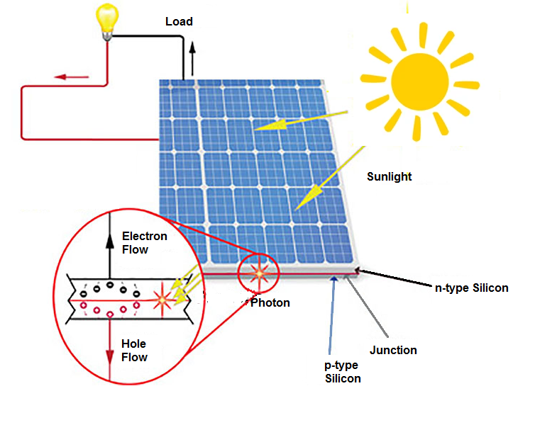
Figure 4. Diagram of Solar Panel.
    - Advantage of Solar Energy
- Solar energy has the least negative impact on the environment. During the generation of power it does not involve in any kind of pollution such as air, water, soil and noise pollution.
- It is clean technology, does not emit any green house gases during generation of electricity.
- Assessable duration is unlimited. The life of sun is minimum 5 billion years as calculated by the Scientists.
- Reduce dependency on fossil fuel especially for power generation.
- This energy can be used for diverse purposes. Like power generation (photovoltaic cell), heating water in winter or colder region and cooking food by using solar cooker (solar thermal).
- Low maintained Cost. It has no moving part, so no option of crack or tear/gear of parts.
- Reduce the electricity bill. Solar panel offered green investment even more beneficial
    - Disadvantage of Solar Energy
- The initial cost of purchasing and installation is fairly high.
- Function of Solar panel depend on sunlight to effectively gather light.
- Need large batteries for storage.
- Lot of space required for the setup of solar panel.
- Some toxic materials & hazardous substance used during the manufacturing process of solar photovoltaic system which indirectly affects the environment.
  - Wind Energy
In the present scenario, Wind power reported one of the fastest-growing renewable energy technologies. It account 16% of the electricity generation by renewable resources (Devabhktuni et al., 2015). The kinetic energy of wind has been used to generate electricity. For this purpose only electric turbines and windmills are required. Wind first hits a turbine’s blades, causing them to rotate and turn the turbine connected to them. It converts the kinetic energy of water flow into rotational energy, by moving a shaft which is connected to a generator, and thereby producing electrical energy through electromagnetism. The amount of power that can be harvested from wind depends on the size of the turbine and the length of its blades. The output is proportional to the dimensions of the rotor and to the cube of the wind speed. Theoretically, when wind speed doubles, wind power potential increases by a factor of eight. Figure 5 Showing the wind energy Site. The size of windmills is so large that it cannot be installed in populated area. Offshore wind turbines provide steady, reliable clean energy in various countries ( Wikipedia, Wind Power).

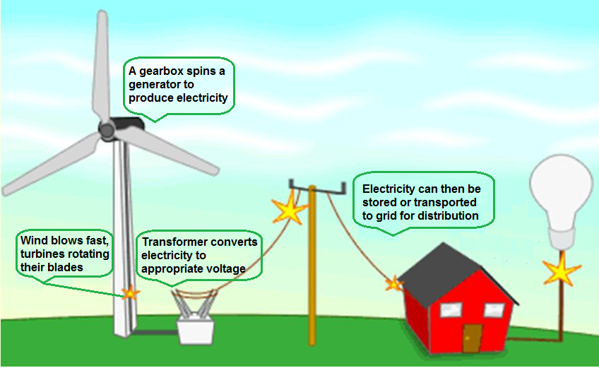
Figure 5. Generation of electricity from wind energy.

Table 3 showing the list of countries and their wind power capacity year-wise.

Table 3. List of countries with their wind power capacity.
Country | Total Wind power capacity in GW year-wise
 | 2020 | 2019 | 2018 | 2017
China | 281.99 | 236.32 | 211.39 | 188.23
European Union | 201.51 | 192.02 | 178.83 | 153.73
United State | 117.74 | 105.47 | 96.67 | 89.08
Germany | 62.18 | 61.36 | 59.31 | 56.13
India | 38.56 | 37.51 | 35.13 | 32.85
Spain | 27.09 | 25.81 | 23.49 | 23.17

Source: According to IEA’s Renewable report 2020 & Encyclopedia
    - Advantage of Wind Energy
- Wind energy is a reliable, clean, infinitely renewable energy resource.
- It is cost-effective. The installation and maintenance charges are nominal.
- Not involve in emission of the greenhouse gases or carbon residue as fossil fuel.
- Off-shore wind farms can have the maximum advantage without disturbing the landscape views.
- Wind energy is space-efficient. The land used for wind farms can also be used for different purposes like farming.
    - Disadvantage of Wind energy
- The Flow and speed of wind are unpredictable. Not uniform at any place and time.
- Habitats of birds or marine life disturb due to wind turbines.
- The setup of large-scale of wind farms can be expensive.
- Wind turbines produce noise which can be unpleasant.
- Visual appearance of the landscape can be affected by wind farms.

  - Hydropower Energy
Hydropower energy is also considered a renewable energy resources. It has been reported most widely utilized form of renewable energy. During the year 2019-20 it accounted for more than 18% of global’s total power generation of using renewable resources. Hydropower using the flow of water to power turbines and generate electricity. The kinetic energy of flowing water as it moves downstream has been used to produce power in the form of electric energy(Wikipedia, Hydropower). Mainly two types of equipments, turbines and generators have been used for this purpose. Figure 6 represent the working principle of conversion of a different form of energy of water into electrical energy. The capacity for power generation via hydropower of different countries shown in table 4.
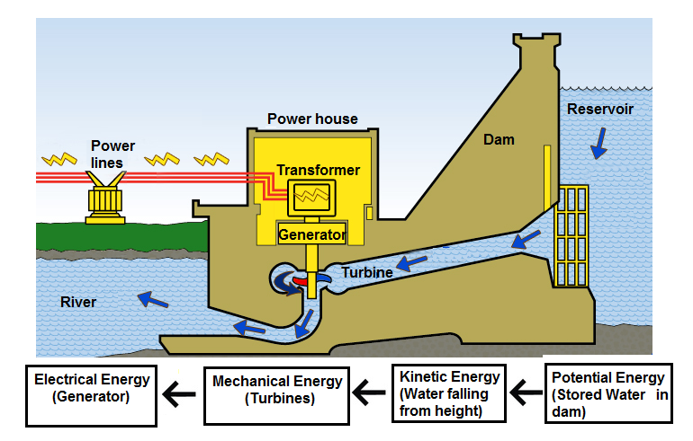
Figure 6. Diagram of Hydropower generation
Table 4. Country-wise power generation capacity by water.
Country | Total Hydro power capacity in GW year-wise
 | 2020 | 2019 | 2018 | 2017
China | 356.4 | 302 | 352.2 | 341.1
Brazil | 109.1 | 386.95 | 344 | 100
United State | 102.8 | 274.0 | 245 | 102
Canada | 81.4 | 398.0 | … | 225
India | 50.1 | 162.1 | 159.8 | 156

Source: IRENA Report

  - Biomass Energy
Biomass is another form of renewable source of energy. It is a kind of fuel developed from organic matter and utilize in generating electricity or also used in different forms ( Wikipedia, biomass). In a biomass power plants, organic waste is burned to produce steam that helps to run the turbines and transfer convert into electricity (Figure 7). Apart from that biomass is used to synthesize bio-fuel like Ethanol, bio-diesel, etc. Somehow procedure of composting is also popular now- a-days because it does not pollute the soil and having free of cost (Zou et al., 2016).
Examples of few materials used as biomass are as below:
- Agricultural wastes
- Forest product debris
- Organic scrap like wood, dead organic matters
- Manure
- Human & animals extracts
- Other organic wastes residues such as pulp of fruits & vegetables etc

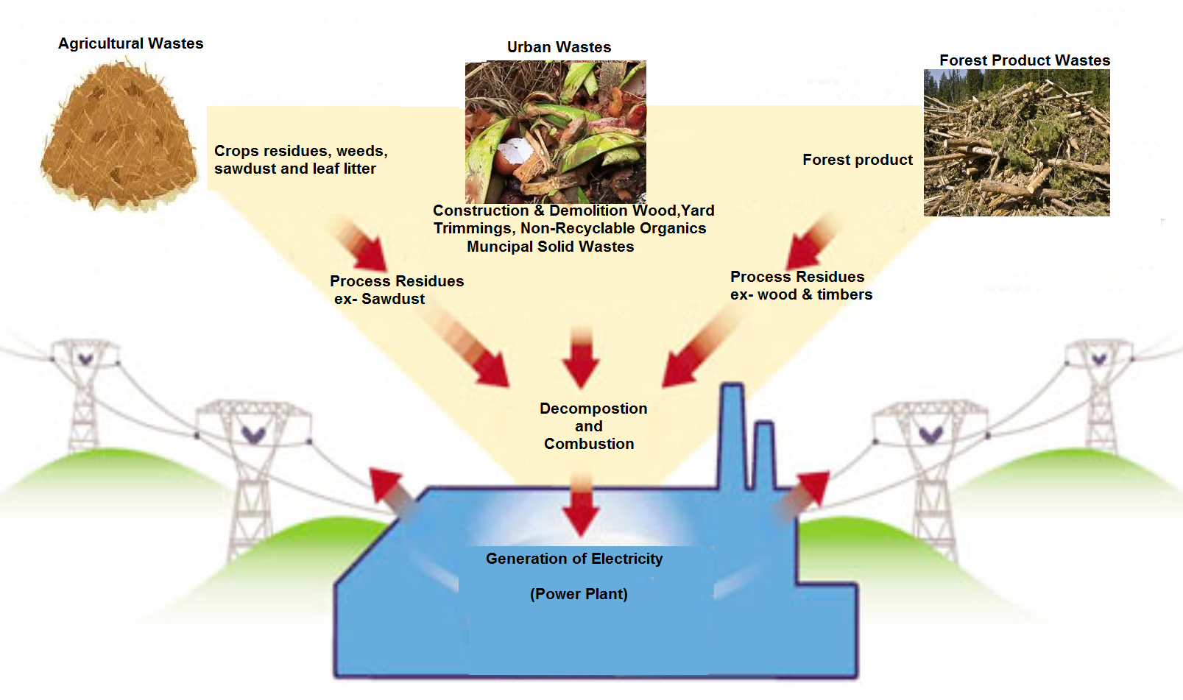
Figure 7. Sources of biomass energy
    - Advantage of Biomass Energy
- Biomass is a form of a renewable, infinite, and safe form of energy resource.
- Green Technology with no carbon residues.
- It reduces the dependency on fossil fuels
- Biomass technology is much cheaper.
- Due to proper management of organic wastes, it reduces the amount of garbage dumped in landfills by 60-90%. The requirement of land for landfills also has been reduced.
- Application of biomass energy helps in adding revenue from wastes

    - Disadvantage of Biomass Energy
- Biomass energy is not much effective as compared to fossil fuel.
- It is not entirely clean. During the processing of biomass, methane gas is released which may cause pollution in the environment.
- Possibility of deforestation. As the necessity of raw materials for bio-energy, it may promotes deforestation.
- Lot of space required for storing & management of biomass materials.

- Importance of Recycling
Recycling is the method of converting trash & waste materials into new products. This process involves collecting waste, recovery and reprocessing trash materials into new products (Zou et al., 2016). This is a key component of waste management to reduce waste or soil pollution. It is the third component of “3R” waste management i.e Reduce, Reuse and Recycle. Thus, it has been clearer that recycling helps towards maintaining environmental sustainability by substituting waste materials as input and after processing gets valuable output. Figure 8 showing the recycling practice in our society. Different bins have been used to segregate the waste materials, because each of this recycled waste has different way of processing (Jasanoff, 2017).
List of few materials which can be recycled
- Metal cans
- Scarps of Automobiles
- Paper products like, books, newspapers, paper towels, Cereal boxes, cartons, etc
- Trash bags
- Glass materials such as glass container, broken glass windows, etc
- Steel products, unused cook-wares
- Carpeting
- Thermoplastic materials

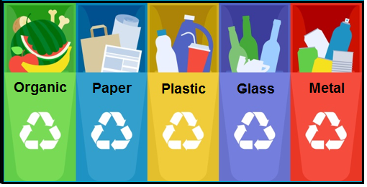
Figure 8 Separate Dustin for different type of recycled wastes.
The process has been done in 3 steps.
Step1. Collection and processing – there are so many methods for collecting recyclables wastes like curbside collection, drop-off centre and deposit.
Recyclables wastes have been sent to a recovery zone after the collection step. Then is sorted, cleaned, processed into useful materials that can be used in manufacturing.
Step 2. Manufacturing- It involves the making of new and fresh product from recycled waste. Few examples of recycled materials are as:
- Newspaper and paper towels
- Plastic laundry detergent bottles
- Metal, steel and glass containers/ Cans
Recycled materials can also be used in different ways such as recovered plastic used in carpeting and park benches, recovered glass in asphalt to pave roads.
Step 3. Purchasing new products obtained from recycled materials- The two must be observed while shopping because it will help in reducing the environmental pollution.
- Products that can be easily recycled
- Products that contain recycled content
Figure 9 Showing the meaning of the three arrows mentioned in recyclable products. Also try to promote to purchase such items which can recycle. It will help to reduce the quantity of waste.

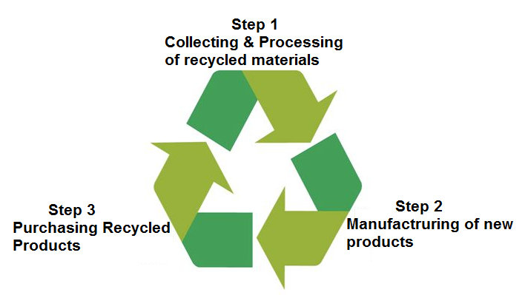
Figure 9. Meaning of 3 arrows in recyclables items
  - Benefits of Recycling
- Recycling helps in conserving natural resources. The environmental resources are finite so it is necessary to reduce its consumption rate.
- Reduce environmental pollution and thus protect our entire ecosystem. It reduces the need to grow, harvest or extract new resources from the earth.
- Demands for fresh raw materials are also reduced.
- Energy- saver methodology. Making of recycled products required less energy as compared to new products from fresh new materials.
- Less energy consumption helps in reducing carbon emission.
- The collection of waste and processing is cheaper than disposal. Researchers have proved that it is 6 times cheaper to dispose of recycled waste than general refuse.
- Proper waste management promotes employment

- Global Future trends in renewable energy
Rapid growth in global energy trends and their possible direct & indirect impact are closely related to the problem like supply and demand, assessment of energy and air as well as environmental pollution. Present policies focused on reduction of air pollution and planned to implement in such a way that it should meet long term climate goal. Due to cost reduction and supportive polices by government promote renewable technologies and provide market for it. The government of India, create possible environment to establish setup for renewable energy resource by lowing prices to attract investor.
The sharing of global energy supply by renewable expected to be rise up upto 40 % in 2040. On the other hand dependency on conventional mode will be reduced . it will help to make reserves of fossil fuels for future generation. In future, the market based on power generation depend on the variability in supplies and power system will expected to have flexible and adaptable. To increase activeness in sharing of renewable require grid investment, market reforms and new enabling technologies (IEA, World Energy Outlook,2018).
Global energy trend focused on the encouraging green technology with regards to the opportunities and challenges. The impression of global energy technology are depend upon competiveness and establishment of renewable based industries in future. Innovation and advance technology help to reduce industry dependency on foreign technology. To improve present technology, basic international trends come into light, which are as follow:
- To reform Technology Union
- Advanced information & communication technology
- Adopting digitization
- Special attention on Industries based on advanced technology
- Recognition of transnational corporation
By choosing an suitable energy source in the energy mix, factors such as technologies innovation, cost effectiveness, energy storage technology and increasing consumer demand are important for the handling of renewable and alternatives resources.

- Recent Innovation in Green Technology and applications
Innovation in Green Technology focuses on a challenge-oriented approach to solutions that bring together excellent natural sciences which underpin the development and application of technologies, to understand and deliver a sustainable future (http, Green Technology). Ti encourages and disseminates the creation and development of new innovative products, technologies and ideas that improve our environment (http, sustainability, 2019).
From recent research paper (SUSCHEM,2018) it is clear that, high R & D work, rapid innovative implementation, high capital expenditure and highly skilled employment are helpful to develop green technology. The sustainable development in view of enabling technologies required following things to sustain and develop:
- To address global challenges like low-carbon producing energy or resource efficiency
- To support the development of new products
- To stimulate economic growth and create job
- To adopt recent advancement in enabling technology

the combination of enabling trend and demand trend are required for global renewable energy development by providing improve integration and reduce cost. Recent or popular enabling technology are as below:
- Nanotechnology
- Biotechnology Industry
- Photonics
- Advanced materials
- Micro and nano-electronics
Green technology is on the rise, there are amazing green innovations happening all over the world helping us to live more sustainably. Few innovations based on green technology is mentioned here.
- Public Electric Transport- There are 160 electric and hybrid vehicle models available today. These E-Buses or E-Vehicles have higher acquisition prices due to up front battery costs. Their total cost of ownership (TCO) is lower due to their independence from pricey diesel. They also eliminate less particulate, SOx, NOx, and CO₂ as compared to fossil fuels.
- Battery whose capacity increase with time- This is one of the best green innovation by John Goodenough. His team has invented a lithium-glass battery whose energy density is thrice as compared to Lithium-ion batteries and it’s working capacity increases with time. This battery can be operate at low temperature, low cost, safe & clean to use, shorter charging time and can store more energy the older it gets.
- Notebook which never end- the Roketbook Everlast is a notebook with 36 pages. The extraordinary quality of this notebook is that can be easily wiped & clean with a damp cloth. Such green innovation save lots of trees over a life time.
- Biodegradable lunch-box- This is 100% biodegradable, zero waste and plastic free lunch box. It is made from organic rice husk and bind together with natural binding agent normally found in plant& trees. The lunch box is leak proof, durable, safe in oven/microwave, store in freeze and can be washed in dishwasher.
- Wooden Computer Chips- The University of Wiscosin-Madison developed a computer microchips from epoxy-coated cellulose nano fibril. This materials help the chip from moisture as wood usually does.
- Long-lasting Light Bulb- The Dyson company has developed a light bulb that can last for 37 years. It promote to reduce e-waste or non-biodegradable stockpile.
- Generation of Energy from the Waves- First plant was setup in Agucadoura, Portugal, 8 km away from the coast. The capacity of this plant to generate 2.25 MW of electricity. The installation consists of steel tubes of 150 m long and 3.5 m of diameter floating on the surface called “ Pelamis”. This devices are semi submerged in the sea and are responsible to convert kinetic energy of waves into electrical energy.

Reference
- Albert S. Introductory Chapter: Introduction to Global Green Technologies. Innovation in Global Green Technologies 2020. 1-10
- Bergek A, Berggren C, KITE Research group. The impact of environmental policy instruments on innovations: A review of energy and automotive industry studies. Ecological Economics.2014;106:112-123.
- WMO. The State of Greenhouse Gases in the Atmosphere based on Global observations through 2016. Greenhouse Gas Bulletin. 2017:13:1-8
- Jasanoff S. Just transitions: A humble approach to global futures. Energy Research & Social Science. 2018;35:11—14.
- https://en.wikipedia.org/wiki/Solar_energy
- https://en.wikipedia.org/wiki/Wind_power
- https://en.wikipedia.org/wiki/Hydropower
- https://www.reenergyholdings.com/renewable-energy/what-is-biomass/
- Zou C, Qun Z, Zhang G, Bo X. Energy revolution: From a fossil energy era to a new energy era. Natural Gas Industry B.2016;3:1-119
- Jasanoff S. Technologies of humility. Nature.2007; 450:33
- Rodriguez N, McLaughlin M, Pennock D. Soil Pollution: A Hidden Reality. Rome:FAO; 2018.
- https://www.tecamgroup.com/10-examples-of-green-technology/
- https://www.mckinsey.com/business-functions/sustainability/our-insights/sustainability-blog/these-9-technological-innovations-will-shape-the-sustainability-agenda-in-2019
- UN. World Population Prospects 2019 Highlights [Internet]. 2019. Available from: https://population.un.org › Publications › Files [Accessed: 19 September 2019]
- .WEC. World Energy Resources 2016 Summary [Internet]. 2016. Available from: https://www.worldenergy.org › wp-content › uploads › 2016/10 › World [Accessed: 19 September 2019]
- .WEC. World Energy Scenarios [Internet]. 2019. Available from: https://www.worldenergy.org › assets › Scenarios_Report_FINAL_for_website [Accessed: 19 September 2019]
- Anastassios P. Technology Trends: A Review of Technologies and Policies Study on Technology Trends DTI [Internet]. 2012. p. 97. Available from: www.dti.gov.za › industrial development › docs [Accessed: 19 September 2019]
- IEA. Renewable Information: Overview [Internet]. 2019 Edition. p. 12. Available from: https://webstore.iea.org/renewables-information-2019-overview [Accessed: 19 September 2019]
- IEA. World Energy Balances: Overview [Internet]. 2019 Edition. p. 23. Available from: https://webstore.iea.org › … › Statistics & Data [Accessed: 19 September 2019]
- IEA. Renewables 2018 Analysis and Forecasts to 2O23 Executive Summary [Internet]. p. 10 Available from: https://webstore.iea.org › download › summary [Accessed: 19 September 2019]
- UN. Pathways to Sustainable Energy Exploring Alternative Outcomes. United Nations Publication. eISBN: 978-92-1-057736-6 ISSN 1014-7225 Copyright © United Nations; 2015
- Majid J, Sheeraz K, Mohammad R. Techno-economic feasibility analysis of solar photovoltaic power generation: A review. The Smart Grid and Renewable Energy. 2012;3:266-274
- Renewable Energies Innovation for the Future [Internet]. p. 129. Available from: https://www.dlr.de › system › publications › broschuere_ee_innov_zukunft_en [Accessed: 19 September 2019]
- Renewable Energy and Energy Efficiency in China. Current Status and Prospects for 2020. Worldwatch Institute. 2010. p. 50. Available from: www.worldwatch.org [Accessed: 19 September 2019]
- IEA. World Energy Outlook [Internet]. 2018. Available from: https://www.iea.org › weo [Accessed: 19 September 2019]
- IEA. Energy Technology Perspectives [Internet]. 2017. Available from: https://www.iea.org › etp [Accessed: 19 September 2019]
- SUSCHEM. Key Enabling Technologies in Horizon Europe Paper. 20 June 2018, p. 22. Available from: www.suschem.org › files › library › IMPACT_K… [Accessed: 19 September 2019]
- Athukoralaa AUCD, Jayasuriyaa WJA, Ragulageethana S, Pereraa ATD, Sirimannaa MPG, Attalagea RA. A techno-economic analysis for an integrated solar PV/T system with thermal and electrical storage – case study. Moratuwa Engineering Research Conference (MERCon); 2015. pp. 182-187
- Depuru S, Green RC, Nims D, Near C, Devabhaktuni V, Alam M. Solar energy: Trends and enabling technologies. Renewable and Sustainable Energy Reviews. 2013;19:555-564
- Devabhaktuni V, Alam M, Boyapati P, Chandna P, Kumar A, Lack L, et al. Wind energy: Trends and enabling technologies. Renewable and Sustainable Energy Reviews. 2015;53:209-224

