TEACHERS PERSPECTIVES ON EMOTIONAL QUOTIENT, SPIRITUAL QUOTIENT, HAPPINESS QUOTIENT - EXCELLENCE IN HIGHER EDUCATION

Dr.G.SASIKALA
ASSISTANT PROFESSOR
PG & RESEARCH DEPARTEMENT OF REHABILITATION SCIENCE
HOLY CROSS COLLEGE
TRICHIRAPPALLI
TAMILNADU

E.mail: sasimano2003@gmail.com
Mob. No. 8903400923

ABSTRACT
Education plays an important role in the overall development of personality. The main goals of the educational system to adapt the students to life as individuals having emotional, spiritual, happiness qualities, to help them in gaining an outlook to see the world with higher self-confidence, self- awareness. To achieve all the above mentioned goals, it is of great importance for the teachers who have to supply the needed background to their students, to integrate their Emotional Quotient (EQ), Spiritual Quotient (SQ) and Happiness Quotient (HQ) in order to create inner synergy and expose a powerful modelling role.

Teacher’s wealth of opportunities to extend their influence beyond their own classrooms to their students excellence, develop ,release the full potential of their students at an individual level. They promote fairness, equality, involvement to empower their students, communicate, reward, recognise in a way that motivates students and builds commitment to use their skills, knowledge for the benefit of society.

This concept paper dwells on the excellence in higher education depends on the skills of teachers. The author intends to discuss EQ, SQ and HQ altogether from the perspective of teacher to point the significant role they play in improving excellence in higher education.

Key words: Emotional Quotient, Spiritual Quotient, Happiness Quotient, Teachers Perspectives, Excellence, Higher Education

INTRODUCTION

The rapid global changes, tough competition and globalization in the educational industry have caused tremendous impact in the life of students from all over the world. Education plays an important role in the overall development of personality. Educated children are empowered, motivated and skilled enough to take up challenges of life. They are asset to the family, society and the nation.

“Education should contribute to every person’s complete development – mind and body, intelligence, sensitivity, aesthetics, appreciation and spirituality” -This fundamental principle has been forcefully reasserted by the International Commission on Education for Twenty-first Century (UNESCO, 1996). Most of the educators, especially from the 20th century onwards, lay stress on the social aspects of education in addition to the academic areas. They uphold that education is a life-long process by which an individual adapts herself/himself gradually and gracefully to the available physical, intellectual, emotional, social and spiritual environments.

The ‘teacher’ is the most powerful ‘environment’ for the child especially in schools. It is the personality of the teacher that has the most permanent influence on the child. The teacher has to select and present to the learner, the experiences which may lead him to the fulfilment of his needs and his obligation to the society. An ideal teacher has to be ‘heavy enough’ to take care of her / his students’ not only intellectual environment, but also the emotional / social and the spiritual environments and lead them in the right direction - this makes a teacher – a’ preceptor’.

The recent ‘National Curriculum Frame work’ (NCF,2000 as well as NCF,2005 for School Education by NCERT, apart from broad based general education to all learners, emphasizes very much on acquiring basic life skills and development of high standards of IQ as well as Emotional Intelligence Quotient (EQ) and Spiritual Intelligence Quotient (SQ).NCF (2000) even stresses on assessment of EQ & SQ in addition to IQ.

The Teachers are the flywheel of the whole lively educational machine. If students have to develop HQ, EQ & SQ, their teachers should not only be intelligent enough (of high IQ) so as to work as sea of knowledge and skills but also have highly developed affective domain (with high EQ ,SQ & HQ). In these demanding times which are full of challenges, conflicts and contradictions, only ‘emotionally and spiritually & happiness intelligent teachers’ are able to tune their students’ world around, read their situations and connect them with others, of course while taking charge of their own emotional life with their inner being illuminated by happiness and spirituality.

EXCELLENCE IN TEACHING

The concept of “excellence‟ is well established in many fields of activity, and the term is used frequently to refer to an outstanding performance. In higher education it means different things in different contexts. Educative practices and curriculum that dynamizes personal and systems transformation, holistic education is a must. Transpersonal practices of holistic education nurture levels of wholeness through personal transformation.

Excellence may be equated with the reputation and standing of institutions, but much depends on the perception of student experience and the varying missions of institutions. There are numerous definitions suiting different purposes and different areas of quality assurance and stakeholders‟ involvement. The concept is vague enough to offer plentiful grounds for both theoretical and practical research.

Excellence in teaching can be achieved by

i) Creating an engaging, motivating, and intellectually stimulating learning experience
ii) Encouraging the spirit of critical analysis and creative innovation informed by current research.
iii) Emphasizing the importance, relevance, and integration of theory and knowledge with professional practice to develop solutions to real world issues

Teaching excellence‟ is a contested concept. There are different definitions of what it means to be an `excellent‟ teacher and these are located within a shifting social, economic and political context. Assessing the quality of teaching has been a long-standing issue for higher education. Excellence in teaching is determined by factors such as the inspirational nature of individual lecturers, the organisation of presentations, the interaction with students as participants and how well the information provided meets the learning objectives of the course.

Excellence can be identified both in terms of student satisfaction and also in terms of the performance of students in assessment. There are differences between deep and surface learning. Excellent teaching may be seen as the efficient presentation of information which maximises the students‟ opportunities to gain the highest marks from the course.

Alternatively, excellence could be recognised as the stimulus for students to engage with the subject and to enhance their understanding and knowledge. The ultimate goal of Education is all round development of pupil. All round development means person must be physically fit, mentally balanced, emotionally strong, socially adjusted.

EMOTIONAL QUOTIENT

Emotional Intelligence also known as Emotional Quotient. Emotional Quotient is a key factor in the growing process of the college students. The EQ level of contemporary college students will not only affect their learning, life and body and mental health, but also affect the quality of the whole nation and national prosperity. Therefore, strengthening the college students' EQ education, improving college students' EQ level, is an important subject of higher education, which should be the concern of the whole society.

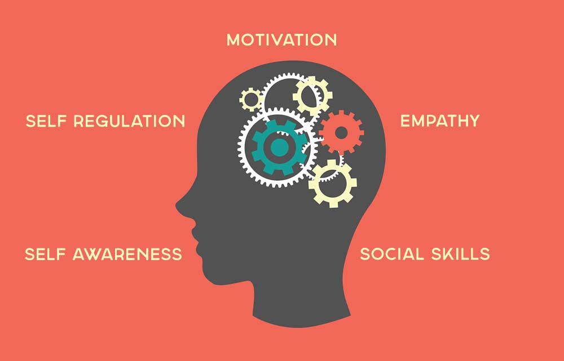

In 1995, American psychologist Daniel Goleman proposed the concept of “Emotional Quotient (EQ)” in Emotional Intelligence. It is thought that Emotional Quotient is an important individual ability for survival; it is a key factor that could dig the emotional potential, affect the life of each level and the future life through the ability to use emotional intelligence. In the elements of one’s success, mental factors are important, but more important one is emotional factors. Emotional Quotient includes the ability in five aspects: the ability for understanding their own emotions, the ability to manage emotions properly, the ability of self-motivated the ability of cognitive emotion, and the ability on interpersonal communication.

Emotional Quotient, as a kind of non-intelligence factors, is of great importance to one's career success. The research result of psychologist Daniel Goleman shows that, Intelligence Quotient accounted only for 20% in the affecting factors in the personnel success, while the 80% is attributed to the Emotional Quotient.

A degree of E.Q. is awareness of one's own and other people's feeling such as sympathy, comparison motivation and the ability to respond to pain and pleasure appropriately (Goleman, 1995). In other words, we can describe E.Q. in such of way that "intelligence with emotions" is called emotional intelligence.

Teaching adolescents about their emotions and how they deal with others as well as their own actions can be very helpful in their struggles. Furthermore, in order to encourage a smooth transition from adolescence to adulthood, a good understanding of emotions of adolescents is important in determining their psychological wellbeing. Here, the concept of 'personal meaning' in life of adolescents can play a major role in relation to the emotional intelligence of adolescent. Wong (1998) defines meaning in life as it refers "to making sense,order or coherence out of one's existence and having a purpose and striving towards a goal or goals."

SPIRITUAL QUOTIENT

Emotional Quotient (EQ) is as important as Intelligence Quotient (IQ). EQ gives awareness of our own and other people’s feelings. Experts say EQ is basic requirement for IQ. If the person is emotionally intelligent, he thinks effectively in every situation and that automatically contributes to better decision making. Researchers have found out that IQ and EQ are not the whole human intelligence, there is more to it. Hence the “third Q” came into existence and that is “Spiritual Quotient- SQ”

Spiritual intelligence or SQ is a coined term. It sounds familiar, yet most people have never heard the term, never read about it, and never discussed it with anyone else. Some may think they know its meaning, but they may be confusing spiritual intelligence with spiritual knowledge. Spiritual intelligence is a way of thinking. We are all born with it, live with it, and use it. It can never be taken from us. As Dana Zohar describes in her joint book SQ Spiritual Intelligence, the Ultimate Intelligence; “SQ is what we use to develop our longing and capacity for meaning, vision and value. It facilitates a dialogue between reason and emotion, between mind and body.

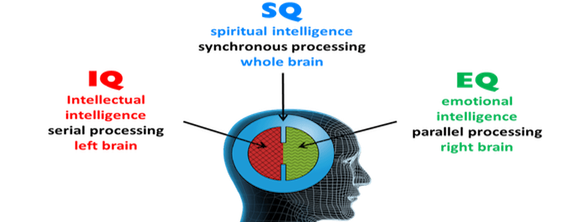

Danah Zohar, a researcher in the field of Spirituality and Leadership offers a framework for
fostering spiritually intelligent leadership by nurturing the following traits:

• Self-awareness: knowing what I believe in and value, and what deeply motivates me
• Spontaneity: living in and being responsive to the moment
• Being vision- and value-led: acting from principles and deep beliefs, and living accordingly
• Holism: seeing larger patterns, relationships, and connections; having a sense of belonging
• Compassion: having the quality of “feeling-with” and deep empathy
• Celebration of diversity: valuing other people for their differences, not despite them
• Field independence: standing against the crowd and having one’s convictions
• Humility: having the sense of being a player in a larger drama, of one’s true place in the
world
• Urge to ask fundamental ‘Why?’ questions: need to understand things in depth, not just
superficially
• Ability to reframe: to stand back from a situation or problem and see the bigger picture
• Positive use of adversity: Learning and growing from mistakes, setbacks, and suffering
• Sense of vocation: feeling called upon to serve, to give something back

A person may be very high in SQ but have no religious faith or belief of any kind. Equally a person may be religious but low in SQ. Spiritual intelligence could function as the guidelines in our differentiating to the good and bad. Spiritual intelligence on the other hand is the ultimate intelligence with which we address and solve problems of meaning and value, our lives in a wide richer meaning giving context to the intelligence with which we can assess that one's course of action or one's life path is more meaningful than the others (Zohar and Marshall, 2001).

HAPPINESS QUOTIENT

The Happiness quotient (HQ) is a concept that measures approximately, the measure of happiness each person has achieved in his life.The happiness quotient is a model that makes it easier for people to objectively judge their own happiness on multiple aspects. These aspects are called happiness quotients. In total, there are 7 quotients which together form the happiness quotient:

- Emotional happiness
- Physical happiness
- Social happiness
- Occupational happiness
- Intellectual happiness
- Environmental happiness
- Spiritual happiness

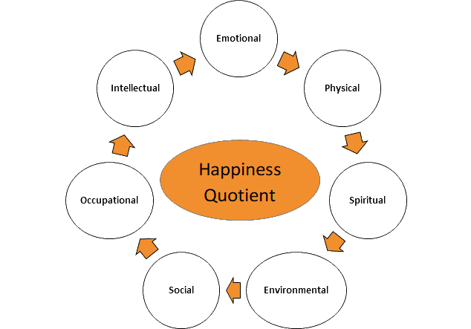

THE CONNECTION BETWEEN EQ, SQ AND HQ

Man lives in society, which is an association of individuals & created by individuals for their own good. In present scenario the condition of the society is pathetic and compels us to think various aspects like loss of moral values, lack of emotional control, no regard for each other etc. These problems arise from lack of EQ, SQ, HQ & Values. Inorder to overcome their problems knowledge about EQ, SQ, HQ & Values must be taught to the students. Students are the foundation of the society, who comes from the schools. The connections between spirituality and education are often not in schools.

To make these possible changes in attitudes, behaviour & Values are required. Besides improving all aspects of quality of education &ensuring excellence, the measurable learning outcomes are to be achieved by all, especially in literacy, numeracy & essential life skills. In brief the quality education is one that satisfies basic learning needs & enriches the lives of learners & their overall experience of life.

By teaching emotional, spiritual &happiness skills the students can be developed with self-acceptance, anger management ability to make and keep friends, ability to resolve conflict, motivation to cooperate and power to express. Fisher (1998) pointed out that recent research has shown attention to the importance of spirituality in human health and wellbeing. Spiritually wellbeing people manifest a positive energy that helps them to manage challenges, have a commitment to truth and are often a source of inspiration to others (Ingerson, 1998).

Human Intelligence is highly complex. Neither IQ alone nor EI (and IQ) of a person would represent the totality of his/her intelligences. Computers have high (of course artificial) IQ but not EI. EQ enables a person to judge what situation he is in and then to behave appropriately within it; i.e., he is working within the boundaries of the situation, allowing the situation to guide him; but one’s SQ enables him to ask the question “why should he be there in that particular situation in the first place?”. Unlike EQ, SQ can give him transformative power, power to change the situation by creating a better one; i.e. one’s SQ can help him/her in dealing with the situation by allowing him to guide the situation, to create new values by understanding existing situational values, etc

In an ideal case, these three intelligences should work together by supporting each other; human brain is designed to coordinate these three; as each one has its own area of strengths, they can function separately too. Human being in general, need not be high or low in IQ, EQ, SQ &HQ simultaneously. All variations are possible i.e. high IQ & lower EQ, SQ &HQ is possible; one need not have higher IQ to possess higher EQ/SQ/HQ. Ideally, all the three intelligences should be well developed to succeed in life.

EXCELLENCE IN HIGHER EDUCATION

A fundamental need of an institution is to imbibe certain values and principles among students to shape up their personality according to the present need, but this is missing from academic institutions. For the development of good personality of students we have to provide emotional, spiritual, happiness & value education, so that the students can enhance their self-concept and self-esteem. Emotional Quotient, Spiritual Quotient, Happiness Quotient & values influence our life in most of the areas like family, society and schools etc.

During the adolescence students suffer from stress & tension. It is a period of emotionality and stage of development of thoughts & ideas in their mind. During this period they feel various negative feelings such as anger, grief, blame and fear etc. There are some emotions which are toxic to learning and some are helpful in improving learning. Education regarding emotional, spiritual and values would be beneficial to control negative emotions.

Singh (2001) suggest that emotions can be positive and negative because they react to specific condition or situations. Hence, the Education has to be carefully given by keeping in mind the chief issues of emotionality, spirituality, happiness. Due to negligence of chief issues in today's education, incidents such as shooting in the classroom, using abusive language, suicidal cases etc., do occur in our colleges, school/society. Hence, emotional, spiritual, happiness& values aspects should also be stressed for the complete development of an individual. Such a vision should enlighten and guide future educational reforms and policies in relation to content methods. Emotional, spiritual & happiness quotient are observed to be essential for dealing with students in their learning environment, and to make proper decisions. EQ, SQ, HQ & values are therefore becoming an important area of study.

Spiritual intelligence put our individual lives in large context. It provides meaning and purpose to life. With high spiritual intelligence students are able to understand the importance of human nature and are able to improve and modify their behaviour. In NCERT curriculum framework of secondary education (2000), one of the objectives was to provide – "Broad based general education to all learners up to the end of the secondary stage to help them to become lifelong learners and acquire basic life skills and high standards of Intelligence Quotient (IQ), Emotional Intelligence (EQ) and Spiritual intelligence (S.Q.)."The connections between spirituality and education are often not found in schools.

Education systems do affect the behaviour, thoughts and beliefs of students. An Education system (curriculum planners and administrator) must be aware of the EQ, SQ, HQ & values help their students for meaningful and valuable life that's why the education system must be focused on EQ, SQ, HQ & values.

TEACHER’S PERSPECTIVES ON EQ, SQ &HQ THROUGHOUT THE EDUCATIONAL PROCESS

Teaching is a creative and adventurous profession where passion cannot be an option. Teachers with a passion for teaching are those, who are committed, enthusiastic, and intellectually, emotionally & spiritually energetic in their work with children, as well as with their colleagues, parents and the members of the society at large. This passion is essential to achieve high quality in teaching. As such teachers are the torch bearers in creating and enhancing social cohesion, national integration, global understanding and a learned society. Even the best of a social / educational system is bound to fail unless, good teachers are available; even some serious defects of the system can be largely overcome, once we have good teachers.

Most of the educators, especially from the 20th century onwards, lay stress on the social aspects of education in addition to the academic areas. They uphold that education is a life-long process by which an individual adapts herself/himself gradually and gracefully to the available physical, intellectual, emotional, social and spiritual environments. Hence, to carry out the process of education, teachers’ all round development should also be considered seriously at the perspectives of EQ, SQ & HQ throughout her/his career.

Teachers do influence the personality of a student. Their emotional, intellectual, moral, ethical and spiritual realms have profound influence on the development of children. If the teacher is emotionally and spiritually intelligent & happy, s/he can manage the emotional and spiritual traits of her/his students in order to provide balanced environment in the classroom. Sense of self, empathy, kindness, intuition, motivation, awareness, social skills, forgiveness, reconciliation, dedication is some of the major components of emotional / spiritual & happiness quotient.

Educators have to find suitable ways to solve the problems of their students as much as possible. And to achieve this, educators should be well trained in areas such as class management, educational communication and psychology because education also has a meaning of sharing “love” and knowledge passing from the individual to the family and then to the whole humanity. The final goal is to train loving, respecting, responsible, successful, self-confident, virtuous, assertive etc. individuals. As seen, the main goal of education is also the goal of psychological health (Yavuzer 1999: 215)

Educators can train their students according to the above mentioned competencies. But to develop self-awareness is a prerequisite of this process. In other words, educators should ask questions to themselves, considering the meaning of knowledge, feelings and life itself and be able to assimilate these answers within themselves. In order to understand whether an educator has an integrated EQ,SQ &HQ competency, it is possible to interrogate his/her way
of approaching life, knowledge, love, nature, and observe his/her comprehension, tolerance and compassion. To develop and integrate these competencies, below are the behavioural types that educators should consider:

1. The attitude of the educators at the very beginning of the academic term is important from the perspective of students. Positive attitudes, behaviors and approaches shape the first impressions of students.
2. Educators should be well educated in their own professional topics and transmit what they know persuasively.
3. Active and empathic listening is of great importance both from the point of educators and students.
4. Educators should pay attention to their students’ psychology and emotions.
In this way, they can help their students to develop their emphatic skills, and overcome fear, anger, sorrow and such negative feelings more easily.
5. Educators should also help their students on how to manage themselves, what to consider in social relations, how to motivate themselves and how to improve team work etc.
6. They should also encourage their students to engage in various activities in order to increase their general knowledge, which in turn would support the students’ EQ, SQ &HQ.
7. Educators can also use humor and real life stories throughout the educational communication process, which would enlighten both their own and their students’ lives.

CONCLUSION

Recent studies show that high IQ is not a guarantee for a successful, prestigious and happy life. However, in most educational institutions academic achievement and high grades are still valued. Unfortunately, developing social and emotional abilities, paying attention to the ‘other voice of mind’ are underestimated in educational communication. Usually socializing students in the current curriculum, supplying them with a strong infrastructure by improving their interpersonal communication skills are taken as secondary items through this process.

Recent researches on EQ points out individuals with high emotional and social skills have more happy and productive lives. The people who cannot control their emotions are usually found to be in a troubled spirit and in an internal struggle which hinder their clear thinking and concentration. However, the ones with high EQ and SQ seem to have more advantageous positions both in their private and professional lives. People with high SQ level have the ability to give inspiration to others. So especially the educators whose mission is to train their students mentally, emotionally, and spiritually have to learn to integrate their IQ, EQ, SQ &HQ in the first place.

In conclusion, it is very important to integrate EQ, SQ &HQ competencies in higher education. That is why this process should be strategically planned, managed and evaluated by educators and by the educational institutions, and in order to accomplish this, it is a prerequisite to supply the needed training courses to educators on EQ,SQ &HQ literacy.

REFERENCES

- Alam, Md. Mahmoud. (2012). Emotional Intelligence, Self efficacy and career maturity among the students of Hyderabad city. Journal of Community Guidance and Research, 29(2), Pp. 272-283.
- Bhangale, S. and Mahajan P., S. (2013).Spiritual Intelligence - Emerging Issue in Education. Retrieved September 7, 2015
- Daniel Goleman. (1997). Emotional Quotient. Shanghai: Shanghai science and Technology Press.
- Daniel Goleman (1995) Emotional Intelligence: Why It Can Matter More Than IQ
- E-book on IQ-EQ-SQ by Basic Foundation, www.folknet.in
- GOLEMAN, Daniel (1995), Emotional Intelligence; Why It Can Matter More ThanIQ, NY: Bantam Books.
- Yun Ming, Hai. (1997). Emotional intelligence. Beijing: China City Publishing House.

-----------------------x---------------------------------x----------------------------------x------------------

